Implementation of List using Array ADT
EXPERIMENT 1-A
AIM:
To implement the List Abstract Data Type (ADT) using an array and structure in C and perform the basic operations: Insertion, Deletion, Updation and Display.

PSEUDOCODE:
- Start.
- Define a structure List containing:
  - An integer array.
  - A variable size to store the current number of elements.
- Initialize size to 0.
- Display the menu:
  - Insert
  - Delete
  - Update
  - Display
  - Exit
- Read the user's choice.
- If the choice is Insert:
  - Read the position and value.
  - Shift the elements to the right.
  - Insert the new element.
  - Increase size.
- If the choice is Delete:
  - Read the position.
  - Shift the elements to the left.
  - Decrease size.
- If the choice is Update:
  - Read the position and new value.
  - Replace the existing element with the new value.
- If the choice is Display:
  - Display all the elements of the list.
- If the choice is Exit:
  - Terminate the program.
- Stop.

CODE:
#include <stdio.h>
#define MAX 100
struct List
{
int arr[MAX];
int size;
};
void initialize(struct List *l)
{
l->size = 0;
}
void insert(struct List *l, int pos, int value)
{
if (l->size == MAX)
{
printf("List is Full!\n");
return;
}
if (pos < 0 || pos > l->size)
{
printf("Invalid Position!\n");
return;
}
for (int i = l->size; i > pos; i--)
l->arr[i] = l->arr[i - 1];
l->arr[pos] = value;
l->size++;
printf("Element inserted successfully.\n");
}

void delete(struct List *l, int pos)
{
if (l->size == 0)
{
printf("List is Empty!\n");
return;
}

if (pos < 0 || pos >= l->size)
{
printf("Invalid Position!\n");
return;
}
for (int i = pos; i < l->size - 1; i++)
l->arr[i] = l->arr[i + 1];
l->size--;
printf("Element deleted successfully.\n");
}

void update(struct List *l, int pos, int value)
{
if (pos < 0 || pos >= l->size)
{
printf("Invalid Position!\n");
return;
}

l->arr[pos] = value;

printf("Element updated successfully.\n");
}

void display(struct List *l)
{
if (l->size == 0)
{
printf("List is Empty!\n");
return;
}

printf("List Elements: ");

for (int i = 0; i < l->size; i++)
printf("%d ", l->arr[i]);

printf("\n");
}

int main()
{
struct List list;
initialize(&list);

int choice, pos, value;

while (1)
{
printf("\n----- LIST ADT USING STRUCTURE -----\n");
printf("1. Insert\n");
printf("2. Delete\n");
printf("3. Update\n");
printf("4. Display\n");
printf("5. Exit\n");
printf("Enter your choice: ");
scanf("%d", &choice);

switch (choice)
{
case 1:
printf("Enter position: ");
scanf("%d", &pos);
printf("Enter value: ");
scanf("%d", &value);
insert(&list, pos, value);
break;
case 2:
printf("Enter position to delete: ");
scanf("%d", &pos);
delete(&list, pos);
break;

case 3:
printf("Enter position to update: ");
scanf("%d", &pos);
printf("Enter new value: ");
scanf("%d", &value);

update(&list, pos, value);
break;
case 4:
display(&list);
break;
case 5:
printf("Exiting...\n");
return 0;
default:
printf("Invalid Choice!\n");
}
}

return 0;
}

OUTPUT:
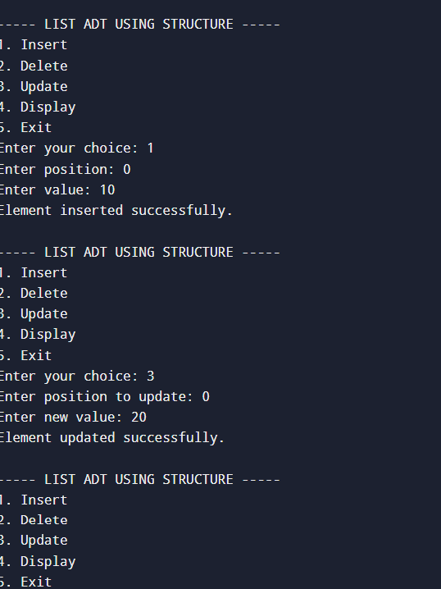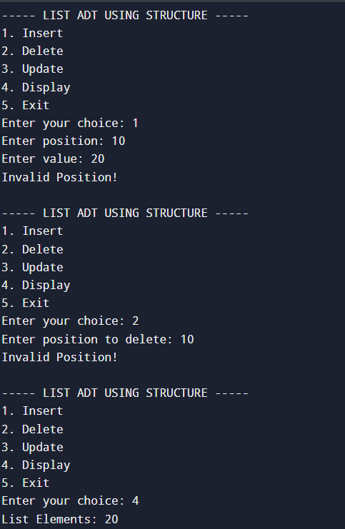
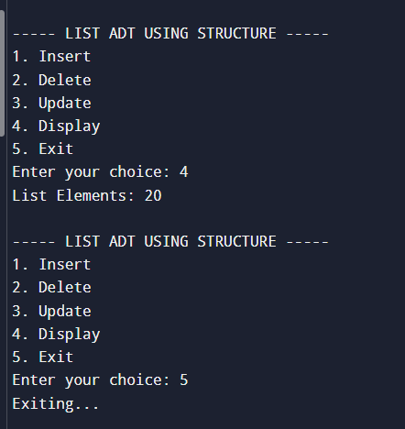

RESULT:
The List ADT was successfully implemented using an array and structure in C. The operations Insertion, Deletion, Updation, Display, and Exit were performed successfully using a menu-driven program.

EXPERIMENT 1-B
AIM:
To implement the Linear Search operation using an array in Abstract Data Type (ADT) and search for a given element.

PSEUDOCODE:
- Start.
- Read the number of elements n.
- Read the n elements into the array.
- Read the element to be searched.
- Compare the search element with each element of the array one by one.
- If the element is found:
  - Display its position.
  - Stop searching.
- If the element is not found after checking all elements:
  - Display "Element not found".
- Stop.

CODE:
#include <stdio.h>
#define MAX 100

struct List
{
int arr[MAX];
int size;
};

int main()
{
struct List l;
int i, key, found = 0;

printf("Enter number of elements: ");
scanf("%d", &l.size);

printf("Enter elements: ");
for(i = 0; i < l.size; i++)
scanf("%d", &l.arr[i]);

printf("Enter element to search: ");
scanf("%d", &key);

for(i = 0; i < l.size; i++)
{
if(l.arr[i] == key)
{
printf("Element found at position %d", i);
found = 1;
break;
}
}

if(!found)
printf("Element not found");

return 0;
}

OUTPUT:
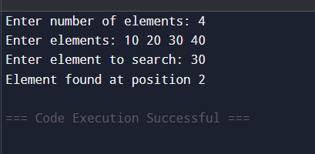

RESULT:
The Linear Search operation using an array in ADT was successfully implemented, and the given element was searched successfully.

EXPERIMENT 1-C
AIM:
To implement the Binary Search operation using an array in ADT to search for a given element.
PSEUDOCODE:
- Start.
- Read the number of elements n.
- Read the sorted elements into the array.
- Read the element to be searched (key).
- Initialize:
- low = 0
- high = n - 1
- Repeat while low <= high:
- Find mid = (low + high) / 2.
- If arr[mid] == key:
  - Display "Element found at position mid".
  - Stop.
- Else if key < arr[mid]:
  - Set high = mid - 1.
- Else:
  - Set low = mid + 1.
- If the element is not found, display "Element not found".
- Stop.

CODE:
#include <stdio.h>
#define MAX 100

struct List
{
int arr[MAX];
int size;
};

int main()
{
struct List l;
int i, key, low, high, mid, found = 0;

printf("Enter number of elements: ");
scanf("%d", &l.size);

printf("Enter sorted elements: ");
for(i = 0; i < l.size; i++)
scanf("%d", &l.arr[i]);

printf("Enter element to search: ");
scanf("%d", &key);

low = 0;
high = l.size - 1;

while(low <= high)
{
mid = (low + high) / 2;

if(l.arr[mid] == key)
{
printf("Element found at position %d", mid);
found = 1;
break;
}
else if(l.arr[mid] < key)
low = mid + 1;
else
high = mid - 1;
}

if(!found)
printf("Element not found");

return 0;
}

OUTPUT:
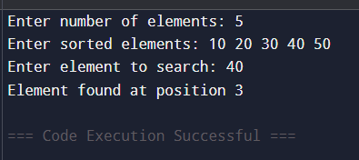
RESULT:
The Binary Search operation using an array in ADT was successfully implemented, and the given element was searched successfully in the sorted array.

