Data Structures and Algorithms Laboratory Record
Experiment: Arrays and Array-Based Technique
QUESTION-1
AIM:
To write a C program to square each element of a sorted array and return the squared values in sorted order using the Two-Pointer Technique.

PSEUDOCODE:
Start
Read the size of the array (N)
Read N sorted elements into the array
Initialize:
left = 0
right = N - 1
pos = N - 1
Create an output array
While left <= right
If square(arr[left]) > square(arr[right])
output[pos] = square(arr[left])
left = left + 1
Else
output[pos] = square(arr[right])
right = right - 1
End If
pos = pos - 1
End While
Print the output array
Stop
CODE:
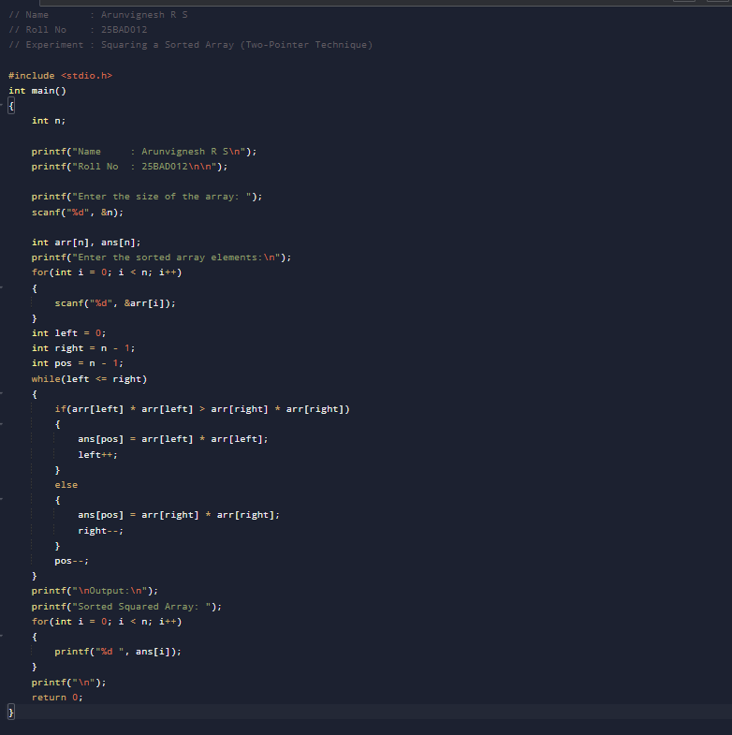
OUTPUT:
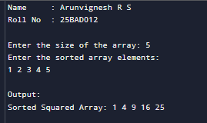

RESULT:
Thus, the C program to square each element of a sorted array and display the squared values in sorted order using the Two-Pointer Technique was implemented successfully, and the desired output was obtained.
QUESTION-2
AIM:
To write a C program to compute the cumulative sum (Prefix Sum) of an array using the Prefix Sum Technique

PSEUDOCODE:
Start
Read the size of the array (N)
Read N elements into the array
Initialize sum = 0
For each element in the array
sum = sum + current element
Print sum
End For
Stop

CODE:
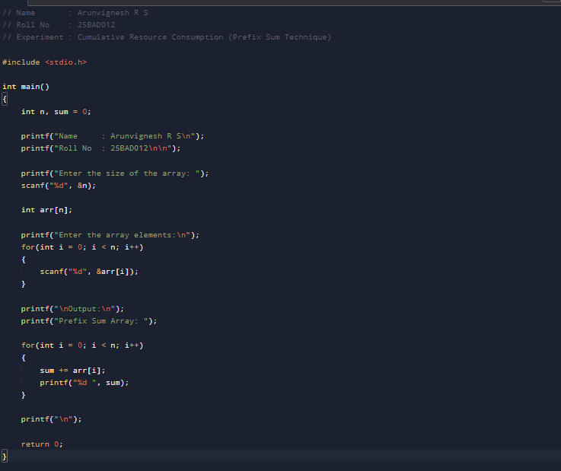
OUTPUT:
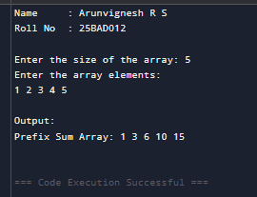
RESULT:
The Linear Search operation using an array in ADT was successfully implemented, and the given element was searched successfully.

QUESTION-3
AIM:
To write a C program to find the minimum number of swaps required to bring all 1's together in a binary array using the Fixed-Size Sliding Window Technique.
PSEUDOCODE:
Start
Read the size of the array (N)
Read the binary array
Count the total number of 1's (count)
If count is 0 or 1
Print "Min Swaps: 0"
Stop
End If
Count the number of 1's in the first window of size count
Store it as maxOnes
Slide the window through the array
Add the new element entering the window
Remove the element leaving the window
Update maxOnes if needed
End While
Minimum Swaps = count - maxOnes
Create a new array filled with 0's
Place all the 1's together in the best window
Display the minimum swaps
Display the final grouped array
Stop
CODE:
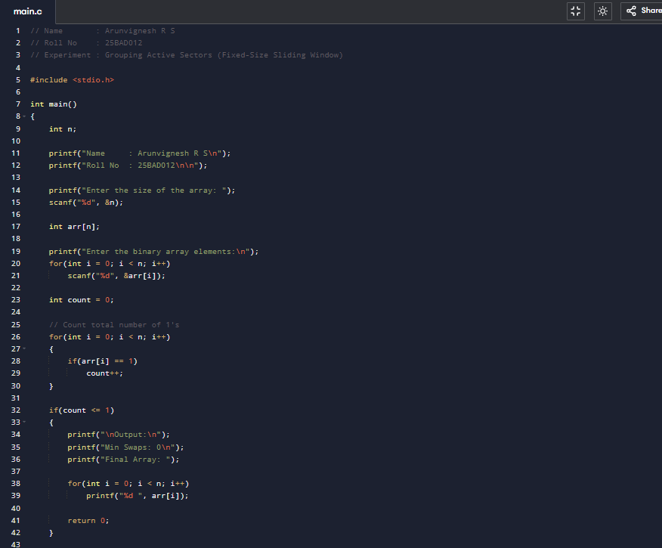
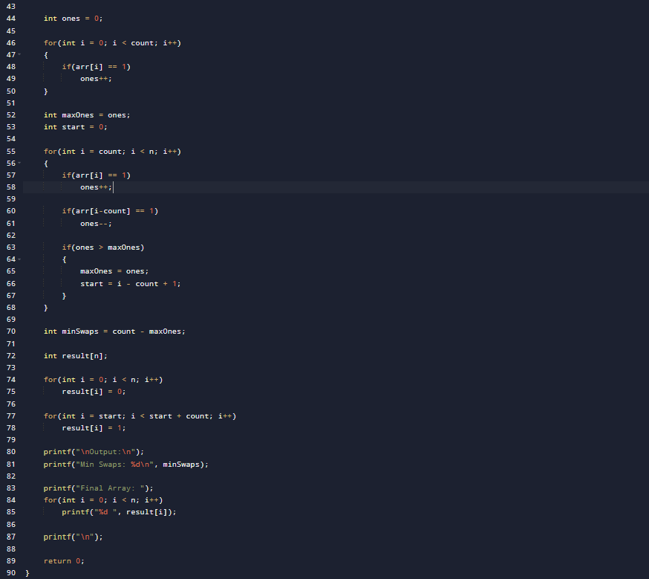
OUTPUT:
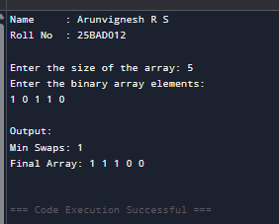
RESULT:
Thus, the C program to find the minimum number of swaps required to group all the 1's together using the Fixed-Size Sliding Window Technique was implemented successfully, and the desired output was obtained.

QUESTION-4
AIM:
To write a C program to find the maximum number of consecutive tasks whose total energy consumption does not exceed the given budget using the Variable-Size Sliding Window Technique.
PSEUDOCODE:
Start
Read N and P
Read N array elements
Initialize:
start = 0
sum = 0
maxLength = 0
For end = 0 to N-1
Add current element to sum
While sum > P
Subtract arr[start] from sum
Increment start
End While
Update maxLength if current window is larger
End For
Display maxLength
Stop

CODE:
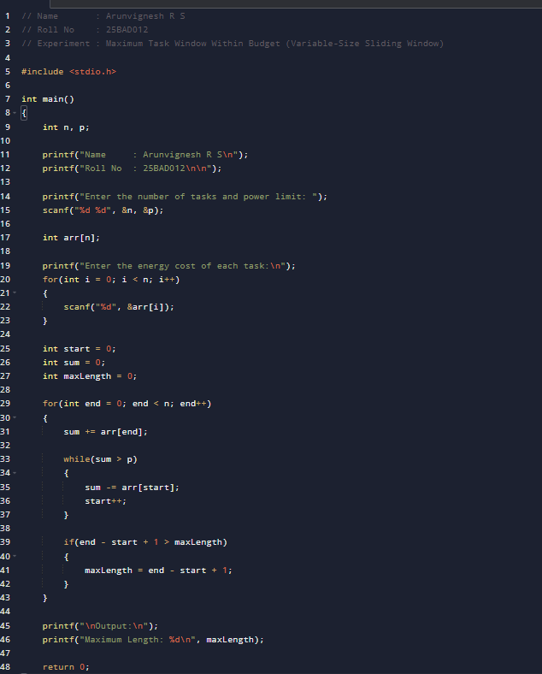

OUTPUT:
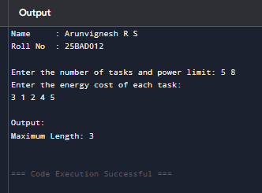
RESULT:
Thus, the C program to find the maximum number of consecutive tasks whose total energy consumption does not exceed the given budget using the Variable-Size Sliding Window Technique was implemented successfully, and the desired output was obtained.

QUESTION-5
AIM:
To write a C program to find the maximum element in every sliding window of size K using the Monotonic Queue (Deque) Technique.
PSEUDOCODE:
Start
Read N and K
Read N array elements
Create an empty deque
For each element from 0 to N-1
Remove indices from the front if they are outside the current window
Remove indices from the back while the current element is greater than
or equal to the elements represented by those indices
Insert the current index into the deque
If the first window is formed
Print the element at the front of the deque
End For
Stop

CODE:
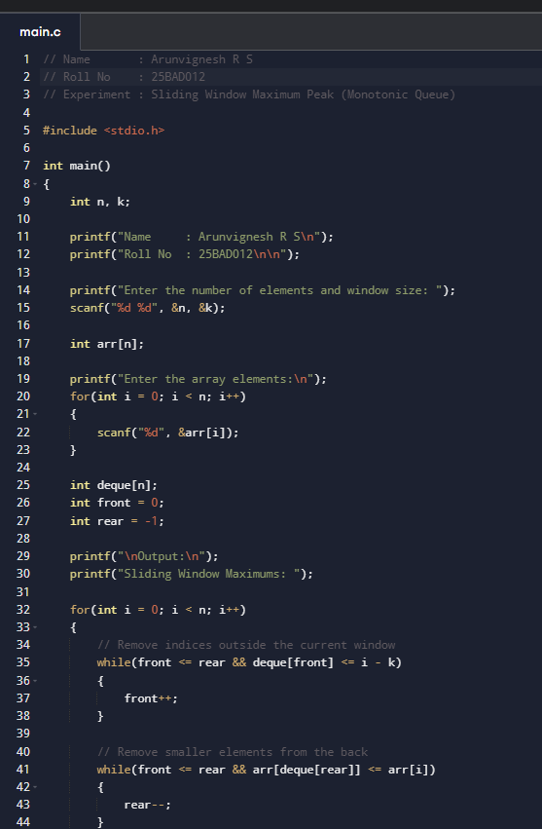
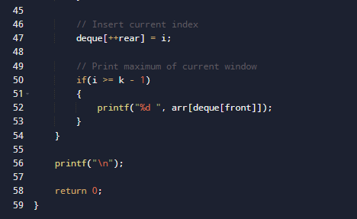

OUTPUT:
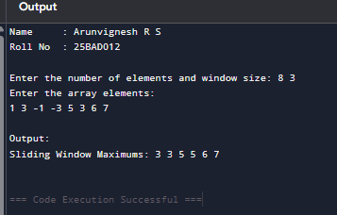
RESULT:
Thus, the C program to find the maximum element in every sliding window of size K using the Monotonic Queue (Deque) Technique was implemented successfully, and the desired output was obtained.

