vivo Pro Kabaddi League 2019 | Schedule, Live Scores, News, Team, Player list and more

- Home
- Latest Updates
- News Features
- Gallery
- Photos Videos
- Results
- Standings
- Teams
- Bengal Warriors Bengaluru Bulls Dabang Delhi K.C. Gujarat Fortunegiants Haryana Steelers Jaipur Pink Panthers Patna Pirates Puneri Paltan Tamil Thalaivas Telugu Titans U Mumba U.P. Yoddha
- Stats
- About
- About Vivo Pro Kabaddi Vivo Pro Kabaddi Rules Kabaddi Rules
- Fan Army
- About Fan Army Join the Fan Community Fans' Photos Fans' Videos

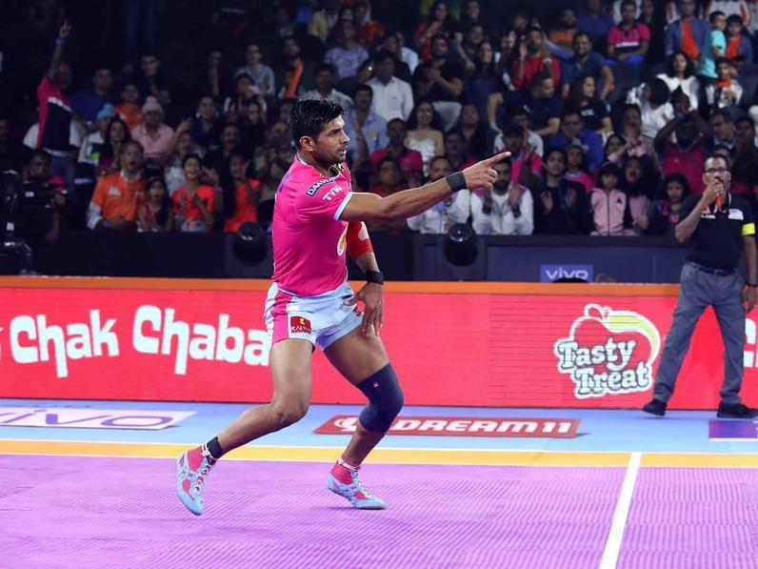

01

Five all-rounders who proved to be best in vivo Pro Kabaddi Season 7
12 Nov, 2019

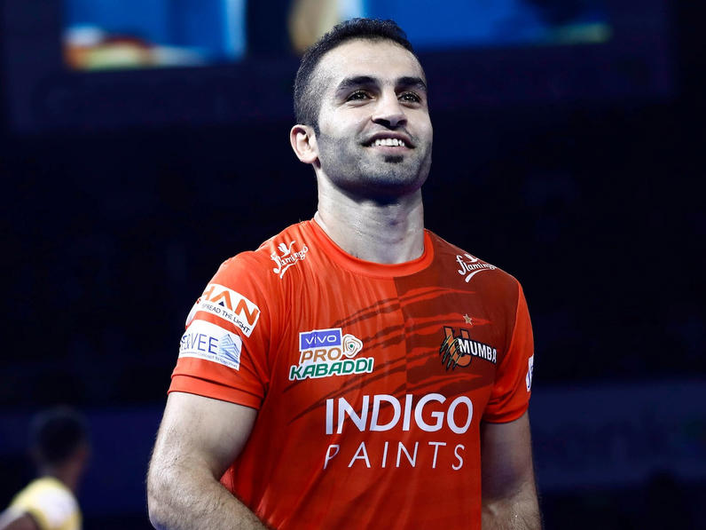

02

Five most dangerous defenders to deal with in vivo Pro Kabaddi Season 7
05 Nov, 2019

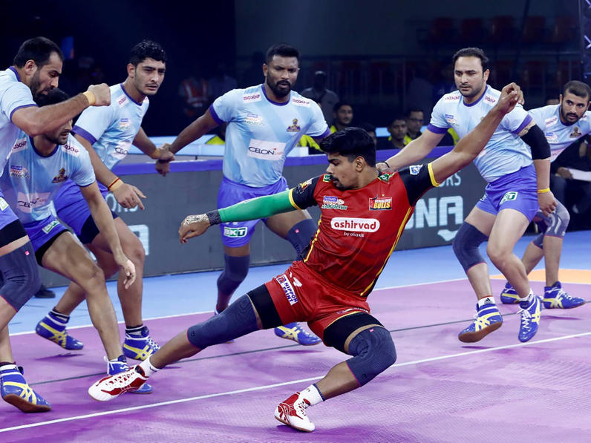

03

Five raiders who set the vivo Pro Kabaddi Season 7 stage ablaze
30 Oct, 2019

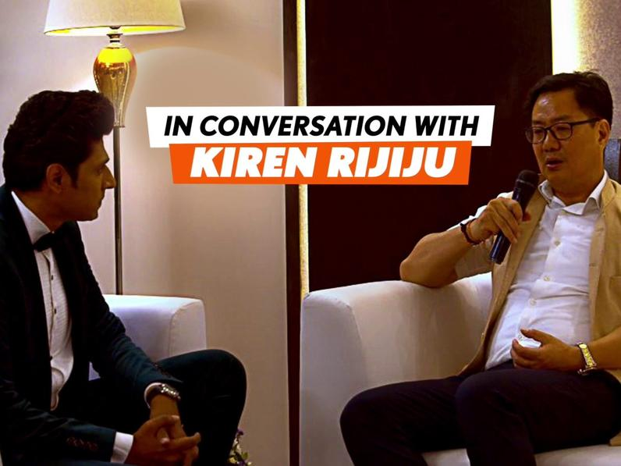

04

WATCH: In conversation with Kiren Rijiju
29 Oct, 2019

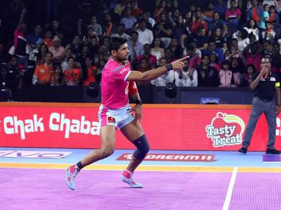

Five all-rounders who proved to be best in vivo Pro Kabaddi Season 7
12 Nov, 2019

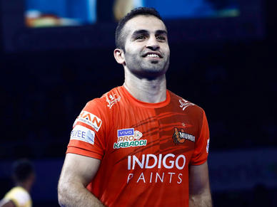

Five most dangerous defenders to deal with in vivo Pro Kabaddi Season 7
05 Nov, 2019

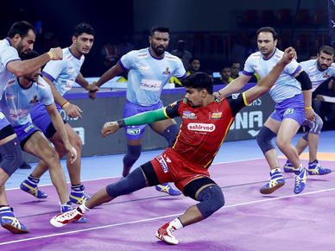

Five raiders who set the vivo Pro Kabaddi Season 7 stage ablaze
30 Oct, 2019

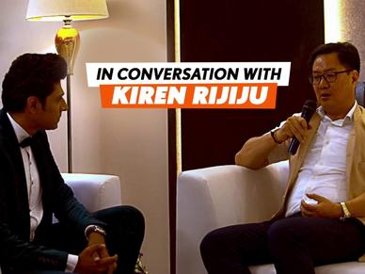

WATCH: In conversation with Kiren Rijiju
29 Oct, 2019

Special Videos



Chaudhari's chaperone around Chennai ft. Ajay Thakur
22 Aug, 2019

1

The Toughest Raid ft. Pawan Sehrawat
14 Aug, 2019

1

Hadi Oshtorak's Thigh Hold Deconstructed
13 Aug, 2019

1

The jaw-dropping record raid
19 Oct, 2018

1

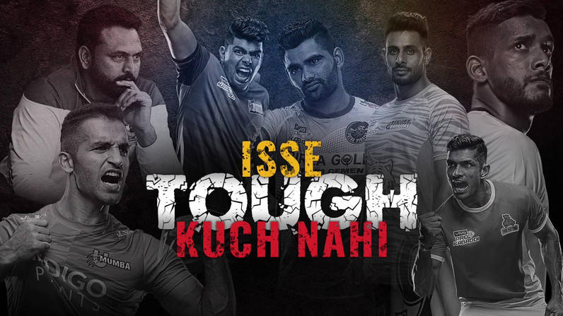

Isse Tough Kuch Nahi
05 Oct, 2019

1

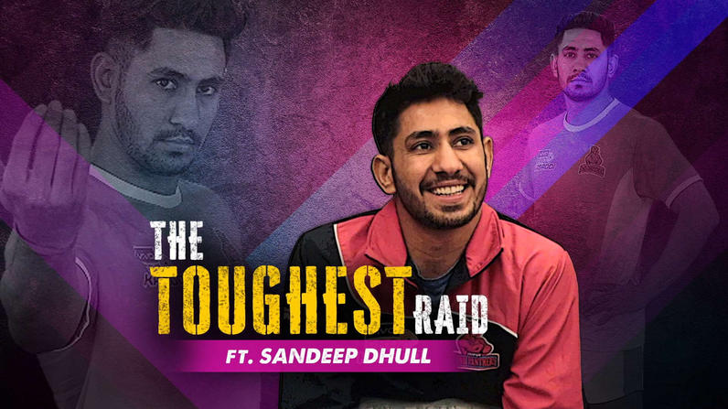

The Toughest Raid ft. Sandeep Dhull
20 Sep, 2019

1

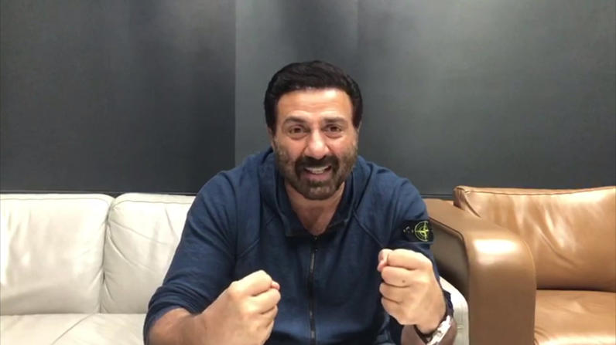

vivo Pro Kabaddi with Sunny Deol
03 Sep, 2019

1

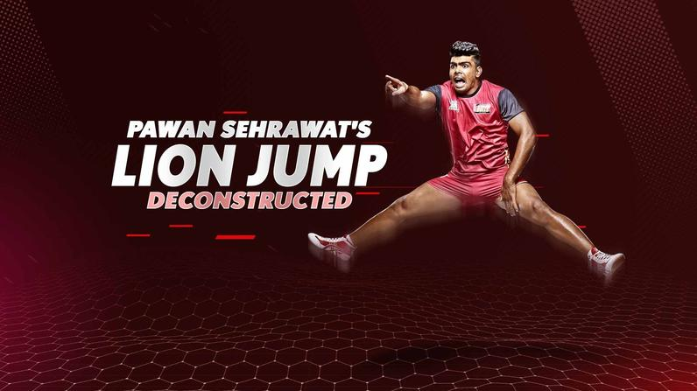

Pawan Sehrawat's Lion Jump Deconstructed
03 Sep, 2019

1

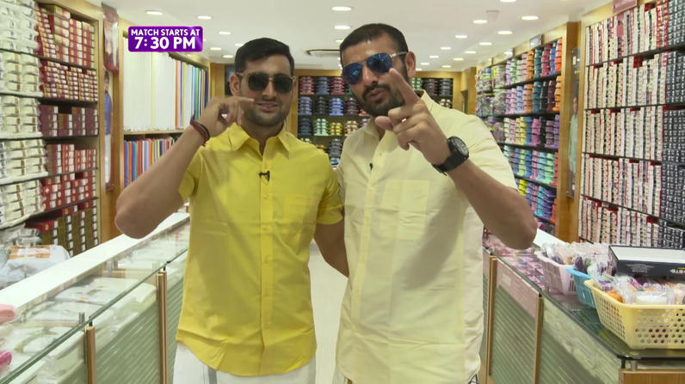

Chaudhari's chaperone around Chennai ft. Ajay Thakur
22 Aug, 2019

1

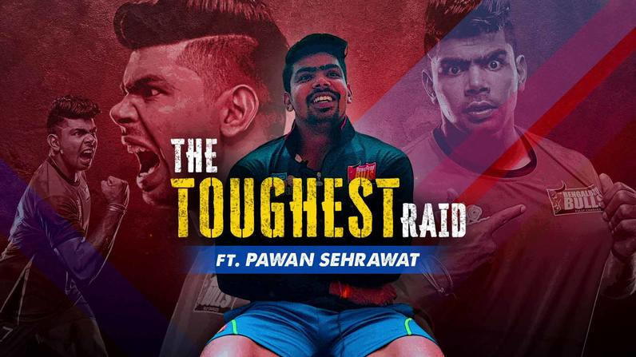

The Toughest Raid ft. Pawan Sehrawat
14 Aug, 2019

1

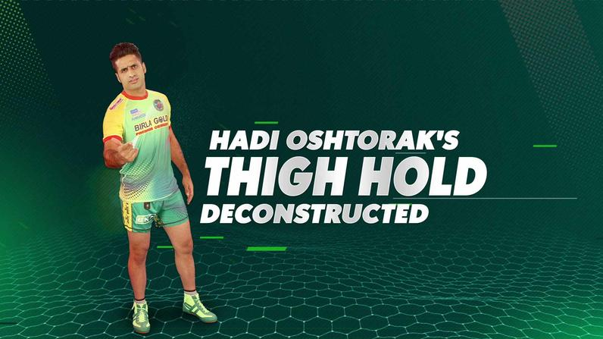

Hadi Oshtorak's Thigh Hold Deconstructed
13 Aug, 2019

1

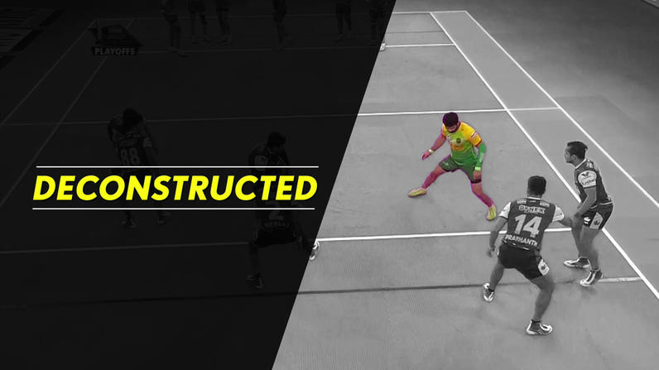

The jaw-dropping record raid
19 Oct, 2018

1

Isse Tough Kuch Nahi
05 Oct, 2019

1

The Toughest Raid ft. Sandeep Dhull
20 Sep, 2019

1

vivo Pro Kabaddi with Sunny Deol
03 Sep, 2019

1

Pawan Sehrawat's Lion Jump Deconstructed
03 Sep, 2019

1

Videos
view All

In conversation with Kiren Rijiju
29 Oct, 2019

Top 5 Tackles: Season 7
21 Oct, 2019

Top 5 Raids: Season 7
21 Oct, 2019

Match in 90 Seconds: Season 7 Final
20 Oct, 2019

Final: Moment of the Day
20 Oct, 2019

Photos
- All
- Video
- Photos
view All

Fan Fest ft. Kanika Kapoor, Amit Trivedi and Darshan Raval
20 Oct, 2019

Final - Dabang Delhi K.C. vs Bengal Warriors
19 Oct, 2019

Semi-Final 2: Bengal Warriors vs U Mumba
16 Oct, 2019

Results
View Full Schedule
Semi-Final 1
Completed
October 16


Dabang
Delhi K.C.
Dabang
Delhi K.C.
44
Created with Raphaël 2.2.0
FT
38
Ahmedabad

View Matchcentre


Bengaluru
Bulls
Bengaluru
Bulls
Semi-Final 2
Completed
October 16


Bengal
Warriors
Bengal
Warriors
37
Created with Raphaël 2.2.0
FT
35
Ahmedabad

View Matchcentre


U
Mumba
U
Mumba
Final
Completed
October 19

Dabang
Delhi K.C.
Dabang
Delhi K.C.
34
Created with Raphaël 2.2.0
FT
39
Ahmedabad

View Matchcentre

Bengal
Warriors
Bengal
Warriors

Standings
View Full Table
rank rank
team team
p p
w w
l l
pts pts

1 q
Dabang Delhi K.C.
22
15
4
85

2 q
Bengal Warriors
22
14
5
83

3 q
U.P. Yoddha
22
13
7
74

4 q
U Mumba
22
12
8
72

5 q
Haryana Steelers
22
13
8
71

6 q
Bengaluru Bulls
22
11
10
64

7
Jaipur Pink Panthers
22
9
11
58

8
Patna Pirates
22
8
13
51

9
Gujarat Fortunegiants
22
7
13
51

10
Puneri Paltan
22
7
12
48

11
Telugu Titans
22
6
13
45

12
Tamil Thalaivas
22
4
15
37

Kabaddi Rules
view All

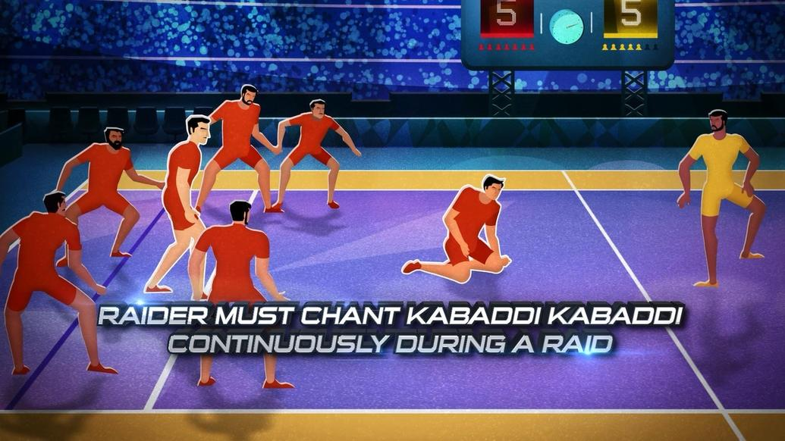

16 May, 2019

Basics of Kabaddi

16 May, 2019

Field of Play

16 May, 2019

Team Formation
follow your favourite team now!
- Bengal Warriors
- Bengaluru Bulls
- Dabang Delhi K.C.
- Gujarat Fortunegiants
- Haryana Steelers
- Jaipur Pink Panthers
- Patna Pirates
- Puneri Paltan
- Tamil Thalaivas
- Telugu Titans
- U Mumba
- U.P. Yoddha
Season 7 Top Performers
Top Raiders
Top Defenders
Top All Rounders
Top Raiders

Raid Points
302
Raider
Pardeep
Narwal
Raid Points
346
Raider
Pawan
Kumar Sehrawat
Raid Points
301
Raider
Naveen
Kumar
Top Defenders
Tackle Points
77
Defender
Sumit
Tackle Points
82
Defender
Fazel
Atrachali
Tackle Points
75
Defender
Nitesh
Kumar
Top All Rounders
Total Points
142
All Rounder
Rohit
Gulia
Total Points
158
All Rounder
Deepak
Niwas Hooda
Total Points
122
All Rounder
Mohammad
Esmaeil Nabibakhsh

Social Wall

@ProKabaddi

Bal(dev) ka poora istemaal karna koi isse seekhe! Afterall, it helped @BengalWarriors lift the #VIVOProKabaddi Season 7 🏆, didn't it? 😏 #IsseToughKuchNahi

@ProKabaddi

#TuesdayThoughts: Yeh #VIVOProKabaddi hai, aur #IsseToughKuchNahi! 😅 What's running through these guys' minds? Tell us your best guess!

@ProKabaddi

Kabaddi's seen a steep rise in 🇮🇳 , and the Honourable Sports Minister @KirenRijiju couldn't be prouder of the stature the sport enjoys today! Watch the video to know his thoughts on the subject. #VIVOProKabaddi #IsseToughKuchNahi

@ProKabaddi

Which players would you like to see playing for them next season?

@ProKabaddi

Taking the game (San)deep and making 🔝 defensive plays - just another day on the #VIVOProKabaddi mat for Dhull! 💪 #IsseToughKuchNahi

@ProKabaddi

Do you suffer from a case of the Monday Blues too? Drive them away with this solid tackle by @tamilthalaivas! 💪 #VIVOProKabaddi #IsseToughKuchNahi #MondayMood

@ProKabaddi

They would be an unstoppable force, indeed! How would you rank these 3 players among themselves?

@ProKabaddi

It's a game he's played as a child, and one he still remembers fondly! 😃 Hear from our Honourable Sports Minister @KirenRijiju, as he recounts his earliest memories of playing Kabaddi. #VIVOProKabaddi #IsseToughKuchNahi

@ProKabaddi

Eyes on the 🎯, and skills beyond compare - is it any wonder that these 3⃣ superstars have us repeating #IsseToughKuchNahi? #VIVOProKabaddi

@ProKabaddi

Hi! We request you to stay tuned to our social media handles for updates related to the same.

@ProKabaddi

TFW your gang's favourite song comes on at the club! 🕺🕺 #VIVOProKabaddi #IsseToughKuchNahi

@ProKabaddi

Hi For all #VIVOProKabaddi rules and information related to the field of play, you can refer to this link: https://t.co/OZRZdEbohU.

@ProKabaddi

There's something about the name Desai and stunning people with a 💥 #VIVOProKabaddi debut! 🤭 #IsseToughKuchNahi

@ProKabaddi

Throwback to the moment when all the 🤜💥🤛 started in #VIVOProKabaddi Season 7! 🤩 #ThrowbackThursday #IsseToughKuchNahi #HYDvMUM

@ProKabaddi

Surj-ing ahead to conquer either of these Sumit(s) - #IsseToughKuchNahi! 👊 #VIVOProKabaddi

@ProKabaddi

Mix together 🔝 skill, 💪 toughness and a willingness to work hard, and what do you get? A #VIVOProKabaddi season like Super Man-inder’s! #IsseToughKuchNahi

@ProKabaddi

A raider far beyond his years, Pawan is an absolute #VIVOProKabaddi treasure! 🤩 #IsseToughKuchNahi

@ProKabaddi

Hi! We request you to stay tuned to our social media handles for related updates.

Title Sponsor

Associate Sponsors


Partners


Latest Updates
- News
- Features
- Matches
- Standings

Kabaddi Masters

Tickets Terms & Conditions

About Us
- About VIVO Pro Kabaddi
- VIVO Pro Kabaddi Rules
- Rules & Format

Terms & Conditions

Privacy Policy

Personal Data Privacy Policy

All Stars Match

Teams
- Bengal Warriors
- Bengaluru Bulls
- Dabang Delhi K.C.
- Gujarat Fortunegiants
- Haryana Steelers
- Jaipur Pink Panthers

Teams
- Patna Pirates
- Puneri Paltan
- Tamil Thalaivas
- Telugu Titans
- U Mumba
- U.P. Yoddha
Sanctioned By
Managed By
Broadcast Partners
Pro Kabaddi Official App
Social On

© Copyright Pro Kabaddi 2019. All rights reserved.
Powered by:

By using our site, you acknowledge that you have read and understand our Privacy Policy, and our Terms and Conditions.
Got It

