
Open2Test Test Automation Framework installation Guide for QTP
Version 3.0
Jan 2014
DISCLAIMER
Verbatim copying and distribution of this entire article are permitted worldwide, without royalty, in any medium, provided this notice is preserved.
Table of Contents
1 Purpose of the Document 3
How to use Open2Test in QTP 4
1.1 Tool Version Support Matrix 4
1.2 Open2Test Framework files 4
1.3 New Test 4
1.4 Run Settings 4
1.5 Resources Settings 5
1.5.1 Environment Tab Settings 7
1.6 Managing Object Repository 8
1.7 Call to Framework 9
1.8 Usage of Keywords 10
1.9 Test Results for a Keyword-driven Script 10

Purpose of the Document
This document provides an overview of the prerequisites and settings required to implement the Open2Test in HP QuickTest Professional (QTP).

How to use Open2Test in QTP
The Open2Test Test Automation framework is an application independent framework that performs all possible actions and verifications on an object since the code for the same object can be used across different applications.
In the keyword-driven approach the entire script is developed with keywords. The script is developed in a spreadsheet that is interpreted by the main driver script, which then uses the function library to execute the complete script.

Tool Version Support Matrix
QTP - 8.2,9.0,9.1,9.2,9.5,10,11. UFT - 11,5

Open2Test Framework files
Make sure you have downloaded the Open2Test framework files (QTP_Web.txt, Keyword_Driver.txt & User_Defined_Functions.txt). Please note that depending on the technology of your application under test, you will have to download the appropriate files. This document assumes that the Application Under Test is developed using the Web technology and so uses QTP_Web.txt.

New Test
Create a New Test in QTP. Ensure selecting the appropriate technology addins in QTP while creating a new test.

Run Settings
Go to Test Settings dialog,
- The Run one iteration only radio button will be selected.
- The Disable Smart Identification during the run session check box will be checked.
- The Object Synchronization timeout value will be set as 20 seconds.
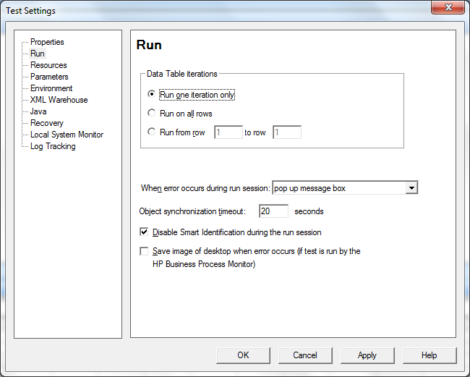
Figure 1: Run Settings

Resources Settings
After the run settings are completed, the QTP Settings file associates the framework with the test script. Here, the names of the framework files need to be specified in the QTP Settings file.

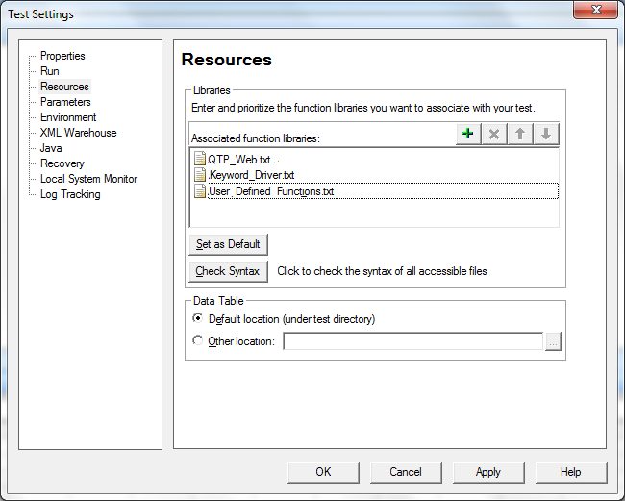
Figure 2: Associating Framework Files

Environment Tab Settings
If you do not have any environment variables to be used, you can ignore this step.
QTP can insert a value from the environment variable list, which is a list of variables and corresponding values that can be accessed from the test. Throughout the test run, the value of an environment variable remains the same, regardless of the number of iterations, unless the value of the variable is changed programmatically in the script.
Associating the user-defined Environment Variables file with the test is also handled by the QTP Settings file. The Environment Variables file with an .xml file type will be taken from the path specified in the QTP Settings file and associated with the test.

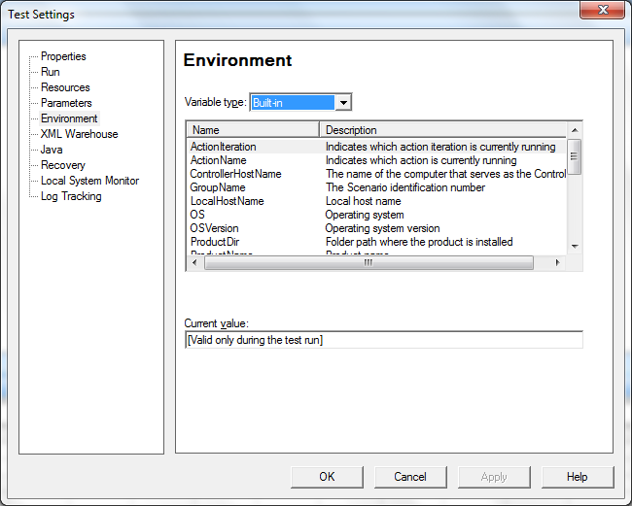
Figure 3: Environment variables

Test Options and Folder Settings
Here one has to add all the paths & locations where the project files are placed. QTP will look for the files only on the paths/locations added in this tab.

Managing Object Repository
After the test settings are completed, the QTP Settings file continues to associate the specified shared object repositories with the test. The objects from the shared repository will be uploaded and made available for the current and future tests.

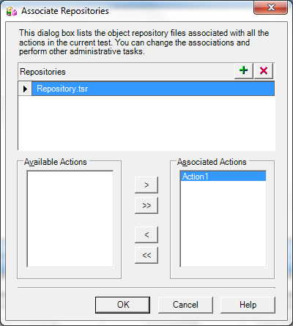
Figure 4: Associate Repositories Dialog

Call to Framework
The call to Keyword_Driver() needs to be specified in the Expert View as shown below. This will call the Framework file associated with the test and perform the actions by interpreting the keywords specified in the data table.

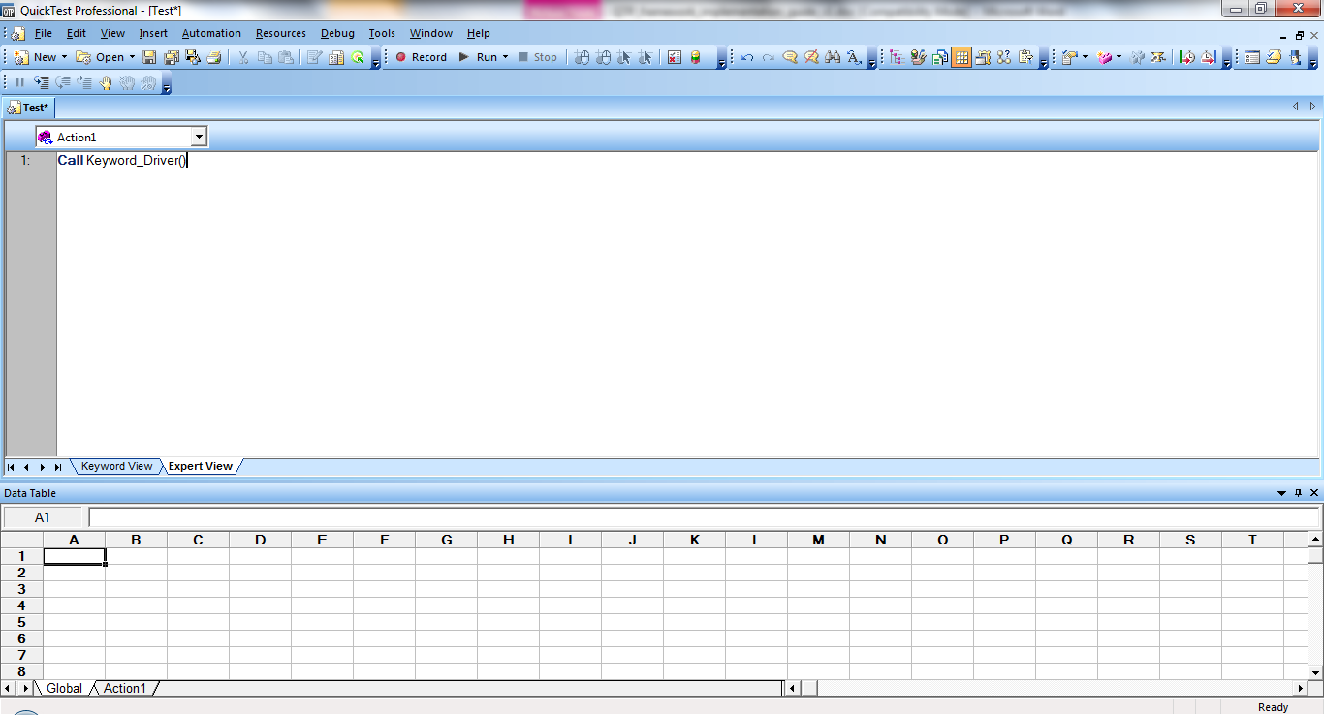
Figure 5: Call to Framework

Usage of Keywords
The keywords should be entered in the ‘Action1’ sheet of the data table of the test according to the syntax. To access the data table, choose View > Data Table or click on the toolbar button.

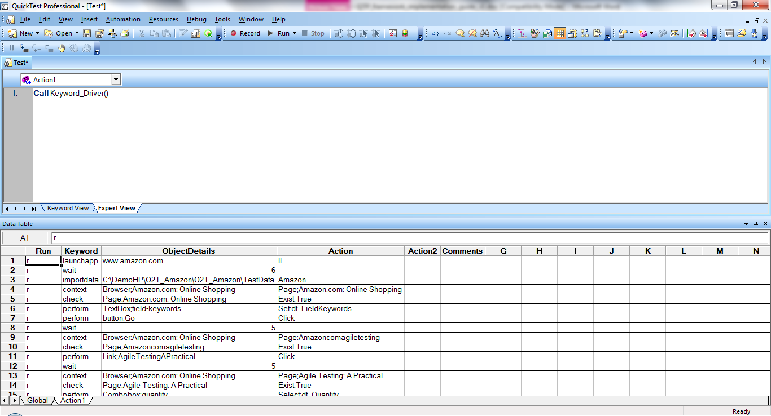
Figure 6: Using the keyword test script in the Data Table

Read the QTP_framework_introduction and keywords documentation to learn more about how to write test scripts using Open2Test.

Test Results for a Keyword-driven Script
Test execution results can be viewed and analyzed as soon as the run session ends. To access the test results, choose Automation > Results or click on the toolbar button. The results window will be displayed.

Copyright
This library is free software; you can redistribute it and/or modify it under the terms of the GNU Library General Public License as published by the Free Software Foundation; either version 2 of the License, or (at your option) any later version.
This library is distributed in the hope that it will be useful, but WITHOUT ANY WARRANTY; without even the implied warranty of MERCHANTABILITY or FITNESS FOR A PARTICULAR PURPOSE. See the GNU Library General Public License for more details.
You should have received a copy of the GNU Library General Public License along with this library; if not, write to the Free Software Foundation, Inc., 51 Franklin St, Fifth Floor, Boston, MA 02110-1301, USA.

