**Kafka**

Kafka is a distributed Messaging streaming platform that uses publish and subscribe mechanism t stream the records.

**Kafka Cluster –** It is group of kafka brokers. Broker is a server on which kafka runs. For eg KB1,KB2,KB3 and KB4.

**Kafka Producer-** It write new data into the kafka cluster.

**Kafka Consumer** – It uses or consumes the data from kafka cluster.

**Zookeeper** – keeps tracks the kafka cluster health.

**Kafka Connect** – If we want to import the data from external entity in the Kafka cluster. For eg if any DB or file without writing any code. It is also known as declarative integration.

**Source** – Data goes from the source to cluster

**Sink –** Data goes out from the kafka cluster and dumps the data in Kafka Connect

**Kafka Stream –** This is the functionality which we use in data transformation.

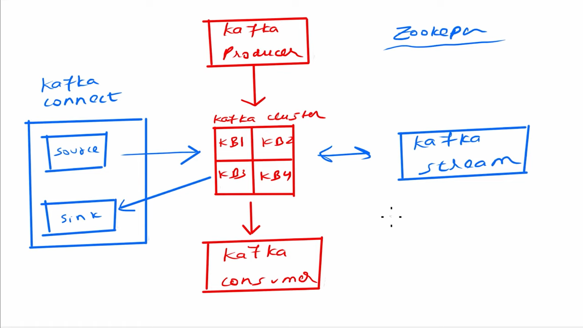

**To start the zookeeper:**

C:\kafka_2.13-3.7.0\bin\windows>**zookeeper-server-start.bat ..\..\config\zookeeper.properties**

**To Start the Kafka broker:**

C:\kafka_2.13-3.7.0\bin\windows>**kafka-server-start.bat ..\..\config\server.properties**

**The above command registers the kafka broker in zookeeper**

**Bootstrap server – means kafka broker**

**To create the topic:**

C:\kafka_2.13-3.7.0\bin\windows**>kafka-topics.bat --create --topic my-new-topic --bootstrap-server localhost:9092 --replication-factor 1 --partitions 3**

**Created topic my-new-topic.**

**Kafka Producer**

**C:\kafka_2.13-3.7.0\bin\windows>kafka-console-producer.bat --broker-list localhost:9092 --topic my-new-topic**

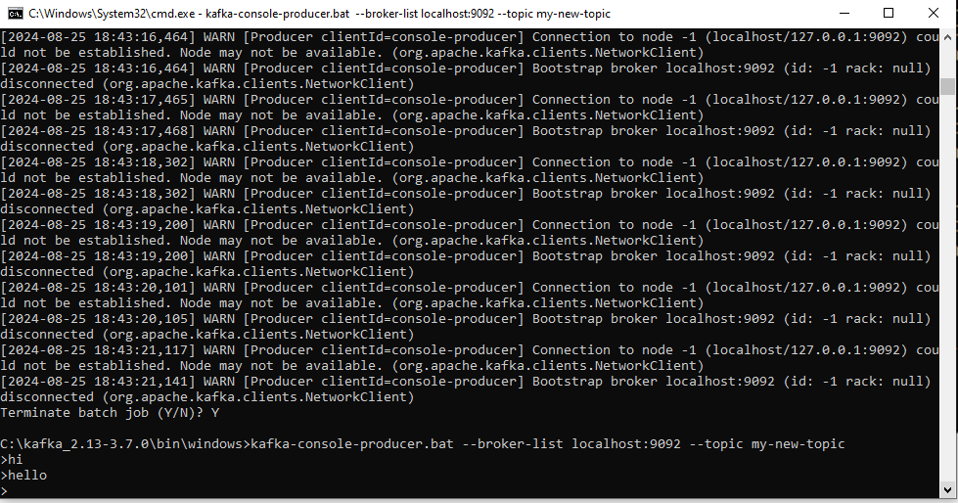

**Kafka Consumer**

**C:\kafka_2.13-3.7.0\bin\windows>kafka-console-consumer.bat --bootstrap-server localhost:9092 --topic my-new-topic --from-beginning**

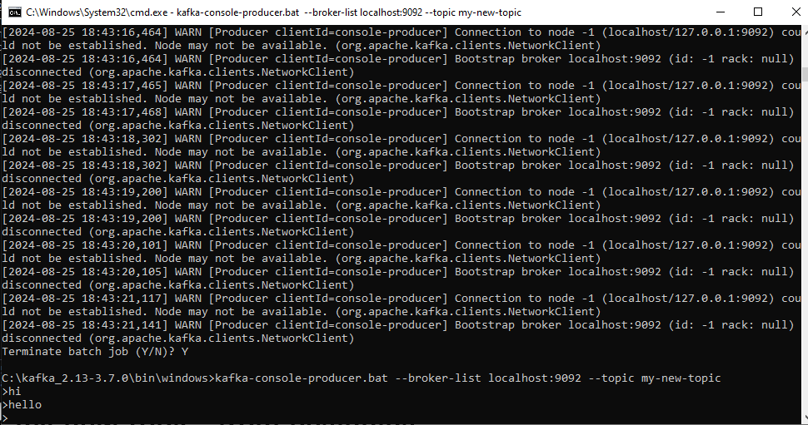

**From Beginning**

If we close the producer and consumer and then again start it wil start consuming the data from beginning

Producer:

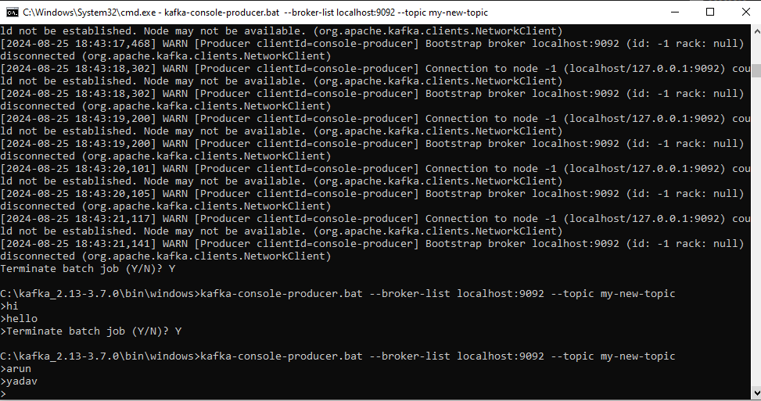

Consumer:

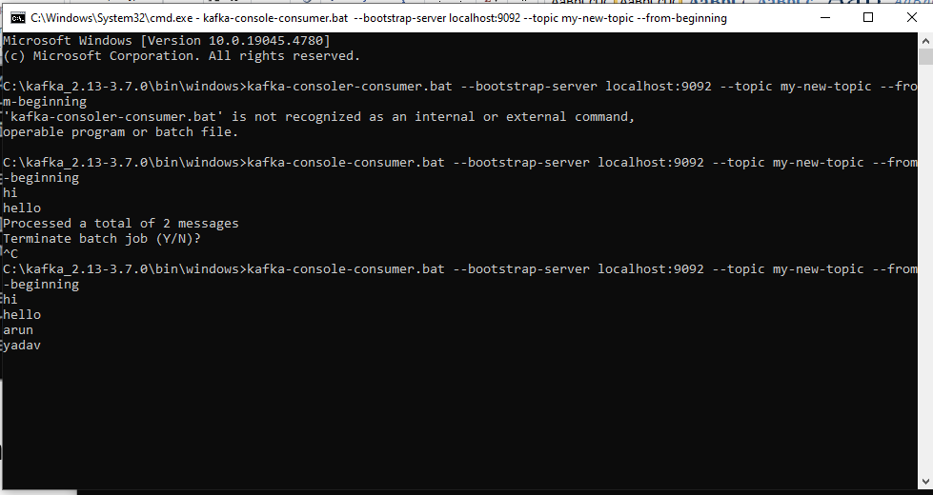

**Removing From Beginning**

IF we don’t put he from-beginning then data will not be consumed

Producer:

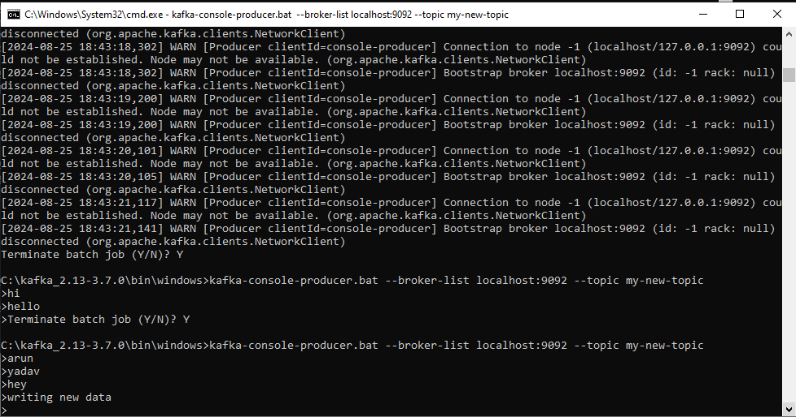

Consumer:

