**Check Constraint**

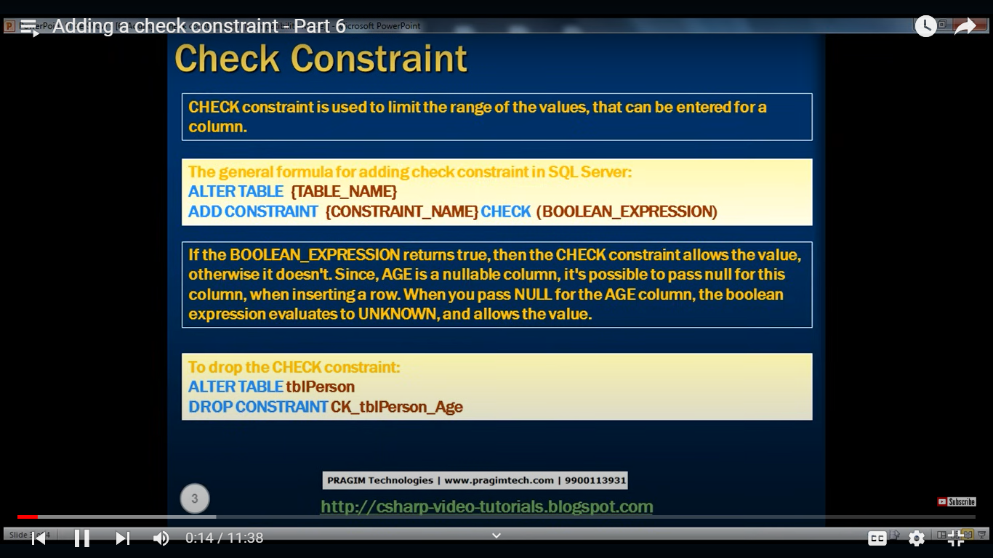

**Query to Delete all rows from tables**

Delete from tblPerson where 1=1;

**Query to add a new column in the table**

Alter table tblPerson

Add Age int;

**Current Data in the tables**

Select * from tblGender;

Select * from tblPerson;

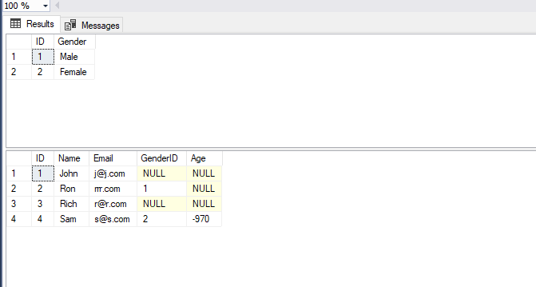

**To open the constraint go to table (tblPerson) – expand – click on constraint – right click and click on Add constraint**

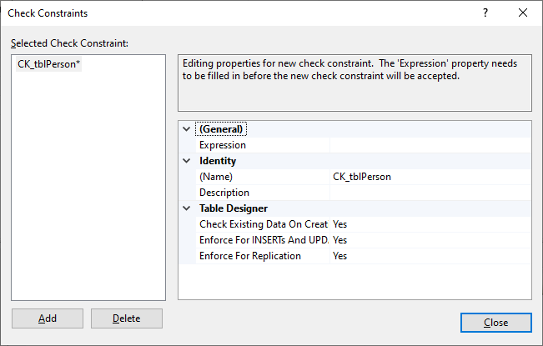

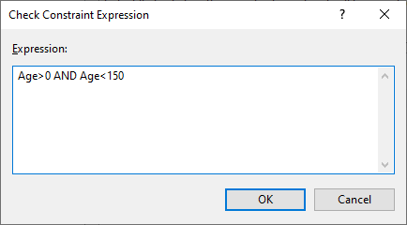

Table before entering new data

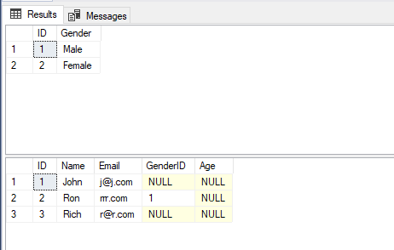

Insert into tblPerson (ID,Name,Email,GenderID,Age) values (4,'Sara','s@s.com',2,10);

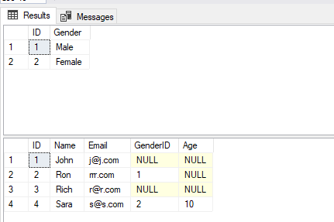

Insert into tblPerson (ID,Name,Email,GenderID,Age) values (5,'Sara','s@s.com',2,NULL);

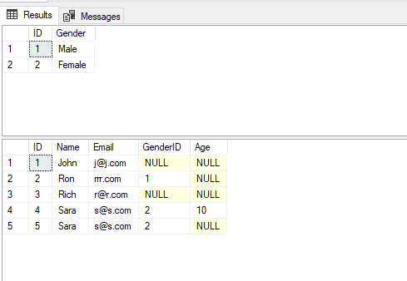

Now we have already applied check constraint so if we take below query:

Insert into tblPerson (ID,Name,Email,GenderID,Age) values (6,'Lara','l@l.com',2,160);

**Then we will get:**

Msg 547, Level 16, State 0, Line 19

The INSERT statement conflicted with the CHECK constraint "CK_tblPerson_Age". The conflict occurred in database "Sample", table "dbo.tblPerson", column 'Age'.

The statement has been terminated.

**Deleting check constraint**

Alter table tblPerson

Drop Constraint CK_tblPerson_Age;

Adding Constraint through query

use Sample;

Alter Table tblPerson

Add Constraint CK_tblPerson_Age CHECK (Age>0 AND AGE < 150)

Now let’s try to insert the data

Insert into tblPerson values(6,'Kara','k@k.com',2,950);

Msg 547, Level 16, State 0, Line 7

The INSERT statement conflicted with the CHECK constraint "CK_tblPerson_Age". The conflict occurred in database "Sample", table "dbo.tblPerson", column 'Age'.

The statement has been terminated.