**Default Constraint**

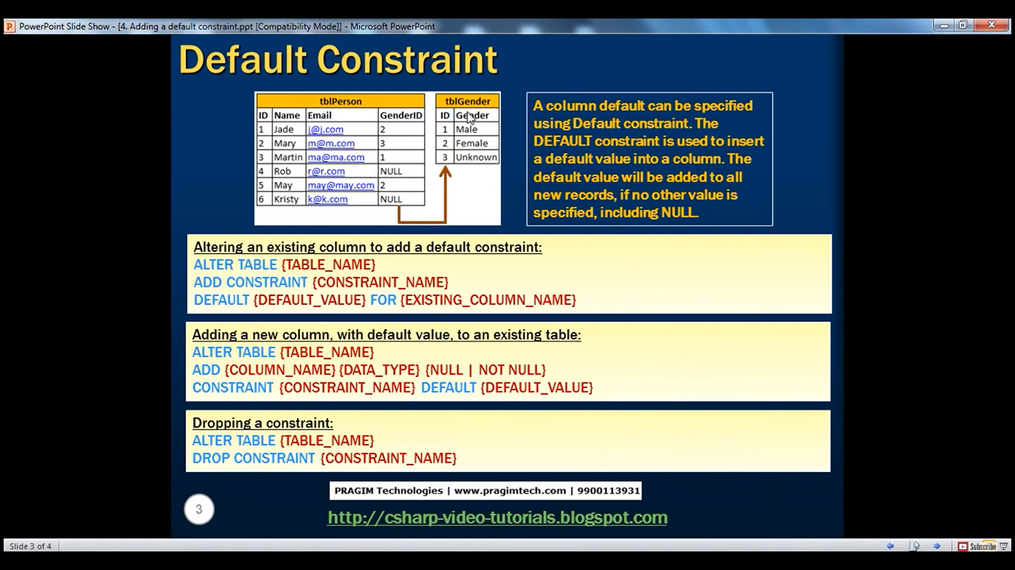

For eg entering below entry into table tblPerson

Insert into tblPerson (ID,name,Email) Values (7,'Rich','r@r.com')

But as we know we have one more field GenderID so if we don’t specify value then default value taken will be NULL

So to add a default constraint

Alter table tblPerson

Add constraint DF_tblPerson_GenderId

Default 3 For GenderId

Now let’s add one more record

Insert into tblPerson (ID,name,Email) Values (8,'Mike','mike@r.com')

And check the entry for GenderID in the table tblPerson

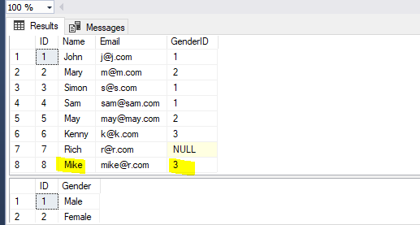

Now if we add one entry with GenderID then default constraint will not work

Insert into tblPerson (ID,name,Email,GenderID) Values (9,'Sara','s@r.com',1)

