**Referential Integrity**

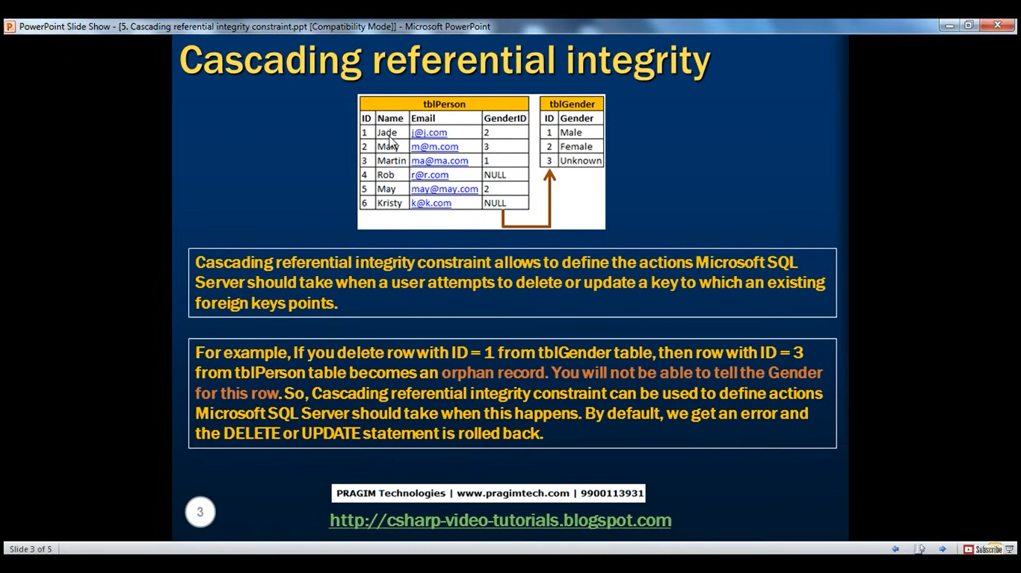

For eg if we delete 2 from tblGender then Jade and Mary will become orphan records in tblPerson.

Delete from tblGender Where ID=2

Msg 547, Level 16, State 0, Line 18

The DELETE statement conflicted with the REFERENCE constraint "tblPerson_GenderID_FK". The conflict occurred in database "Sample", table "dbo.tblPerson", column 'GenderID'.

The statement has been terminated.

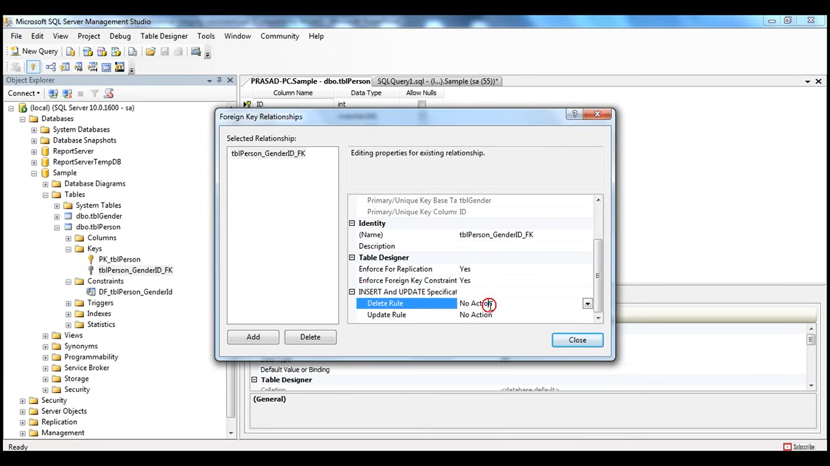

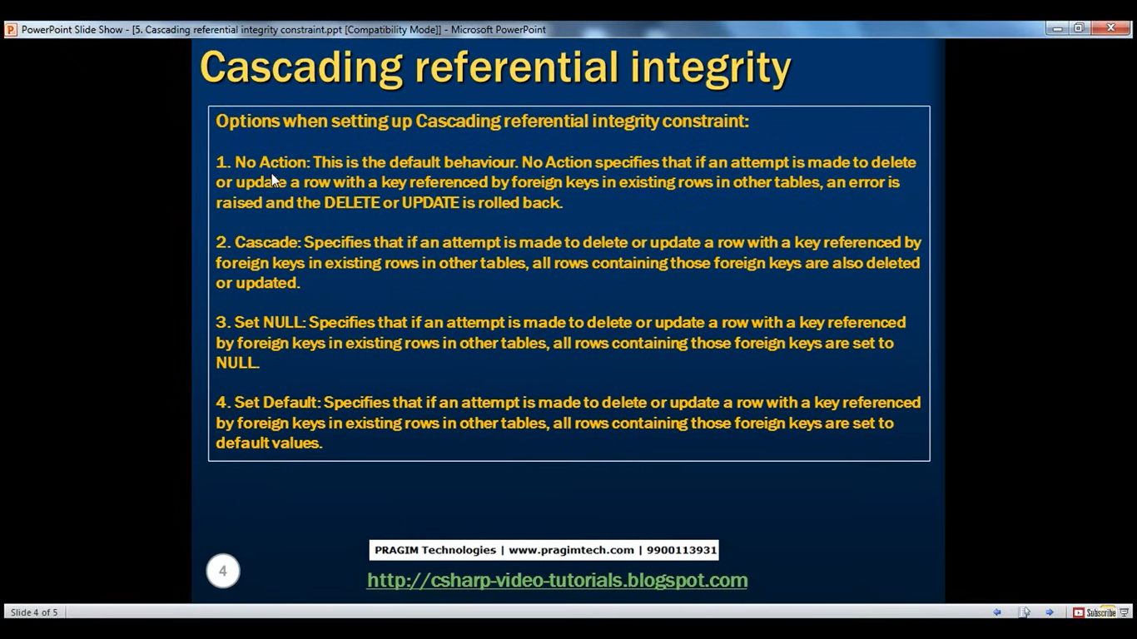

**Set Default**

Suppose if someone tries to deletes the ID in tblGender then

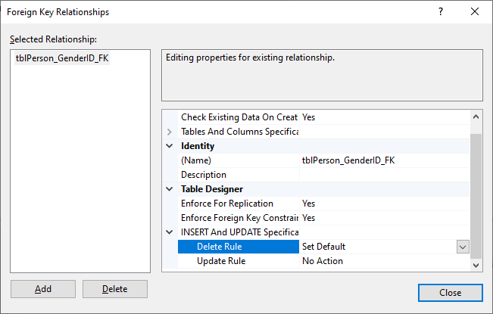

If we make Delete rule to set default then it will be set to default

Use Sample;

Delete from tblGender where ID=2;

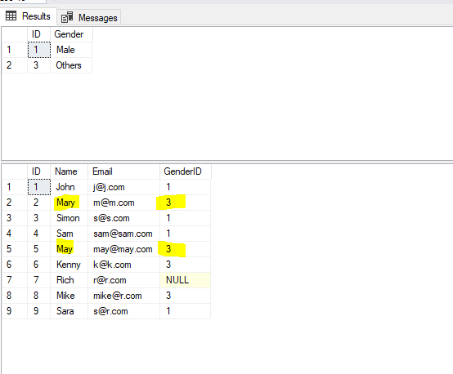

**Set Null**

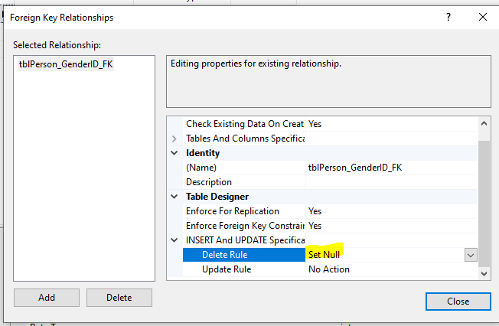

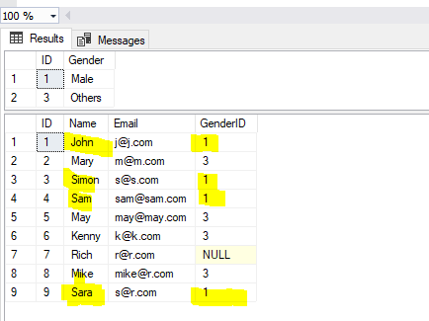

Delete from tblGender where ID=1;

Select * from tblGender;

Select * from tblPerson;

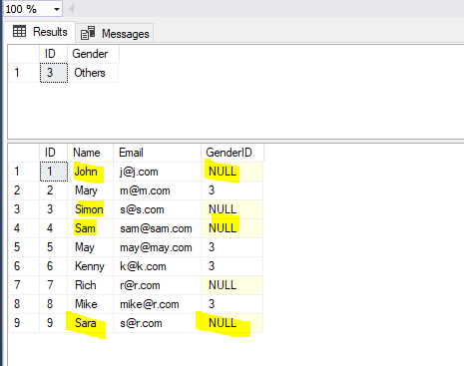

**Cascade**

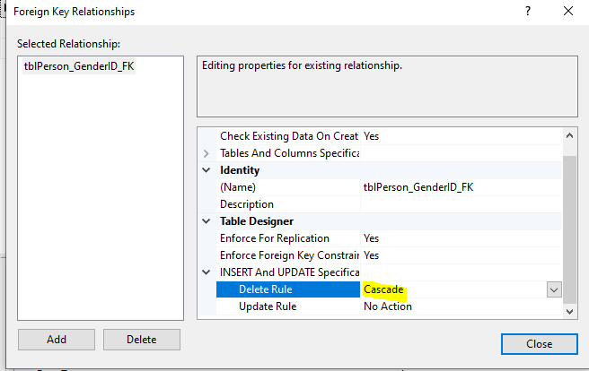

Now delete the ID 3 from tblGender

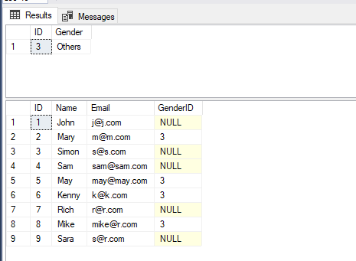

Delete from tblGender where ID=3;

Select * from tblGender;

Select * from tblPerson;

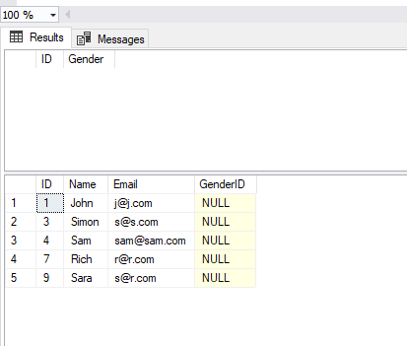

All records with ID 3 will be deleted.