Altitude Measurement High-Level Design (HLD)
Version: 1.0
Date: 17-02-2026
Prepared by: Arunya V A

1. Purpose
This document defines the high-level design for acquiring altitude data from the sensor module, validating the readings against predefined thresholds, and triggering automated alarms based on the processed output.

2. System Overview
The Altitude Measurement System is designed to acquire real-time altitude values from a sensor module. It operates at a defined frequency [F] and monitoring interval [I]. During each interval [I], the system processes sensor data [MIN_RANGE , MAX RANGE], performs validation against defined altitude thresholds [THRESHOLD_MIN, THRESHOLD_MAX], and executes an alarm up to define timeout [ALARM_TIMEOUT] if necessary .

2.1 Key components
2.1.1. Sensor Management
The Sensor Management system interfaces with the sensor module with given frequency [F] to gather real time altitude data. The timing is synchronized to a fixed interval [I] to ensure data consistency. Expect sensor value as maximum of 4-byte data.
2.1.2 Validation Engine
In Validation Engine, the system executes within a specific interval [I], the system processes raw data to analyze the altitude values within range [MIN_RANGE , MAX RANGE] . The system validates the altitude readings against predefined thresholds [THRESHOLD_MIN, THRESOLD_MAX]. If a value exceeds the limit set event bit.
2.1.3. Alarm Management
The alarm management system will be read the event bit, and an alarm is triggered up to a specified timeout [ALARM_TIMEOUT].

2.2 High Level Architecture

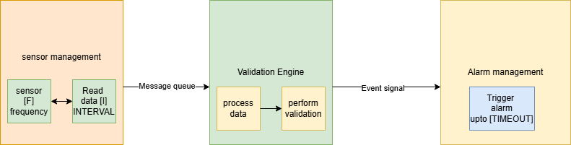

3. Software Architecture
The software is designed to follow layered architecture, that ensures each module is well defined and organized .

3.1. Modules

No | Modules | Responsibility
1 | Sensor Management | Initialize the sensor module with [F] frequency. Read data from [I] interval and push to the message queue.
2 | Validation Engine | Read data from the message queue and perform validation with [THRESHOLD_MIN, THRESOLD_MAX]. If processed output exceeds the limit it, set event signal.
3 | Alarm Management | Check the event signal and execute alarm up to a defined timeout [ALARM_TIMEOUT].

3.2 Data Control Flow Diagram

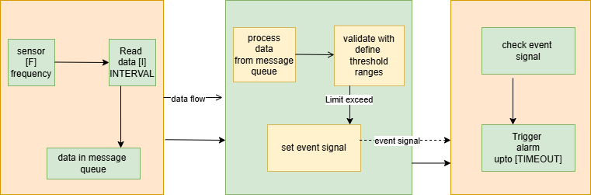

4. Module Descriptions

4.1 Sensor Management
Sensor management will initialize ,read and push the altitude data. The responsibility of the modules is
- Initialization of sensor module with [F] frequency.
- Read Sensor data in [I] interval.
- Create message queue.
- Push the raw data in message queue.

4.2 Validation Engine
The Validation engine performs the processing of data and validation. The responsibility of the modules is
- Read the raw data from the message queue and check them with [MIN_RANGE , MAX RANGE]
- Validate the altitude data with predefined threshold value [THRESHOLD_MIN, THRESHOLD_MAX].
- If altitude exceeds the boundary [THRESHOLD_MIN, THRESHOLD_MAX] we set, then set an event signal.

4.3 Alarm Management
Alarm Management system will be triggering the alarm based on received event signal. The responsibility of the modules is
- Check for the event signal.
- If Event signal is set, trigger an alarm up to define timeout [ALARM_TIMEOUT].
- Clear the event signal.

5. Interface Design

5.1 Define APIs

API | Description | Input Parameter | Result
bool SensorInitialization(uint32_t ulFrequency) | This is used to initialize the sensor module with [F] frequency. | uint32_t ulFrequency | 1-On success  0-On failure
void* SensorReadHandler() | Thread implementation to read data from sensor module in a define interval [I] and push the data to the message queue.
void* ProcessSensorData() | Thread implementation to process the sensor data from the message queue and validate with define threshold value [THRESHOLD_MIN, THRESOLD_MAX], set event flag if limit exceeds
Void*AlarmInfoProcessHandler() | Thread implementation which checks the event signal and calls the alarm execution function.
void SensorAltitudeMeasure(void) | Responsible for thread creation, IPC enabling , event creation

5.2 Inter-process Communication method
The system implements message queue for Inter process communication. Sensor management module pushes sensor data . Validation engine read and execute validation. Set below parameter for implementing message queue.
- Set Message Queue size.
- Set Message Size.

Data exchange Formats
The system receives 4-byte unsigned integer from sensor module. This Must be in range of [MIN_RANGE , MAX RANGE]

6. Data Flow
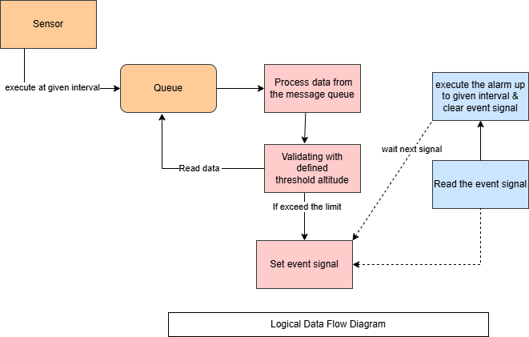

7. Error Handling & Fault Management

7.1.Fault Detection
- Check the status of thread initialization. If fails to initialize, exit with a warning.
- Check message queue initialization. If failed to create exit with a warning.
- Message queue overflow detection and prevention
- If you do not get data from message queue in a certain period ,treat it as hardware failure.

7.2.Recovery Mechanism
Define an ideal interval [T] , Check the whole system work in that ideal interval [T] , if not reboot the whole system with escalation warnings.

8. Traceability
SRS document – Requirement and functionality analysis (V1.0)

