High-Level Design (HLD)
Version: 1.0
Date: [16-02-206]
Prepared by: [Trenser Technology Solutions (P) Ltd]

1. Purpose
To receive altitude value from the sensor and process the value in MCU. Compare the received values and predefined values. Based on the output fire the alarm with desired volume.

2. System Overview
👉 The system uses a sensor to measure the altitude values, that send to the microcontroller. MCU process the data. It compares with some predefined values and fire the alarm with desired volume.
Components : Sensor, MCU, alarm module.
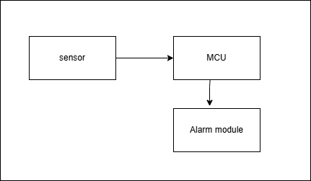

3. Software Architecture
Modules
- Sensor value reading.
- Process received sensor values.
- Fire an alarm based on the received values.
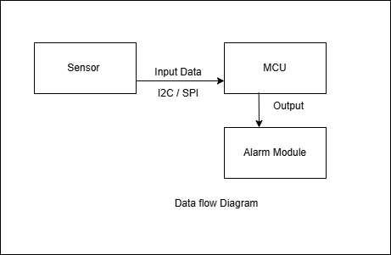

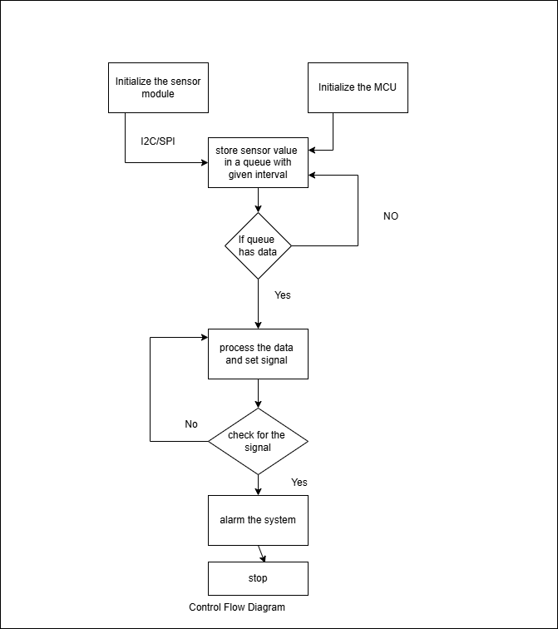

4. Module Descriptions
1 .ReadSensorData - Initialize the sensor , initialize the MCU. Read data from the sensor and store in a queue.
2.ProcessSensorData – Retrieve the sensor value from the queue and process with predefined values . If the output meet the alarm criteria set a event.
3.AlarmProcess – Read the event bit fire a alarm.

5. Interface Design
1.InitializeSensor() – Initialize the Sensor module.
2.InitializeMcu() – Initialize the MCU.
3.ReadDataHandler() – thread to read data.
4.ReadDataFromSensor() – Read data from the sensor module and store in a queue.
5.ProcessDataHandler – Thread responsible for Processing data.
6.ProcessSensorData – Process data in the queue and compare with predefine values and set a event signal.
7.AlarmDataHandler – Thread responsible for reading event and fire a alarm.

6. Data Flow
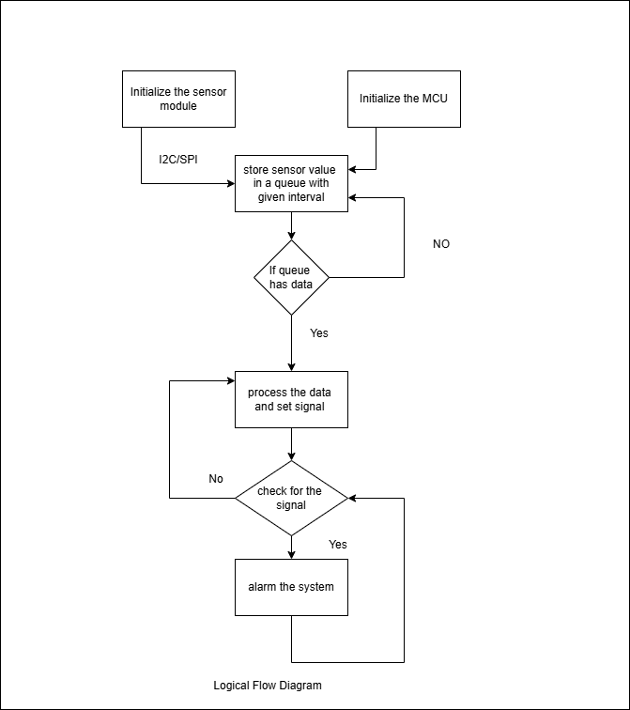

7. Error Handling & Fault Management
1. To cross check with predefine values .
2. check data format and exclude the error pattern without saving to the queue.
3. check senor failure conditions.
4. check MCU failure conditions.
5. Check alarm failure condition.
6. Cross check the predefine values with junk data and maintain the system without any crash.
7. Check thread initialization.
8. Check memory allocation for the queue.
9. Check the possibility of system crash and race conditions.

8. Traceability
System Features / Requirement

