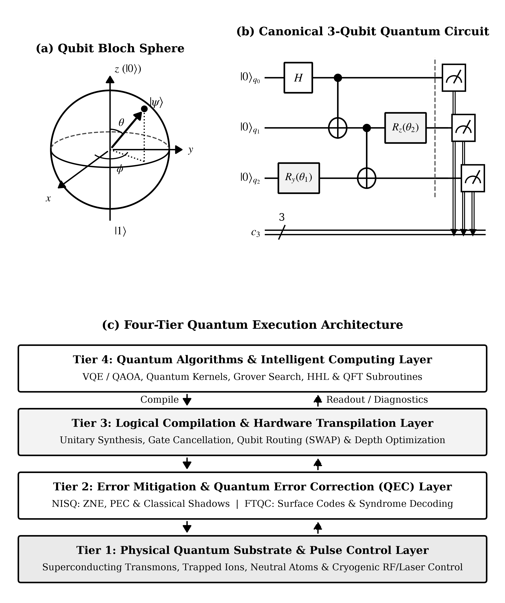
Figure 1. Architectural overview of gate-based quantum computation: (a) geometric Bloch sphere representation of a pure single-qubit state |ψ(θ, φ)⟩ = cos(θ/2)|0⟩ + exp(iφ)sin(θ/2)|1⟩; (b) canonical three-qubit quantum circuit illustrating computational-basis initialization, Hadamard superposition (H), two-qubit CNOT entanglement, parameterized single-qubit rotations Ry(θ1) and Rz(θ2), and projective measurement onto a classical bit register c3; and (c) four-tier hardware-to-algorithm execution stack linking physical qubit control pulses to intelligent computing applications.

