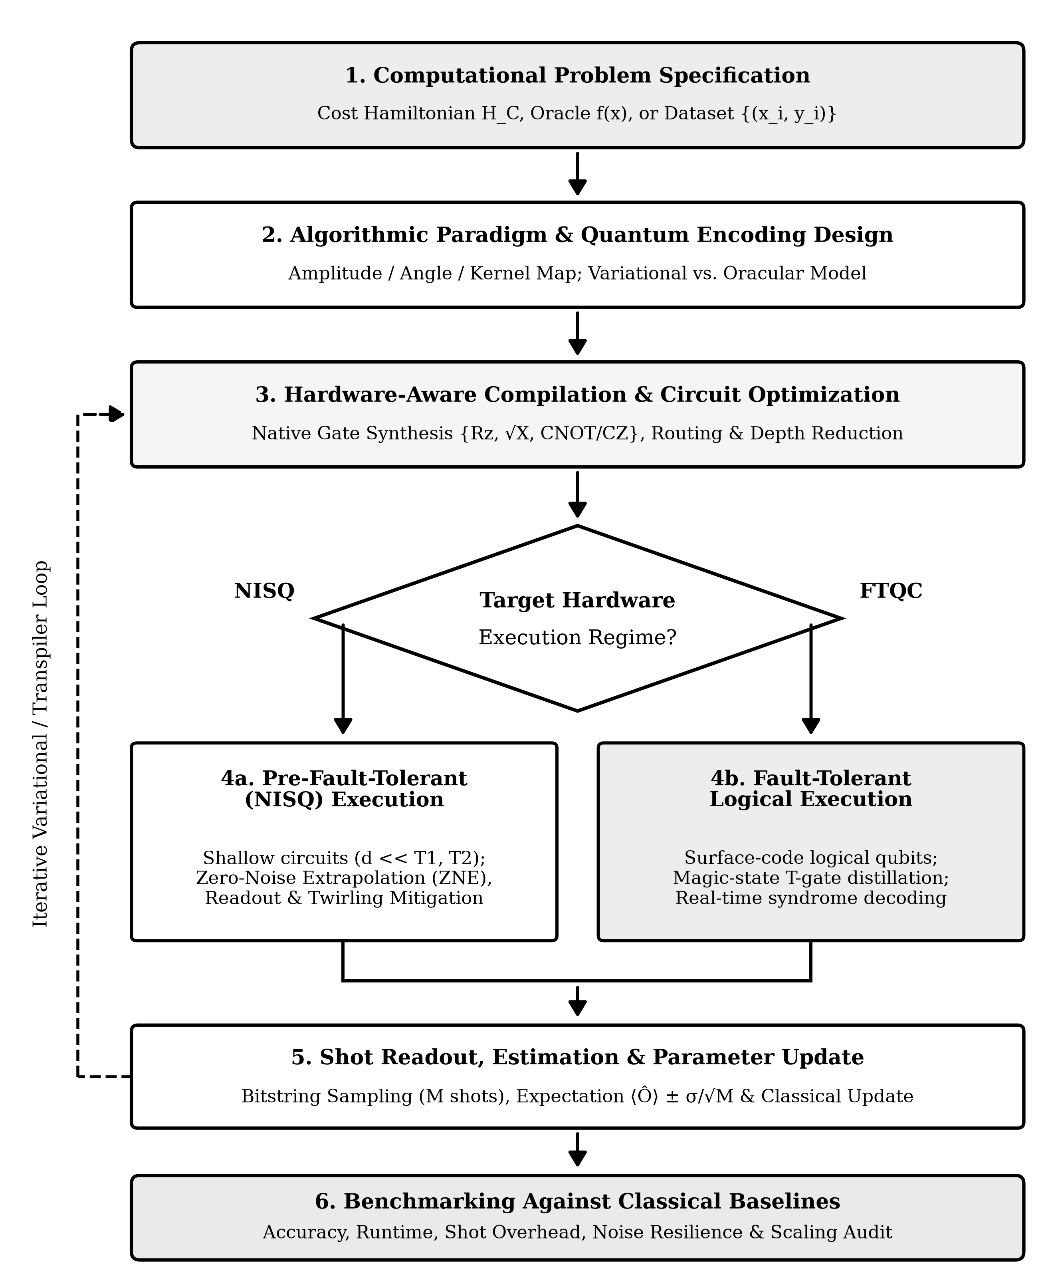
Figure 2. End-to-end quantum algorithm design, compilation, error suppression, and execution workflow across noisy intermediate-scale quantum (NISQ) and fault-tolerant computing regimes. Solid arrows indicate forward synthesis and execution stages; dashed arrows indicate iterative variational parameter updates and hardware-aware compilation feedback.

