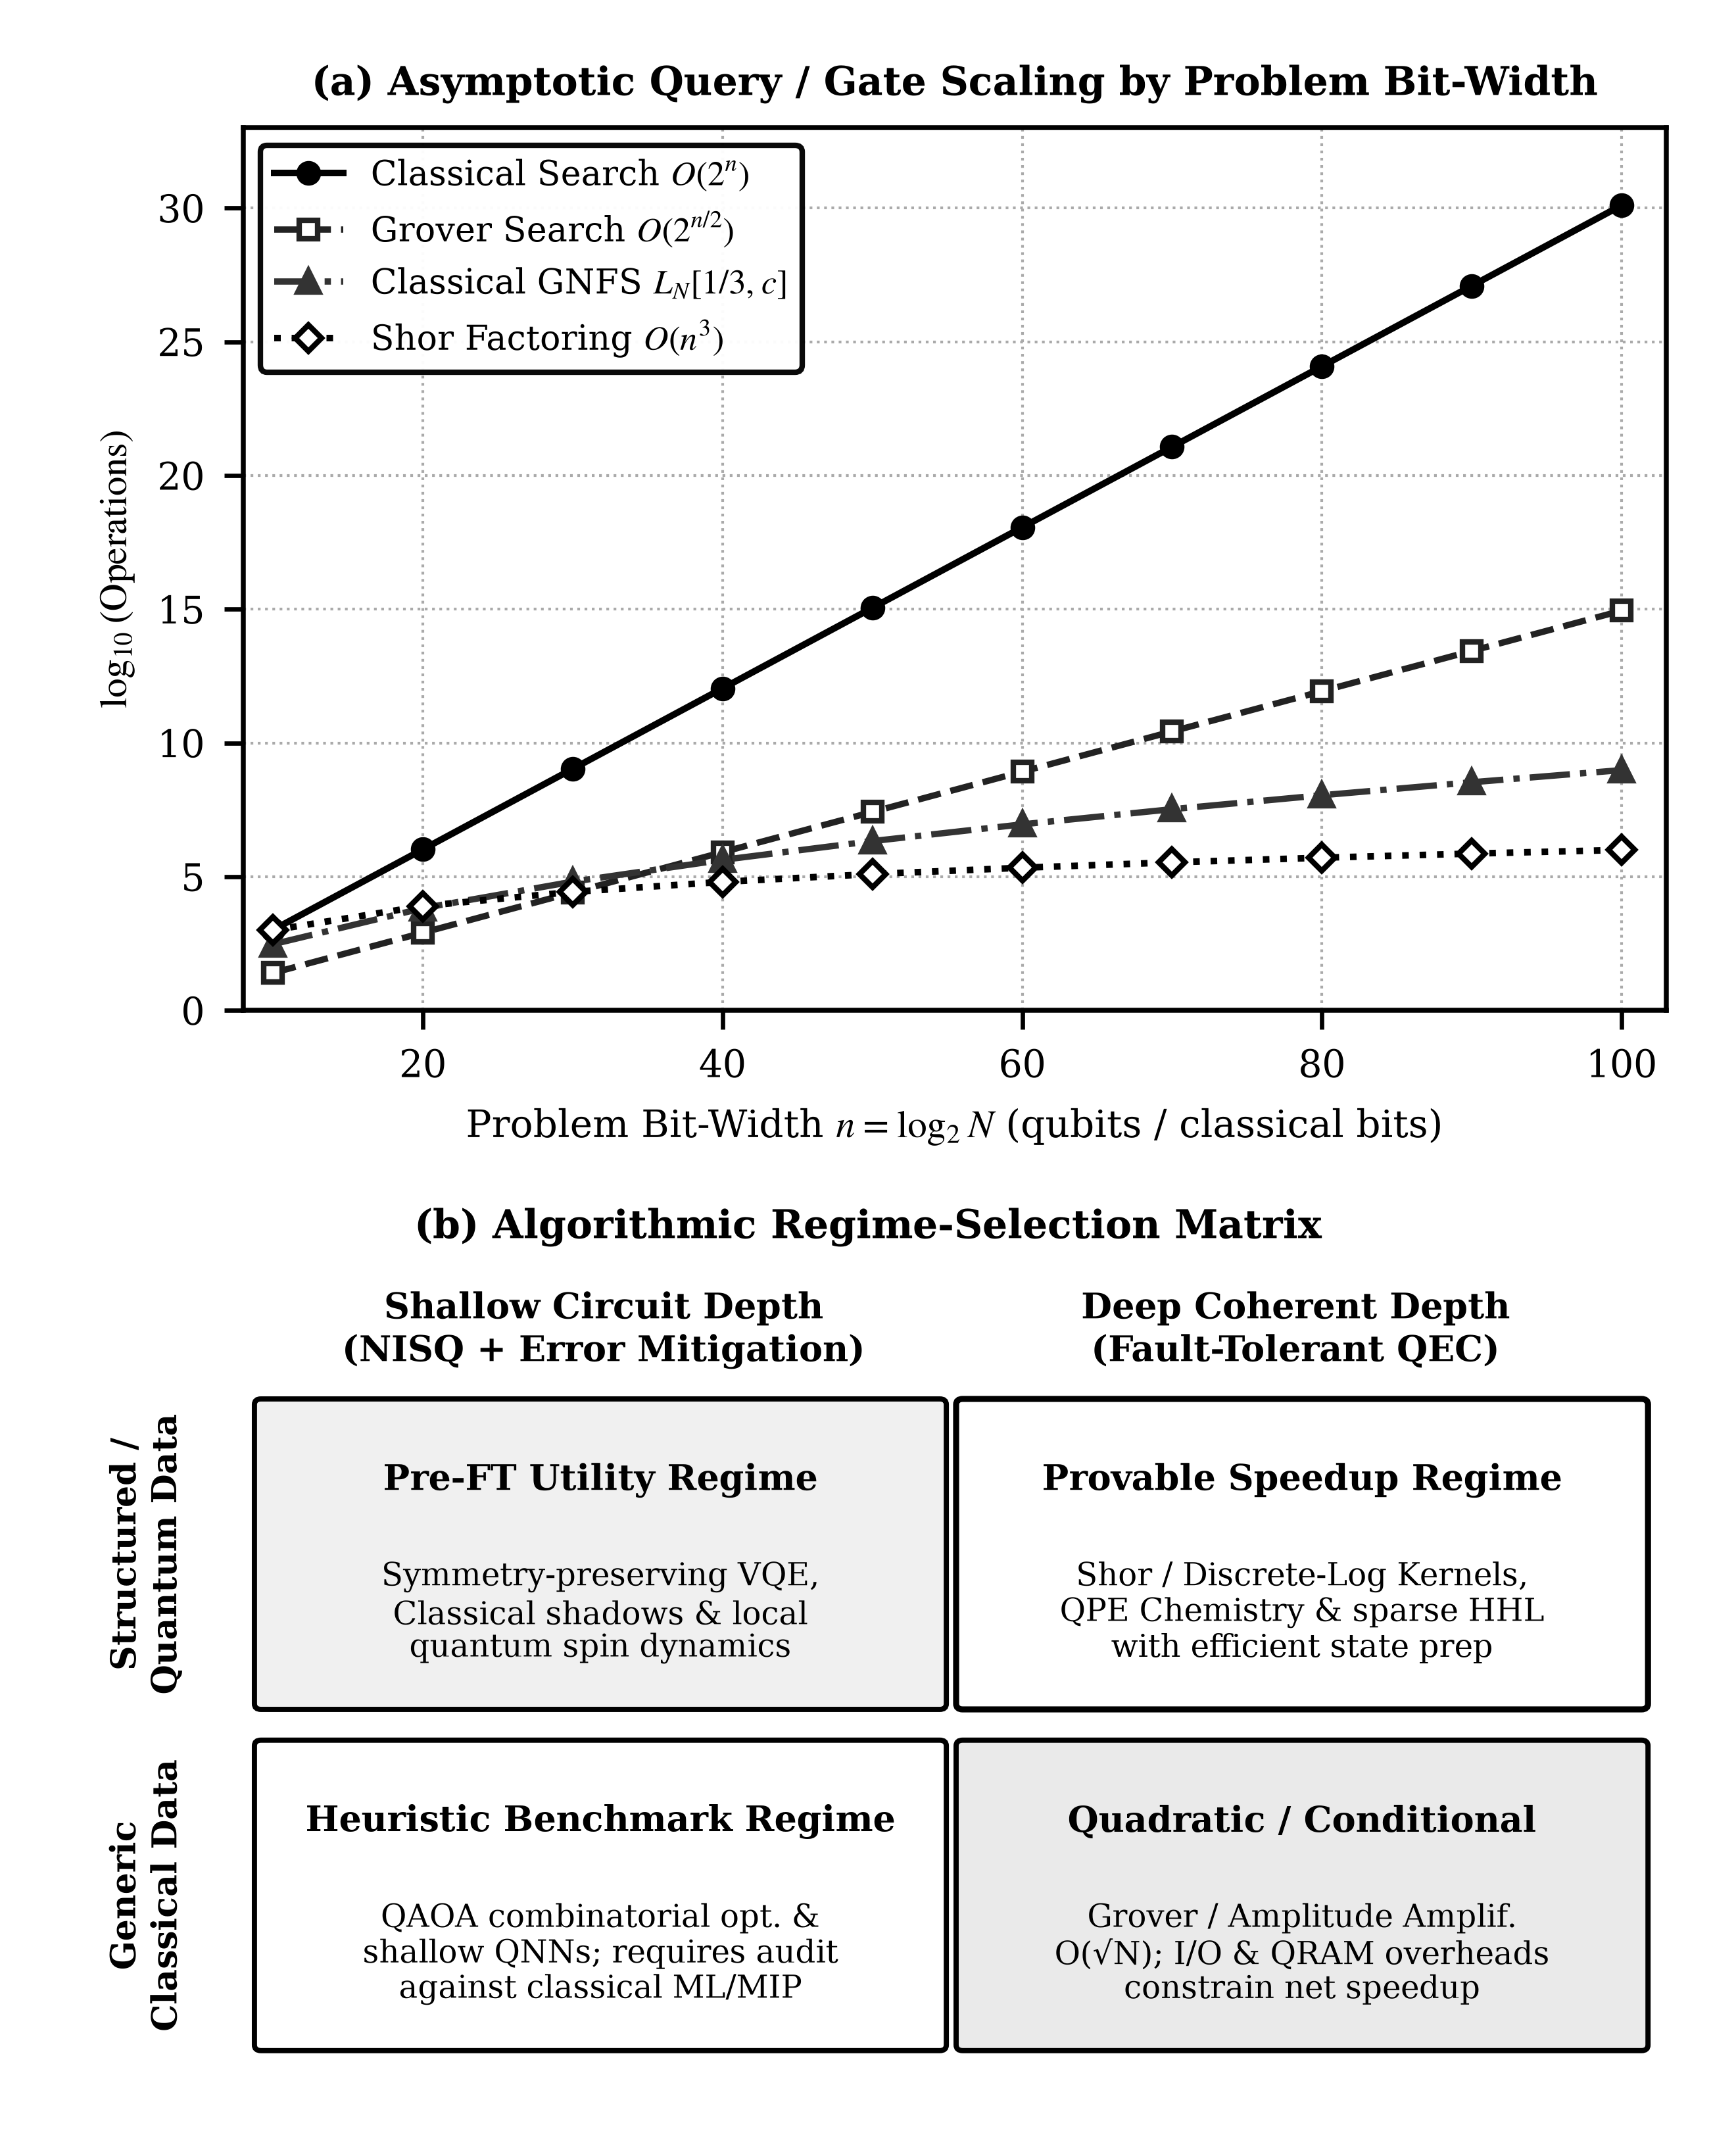
Figure 4. Comparative scaling and regime-selection framework for quantum and classical intelligent computing: (a) semi-logarithmic comparison of query/gate complexity log10(ops) versus register width n = log2(N) across unstructured classical search O(N), Grover search O(√N), sub-exponential number field sieve scaling, and Shor polynomial-time factoring O(n^3); and (b) structured decision matrix classifying problem regimes across classical baselines, NISQ hybrid heuristics, and fault-tolerant quantum algorithms.

