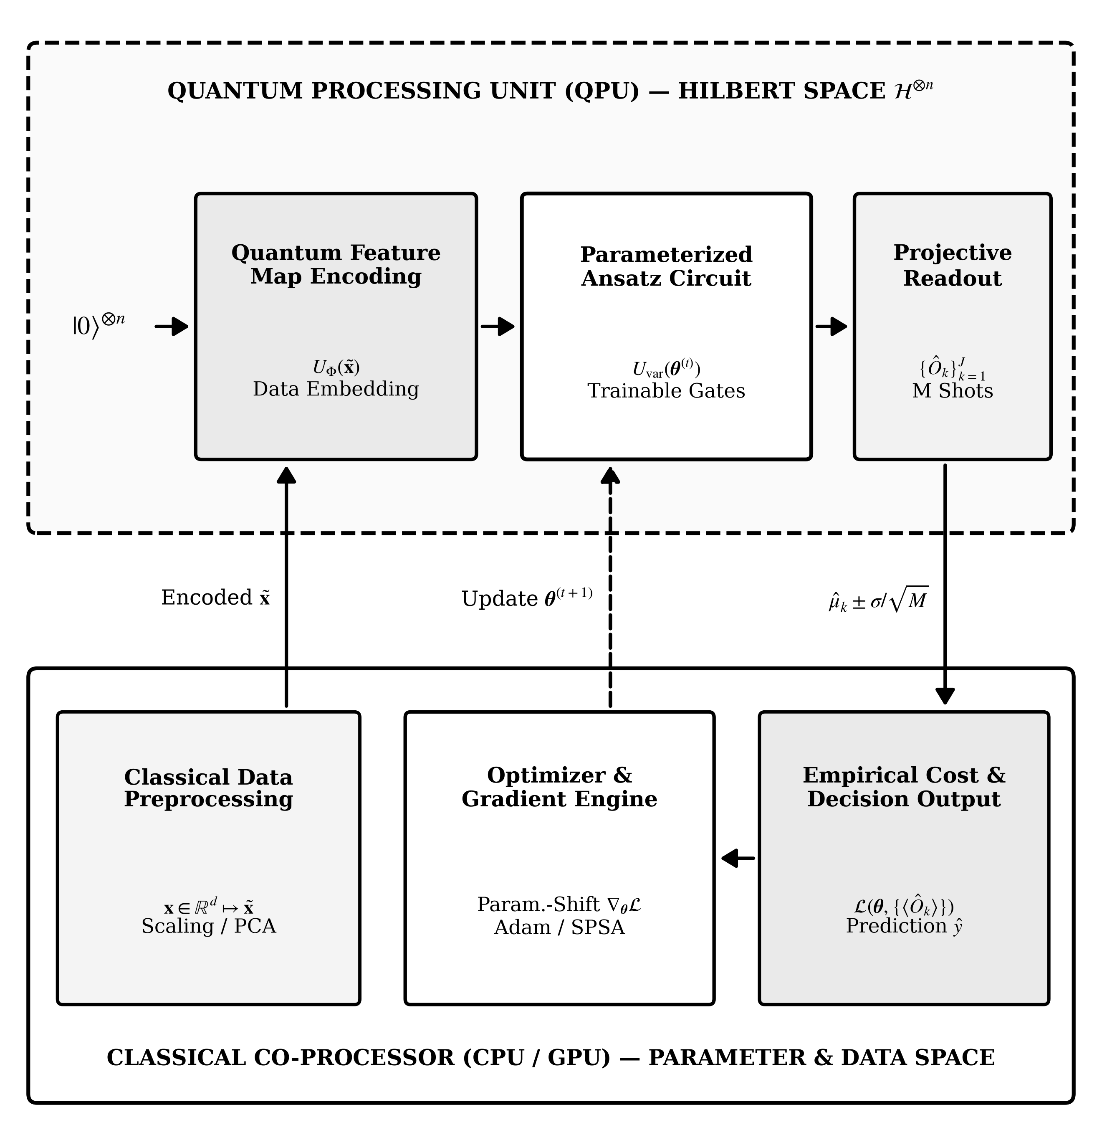
Figure 3. Closed-loop hybrid quantum–classical intelligent computing architecture. Classical input features x ∈ R^d undergo preprocessing and quantum state encoding U_Φ(x), followed by trainable parameterized layers U_var(θ) and shot-based observable estimation on the quantum processing unit (QPU), while a classical co-processor evaluates empirical loss L(θ) and updates parameters θ^(t+1) via parameter-shift gradients or derivative-free optimizers.

