In: Quantum Artificial Intelligence and Machine Learning: Principles, Algorithms, and Applications
Editors: [Editor Name(s)] | Publisher: Nova Science Publishers
Chapter
Quantum Circuits and Quantum Algorithms: Foundations, Design Principles, and Applications in Intelligent Computing
[First Middle Last, PhD]^{1,*} and [Second Author First Middle Last, PhD]²
¹[Department Name], [University or Research Institution], [City], [State (if applicable)], [Country]
²[Department Name], [University or Research Institution], [City], [State (if applicable)], [Country]
*Corresponding Author's Email: [corresponding.author@institution.edu]
Abstract
Quantum computing offers a mathematically distinct model of information processing grounded in Hilbert-space state evolution, unitary gate synthesis, and projective measurement, motivating growing interest across artificial intelligence and machine learning. However, translating asymptotic quantum speedups into practical intelligent computing systems remains constrained by state-preparation overheads, barren optimization landscapes, hardware decoherence, and classical dequantization results. This chapter establishes a unified theoretical and engineering framework connecting foundational quantum circuit design principles to modern quantum and hybrid quantum-classical algorithms for optimization, search, kernel learning, and decision support. Using a structured literature synthesis, formal mathematical analysis, and comparative architectural evaluation, this chapter examines gate decompositions, variational ansätze, amplitude amplification, quantum feature maps, error mitigation, and fault-tolerant scaling laws. The synthesis demonstrates that credible quantum utility requires aligning problem algebraic structure with shallow symmetry-informed circuits or fault-tolerant logical architectures, providing researchers with rigorous criteria for algorithm selection and benchmarking.
Keywords: quantum circuits, quantum algorithms, variational quantum algorithms, quantum machine learning, hybrid quantum-classical architectures, quantum error mitigation
1. Introduction
1.1 Background and Motivation
Modern intelligent computing systems rely on classical von Neumann and tensor-accelerator architectures whose empirical effectiveness across statistical learning and combinatorial optimization scales with parallel hardware throughput. Fundamental bottlenecks nevertheless arise when problem instances induce exponentially large state spaces, strongly correlated quantum many-body structure, or intractable group-theoretic operations. Quantum computing replaces Boolean bit registers with state vectors and density operators defined on complex Hilbert spaces, evolving coherently under reversible unitary circuits prior to probabilistic projective measurement (Feynman, 1982; Deutsch, 1985; Nielsen & Chuang, 2010). Rather than accelerating arbitrary classical workloads indiscriminately, quantum processors achieve speedups only when wave interference amplifies target solution amplitudes more efficiently than classical randomized or heuristic algorithms (Biamonte et al., 2017). Two hardware regimes now shape research: noisy intermediate-scale quantum (NISQ) processors executing shallow error-mitigated hybrid circuits (Preskill, 2018; Kim et al., 2023; Cai et al., 2023) and emerging early fault-tolerant architectures demonstrating below-threshold surface-code logical memories (Acharya et al., 2025).
1.2 Research Problem and Significance
A persistent conceptual divide separates formal quantum algorithm theory from applied machine learning engineering. Foundational complexity proofs frequently assume fault-tolerant logical qubits, idealized black-box oracles, or cost-free quantum random access memory (QRAM), obscuring state-preparation and readout bottlenecks that dominate end-to-end runtime (Harrow et al., 2009; Biamonte et al., 2017). Conversely, heuristic studies of parameterized quantum circuits often treat variational ansätze as drop-in replacements for classical neural networks, overlooking exponentially vanishing barren-plateau gradients (McClean et al., 2018), quantum-inspired classical dequantization of low-rank linear algebra (Tang, 2019), and inner-product concentration in generic quantum kernels (Cerezo et al., 2025). Without unified architectural guidance connecting physical gate synthesis to statistical learning theory, practitioners risk misallocating quantum resources to tasks where classical tensor networks or gradient-boosted ensembles perform faster, cheaper, and more reliably. Bridging low-level circuit mechanics with rigorous complexity bounds is therefore critical for identifying genuine utility.
1.3 Objectives and Research Questions
The objective of this chapter is to establish a mathematically rigorous, engineering-oriented synthesis linking quantum circuit design principles to quantum algorithms for intelligent computing. Specifically, this chapter addresses four research questions: (RQ1) How do Hilbert-space state representations, universal gate decompositions, and projective measurement statistics govern the expressive capacity and shot complexity of quantum circuits? (RQ2) Which structural compilation principles enable hardware efficiency, symmetry preservation, and error suppression across NISQ and fault-tolerant regimes? (RQ3) Under what formal assumptions do variational algorithms, QAOA, amplitude amplification, linear-system solvers, and quantum kernels achieve provable or empirically credible advantages over classical baselines? (RQ4) How should hybrid quantum-classical architectures be designed and benchmarked to navigate barren plateaus and noise?
1.4 Scope and Contributions of the Chapter
This chapter focuses on gate-based digital quantum computation and hybrid quantum-classical learning and optimization workflows, referencing analog annealing or continuous-variable photonics only for boundary contrast. Four principal contributions distinguish this chapter: (1) a unified operator-theoretic formulation connecting pure states, open-system density matrices, universal gate sets, and finite-shot measurement variance; (2) an end-to-end circuit synthesis and execution methodology spanning both error-mitigated NISQ and surface-code fault-tolerant regimes; (3) rigorous mathematical derivations and side-by-side comparisons of core intelligent computing algorithms that separate proven complexity separations from heuristic proposals; and (4) a critical synthesis of verified published benchmarks and practical selection trade-offs.
1.5 Organization of the Chapter
Section 2 reviews foundational literature across quantum computation, circuit synthesis, quantum machine learning, and open research gaps. Section 3 details the analytical methodology of this chapter, circuit representation conventions, hybrid execution workflows, evaluation criteria, and reproducibility assumptions. Section 4 formalizes qubit state spaces, single- and multi-qubit unitary gates, open-system readout, foundational subroutines, and complexity classes. Section 5 analyzes variational quantum algorithms, QAOA, quantum search, quantum kernels, generalization bounds, and hybrid architectures. Section 6 evaluates applications, published empirical and theoretical benchmarks, and hardware scaling barriers. Sections 7 and 8 synthesize implications, limitations, future research opportunities, and concluding insights.
2. Literature Review and Theoretical Foundations
2.1 Fundamentals of Quantum Computing
Feynman (1982) first observed that classical computers incur exponential memory and runtime costs when simulating local quantum many-body dynamics, motivating controllable quantum systems as computational substrates. Deutsch (1985) formalized the universal quantum Turing machine, while subsequent circuit theory established networks of reversible unitary gates acting on multi-qubit registers as the canonical operational model (Nielsen & Chuang, 2010). Closed-system evolution is linear, norm-preserving, and unitary, forbidding fan-out state cloning via the no-cloning theorem and requiring ancilla uncomputation for non-bijective Boolean logic. Furthermore, Holevo's bound proves that projective measurement of $n$ qubits extracts at most $n$ classical bits per shot despite the $2^{n}$-dimensional state vector, implying that useful algorithms must concentrate amplitude onto target outcomes via wave interference.
2.2 Qubits, Superposition and Entanglement
A physical qubit encodes information within two isolated energy or polarization levels spanning $ℋ≅ℂ^{2}$, realized experimentally across superconducting transmon circuits (Arute et al., 2019; Acharya et al., 2025), trapped ions, neutral atom arrays, and integrated photonics (Peruzzo et al., 2014). Superposition enables coherent phase encoding within single registers, whereas non-factorizable multi-qubit states in $ℋ^{⊗n}≅ℂ^{2^{n}}$ exhibit quantum entanglement (Nielsen & Chuang, 2010). Product-state circuits and pure Clifford stabilizer circuits remain efficiently simulable on classical computers via tensor contractions or the Gottesman–Knill theorem, making non-Clifford magic and multipartite entanglement necessary resources for quantum speedups. Paradoxically, however, excessive volume-law entanglement in deep variational circuits thermalizes local reduced states toward maximally mixed ensembles, inducing untrainable barren plateaus (McClean et al., 2018; Cerezo et al., 2025).
2.3 Quantum Gates and Quantum Circuits
Barenco et al. (1995) proved that arbitrary single-qubit rotations combined with two-qubit Controlled-NOT ($CNOT$) gates form an exact universal basis for all unitaries in $U(2^{n})$. For fault-tolerant architectures, the discrete Clifford+$T$ library—comprising Hadamard ($H$), phase ($S$), $CNOT$, and $T$ gates—approximates arbitrary single-qubit unitaries within operator norm $ϵ$ using $O(\log^{c}(1/ϵ))$ gates via the Solovay–Kitaev theorem and optimal Ross–Selinger synthesis (Nielsen & Chuang, 2010). Figure 1 depicts the single-qubit Bloch sphere, a canonical three-qubit entangling circuit with classical readout, and the four-tier execution architecture. Table 1 catalogs canonical gate families and their algorithmic functions.
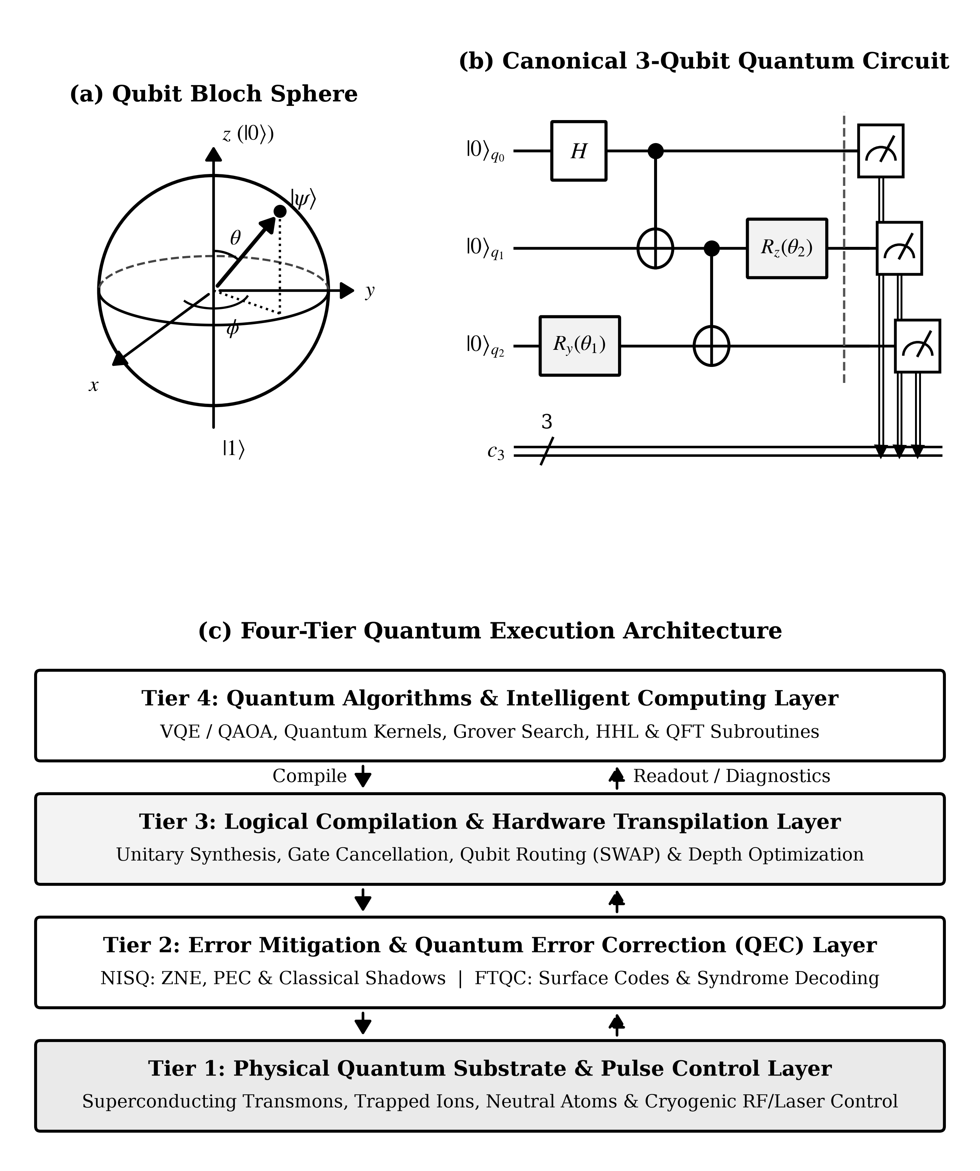
Figure 1. Foundations of gate-model quantum computing: (a) Bloch sphere representation of a pure single-qubit state parameterized by polar angle θ and azimuthal phase φ; (b) canonical three-qubit entangling circuit preparing a Greenberger–Horne–Zeilinger state with projective readout onto classical register c; and (c) four-layer architectural stack linking high-level intelligent computing algorithms to physical hardware.
Table 1. Canonical single-qubit and multi-qubit quantum gates, algebraic properties, and functional roles in intelligent computing circuits.
Gate Family | Qubits | Unitary Generator / Action | Primary Algorithmic Role
Pauli (X, Y, Z) | 1 | Involutory bit/phase flips; Hermitian observables | Basis preparation, stabilizer checks, Hamiltonian terms
Hadamard (H) | 1 | Maps computational basis to uniform superposition | Interference setup in QFT, Grover, QPE, and kernels
Phase (S, T) | 1 | π/2 Clifford phase (S) and π/4 non-Clifford phase (T) | Universal fault-tolerant synthesis with Clifford group
Parameterized (Rx, Ry, Rz) | 1 | Continuous SU(2) rotations exp(-iθσ/2) | Angle data embedding and trainable variational weights
CNOT / CZ | 2 | Conditional bit-flip or conditional π phase kickback | Entanglement generation in ansätze and surface codes
SWAP / iSWAP | 2 | Exchanges two-qubit states on coupled hardware graphs | Topology routing on planar superconducting processors
Toffoli (CCX) | 3 | Doubly controlled NOT; universal reversible logic | Arithmetic predicates, coherent lookup, Grover oracles
2.4 Quantum Algorithms: Historical Development and Core Principles
Early oracle results such as the Deutsch–Jozsa problem demonstrated exponential query separations over deterministic classical algorithms via phase kickback (Deutsch, 1985; Nielsen & Chuang, 2010). Shor (1997) transformed coherent interference into polynomial-time algorithms for integer factorization and discrete logarithms using modular exponentiation and the Quantum Fourier Transform (QFT). Concurrently, Grover (1996) derived an optimal $O(\sqrt{N})$ unstructured search algorithm generalized by Brassard et al. (2002) into universal amplitude amplification and estimation. Harrow et al. (2009) extended quantum phase estimation (QPE) to sparse linear systems (HHL), preparing states proportional to $A^{−1}b$. To accommodate limited NISQ coherence, Peruzzo et al. (2014) and Farhi et al. (2014) introduced variational eigensolvers (VQE) and QAOA, coupling shallow parameterized circuits to classical optimizers (Cerezo et al., 2021; Tilly et al., 2022).
2.5 Quantum Machine Learning and Intelligent Computing
Quantum machine learning encompasses fault-tolerant linear-algebraic accelerators (Biamonte et al., 2017), differentiable parameterized quantum circuits trained via analytic parameter-shift rules (Mitarai et al., 2018), and quantum kernel methods mapping classical inputs into feature Hilbert spaces (Havlíček et al., 2019). Foundational statistical learning theory further characterizes circuit expressibility and inductive bias (Cerezo et al., 2021), randomized shadow tomography (Huang et al., 2020), provable discrete-logarithm kernel separations (Liu et al., 2021), and finite-sample generalization error scaling as $\overset{\sim }{O}(\sqrt{T/S})$ for $T$ trainable gates across $S$ training examples (Caro et al., 2022).
2.6 Critical Review of Existing Research
Rigorous scrutiny has overturned several overly broad claims in early QML research. Tang (2019) proved that quantum-inspired classical sampling algorithms match polylogarithmic quantum runtimes for low-rank recommendation and matrix tasks when given comparable $ℓ_{2}$-sampling access, eliminating putative exponential speedups on unstructured classical matrices. McClean et al. (2018) established that expressive random ansätze suffer exponential gradient decay, extended by subsequent work to global observables, entanglement-induced thermalization, and hardware noise (Cerezo et al., 2021). Crucially, Cerezo et al. (2025) demonstrated that many architectures proven immune to barren plateaus evolve within polynomial-dimension Lie algebras or shallow causal cones that remain classically simulable unless initialized from non-trivial quantum states.
2.7 Research Gaps and Conceptual Foundations
Four gaps persist across applied studies: (1) omitting state-preparation and shot overheads when claiming asymptotic speedups; (2) extrapolating $4$- to $12$-qubit noiseless simulations where barren plateaus remain invisible; (3) conflating exponential-overhead NISQ error mitigation (Cai et al., 2023) with scalable fault-tolerant error correction (Acharya et al., 2025); and (4) lacking systematic decision rules matching data structure to circuit depth. Addressing these four gaps forms the conceptual foundation of this chapter.
3. Research Methodology and Design Framework
3.1 Research Approach and Chapter Method
This chapter adopts a structured conceptual synthesis combined with formal linear-algebraic derivation and comparative architectural analysis. No new laboratory quantum hardware runs or synthetic empirical benchmarks are fabricated or claimed, nor is a bibliometric PRISMA review asserted. Instead, archival theoretical proofs and verified experimental hardware milestones are synthesized under uniform mathematical notation to evaluate circuit expressibility, gradient trainability, sample complexity, and noise scaling on equal footing.
3.2 Quantum Circuit Representation and Design Principles
Quantum circuits in this chapter are modeled as left-to-right directed acyclic networks over $n$ quantum wires initialized in $|0⟩^{⊗n}$ and classical readout registers (Nielsen & Chuang, 2010). Four design rules govern synthesis: (1) reversible ancilla uncomputation back to $|0⟩$ to prevent unintended entanglement decoherence; (2) hardware-aware gate compilation minimizing two-qubit $CNOT/CZ$ layers and $SWAP$ routing overhead on planar topologies (Barenco et al., 1995); (3) symmetry-informed inductive bias constraining ansätze to problem-invariant subspaces (Cerezo et al., 2021; Cerezo et al., 2025); and (4) measurement parsimony via commuting Pauli grouping or classical shadows (Huang et al., 2020; Tilly et al., 2022).
3.3 Quantum Algorithm Design and Execution Workflow
Figure 2 formalizes the six-stage design and execution workflow used throughout this chapter. Problem specifications (Stage 1: cost Hamiltonians ${\overset{^}{H}}_{C}$, Boolean oracles, or labeled datasets) are mapped into quantum encoding and algorithmic structures (Stage 2) and transpiled into hardware-native gate sequences (Stage 3). Execution then bifurcates by hardware regime: pre-fault-tolerant NISQ execution (Stage 4a) restricts depth within relaxation times $T_{1},T_{2}$ and applies statistical error mitigation such as zero-noise extrapolation (ZNE) and probabilistic error cancellation (PEC) (Kim et al., 2023; Cai et al., 2023), whereas fault-tolerant execution (Stage 4b) encodes logical qubits in surface codes with real-time syndrome decoding and magic-state $T$-gate distillation (Acharya et al., 2025). Both paths feed shot-based expectation estimation and parameter updates (Stage 5) before rigorous comparison against state-of-the-art classical solvers (Stage 6).
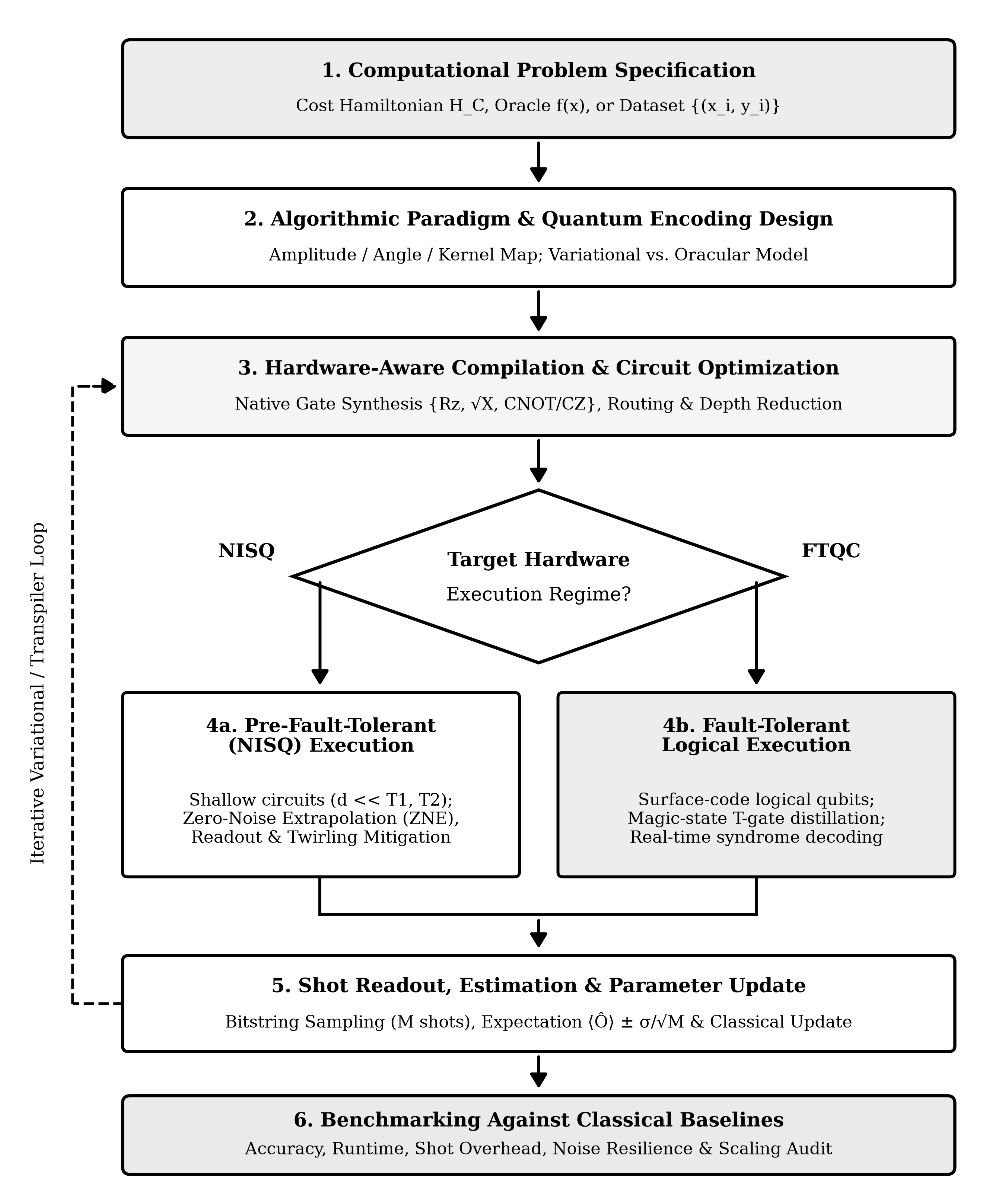
Figure 2. Six-stage quantum algorithm design, compilation, execution, and classical baseline benchmarking workflow contrasting pre-fault-tolerant NISQ error mitigation (Stage 4a) against surface-code fault-tolerant execution with magic-state distillation (Stage 4b).
3.4 Quantum-Classical Hybrid Architectures
Contemporary intelligent computing predominantly relies on tightly coupled hybrid architectures partitioning workload by physical strength (Peruzzo et al., 2014; Cerezo et al., 2021). As depicted in Figure 3, a classical CPU/GPU co-processor performs feature scaling, principal component compression, loss evaluation, and parameter updates, while the QPU executes state embedding $U_{Φ}(\overset{\sim }{x})$, parameterized evolution $U_{var}(θ^{(t)})$, and $M$-shot observable sampling returning empirical means ${\overset{^}{μ}}_{k}±σ/\sqrt{M}$ for analytic parameter-shift or stochastic optimization (Mitarai et al., 2018; Tilly et al., 2022).
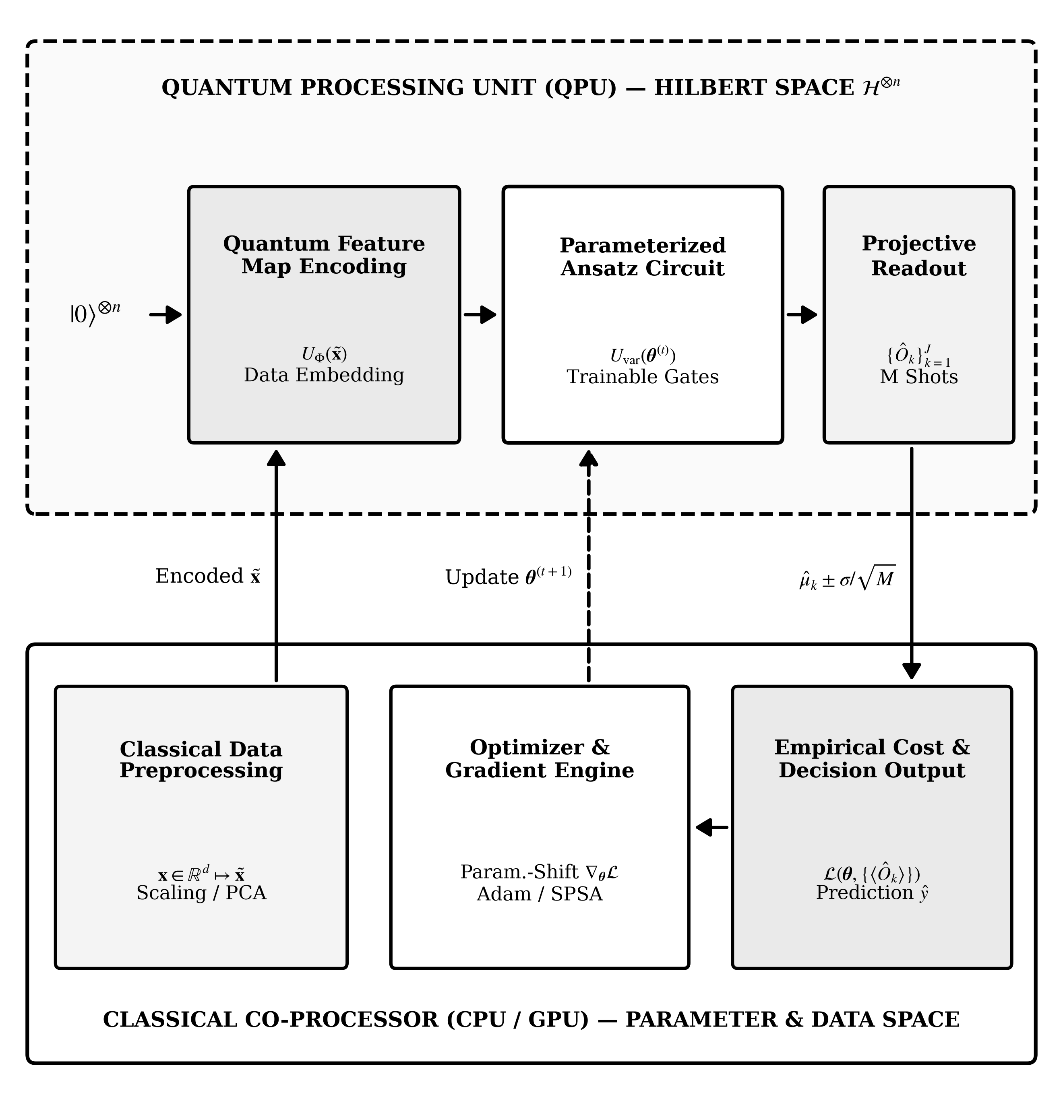
Figure 3. Closed-loop hybrid quantum-classical learning and variational optimization architecture showing classical CPU/GPU feature reduction, loss evaluation, and parameter updates coupled with QPU state encoding, parameterized unitary evolution, and finite-shot projective sampling.
3.5 Evaluation Metrics and Comparison Criteria
Credible algorithmic comparison requires evaluating six orthogonal metrics simultaneously rather than citing noiseless gate counts in isolation (Tilly et al., 2022; Cai et al., 2023). First, qubit footprint must separate unencoded physical qubits from error-corrected logical qubits together with routing ancillas. Second, circuit depth must count sequential entangling two-qubit gate layers after transpilation onto the target device coupling graph rather than pre-compilation abstract unitaries. Third, non-Clifford resource cost tracks logical $T$-gate count and $T$-depth, which dictate magic-state factory overhead in fault-tolerant systems. Fourth, total shot complexity accounts for all repeated circuit executions summed across every observable term, gradient evaluation, and error-mitigation noise scale factor. Fifth, trainability tracks cost-gradient variance scaling with system width $n$. Sixth, end-to-end data I/O accounts for state-preparation depth relative to classical memory bandwidth. Table 2 summarizes these six evaluation criteria across NISQ and fault-tolerant execution regimes.
Table 2. Multidimensional evaluation framework for comparing quantum, hybrid, and classical intelligent computing algorithms.
Dimension | Primary Metric | NISQ Implications | Fault-Tolerant Target
Space Overhead | Physical vs. logical qubit count n | 50–1,000 noisy physical qubits without full QEC | 2d^2 - 1 physical qubits per surface-code logical qubit
Circuit Depth | Two-qubit entangling gate layers L | Restricted by T1/T2 coherence to O(10)–O(10^2) layers | Polynomial logical depth sustained via syndrome decoding
Non-Clifford Cost | Logical T-gate count and T-depth | Absorbed into continuous native rotations with gate noise | Dominant spacetime bottleneck via magic-state factories
Sampling Budget | Measurement shots M and gradient evals | Scales as O(1/ε^2); error mitigation inflates variance | Coherent amplitude estimation reduces scaling toward O(1/ε)
Trainability | Cost gradient variance Var[∂E/∂θ_j] | Exponential barren plateaus under deep global ansätze | Requires Lie-algebraic or symmetry-constrained structure
Data I/O Model | Encoding depth or oracle calls | Classical feature loading can dominate wall-clock runtime | Speedups require compact data or efficient circuit synthesis
3.6 Assumptions, Constraints and Reproducibility
Every analysis in this chapter explicitly distinguishes three physical models: (1) closed-system ideal unitary mechanics; (2) open-system NISQ channels subject to depolarizing, amplitude-damping, and readout noise under finite shot budgets $M$; and (3) fault-tolerant logical circuits operating below code threshold $p<p_{thr}$. Reproducible reporting requires specifying native gate sets, transpiled two-qubit depth, total shots across all optimization steps, error-mitigation scale factors, random seeds, and tuned classical baseline implementations.
4. Quantum Circuits and Quantum Algorithmic Foundations
4.1 Mathematical Representation of Qubits and Quantum States
In Dirac bra-ket notation, a pure single-qubit state is represented by a unit column vector $|ψ⟩$ in a two-dimensional complex Hilbert space $ℋ≅ℂ^{2}$ with orthonormal computational basis $|0⟩=(1,0)^{⊤}$ and $|1⟩=(0,1)^{⊤}$, conjugate transpose dual bras $⟨ψ|=|ψ⟩^{†}$, and complex probability amplitudes $α,β∈ℂ$ satisfying Born normalization:
$|ψ⟩=α|0⟩+β|1⟩,|α|^{2}+|β|^{2}=1$ (1)
Because global phase factors $e^{iχ}|ψ⟩$ ($χ∈ℝ$) yield identical observable statistics, every pure single-qubit state maps bijectively (up to poles) onto a point on the unit Bloch sphere parameterized by polar angle $θ∈[0,π$] and azimuthal angle $ϕ∈[0,2π)$ (Nielsen & Chuang, 2010), as illustrated in Figure 1(a):
$|ψ(θ,ϕ)⟩=cos\left(\frac{θ}{2}\right)|0⟩+e^{iϕ}sin\left(\frac{θ}{2}\right)|1⟩$ (2)
For an $n$-qubit register, the composite Hilbert space is the $2^{n}$-dimensional tensor product $ℋ^{⊗n}≅ℂ^{2^{n}}$ spanned by binary basis kets $|x⟩=|x_{n−1}⋯x_{1}x_{0}⟩$ indexed by integers $x=\sum_{q=0}^{n−1}{x_{q}2^{q}∈\{0,…,2^{n}−1\}}$ with amplitudes $c_{x}∈ℂ$:
$|Ψ⟩=\sum_{x=0}^{2^{n}−1}{c_{x}|x⟩},\sum_{x=0}^{2^{n}−1}{|c_{x}|^{2}}=1$ (3)
In realistic NISQ processors interacting with thermal and electromagnetic environments, states are statistical ensembles or reduced subsystems described by a positive semidefinite Hermitian density operator $\overset{^}{ρ}⪰0$ generated by classical probabilities $p_{k}≥0$ ($\sum_{k}{p_{k}=1}$), where purity $Tr({\overset{^}{ρ}}^{2})$ equals $1$ exclusively for pure states and decreases toward $1/2^{n}$ under decoherence:
$\overset{^}{ρ}=\sum_{k}{p_{k}|ψ_{k}⟩⟨ψ_{k}|},Tr(\overset{^}{ρ})=1,Tr({\overset{^}{ρ}}^{2})≤1$ (4)
4.2 Single-Qubit and Multi-Qubit Gates
Closed-system quantum gates act as unitary linear operators $U∈U(2^{n})$ satisfying $U^{†}U=UU^{†}=I$. Single-qubit algebra is anchored by the identity $I$ and the three Hermitian, unitary, traceless Pauli matrices $X$, $Y$, and $Z$, which satisfy $σ^{2}=I$ for $σ∈\{X,Y,Z\}$ and generate the Lie algebra $su(2)$:
$X=\left(\begin{matrix}0 & 1 \\ 1 & 0\end{matrix}\right),Y=\left(\begin{matrix}0 & −i \\ i & 0\end{matrix}\right),Z=\left(\begin{matrix}1 & 0 \\ 0 & −1\end{matrix}\right)$ (5)
Discrete fault-tolerant synthesis relies on the Hadamard gate $H$—which maps $|0⟩$ to $|+⟩=(|0⟩+|1⟩)/\sqrt{2}$ and $|1⟩$ to $|−⟩=(|0⟩−|1⟩)/\sqrt{2}$—alongside the Clifford phase gate $S$ and the non-Clifford $π/8$ gate $T$:
$H=\frac{1}{\sqrt{2}}\left(\begin{matrix}1 & 1 \\ 1 & −1\end{matrix}\right),S=\left(\begin{matrix}1 & 0 \\ 0 & i\end{matrix}\right),T=\left(\begin{matrix}1 & 0 \\ 0 & e^{iπ/4}\end{matrix}\right)$ (6)
Parameterized quantum circuits and hardware-native pulse compilers employ continuous rotation operators $R_{σ}(θ)$ around axis $σ∈\{X,Y,Z\}$ by rotation angle $θ∈ℝ$, enabling arbitrary $SU(2)$ synthesis via Euler decomposition $U(α,β,γ)=R_{z}(α)R_{y}(β)R_{z}(γ)$:
$R_{σ}(θ)=exp\left(−i\frac{θ}{2}σ\right)=cos\left(\frac{θ}{2}\right)I−isin\left(\frac{θ}{2}\right)σ$ (7)
Multi-qubit entanglement arises through conditional two-qubit gates. In the ordered basis $\{|00⟩,|01⟩,|10⟩,|11⟩\}$, $CNOT$ flips the target qubit conditioned on control state $|1⟩$, mapping $(H⊗I)|00⟩$ to the maximally entangled Bell state $|Φ^{+}⟩$ whose reduced single-qubit states ${Tr}_{B}(|Φ^{+}⟩⟨Φ^{+}|)=I/2$ possess zero local bias yet maximal correlation:
$CNOT=\left(\begin{matrix}1 & 0 & 0 & 0 \\ 0 & 1 & 0 & 0 \\ 0 & 0 & 0 & 1 \\ 0 & 0 & 1 & 0\end{matrix}\right),|Φ^{+}⟩=\frac{1}{\sqrt{2}}\left(|00⟩+|11⟩\right)$ (8)
4.3 Circuit Composition, Measurement and Readout
Parallel gates acting on disjoint registers combine via the Kronecker tensor product $U_{A}⊗U_{B}$, whereas sequential circuit layers one through $L$ compose by matrix multiplication in reverse chronological order. Under open-system NISQ noise, ideal unitary evolution is replaced by a completely positive trace-preserving (CPTP) quantum channel $ℰ(\overset{^}{ρ})$ expressed via Kraus operators $\{K_{m}\}$ (Nielsen & Chuang, 2010):
$U_{circ}=U_{L}U_{L−1}⋯U_{1},ℰ(\overset{^}{ρ})=\sum_{m}{K_{m}\overset{^}{ρ}K_{m}^{†}},\sum_{m}{K_{m}^{†}K_{m}}=I$ (9)
Readout performs a projective measurement defined by complete orthogonal projectors $\{Π_{m}\}$ satisfying $Π_{m}Π_{m^{′}}=δ_{mm^{′}}Π_{m}$ and $\sum_{m}{Π_{m}=I}$. Outcome $m$ occurs with Born probability $p(m)$ and projects the state onto ${\overset{^}{ρ}}_{m}$:
$p(m)=Tr(Π_{m}\overset{^}{ρ}),{\overset{^}{ρ}}_{m}=\frac{Π_{m}\overset{^}{ρ}Π_{m}}{Tr(Π_{m}\overset{^}{ρ})}$ (10)
When estimating the expectation value of a Hermitian observable $\overset{^}{O}$ across $M$ independent circuit executions (shots), the sample mean estimator ${\overset{^}{μ}}_{M}$ is unbiased with variance inversely proportional to $M$, establishing an inescapable $M=O(1/ϵ^{2})$ sampling cost for additive precision $ϵ$ in standard NISQ readout (Tilly et al., 2022):
$⟨\overset{^}{O}⟩=Tr(\overset{^}{ρ}\overset{^}{O}),Var({\overset{^}{μ}}_{M})=\frac{⟨{\overset{^}{O}}^{2}⟩−⟨\overset{^}{O}⟩^{2}}{M}$ (11)
4.4 Quantum Circuit Design Principles
Effective circuit synthesis balances expressibility against compilation overhead and noise accumulation. First, multi-controlled Boolean oracles require clean ancilla qubits that must be uncomputed via inverse gate mirrors $U_{anc}^{†}$ before final interference steps; residual entanglement with garbage ancillas destroys off-diagonal coherence across computational branches (Barenco et al., 1995; Nielsen & Chuang, 2010). Second, on superconducting heavy-hex or planar grid processors with nearest-neighbor coupling, non-local two-qubit gates compile into chains of $SWAP$ gates—each costing three $CNOT$ operations—making hardware-native topology matching vital to bounding circuit error (Kim et al., 2023). Third, preserving physical symmetries such as particle number (Hamming weight), time-reversal real amplitudes, or graph permutation equivariance restricts parameterized evolution to compact invariant subspaces, dramatically improving sample efficiency and trainability (Cerezo et al., 2021; Cerezo et al., 2025). Fourth, gate cancellation passes and Cartan KAK two-qubit decompositions compress arbitrary two-qubit unitaries into at most three $CNOT$ gates plus local single-qubit rotations, eliminating redundant entangling layers prior to hardware execution (Barenco et al., 1995; Tilly et al., 2022).
4.5 Representative Quantum Algorithms
Three foundational quantum subroutines underpin higher-level intelligent computing algorithms. First, phase kickback converts oracle evaluations $U_{f}|x⟩|−⟩=(−1)^{f(x)}|x⟩|−⟩$ into relative phase patterns distinguishable in $O(1)$ query on structured promises (Deutsch, 1985; Nielsen & Chuang, 2010). Second, the Quantum Fourier Transform over $N=2^{n}$ basis states maps computational basis state $|x⟩$ coherently into frequency space using only $n(n+1)/2=O(n^{2})$ Hadamard and controlled-phase gates—an exponential gate reduction relative to the $O(n2^{n})$ classical Fast Fourier Transform—powering both Shor's factoring algorithm (Shor, 1997) and QPE:
${QFT}_{N}|x⟩=\frac{1}{\sqrt{N}}\sum_{k=0}^{N−1}{e^{2πixk/N}|k⟩}$ (12)
Third, for a Hermitian $s$-sparse system $Ax=b$ of dimension $N$ with spectral condition number $κ=‖A‖‖A^{−1}‖$, the HHL algorithm (Harrow et al., 2009) combines QPE, ancilla rotation conditioned on reciprocal eigenvalues, and QPE uncomputation to prepare normalized quantum state $|x⟩$ to error $ϵ$ with query complexity $Q_{HHL}$ polylogarithmic in $N$, provided $|b⟩$ is efficiently preparable and only expectation observables $⟨x|\overset{^}{M}|x⟩$ rather than all $N$ vector components are required:
$A|x⟩=|b⟩,|x⟩=\frac{A^{−1}|b⟩}{‖A^{−1}|b⟩‖},Q_{HHL}∈\overset{\sim }{O}\left(\frac{s^{2}κ^{2}}{ϵ}\right)$ (13)
4.6 Computational Complexity and Resource Considerations
In computational complexity theory, the class of decision problems solvable with bounded error in polynomial time by uniform families of quantum circuits is Bounded-Error Quantum Polynomial Time ($BQP$), which satisfies the containment hierarchy $P⊆BPP⊆BQP⊆PSPACE$ (Nielsen & Chuang, 2010; Montanaro, 2016). Integer factoring and discrete logarithms lie inside $BQP∩NP∩coNP$, supplying strong evidence that $BQP$ strictly exceeds classical probabilistic polynomial time $BPP$. Crucially, however, complexity theorists widely conjecture $NP⊈BQP$: quantum computers are not expected to solve arbitrary $NP$-complete combinatorial problems in polynomial worst-case time, bounding generic unstructured combinatorial speedups to polynomial (such as quadratic Grover) or heuristic improvements (Montanaro, 2016). In hardware engineering, resource accounting further separates NISQ circuits—dominated by two-qubit gate infidelity and shot overhead—from fault-tolerant circuits, where logical $T$-gate count and magic-state distillation volume dominate spacetime cost.
5. Quantum Algorithms in Intelligent Computing
5.1 Variational Quantum Algorithms
Variational quantum algorithms (VQAs) cast eigenvalue estimation, combinatorial optimization, and supervised learning as hybrid optimization over a $K$-parameter unitary ansatz $U(θ)$ acting on $|0^{⊗n}⟩$ (Peruzzo et al., 2014; Cerezo et al., 2021; Tilly et al., 2022). Decomposing target Hamiltonian $\overset{^}{H}=\sum_{ℓ=1}^{J}{c_{ℓ}{\overset{^}{P}}_{ℓ}}$ as a real linear combination of $J=poly(n)$ Pauli strings ${\overset{^}{P}}_{ℓ}∈\{I,X,Y,Z\}^{⊗n}$, the Rayleigh–Ritz variational principle guarantees an upper bound on ground-state energy $E_{0}$:
$\min_{θ∈ℝ^{K}}E(θ)=⟨0^{⊗n}|U^{†}(θ)\overset{^}{H}U(θ)|0^{⊗n}⟩≥E_{0}$ (14)
When parameter $θ_{j}$ enters gate $U_{j}(θ_{j})=exp(−iθ_{j}G_{j}/2)$ generated by an involutory Hermitian operator $G_{j}^{2}=I$ with unit vector $e_{j}$, exact analytic partial derivatives can be evaluated directly on hardware without finite-difference step-size bias using the two-term parameter-shift identity (Mitarai et al., 2018; Cerezo et al., 2021):
$\frac{∂E(θ)}{∂θ_{j}}=\frac{1}{2}\left[E\left(θ+\frac{π}{2}e_{j}\right)−E\left(θ−\frac{π}{2}e_{j}\right)\right]$ (15)
Despite exact differentiability, McClean et al. (2018) proved that whenever an ansatz of sufficient depth approximates a unitary 2-design over $SU(2^{n})$, partial derivatives have zero mean and exponentially small variance across parameter space, requiring $Ω(2^{n})$ measurement shots per step merely to distinguish gradient sign from statistical shot noise:
$𝔼_{θ}\left[\frac{∂E(θ)}{∂θ_{j}}\right]=0,{Var}_{θ}\left[\frac{∂E(θ)}{∂θ_{j}}\right]∈O\left(\frac{1}{2^{n}}\right)$ (16)
5.2 Quantum Approximate Optimization Algorithm
Designed specifically for discrete combinatorial optimization, QAOA prepares a $2p$-parameter state $|ψ_{p}(γ,β)⟩$ by alternating phase-separation unitaries generated by diagonal problem Hamiltonian ${\overset{^}{H}}_{C}$ with mixing unitaries generated by non-commuting transverse-field Hamiltonian ${\overset{^}{H}}_{B}$ acting on the uniform superposition $|+⟩^{⊗n}=H^{⊗n}|0⟩^{⊗n}$ (Farhi et al., 2014):
$|ψ_{p}(γ,β)⟩=\prod_{l=1}^{p}{e^{−iβ_{l}{\overset{^}{H}}_{B}}e^{−iγ_{l}{\overset{^}{H}}_{C}}}|+⟩^{⊗n}$ (17)
For weighted MaxCut on graph $G=(V,E)$ with edge weights $w_{uv}≥0$, ${\overset{^}{H}}_{C}$ and standard mixer ${\overset{^}{H}}_{B}$ are expressed via Pauli-$Z$ correlations and single-qubit Pauli-$X$ flips as follows:
${\overset{^}{H}}_{C}=\frac{1}{2}\sum_{(u,v)∈E}{w_{uv}\left(I−Z_{u}Z_{v}\right)},{\overset{^}{H}}_{B}=\sum_{u∈V}{X_{u}}$ (18)
In the limit $p→∞$, QAOA can trotterize adiabatic quantum evolution and converge to global optima. At shallow constant depth $p$, however, local causal light-cones restrict correlations on sparse graphs, enabling classical algorithms such as Goemans–Williamson semidefinite programming or local message-passing algorithms to match or exceed low-depth QAOA approximation ratios on specific graph families, motivating warm-started and counterdiabatic QAOA variants (Cerezo et al., 2021).
5.3 Quantum Search and Amplitude Amplification
In unstructured search across $N=2^{n}$ candidates containing $K_{sol}≥1$ valid solutions marked by phase oracle $O_{f}|x⟩=(−1)^{f(x)}|x⟩$, Grover's operator $G=(2|ψ_{0}⟩⟨ψ_{0}|−I)O_{f}$ rotates initial uniform state $|ψ_{0}⟩=cosθ_{0}|ψ_{bad}⟩+sinθ_{0}|ψ_{good}⟩$ by angle $2θ_{0}$ per iteration within the two-dimensional invariant subspace spanned by unmarked superposition $|ψ_{bad}⟩$ and marked superposition $|ψ_{good}⟩$, where $sinθ_{0}=\sqrt{K_{sol}/N}$ (Grover, 1996; Brassard et al., 2002):
$G^{r}|ψ_{0}⟩=sin\left((2r+1)θ_{0}\right)|ψ_{good}⟩+cos\left((2r+1)θ_{0}\right)|ψ_{bad}⟩,r^{⋆}=\left\lfloor \frac{π}{4}\sqrt{\frac{N}{K_{sol}}}\right\rfloor$ (19)
Within intelligent computing, amplitude amplification accelerates combinatorial branch-and-bound search, satisfiability subroutines, k-nearest-neighbor distance minima, and Monte Carlo expectation estimation—reducing sampling complexity from classical $O(1/ϵ^{2})$ to Heisenberg-limited $O(1/ϵ)$ under coherent fault-tolerant execution (Brassard et al., 2002; Montanaro, 2016).
5.4 Quantum Machine Learning Algorithms
Quantum kernel methods map classical input vector $x∈ℝ^{d}$ into pure feature state $|ϕ(x)⟩=U_{Φ}(x)|0^{⊗n}⟩$ (or density operator $\overset{^}{ρ}(x)=|ϕ(x)⟩⟨ϕ(x)|$) and evaluate positive definite fidelity kernel entries $K_{Q}(x,x^{′})$ via inversion tests or SWAP tests on quantum hardware before solving convex quadratic support-vector dual programs classically (Havlíček et al., 2019; Huang et al., 2021):
$K_{Q}(x,x^{′})=|⟨ϕ(x)|ϕ(x^{′})⟩|^{2}=|⟨0^{⊗n}|U_{Φ}^{†}(x)U_{Φ}(x^{′})|0^{⊗n}⟩|^{2}$ (20)
Crucially, Liu et al. (2021) proved an unconditional super-polynomial separation over classical learners (under standard discrete-logarithm cryptographic hardness) using classical input data mapped via Shor-type feature circuits on fault-tolerant hardware. For variational QML models containing $T$ trainable local gates trained on $S$ independent data samples, covering-number bounds establish that generalization error between true risk $R(θ)$ and empirical risk ${\overset{^}{R}}_{S}(θ)$ scales favorably with gate count (Caro et al., 2022):
$gen(θ)=R(θ)−{\overset{^}{R}}_{S}(θ)∈\overset{\sim }{O}\left(\sqrt{\frac{T}{S}}\right)$ (21)
5.5 Hybrid Quantum-Classical Learning Architectures
Modern hybrid learning architectures extend basic variational classifiers in four directions: (1) data re-uploading circuits that interleave feature encoding unitaries $U_{Φ}(x)$ repeatedly with trainable layers to generate rich truncated Fourier series in input space (Cerezo et al., 2021); (2) Quantum Convolutional Neural Networks (QCNNs) employing translational parameter sharing and mid-circuit pooling measurements that maintain logarithmic depth and polynomial gradient variance (Caro et al., 2022); (3) hybrid tensor-quantum pipelines where classical deep encoders compress high-dimensional images or sequences into compact latent vectors matching qubit counts; and (4) classical shadow learning, where randomized single-qubit Pauli or Clifford measurements convert quantum states into classical descriptions capable of predicting $M_{obs}$ bounded observables from $O(logM_{obs})$ experiments (Huang et al., 2020; Huang et al., 2021).
5.6 Algorithm Selection and Practical Design Trade-Offs
Selecting an appropriate quantum algorithm requires balancing provable asymptotic scaling against state-loading cost, circuit depth, shot overhead, and classical simulability (Montanaro, 2016; Cerezo et al., 2025). Practitioners face four recurring engineering trade-offs. First, an expressibility-versus-trainability trade-off governs variational ansatz design: deep hardware-efficient circuits span high-dimensional regions of $SU(2^{n})$ but suffer exponentially flat landscapes, whereas symmetry-preserving ansätze remain trainable yet must avoid collapsing into classically simulable Lie subalgebras (McClean et al., 2018; Cerezo et al., 2025). Second, an encoding-depth-versus-dimension trade-off separates amplitude encoding—which compresses exponentially many classical features into n qubits at exponential gate synthesis cost—from angle encoding, which loads d features in constant depth using O(d) qubits or re-uploading layers. Third, an error-mitigation-versus-sampling trade-off governs NISQ execution, since exponential variance blow-up limits unencoded circuit volume even when zero-noise extrapolation eliminates first-order bias (Cai et al., 2023). Fourth, quadratic fault-tolerant speedups must overcome logical clock-rate overheads relative to massively parallel classical GPUs. Table 3 synthesizes these design trade-offs across the six principal algorithmic families.
Table 3. Comparative taxonomy of core quantum algorithms for intelligent computing, highlighting hardware regime, theoretical guarantees, and dominant bottlenecks.
Algorithm | Regime | Core Mechanism | Theoretical Status | Key Bottleneck
VQE / Variational Classifiers | NISQ / Early FT | Rayleigh–Ritz or empirical loss minimization via PQCs | Heuristic; generalization O~(√(T/S)) | Barren plateaus, shot noise, local minima
QAOA | NISQ / Early FT | Alternating cost and mixer Hamiltonian trotterized layers | Worst-case bounds at fixed p; heuristic scaling | Deep p needed on dense graphs; gate noise
Grover / Amplitude Amplif. | Fault-Tolerant | Reflections in 2D subspace spanned by initial/target states | Proven optimal quadratic speedup O(√(N/K)) | Oracle synthesis depth and QEC clock overhead
Quantum Kernel SVM | NISQ / Fault-Tolerant | Fidelity inner product in 2^n feature Hilbert space | Proven exponential speedup on discrete-log data | Kernel concentration; O(S^2) pair evaluations
HHL Linear Systems | Fault-Tolerant | QPE eigenvalue inversion and controlled ancilla rotation | Proven O~(s^2 κ^2 / ε) under QRAM/sparsity | State preparation, readout of full x, dequantization
QPE / Shor Subroutines | Fault-Tolerant | Coherent phase kickback and inverse QFT period finding | Proven super-polynomial / exponential speedup | Requires thousands of error-corrected logical qubits
6. Applications, Results and Comparative Analysis
6.1 Applications in Artificial Intelligence and Machine Learning
Across artificial intelligence, quantum algorithms target three distinct problem classes that differ sharply in their evidentiary maturity. The highest-confidence class comprises learning over native quantum data—such as classifying phases of matter from quantum sensors, learning Hamiltonians, and characterizing molecular electronic structure—where quantum transducers or state preparation avoid classical bit-loading bottlenecks altogether (Peruzzo et al., 2014; Huang et al., 2020; Tilly et al., 2022). A second class targets structured algebraic learning tasks where feature maps encode cryptographically hard group invariances inaccessible to polynomial classical kernels (Liu et al., 2021). A third, exploratory class applies hybrid variational circuits and quantum Born machines to generative modeling, reinforcement-learning policy approximation, and anomaly detection on compact tabular datasets (Biamonte et al., 2017; Caro et al., 2022).
6.2 Optimization, Classification and Pattern Recognition
In combinatorial optimization, QAOA and variational Ising formulations encode quadratic unconstrained binary optimization (QUBO) instances arising in network routing, portfolio risk allocation, job-shop scheduling, and graph partitioning onto diagonal spin Hamiltonians ${\overset{^}{H}}_{C}$ (Farhi et al., 2014). Penalty multipliers enforce linear equality and inequality constraints directly within the diagonal energy objective, although large penalty weights widen spectral range and tighten shot precision requirements during classical parameter optimization (Cerezo et al., 2021). In supervised classification and pattern recognition, fidelity quantum kernels and variational circuit classifiers separate nonlinearly entangled decision boundaries in Hilbert space (Havlíček et al., 2019). Critically, empirical research shows that generic feature maps applied without structural priors to downsampled image or tabular benchmarks rarely outperform tuned radial-basis-function support vector machines or gradient-boosted decision trees unless the quantum embedding mirrors underlying data symmetry or projected local observables prevent exponential kernel concentration (Huang et al., 2021; Liu et al., 2021).
6.3 Data Analysis and Decision Support
In quantitative decision support and risk analytics, fault-tolerant quantum amplitude estimation accelerates Monte Carlo pricing, conditional value-at-risk estimation, and Bayesian inference by achieving $O(1/ϵ)$ query scaling relative to classical $O(1/ϵ^{2})$ Monte Carlo sampling (Brassard et al., 2002; Montanaro, 2016). Similarly, sparse linear solvers and spectral estimation subroutines support partial differential equation discretization and network centrality analysis when matrix entries are computed on the fly by compact reversible circuits rather than loaded from classical RAM (Harrow et al., 2009), avoiding the low-rank classical dequantization regime identified by Tang (2019).
6.4 Comparative Evaluation of Quantum and Classical Approaches
To synthesize when quantum algorithms genuinely outperform classical methods, Figure 4 contrasts asymptotic operation scaling across canonical problem classes alongside a two-dimensional regime decision matrix parameterized by circuit-depth tolerance and data structure. Three practical decision principles emerge from this comparison. First, unstructured classical tabular, text, and image workloads remain firmly within the classical GPU regime because state loading and shot sampling outweigh shallow circuit expressibility gains. Second, tasks featuring compact symmetry-preserving ansätze or direct quantum sensor inputs populate the pre-fault-tolerant hybrid regime when paired with classical shadows and zero-noise extrapolation. Third, super-polynomial advantages in modular arithmetic, high-condition-number sparse linear algebra, long-time quantum dynamics, and discrete-logarithm kernels require fault-tolerant logical qubits operating below threshold. Table 4 complements Figure 4 with exact asymptotic complexity bounds and operational caveats.
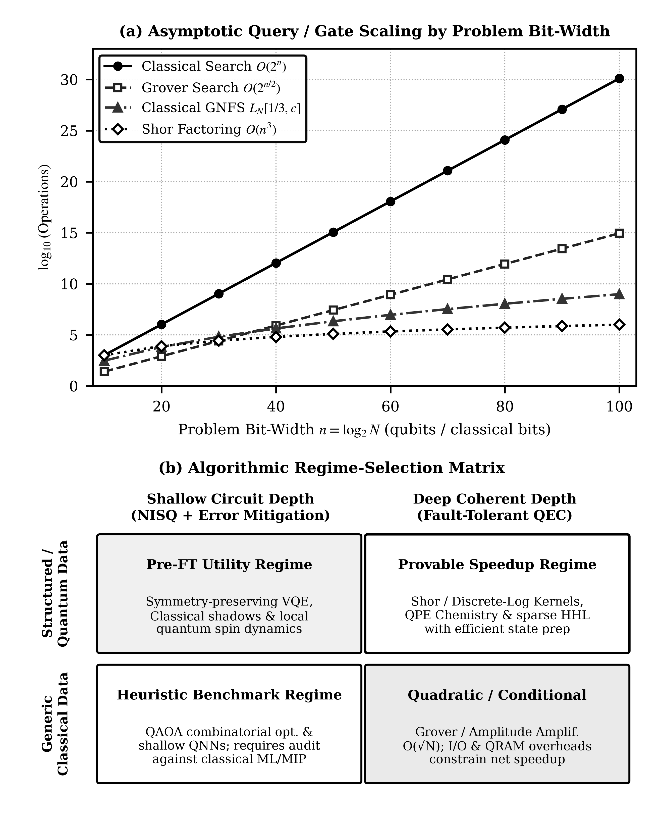
Figure 4. Comparative evaluation of quantum and classical computing regimes: (a) schematic log-scale asymptotic operation scaling across unstructured search, sparse linear systems, and group-theoretic modular arithmetic or discrete-logarithm learning; and (b) two-dimensional regime selection matrix across circuit-depth tolerance and problem structure.
Table 4. Asymptotic time/query complexity comparison between quantum subroutines and best known classical counterparts across canonical computational tasks.
Computational Task | Best Classical Scaling | Quantum Scaling | Critical Caveats & Conditions
Unstructured search (N items, K=1) | O(N) queries | O(√N) queries (Grover, 1996) | Provably optimal; practical win requires fast logical oracle
Integer factoring (n-bit integer N) | exp(O(n^(1/3) (log n)^(2/3))) (GNFS) | O(n^3) gates (Shor, 1997) | Requires fault-tolerant logical qubits and modular arithmetic
Discrete-log kernel classification | Super-polynomial (under DLP hardness) | Polynomial time (Liu et al., 2021) | Classical input vectors; requires fault-tolerant feature circuit
s-sparse linear system Ax = b | O(N s κ log(1/ε)) (Conjugate Gradient) | O~(s^2 κ^2 / ε) state prep (HHL, 2009) | Outputs quantum state |x⟩, not all N entries; QRAM caveat
Low-rank matrix recommendation | O(poly(k, log N)) (Tang, 2019) | O(poly(k) polylog(N)) | Exponential speedup dequantized under l2-norm sampling
M observable shadows (n qubits) | Exponential full state tomography | O(log M) random measurements (Huang et al., 2020) | Applies to bounded shadow-norm local/low-rank observables
6.5 Results from Verified Literature or Reproducible Experiments
Because this chapter conducts a critical synthesis rather than reporting new laboratory runs, empirical evaluation rests strictly on verified peer-reviewed hardware and theoretical studies, summarized in Table 5. Early proof-of-principle experiments validated VQE ground-state estimation on photonic hardware (Peruzzo et al., 2014) and supervised quantum feature-space classification on superconducting qubits (Havlíček et al., 2019). Arute et al. (2019) demonstrated random circuit sampling across 53 transmon qubits in two hundred seconds, spurring both hardware progress and vastly improved classical tensor-network simulators. At pre-fault-tolerant utility scale, Kim et al. (2023) executed 127-qubit kicked-Ising circuits up to 60 two-qubit gate layers using zero-noise extrapolation, while Acharya et al. (2025) demonstrated exponential surface-code logical error suppression below threshold on the Willow superconducting processor. Together, these milestone studies confirm steady progress across hardware generations while reinforcing that careful classical baseline benchmarking remains indispensable before claiming enduring computational advantage.
Table 5. Synthesis of verified experimental and theoretical milestones published in peer-reviewed quantum computing literature.
Study | Platform / Scope | Task Investigated | Verified Published Finding
Peruzzo et al. (2014) | 2-qubit photonic processor | HeH+ molecular ground-state energy via VQE | Demonstrated hybrid variational convergence resilient to systematic gate calibration errors
Havlíček et al. (2019) | 2-qubit superconducting chip | Quantum variational classifier & kernel SVM | Demonstrated experimental supervised classification on custom entangling feature spaces
Arute et al. (2019) | 53-qubit Sycamore transmon | Random quantum circuit sampling (20 cycles) | Sampled 2^53 state space at ~0.2% linear cross-entropy fidelity in 200 s hardware execution
Kim et al. (2023) | 127-qubit Eagle transmon | 2D transverse-field Ising Trotter dynamics | Zero-noise extrapolation recovered accurate expectations up to 60 two-qubit gate layers
Acharya et al. (2025) | 105-qubit Willow transmon | Distance-5 and distance-7 surface-code memory | Below-threshold suppression factor Λ = 2.14 ± 0.02; 0.143% ± 0.003% error per cycle at d = 7
6.6 Scalability, Noise, Hardware Limitations and Practical Barriers
Scaling quantum intelligent computing confronts four concrete physical and algorithmic barriers. First, gate errors, thermal relaxation ($T_{1}$), pure dephasing ($T_{2}$), crosstalk, and readout assignment errors exponentially attenuate unmitigated expectation signals with circuit volume. While quantum error mitigation protocols such as ZNE and PEC accurately remove estimator bias at moderate depths, information-theoretic bounds prove that mitigation sampling variance grows exponentially with circuit error count (Cai et al., 2023). Overcoming this barrier at scale requires fault-tolerant quantum error correction, where encoding one logical qubit into $2d^{2}−1$ physical qubits of a distance-$d$ surface code exponentially suppresses logical error per cycle $ε_{d}$ whenever physical error rate $p$ lies strictly below code threshold $p_{thr}$, with error suppression factor $Λ=ε_{d}/ε_{d+2}>1$ (Acharya et al., 2025):
$ε_{d}∝{\left(\frac{p}{p_{thr}}\right)}^{(d+1)/2}=ε_{0}Λ^{−(d+1)/2}$ (22)
Even under fault tolerance, logical clock speeds remain orders of magnitude slower than gigahertz classical GPUs due to syndrome decoding latency and magic-state factories, meaning quadratic speedups require large problem sizes to overcome constant-factor crossover overheads, whereas super-polynomial speedups offer far more compelling practical crossover thresholds.
7. Discussion and Future Directions
7.1 Interpretation of the Main Findings
Synthesizing across Sections 2 through 6 yields a clear unifying principle: quantum computational advantage in intelligent computing is neither universal nor automatic, but emerges exclusively where quantum circuit structure aligns with intrinsic algebraic, combinatorial, or physical structure in the computational task. Addressing RQ1 and RQ2, exponential Hilbert-space dimension $2^{n}$ provides operational leverage only when paired with hardware-aware compilation, ancilla uncomputation, and bounded shot variance (Barenco et al., 1995; Nielsen & Chuang, 2010). Addressing RQ3 and RQ4, rigorous super-polynomial separations arise for group-structured feature spaces (Shor, 1997; Liu et al., 2021), Hamiltonian simulation, and randomized shadow learning (Huang et al., 2020), whereas unstructured deep ansätze confront either barren plateaus or classical simulability (McClean et al., 2018; Cerezo et al., 2025).
7.2 Implications for Intelligent Computing
For artificial intelligence architects and systems engineers, quantum processing units should be conceptualized not as standalone replacements for classical CPUs and GPUs, but as specialized co-processors invoked selectively on structured kernels, sampling subroutines, and physical simulation modules within heterogeneous workflows (Preskill, 2018; Cerezo et al., 2021). Near-term value concentrates in learning directly from quantum sensors, accelerating molecular and materials property screening, and warm-starting hybrid discrete optimization pipelines where classical neural surrogates initialize compact quantum circuits near high-gradient regions.
7.3 Current Technical and Theoretical Limitations
Four substantive technical and theoretical limitations constrain immediate deployment. First, hardware-realizable QRAM capable of coherent polylogarithmic access to large classical databases remains unavailable at scale, restricting linear-algebraic speedups on raw big data (Biamonte et al., 2017; Tang, 2019). Second, NISQ error mitigation incurs exponential shot overhead as circuit volume grows (Cai et al., 2023). Third, global loss landscapes, hardware noise, and excessive entanglement induce barren plateaus across generic variational models (Larocca et al., 2025). Fourth, although below-threshold surface-code logical memory has now been demonstrated experimentally (Acharya et al., 2025), scaling from isolated logical memories to hundreds of interacting fault-tolerant logical qubits remains a multi-year engineering undertaking.
7.4 Research Opportunities and Future Directions
Four research trajectories offer high scientific leverage over the coming decade: (1) early fault-tolerant algorithmic design that minimizes logical ancilla qubits and T-gate depths through randomized compilation and linear combinations of unitaries; (2) equivariant and physics-informed variational ansätze initialized via classical tensor networks or graph neural surrogates within trainable basins (Caro et al., 2022; Cerezo et al., 2025); (3) high-rate quantum low-density parity-check (qLDPC) codes and modular interconnects reducing physical-to-logical qubit overhead substantially below planar surface-code $2d^{2}−1$ scaling; and (4) reproducible community benchmarks evaluating wall-clock runtime, total shot budget, and energy consumption against tuned classical GPU baselines.
8. Conclusion
8.1 Summary of Major Insights
This chapter established an integrated mathematical and architectural synthesis of quantum circuits and quantum algorithms for intelligent computing across NISQ and fault-tolerant hardware regimes. Starting from Hilbert-space ket and density-operator representations, universal Clifford+$T$ and continuous rotation gates, CPTP noise channels, and finite-shot readout variance, this chapter traced how circuit-level mechanics directly govern VQE, QAOA, Grover amplitude amplification, HHL linear solvers, and quantum kernel classifiers.
8.2 Theoretical and Practical Implications
Theoretically, this synthesis demonstrates that expressibility, gradient trainability, generalization capacity, data-loading depth, and classical simulability form a coupled system of constraints that cannot be optimized one metric at a time. Practically, the six-stage design workflow, six-dimensional evaluation framework, and regime-selection matrix provide researchers and practitioners with concrete engineering criteria for matching problem structure to classical, error-mitigated NISQ, or fault-tolerant quantum architectures.
8.3 Limitations of the Chapter
Three scope boundaries merit explicit acknowledgment. First, this chapter is a structured conceptual and mathematical synthesis of peer-reviewed literature and reports no original quantum hardware runs or simulated empirical datasets. Second, continuous-variable optical models, analog quantum annealers, measurement-based cluster states, and topological computation fall outside primary focus. Third, physical coherence times, two-qubit gate fidelities, and real-time syndrome decoding latencies continue to advance rapidly across experimental hardware platforms.
8.4 Future Research Directions
Realizing durable, verifiable quantum utility across artificial intelligence and machine learning will require co-designing structure-aware quantum circuits, low-overhead fault-tolerant error correction, classical shadow interfaces, and transparent empirical benchmarks grounded in rigorous complexity theory. Sustained collaboration across quantum physics, computer architecture, and statistical learning will translate asymptotic theory into reliable intelligent systems.
Declarations and Editorial Disclosures
Funding: [Placeholder — Specify external grant agencies and award numbers supporting this chapter, or state: 'This research received no external funding.']
Conflict of Interest: [Placeholder — Declare any financial or non-financial competing interests of the authors, or state: 'The authors declare no conflict of interest relevant to this chapter.']
Research Ethics and Informed Consent: This chapter consists exclusively of mathematical analysis, conceptual synthesis, and critical evaluation of published peer-reviewed literature; no human participants, clinical data, or animal subjects were involved.
Third-Party Permissions: All four figures (Figures 1–4) and all five tables (Tables 1–5) in this chapter are original author-created works prepared specifically for this manuscript; no previously published or copyrighted graphics or tables requiring third-party reproduction permissions are included.
Biographical Sketch (Author Placeholder — Per Nova Chapter Guidelines)
Name: [First Name Middle Initial Last Name]
Affiliation: [Department, University / Research Institute, City, State (if applicable), Country]
Education: [Year–Year: Degree and Field, Institution, Country]
Business Address: [Institutional Mailing Address — for Nova Biographical Sketch record only]
Research and Professional Experience: [Concise summary of academic and research appointments]
Professional Appointments: [Current academic rank, laboratory leadership, editorial service]
Honors: [Fellowships, awards, academic distinctions]
Publications from the Last 3 Years: [List selected peer-reviewed publications in APA style]
References
Acharya, R., Abanin, D. A., Aghababaie-Beni, L., Aleiner, I., Andersen, T. I., Ansmann, M., Arute, F., Arya, K., Asfaw, A., Astrakhantsev, N., Atalaya, J., Babbush, R., Bacon, D., Ballard, B., Bardin, J. C., Bausch, J., Bengtsson, A., Bilmes, A., Blackwell, S., ... Zobrist, N. (2025). Quantum error correction below the surface code threshold. Nature, 638(8052), 920–926. https://doi.org/10.1038/s41586-024-08449-y
Arute, F., Arya, K., Babbush, R., Bacon, D., Bardin, J. C., Barends, R., Biswas, R., Boixo, S., Brandao, F. G. S. L., Buell, D. A., Burkett, B., Chen, Y., Chen, Z., Chiaro, B., Collins, R., Courtney, W., Dunsworth, A., Farhi, E., Foxen, B., ... Martinis, J. M. (2019). Quantum supremacy using a programmable superconducting processor. Nature, 574(7779), 505–510. https://doi.org/10.1038/s41586-019-1666-5
Barenco, A., Bennett, C. H., Cleve, R., DiVincenzo, D. P., Margolus, N., Shor, P., Sleator, T., Smolin, J. A., & Weinfurter, H. (1995). Elementary gates for quantum computation. Physical Review A, 52(5), 3457–3467. https://doi.org/10.1103/PhysRevA.52.3457
Biamonte, J., Wittek, P., Pancotti, N., Rebentrost, P., Wiebe, N., & Lloyd, S. (2017). Quantum machine learning. Nature, 549(7671), 195–202. https://doi.org/10.1038/nature23474
Brassard, G., Høyer, P., Mosca, M., & Tapp, A. (2002). Quantum amplitude amplification and estimation. In S. J. Lomonaco Jr. & H. E. Brandt (Eds.), Quantum computation and quantum information: A millennium volume (Vol. 305, pp. 53–74). American Mathematical Society. https://doi.org/10.1090/conm/305/05215
Cai, Z., Babbush, R., Benjamin, S. C., Endo, S., Huggins, W. J., Li, Y., McClean, J. R., & O'Brien, T. E. (2023). Quantum error mitigation. Reviews of Modern Physics, 95(4), 045005. https://doi.org/10.1103/RevModPhys.95.045005
Caro, M. C., Huang, H.-Y., Cerezo, M., Sharma, K., Sornborger, A., Cincio, L., & Coles, P. J. (2022). Generalization in quantum machine learning from few training data. Nature Communications, 13(1), 4919. https://doi.org/10.1038/s41467-022-32550-3
Cerezo, M., Arrasmith, A., Babbush, R., Benjamin, S. C., Endo, S., Fujii, K., McClean, J. R., Mitarai, K., Yuan, X., Cincio, L., & Coles, P. J. (2021). Variational quantum algorithms. Nature Reviews Physics, 3(9), 625–644. https://doi.org/10.1038/s42254-021-00348-9
Cerezo, M., Larocca, M., García-Martín, D., Diaz, N. L., Braccia, P., Fontana, E., Rudolph, M. S., Bermejo, P., Ijaz, A., Thanasilp, S., Anschuetz, E. R., & Holmes, Z. (2025). Does provable absence of barren plateaus imply classical simulability? Nature Communications, 16(1), 7907. https://doi.org/10.1038/s41467-025-63099-6
Deutsch, D. (1985). Quantum theory, the Church–Turing principle and the universal quantum computer. Proceedings of the Royal Society of London. Series A, Mathematical and Physical Sciences, 400(1818), 97–117. https://doi.org/10.1098/rspa.1985.0070
Farhi, E., Goldstone, J., & Gutmann, S. (2014). A quantum approximate optimization algorithm. arXiv preprint arXiv:1411.4028. https://doi.org/10.48550/arXiv.1411.4028
Feynman, R. P. (1982). Simulating physics with computers. International Journal of Theoretical Physics, 21(6–7), 467–488. https://doi.org/10.1007/BF02650179
Grover, L. K. (1996). A fast quantum mechanical algorithm for database search. In Proceedings of the Twenty-Eighth Annual ACM Symposium on Theory of Computing (pp. 212–219). Association for Computing Machinery. https://doi.org/10.1145/237814.237866
Harrow, A. W., Hassidim, A., & Lloyd, S. (2009). Quantum algorithm for linear systems of equations. Physical Review Letters, 103(15), 150502. https://doi.org/10.1103/PhysRevLett.103.150502
Havlíček, V., Córcoles, A. D., Temme, K., Harrow, A. W., Kandala, A., Chow, J. M., & Gambetta, J. M. (2019). Supervised learning with quantum-enhanced feature spaces. Nature, 567(7747), 209–212. https://doi.org/10.1038/s41586-019-0980-2
Huang, H.-Y., Broughton, M., Mohseni, M., Babbush, R., Boixo, S., Neven, H., & McClean, J. R. (2021). Power of data in quantum machine learning. Nature Communications, 12(1), 2631. https://doi.org/10.1038/s41467-021-22539-9
Huang, H.-Y., Kueng, R., & Preskill, J. (2020). Predicting many properties of a quantum system from very few measurements. Nature Physics, 16(10), 1050–1057. https://doi.org/10.1038/s41567-020-0932-7
Kim, Y., Eddins, A., Anand, S., Wei, K. X., van den Berg, E., Rosenblatt, S., Nayfeh, H., Wu, Y., Zaletel, M., Temme, K., & Kandala, A. (2023). Evidence for the utility of quantum computing before fault tolerance. Nature, 618(7965), 500–505. https://doi.org/10.1038/s41586-023-06096-3
Larocca, M., Thanasilp, S., Wang, S., Sharma, K., Biamonte, J., Coles, P. J., Cincio, L., McClean, J. R., Holmes, Z., & Cerezo, M. (2025). Barren plateaus in variational quantum computing. Nature Reviews Physics, 7(4), 174–189. https://doi.org/10.1038/s42254-025-00813-9
Liu, Y., Arunachalam, S., & Temme, K. (2021). A rigorous and robust quantum speed-up in supervised machine learning. Nature Physics, 17(9), 1013–1017. https://doi.org/10.1038/s41567-021-01287-z
McClean, J. R., Boixo, S., Smelyanskiy, V. N., Babbush, R., & Neven, H. (2018). Barren plateaus in quantum neural network training landscapes. Nature Communications, 9(1), 4812. https://doi.org/10.1038/s41467-018-07090-4
Mitarai, K., Negoro, M., Kitagawa, M., & Fujii, K. (2018). Quantum circuit learning. Physical Review A, 98(3), 032309. https://doi.org/10.1103/PhysRevA.98.032309
Montanaro, A. (2016). Quantum algorithms: An overview. npj Quantum Information, 2(1), 15023. https://doi.org/10.1038/npjqi.2015.23
Nielsen, M. A., & Chuang, I. L. (2010). Quantum computation and quantum information: 10th anniversary edition. Cambridge University Press. https://doi.org/10.1017/CBO9780511976667
Peruzzo, A., McClean, J., Shadbolt, P., Yung, M.-H., Zhou, X.-Q., Love, P. J., Aspuru-Guzik, A., & O'Brien, J. L. (2014). A variational eigenvalue solver on a photonic quantum processor. Nature Communications, 5(1), 4213. https://doi.org/10.1038/ncomms5213
Preskill, J. (2018). Quantum computing in the NISQ era and beyond. Quantum, 2, 79. https://doi.org/10.22331/q-2018-08-06-79
Shor, P. W. (1997). Polynomial-time algorithms for prime factorization and discrete logarithms on a quantum computer. SIAM Journal on Computing, 26(5), 1484–1509. https://doi.org/10.1137/S0097539795293172
Tang, E. (2019). A quantum-inspired classical algorithm for recommendation systems. In Proceedings of the 51st Annual ACM SIGACT Symposium on Theory of Computing (pp. 217–228). Association for Computing Machinery. https://doi.org/10.1145/3313276.3316310
Tilly, J., Chen, H., Cao, S., Picozzi, D., Setia, K., Li, Y., Grant, E., Wossnig, L., Rungger, I., Booth, G. H., & Tennyson, J. (2022). The Variational Quantum Eigensolver: A review of methods and best practices. Physics Reports, 986, 1–128. https://doi.org/10.1016/j.physrep.2022.08.003

