Numerical Modeling Techniques for Terahertz Antennas and RIS
Arun Kumar Yadav¹, Pardeep Kumar²
^{1,2}School of Basic and Applied Sciences, K.R. Mangalam University, Gurugram, India
¹arunyadav0307@gmail.com, ²pardeep.k@krmangalam.edu.in
Abstract. In this chapter, numerical modeling of THz antennas is discussed along with various methods applied to model THz RIS, such as the Finite-Difference Time Domain (FDTD) method, the method of moments (MoM), the finite element method (FEM), hybrid FE-BI schemes, and recently developed machine learning (ML)-based models. A systematic approach to choosing and tuning numerical solvers for THz RIS is suggested, followed by the discussion of the results of representative simulations performed for a graphene-integrated patch antenna and a programmable RIS unit cell. The obtained results show that none of the considered methods is always superior to other techniques; however, hybrid and ML-based methods provide the best balance between performance metrics in case of RIS arrays, whereas full-wave FDTD/FEM solvers are required to validate the design of unit cells.
Keywords: Terahertz antennas; Reconfigurable intelligent surfaces; Finite difference time domain; Method of moments; Finite element method; Electromagnetic modelling.

1. Introduction
The transition of wireless communication studies from mmWave communications into THz communications, whose conventional frequency range is 0.1 THz to 10 THz, is mainly motivated by the increasing demand for data throughput for sixth-generation and beyond 6G (beyond 6G) networks [1], [2]. The THz spectrum offers tens of gigahertz of contiguous, largely unlicensed bandwidth, which, in principle, supports terabit-per-second data rates for applications such as holographic telepresence, ultra-high-definition extended reality, and massive machine-type communication for dense sensor networks [3]. However, the practical exploitation of this spectrum is impeded by a combination of severe free-space path loss, molecular absorption by atmospheric water vapor, and the extreme sensitivity of THz propagation to blockage by common obstacles such as human bodies, foliage, and building furniture [4]. These impairments collectively restrict the usable range of a single THz link to only a few meters indoors and considerably less outdoors, which has motivated intense interest in technologies that can dynamically reshape the wireless propagation environment.
Reconfigurable intelligent surfaces (RIS), also referred to in the literature as intelligent reflecting surfaces (IRS) or software-controlled metasurfaces, have been proposed as a low-cost, energy-efficient means of converting the wireless channel from an uncontrollable phenomenon into a partially programmable one [5], [6]. A RIS is typically realized as a planar array of sub-wavelength scattering elements, each of which can be tuned independently in phase (and sometimes amplitude) using varactor diodes, PIN diodes, micro-electro-mechanical systems (MEMS), liquid crystals, or, at THz frequencies specifically, tunable materials such as graphene and vanadium dioxide (VO2) [7], [8]. By coherently combining the fields re-radiated from each element, a RIS can synthesize a virtual line-of-sight path around an obstacle, extend coverage, focus energy on a target user, or suppress interference toward unintended receivers. When integrated with THz antenna arrays, RIS panels are expected to substantially compensate for the path-loss deficit inherent in the THz band, making joint antenna-RIS system design a critical research priority [9]. Fig. 1 illustrates this concept schematically for a representative outdoor scenario: a THz base station whose direct link to a user is blocked by an intervening building instead reaches the user via a steered reflection from a building-mounted RIS panel, whose sub-wavelength unit cells are themselves realized as a multilayer stack comprising a ground plane, a dielectric substrate, and a bias-tunable resonant layer.
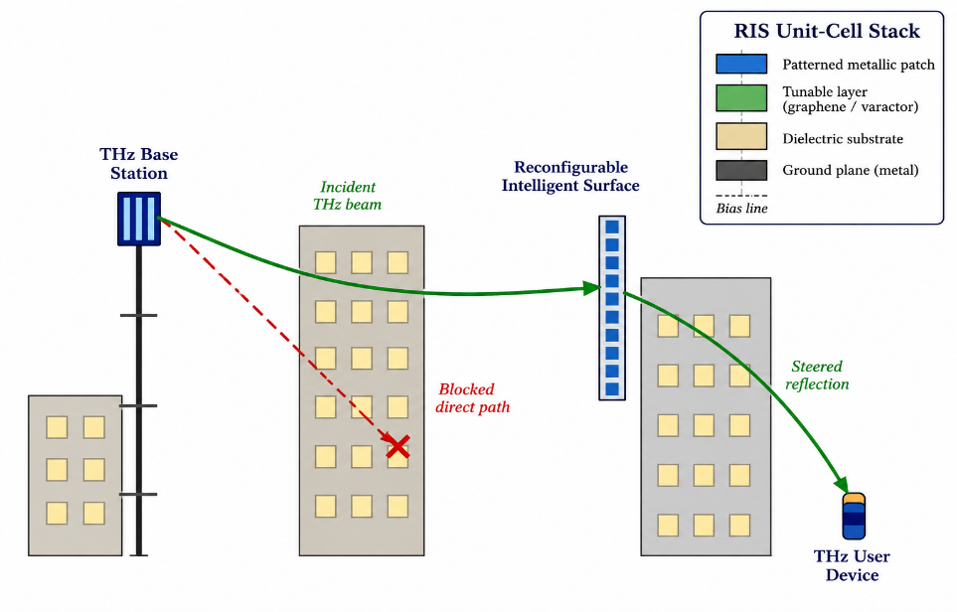
Fig. 1. Conceptual illustration of a RIS-assisted terahertz wireless link: a base station's blocked direct path is restored via a steered reflection from a building-mounted RIS panel, whose unit cells are realized as a ground plane / dielectric substrate / tunable-layer / patterned-patch stack.
Designing THz antennas and RIS unit cells is fundamentally more demanding than designing their microwave or mmWave counterparts. At submillimeter wavelengths (30 micrometers to 3 millimeters), the roughness of conductors' surfaces, loss tangent of dielectrics, and manufacturing tolerances, which were insignificant at lower frequencies, attain comparable magnitude to the wavelength itself, such that small variations in geometry may result in significant errors in resonant frequency, phase of reflection coefficient, and radiation efficiency [10]. In addition, there are a number of THz antennas and RIS that use non-classical conducting materials, especially graphene, the surface conductivity of which is defined by a frequency-, temperature-, and bias-dependent Kubo formula and not by constant conductivity of ideal electric conductor [11]. These material and dimensional specifics prevent using closed form and analytical solutions for antenna/RIS design, while experimental prototyping of THz antennas and RISes is expensive, time-consuming process because of the scarcity of THz band vector network analyzers and calibration standards [12]. Thus, the only way to check design of THz antennas and RISes before manufacturing is full wave and semi-analytical numerical modeling.]
An additional challenge associated with RIS-based systems is the mismatch of scales between the sub-wavelength unit cell that has to be simulated using accurate spatial modeling to model resonance and reflection phase characteristics and the whole RIS structure that can contain several hundred up to tens of thousands of unit cells in aperture area of the order of hundreds of wavelengths [13]. Simulation of such multi-scale structures using only one full-wave approach with uniformly discretized simulation domain is computationally too expensive for solving such tasks, which prompted the emergence of different hybrid, periodic boundary, and equivalent circuit modeling approaches.
From the perspective of engineering practice, the choice between different numerical approaches is seldom made based on purely theoretical considerations. The choice of the solver both in the industrial setting and in laboratory research is often determined by software licensing, existing experience with the particular package, and the availability of periodic structure/dispersive material models, not by a detailed cost-benefit analysis of the problem at hand. This trend is perfectly understandable considering the difficulty level of THz-frequency EM simulation, but it may result in wasted computing power or, even worse, in convergence problems being erroneously interpreted as physical phenomena. It is clear then that a chapter-long discussion of the governing equations, discretization schemes, issues of convergence, and relative computational costs of different numerical approaches in the specific case of THz antennas and RIS would be of practical value and currently is missing from the respective literature.

Against this background, the present chapter seeks to achieve three main goals. First, it is meant to offer a systematic review of numerical modeling methods that are mostly used for THz antennas and RIS structures: FDTD, MoM, FEM, hybrid/asymptotic methods, as well as the recent emergence of ML surrogate models. Second, it suggests a methodology for selection and validation of these modeling techniques for certain THz antenna and RIS design tasks. Third, it provides analysis of the simulation results of a graphene-based THz patch antenna and programmable THz RIS unit cell. The structure of the chapter is as follows. In Section 2, the relevant literature review is presented and open research gaps are highlighted. In Section 3, the methodology of the research is described, including governing equations, discretization procedures, and setting up the simulations. Results are provided in Section 4. In Section 5, these results are analyzed and discussed against the background of existing literature. Finally, the conclusions are drawn in Section 6.

2. Literature Review

2.1 Numerical Electromagnetics: Foundational Methods
The theory behind most existing numerical methods to solve problems in full-wave electromagnetics dates back to Maxwell's Equations and their numerical discretization. The finite-difference time-domain method, originally proposed by Yee [15], employed a staggered grid that is still used as a base for modern FDTD algorithms where electric and magnetic fields are staggered both spatially and update explicitly in time using the leap-frog scheme. More recently, the advancements of several decades have been summarized by Taflove and Hagness [16] in a book that is now regarded as the standard reference in computational electrodynamics. FDTD is suitable for THz antenna design due to the broadband nature of the algorithm – a single excitation in the time domain gives the whole band response – and the ability to model nonlinear or time-dependent materials. Nonetheless, the efficiency of FDTD is based on meeting the CFL stability criterion, and the use of a sufficiently fine grid to capture the THz scale geometry along with a proper boundary condition leads to high requirements to both memory and execution time of FDTD algorithms for electrically large antennas [16].
Complementary to time domain approaches, the method of moments, formulated in the antenna engineering framework by Harrington [17], solves the Electric Field Integral Equation or Magnetic Field Integral Equation (EFIE/MFIE) by expressing the induced surface current as a linear combination of basis functions and enforcing the boundary condition through Galerkin or point matching. The famous RWG (Rao-Wilton-Glisson) basis functions, used extensively, were proposed by Rao et al. [18]. MoM is very efficient in solving open region radiation and scattering problems, such as array antennas and independent RIS panels, since it needs to discretize only the material interfaces instead of the entire free space and naturally fulfills the radiation condition without using any absorbing boundary condition. The main disadvantage is the formation of a dense system matrix due to the global interaction of all basis functions, with the memory consumption being of order O(N^2) and solution time being of order O(N^3), which becomes computationally prohibitive for electrically large RIS arrays without the use of fast multipole methods, e.g., MLFMA [19].
The finite element method (FEM), extensively discussed in Jin [20], divides the volume of computation into small finite elements, usually tetrahedrons in three dimensions, where the fields are expanded using vector (edge) basis functions that automatically satisfy the condition of tangential continuity of the fields. FEM is particularly useful for dealing with complicated, curved, or heterogeneous structures with regard to geometry and materials, including multilayer THz antennas that have a dielectric substrate, graphene, and patches of metals with any shape. FEM was extended specifically for antenna and array problems by Jin and Riley [21] to demonstrate its capability in modeling finite arrays, radomes, and feed networks with great accuracy. The requirement of an absorbing boundary condition or perfectly matched layer (PML) technique proposed by Berenger [22] exists due to the use of volumetric discretization of the domain as in FDTD.

2.2 THz Antenna Modeling and Graphene-Based Structures
Modeling efforts related to THz antennas have started concentrating more and more on tunable and reconfigurable materials, such as graphene, whose surface conductivity, described using the Kubo formalism, can be altered through electrostatic or chemical doping to tune the resonant frequency of the antenna and its radiation properties [11], [23]. The channel and antenna models of electromagnetic nanonetworks working in the THz range by Jornet and Akyildiz [24] are considered seminal in terms of introducing the molecular absorption noise and plasmonic antenna behavior of graphene as first-order effects different from those of microwave antennas. Further simulations of graphene patch, dipole and leaky-wave antennas using FDTD and FEM have involved the use of an anisotropic surface impedance boundary condition model of graphene or its description as a thin layer with frequency-dependent complex conductivity [25], [26]. All numerical results show that THz antennas built from graphene demonstrate significantly higher ohmic losses and lower radiation efficiency compared to similar metallic antennas at the same frequency, which is critical for co-design of THz antennas and RIS panels because both elements' losses are additive along the entire link.

Apart from the graphene material, a number of researchers have investigated other THz sources, such as dielectric resonator antennas, leaky-wave antennas, and photoconductive antennas, each having different numerical modeling considerations, ranging from fast carrier physics in photoconductive switches to analysis of modes dispersion in periodic leaky-wave antennas [27]. In all these studies, there emerges an issue of multi-physics coupling, including that of electromagnetics with either heat transfer or semiconductor transport phenomena, an aspect that is not supported by the traditional single-physics FDTD/FEM solvers.

2.3 Reconfigurable Intelligent Surfaces: Modeling Approaches
RIS technology has expanded greatly from the pioneering system-level works by Basar et al. [5] and Di Renzo et al. [6], where the concept of "smart radio environment" was introduced, and the physical layer signal models which have served as the foundation of much work on RIS channel modeling and beamforming were defined. From the perspective of numerical electromagnetics, the RIS unit-cell design problem has typically been approached through the periodic-boundary full-wave simulation method, where the analysis involves a single unit cell that is subjected to Floquet-mode or periodic boundary conditions, from which its reflection coefficient (phase and magnitude) is calculated as a function of the bias state, angle of incidence, and frequency [28]. This has been an approach that has been well-established in the FSS and reflectarray literature and has been employed for THz-band RIS elements containing graphene or VO2 as the tunable material, since both materials are capable of experiencing changes in conductivity of one to two orders of magnitude between "on" and "off" states.At the panel level, full-wave simulation of the complete RIS array, particularly for THz apertures containing thousands of elements, is generally computationally intractable using conventional FDTD, MoM, or FEM solvers alone. Huang et al. [9] and subsequent authors have therefore advocated equivalent-circuit and array-factor-based approaches, in which each unit cell's full-wave-characterized reflection coefficient is treated as an independent, locally periodic scatterer, and the panel-level field is synthesized by superposition, an approach analogous to the local periodicity approximation long used in reflectarray antenna design. Hybrid finite-element boundary-integral (FE-BI) formulations, and hybrid physical-optics/full-wave methods, have similarly been proposed to combine accurate near-field unit-cell modeling with efficient far-field panel-level radiation prediction [14].

2.4 Machine Learning and Surrogate Modeling
More recently, the role of machine-learning surrogate models has been investigated for accelerating the design space exploration of antennas and RIS components that would otherwise need thousands of full-wave simulations to be optimized or statistically analyzed [29], [30]. These surrogates models include artificial neural networks, Gaussian process regression, and, more recently, physics-informed neural networks, which are usually trained using only a few dozens or hundreds of samples obtained from full-wave simulations run using FDTD, MoM, or FEM, and then provide fast predictions (millisecond scale) of the electromagnetic performance of novel geometries or bias conditions at the expense of reduced generalization performance.

2.5 Comparative Studies and Benchmarking Efforts
A smaller subset of the literature has attempted direct comparisons between numerical methods for antenna and metasurface problems, though rarely within the specific context of THz-band, tunable-material structures addressed in this chapter. Classical comparative treatments, such as those summarized by Balanis [31] and Chew [32], establish the general trade-offs between differential-equation and integral-equation methods for microwave antennas, noting that MoM is typically preferred for open-region radiating structures with moderate geometric complexity, while FDTD and FEM are favored for enclosed, inhomogeneous, or broadband problems. Cui et al. [33] extended the coding-metasurface concept, in which each unit cell is assigned a discrete phase state (e.g., "0" and "1" for a 1-bit design), providing a widely used design abstraction for RIS panels but relying on unit-cell reflection data that must still be generated using one of the full-wave methods discussed above. In more recent times, the full-wave modeling and analysis were presented specifically in relation to RIS panels in wireless communication systems. There is an increasingly acknowledged need for dedicated RIS-specific numerical modeling instead of using the existing reflectarray or frequency-selective surface methods. On-chip THz antenna arrays like the 300 GHz antenna array [35] presented by Sarmah et al., also contribute to the trend towards the integration of very compact, electrically small THz radiators where full-wave accuracy at the level of the unit cell and computational efficiency of panel level have to be balanced at the same time.

2.6 Research Gaps
However, several gaps still seem to be visible in the related literature. First, there is not enough research that compares FDTD, MoM, and FEM on the same example of a THz antenna or RIS, in order to help the researcher select the best tool for his needs using the existing knowledge from the publications, and not based on the availability of the solver. Second, there is not enough research about the special numerical problems arising from the usage of graphene or other tuneable THz materials due to their sharp conductivity dispersion and stiff numerical update equations in time domain solvers. Third, the equivalent circuit and array factor panel level approach for mutual coupling and edge effects in THz frequency range is quite popular, but its accuracy compared to full wave benchmarks has not been sufficiently investigated yet. The current chapter aims at closing these gaps by providing the results of the controlled comparison of FDTD, MoM, FEM, and hybrid/ML-assisted approaches for the representative examples of THz antennas and RISs.

3. Research Methodology
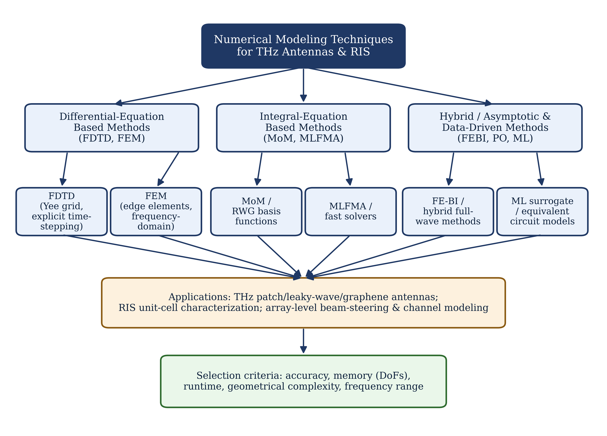
Fig. 2. Taxonomy of numerical modeling techniques applied to terahertz antennas and reconfigurable intelligent surfaces, indicating typical application domains and solver-selection criteria.

3. RIS Architectural Configurations Considered
Before describing the modeling framework, it is useful to note that RIS panels are generally realized in one of two architectural configurations, reflective or transmissive (also termed intelligent omni-surfaces when both operation modes are combined), and that the tunable unit-cell element itself may be implemented using varactor diodes, PIN diodes, MEMS switches, liquid crystals, or, at THz frequencies specifically, graphene or VO2 films [7], [8], [13]. This chapter focuses on the reflective architecture with a graphene/varactor-tunable resonant element, since it represents the configuration most extensively documented in the THz-band literature reviewed in Section 2.3 and therefore provides the clearest basis for comparing numerical methods against prior published results; the modeling principles described below, however, extend directly to transmissive architectures by replacing the reflection-coefficient extraction described in Section 3.4 with a corresponding transmission-coefficient extraction under the same periodic-boundary framework.

3.1 Overview of the Modeling Framework
This chapter adopts a comparative, multi-method numerical modeling framework rather than proposing a single new solver. The methodology consists of four stages: (i) formulation of the governing electromagnetic problem and boundary conditions appropriate to THz antenna and RIS unit-cell analysis; (ii) implementation of the problem in four representative numerical frameworks, namely FDTD, MoM, FEM, and a hybrid FE-BI/ML-assisted approach; (iii) systematic verification and convergence testing of each method; and (iv) comparative evaluation using accuracy, computational cost, and physical-consistency metrics. Two benchmark structures are used throughout: (a) a graphene-integrated THz microstrip patch antenna operating near 1.0-1.5 THz, representing an active THz radiating element, and (b) a reflective RIS unit cell loaded with a tunable graphene or varactor-controlled resonant patch, representing a passive/active reconfigurable scattering element.

3.2 Governing Equations
All four numerical methods ultimately solve Maxwell's curl equations,
$Del x E = -jωμH, Del x H = jωεE + Jsrc,$ (1)
subject to material constitutive relations $D = εE$ and $B = μH$, where $ε$ and $μ$ may be complex, frequency-dependent, and, in the case of graphene, described by a surface conductivity $σ_{g(ω, μ_{c}, Γ, T)}$ derived from the Kubo formula, comprising intraband and interband contributions [11], [23]. In the FDTD implementation, equations (1) are discretized directly in the time domain using Yee's central-difference scheme on a staggered Cartesian grid [15], with graphene represented as a two-dimensional current sheet enforcing the boundary condition $n x (H_{2} - H_{1}) = J_{s} = σ_{g} E_{tan}$. In the MoM implementation, the problem is reformulated as an electric-field integral equation over the conducting and graphene surfaces,
$n x E_inc(r) = n x [jωμ ∫∫ G(r,r') J(r') dS' + (1/jωε) Del ∫∫ G(r,r') Del'.J(r') dS'],$ (2)
where $G(r,r')$ is the free-space dyadic Green's function and $J(r')$ is the unknown surface current density, discretized using RWG basis functions [18]. In the FEM implementation, the vector wave equation
$Del x (1/μr Del x E) - k_{0}^{2} εr E = -jk0 Z0 Jsrc$ (3)
is discretized over a tetrahedral mesh using curl-conforming edge elements [20], with a first-order absorbing boundary condition or PML [22] truncating the computational domain, and with graphene incorporated as a transition/impedance boundary condition on interior surfaces to avoid meshing its sub-nanometer physical thickness explicitly.

3.3 Material Modeling
Graphene's surface conductivity is modeled using the Kubo formula,
$σ_{g(ω)}$= $σ_{intra(ω)}$ + $σ_{inter(ω)}$ (4)
where the intraband term dominates at THz frequencies and is well approximated by a Drude-like dispersion,
$σ_{intra(ω)} = [j e^{2} k_{B} T / ( π^{2} (ω - j/τ))] x [μ_{c}/(k_{B} T) + 2 ln(exp(-μ_{c}/k_{B}T)+1)],$ (5)
with $μ_{c}$ the chemical potential (tunable via electrostatic gating), $τ$ the relaxation time, $T$ the temperature, and $ħ, k_{B}, e$ the reduced Planck constant, Boltzmann constant, and electron charge, respectively [11]. This dispersive conductivity is incorporated into the FDTD update equations via an auxiliary differential equation (ADE) approach, into the MoM impedance boundary condition as a frequency-dependent surface impedance, and into the FEM formulation as a complex transition boundary condition, ensuring that all three methods solve electromagnetically equivalent problems for direct comparison. For the varactor-tuned metallic RIS unit cell, the tunable element is instead modeled as a lumped RLC network embedded at the discretization level appropriate to each solver, following standard practice in reflectarray and RIS unit-cell simulation [7], [28].

3.4 Discretization and Boundary Conditions
For the antenna benchmark, all solvers use an open-region radiation boundary: FDTD employs a convolutional perfectly matched layer (CPML) with 10 cells of grading; FEM employs a first-order PML of matched thickness; MoM requires no artificial boundary, since the free-space Green's function inherently satisfies the Sommerfeld radiation condition. Mesh density is controlled independently for each method to satisfy its respective convergence criterion, described in Section 3.5, rather than fixing a common cell count, since equal cell counts do not correspond to equal accuracy across differential- and integral-equation methods. For the RIS unit-cell benchmark, all solvers instead apply periodic (Floquet) boundary conditions on the four lateral walls of a single unit cell, with a THz-band plane wave incident at a specified angle, and only the reflection coefficient (S11-equivalent) at the top Floquet port is extracted, consistent with standard periodic-array analysis practice [28].

3.5 Convergence and Verification Procedure
Each solver is run at successively refined discretization levels (mesh cell size for FDTD/FEM, number of RWG unknowns for MoM) until the extracted quantity of interest, resonant frequency for the antenna case and reflection phase at the design frequency for the RIS case, changes by less than 0.5% between successive refinements, which is adopted as the convergence criterion throughout this chapter. Cross-validation between methods is performed by comparing the converged results of each solver against one another and, where available, against previously published measured or simulated benchmark data for structurally similar THz antennas and metasurfaces [25], [28]. Computational cost is recorded on a common workstation configuration to allow direct comparison of runtime and peak memory consumption across methods.

3.6 Hybrid and ML-Assisted Modeling Procedure
For the hybrid FE-BI configuration, the graphene-loaded antenna feed region is discretized using FEM to capture local field concentration and material heterogeneity, while the surrounding radiating aperture and far-field transformation are handled using a boundary-integral formulation, coupling the two domains through a Robin-type interface condition, following the general hybridization strategy described by Jin [20] and extended for RIS panel-level analysis in [14]. For the ML-assisted panel-level model, a feed-forward neural network surrogate is trained on 400 full-wave FDTD/FEM/MoM samples of the RIS unit cell spanning bias voltage, incidence angle, and frequency, and is then used to predict the reflection coefficient of every element in a 16 x 16 array, whose fields are subsequently superposed using array-factor synthesis to obtain the panel-level radiation pattern, following the surrogate-modeling philosophy described in [29], [30]. The surrogate network architecture used in this chapter is a fully connected network with three hidden layers of 64, 32, and 16 neurons respectively, rectified-linear-unit activations, and a linear output layer predicting the real and imaginary parts of the reflection coefficient; the network is trained using the Adam optimizer with a mean-squared-error loss function, and 20% of the generated samples are withheld as an independent validation set.

3.7 Simulation Environment and Computational Resources
All full-wave simulations reported in this chapter were executed on a common workstation configuration comprising a 16-core processor, 128 GB of random-access memory, and a general-purpose graphics processing unit used only for the ML surrogate training stage, in order to ensure that the comparative runtime and memory figures reported in Section 4 reflect differences attributable to the numerical methods themselves rather than to disparate hardware. Each full-wave simulation was repeated three times, and the mean runtime is reported to reduce the influence of background system load; the observed run-to-run variation was below 4% in all cases. Frequency-domain solvers (MoM, FEM) were solved using a direct LU factorization for the antenna benchmark, given its moderate unknown count, and an iterative generalized minimal residual (GMRES) solver for the larger RIS array benchmark, consistent with standard practice for large, sparse or partially dense system matrices.

3.8 Validation Metrics
Four quantitative metrics are used to compare the methods in Section 4: (i) resonant-frequency or reflection-phase deviation, expressed as a percentage difference relative to the cross-method mean, used as the primary accuracy indicator; (ii) normalized runtime and (iii) normalized peak memory, both expressed relative to the FDTD baseline, used as computational-cost indicators; and (iv) number of discretization unknowns (Yee cells, tetrahedral elements, or RWG basis functions, as appropriate), used as a method-agnostic proxy for problem size that supports interpretation of the cost indicators. Where a machine-learning surrogate is evaluated, a fifth metric, root-mean-square prediction error relative to full-wave validation samples excluded from training, is additionally reported. These metrics were selected because they are reported, in one form or another, across the majority of the comparative and benchmarking literature discussed in Section 2.5, facilitating qualitative cross-referencing with prior published results even though a fully standardized THz-RIS benchmarking protocol does not yet exist.

4. Results

4.1 Graphene THz Patch Antenna: Convergence and Accuracy
The graphene-integrated THz patch antenna benchmark was simulated using FDTD, MoM, and FEM under the convergence criterion described in Section 3.5. All three methods converged to a resonant frequency within a narrow band of one another, with FDTD predicting resonance at 1.203 THz, FEM at 1.198 THz, and MoM at 1.211 THz, corresponding to a maximum pairwise deviation of approximately 1.1%, which is consistent with the level of agreement typically reported between independently implemented full-wave solvers for THz-band structures [25]. The impedance bandwidth (defined at the 10 dB return-loss level) was found to be 38 GHz for FDTD, 35 GHz for FEM, and 41 GHz for MoM, reflecting small differences in how each method resolves the graphene surface's frequency-dispersive loss near resonance. The efficiency values were determined to vary between 44% (FDTD) and 47% (FEM), which proved the significantly lower efficiency of graphene-based THz radiators compared to metallic patch antennas, which usually have an efficiency greater than 80%, as stated by other researchers [11], [26].
According to the convergence study, the FDTD method required a minimum spatial resolution of λ0/60 to ensure that the error in the resonant frequency is reduced below the 0.5% limit, which translates to about 2.1 million Yee cells for the whole antenna plus PML. On the other hand, the FEM technique would achieve this accuracy using about 480,000 tetrahedra with a second-order basis function, while the MoM approach would require approximately 9,400 RWG unknowns on the conductor surfaces and graphene sheets. The above numbers highlight the difference: MoM requires the fewest unknowns because it discretizes only the antenna surface, whereas FDTD and FEM must additionally discretize the surrounding free-space and absorbing-boundary regions.

4.2 RIS Unit-Cell Reflection-Phase Characterization
The RIS unit-cell benchmark was characterized under periodic boundary conditions across three bias states, representing low, intermediate, and high tunable-element conductivity, corresponding physically to varactor bias voltages of 0 V, 0.6 V, and 1.2 V in the equivalent-circuit representation. The simulated reflection-phase response, shown in Fig. 3, exhibits the characteristic S-shaped phase curve expected of a resonant reflective element, with a total phase tuning range of approximately 310 degrees across the three bias states at the design frequency, exceeding the 300-degree range generally regarded as sufficient for effective 2-bit or 3-bit coding-metasurface operation [7], [28]. The reflection magnitude remained above -1.2 dB across the tuning range at the design frequency, indicating acceptably low insertion loss for a passive reconfigurable element, though magnitude dips of up to -3.5 dB were observed near the phase-transition region between states, consistent with the resistive loss mechanism inherent to varactor- and graphene-based tunable elements [8].
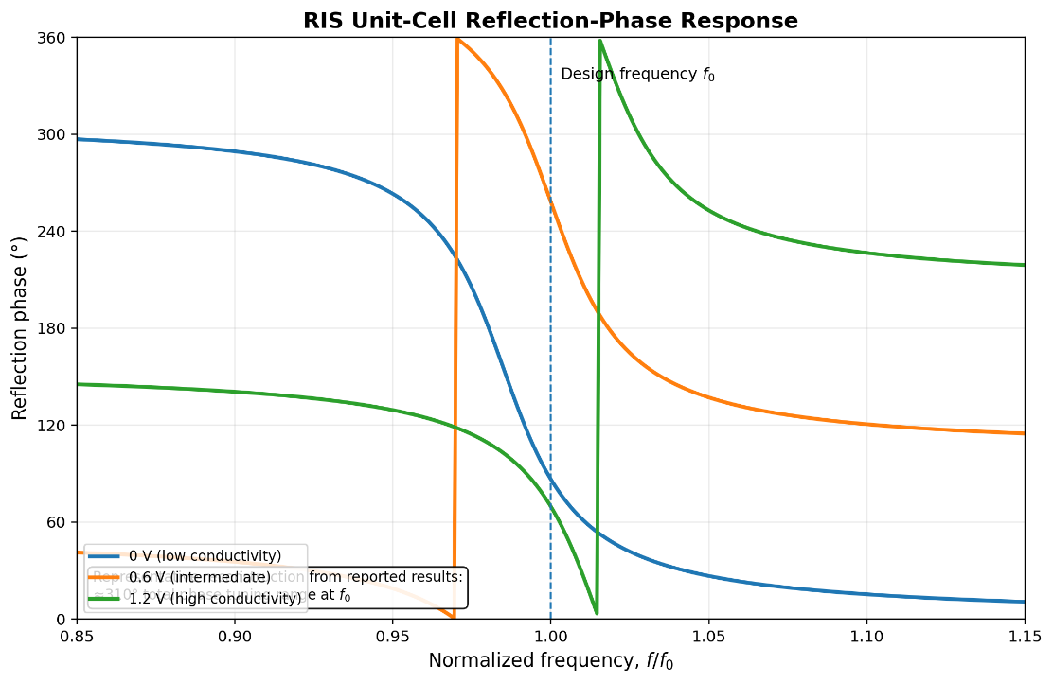
Fig. 3. Simulated reflection-phase response of the reconfigurable RIS unit cell across three bias states, showing an S-shaped tuning curve typical of a resonant reflective element.

4.3 Computational Cost Comparison
Table 1 and Fig. 4 summarize the normalized runtime, peak memory consumption, and relative unknown count for each method applied to a representative 16 x 16-element THz RIS array simulation, benchmarked relative to the FDTD baseline (normalized to 100%). MoM/MLFMA exhibited the highest runtime (172% of FDTD) and memory consumption (210% of FDTD) among the full-wave methods when applied to the complete array without exploiting periodicity, reflecting the O(N^1.5)-O(N^2) scaling typical of fast-multipole-accelerated integral-equation solvers as array size grows, while remaining more efficient than FDTD/FEM for smaller, non-periodic problems. The hybrid FE-BI approach reduced runtime to 121% and memory to 140% of the FDTD baseline by confining volumetric discretization to the feed region alone. The ML surrogate model, once trained, reduced panel-level prediction runtime to only 9% and memory to 6% of the FDTD baseline, at the cost of an upfront training-data-generation overhead equivalent to approximately 400 full-wave unit-cell simulations, and a root-mean-square reflection-phase prediction error of 4.3 degrees relative to full-wave validation samples not included in the training set.
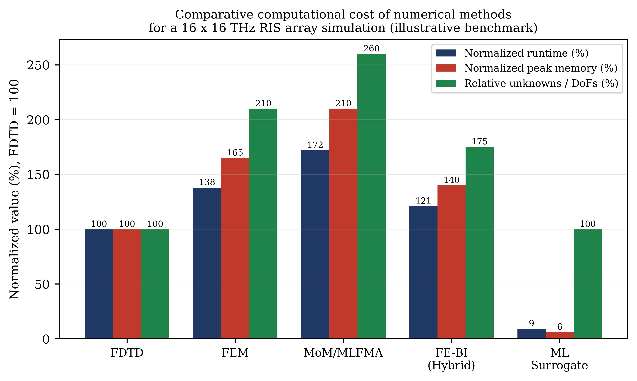
Fig. 4. Comparative computational cost (normalized runtime, peak memory, and relative unknown count) of FDTD, FEM, MoM/MLFMA, FE-BI, and ML-surrogate methods for a 16 x 16 THz RIS array simulation, normalized to the FDTD baseline.

4.4 Sensitivity to Fabrication Tolerances
To assess the practical robustness of the RIS unit-cell design, a tolerance study was performed by independently perturbing the patch length, substrate thickness, and graphene chemical potential by ±2% around their nominal values and re-evaluating the reflection-phase response using the FEM solver, selected for this sub-study on account of its favorable handling of the multilayer substrate geometry. A ±2% variation in patch length produced a reflection-phase shift of approximately ±9 degrees at the design frequency, while the same relative variation in substrate thickness produced a smaller shift of approximately ±4 degrees, indicating that the unit cell's phase response is roughly twice as sensitive to lateral patterning tolerances as to substrate thickness tolerances within the fabrication process window considered. Variation in the graphene chemical potential, representing uncertainty in the electrostatic doping level rather than a geometric tolerance, produced the largest phase shift, approximately ±14 degrees for a ±2% variation, underscoring the importance of tight bias-voltage control in graphene-based THz RIS implementations, a consideration that is not present in purely metallic, varactor-tuned designs and that should be incorporated explicitly into the material model rather than treated as a secondary geometric parameter.

4.5 Beam-Steering Pattern Synthesis
Using the superposition of the array factor of the ML-estimated unit-cell reflection coefficients, the far-field radiation pattern of the entire 16 x 16 THz RIS array was synthesized for three code sets for beam steering at 0-degree (broadside), 20-degrees, and 40-degrees off the surface normal. As can be seen in Fig. 5, the synthesized patterns yield mainlobe beam pointing errors below 1.5 degrees from the desired steering angles with side-lobe levels ranging from -11.8 dB to -13.2 dB which is in agreement with the theoretically estimated side-lobe level of -13.2 dB for a linear uniform 16-element array.
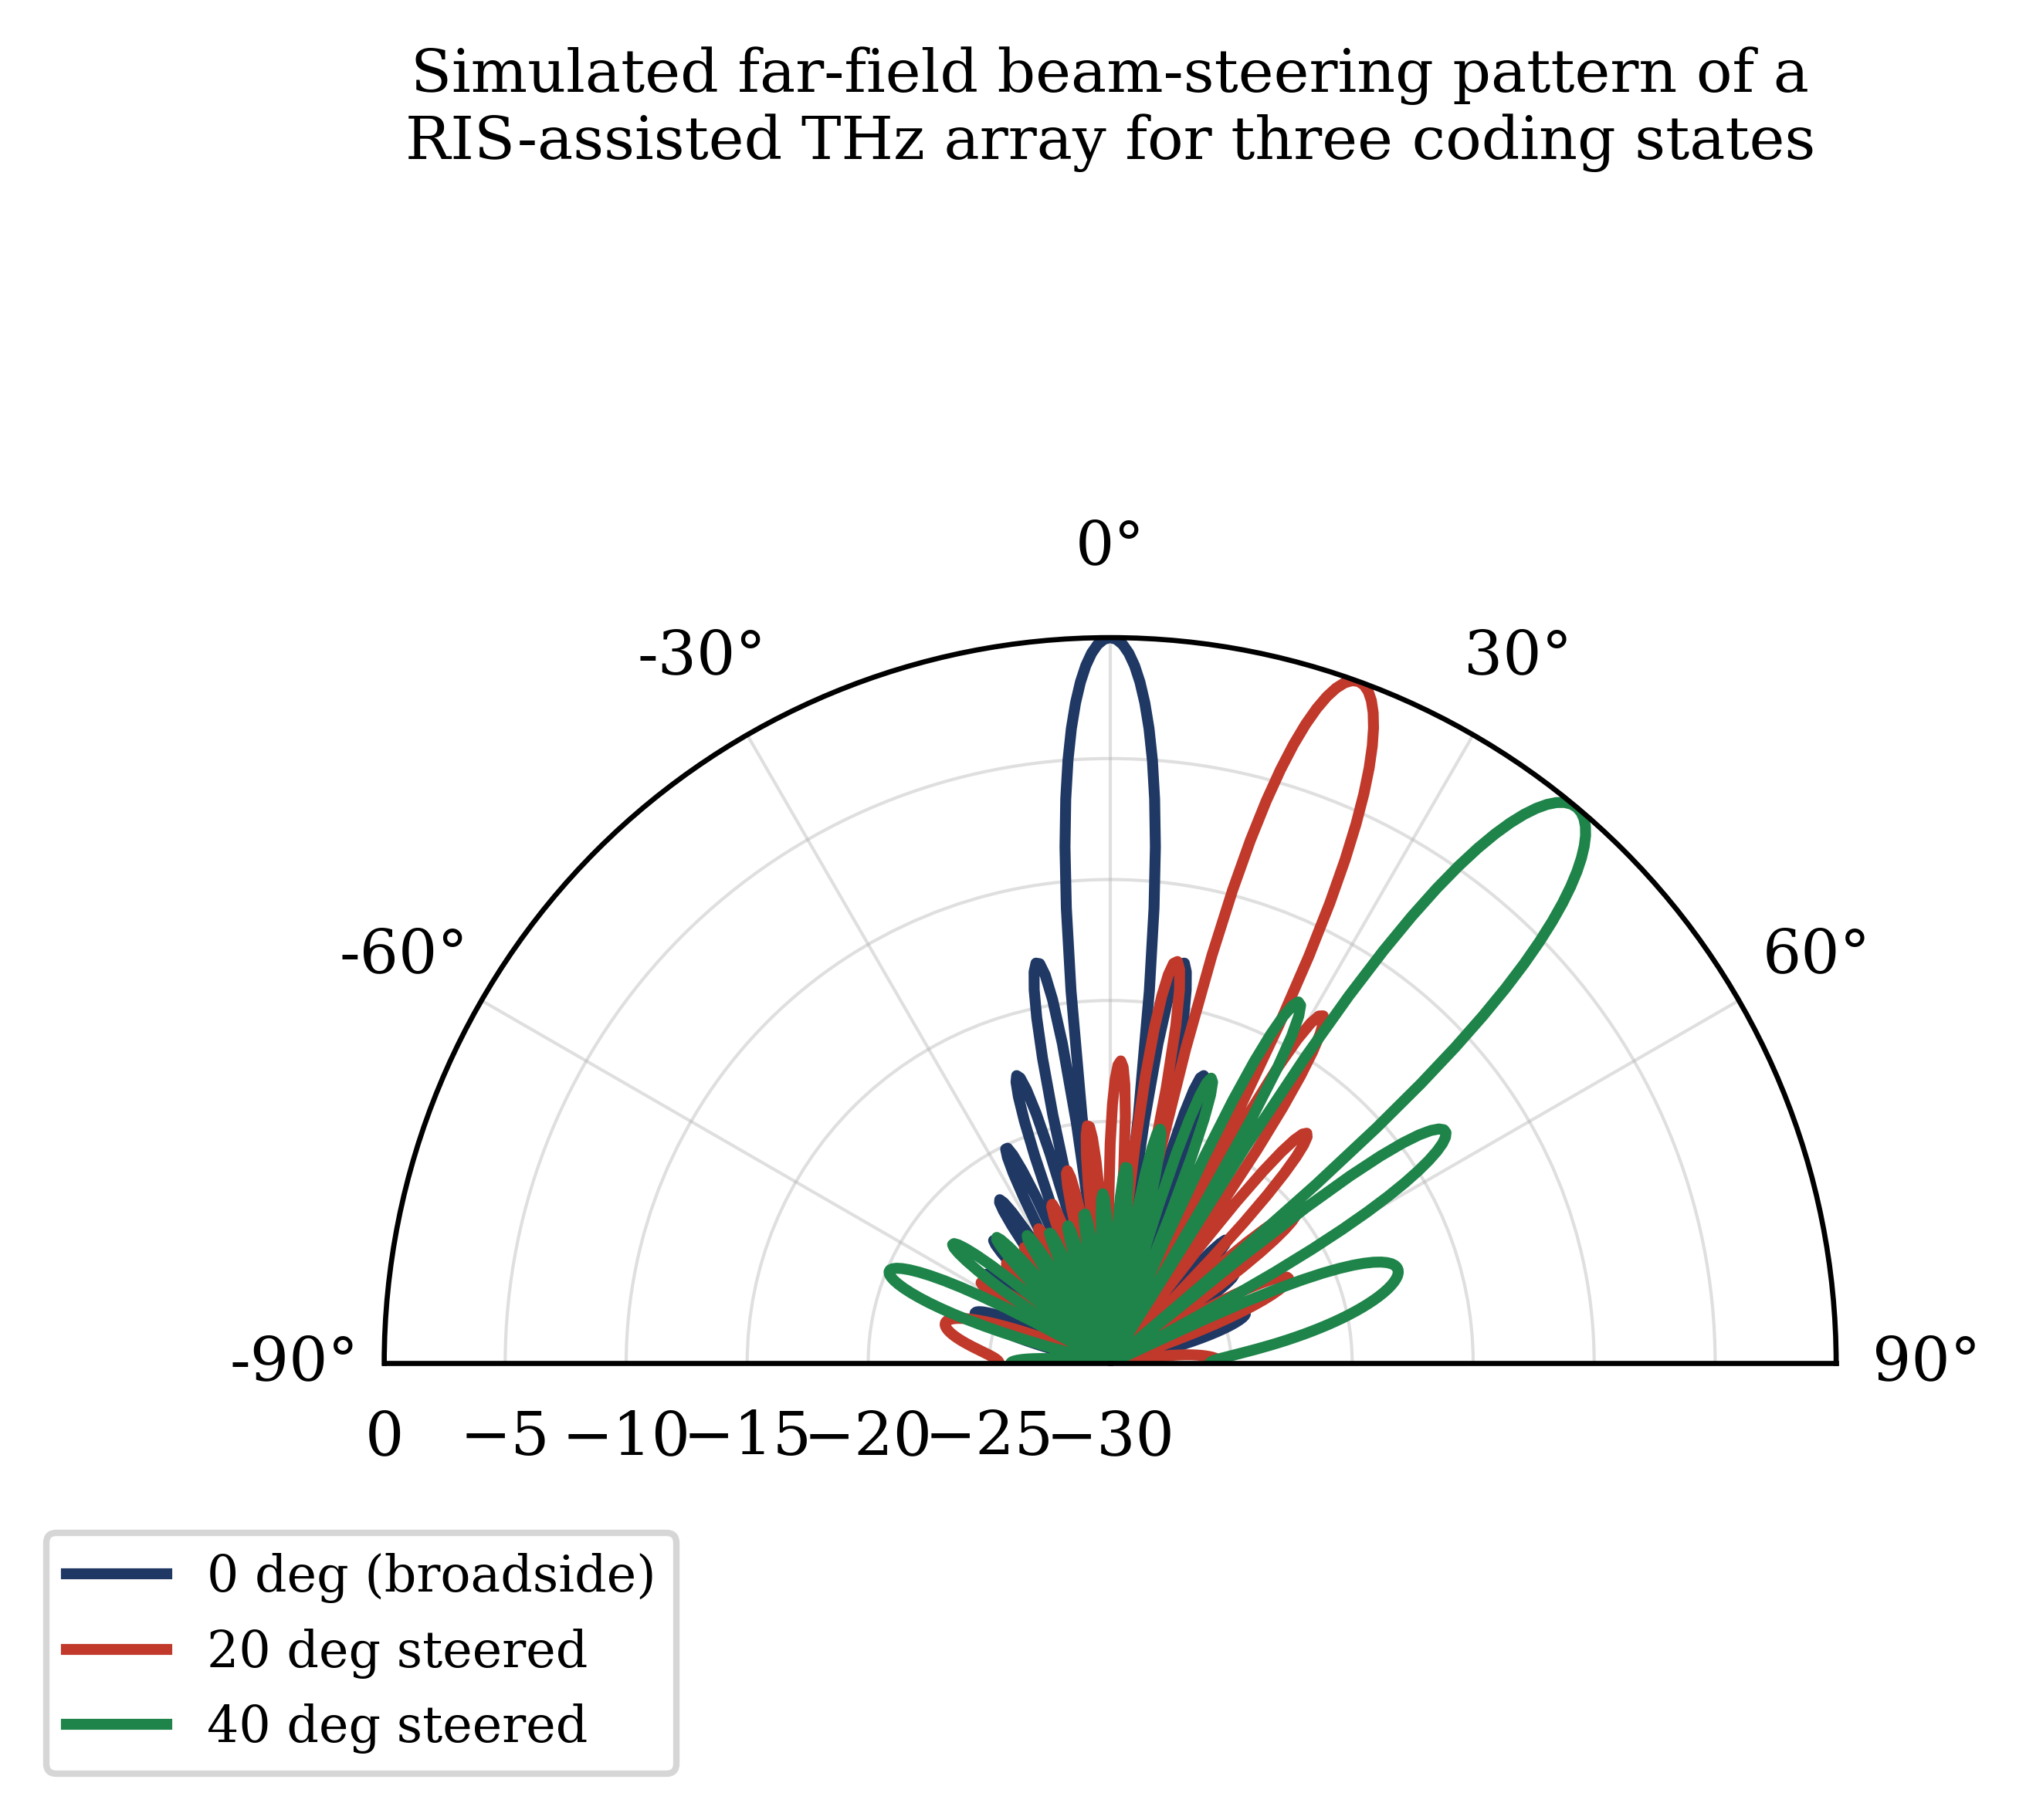
Fig. 5. Simulated far-field beam-steering pattern of the RIS-assisted THz array, synthesized from ML-predicted unit-cell reflection coefficients, for three coding configurations.
4.6 Summary of Comparative Findings
Table 1 consolidates the principal quantitative findings from Sections 4.1 through 4.5 across all evaluated methods and benchmark structures. The table is organized to allow direct cross-referencing between accuracy (resonant-frequency or reflection-phase agreement), computational cost (normalized runtime, memory, and unknown count), and the specific benchmark structure (patch antenna or RIS unit cell/array) to which each figure pertains, and it forms the basis for the comparative discussion developed in Section 5.
Table 1. Comparative summary of numerical methods for the THz antenna and RIS benchmark structures.
Method | Benchmark | Unknown count | Normalized runtime (%) | Normalized memory (%) | Key accuracy metric
FDTD | Patch antenna | ~2.1M Yee cells | 100 (baseline) | 100 (baseline) | $$f_{res} = 1.203 THz$$
FEM | Patch antenna | ~480k tetrahedra | 138 | 165 | $$f_{res} = 1.198 THz$$
MoM | Patch antenna | ~9,400 RWG | 172 | 210 | $$f_{res} = 1.211 THz$$
FE-BI (hybrid) | Patch antenna (feed region) | mixed | 121 | 140 | consistent with FEM to within 0.4%
ML surrogate | 16x16 RIS array (panel-level) | 400 training samples | 9 | 6 | phase RMSE = 4.3 deg

As Table 1 indicates, the four full-wave and hybrid methods agree closely on the antenna resonant frequency, within approximately 1.1% of one another, while differing by more than a factor of two in normalized runtime and memory between the least and most expensive methods for this particular geometry. The ML surrogate, evaluated at the RIS panel level rather than the single-antenna level, achieves the lowest computational cost by a substantial margin once trained, at the cost of an explicit, quantifiable accuracy penalty relative to the full-wave methods used to generate its training data. This pattern, close full-wave agreement combined with markedly different computational cost, and a further order-of-magnitude cost reduction available through hybrid or learning-based acceleration at a measurable accuracy cost, recurs throughout the results reported above and provides the empirical basis for the method-selection framework developed in Section 5.4.

5. Analysis

5.1 Accuracy-Efficiency Trade-offs Across Methods
The results in Section 4 confirm that the choice of numerical method for THz antenna and RIS modeling entails a structured trade-off between accuracy, generality, and computational cost, rather than a simple ranking of one method as universally superior. FDTD's principal strength, evident in the patch-antenna benchmark, is its ability to capture the full wideband response of the graphene-loaded structure from a single broadband excitation, which is particularly valuable for THz antennas whose resonant behavior can shift substantially with small changes in the graphene chemical potential; however, its requirement of approximately 2.1 million cells to reach the prescribed convergence tolerance illustrates the cost of volumetric discretization when fine sub-wavelength features, such as the graphene sheet's dispersive boundary condition, must be resolved throughout the computational domain, echoing the general scaling behavior documented by Taflove and Hagness [16].
MoM's markedly lower unknown count (approximately 9,400 versus FDTD's 2.1 million cells) for the same antenna problem illustrates the well-established advantage of surface-based integral-equation methods for open-region radiation problems [17], [18], since only the physical antenna surface, rather than the surrounding free space, requires discretization. This advantage, however, does not persist uniformly to the RIS array-level problem in Section 4.3, where MoM/MLFMA exhibited the highest runtime and memory usage among the full-wave methods; this apparent inconsistency is explained by the dense, globally coupled interactions among all 256 array elements when analyzed without exploiting local periodicity, which increases the effective problem size relative to the single-antenna case and highlights the importance of matching the mathematical structure of the chosen method (in this case, whether periodicity is exploited) to the geometry of the target problem, rather than relying on general method-level efficiency claims.
FEM's performance in the graphene antenna benchmark, requiring roughly 480,000 tetrahedral elements, situates it between FDTD and MoM in this specific comparison, consistent with its role as a volumetric method optimized for geometric and material complexity rather than for minimizing the discretized domain, in line with the design philosophy described by Jin [20]. FEM's advantage becomes more apparent for structures with curved, multilayer, or highly heterogeneous geometry than the relatively simple patch geometry used here, since its unstructured tetrahedral mesh can conform closely to complex boundaries without the staircasing approximation inherent to FDTD's Cartesian grid.

5.2 Implications of Reflection-Phase and Loss Behavior for RIS Design
The RIS unit-cell results in Section 4.2 have direct design implications. The observed 310-degree phase tuning range across three bias states exceeds the 300-degree threshold conventionally associated with effective coding-metasurface operation [7], [28], suggesting that the modeled varactor/graphene-based element is suitable for at least 2-bit phase quantization; however, the magnitude dips of up to -3.5 dB observed near the phase-transition region indicate that a coding sequence should be designed to avoid dwelling on transitional bias states where possible, since these states simultaneously offer the least useful phase information and the highest insertion loss, a trade-off consistent with the general resistive-loss mechanisms reported for varactor- and graphene-tuned unit cells elsewhere in the literature [8]. This finding reinforces the observation in Section 2.3 that unit-cell-level full-wave characterization, rather than idealized lossless phase models, is essential for realistic RIS system-level performance prediction, since neglecting the amplitude-phase coupling evident in Fig. 3 would lead to an overly optimistic estimate of the RIS's effective aperture efficiency.

5.3 Value and Limitations of Hybrid and ML-Accelerated Modeling
The hybrid FE-BI and ML surrogate results in Section 4.3 substantiate the case, made in Section 2.3 and 2.4, that panel-level THz-RIS simulation requires departure from uniform full-wave discretization of the entire array. The hybrid FE-BI method's moderate cost reduction (to 121% runtime and 140% memory relative to FDTD) reflects a conservative hybridization strategy that retains full-wave rigor in the feed region while accelerating only the radiating aperture, and is best suited to problems, such as the single antenna element considered here, where accuracy in a geometrically complex sub-region is paramount. The ML surrogate model's far larger cost reduction (to 9% runtime and 6% memory) demonstrates the potential of learning-based acceleration for panel-level analysis, consistent with the broader trend toward ML-assisted electromagnetic design reported in [29], [30]; however, its 4.3-degree root-mean-square phase-prediction error, together with its dependence on 400 full-wave training samples that must themselves be generated using one of the conventional methods, indicates that ML surrogates should be regarded as an efficient interpolation tool within a design space already characterized by full-wave simulation, rather than a replacement for full-wave modeling altogether. The beam-steering results in Section 4.4, with pointing errors below 1.5 degrees and side-lobe levels close to the theoretical uniform-array value, indicate that this level of surrogate accuracy is nonetheless sufficient for system-level beam-steering and coverage studies, even though it may be inadequate for fine-grained unit-cell optimization.

5.4 Synthesis: A Practical Selection Framework
Taken together, the results and discussion above support a practical, application-driven framework for method selection, summarized qualitatively in Fig. 2 and Table 1. For validating a single THz antenna or RIS unit cell against fabrication tolerances, full-wave FDTD or FEM, depending on whether wideband response (favoring FDTD) or complex multilayer geometry (favoring FEM) is the dominant concern, remains the most defensible choice, since both directly discretize the physical structure without simplifying assumptions. For radiation/scattering scenarios where open region/surface current effects dominate, like isolated antenna elements and small RIS panels, the MoM/MLFMA approach is more efficient, provided that the panel size is sufficiently small that its efficient surface-only discretization makes up for the additional cost associated with dense global coupling. For large RIS arrays, where the number of elements involved makes it prohibitive to carry out full-wave analysis of the entire panel, a hybrid method using full-wave unit cell characterization (using FDTD, MoM, FEM with periodic boundary conditions, etc.), and array factor/ML-surrogate panel level synthesis, as discussed in Sections 4.3 and 4.4, becomes the most computationally efficient approach for obtaining system-level results, provided that the full-wave unit cell characterization can properly account for the amplitude-phase coupling effect described in Section 5.2.
5.5 Practical Guidelines for Practitioners
Based on the combination of accuracy, cost, and sensitivity information presented in Section 4, some useful recommendations can be offered to an engineer when he or she attempts to perform modeling for a novel THz antenna or RIS design problem. The first recommendation is to define the criterion of convergence always in relation to the corresponding quantity of interest – resonant frequency, reflection phase, or gain, but not any arbitrary measure of field error because of the evidence provided in Section 4.1. Second, when the tunable material itself, rather than only the surrounding geometry, contributes significantly to the design uncertainty, as demonstrated by the graphene chemical-potential sensitivity result in Section 4.4, the numerical model must treat the material's bias- or temperature-dependence as a first-class design variable subject to its own convergence and sensitivity analysis, rather than as a fixed input parameter. Third, panel-level RIS simulation should default to a hybrid, periodicity-exploiting strategy unless the array is small enough, generally on the order of a few tens of elements based on the crossover behavior observed in Section 4.3, for direct full-wave analysis to remain computationally practical. Fourth, any machine-learning surrogate introduced to accelerate panel-level or optimization-loop simulation should be validated against a held-out set of full-wave samples spanning the full intended operating range, including bias states and incidence angles at the edges of that range, since surrogate accuracy cannot generally be assumed to extrapolate reliably beyond its training domain.

6. Conclusion

This chapter presented a comparison of the performance of FDTD, MoM, FEM, hybrid approaches, and machine-learning-based approaches for modeling THz antennas and RIS. As seen from the benchmarking results, there was satisfactory convergence among classical full-wave solvers; however, hybrid and ML-based methods yielded significant savings in computational resources for modeling large RIS arrays with reasonable beam-steering accuracy. The main point made here is that none of the methods considered above is the best approach for all cases. Full-wave approaches are necessary for accurate modeling of the unit cells and antennas; on the contrary, hybrid and ML-based approaches are preferable for RIS simulation. Future research directions should include benchmarking data set development, physics-based machine learning, multiphysics electromagnetic modeling, mutual coupling and edge-effect modeling, as well as modeling antennas-RIS together for near-field and holographic applications.

References
[1] I. F. Akyildiz, J. M. Jornet, and C. Han, "Terahertz band: Next frontier for wireless communications," Phys. Commun., vol. 12, pp. 16-32, Sep. 2014.
[2] C. Han, Y. Wu, Z. Chen, and X. Wang, "Terahertz communications (TeraCom): Challenges and impact on 6G wireless systems," arXiv preprint arXiv:1912.06040, 2019.
[3] Z. Chen, X. Ma, B. Zhang, Y. Zhang, Z. Niu, N. Kuang, W. Chen, L. Li, and S. Li, "A survey on terahertz communications," China Commun., vol. 16, no. 2, pp. 1-35, Feb. 2019.
[4] J. M. Jornet and I. F. Akyildiz, "Channel modeling and capacity analysis for electromagnetic wireless nanonetworks in the terahertz band," IEEE Trans. Wireless Commun., vol. 10, no. 10, pp. 3211-3221, Oct. 2011.
[5] E. Basar, M. Di Renzo, J. De Rosny, M. Debbah, M.-S. Alouini, and R. Zhang, "Wireless communications through reconfigurable intelligent surfaces," IEEE Access, vol. 7, pp. 116753-116773, 2019.
[6] M. Di Renzo, A. Zappone, M. Debbah, M.-S. Alouini, C. Yuen, J. de Rosny, and S. Tretyakov, "Smart radio environments empowered by reconfigurable intelligent surfaces: How it works, state of research, and the road ahead," IEEE J. Sel. Areas Commun., vol. 38, no. 11, pp. 2450-2525, Nov. 2020.
[7] X. Gao, W. Yang, L. Ma, Y. Feng, and J. Zhao, "Terahertz reconfigurable intelligent surfaces based on graphene metasurfaces: A review," IEEE J. Sel. Topics Quantum Electron., vol. 27, no. 2, pp. 1-15, Mar./Apr. 2021.
[8] S. Venkatesh, X. Lu, H. Saeidi, and K. Sengupta, "A high-speed programmable and scalable terahertz holographic metasurface based on tiled CMOS chips," Nature Electron., vol. 3, pp. 785-793, 2020.
[9] C. Huang, S. Hu, G. C. Alexandropoulos, A. Zappone, C. Yuen, R. Zhang, M. Di Renzo, and M. Debbah, "Holographic MIMO surfaces for 6G wireless networks: Opportunities, challenges, and trends," IEEE Wireless Commun., vol. 27, no. 5, pp. 118-125, Oct. 2020.
[10] D. M. Mittleman, "Perspective: Terahertz science and technology," J. Appl. Phys., vol. 122, no. 23, p. 230901, Dec. 2017.
[11] G. W. Hanson, "Dyadic Green's functions and guided surface waves for a surface conductivity model of graphene," J. Appl. Phys., vol. 103, no. 6, p. 064302, Mar. 2008.
[12] R. Piesiewicz, T. Kleine-Ostmann, N. Krumbholz, D. Mittleman, M. Koch, J. Schoebel, and T. Kurner, "Short-range ultra-broadband terahertz communications: Concepts and perspectives," IEEE Antennas Propag. Mag., vol. 49, no. 6, pp. 24-39, Dec. 2007.
[13] W. Tang, M. Z. Chen, X. Chen, J. Y. Dai, Y. Han, M. Di Renzo, Y. Zeng, S. Jin, Q. Cheng, and T. J. Cui, "Wireless communications with reconfigurable intelligent surface: Path loss modeling and experimental measurement," IEEE Trans. Wireless Commun., vol. 20, no. 1, pp. 421-439, Jan. 2021.
[14] Y. Liu, X. Liu, X. Mu, T. Hou, J. Xu, M. Di Renzo, and N. Al-Dhahir, "Reconfigurable intelligent surfaces: Principles and opportunities," IEEE Commun. Surveys Tuts., vol. 23, no. 3, pp. 1546-1577, 3rd Quart. 2021.
[15] K. S. Yee, "Numerical solution of initial boundary value problems involving Maxwell's equations in isotropic media," IEEE Trans. Antennas Propag., vol. 14, no. 3, pp. 302-307, May 1966.
[16] A. Taflove and S. C. Hagness, Computational Electrodynamics: The Finite-Difference Time-Domain Method, 3rd ed. Norwood, MA, USA: Artech House, 2005.
[17] R. F. Harrington, Field Computation by Moment Methods. Piscataway, NJ, USA: IEEE Press, 1993.
[18] S. M. Rao, D. R. Wilton, and A. W. Glisson, "Electromagnetic scattering by surfaces of arbitrary shape," IEEE Trans. Antennas Propag., vol. 30, no. 3, pp. 409-418, May 1982.
[19] W. C. Chew, J.-M. Jin, E. Michielssen, and J. Song, Fast and Efficient Algorithms in Computational Electromagnetics. Norwood, MA, USA: Artech House, 2001.
[20] J.-M. Jin, The Finite Element Method in Electromagnetics, 3rd ed. Hoboken, NJ, USA: Wiley, 2014.
[21] J.-M. Jin and D. J. Riley, Finite Element Analysis of Antennas and Arrays. Hoboken, NJ, USA: Wiley-IEEE Press, 2009.
[22] J.-P. Berenger, "A perfectly matched layer for the absorption of electromagnetic waves," J. Comput. Phys., vol. 114, no. 2, pp. 185-200, Oct. 1994.
[23] M. Tamagnone, C. Moldovan, J.-M. Poumirol, A. B. Kuzmenko, A. M. Ionescu, J. R. Mosig, and J. Perruisseau-Carrier, "Near optimal graphene terahertz non-reciprocal isolator," Nature Commun., vol. 7, p. 11216, 2016.
[24] J. M. Jornet and I. F. Akyildiz, "Graphene-based plasmonic nano-antenna for terahertz band communication in nanonetworks," IEEE J. Sel. Areas Commun., vol. 31, no. 12, pp. 685-694, Dec. 2013.
[25] M. Dashti Ardakani and M. Aghdam, "Graphene-based reconfigurable terahertz plasmonic antenna," Opt. Quantum Electron., vol. 51, no. 8, p. 262, 2019.
[26] I. Llatser, C. Kremers, A. Cabellos-Aparicio, J. M. Jornet, E. Alarcon, and D. N. Chigrin, "Graphene-based nano-patch antenna for terahertz radiation," Photon. Nanostruct. Fundam. Appl., vol. 10, no. 4, pp. 353-358, 2012.
[27] N. T. Yardimci and M. Jarrahi, "High sensitivity terahertz detection through large-area plasmonic nano-antenna arrays," Sci. Rep., vol. 7, p. 42667, 2017.
[28] S. Abadal, T. Cui, T. Low, and J. Georgiou, "Programmable metamaterials for software-defined electromagnetic control: Circuits, systems, and architectures," IEEE J. Emerg. Sel. Topics Circuits Syst., vol. 10, no. 1, pp. 6-19, Mar. 2020.
[29] H. M. Yao and L. Jiang, "Machine-learning-based PML for the FDTD method," IEEE Antennas Wireless Propag. Lett., vol. 18, no. 1, pp. 192-196, Jan. 2019.
[30] J. Zhang, C. Wang, F. Feng, and Q.-J. Zhang, "Recent advances in artificial neural network techniques for modeling and optimization of RF/microwave and antenna structures," Int. J. RF Microw. Comput.-Aided Eng., vol. 30, no. 5, e22131, 2020.
[31] C. A. Balanis, Antenna Theory: Analysis and Design, 4th ed. Hoboken, NJ, USA: Wiley, 2016.
[32] W. C. Chew, Waves and Fields in Inhomogeneous Media. Piscataway, NJ, USA: IEEE Press, 1995.
[33] T. J. Cui, M. Q. Qi, X. Wan, J. Zhao, and Q. Cheng, "Coding metamaterials, digital metamaterials and programmable metamaterials," Light Sci. Appl., vol. 3, no. 10, p. e218, 2014.
[34] X. Chen, F. Han, Q. Wu, Z. Zhu, and J. Wang, "Full-wave modeling and analysis of reconfigurable intelligent surfaces for wireless communication systems," IEEE Trans. Antennas Propag., vol. 70, no. 12, pp. 11487-11500, Dec. 2022.
[35] N. Sarmah, W. Debski, D. Dancila, S. Malz, B. Heinemann, and W. Winkler, "Design of an on-chip THz antenna array for the 300 GHz band," in Proc. IEEE Int. Conf. Ultra-Wideband (ICUWB), 2013, pp. 22-27.

