AI - powered smart travel experience personalization and intelligent booking recommendation system.
A Project Based Learning Report Submitted in partial fulfilment of the requirements for the award of the degree
of
Bachelor of Technology
in The Department of CSE
Course name : DATABASE SYSTEMS ENGINEERING AND DISTRIBUTED BACKEND DEVELOPMENT
Course Code : 25CS1302E
Submitted by
2510030031: Tippani Aniketh Reddy
2510030033: Karri Sri Sai Prashanth
2510030072: Kolla Arun Yadav
2510030171: Suraram Ashwithnath Reddy
251030177 : Vivek Reddy

Under the guidance of
Dr Sasidhar K


Department of Computer Science and Engineering
Koneru Lakshmaiah Education Foundation, Aziz Nagar
Aziz Nagar – 500075
OCT - 2026.

Abstract
Travel planning today is fragmented: a traveller searches one site for destinations, another for flights, a third for activities and a fourth for payments, and none of them remembers what the traveller actually likes. This project, TripWise – an AI-powered smart travel experience personalization and intelligent booking recommendation system, brings these tasks into a single database-driven web application. The work is carried out for the Database Management Systems course and its central theme is the design of a data layer that is correct, consistent and fast enough to support intelligent features.
TripWise follows a polyglot-persistence design. PostgreSQL 16 (with the pgvector and pg_trgm extensions) stores all transactional, relational data – users, bookings, flight, hotel and tour bookings, payments, seat inventory and destination embeddings – under primary keys, foreign keys with cascading deletes, JSONB columns, row-level locking, a generated tsvector column, an HNSW vector index and a GIN full-text index. MongoDB 7 stores the flexible, document-shaped data – destinations with nested nearby places, tours, reviews, traveller preferences and notifications. A FastAPI back end exposes more than fifty REST endpoints, a Node.js micro-service consumes domain events (HTTP or Kafka) and writes notifications, and a vanilla HTML/CSS/JavaScript front end served by Nginx provides the traveller storefront, a payment page and an administrator portal.
The intelligence layer consists of (i) a content-based recommender that builds TF-IDF vectors from the traveller's saved interests and compares them with destination text using cosine similarity, boosted by a travel-type matrix and the destination rating; (ii) semantic and hybrid search that fuse 384-dimensional MiniLM sentence embeddings with PostgreSQL full-text ranking through Reciprocal Rank Fusion; (iii) an interest-aware itinerary planner; and (iv) a rule-based assistant. Seat overbooking is prevented with SELECT … FOR UPDATE, and bookings progress through a pending → confirmed/cancelled life cycle tied to a simulated multi-method payment flow.
The report documents the architecture, the entity–relationship design, data dictionary, normalization, indexing, algorithms, deployment and experiments. Running the project's own recommender, planner, pricing and query-building code over the 30-destination seed data shows that the profiles produce sensible, explainable rankings (for example Phuket for a beach-loving couple and Machu Picchu for a solo adventure traveller), that the travel-type boost changes rankings in the intended direction, and that the cost, fee and itinerary calculations behave as specified.
Keywords: DBMS, PostgreSQL, MongoDB, polyglot persistence, pgvector, hybrid search, TF-IDF, recommendation system, travel booking, FastAPI, ACID transactions.

List of Figures
Fig. 1. Use-case diagram of TripWise. 11
Fig. 2. Layered architecture of TripWise: presentation, application and data/messaging layers. 12
Fig. 3. Polyglot persistence: relational and vector data in PostgreSQL, document data in MongoDB. 13
Fig. 4. Entity–relationship diagram of the PostgreSQL schema. 14
Fig. 5. MongoDB collections and their key fields. 18
Fig. 6. Content-based recommendation pipeline (TF-IDF, cosine similarity, boost, rating bonus). 20
Fig. 7. Hybrid search: pgvector branch and full-text branch fused by Reciprocal Rank Fusion. 21
Fig. 8. Itinerary planner algorithm. 22
Fig. 9. End-to-end booking and payment flow. 23
Fig. 10. Booking and payment state transitions. 24
Fig. 11. Event-driven notification flow from the API to MongoDB. 25
Fig. 12. Docker Compose deployment topology. 27
Fig. 13. Two concurrent transactions competing for the last seat. 31
Fig. 14. Sequence diagram for booking, payment and notification. 32
Fig. 15. Frequency of interest tags across the 30 seeded destinations. 35
Fig. 16. Average cost per day (USD) of each destination in the seed data. 36
Fig. 17. Final score of the top-ranked destination for each sample profile. 39
Fig. 18. Home page with the semantic search box, category filters and chatbot button. 42
Fig. 19. Destination catalogue showing rating, interest tags and average cost per day read from MongoDB. 43
Fig. 20. Guided tours catalogue with duration, rating and price per person. 43
Fig. 21. Semantic search results for the natural-language query “a place can visit with friends in summer”, ranked by similarity score. 43
Fig. 22. (a) Account registration form; (b) profile and preference form (travel type, cabin, hotel rating, budget, interests) that feeds the recommender. 44
Fig. 23. “Recommended for you” – destinations ranked from the saved travel profile. 44
Fig. 24. (a) Destination detail with map and day-wise itinerary generator; (b) rule-based TripWise assistant answering a login question. 45
Fig. 25. Booking flow: (a) tour booking dialog with price estimate; (b) My Bookings showing the pending/unpaid booking; (c) payment dialog with UPI QR code and method tabs. 45

List of Tables
Table I. Functional requirements 9
Table II. Non-functional requirements 10
Table III. Technology stack of the project 12
Table IV. Criteria used to place each data set 13
Table V. Table users 14
Table VI. Table bookings 15
Table VII. Tables flight_bookings, hotel_bookings and tour_bookings 15
Table VIII. Table payments 15
Table IX. Tables seat_inventory and user_preferences 16
Table X. Table destination_embeddings 16
Table XI. Integrity constraints in the relational schema 16
Table XII. Normal-form review 17
Table XIII. MongoDB collections 18
Table XIV. Indexes used in the system 19
Table XV. Travel-type boost matrix (rows: traveller; columns: destination suitability) 21
Table XVI. Payment methods and fees 24
Table XVII. Domain events and the notifications they produce 25
Table XVIII. Main configuration parameters 27
Table XIX. User-facing endpoints 27
Table XX. Administrator endpoints (prefix /admin, all require role A) 28
Table XXI. Query catalogue and techniques 31
Table XXII. Transaction boundaries of the main operations 31
Table XXIII. Threats and countermeasures 32
Table XXIV. Experiment plan 33
Table XXV. Source files, roles and line counts 34
Table XXVI. Seed data summary 35
Table XXVII. Traveller profiles used in E2 36
Table XXVIII. Functional and integrity test scenarios (E8) 37
Table XXIX. Top-5 recommendations per profile (final score = cosine × boost + 0.02 × rating) 38
Table XXX. Top-3 destinations for interests food + culture by travel type (final score in brackets) 40
Table XXXI. Generated itineraries (E4) 40
Table XXXII. Booking estimates (E5) 40
Table XXXIII. Payment fee for a Rs 1,44,000 booking (E5) 41
Table XXXIV. Keyword query construction (E6) 41
Table XXXV. Reciprocal Rank Fusion scores with α = 0.6 (E6) 41
Table XXXVI. Assistant routing (E7) 42
Table XXXVII. Traveller journey and the data operations behind each step 45
Table XXXVIII. Administrator views and the operations behind them 46
Table XXXIX. Known limitations and their impact 47

Table of Contents
Abstract 2
List of Figures 3
List of Tables 4
1. Introduction 8
a. Background and motivation 8
b. Problem statement 8
c. Objectives 8
d. Scope of the project 9
e. Why polyglot persistence? 9
f. Organisation of the report 9
2. Methodology 9
a. Requirements and use cases 9
b. Overall system architecture 11
c. Technology stack 12
d. Polyglot data distribution 13
e. Relational schema design 13
f. Data dictionary 14
g. Keys, constraints and referential integrity 16
h. Normalization analysis 17
i. Document model in MongoDB 17
j. Indexing strategy 19
k. Vector and full-text capabilities 19
l. Authentication and authorization 19
m. Recommendation engine 20
n. Semantic and hybrid search 21
o. Itinerary planner 22
p. Booking workflow and concurrency control 22
q. Payment module 24
r. Event-driven notifications 25
s. Rule-based assistant 25
t. Administrator portal and analytics 26
u. Front-end design 26
v. Deployment and configuration 26
w. API reference 27
x. SQL schema and query catalogue 28
y. Transactions, ACID properties and concurrency 31
z. Security analysis and performance considerations 32
3. Experiments 33
a. Experimental objectives 33
b. Code base and project structure 33
c. Test environment 34
d. Dataset and seed procedure 34
e. Recommender experiment design (E2, E3) 36
f. Itinerary, pricing and payment experiments (E4, E5) 36
g. Query-processing and assistant experiments (E6, E7) 37
h. Functional and integrity scenarios (E8) 37
4. Results 38
a. Recommender output (E2) 38
b. Effect of the travel type (E3) 39
c. Itinerary generation (E4) 40
d. Booking cost and payment fee (E5) 40
e. Hybrid search query processing (E6) 41
f. Assistant behaviour (E7) 42
g. Application walkthrough and database operations 45
h. Discussion 46
5. Conclusion and Future Work 47
a. Conclusion 47
b. Limitations 47
c. Future work 48
References 48

AI-Powered Smart Travel Experience Personalization and Intelligent Booking Recommendation System

Introduction

Background and motivation
Tourism is one of the largest consumer-facing digital industries, and its data is unusually varied. A single trip touches structured records (identities, prices, seat counts, payment states), semi-structured records (destination profiles with lists of tags, seasons and nearby attractions) and unstructured text (descriptions and reviews). Online travel platforms such as flight aggregators and hotel marketplaces solve the search-and-book problem well, but they are generally weak at the first step of the journey: deciding where to go. A traveller who enjoys quiet beaches and food markets receives the same ranked list as a traveller who wants nightlife and shopping, because the platform knows little about the person behind the query.
Personalization needs data that is stored, related and retrievable in several different ways at once. The traveller's preferences must be saved, destination descriptions must be compared with them, a booking must be created without ever selling the same seat twice, and a payment must either fully succeed or leave the booking untouched. These are classical database-management concerns – schema design, integrity constraints, transactions, concurrency control, indexing and query processing – and they are the reason the project was chosen for a Database Management Systems course. The artificial-intelligence features (recommendation, semantic search, itinerary planning) are not bolted on from outside; they are implemented inside the data layer, using vector columns, full-text indexes and aggregation queries of the database engines themselves.

Problem statement
Existing travel portals present static catalogues, offer limited personalization, separate discovery from booking, and treat all data with a single storage model. The problem addressed here is: how can a travel platform store heterogeneous travel data reliably, recommend destinations that match an individual traveller's interests and travel style, support natural-language discovery, and complete a consistent booking-and-payment transaction – all on a maintainable, containerised stack?

Objectives
- Design a normalized relational schema in PostgreSQL for users, bookings, payments, seat inventory and embeddings, with enforced keys, foreign keys and cascading rules.
- Design a flexible document schema in MongoDB for destinations (with nested nearby places), tours, reviews, preferences, travel history and notifications.
- Implement a personalised, explainable recommender based on TF-IDF vectors, cosine similarity, a travel-type boost matrix and destination ratings.
- Implement semantic and hybrid search by combining pgvector similarity with PostgreSQL full-text search using Reciprocal Rank Fusion.
- Guarantee booking correctness: no overbooking under concurrent requests, a clear status life cycle, and consistent payment confirmation and refund.
- Provide an event-driven notification path (HTTP or Kafka) and an administrator portal with CRUD operations and SQL analytics.
- Package the whole system with Docker Compose so that it can be started, seeded and demonstrated with a few commands.

Scope of the project
TripWise covers the complete traveller journey inside one application: registration and login; saving preferences; discovering 30 seeded destinations and 10 tours; viewing destination details, a map and nearby places; generating a day-wise itinerary; booking a flight-and-stay package or a tour; attaching planned activities to a booking; paying through four simulated methods; reviewing destinations; and receiving notifications. An administrator can manage users, bookings, payments, destinations, tours and reviews and view revenue analytics. Payments are simulated (no real gateway), flight and hotel inventory are modelled rather than integrated with external suppliers, and the chatbot is rule-based; these boundaries are discussed again under limitations and future work.

Why polyglot persistence?
A frequent first instinct is to choose one database for everything. TripWise deliberately does not. Money and seats require ACID transactions, referential integrity and row locks – the strengths of a relational engine. A destination, however, is a naturally nested document: its tags, travel types and list of nearby places vary in length and are always read together, so storing them as one document avoids a chain of joins and lets an administrator add a new attribute without a schema migration. PostgreSQL with pgvector is also used for the one workload that is neither purely relational nor purely document-oriented: nearest-neighbour search over sentence embeddings. Choosing the engine per workload is the central design decision of the project and is justified in detail in the methodology.

Organisation of the report
Section 2 (Methodology) describes the architecture, technology stack, relational and document schemas, indexing, algorithms and modules. Section 3 (Experiments) describes the seed data, test environment, query experiments and test scenarios. Section 4 (Results) reports the outputs obtained by executing the project logic on the seed data and discusses them. Section 5 concludes the report and lists limitations and future work, followed by the references.

Methodology

Requirements and use cases
The requirements were derived from the problem statement and are grouped into functional requirements (what the system does, Table below) and non-functional requirements (how well it does it). Two actors use the system – the traveller and the administrator – and a third, non-human actor, the event bus with the notification service, receives events (Fig. 1).
- Functional requirements
ID | Requirement | Realised by
FR1 | A visitor can register and sign in; passwords are stored hashed | /auth/register, /auth/login, bcrypt, JWT
FR2 | A traveller can save interests, travel type and preferred cabin | /profile/preferences (MongoDB)
FR3 | The system recommends destinations that match the saved profile | recommendation_service, /recommendations
FR4 | A visitor can browse destinations and tours and read reviews | /destinations, /tours, /reviews
FR5 | A visitor can search by meaning and by keyword | /search/semantic, /search/hybrid
FR6 | A visitor can view nearby places on a map and generate a day-wise itinerary | /destinations/{name}/nearby, /itinerary, /plan
FR7 | A traveller can book a flight-and-stay package or a tour with an automatic price estimate | /bookings/flight, /bookings/tour
FR8 | The system must never sell more seats than exist for a route and date | seat_inventory + FOR UPDATE
FR9 | A traveller can edit or cancel a pending booking and attach planned activities | /bookings/{id}, /cancel, /attach-plan
FR10 | A traveller can pay through UPI/QR, card, net banking or wallet, or pay later | /payments/*, pay.html
FR11 | A traveller can review a destination once | /reviews (duplicate check)
FR12 | A traveller receives notifications on registration, booking and payment events | event_bus, notification service
FR13 | An administrator can manage users, bookings, payments, destinations, tours and reviews | /admin/*, admin.html
FR14 | An administrator can see revenue, status counts, top customers and database statistics | /admin/analytics, /admin/db-stats
FR15 | A user can ask the assistant common questions | /search/chat

- Non-functional requirements
Quality | Requirement | How it is addressed
Consistency | No partial bookings, no negative or oversold seat counts | Single transaction per booking; row lock; constraints
Integrity | No orphan rows; unique accounts | Foreign keys with cascade; UNIQUE e-mail
Security | Credentials and tokens protected; admin functions restricted | bcrypt, JWT, ownership checks, require_admin, HTML escaping
Performance | Interactive response for search and recommendations | Async I/O, HNSW and GIN indexes, small in-memory recommender
Availability | Core booking must work when messaging is down | Event bus defaults to off and never raises
Flexibility | New destination attributes without schema migration | Document model in MongoDB
Portability | One-command deployment on any machine with Docker | Docker Compose, pinned versions
Maintainability | Clear module boundaries | Routers, services, models, scripts separated

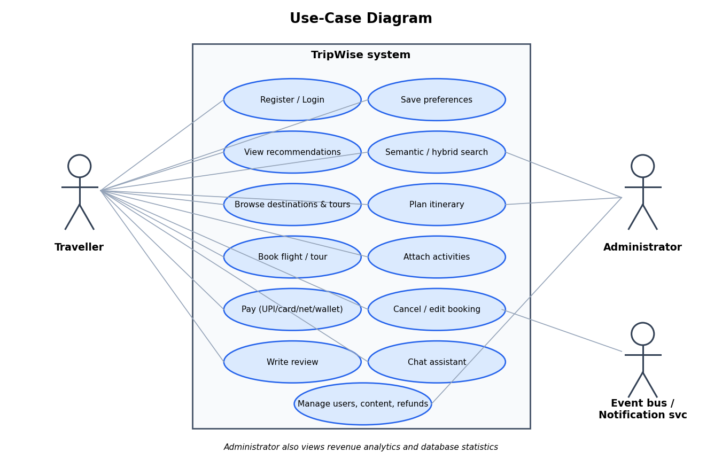
- Use-case diagram of TripWise.

Overall system architecture
TripWise is organised in three layers, shown in Fig. 2. The presentation layer is a static web application served by Nginx on port 5500: a storefront (index.html with app.js), a payment page (pay.html with pay.js) and an administrator portal (admin.html with admin.js). Nginx also acts as a reverse proxy, forwarding every request that begins with /api/ to the back end, so the browser talks to a single origin and no cross-origin configuration is needed in the deployed setup.
The application layer is a FastAPI service (Uvicorn, port 8000, version 2.0.0). It is split into nine routers – authentication and profile, bookings, payments, search (semantic, hybrid and chat), recommendations, destinations, tours, reviews and admin – and three services: the recommendation service, the embedding service and the event bus. All endpoints use asynchronous database drivers (asyncpg for PostgreSQL, Motor for MongoDB), so a slow query on one request does not block others. At start-up the application runs Base.metadata.create_all, which creates any missing PostgreSQL tables and indexes from the SQLAlchemy models.
The data and messaging layer contains PostgreSQL 16 (image pgvector/pgvector:pg16), MongoDB 7, an optional Kafka and Zookeeper pair, and a Node.js notification service on port 4000 that stores notifications in MongoDB. Every domain event (user registered, booking created, payment successful and so on) is published through the event bus; its mode is configured with EVENT_BUS_MODE as off, http or kafka, so the core application keeps working even when no messaging infrastructure is running.
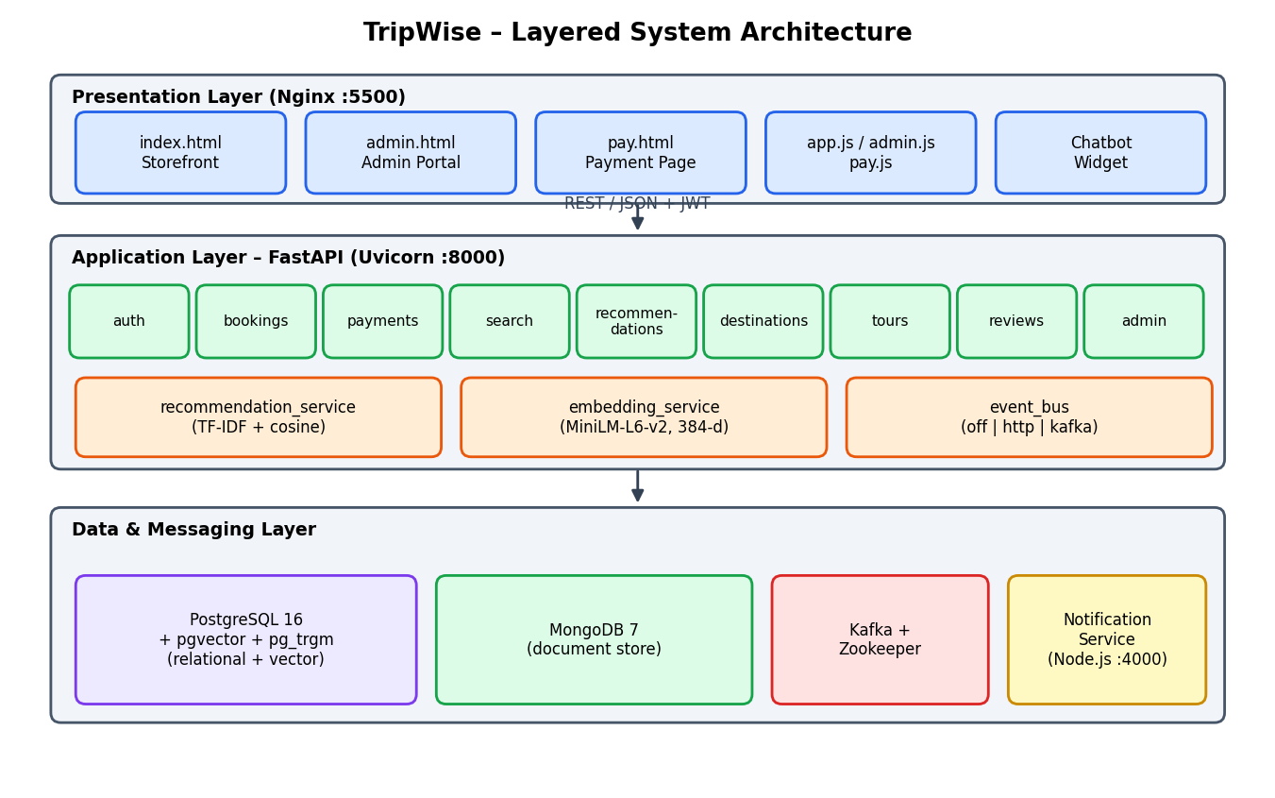
- Layered architecture of TripWise: presentation, application and data/messaging layers.

Technology stack
The technology choices follow the principle of using each tool where its strengths matter (Table III). All Python dependencies are pinned in requirements.txt, the back end image is based on python:3.11-slim with CPU-only PyTorch to avoid multi-gigabyte CUDA wheels, and the notification service uses node:20-alpine.
- Technology stack of the project
Layer | Technology / version | Purpose
Front end | HTML5, CSS3, vanilla JavaScript (≈4.1k lines incl. admin); Nginx 1.27 | Storefront, payment page, admin portal; static hosting and /api reverse proxy
API framework | FastAPI 0.115.0, Uvicorn 0.32.0, Pydantic 2.9 | Typed REST endpoints, validation, OpenAPI docs
Relational DB | PostgreSQL 16, SQLAlchemy 2.0.36 (async), asyncpg 0.30 | Transactional data, constraints, row locks, JSONB
Vector / text search | pgvector 0.3.6, pg_trgm, tsvector + GIN, HNSW index | Embedding similarity, full-text keyword ranking
Document DB | MongoDB 7, Motor 3.6.0, ODMantic 1.0.2 | Destinations, tours, reviews, preferences, notifications
Embeddings | sentence-transformers 3.3.1, all-MiniLM-L6-v2 (384-d) | Semantic representation of destination text
Security | passlib + bcrypt 4.0.1, python-jose (JWT, HS256) | Password hashing, 60-minute access tokens
Payments | qrcode[pil] 7.4.2 | QR code for the simulated UPI payment link
Messaging | aiokafka 0.11.0, httpx 0.27.2, Kafka/Zookeeper 7.6.0 | Event publishing in kafka or http mode
Notifications | Node.js 20, Express 4, mongodb driver 6, kafkajs 2, jsonwebtoken 9 | Event consumer and notification REST API
Packaging | Docker Compose (7 services, 3 volumes) | Reproducible deployment

Polyglot data distribution
Fig. 3 shows which data lives in which engine and Table IV lists the criteria that led to each placement. The rule applied throughout is simple: data that must be consistent, related and countable goes to PostgreSQL; data that is read as a whole, varies in shape, or is edited by administrators goes to MongoDB. The two stores are joined only by value – for instance destination_embeddings.destination_name matches destinations.name, and reviews.user_id stores the PostgreSQL user_id as text – so the application layer, not a distributed transaction, is responsible for cross-store consistency.
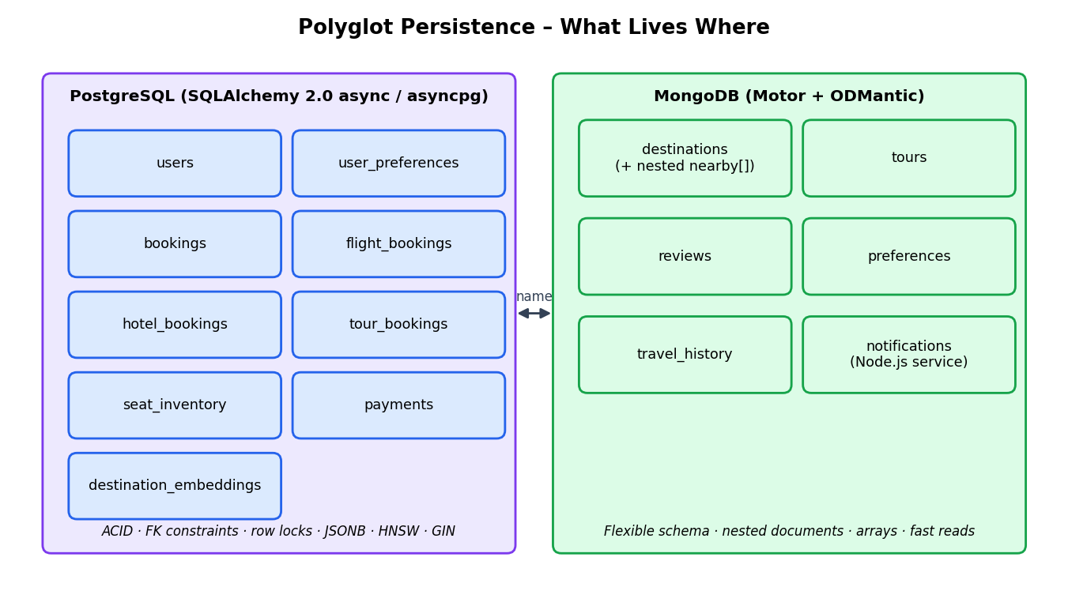
- Polyglot persistence: relational and vector data in PostgreSQL, document data in MongoDB.
- Criteria used to place each data set
Data set | Engine | Reason
Users, credentials, roles | PostgreSQL | Unique e-mail, referential parent of bookings and payments
Bookings and their flight/hotel/tour parts | PostgreSQL | Multi-row atomic writes, foreign keys, status life cycle
Seat inventory | PostgreSQL | Counters that need SELECT … FOR UPDATE row locks
Payments | PostgreSQL | Financial records; audit trail; ties to booking status
Destination embeddings | PostgreSQL + pgvector | Nearest-neighbour search and full-text ranking in one engine
Destinations (tags, nearby[ ]) | MongoDB | Nested arrays read together; schema evolves without migration
Tours and reviews | MongoDB | Free text, variable arrays, administrator-edited content
Preferences and travel history | MongoDB | Per-user documents with optional fields
Notifications | MongoDB | Append-heavy, write-once documents indexed by user and time

Relational schema design
The relational design (Fig. 4) has nine tables. users is the root: each user owns many bookings, many payments and (optionally) preference rows. bookings is the central business entity and carries the status, payment status, total price, currency and an attached activity plan. A booking is specialised into one or more part tables – flight_bookings, hotel_bookings and tour_bookings – each holding the details of that product type, so that columns that only make sense for flights (origin, destination, departure and return time) never appear as nullable noise on tours. payments links a booking to a payment attempt, and seat_inventory tracks capacity per route and date. destination_embeddings stores the vector and text-search data used by the AI features.
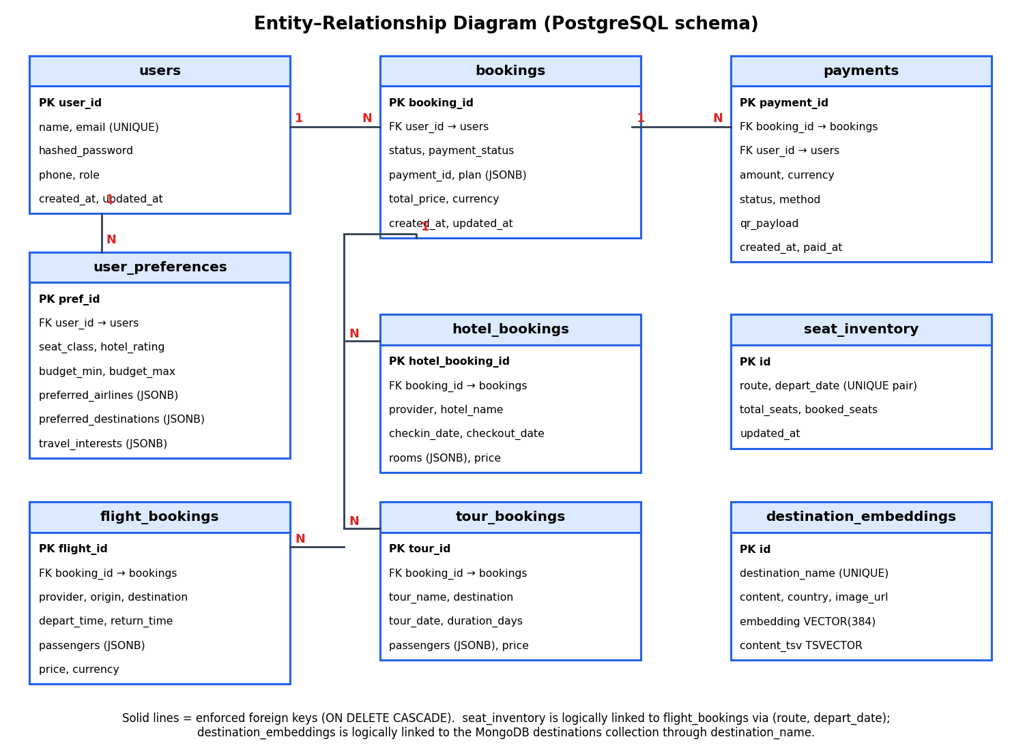
- Entity–relationship diagram of the PostgreSQL schema.

Data dictionary
Tables V to X give the data dictionary exactly as defined in app/models.py. Primary keys are marked PK and foreign keys FK; all foreign keys use ON DELETE CASCADE, so deleting a user removes that user's bookings, payments and preferences, and deleting a booking removes its flight, hotel and tour parts and its payments.
- Table users
Column | Type | Constraint / default | Description
user_id | BIGINT | PK, auto-increment | Surrogate identifier; shown as TW-US-00000001
name | VARCHAR(100) | NOT NULL | Full name
email | VARCHAR(255) | NOT NULL, UNIQUE, indexed | Login identifier
hashed_password | VARCHAR(255) | NOT NULL | bcrypt hash; the plain password is never stored
phone | VARCHAR(20) | NULL | Optional contact number
role | VARCHAR(20) | NOT NULL, default 'user' | user or admin
created_at / updated_at | TIMESTAMP | server default now(); update on change | Audit timestamps

- Table bookings
Column | Type | Constraint / default | Description
booking_id | BIGINT | PK, auto-increment | Shown as TW-BK-00000001
user_id | BIGINT | FK → users, ON DELETE CASCADE | Owner of the booking
status | VARCHAR(20) | NOT NULL, default 'pending' | pending, confirmed, cancelled
payment_status | VARCHAR(20) | NOT NULL, default 'unpaid' | unpaid, paid, refunded
payment_id | VARCHAR(64) | NULL | Latest payment reference
total_price | NUMERIC(12,2) | NOT NULL | Flight + stay + attached activities
currency | CHAR(3) | default 'INR' | ISO currency code
plan | JSONB | default [] | Attached activities: place_name, price_per_person, day
created_at / updated_at | TIMESTAMP | server default now() | Audit timestamps

- Tables flight_bookings, hotel_bookings and tour_bookings
Table | Columns (type) | Notes
flight_bookings | PK flight_id BIGINT; FK booking_id; provider VARCHAR(50) NOT NULL; origin CHAR(3) NOT NULL; destination CHAR(3) NOT NULL; depart_time TIMESTAMP NOT NULL; return_time TIMESTAMP; passengers JSONB NOT NULL; price NUMERIC(10,2) NOT NULL; currency CHAR(3) NOT NULL | Passenger list (name, age, type, contact, lead flag) is stored as JSONB; IATA-style 3-letter codes
hotel_bookings | PK hotel_booking_id BIGINT; FK booking_id; provider VARCHAR(50); hotel_name VARCHAR(255); checkin_date DATE; checkout_date DATE; rooms JSONB; price NUMERIC(10,2); currency CHAR(3) | Present in the schema for stay products; the storefront currently prices the stay inside the flight booking
tour_bookings | PK tour_id BIGINT; FK booking_id; tour_name VARCHAR(255) NOT NULL; destination VARCHAR(100); tour_date DATE NOT NULL; duration_days INT; passengers JSONB; price NUMERIC(10,2); currency CHAR(3) | Created by the tour booking modal

- Table payments
Column | Type | Constraint / default | Description
payment_id | VARCHAR(64) | PK | 'PAY-' + 16 hex characters (UUID based)
booking_id | BIGINT | FK → bookings, CASCADE | Booking being paid
user_id | BIGINT | FK → users, CASCADE | Payer
amount | NUMERIC(12,2) | NOT NULL | Booking total + method fee
currency | CHAR(3) | NOT NULL, default 'INR' | Copied from booking
status | VARCHAR(20) | NOT NULL, default 'pending' | pending, success, failed, refunded
method | VARCHAR(30) | NOT NULL | upi, card, netbanking, wallet (+ detail after confirmation)
qr_payload | VARCHAR | NULL | Payment link encoded in the QR code
created_at / paid_at | TIMESTAMP | default now(); paid_at NULL | Creation and settlement time

- Tables seat_inventory and user_preferences
Table | Columns (type) | Notes
seat_inventory | PK id BIGINT; route VARCHAR(10) NOT NULL; depart_date DATE NOT NULL; total_seats INT NOT NULL default 50; booked_seats INT NOT NULL default 0; updated_at TIMESTAMP | One row per route (e.g. DEL-BAL) and date; locked with FOR UPDATE during booking
user_preferences | PK pref_id BIGINT; FK user_id; seat_class VARCHAR(50) default 'Economy'; hotel_rating INT; budget_min, budget_max NUMERIC(10,2); preferred_airlines, preferred_destinations, travel_interests JSONB; language VARCHAR(10) default 'en' | Defined for relational preference storage; the live personalisation path stores preferences in MongoDB

- Table destination_embeddings
Column | Type | Constraint / default | Description
id | BIGINT | PK | Surrogate key
destination_name | VARCHAR(120) | NOT NULL, UNIQUE | Matches MongoDB destinations.name
content | TEXT | NOT NULL | Searchable text: name, country, tags, description
image_url / country | VARCHAR(500) / VARCHAR(100) | default '' | Display data returned with search hits
embedding | VECTOR(384) | — | Normalised MiniLM sentence embedding
content_tsv | TSVECTOR | GENERATED ALWAYS AS to_tsvector('english', content) STORED | Pre-computed full-text document
created_at | TIMESTAMP | default now() | Audit timestamp

Keys, constraints and referential integrity
Integrity is enforced by the database rather than left to application code (Table XI). Entity integrity comes from primary keys on every table; domain integrity from NOT NULL, column types such as NUMERIC(12,2) for money and CHAR(3) for codes, and defaults; and referential integrity from foreign keys with ON DELETE CASCADE. The unique constraint on users.email guarantees one account per address even if two registrations race, and the application translates the resulting error into a friendly message after an explicit pre-check.
- Integrity constraints in the relational schema
Constraint type | Where applied | Effect
PRIMARY KEY | All nine tables | Unique, non-null row identity; payments use a business-readable string key
UNIQUE | users.email; destination_embeddings.destination_name | One account per e-mail; one embedding row per destination
FOREIGN KEY … ON DELETE CASCADE | bookings.user_id; payments.user_id/booking_id; flight/hotel/tour_bookings.booking_id; user_preferences.user_id | No orphan child rows; user or booking deletion cleans dependants
NOT NULL | Prices, dates, status fields, provider, route | Rejects incomplete records
DEFAULT | status='pending', payment_status='unpaid', role='user', currency='INR', total_seats=50, booked_seats=0 | Safe initial state for new rows
GENERATED (stored) | content_tsv | Full-text vector cannot drift away from content
Application-level rules | Admin e-mail reserved; one review per user per destination; only pending bookings editable; confirmed bookings cannot be cancelled online | Business rules enforced in the API

Normalization analysis
The relational part of the schema is in third normal form (Table XII). Every non-key attribute depends on the key, the whole key and nothing but the key: user details live only in users; booking-level facts (status, total, plan) only in bookings; and product-specific facts only in the part tables. Splitting flight, hotel and tour data from bookings is an application of vertical decomposition that removes optional-column sparsity. Two deliberate denormalizations are made and documented: passenger and room lists are stored as JSONB arrays instead of separate child tables, because they are always read and written together with their parent row and are never joined or counted across bookings; and payments.amount stores the fee-inclusive total so that a receipt remains correct even if fee rates change later.
- Normal-form review
Table | 1NF | 2NF | 3NF | Comment
users | Yes | Yes | Yes | Single-column key; no transitive dependencies
bookings | Yes | Yes | Yes | payment_id duplicates the latest payment for fast lookup (controlled redundancy)
flight / hotel / tour_bookings | Yes (arrays in JSONB) | Yes | Yes | JSONB passengers/rooms are intentional document-style attributes
payments | Yes | Yes | Yes | user_id is also derivable via booking; kept for direct per-user history queries
seat_inventory | Yes | Yes | Yes | Natural key (route, depart_date); counters depend on both
destination_embeddings | Yes | Yes | Yes | content_tsv is a generated column, not a free attribute

Document model in MongoDB
The MongoDB database tripwise_db has six collections (Fig. 5 and Table XIII), mapped to Python classes with ODMantic so that documents are validated against typed models. A destination is a single document that embeds its list of nearby places, because the application always loads a destination together with its attractions and each attraction is meaningless without its parent. Reviews, by contrast, are kept in their own collection and linked by destination_name, because they grow without bound and are queried independently (by destination, by user, by the administrator).
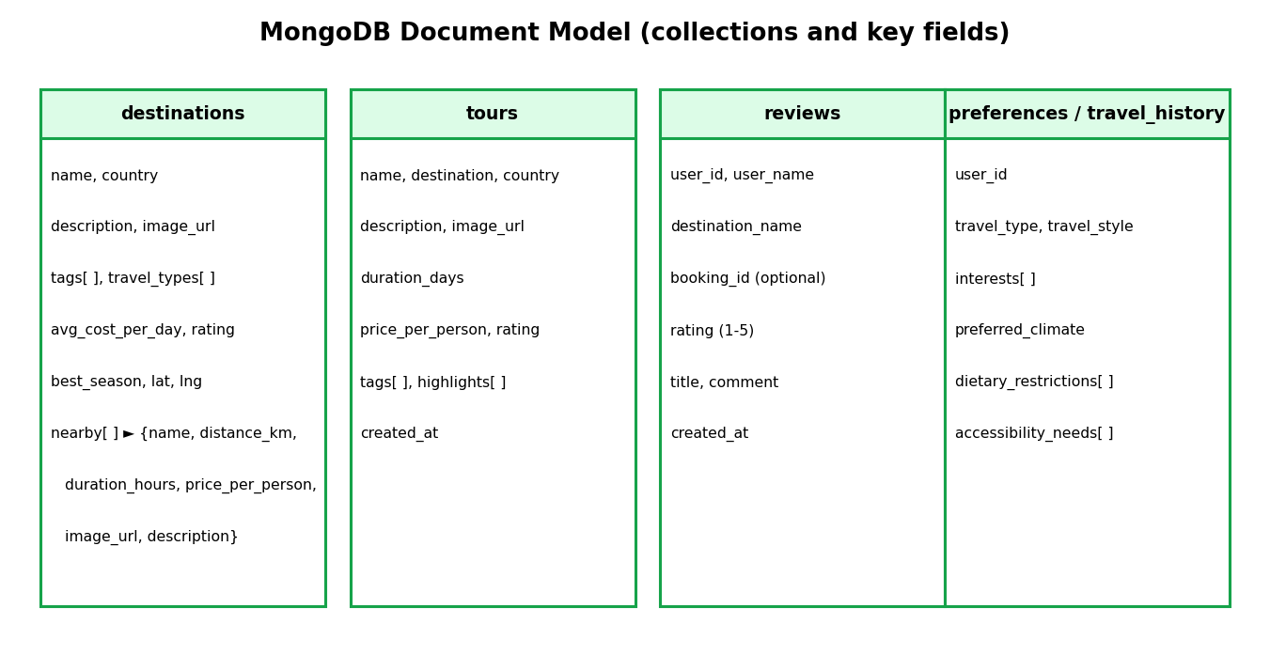
- MongoDB collections and their key fields.
- MongoDB collections
Collection | Key fields | Notes
destinations | name, country, description, image_url, tags[ ], travel_types[ ], avg_cost_per_day, best_season, rating, lat, lng, nearby[ ] | 30 seeded; nearby[ ] holds name, distance_km, duration_hours, price_per_person, image_url, description (4 per destination, 120 in total)
tours | name, destination, country, description, image_url, duration_days, price_per_person, rating, tags[ ], highlights[ ], created_at | 10 seeded curated packages
reviews | user_id, user_name, destination_name, booking_id, rating (1–5), title, comment, created_at | One review per user per destination (checked before insert)
preferences | user_id, travel_type, travel_style, interests[ ], preferred_climate, dietary_restrictions[ ], accessibility_needs[ ], created_at | Input to the recommender
travel_history | user_id, destinations[ ], total_trips, updated_at | Modelled for trip history
notifications | user_id, event_type, title, body, meta{ }, read, created_at | Written by the Node.js service; index {user_id: 1, created_at: −1}

A sample destination document, abbreviated from the seed data, illustrates the nesting:
{
"name": "Bali", "country": "Indonesia",
"tags": ["beach","culture","adventure","wellness"],
"travel_types": ["couple","friends","solo","family"],
"avg_cost_per_day": 75, "best_season": "May-September", "rating": 4.7,
"lat": -8.4095, "lng": 115.1889,
"nearby": [
{"name": "Ubud Monkey Forest", "distance_km": 15, "duration_hours": 2,
"price_per_person": 500, "description": "Sacred sanctuary with 1,200+ macaques."},
{"name": "Tanah Lot Temple", "distance_km": 22, "duration_hours": 3, "price_per_person": 400}
]
}
Listing 1. Abbreviated destination document (MongoDB).

Indexing strategy
Indexes are chosen per access path (Table XIV). The B-tree indexes behind primary keys and the unique e-mail constraint serve login and joins. The two indexes on destination_embeddings serve the AI features: an HNSW index on the embedding column with operator class vector_cosine_ops, m = 16 and ef_construction = 64, gives approximate nearest-neighbour search that scales sub-linearly, and a GIN index on the generated tsvector column serves keyword queries with @@. The pg_trgm extension is installed by the initialisation script (docker/init-pg.sql, which also creates the vector extension) to allow trigram-based fuzzy matching in future. In MongoDB, the notification service creates a compound index on user_id and descending created_at, which matches the dominant query – the latest 50 notifications for a user.
- Indexes used in the system
Index | Table / collection | Type | Serves
Primary-key indexes | All tables | B-tree | Lookups by id, join keys
users_email unique index | users | B-tree, UNIQUE | Login lookup, duplicate prevention
idx_dest_emb_hnsw | destination_embeddings(embedding) | HNSW, vector_cosine_ops, m=16, ef_construction=64 | Semantic nearest-neighbour search
idx_dest_emb_tsv | destination_embeddings(content_tsv) | GIN | Keyword match with to_tsquery
destination_name unique index | destination_embeddings | B-tree, UNIQUE | One vector per destination, upsert-safe seeding
{user_id, created_at} | notifications (MongoDB) | Compound | Latest notifications per user
_id | All MongoDB collections | Default | Document lookup by id

Vector and full-text capabilities
Semantic features rely on the all-MiniLM-L6-v2 sentence-transformer [3], which maps any text to a 384-dimensional vector. The embedding_service loads the model lazily on first use, so the API starts quickly, and always requests normalised vectors, which makes cosine similarity equal to a dot product. For every destination the seed script builds a content string (name, country, tags and description), embeds the whole batch with embed_batch (batch size 32) and stores the vector in destination_embeddings.embedding. The first run downloads about 90 MB of model weights; in Docker the Hugging Face cache is kept in a named volume (hf_cache) so the download happens only once.
In PostgreSQL the cosine distance operator <=> returns the distance between two vectors, so 1 − (embedding <=> query) is the similarity score. For keyword search the generated column content_tsv = to_tsvector('english', content) is maintained by the database itself; queries use to_tsquery('english', …) with ts_rank for scoring, and the GIN index makes @@ matching fast. Keeping vector data, text-search data and relational data in one engine means a hybrid query is a single SQL statement executed in one round trip, with no synchronisation job between a separate search server and the database.

Authentication and authorization
Passwords are hashed with bcrypt through passlib before storage. POST /auth/login accepts the OAuth2 password form, verifies the hash, and returns a JSON Web Token [11] signed with HS256 that carries the user id (sub), e-mail and role and expires after ACCESS_TOKEN_EXPIRE_MINUTES = 60. Protected endpoints depend on get_current_user, which decodes the token, loads the user from PostgreSQL and rejects invalid or unknown tokens with HTTP 401. Administrator endpoints additionally depend on require_admin, which allows access only to the single reserved address admin@tripwise.com whose stored role is admin; registration with that address is refused, and any other account that somehow holds the admin role is demoted to user at its next login. Ownership is enforced inside the booking and payment endpoints: a user who requests another user's booking receives HTTP 403.
The Node.js notification service validates the same JWT with the shared secret, so a user can read only the notifications whose user_id equals the token subject. The front end stores the token in localStorage and attaches it as a Bearer header through a small apiFetch wrapper that signs the user out when the API answers 401.

Recommendation engine
The recommender (recommendation_service.py) is a content-based filter written without external machine-learning libraries so that every step can be inspected and explained. Its pipeline is shown in Fig. 6. The traveller's saved profile is read from the preferences collection; if the traveller has no profile, the service falls back to the highest-rated destinations. Otherwise two kinds of text are built. The user document is the concatenation of the interest list, the travel style (the lower-cased cabin class, for example economy or business) and the travel type (solo, couple, family, friends or business). Each destination document is its name, country, tags and description.
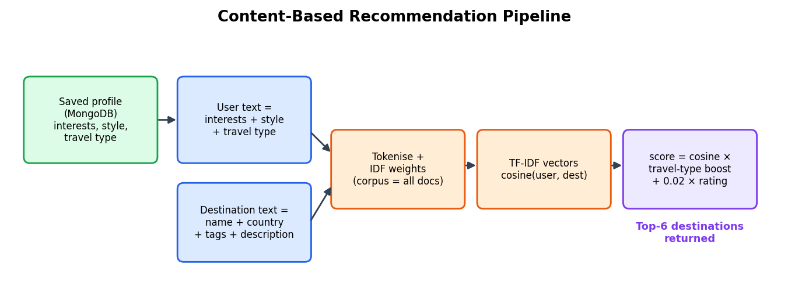
- Content-based recommendation pipeline (TF-IDF, cosine similarity, boost, rating bonus).
Tokens are lower-cased whitespace-separated words. For a term t in document D, the term frequency is tf(t, D) = count(t) / |D| and the inverse document frequency, computed over all destination documents plus the user document, is idf(t) = ln((1 + N) / (1 + df(t))) + 1 [1]. The TF-IDF vector of a document has the weight tf × idf for each of its terms. The base similarity is the cosine of the angle between the user vector u and destination vector v:
base(u, v) = (u · v) / (‖u‖ ‖v‖), score = base × boost(travel type, destination types) + 0.02 × rating.
The boost comes from a matrix that expresses how well each destination type suits each kind of traveller (Table XV). For a destination that lists several suitable travel types, the largest applicable factor is used; unknown combinations default to 0.70. The small rating term (at most 0.02 × 5 = 0.10) acts as a quality prior that breaks near-ties in favour of better-reviewed places without overriding interest matching. The destinations are sorted by score and the top six are returned by GET /recommendations.
- Travel-type boost matrix (rows: traveller; columns: destination suitability)
Traveller type | solo | couple | family | friends | Business
solo | 1.30 | 0.90 | 0.85 | 1.10 | 0.80
couple | 0.95 | 1.30 | 0.80 | 0.90 | 0.75
family | 0.70 | 0.95 | 1.35 | 0.85 | 0.60
friends | 1.10 | 0.90 | 0.85 | 1.30 | 0.75
business | 1.05 | 0.85 | 0.65 | 0.85 | 1.30

Semantic and hybrid search
Two search endpoints complement the recommender. GET /search/semantic embeds the query and returns the nearest destinations by cosine similarity. GET /search/hybrid combines meaning and wording (Fig. 7). The query is embedded once for the semantic branch. For the keyword branch it is split on non-word characters, lower-cased, stripped of words shorter than three letters and of a list of stop-words (including travel filler words such as place, visit, trip and want), and the survivors are joined with | to make an OR query: the sentence “romantic beach places to visit in asia” becomes romantic | beach | asia. If no keyword survives, the endpoint silently falls back to pure vector search.
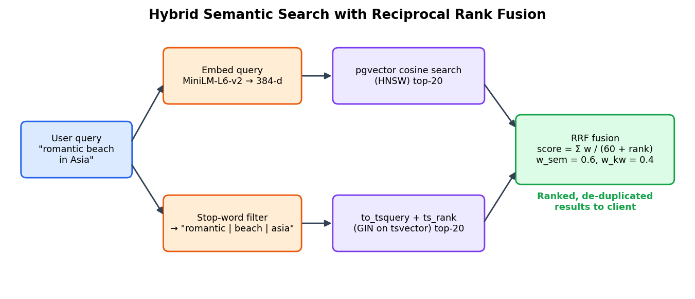
- Hybrid search: pgvector branch and full-text branch fused by Reciprocal Rank Fusion.
The two ranked lists (top 50 each) are fused with Reciprocal Rank Fusion [2]. A destination that appears at semantic rank r_s and keyword rank r_k receives score = α / (60 + r_s) + (1 − α) / (60 + r_k), where α is the request parameter alpha (default 0.6, range 0–1) and a missing rank contributes zero. RRF is attractive because it needs no score normalisation – cosine similarity and ts_rank live on different scales – and because a document that is good in both lists naturally rises above one that is excellent in only one. The whole computation is a single SQL statement made of two common table expressions and a left join, shown in Listing 2.
WITH vec AS (
SELECT id, 1-(embedding <=> CAST(:qvec AS vector)) AS sem_score,
ROW_NUMBER() OVER (ORDER BY embedding <=> CAST(:qvec AS vector)) AS sem_rank
FROM destination_embeddings
ORDER BY embedding <=> CAST(:qvec AS vector) LIMIT 50),
kw AS (
SELECT id, ts_rank(content_tsv, to_tsquery('english', :kw_or)) AS kw_score,
ROW_NUMBER() OVER (ORDER BY ts_rank(content_tsv,
to_tsquery('english', :kw_or)) DESC) AS kw_rank
FROM destination_embeddings
WHERE content_tsv @@ to_tsquery('english', :kw_or) LIMIT 50)
SELECT e.destination_name, e.content, e.image_url, e.country,
COALESCE(:alpha*(1.0/(60+v.sem_rank)),0)
+ COALESCE((1-:alpha)*(1.0/(60+k.kw_rank)),0) AS score
FROM destination_embeddings e
LEFT JOIN vec v ON v.id=e.id LEFT JOIN kw k ON k.id=e.id
WHERE v.id IS NOT NULL OR k.id IS NOT NULL
ORDER BY score DESC LIMIT :top_k;
Listing 2. Hybrid search query (RRF) as implemented in routers/search.py.

Itinerary planner
The planner turns the nearby places stored inside a destination document into a day-wise plan (Fig. 8). GET /destinations/{name}/itinerary receives a start date, an end date and an optional comma-separated interest list; POST /destinations/plan accepts a number of days (clamped to 1–14) and an optional per-person budget that removes places whose price is above it. Places are scored by counting how many interest keywords occur in their name or description, then sorted by interest score (descending), distance from the centre (ascending) and duration (ascending), so the nearest, most relevant sights come first. The sorted list is split into consecutive blocks of ⌈n / days⌉ places, each block becomes one day, the first day is labelled “Arrival & nearby”, the last “Last day / departure”, and every day carries the sum of its places' prices as estimated_cost. The date range is capped at 30 days. The traveller can tick places in the nearby dialog, and POST /bookings/{id}/attach-plan stores them in the booking's plan JSONB column and adds their prices to total_price.
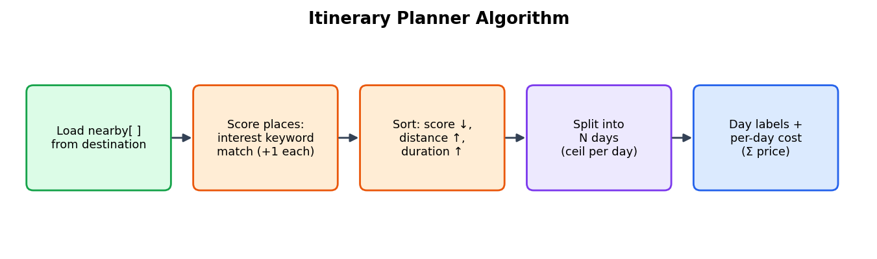
- Itinerary planner algorithm.

Booking workflow and concurrency control
The booking life cycle (Fig. 9 and Fig. 10) is the transactional heart of the system. The storefront computes an estimate and posts it to POST /bookings/flight: the flight cost is a base fare of Rs 75,000 per passenger multiplied by a cabin factor (Economy 1.0, Premium Economy 1.5, Business 2.6, First 4.0), and the stay cost is the destination's average daily cost converted at 85 INR per USD, multiplied by the number of nights and passengers. The route code is built from the origin (fixed to DEL in the storefront) and the first three letters of the destination, such as DEL-BAL.
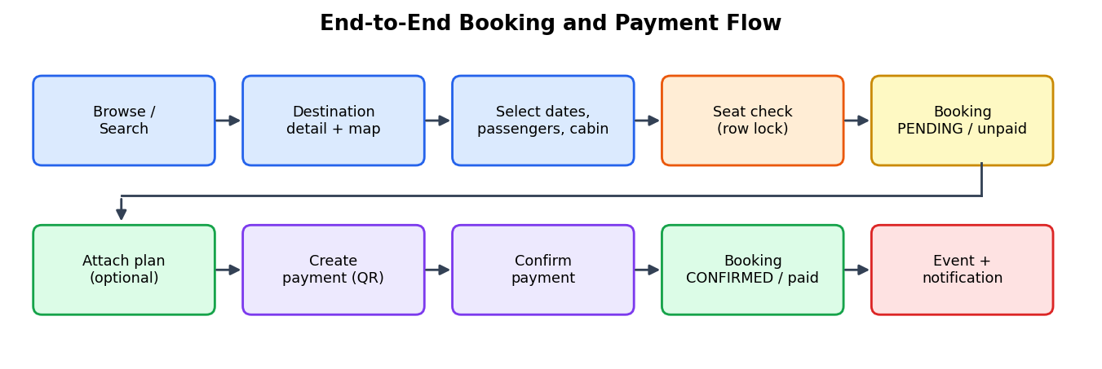
- End-to-end booking and payment flow.
Seat allocation is protected against concurrent requests by pessimistic locking (Listing 3). Inside one transaction the endpoint selects the seat_inventory row for the route and date with FOR UPDATE; a second request for the same route and date blocks until the first commits and then sees the updated counter. If the row does not exist it is created with 50 seats. If the requested passengers exceed the available seats the request is rejected with HTTP 400 and a message naming the remaining seats; otherwise booked_seats is incremented, a bookings row (status pending, payment status unpaid) and its flight_bookings row are inserted, and everything is committed together. Because the counter update and both inserts share one transaction, a failure at any point leaves no half-created booking and no leaked seat. After the commit the event booking.created is published.
inv = (await db.execute(
select(SeatInventory).where(SeatInventory.route == route,
SeatInventory.depart_date == depart_date)
.with_for_update())).scalar_one_or_none() # SELECT ... FOR UPDATE
if not inv:
inv = SeatInventory(route=route, depart_date=depart_date, total_seats=50, booked_seats=0)
db.add(inv); await db.flush()
available = inv.total_seats - inv.booked_seats
if available < pax_count:
raise HTTPException(400, f"Only {available} seat(s) available ...")
inv.booked_seats += pax_count
booking = Booking(user_id=..., status="pending", payment_status="unpaid", total_price=data.price)
db.add(booking); await db.flush()
db.add(FlightBooking(booking_id=booking.booking_id, ...)); await db.commit()
Listing 3. Seat reservation with row-level locking (routers/bookings.py, abridged).
A pending booking may be edited (dates, passengers, price) by its owner; confirmed bookings cannot be changed or cancelled online. Cancelling a pending booking sets its status to cancelled and returns the passengers' seats to seat_inventory (never below zero), then publishes booking.status.changed. Tour bookings (POST /bookings/tour) create the booking and its tour_bookings row without seat inventory. GET /bookings/availability lets the dialog show the remaining seats for a route and date before the traveller commits, returning 50 of 50 when no inventory row exists yet. GET /bookings/my-bookings returns the traveller's bookings with their flight or tour details.
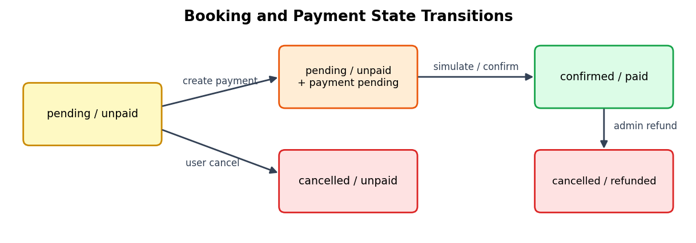
- Booking and payment state transitions.

Payment module
Payment is a separate step so that a traveller may create a booking now and pay later (Table XVI). POST /payments/create verifies that the booking exists, belongs to the caller and is not already paid; looks up the chosen method; adds the method fee to the booking total (fee = round(total × fee% / 100, 2)); and either reuses the booking's existing pending payment or inserts a new one with an identifier of the form PAY- plus sixteen hexadecimal characters. The response includes the payment link, a 600-second expiry hint, the list of supported banks for net banking, and, for UPI, a PNG QR code (error-correction level M) returned as a data URL. Scanning the QR code opens pay.html?token=<payment_id>, a standalone payment page that reads the amount through GET /payments/{id}/status and offers Pay Now and Pay Later.
- Payment methods and fees
Method id | Label | Fee (%) | Extra response data
upi | UPI / QR Code | 0.0 | QR code PNG data URL
card | Credit / Debit Card | 1.5 | —
netbanking | Net Banking | 0.5 | List of 8 banks (SBI, HDFC, ICICI, Axis, PNB, Kotak, Bank of Baroda, Yes Bank)
wallet | Wallet | 0.0 | —

POST /payments/{id}/confirm (and the backward-compatible alias /simulate) marks the payment success, stamps paid_at, appends a short method detail, sets the booking to confirmed/paid in the same transaction, and publishes payment.successful. Calling it again on a successful payment is idempotent and simply returns the stored result. POST /payments/{id}/fail marks a non-successful payment as failed, POST /payments/{id}/pay-later acknowledges postponement without changing state, and GET /payments/my-history and /{id}/receipt return the traveller's records. An administrator can refund a successful payment: the payment becomes refunded, the booking's payment status becomes refunded and a confirmed booking becomes cancelled, and payment.refunded is published. Because the gateway is simulated, the confirm endpoint is intentionally callable from the payment page without a bearer token; a production system would replace it with a signed gateway callback.

Event-driven notifications
Every important state change is published as an event envelope {event_type, occurred_at, payload} through services/event_bus.py (Fig. 11). In off mode the event is only logged, in http mode it is POSTed to the notification service (NOTIFY_URL), and in kafka mode it is produced to the topic tripwise.events with an idempotent, acknowledged (acks=all), gzip-compressed producer keyed by user id or booking id, so that events of one user stay ordered within a partition. Publishing failures are logged and swallowed: a broken message broker must never roll back a committed booking.
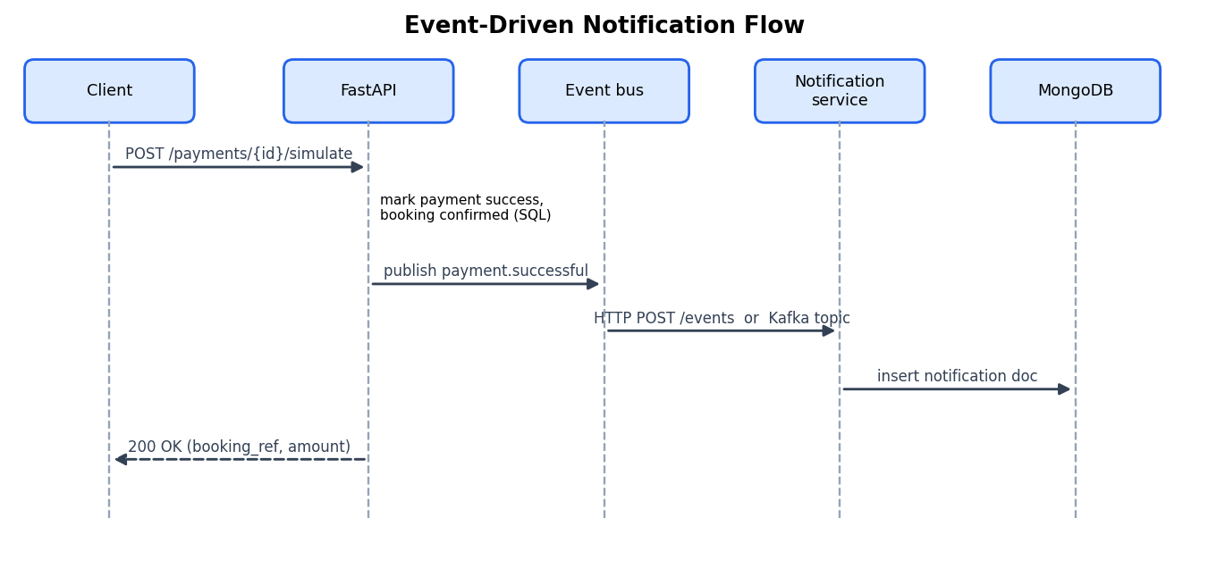
- Event-driven notification flow from the API to MongoDB.
The Node.js service renders each event into a notification document with a title and body and stores it with read: false (Table XVII). Clients read their latest 50 notifications with GET /notifications and mark one as read with PATCH /notifications/:id/read; both calls require the JWT. When KAFKA_ENABLED=true the same service also runs a KafkaJS consumer in the group tripwise-notif-group, so the system works identically with or without Kafka.
- Domain events and the notifications they produce
Event type | Raised by | Notification title
user.registered | POST /auth/register | Welcome to TripWise
booking.created | POST /bookings/flight, /bookings/tour | Booking received — TW-BK-…
booking.updated | PATCH /bookings/{id} | (generic event notification)
booking.plan.attached | POST /bookings/{id}/attach-plan | Activities added
booking.status.changed | Cancel, admin status change | Booking cancelled/confirmed — TW-BK-…
payment.successful | POST /payments/{id}/confirm | Payment received — TW-BK-…
payment.refunded | POST /admin/payments/{id}/refund | (generic event notification)

Rule-based assistant
The chat widget calls POST /search/chat, which delegates to rule_based_reply in _chatbot_rules.py. The assistant is a small keyword-scoring matcher: every rule lists trigger phrases, the score of a rule is the total length of the trigger phrases that occur in the message, and the highest-scoring rule answers; if nothing matches, a help message is returned. It covers greetings, login, registration, how to book, cancellation, nearby places, payment and cost, available destinations and thanks. The response model already contains a sources field and the configuration has placeholders for Gemini and OpenAI keys, which leaves a clear upgrade path to a retrieval-augmented assistant built on the same embeddings, but the present implementation is deterministic and needs no external service.

Administrator portal and analytics
The administrator portal (admin.html) offers a dashboard, user, booking, payment, destination, tour and review views, and an analytics view with a revenue chart. Behind it, /admin/* endpoints provide list, view, update and delete operations for users (including a role change), bookings (status change, edit, delete), payments (list and refund), destinations, tours and reviews (CRUD against MongoDB). GET /admin/db-stats reports the database name, server version and row counts for five tables.
GET /admin/analytics demonstrates several SQL features in three queries (Listing 4): conditional aggregation with COUNT(*) FILTER (WHERE …) and SUM(…) FILTER (WHERE …) for booking and payment totals in a single scan, and a LEFT JOIN with GROUP BY and the window function ROW_NUMBER() OVER (ORDER BY …) to rank the top ten customers by confirmed spend while still listing users with no bookings.
SELECT COUNT(*) AS total_bookings,
COUNT(*) FILTER (WHERE status='confirmed') AS confirmed,
COUNT(*) FILTER (WHERE status='pending') AS pending,
COUNT(*) FILTER (WHERE status='cancelled') AS cancelled,
COALESCE(SUM(total_price) FILTER (WHERE status='confirmed'),0) AS revenue,
COALESCE(SUM(total_price),0) AS gross_volume
FROM bookings;

SELECT u.email,
COUNT(b.booking_id) FILTER (WHERE b.status='confirmed') AS total_bookings,
COALESCE(SUM(b.total_price) FILTER (WHERE b.status='confirmed'),0) AS total_spent,
ROW_NUMBER() OVER (ORDER BY COALESCE(SUM(b.total_price)
FILTER (WHERE b.status='confirmed'),0) DESC) AS rank
FROM users u LEFT JOIN bookings b ON b.user_id = u.user_id
GROUP BY u.email ORDER BY rank LIMIT 10;
Listing 4. Administrator analytics queries (routers/admin.py, abridged).

Front-end design
The storefront is a single-page application without a framework. index.html holds the page sections (hero search, destinations, tours, reviews, recommendations) and fourteen modal dialogs (login, register, profile and preferences, my bookings, flight booking, tour booking, payment, edit booking, review, confirmation, destination detail, nearby places and planner). app.js (about 1,300 lines) implements API access, rendering, cost estimation, the booking and payment flows, the map and the chatbot. The booking dialog recalculates the estimated cost on every input event, pre-selects the traveller's preferred cabin, and shows a “Personalized for you” box listing the travel style, preferred cabin and maximum budget taken from the saved preferences. The destination detail view uses an interactive map with markers for the destination and its nearby places. All text that comes from the database is passed through an escapeHtml helper before insertion, which prevents stored cross-site-scripting through reviews or administrator-edited content.

Deployment and configuration
The whole platform starts with docker compose up (Fig. 12). Seven services are defined: postgres (health-checked with pg_isready), mongo (health-checked with a mongosh ping), zookeeper, kafka, backend, notifications and frontend. The backend waits for both databases to be healthy; the frontend publishes port 5500. Data survives restarts in three named volumes (pgdata, mongodata, hf_cache). Kafka and Zookeeper are optional because the default event-bus mode is off. Configuration is supplied through environment variables read by pydantic-settings (Table XVIII), with an .env file supported for local development.
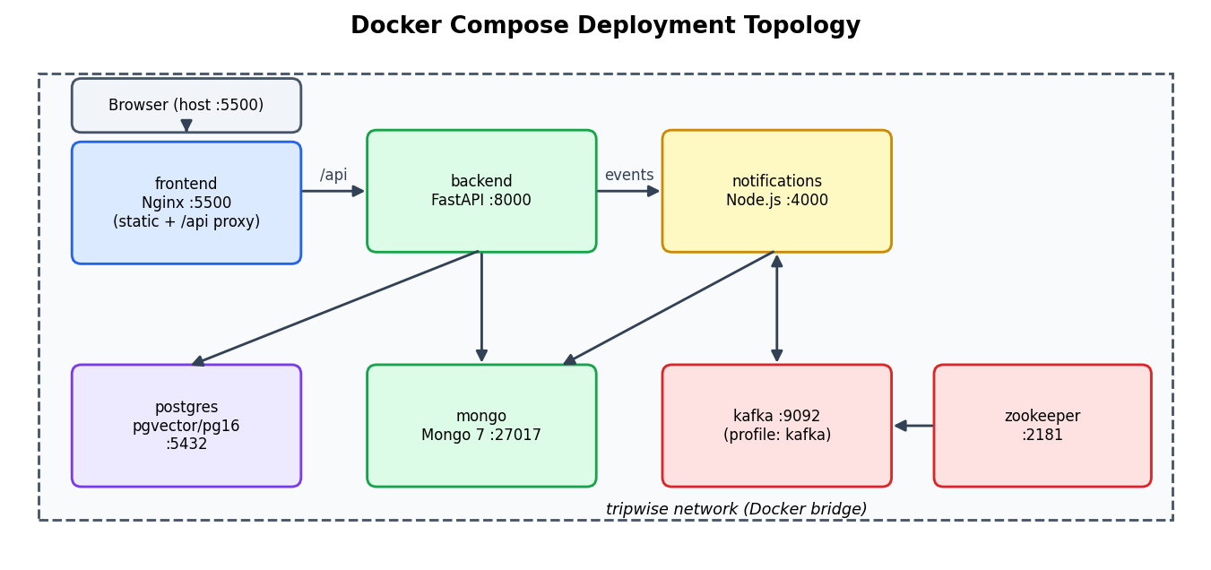
- Docker Compose deployment topology.
- Main configuration parameters
Variable | Default / example | Meaning
DATABASE_URL | postgresql+asyncpg://…@postgres:5432/tripwise | PostgreSQL connection (async driver)
MONGODB_URL / MONGODB_DB | mongodb://mongo:27017 / tripwise_db | MongoDB connection and database name
SECRET_KEY, ALGORITHM | (secret) / HS256 | JWT signing key and algorithm
ACCESS_TOKEN_EXPIRE_MINUTES | 60 | Token lifetime
EVENT_BUS_MODE | off | http | kafka | Event publishing mode
KAFKA_BROKER, KAFKA_TOPIC | kafka:9092, tripwise.events | Kafka endpoint and topic
NOTIFY_URL | http://notifications:4000/notify | HTTP target in http mode
KAFKA_ENABLED (notifications) | false | Starts the Kafka consumer in the Node service
GEMINI_API_KEY, OPENAI_API_KEY | empty | Reserved for a future LLM assistant

API reference
The REST API is self-documented by FastAPI at /docs. Tables XIX and XX summarise the endpoints by router. Authentication column: P = public, U = signed-in user, A = administrator.
- User-facing endpoints
Method and path | Auth | Purpose
POST /auth/register | P | Create an account (reserved admin e-mail refused)
POST /auth/login | P | Return a JWT access token
GET /profile/me | U | Current user profile with TW-US reference
GET, POST /profile/preferences | U | Read / save interests, travel type and style (MongoDB)
GET /destinations, /destinations/{name} | P | List destinations; one destination with nearby places
GET /destinations/{name}/nearby | P | Nearby places of a destination
POST /destinations/plan | P | Itinerary for N days with optional budget
GET /destinations/{name}/itinerary | P | Date-based itinerary with interests
GET /tours, /tours/{id} | P | List tours; one tour
GET /reviews/{destination} | P | Reviews of a destination
POST /reviews; GET /reviews/me/list; DELETE /reviews/{id} | U | Create (one per destination), list own, delete
GET /recommendations; /recommendations/all | U / P | Top-6 personalised destinations; all destinations
GET /search/semantic; /search/hybrid; POST /search/chat | P | Vector search; hybrid RRF search; assistant
GET /bookings/availability | P | Seats left for a route and date
POST /bookings/flight; POST /bookings/tour | U | Create flight/stay or tour booking
GET /bookings/my-bookings | U | List own bookings
PATCH /bookings/{id}; PATCH /bookings/{id}/cancel | U | Edit or cancel a pending booking
POST /bookings/{id}/attach-plan | U | Attach activities and add their price
GET /payments/methods | P | Methods, fees and banks
POST /payments/create | U | Create or reuse a pending payment
GET /payments/{id}/status; POST …/confirm, /simulate, /fail, /pay-later | P | Status and state changes (simulated gateway)
GET /payments/my-history; GET /payments/{id}/receipt | U | Payment history and receipt
GET /health; GET / | P | Liveness and version

- Administrator endpoints (prefix /admin, all require role A)
Method and path | Purpose
GET /users; GET /users/{id}; PATCH /users/{id}; PATCH /users/{id}/role; DELETE /users/{id} | User management
GET /bookings; PATCH /bookings/{id}/status; PATCH /bookings/{id}; DELETE /bookings/{id} | Booking management
GET /payments; POST /payments/{id}/refund | Payment list and refund
GET, POST /destinations; PUT, DELETE /destinations/{name} | Destination CRUD (MongoDB)
GET, POST /tours; PUT, DELETE /tours/{id} | Tour CRUD (MongoDB)
GET /reviews; PATCH, DELETE /reviews/{id} | Review moderation
GET /analytics; GET /db-stats | Revenue, status counts, top users; database statistics

SQL schema and query catalogue
For completeness Listing 5 gives the PostgreSQL DDL that is equivalent to the SQLAlchemy models (the application creates the tables itself on start-up with create_all). The data-definition statements make the keys, constraints, generated column and indexes explicit. Listing 6 then shows representative queries that the schema supports. The analytics statements of Listing 4 and the hybrid-search statement of Listing 2 are part of the code base; the remaining queries are provided to demonstrate the query capabilities of the design (joins, anti-join, grouping, JSONB expansion, vector search and a reporting view) and can be run directly on the seeded database.
CREATE EXTENSION IF NOT EXISTS vector; CREATE EXTENSION IF NOT EXISTS pg_trgm;

CREATE TABLE users (
user_id BIGSERIAL PRIMARY KEY, name VARCHAR(100) NOT NULL,
email VARCHAR(255) NOT NULL UNIQUE, hashed_password VARCHAR(255) NOT NULL,
phone VARCHAR(20), role VARCHAR(20) NOT NULL DEFAULT 'user',
created_at TIMESTAMP DEFAULT now(), updated_at TIMESTAMP DEFAULT now());

CREATE TABLE user_preferences (
pref_id BIGSERIAL PRIMARY KEY,
user_id BIGINT REFERENCES users(user_id) ON DELETE CASCADE,
seat_class VARCHAR(50) DEFAULT 'Economy', hotel_rating INT,
budget_min NUMERIC(10,2), budget_max NUMERIC(10,2),
preferred_airlines JSONB DEFAULT '[]', preferred_destinations JSONB DEFAULT '[]',
travel_interests JSONB DEFAULT '[]', language VARCHAR(10) DEFAULT 'en');

CREATE TABLE bookings (
booking_id BIGSERIAL PRIMARY KEY,
user_id BIGINT REFERENCES users(user_id) ON DELETE CASCADE,
status VARCHAR(20) NOT NULL DEFAULT 'pending',
payment_status VARCHAR(20) NOT NULL DEFAULT 'unpaid', payment_id VARCHAR(64),
total_price NUMERIC(12,2) NOT NULL, currency CHAR(3) DEFAULT 'INR',
plan JSONB DEFAULT '[]', created_at TIMESTAMP DEFAULT now(), updated_at TIMESTAMP DEFAULT now());

CREATE TABLE flight_bookings (
flight_id BIGSERIAL PRIMARY KEY,
booking_id BIGINT REFERENCES bookings(booking_id) ON DELETE CASCADE,
provider VARCHAR(50) NOT NULL, origin CHAR(3) NOT NULL, destination CHAR(3) NOT NULL,
depart_time TIMESTAMP NOT NULL, return_time TIMESTAMP, passengers JSONB NOT NULL,
price NUMERIC(10,2) NOT NULL, currency CHAR(3) NOT NULL);

CREATE TABLE hotel_bookings (
hotel_booking_id BIGSERIAL PRIMARY KEY,
booking_id BIGINT REFERENCES bookings(booking_id) ON DELETE CASCADE,
provider VARCHAR(50) NOT NULL, hotel_name VARCHAR(255) NOT NULL,
checkin_date DATE NOT NULL, checkout_date DATE NOT NULL, rooms JSONB NOT NULL,
price NUMERIC(10,2) NOT NULL, currency CHAR(3) DEFAULT 'INR');

CREATE TABLE tour_bookings (
tour_id BIGSERIAL PRIMARY KEY,
booking_id BIGINT REFERENCES bookings(booking_id) ON DELETE CASCADE,
tour_name VARCHAR(255) NOT NULL, destination VARCHAR(100), tour_date DATE NOT NULL,
duration_days INT, passengers JSONB DEFAULT '[]',
price NUMERIC(10,2) NOT NULL, currency CHAR(3) DEFAULT 'INR');

CREATE TABLE seat_inventory (
id BIGSERIAL PRIMARY KEY, route VARCHAR(10) NOT NULL, depart_date DATE NOT NULL,
total_seats INT NOT NULL DEFAULT 50, booked_seats INT NOT NULL DEFAULT 0,
updated_at TIMESTAMP DEFAULT now());

CREATE TABLE payments (
payment_id VARCHAR(64) PRIMARY KEY,
booking_id BIGINT REFERENCES bookings(booking_id) ON DELETE CASCADE,
user_id BIGINT REFERENCES users(user_id) ON DELETE CASCADE,
amount NUMERIC(12,2) NOT NULL, currency CHAR(3) NOT NULL DEFAULT 'INR',
status VARCHAR(20) NOT NULL DEFAULT 'pending',
method VARCHAR(30) NOT NULL DEFAULT 'qr_simulated', qr_payload VARCHAR,
created_at TIMESTAMP DEFAULT now(), paid_at TIMESTAMP);

CREATE TABLE destination_embeddings (
id BIGSERIAL PRIMARY KEY, destination_name VARCHAR(120) NOT NULL UNIQUE,
content TEXT NOT NULL, image_url VARCHAR(500) DEFAULT '', country VARCHAR(100) DEFAULT '',
embedding VECTOR(384),
content_tsv TSVECTOR GENERATED ALWAYS AS (to_tsvector('english', content)) STORED,
created_at TIMESTAMP DEFAULT now());
CREATE INDEX idx_dest_emb_hnsw ON destination_embeddings
USING hnsw (embedding vector_cosine_ops) WITH (m = 16, ef_construction = 64);
CREATE INDEX idx_dest_emb_tsv ON destination_embeddings USING gin (content_tsv);
Listing 5. PostgreSQL DDL equivalent to the SQLAlchemy models.
-- Q1 Booking history of one traveller (join)
SELECT b.booking_id, b.status, b.payment_status, b.total_price,
f.origin, f.destination, f.depart_time
FROM bookings b JOIN flight_bookings f USING (booking_id)
WHERE b.user_id = :uid ORDER BY b.created_at DESC;

-- Q2 Seats still available per route and date
SELECT route, depart_date, total_seats - booked_seats AS available
FROM seat_inventory WHERE depart_date >= CURRENT_DATE ORDER BY depart_date;

-- Q3 Collected money by payment method (detail after ':' is ignored)
SELECT split_part(method, ':', 1) AS method, COUNT(*) AS payments, SUM(amount) AS collected
FROM payments WHERE status = 'success' GROUP BY 1 ORDER BY collected DESC;

-- Q4 Registered users who never booked (anti-join)
SELECT u.user_id, u.email FROM users u
WHERE NOT EXISTS (SELECT 1 FROM bookings b WHERE b.user_id = u.user_id);

-- Q5 Pending bookings older than 24 hours (clean-up candidates)
SELECT booking_id, user_id, created_at FROM bookings
WHERE status = 'pending' AND created_at < now() - interval '24 hours';

-- Q6 Most booked routes among confirmed bookings
SELECT fb.origin || '-' || fb.destination AS route, COUNT(*) AS bookings, SUM(fb.price) AS value
FROM flight_bookings fb JOIN bookings b USING (booking_id)
WHERE b.status = 'confirmed' GROUP BY 1 ORDER BY bookings DESC LIMIT 5;

-- Q7 Passenger count and planned activities (JSONB functions)
SELECT booking_id, jsonb_array_length(passengers) AS pax FROM flight_bookings;
SELECT b.booking_id, p->>'place_name' AS place, (p->>'price_per_person')::numeric AS price
FROM bookings b, jsonb_array_elements(b.plan) AS p WHERE b.booking_id = :id;

-- Q8 Five nearest destinations to a query vector (pgvector, uses HNSW)
SELECT destination_name, 1 - (embedding <=> :qvec) AS score
FROM destination_embeddings ORDER BY embedding <=> :qvec LIMIT 5;

-- Q9 Monthly collected revenue as a reporting view
CREATE VIEW v_monthly_revenue AS
SELECT date_trunc('month', paid_at) AS month, SUM(amount) AS collected
FROM payments WHERE status = 'success' GROUP BY 1;

// Q10 MongoDB: beach destinations for couples, best rated first
db.destinations.find({tags: "beach", travel_types: "couple"}).sort({rating: -1})
// Q11 MongoDB: average rating per destination from reviews
db.reviews.aggregate([{$group: {_id: "$destination_name", avg: {$avg: "$rating"}, n: {$sum: 1}}},
{$sort: {avg: -1}}])
// Q12 MongoDB: free attractions across destinations (unwind nested array)
db.destinations.aggregate([{$unwind: "$nearby"}, {$match: {"nearby.price_per_person": 0}},
{$project: {_id: 0, name: 1, "nearby.name": 1}}])
Listing 6. Representative SQL and MongoDB queries supported by the schema.
- Query catalogue and techniques
Query | Technique | Purpose
Q1 | INNER JOIN with USING, ORDER BY | My-bookings style history
Q2 | Arithmetic on columns, date predicate | Seat availability report
Q3 | GROUP BY, split_part, SUM | Revenue per payment method
Q4 | Correlated NOT EXISTS (anti-join) | Find inactive users
Q5 | Interval arithmetic | Expire stale pending bookings
Q6 | JOIN, string concatenation, aggregation, LIMIT | Popular routes
Q7 | jsonb_array_length, jsonb_array_elements, ->> and casts | Query inside JSONB columns
Q8 | Vector distance operator <=> with HNSW index | Semantic nearest neighbours
Q9 | VIEW, date_trunc | Reusable monthly report
Q10–Q12 | find, aggregate, $group, $unwind, $match | Document queries on MongoDB

Transactions, ACID properties and concurrency
Each state-changing API call maps to one database transaction (Table below). Atomicity: booking creation updates the seat counter and inserts two rows, and payment confirmation updates a payment row and a booking row; each group is committed together or not at all. Consistency: foreign keys, NOT NULL and UNIQUE constraints reject invalid states, and the application rejects invalid transitions (for example cancelling a confirmed booking). Isolation: the engine runs at PostgreSQL's default READ COMMITTED level; where this is not sufficient – the shared seat counter – the code takes an explicit row lock with SELECT … FOR UPDATE, so competing transactions are serialised on that row (Fig. 13). Durability: committed data is written to the write-ahead log and stored on the named Docker volumes pgdata and mongodata, which survive container restarts.
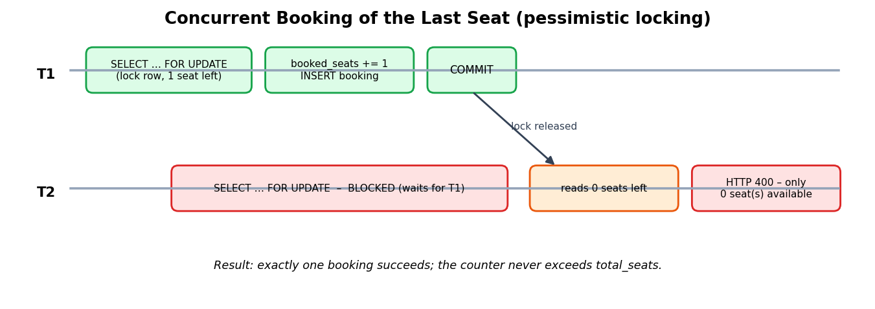
- Two concurrent transactions competing for the last seat.
- Transaction boundaries of the main operations
Operation | Rows read / written in one transaction | Isolation device
Create flight booking | Lock and update seat_inventory; insert bookings and flight_bookings | FOR UPDATE row lock
Cancel booking | Read booking and flight; update seat_inventory and bookings | Ownership and status checks
Attach plan | Update bookings.plan and total_price | Single-row update
Create payment | Read booking; reuse or insert payments; set bookings.payment_id | Pending-payment reuse prevents duplicates
Confirm payment | Update payments (success) and bookings (confirmed, paid) | Idempotent: success is returned unchanged on repeat
Refund (admin) | Update payments (refunded) and bookings | Only status 'success' accepted
Register | Check e-mail; insert users | UNIQUE(email) as final guard

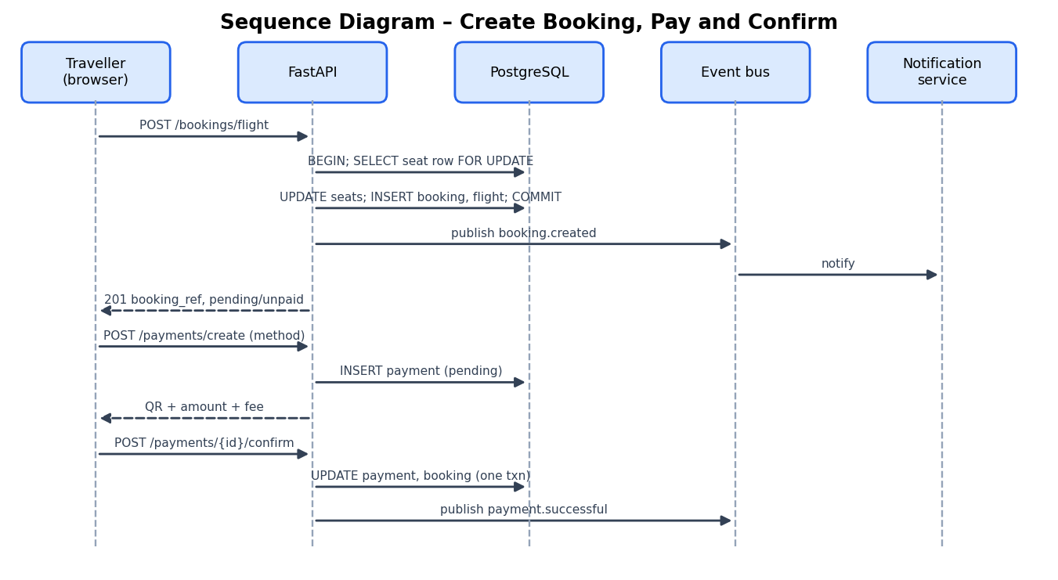
- Sequence diagram for booking, payment and notification.

Security analysis and performance considerations
Table below reviews the main threats against the implemented controls. Database access uses bound parameters everywhere – SQLAlchemy expressions or text() statements with named parameters – so user input is never concatenated into SQL; MongoDB access goes through typed ODMantic models or fixed query documents, which prevents operator injection from request bodies. Controls that are still missing are listed in the limitations table of the conclusion.
- Threats and countermeasures
Threat | Countermeasure in TripWise | Residual risk
SQL injection | Bound parameters in all statements; Pydantic validation of inputs | Low
Cross-site scripting | escapeHtml / escapeAttr before inserting database text into the page | Low
Password disclosure | bcrypt hashes with per-password salt; no plain text stored or logged | Low
Token theft or replay | 60-minute expiry; HTTPS recommended in deployment | Medium without TLS
Privilege escalation | require_admin on every /admin route; admin role bound to one reserved e-mail; ownership checks on bookings and payments | Low
Insecure direct object reference | 403 when booking user_id differs from token user | Low
Payment forgery | Not mitigated: confirm endpoint is public in the simulated gateway | High – demo only
Secret leakage | Defaults exist in configuration files | Medium – use secret store
Excess cross-origin access | CORS allows all origins (no credentials) | Medium – restrict origins

On the performance side, three design choices matter. All I/O is asynchronous, so one worker handles many concurrent requests while queries run. The vector index trades a small recall loss for logarithmic-style lookup, and ef_construction = 64 with m = 16 are moderate values suited to a catalogue that is far smaller than the millions of vectors for which HNSW is usually tuned. The recommender recomputes IDF on each call, a cost proportional to the number of destinations and the average document length; at 30 destinations this is negligible, and the obvious optimisation for a larger catalogue is to cache the IDF table and destination vectors and refresh them when an administrator edits a destination.

Experiments

Experimental objectives
The experiments are designed around the question: does the data layer and the logic built on it behave as specified? Because the database engines run inside containers and the AI components are deterministic functions over stored data, the experiments combine (i) analysis of the seed data that every other result depends on, (ii) execution of the project's own recommendation, itinerary, pricing, payment-fee, query-building and chatbot functions on that data, and (iii) a set of functional test scenarios that define the expected behaviour of each API operation, including the integrity and concurrency rules. Eight experiments were carried out (Table XXIV).
- Experiment plan
ID | Experiment | Component under test | Measure
E1 | Dataset profiling | Seed data in MongoDB / PostgreSQL | Counts, distributions, cost and rating statistics
E2 | Recommender on six traveller profiles | recommendation_service | Top-ranked destinations, scores, explanation of ranking
E3 | Travel-type sensitivity | TRAVEL_TYPE_BOOST | Change of ranking for identical interests
E4 | Itinerary generation | _rank_places, _distribute | Day allocation, per-day cost
E5 | Booking price and payment fee calculation | Booking estimate, PAYMENT_METHODS | Totals for sample bookings
E6 | Query processing for hybrid search | _build_or_query, RRF formula | Keyword query and fused scores
E7 | Rule-based assistant | rule_based_reply | Matched intent per utterance
E8 | Functional and integrity scenarios | Routers, constraints, transactions | Expected behaviour per scenario

Code base and project structure
Table below lists the principal source files with their role and size, which gives a measure of where the project's complexity lies: the administrator router and the storefront script are the largest files, followed by the booking router, the payment router and the seed data.
- Source files, roles and line counts
File | Role | Lines
app/main.py, config.py, db.py | Application factory, settings, database engines (PostgreSQL and MongoDB) | 49 / 24 / 29
app/models.py, models_mongo.py | SQLAlchemy tables; ODMantic document models | 136 / 65
app/routers/auth.py | Registration, login, JWT dependencies, profile and preferences | 164
app/routers/bookings.py | Availability, flight/tour booking, my-bookings, cancel, edit, attach plan | 423
app/routers/payments.py | Methods, create, status, confirm, fail, pay later, history, receipt, QR code | 313
app/routers/destinations.py | Destination list/detail, nearby places, planner, itinerary | 240
app/routers/search.py, _chatbot_rules.py | Semantic search, hybrid search, chat | 147 / 51
app/routers/admin.py | Administrator CRUD, refund, analytics, db-stats | 545
app/routers/reviews.py, tours.py, recommendations.py | Reviews, tours, recommendations | 89 / 60 / 31
app/services/*.py | Recommendation, embedding and event-bus services | 85 / 24 / 67
app/utils/security.py | Password hashing, JWT, auth schemas | 53
app/scripts/seed_all.py and _data_*.py | Seeding and seed data | 115 / 394 / 61 / 11
notifications/server.js | Node.js notification service | 113
frontend/index.html, admin.html, pay.html | Storefront, admin portal and payment pages | 419 / 270 / 33
frontend/js/app.js, admin.js, pay.js | Client logic | 1,324 / 607 / 89
frontend/css/style.css, admin.css | Styling | 383 / 998
docker-compose.yml, Dockerfile.backend, nginx.conf | Deployment | 112 / 40 / 18

Test environment
The reference environment is the Docker Compose stack: PostgreSQL 16 with pgvector (pgvector/pgvector:pg16), MongoDB 7, Python 3.11 with FastAPI 0.115, Node.js 20 for the notification service, and Nginx 1.27 for the front end, all on a single developer machine. The application code comprises about 2,600 lines of application Python in app/ (plus about 580 lines of seed scripts and data) and about 4,100 lines of HTML, CSS and JavaScript in frontend/. For experiments E2–E7 the project's own pure functions were executed unchanged on the seed data, which makes the numbers reported in the next section reproducible by anyone who has the source code; E8 is specified as a scenario catalogue derived from the implemented rules and is suitable for manual or automated execution against the running stack.

Dataset and seed procedure
app/scripts/seed_all.py populates both databases in one run: it creates the administrator account (admin@tripwise.com), loads destinations, tours and sample reviews into MongoDB, and then embeds every destination and fills destination_embeddings in PostgreSQL. The destination set spans 27 countries on six continents and was written to cover contrasting interests: beach and diving (Maldives, Phuket), culture and history (Kyoto, Rome, Jaipur), food and nightlife (Tokyo, Bangkok, Barcelona), adventure and nature (Reykjavik, Machu Picchu, Cape Town) and luxury and shopping (Dubai, Zurich, Hong Kong). Table XXVI and Figs. 15–16 summarise it.
- Seed data summary
Item | Value
Destinations | 30 documents in 27 countries (Japan, India and Thailand have two each)
Nearby places | 120 (exactly 4 per destination); price per person from Rs 0 to Rs 28,000, mean ≈ Rs 2,059; 33 places are free
Interest tags | 25 distinct tags; 24 destinations carry 4 tags, 4 carry 5, 2 carry 3
Most frequent tags | food (20), culture (19), shopping (12), nightlife (11), beach (10), history (9)
Travel-type suitability labels | couple 25, solo 23, friends 21, family 13, business 5
Average cost per day (USD) | min 45 (Jaipur), median 135, mean ≈ 142.8, max 400 (Maldives)
Destination rating | min 4.3, max 4.9, mean ≈ 4.64
Tours | 10 packages, 4–9 days (mean 6.2), Rs 18,000–2,20,000 per person (mean ≈ Rs 86,800), ratings 4.5–4.9
Reviews | 10 sample reviews (six 5-star, four 4-star)
Embeddings | 30 vectors of 384 dimensions, one per destination
Admin account | 1 (role admin)

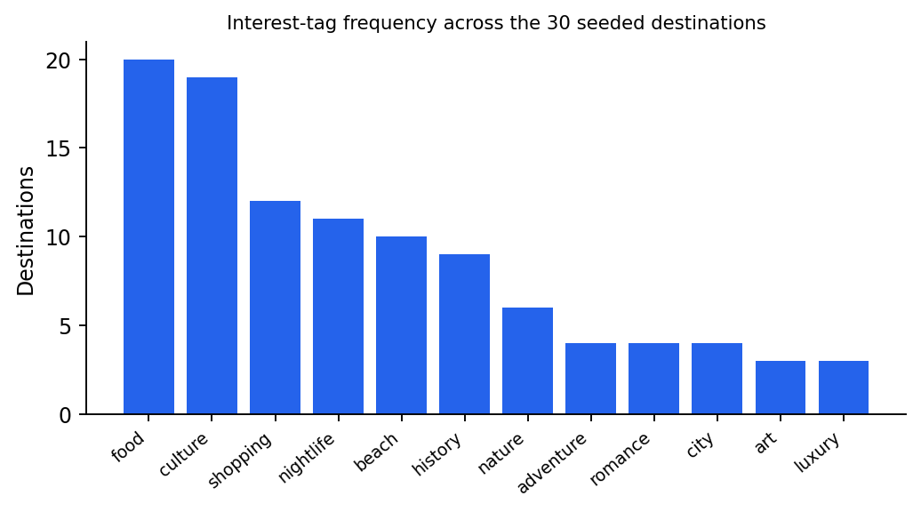
- Frequency of interest tags across the 30 seeded destinations.
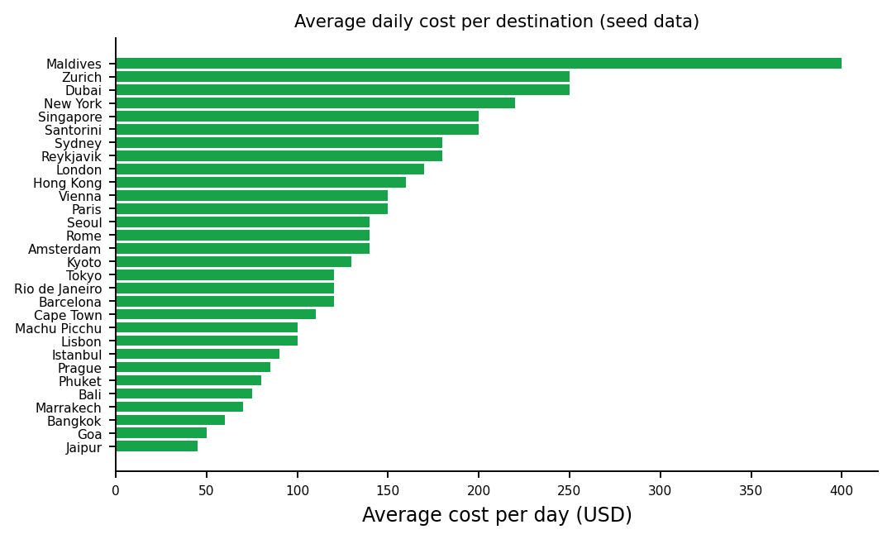
- Average cost per day (USD) of each destination in the seed data.
Two properties of this data matter for the recommender. First, the tag vocabulary is dominated by a few interests (food and culture appear on two-thirds of the destinations), so these words receive a low inverse document frequency and contribute less than rare words such as diving, hiking or luxury, which is the intended behaviour of TF-IDF. Second, business is the rarest suitability label (five destinations), so a business traveller's candidate pool is naturally narrow and the boost matrix has to rely on the solo and friends columns as secondary matches.

Recommender experiment design (E2, E3)
Six synthetic traveller profiles were defined to cover different interests, cabin styles and travel types (Table XXVII). For each profile the project's functions _tokenize, _idf, _tfidf and _cosine and the boost matrix were applied to the 30 destinations exactly as get_recommendations does, and the five best destinations were recorded. In E3 the interests were fixed to food, culture with a balanced style and only the travel type was varied across the five values, to isolate the effect of the boost matrix.
- Traveller profiles used in E2
ID | Interests | Style | Travel type
P1 | beach, diving, wellness | balanced | Couple
P2 | food, culture, nightlife | economy | Friends
P3 | history, culture, art | business | Solo
P4 | family, nature, beach | economy | Family
P5 | adventure, hiking, nature | economy | Solo
P6 | shopping, luxury, city | business | Business

Itinerary, pricing and payment experiments (E4, E5)
For E4 the planner functions were run on the seed destinations Bali (3 days, with and without the interests temple and trek), Paris (4 days, interest museum) and Tokyo (5 days, interest food). For E5 the booking estimate formula of the storefront (Rs 75,000 × passengers × cabin factor + daily cost × 85 × nights × passengers) was evaluated for three bookings, and the fee rule of /payments/create was evaluated for a Rs 1,44,000 booking under each payment method.

Query-processing and assistant experiments (E6, E7)
For E6 four natural-language queries were passed through the keyword builder of the hybrid endpoint, and the RRF formula with α = 0.6 was tabulated for representative rank pairs. The embedding step itself requires the 90 MB MiniLM model and a populated pgvector table and therefore belongs to the running stack, not to these offline experiments. For E7, eight utterances were passed to the rule-based assistant.

Functional and integrity scenarios (E8)
Table XXVIII lists the scenarios that define correct behaviour of the database-facing operations. Each row states the action and the outcome that the implemented code produces, so the table doubles as a test specification for the project demonstration and for future automated tests.
- Functional and integrity test scenarios (E8)
# | Scenario | Expected outcome (from implemented rules)
1 | Register with a new e-mail | User row created with role 'user'; bcrypt hash stored; event user.registered; welcome notification
2 | Register with an existing e-mail | HTTP 400 'Email already registered'; UNIQUE constraint also protects against races
3 | Register with admin@tripwise.com | HTTP 403 'This email is reserved'
4 | Login with wrong password | HTTP 401 'Invalid credentials'; no token issued
5 | Call a protected endpoint without a token | HTTP 401
6 | Call /admin/* as a normal user | HTTP 403 'Admin access required'
7 | Book 2 passengers on a route with 50 free seats | booking pending/unpaid; booked_seats = 2; seats_remaining = 48
8 | Book more passengers than remaining seats | HTTP 400 'Only N seat(s) available'; no booking row, counter unchanged
9 | Two simultaneous bookings for the last seat | Second request waits on FOR UPDATE; exactly one succeeds
10 | Cancel own pending booking | status 'cancelled'; seats returned to inventory; event booking.status.changed
11 | Cancel a confirmed booking online | HTTP 400 'Confirmed bookings cannot be cancelled online'
12 | Open another user's booking | HTTP 403 'Not your booking'
13 | Edit a pending booking | flight row and booking total updated; event booking.updated
14 | Edit a confirmed booking | HTTP 400 'Only pending bookings can be edited'
15 | Attach three planned activities | plan JSONB extended; total_price increased by the sum of prices
16 | Create a card payment for a Rs 1,44,000 booking | fee Rs 2,160; payment amount Rs 1,46,160; status pending
17 | Create UPI payment | fee 0; QR code data URL returned; link pay.html?token=PAY-…
18 | Create a payment for an already paid booking | HTTP 400 'Booking already paid'
19 | Confirm a payment | payment success, paid_at set; booking confirmed/paid; event payment.successful
20 | Confirm the same payment again | Idempotent: returns success with already = true; no duplicate event
21 | Admin refunds a successful payment | payment refunded; booking payment_status refunded; confirmed booking cancelled
22 | Admin refunds a pending payment | HTTP 400 'Only successful payments can be refunded'
23 | Submit a second review for the same destination | HTTP 400 'You already reviewed this destination'
24 | Delete a user | Cascade removes bookings, flight/tour parts, payments and preferences
25 | Hybrid search query with only stop-words | Falls back to pure vector search
26 | Recommendations for a user without preferences | Top-rated destinations returned

Results

Recommender output (E2)
Table XXIX lists the five best destinations for each profile together with the final score, the cosine part and the travel-type boost, as produced by the project's recommender on the seed data. The rankings are intuitive: the beach-and-diving couple (P1) receives the three beach destinations Phuket, Bali and Maldives first; the food-and-nightlife group (P2) receives Bangkok, Lisbon, Tokyo, New York and Barcelona, all of which carry the food and nightlife tags; the history-and-art solo traveller (P3) receives Amsterdam, Barcelona, Paris, Marrakech and Jaipur; the family profile (P4) receives Phuket, Singapore and Dubai, destinations labelled suitable for families; the adventure solo traveller (P5) receives Machu Picchu with a clear lead (0.472 against 0.311 for the runner-up Reykjavik) because adventure, hiking and nature are comparatively rare, high-IDF words that appear together among its tags; and the business profile (P6) receives New York, Dubai, Sydney, Hong Kong and Zurich.
- Top-5 recommendations per profile (final score = cosine × boost + 0.02 × rating)
Profile | Rank | Destination | Final score | Cosine | Boost | Rating
P1 | 1 | Phuket | 0.298 | 0.158 | 1.30 | 4.6
 | 2 | Bali | 0.288 | 0.150 | 1.30 | 4.7
 | 3 | Maldives | 0.279 | 0.140 | 1.30 | 4.9
 | 4 | Santorini | 0.167 | 0.053 | 1.30 | 4.9
 | 5 | Goa | 0.161 | 0.057 | 1.30 | 4.3
P2 | 1 | Bangkok | 0.251 | 0.124 | 1.30 | 4.5
 | 2 | Lisbon | 0.248 | 0.119 | 1.30 | 4.7
 | 3 | Tokyo | 0.239 | 0.110 | 1.30 | 4.8
 | 4 | New York | 0.236 | 0.112 | 1.30 | 4.5
 | 5 | Barcelona | 0.235 | 0.110 | 1.30 | 4.6
P3 | 1 | Amsterdam | 0.271 | 0.137 | 1.30 | 4.6
 | 2 | Barcelona | 0.269 | 0.137 | 1.30 | 4.6
 | 3 | Paris | 0.232 | 0.108 | 1.30 | 4.6
 | 4 | Marrakech | 0.217 | 0.097 | 1.30 | 4.5
 | 5 | Jaipur | 0.211 | 0.093 | 1.30 | 4.5
P4 | 1 | Phuket | 0.404 | 0.231 | 1.35 | 4.6
 | 2 | Singapore | 0.325 | 0.172 | 1.35 | 4.6
 | 3 | Dubai | 0.321 | 0.172 | 1.35 | 4.4
 | 4 | Sydney | 0.255 | 0.119 | 1.35 | 4.7
 | 5 | Cape Town | 0.223 | 0.094 | 1.35 | 4.8
P5 | 1 | Machu Picchu | 0.472 | 0.288 | 1.30 | 4.9
 | 2 | Reykjavik | 0.311 | 0.167 | 1.30 | 4.7
 | 3 | Cape Town | 0.239 | 0.130 | 1.10 | 4.8
 | 4 | Sydney | 0.189 | 0.073 | 1.30 | 4.7
 | 5 | Bali | 0.185 | 0.070 | 1.30 | 4.7
P6 | 1 | New York | 0.276 | 0.143 | 1.30 | 4.5
 | 2 | Dubai | 0.226 | 0.106 | 1.30 | 4.4
 | 3 | Sydney | 0.212 | 0.112 | 1.05 | 4.7
 | 4 | Hong Kong | 0.204 | 0.087 | 1.30 | 4.5
 | 5 | Zurich | 0.197 | 0.079 | 1.30 | 4.7

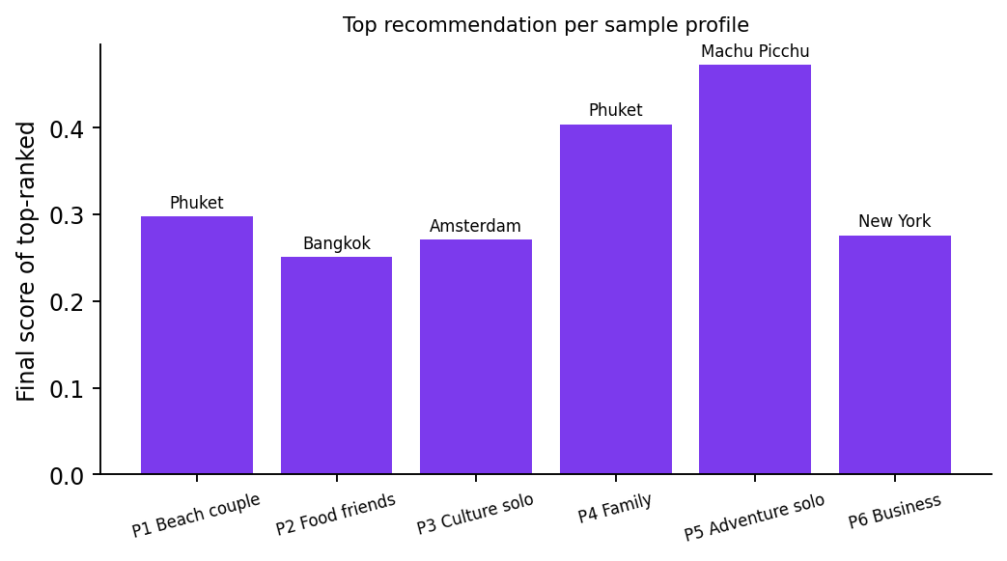
- Final score of the top-ranked destination for each sample profile.
Several observations follow from the table. (1) The cosine part is small in absolute terms (0.05–0.29) because the user document contains only a handful of words while a destination document contains a name, country, tags and a sentence of description; what matters is relative ordering, which is stable. (2) The boost is 1.30 for almost every top result, meaning that the top destinations all list the traveller's own type among their suitable types; Cape Town in P5 (boost 1.10) and Sydney in P6 (boost 1.05) show lower-boost candidates that still enter the top five on the strength of their text match and rating. (3) The rating bonus (0.02 × rating ≈ 0.09–0.10) is of the same order as the cosine part for weak matches, so it behaves as a tie-breaker and a safeguard against recommending poorly rated places, as designed.

Effect of the travel type (E3)
With identical interests (food, culture) and a balanced style, changing only the travel type moves the ranking as shown in Table XXX. A family traveller is steered to Singapore, Phuket and Dubai – the destinations most strongly labelled for families, whose boost of 1.35 outweighs their weaker text match – while solo, couple, friends and business travellers see destinations whose descriptions match food and culture. The business traveller's best score (0.170, New York) is lower than the others because only five destinations carry the business label and the matrix penalises the other types (0.65–1.05). This confirms that the boost matrix acts as a controllable personalisation lever that is independent of the text similarity.
- Top-3 destinations for interests food + culture by travel type (final score in brackets)
Travel type | 1st | 2nd | 3rd
solo | Marrakech (0.180) | Seoul (0.179) | Lisbon (0.179)
couple | Santorini (0.187) | Marrakech (0.180) | Seoul (0.179)
family | Singapore (0.302) | Phuket (0.276) | Dubai (0.258)
friends | Santorini (0.187) | Marrakech (0.180) | Seoul (0.179)
business | New York (0.170) | Marrakech (0.163) | Seoul (0.163)

Itinerary generation (E4)
Table XXXI shows the itineraries produced. Without interests the Bali planner orders places by distance (Tegallalang 12 km, Ubud 15 km, Tanah Lot 22 km, Mount Batur 40 km), giving an easy first day and putting the long trek on the last day together with Tanah Lot. When the traveller states the interests temple and trek, Tanah Lot and Mount Batur move to the front, because the interest score takes precedence over distance. Both plans cost Rs 3,700 in total, since the same places are visited and only their order changes. For Paris the interest museum moves the Louvre to day 1. In the five-day Tokyo example there are only four places, so the last day is empty – the planner never invents places that are not in the database, so a trip longer than the number of stored attractions simply has free days.
- Generated itineraries (E4)
Case | Day 1 | Day 2 | Day 3 | Day 4 | Day 5 | Total (Rs)
Bali, 3 days, no interests | Tegallalang Rice Terraces (300) | Ubud Monkey Forest (500) | Tanah Lot Temple + Mount Batur Sunrise Trek (2,900) | — | — | 3,700
Bali, 3 days, temple + trek | Tanah Lot Temple (400) | Mount Batur Sunrise Trek (2,500) | Tegallalang + Ubud Monkey Forest (800) | — | — | 3,700
Paris, 4 days, museum | Louvre Museum (1,800) | Notre-Dame & Seine Cruise (1,500) | Eiffel Tower (2,200) | Montmartre & Sacré-Cœur (0) | — | 5,500
Tokyo, 5 days, food | Tsukiji Outer Market (1,500) | Shibuya Crossing (0) | Senso-ji Temple (0) | teamLab Planets (3,200) | empty | 4,700

Booking cost and payment fee (E5)
Table XXXII evaluates the estimate formula. For example, a single Economy passenger staying five nights in Bali pays Rs 75,000 for the flight and 6,375 × 5 = Rs 31,875 for the stay, a total of Rs 1,06,875, because Bali's average daily cost of USD 75 converts to Rs 6,375 at 85 INR per USD. The same formula shows how strongly the cabin class dominates the price: two Business passengers to Paris pay Rs 3,90,000 for flights alone. Table XXXIII applies the fee rule to a Rs 1,44,000 booking: UPI and wallet add nothing, net banking adds Rs 720 (0.5 %) and card adds Rs 2,160 (1.5 %). Fees are rounded to two decimals and stored inside the payment amount, so a receipt always matches what was charged.
- Booking estimates (E5)
Destination | Passengers | Cabin | Nights | Daily rate (Rs) | Flight (Rs) | Stay (Rs) | Total (Rs)
Bali | 1 | Economy | 5 | 6,375 | 75,000 | 31,875 | 1,06,875
Paris | 2 | Business | 6 | 12,750 | 3,90,000 | 1,53,000 | 5,43,000
Maldives | 2 | Economy | 4 | 34,000 | 1,50,000 | 2,72,000 | 4,22,000

- Payment fee for a Rs 1,44,000 booking (E5)
Method | Fee % | Fee (Rs) | Amount charged (Rs)
UPI / QR | 0.0 | 0 | 1,44,000
Credit / Debit card | 1.5 | 2,160 | 1,46,160
Net banking | 0.5 | 720 | 1,44,720
Wallet | 0.0 | 0 | 1,44,000

Hybrid search query processing (E6)
Table XXXIV shows how the keyword builder prepares queries. Filler words and words shorter than three letters are removed, so “romantic beach places to visit in asia” becomes romantic | beach | asia, and a query consisting only of stop-words returns an empty string, which triggers the pure-vector fallback (scenario 25). The OR operator makes the keyword branch tolerant: a destination matching any term is a candidate, and ts_rank orders candidates by how many and how strongly they match, while the vector branch contributes meaning even when the destination text does not contain the literal words.
- Keyword query construction (E6)
Natural-language query | Generated tsquery
romantic beach places to visit in asia | romantic | beach | asia
I want to go to a quiet mountain trip | quiet | mountain
cheap food and nightlife | cheap | food | and | nightlife
the a an | (empty) → vector-only search

Table XXXV evaluates the RRF formula with α = 0.6 for representative cases. A destination that is first in both lists scores 0.6/61 + 0.4/61 = 0.01639, whereas the first semantic hit that is absent from the keyword list scores 0.00984 and the first keyword hit that is absent from the semantic list scores 0.00656. A destination that is moderately ranked in both lists (semantic rank 3, keyword rank 10) scores 0.01587 and therefore outranks a semantic-only first hit, which illustrates the “agreement is rewarded” property of the method. The absolute values are small by construction; only their order is used.
- Reciprocal Rank Fusion scores with α = 0.6 (E6)
Semantic rank | Keyword rank | RRF score
1 | 1 | 0.01639
1 | — | 0.00984
— | 1 | 0.00656
3 | 10 | 0.01524
10 | 2 | 0.01502
5 | 5 | 0.01538

Assistant behaviour (E7)
Table XXXVI lists the responses of the rule-based assistant. Each utterance was routed to the expected intent: greetings and unmatched text fall to the help message, “how do I login” to the login steps, “how to book a trip” to the booking steps, “cancel booking” to the cancellation rule, “can I pay by upi” to the payment explanation, “places to visit near bali” to the nearby-places explanation and “thank you” to the closing reply. The matcher is deterministic and instant, but it understands only the phrases in its rules, which is why the report lists a retrieval-augmented assistant as future work.
- Assistant routing (E7)
Utterance | Matched intent / reply begins with
hi | Help message: “I can help with TripWise: login, booking, cancellation…”
how do I login | Sign-in steps: “To sign in: 1. Click ‘Sign in’ at top-right…”
how to book a trip | Booking steps: “How to book: 1. Sign in. 2. Click any Destination…”
cancel booking | Cancellation: “To cancel: My Bookings → find the pending booking…”
can I pay by upi | Payment: “Payment is by QR code. Total = flight + stay + activities…”
places to visit near bali | Nearby places: “Click any destination card to see nearby places…”
thank you | “You're welcome!”
random xyz | Default help message

  - Application output screenshots
The following screenshots of the running TripWise application show the main outputs of the system, in the order in which a traveller meets them.
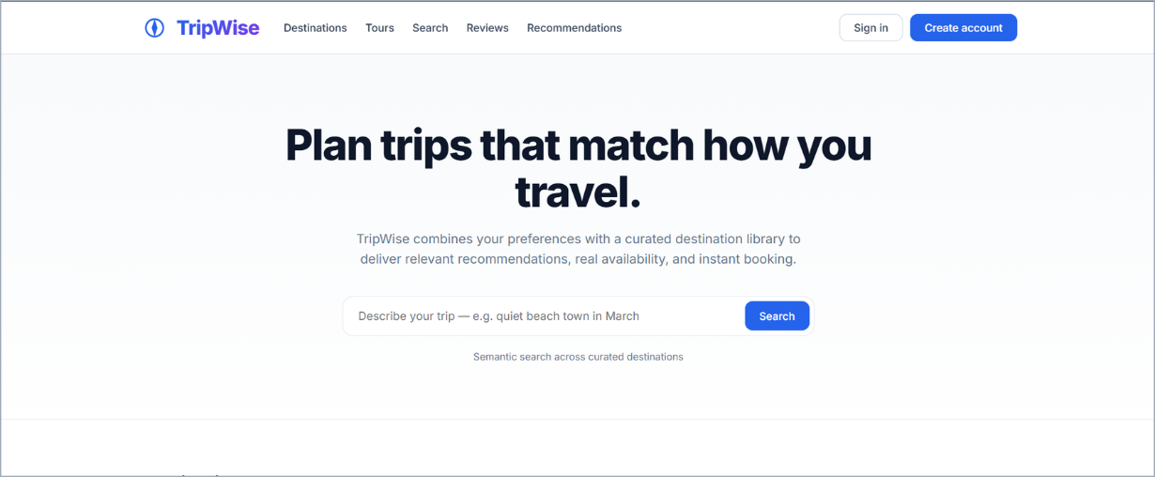
Fig. 18. Home page with the semantic search box, category filters and chatbot button.
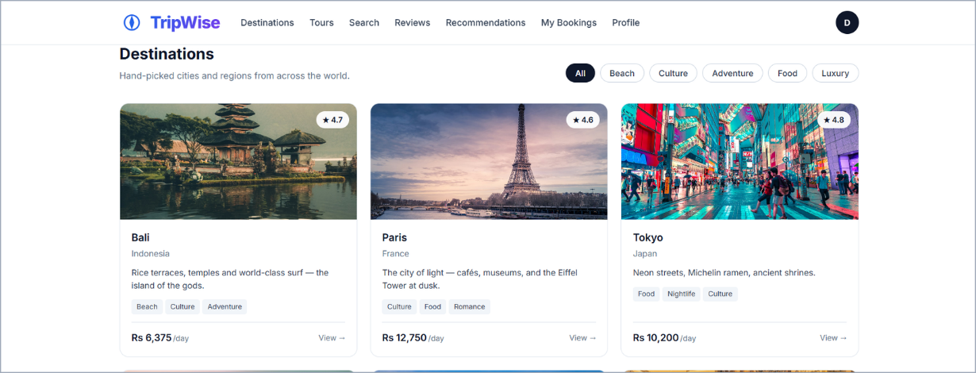
Fig. 19. Destination catalogue showing rating, interest tags and average cost per day read from MongoDB.
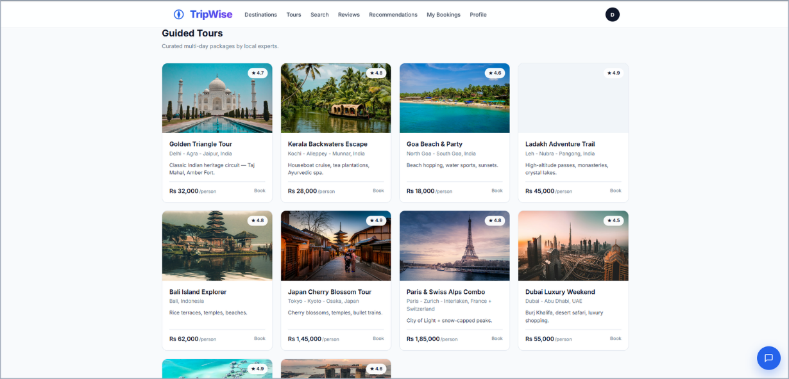
Fig. 20. Guided tours catalogue with duration, rating and price per person.
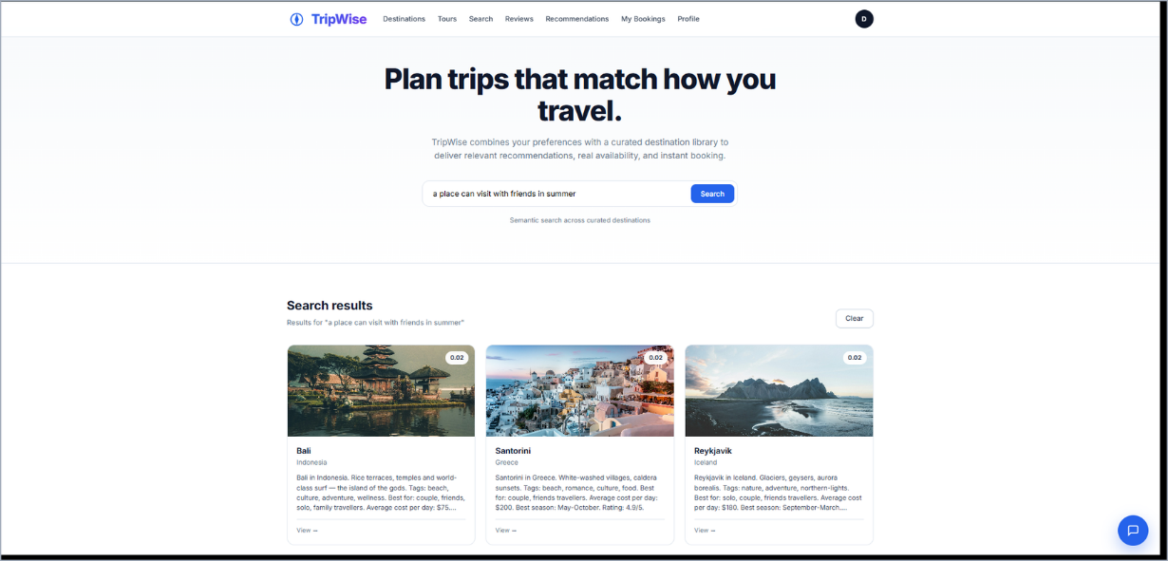
Fig. 21. Semantic search results for the natural-language query “a place can visit with friends in summer”, ranked by similarity score.
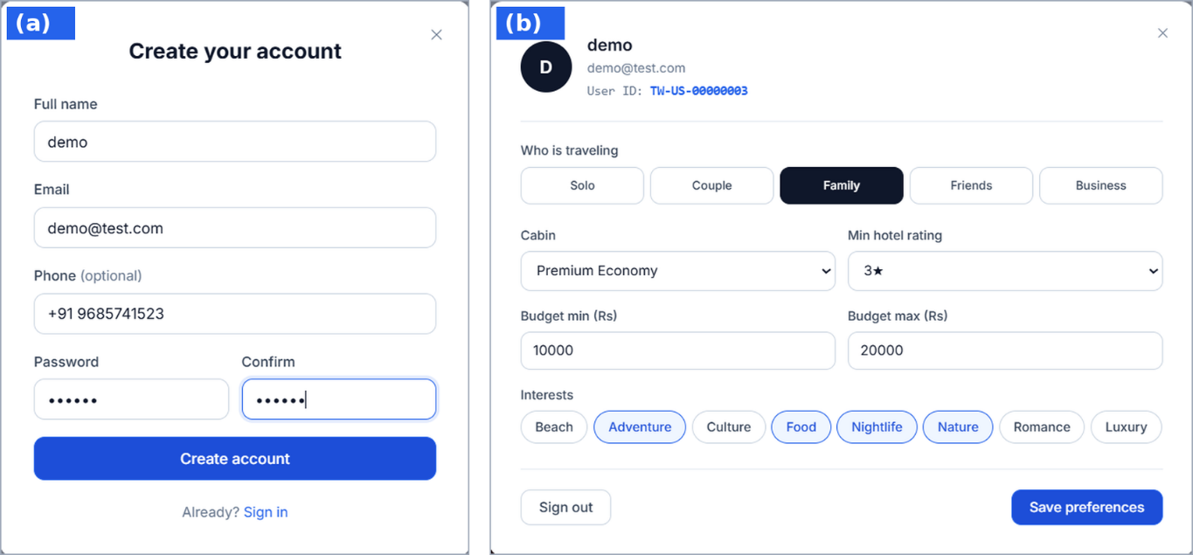
Fig. 22. (a) Account registration form; (b) profile and preference form (travel type, cabin, hotel rating, budget, interests) that feeds the recommender.
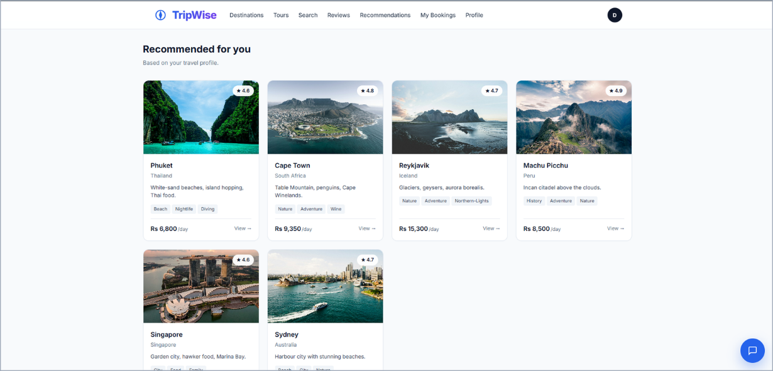
Fig. 23. “Recommended for you” – destinations ranked from the saved travel profile.
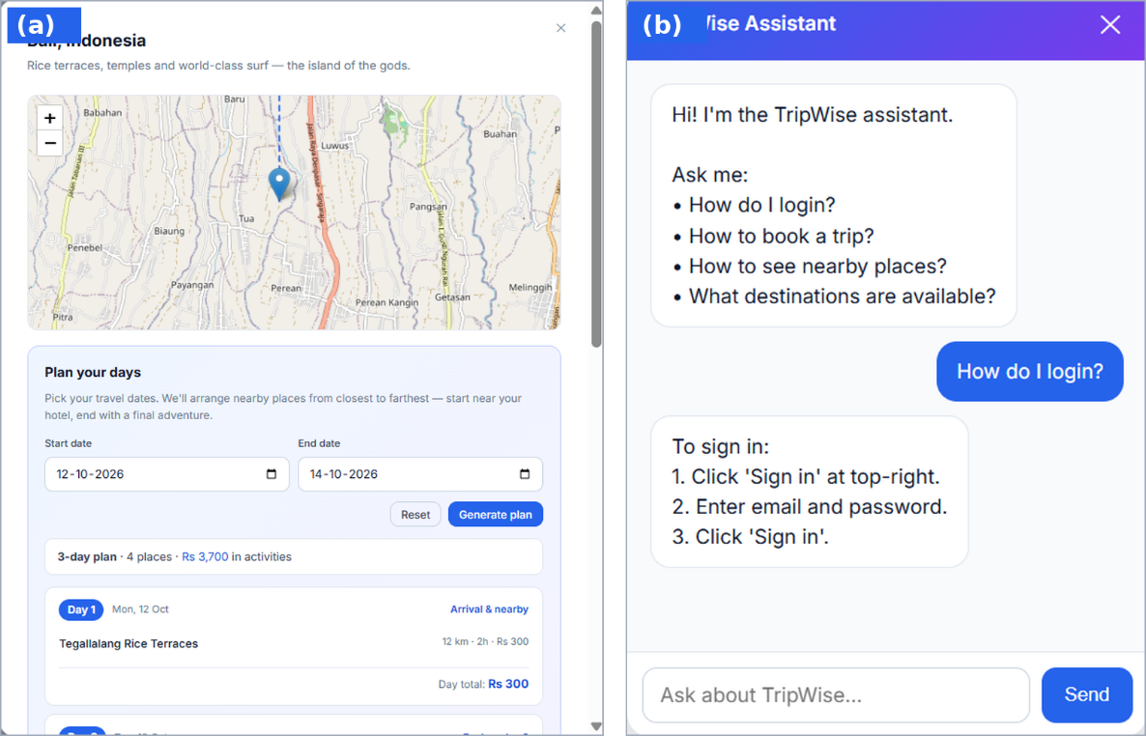
Fig. 24. (a) Destination detail with map and day-wise itinerary generator; (b) rule-based TripWise assistant answering a login question.
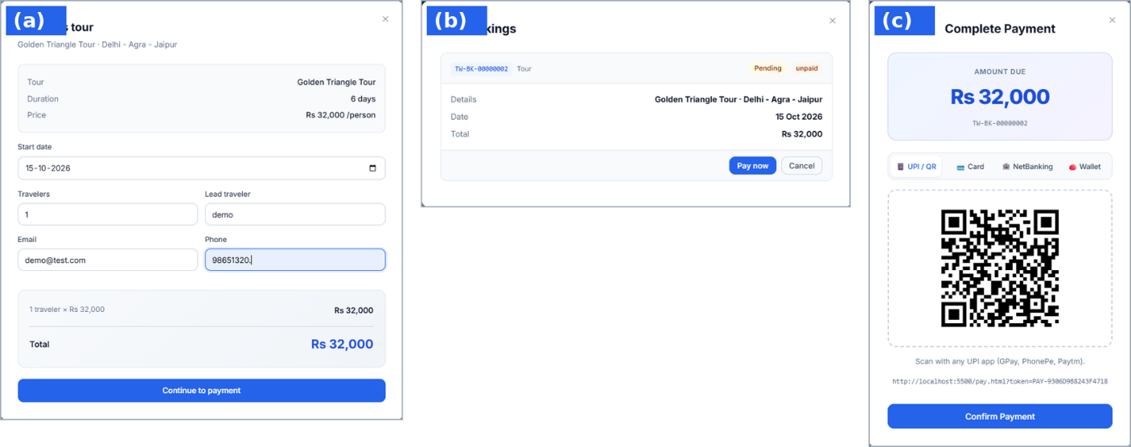
Fig. 25. Booking flow: (a) tour booking dialog with price estimate; (b) My Bookings showing the pending/unpaid booking; (c) payment dialog with UPI QR code and method tabs.

Application walkthrough and database operations
Table below follows a traveller through the application and shows, for each screen, which database operations are executed behind it. It also demonstrates the division of work between the two engines: reading and personalising content touches MongoDB, while every step that creates or changes a commitment (booking, payment) touches PostgreSQL.
- Traveller journey and the data operations behind each step
Step | Screen / action | Database operations
1 | Register | PostgreSQL: SELECT by e-mail, INSERT users (bcrypt hash); event → MongoDB notifications (welcome)
2 | Sign in | PostgreSQL: SELECT users; JWT issued; admin role normalised if needed
3 | Profile → preferences | MongoDB: upsert preferences {interests, travel_style, travel_type}
4 | “Recommended for you” | MongoDB: read preferences and all destinations; scoring in memory
5 | Search box | PostgreSQL: vector and tsvector queries on destination_embeddings
6 | Destination card → detail | MongoDB: read one destination with nested nearby[ ]; reviews by destination
7 | Nearby places and planner | MongoDB: read nearby[ ]; ranking and day split in the API
8 | Book flight | PostgreSQL: lock seat_inventory, INSERT bookings and flight_bookings (one transaction)
9 | Add activities | PostgreSQL: UPDATE bookings.plan and total_price
10 | Pay | PostgreSQL: INSERT payments (pending); on confirm UPDATE payments and bookings
11 | My bookings | PostgreSQL: SELECT bookings with flight/tour details; edit or cancel pending ones
12 | Write a review | MongoDB: duplicate check then INSERT into reviews
13 | Notifications | MongoDB: notifications by user, newest first (limit 50)

- Administrator views and the operations behind them
View | Operations
Dashboard / Analytics | Conditional-aggregate SQL on bookings and payments; ROW_NUMBER ranking of top customers; revenue chart
Users | List and search users; edit name/phone; change role; delete (cascade to bookings and payments)
Bookings | List with owner; change status; edit; delete (cascade to part tables)
Payments | List payments; refund successful payments (updates booking as well)
Destinations | Create, edit, delete destination documents including nearby places (MongoDB)
Tours | Create, edit, delete tour documents (MongoDB)
Reviews | List, edit and delete reviews (MongoDB)
Database statistics | Row counts of five tables, database name and server version

Discussion
Database design. The relational part gives the guarantees that a booking system needs: every row has an identity, every child row has a parent, money is stored as exact decimals, and the one contended resource (seats) is protected by a row lock inside the same transaction that creates the booking. The document part gives the flexibility that content needs: adding a field such as a new tag or a new attraction attribute requires no migration, and a destination page is served from a single document read. The fact that the two engines are only linked by value is a trade-off: it keeps each engine simple, but referential integrity between, for example, reviews.destination_name and destinations.name is enforced by application code, not by the database.
Personalization quality. The recommender is transparent – each score can be decomposed into cosine, boost and rating – and fast: it recomputes IDF and vectors for 30 destinations on every call, which is trivial at this scale. Its weaknesses are also visible in the experiments: it matches exact words, not meanings (a traveller who writes “seafood” will not match “food”); its tokenizer splits on whitespace only, so punctuation attached to a word in a description (for example a trailing comma) creates a different token; and the interest list is the only user signal, because booking history and reviews are not yet used. Semantic and hybrid search address the vocabulary problem for free-text queries, and the roadmap below proposes using them for the recommender as well.
Operational behaviour. Because the event bus swallows publishing errors and defaults to off, the booking path has no hard dependency on Kafka or the notification service, which keeps the core demonstration robust. The seat counter uses pessimistic locking, which is simple and correct for a low-contention workload such as a university project; for very high contention an optimistic UPDATE … WHERE booked_seats + :n <= total_seats with a row-count check would reduce lock waiting.

Conclusion and Future Work

Conclusion
This project designed and implemented TripWise, a travel personalization and booking platform whose intelligence is built directly on its data layer. A polyglot design places transactional data in PostgreSQL – nine tables in third normal form with primary and foreign keys, cascading deletes, JSONB attributes, generated tsvector columns, HNSW and GIN indexes and row-level locking – and flexible content in MongoDB – destinations with nested nearby places, tours, reviews, preferences and notifications. On top of this, the system provides a transparent TF-IDF recommender with a travel-type boost matrix, semantic and hybrid search fused by Reciprocal Rank Fusion in a single SQL statement, an interest-aware itinerary planner, a consistent booking and payment workflow with seat-overbooking protection, an event-driven notification path that works with HTTP or Kafka, an administrator portal with SQL analytics, and a Docker Compose deployment that starts all of it with one command.
The experiments executed the project's own algorithms on the 30-destination seed data. They showed that the recommender produces explainable, profile-appropriate rankings, that the boost matrix is an effective and independent personalisation lever, that the itinerary planner respects interests and distance, and that price, fee and query-building calculations behave exactly as specified. From a database-management viewpoint the main lessons are that choosing the engine per workload simplifies each part of the design, that constraints and transactions are the right place to enforce booking correctness, and that vector and full-text capabilities inside a relational engine let intelligent search be expressed as ordinary SQL.

Limitations
- Known limitations and their impact
Area | Limitation | Impact / mitigation
Payments | Gateway is simulated; the confirm endpoint is callable without a bearer token | Suitable for demonstration only; production needs a signed gateway callback and idempotency keys
Secrets | Default JWT secret and database password appear in configuration and compose files | Move to environment secrets / a vault and rotate before any deployment
Recommender | Whitespace tokenizer, exact-word matching, only declared interests used as signal | Add stemming and punctuation stripping; use embeddings and booking history
Assistant | Rule-based keyword matcher; no retrieval or generation | Plan: retrieval-augmented assistant using existing embeddings
Cross-store integrity | Links between MongoDB and PostgreSQL are by value and enforced in application code | Add reconciliation jobs or use change streams
Inventory model | Seat inventory is per route-date with a default of 50 seats; hotel_bookings has no endpoint yet | Integrate supplier inventory; add room-level inventory
Testing | No automated test-suite is included in the repository | Add pytest integration tests from the scenario catalogue (Table XXVIII)
Cross-origin policy | CORS allows all origins | Restrict to the front-end origin in production

Future work
- Embedding-based recommendation: compare the traveller profile embedding with destination embeddings (and with embeddings of reviews the traveller liked) and blend the result with the TF-IDF score; learn blend weights from click and booking data.
- Collaborative signals: use booking history and ratings in travel_history and reviews to add item-item and user-user collaborative filtering and to solve the cold-start problem with the current content-based model.
- Retrieval-augmented assistant: answer free-form questions by retrieving destinations with hybrid search and passing them to an LLM (the configuration already reserves Gemini and OpenAI keys), citing the sources returned in the sources field.
- Real payments and security: integrate a payment gateway with webhooks, add refresh tokens, rate limiting, secret management and role-based access beyond a single administrator.
- Richer inventory: model hotels and rooms with date-range availability using PostgreSQL range types and exclusion constraints, and add optimistic concurrency for high-contention routes.
- Performance and scale: add caching of recommendation results, connection pooling parameters, query plans (EXPLAIN ANALYZE) in CI, partitioning of bookings by date and Kafka consumer groups for notifications.
- Quality assurance: automated unit, API and load tests; a benchmark suite measuring latency of semantic, hybrid and recommendation queries on larger destination sets.
- Product features: multi-city trips, price alerts, saved wish-lists, localisation using the language preference, and a mobile-friendly progressive web app.

References
- G. Salton and C. Buckley, “Term-weighting approaches in automatic text retrieval,” Information Processing & Management, vol. 24, no. 5, pp. 513–523, 1988.
- G. V. Cormack, C. L. A. Clarke and S. Büttcher, “Reciprocal rank fusion outperforms Condorcet and individual rank learning methods,” in Proc. 32nd ACM SIGIR, pp. 758–759, 2009.
- N. Reimers and I. Gurevych, “Sentence-BERT: Sentence embeddings using Siamese BERT-networks,” in Proc. EMNLP-IJCNLP, pp. 3982–3992, 2019.
- Y. A. Malkov and D. A. Yashunin, “Efficient and robust approximate nearest neighbor search using Hierarchical Navigable Small World graphs,” IEEE Trans. Pattern Analysis and Machine Intelligence, vol. 42, no. 4, pp. 824–836, 2020.
- R. Elmasri and S. B. Navathe, Fundamentals of Database Systems, 7th ed. Pearson, 2016.
- A. Silberschatz, H. F. Korth and S. Sudarshan, Database System Concepts, 7th ed. McGraw-Hill, 2019.
- PostgreSQL Global Development Group, “PostgreSQL 16 Documentation: Full Text Search; Explicit Locking; JSON Types,” postgresql.org/docs/16.
- A. Kane, “pgvector: Open-source vector similarity search for Postgres,” github.com/pgvector/pgvector.
- MongoDB, Inc., “MongoDB Manual: Data Modeling and Indexes,” mongodb.com/docs/manual.
- S. Ramírez, “FastAPI documentation,” fastapi.tiangolo.com.
- M. Jones, J. Bradley and N. Sakimura, “JSON Web Token (JWT),” RFC 7519, IETF, 2015.
- N. Provos and D. Mazières, “A future-adaptable password scheme,” in Proc. USENIX Annual Technical Conference, 1999.

