Smart Research Paper Recommendation System

A Project Based Learning Report Submitted in partial fulfilment of the requirements for the award of the degree

of

Bachelor of Technology
in The Department of CSE
Course Title : DATA STRUCTURES AND ALGORITHMS – 3
Course Code : 25CS2103E

Submitted by
2510030031: Tippani Aniketh Reddy
2510030033: Karri Sri Sai Prashanth
2510030072: Kolla Arun Yadav
2510030171: Suraram Ashwithnath Reddy
2510030177: Vivek Reddy

Under the guidance of
Aftab Yaseen



Department of Computer Science and Engineering
Koneru Lakshmaiah Education Foundation, Aziz Nagar
Aziz Nagar – 500075
OCT - 2026.
Abstract
The volume of published research makes it hard for students and researchers to find relevant papers quickly. This project presents AlgoScholar, a web-based research paper recommender in which the main data structures and algorithms are implemented from scratch instead of being taken from libraries. A corpus of 5,000 papers published between 2012 and 2026 is indexed with BM25 and the best 500 candidates for a query are re-ranked by a hybrid score that fuses the BM25 rank (45%), Smith-Waterman fuzzy matching (20%), PageRank on a keyword-derived citation graph (20%), a citation-trend score (10%) and a Blelloch parallel prefix-sum boost (5%). Aho-Corasick, suffix arrays with Kasai's LCP algorithm, Wagner-Fischer edit distance, Dinic's max-flow and min-cut, Hopcroft-Karp matching, vertex-cover and set-cover approximations and reservoir sampling are available in an interactive Algorithm Lab. A Flask REST API serves a D3.js interface with four views: ranked search, an interactive citation network, graph analytics and the lab. Measurements on the implementation show that the index is built in 0.19 s, the graph with 14,880 edges and its PageRank in under 0.1 s, BM25 retrieval takes about 1 ms and the full hybrid pipeline answers queries with 500 candidates in 0.5 to 0.8 s. Automated checks confirm the correctness of ten of the eleven algorithms; the exception, the first element of the Blelloch scan output, is documented together with its fix.
Keywords: Research paper recommendation, BM25, PageRank, Smith-Waterman, Aho-Corasick, network flow, citation graph, Flask
List of Figures
Figure 1: Architecture of AlgoScholar: browser interface, Flask REST service, algorithm modules and the in-memory paper store. 7
Figure 2: Hybrid ranking pipeline: BM25 candidates are re-scored by four additional signals and fused into one weighted score. 8
Figure 3: Dataset overview: (a) papers per year, (b) distribution of citation counts, (c) most frequent keywords. 10
Figure 4: Query latency of the full hybrid pipeline and of BM25 alone (log scale); the number of candidates is shown in brackets. 12
Figure 5: Running time of the algorithms for increasing input size (log-log scale). 13
Figure 6: Search tab: ranked results for the query "deep learning" with Top-K = 5. 14
Figure 7: Citation Graph tab: interactive network of 200 papers matching the query. 14
Figure 8: Analytics tab: graph metrics, degree distribution and PageRank distribution. 15
Figure 9: Algorithm Lab: reference table of the implemented algorithms. 15
List of Tables
Table 1: Signals and weights used in the hybrid ranking score. 8
Table 2: Algorithms implemented in AlgoScholar. 9
Table 3: Dataset, index and graph statistics. 10
Table 4: Results of the automated correctness checks. 11
Table 5: Search workload: candidates, latency and overlap between the BM25 and hybrid top 10. 12
Table 6: Response time and payload size of the data endpoints. 13
Table of Contents
1. Introduction 6
2. Methodology 7
a. System Architecture 7
b. Dataset and Pre-processing 7
c. BM25 Retrieval 7
d. Hybrid Re-ranking 8
e. Citation Graph and PageRank 8
f. Algorithm Modules 9
g. Web Interface and REST API 9
3. Experiments 10
a. Dataset 10
b. Experimental Set-up 10
c. Correctness Tests 10
d. Search Workload 11
e. Scaling Tests 11
4. Results 11
a. Algorithm Correctness 11
b. Search Performance 11
c. Scaling Behaviour 12
d. REST API Response Times 13
e. Application Output 13
5. Conclusion and Future Work 15

AlgoScholar: Smart Research Paper Recommendation System

Introduction
The number of research papers published every year has grown so quickly that no student or researcher can follow even a narrow field by reading alone. Digital libraries and scholarly search engines respond by indexing millions of documents and linking them in a literature graph of papers, authors and citations [1]. Finding the few papers that really matter for a topic is still hard. A plain keyword match returns hundreds of documents that all contain the query words, and it says nothing about which of them is more central to the field, more recent, or closer to what the reader actually typed. A good recommender therefore has to combine several kinds of evidence: textual relevance, tolerance to spelling variation, the position of a paper in the citation network, and how quickly a paper is gaining attention.
Most modern recommenders hide these ideas behind large libraries, which makes them easy to use but hard to learn from. This project takes the opposite approach. AlgoScholar is a research paper recommender in which every important building block is written from scratch, so that the data structures and algorithms studied in the course (DSA-3) are applied together on one real problem: searching, ranking and exploring a collection of scientific papers. The aim is not only to return good results but also to make the behaviour of each algorithm visible and measurable.
The system indexes a corpus of 5,000 papers published between 2012 and 2026. A query is first matched against an inverted index using the BM25 ranking function [2]. The best 500 candidates are then re-scored with a hybrid formula that adds Smith-Waterman local alignment [3] for fuzzy matching, PageRank [4] computed on a citation graph, a citation-trend score, and a Blelloch parallel prefix-sum boost [5]. Beyond ranking, the application includes an Algorithm Lab in which string algorithms (Aho-Corasick [6], suffix arrays [7] with Kasai's LCP computation [8]), dynamic programming (Wagner-Fischer [9]), network flow (Dinic [10]), bipartite matching (Hopcroft-Karp [11]), approximation algorithms [12, 13] and reservoir sampling [14] can be run on input supplied by the user. A Flask [15] back end serves a D3.js [16] front end that shows ranked results, an interactive citation network and graph analytics.
The objectives of the project are:
- To build an end-to-end research paper search and recommendation system for a 5,000-paper corpus without relying on external search or graph libraries.
- To implement eleven algorithms from the course syllabus from scratch and verify each of them against known answers.
- To combine textual, structural and temporal signals into one transparent ranking score.
- To present the results through an interactive web interface that makes the behaviour of every algorithm visible.
- To measure index build time, query latency and the scaling behaviour of the implementation.
The rest of this report is organised as follows. The methodology section describes the architecture, data preparation, ranking pipeline and algorithm modules. The experiments section explains the dataset, the test set-up and the evaluation procedure. The results section reports correctness tests, performance measurements and screenshots of the application. The last section summarises the findings, the limitations of the current version and directions for future work.

Methodology

System Architecture
AlgoScholar follows a three-layer design, shown in Figure 1. The presentation layer is a single-page web application written in HTML, CSS and JavaScript, with D3.js used for the force-directed citation network. The service layer is a Flask application (app.py) that exposes a JSON REST API: /api/recommend for ranked search, /api/graph for the citation subgraph, /api/metrics and /api/trends for analytics, /api/papers and /api/keywords/top for browsing, and /api/lab/<algorithm> for the interactive demonstrations. The algorithm layer holds the hand-written implementations. At start-up the CSV file is read once and the BM25 index, citation graph, PageRank vector and trend scores are computed and kept in memory, so no database is required.
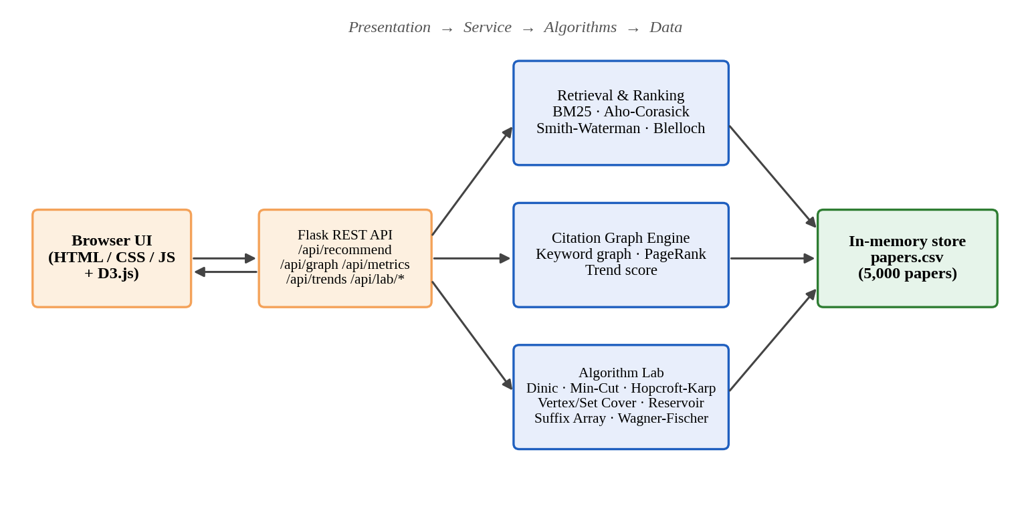
Figure 1: Architecture of AlgoScholar: browser interface, Flask REST service, algorithm modules and the in-memory paper store.

Dataset and Pre-processing
The corpus is a CSV file with 5,000 records. Each record has a paper ID, title, authors, abstract, a list of keywords, a publication year and a citation count. The loader accepts several column-name variants, splits the keyword field on commas or semicolons, and converts year and citation count to integers. Text is lower-cased and split into alphanumeric tokens; common English stop words and single-character tokens are removed. For indexing, the title is repeated twice and joined with the keywords and the abstract, which gives title words roughly twice the weight of abstract words.

BM25 Retrieval
Candidate retrieval uses an inverted index that stores, for every term, the documents containing it and the term frequency. Documents are scored with the BM25 function [2]:
score(D, Q) = Σ IDF(t) · f(t,D)·(k₁ + 1) / ( f(t,D) + k₁·(1 − b + b·|D| / avgdl) )
where f(t,D) is the frequency of term t in document D, |D| is the document length in tokens, avgdl is the average document length, k₁ = 1.5 and b = 0.75. The inverse document frequency is IDF(t) = ln(1 + (N − df + 0.5) / (df + 0.5)). When a query word is not in the vocabulary and has at least three letters, the index falls back to prefix matching and uses up to 25 vocabulary words that start with it (for example "learn" matches "learning"). The 500 highest-scoring documents are passed on to the re-ranking stage.

Hybrid Re-ranking
BM25 ranks documents only by term statistics. To use other kinds of evidence, the candidates are re-scored by the pipeline in Figure 2, which fuses five signals with the weights in Table 1.
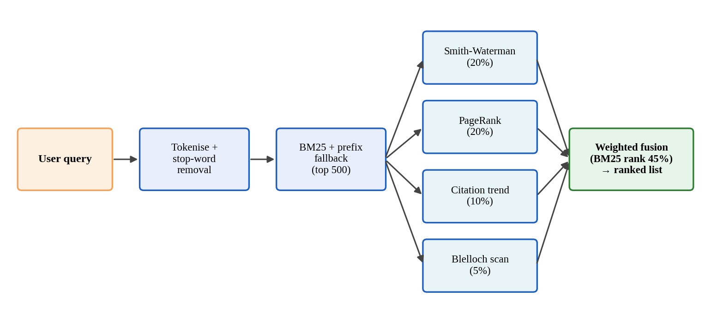
Figure 2: Hybrid ranking pipeline: BM25 candidates are re-scored by four additional signals and fused into one weighted score.
- BM25 rank (45%). Contributes 1/rank, so the best candidate receives 1.0, the second 0.5, and so on.
- Smith-Waterman (20%). The query is locally aligned [3] against the title plus the first 200 characters of the abstract, with +2 for a match and −1 for a mismatch or gap. Scores are divided by the maximum among candidates. Local alignment tolerates spelling variants and partial phrases.
- PageRank (20%). The authority of a paper in the citation graph, computed by power iteration [4] and divided by the maximum among the candidates.
- Citation trend (10%). (citations / age) / (1 + age / 5), where age = latest year in the corpus − publication year + 1. It favours papers that gather citations quickly and discounts older ones slightly.
- Blelloch scan (5%). An inclusive prefix sum [5] over (1/rank + Smith-Waterman score) in rank order, divided by the total, gives a cumulative-position boost.
Score(d) = 0.45·(1/rank_BM25) + 0.20·SW + 0.20·PR + 0.10·Trend + 0.05·Scan
Table 1: Signals and weights used in the hybrid ranking score.
Signal | Algorithm | Weight | Normalisation
Textual relevance | Inverted index + BM25 | 0.45 | 1 / BM25 rank
Fuzzy match | Smith-Waterman local alignment | 0.20 | Divided by candidate maximum
Authority | PageRank on citation graph | 0.20 | Divided by candidate maximum
Recency / impact | Citation trend score | 0.10 | Divided by candidate maximum
Positional boost | Blelloch prefix-sum scan | 0.05 | Divided by total prefix sum

In parallel with scoring, an Aho-Corasick automaton [6] built from the query tokens scans the title and abstract of every candidate in a single pass and flags papers that contain an exact query term. In the current version this flag is collected but is not yet part of the fused score.

Citation Graph and PageRank
The CSV file has no reference lists, so a citation graph is derived from shared keywords. For every keyword, the papers carrying it are sorted from newest to oldest. Each paper then receives a directed edge to the next three papers in that list, provided the target is not newer than the source; this models a newer paper building on older work in the same topic. Taking only three neighbours per keyword keeps the number of edges linear in the number of keyword occurrences. The resulting graph has 5,000 nodes and 14,880 directed edges (average out-degree 2.98). PageRank is computed with damping factor 0.85 and 30 power iterations [4]; nodes without outgoing edges are given an out-degree of one to avoid division by zero.
For a query, /api/graph returns the subgraph induced by the top-N matching papers (N = 200 by default) together with each node's year, citation count, PageRank, trend score and degree. The front end draws it with a force-directed layout and lets the user pick two papers; a breadth-first search over the displayed subgraph then finds the shortest undirected path between them.

Algorithm Modules
Table 2 lists the algorithms implemented from scratch (the eleven course algorithms plus BM25 and PageRank), the role each one plays in the system and its time complexity. Aho-Corasick, Smith-Waterman and the Blelloch scan take part in every search, together with BM25 and PageRank; the other algorithms are available as interactive demonstrations in the Algorithm Lab.
Table 2: Algorithms implemented in AlgoScholar.
Algorithm | Role in the system | Time complexity | Used in
BM25 inverted index | Candidate retrieval with prefix fallback | O(sum of postings) | Search
PageRank | Authority score on the citation graph | O(k(V + E)) | Search
Aho-Corasick | Multi-keyword exact matching | O(n + m + z) | Search, Lab
Smith-Waterman | Fuzzy local-alignment score | O(nm) | Search, Lab
Blelloch scan | Parallel prefix-sum boost | Work O(n), span O(log n) | Search, Lab
Suffix array + Kasai LCP | Repeated substrings, document similarity | O(n log² n) + O(n) | Lab
Wagner-Fischer | Edit distance and similarity | O(nm) | Lab
Dinic's max-flow | Maximum flow in a network | O(V²E) | Lab
Min-cut | Minimum cut from the residual graph | O(V²E) | Lab
Hopcroft-Karp | Maximum bipartite matching | O(E√V) | Lab
Vertex cover 2-approx. | Cover all edges with at most 2x optimal | O(V + E) | Lab
Greedy set cover | Cover a universe with few sets | O(log n) approximation | Lab
Reservoir sampling | Uniform k-sample from a stream | O(n) | Lab

Aho-Corasick builds a trie with failure links and reports every keyword occurrence in one pass over the text. The suffix array is built by prefix doubling and Kasai's algorithm derives the longest-common-prefix (LCP) array in linear time; together they expose repeated substrings [17]. Wagner-Fischer fills an (n + 1) × (m + 1) table of edit distances, and the lab also reports the similarity 1 − d / max(n, m). Dinic's algorithm repeatedly builds a BFS level graph and pushes a blocking flow; the minimum cut is read from the vertices still reachable from the source in the residual graph, so max-flow equals min-cut. Hopcroft-Karp finds a maximum bipartite matching by alternating BFS layering and DFS augmentation. The vertex-cover routine takes both endpoints of any uncovered edge and is therefore at most twice the optimum [12]; the greedy set-cover routine repeatedly takes the set that covers the most uncovered elements and gives a logarithmic approximation [13]. Reservoir sampling keeps k uniformly chosen items from a stream of unknown length in a single pass [14].

Web Interface and REST API
The interface has four tabs. Search accepts a query and an optional Top-K limit, shows keyword suggestions with their paper counts, and lists ranked papers with score, year and citation count. Citation Graph draws the interactive network, supports dragging and zooming, shows a paper inspector with PageRank and trend values, and offers the path finder. Analytics shows graph metrics, the degree and PageRank distributions and a citation timeline. Algorithm Lab provides a reference table and an editable demonstration form for each algorithm. All tabs communicate with the server through the JSON endpoints listed above.

Experiments

Dataset
All experiments use the project data set papers.csv. Table 3 summarises it together with the index and graph built from it, and Figure 3 shows its main distributions. Papers are spread almost evenly over 2012-2026, with roughly 300 to 370 papers per year. Citation counts range from almost zero to 44,998 (mean 15,131, median 11,521); the histogram in Figure 3(b) shows a large group of papers with very few citations and a nearly flat distribution above it. Each paper has 3.8 keywords on average and there are only 77 distinct keywords, so the topics form tight clusters of roughly 240 to 280 papers. Only 840 of the 5,000 titles are distinct: the same title appears on several records with different authors, years and citation counts, which suggests that the corpus was generated or augmented programmatically. This should be kept in mind when interpreting the ranking results.
Table 3: Dataset, index and graph statistics.
Statistic | Value
Papers | 5,000
Years covered | 2012 - 2026 (15 years)
Distinct titles | 840
Distinct keywords | 77
Average keywords per paper | 3.84
Average abstract length | 44.3 words
Citations (mean / median / max) | 15,131 / 11,521 / 44,998
Index vocabulary (after stop-word removal) | 320 terms
Average indexed document length | 60.5 tokens
Citation graph | 5,000 nodes, 14,880 directed edges
BM25 index build time | 0.19 s
Graph build time | 0.017 s
PageRank time (30 iterations) | 0.056 s

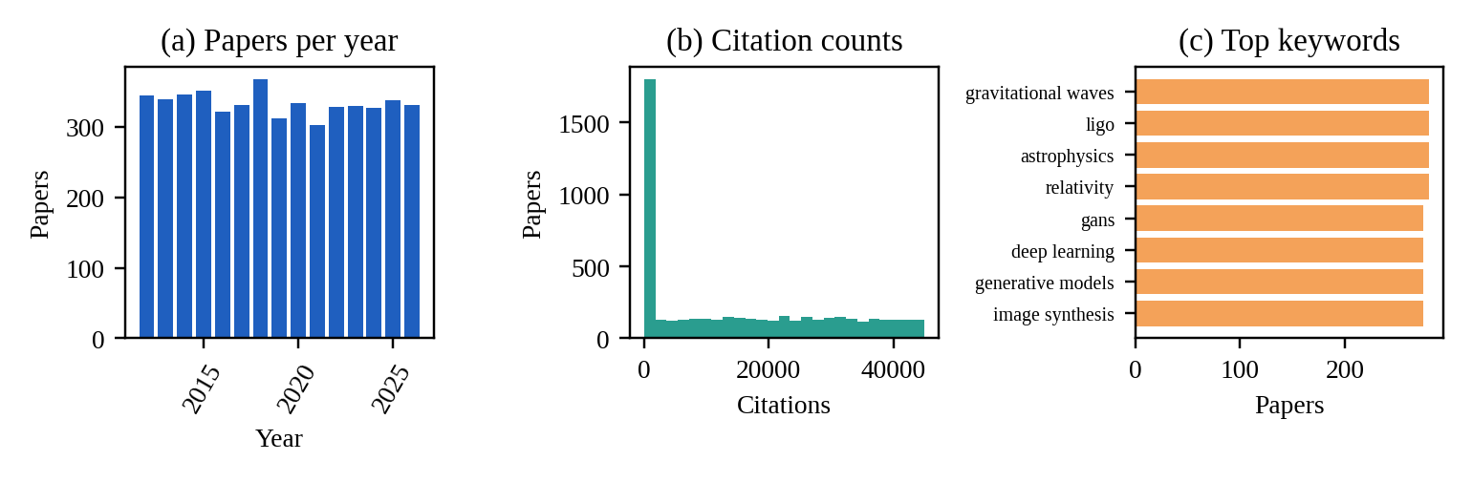
Figure 3: Dataset overview: (a) papers per year, (b) distribution of citation counts, (c) most frequent keywords.

Experimental Set-up
The application runs on Python 3 with Flask 3.0.3; every algorithm in Table 2 is written in plain Python without external algorithm libraries. Measurements were taken on a Linux machine with Python 3.12 using Flask's test client, so network transfer time is not included. Each latency in the report is the best of three runs, and absolute values will differ on other hardware. The experiments are grouped into three parts: correctness tests, a search workload, and scaling tests.

Correctness Tests
Fourteen automated checks were written, one or two for each algorithm. Known-answer tests use textbook examples: edit distance between "kitten" and "sitting", the maximum flow of the classic six-node network [12] (23), the LCP array of "banana", and the matches of the keywords he, she, his and hers in the text "ushers". Randomised tests compare the suffix array with a naive sort of all suffixes on 200 random strings, and the Blelloch scan with serial prefix sums on 100 random arrays. Reservoir sampling is checked statistically: a sample of 3 items from a stream of 10 is drawn 3,000 times and the inclusion probability of every item should be close to 0.3.

Search Workload
Ten queries covering different topics and different numbers of candidate papers were sent to /api/recommend: "machine learning", "deep learning", "quantum", "climate", "blockchain", "neural networks", "gene", "protein folding", "reinforcement learning" and "graph". For each query the experiment records the number of matching papers (capped at 500), the latency of the full hybrid pipeline, the latency of BM25 alone, and the number of papers from the BM25 top 10 that are still in the hybrid top 10.

Scaling Tests
The running time of each algorithm was measured on growing inputs: Wagner-Fischer and Smith-Waterman on strings of 100 to 800 characters, the suffix array on random strings of 1,000 to 16,000 characters, Dinic's algorithm on random networks with 100 to 1,600 nodes and four times as many edges (capacities 1-20), the Blelloch scan on arrays of 1,000 to 64,000 numbers, and Aho-Corasick on texts of 1,000 to 100,000 characters.

Results

Algorithm Correctness
Table 4 shows the outcome of the fourteen checks. Twelve passed. The two failures both concern the Blelloch scan. Its up-sweep and down-sweep phases produce the correct exclusive prefix sums, but the final loop that converts them to inclusive sums starts from the identity value in position 0, so every output value is shifted by the first element: for the input 3, 1, 4, 1, 5, 9, 2, 6 the code returns 0, 1, 5, 6, 11, 20, 22, 28 instead of 3, 4, 8, 9, 14, 23, 25, 31. Because the scan carries only 5% of the ranking weight and is divided by its last value, the effect on the ranking is small, but the lab output does not match its own serial check. The fix is a single line: return the exclusive value plus the input element at every position. All other algorithm families passed every check.
Table 4: Results of the automated correctness checks.
Check | Detail | Result
Wagner-Fischer kitten/sitting | distance = 3 | Pass
Wagner-Fischer identical | distance = 0 | Pass
Smith-Waterman local match | score = 8 (4 matches x 2) | Pass
Suffix array vs naive sort | 200 random strings | Pass
Kasai LCP banana | LCP = [1,3,0,0,2] | Pass
Aho-Corasick ushers | matches: he, she, hers | Pass
Dinic CLRS network | max-flow = 23 | Pass
Min-cut = max-flow | source/sink separated | Pass
Hopcroft-Karp | matching = 3 | Pass
Vertex cover validity | cover size 4 <= 2xOPT(2) | Pass
Greedy set cover | 2 sets chosen | Pass
Blelloch vs serial prefix | Inclusive scan of 3,1,4,1,5,9,2,6 | Fail
Blelloch random arrays | 100 random arrays vs serial prefix sums | Fail
Reservoir uniformity | inclusion prob 0.294-0.310 (ideal 0.300) | Pass

Search Performance
Table 5 and Figure 4 report the search workload. BM25 alone answers every query in under 2 ms. The full hybrid pipeline takes 68 to 787 ms, and its latency grows roughly with the number of candidates (about 0.3 to 1.6 ms per candidate) because the quadratic Smith-Waterman alignment is run once per candidate. Queries whose words are not in the vocabulary, such as "blockchain" and "protein folding", return an empty list in about 0.3 ms. For the other queries only 2 to 7 of the BM25 top 10 papers remain in the hybrid top 10, which shows that the additional signals change the ordering substantially. No human relevance judgements were collected, so these results measure behaviour and speed rather than retrieval accuracy.
Table 5: Search workload: candidates, latency and overlap between the BM25 and hybrid top 10.
Query | Candidates | Hybrid (ms) | BM25 (ms) | Top-10 overlap | Top hybrid result
machine learning | 500 | 590.1 | 1.04 | 3 | Machine Learning Approaches to Credit Risk Assessment
deep learning | 500 | 508.8 | 1.56 | 3 | Deep Learning in Automated Histopathology Slide Analysis
quantum | 252 | 116.3 | 0.21 | 5 | Quantum Computing Platforms Using Trapped-Ion Qubits
climate | 255 | 121.1 | 0.10 | 7 | Impact of Climate Change Risk on Sovereign Bond Yields
blockchain | 0 | 0.3 | 0.02 | - | (no match)
neural networks | 500 | 562.8 | 0.46 | 2 | Reinforcement Learning in Autonomous Robotics Navigation
gene | 242 | 68.0 | 0.11 | 6 | CRISPR-Cas9 Gene Editing in Oncology Applications
protein folding | 0 | 0.3 | 0.04 | - | (no match)
reinforcement learning | 500 | 786.9 | 0.78 | 5 | Reinforcement Learning in Autonomous Robotics Navigation
graph | 240 | 85.7 | 0.14 | 5 | Two-Dimensional Graphene Heterostructures for Nanoelectronic...

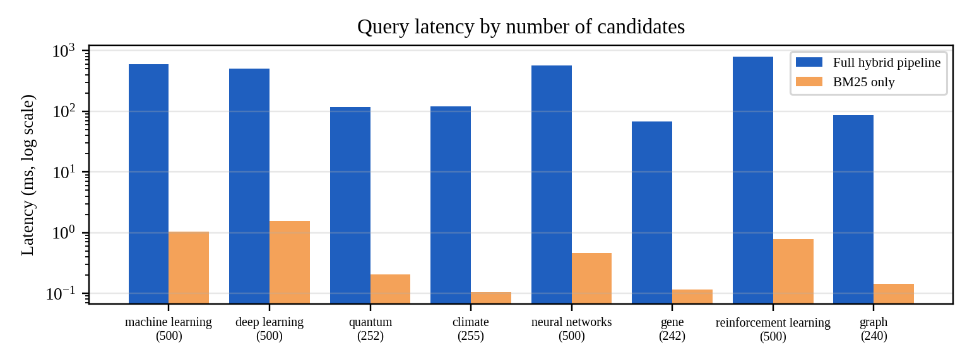
Figure 4: Query latency of the full hybrid pipeline and of BM25 alone (log scale); the number of candidates is shown in brackets.

Scaling Behaviour
Figure 5 shows the scaling tests. For Wagner-Fischer and Smith-Waterman the running time grows about four-fold each time the string length doubles (for example 1.9, 7.5, 36.5 and 173 ms for Wagner-Fischer at n = 100, 200, 400 and 800), as expected for O(nm). The suffix array grows from 1.9 ms at 1,000 characters to 47.6 ms at 16,000 characters, a 25-fold increase for a 16-fold larger input, consistent with O(n log² n). On sparse random networks Dinic's algorithm grows almost linearly (1.2 ms at 100 nodes, 18.8 ms at 1,600 nodes), far below its O(V²E) worst case. The Blelloch scan takes 0.4 ms for 1,000 values and 29.6 ms for 64,000 values, which is linear work; since the code runs sequentially, the O(log n) span cannot show up as a speed-up. Aho-Corasick scans 100,000 characters in about 8 ms.
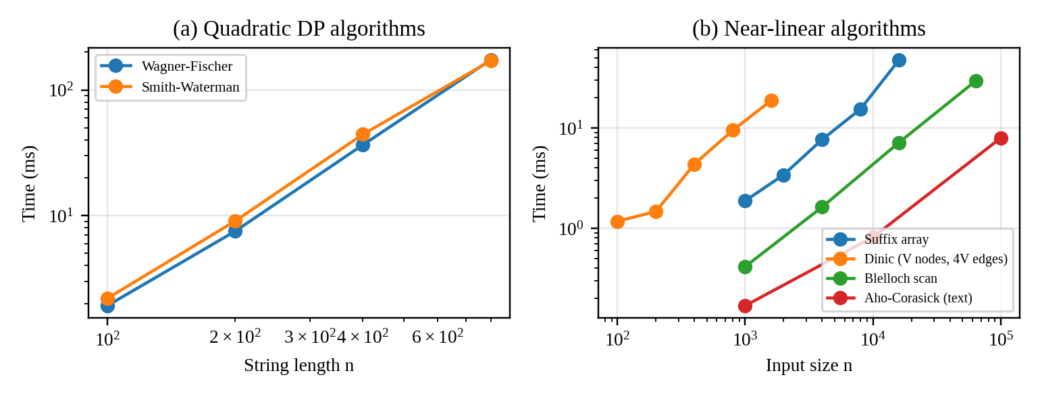
Figure 5: Running time of the algorithms for increasing input size (log-log scale).

REST API Response Times
Table 6 lists the response times of the data endpoints. All of them answer in under 7 ms because the graph, PageRank vector and trend scores are precomputed at start-up; only /api/recommend does real work per request (Table 5).
Table 6: Response time and payload size of the data endpoints.
Endpoint | Content | Payload | Time (ms)
/api/graph?n=200 | 200-paper citation subgraph | 133 KB | 2.6
/api/graph?n=800 | 800-paper citation subgraph | 557 KB | 6.2
/api/metrics | Graph metrics and histograms | 0.2 KB | 2.4
/api/trends | Citation timeline | 0.8 KB | 1.3
/api/keywords/top?n=12 | Suggestion chips | 0.5 KB | 3.4

Application Output
Figures 6 to 9 show the finished application. The search tab (Figure 6) lists the ranked papers for the query "deep learning" with their hybrid score, year and citation count. The records at ranks 1 and 2 share a title because titles repeat in the data set.
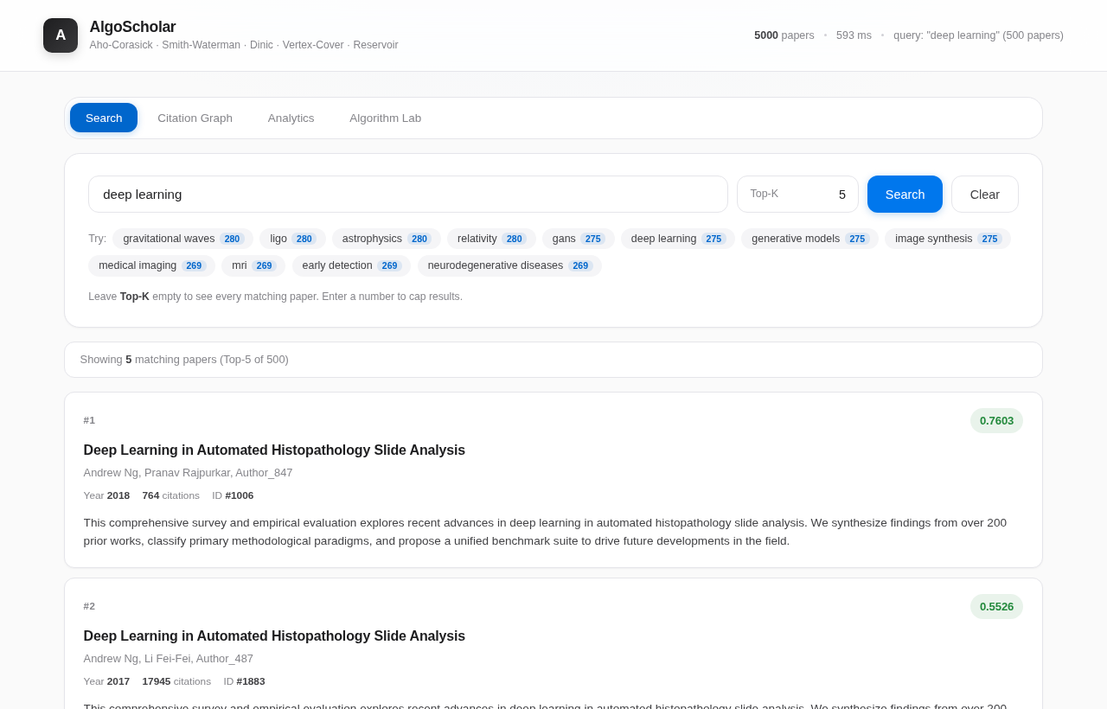
Figure 6: Search tab: ranked results for the query "deep learning" with Top-K = 5.
The citation graph tab (Figure 7) shows the force-directed network of the matching papers. Nodes can be dragged, selected to open the inspector, and paired to find the shortest path.
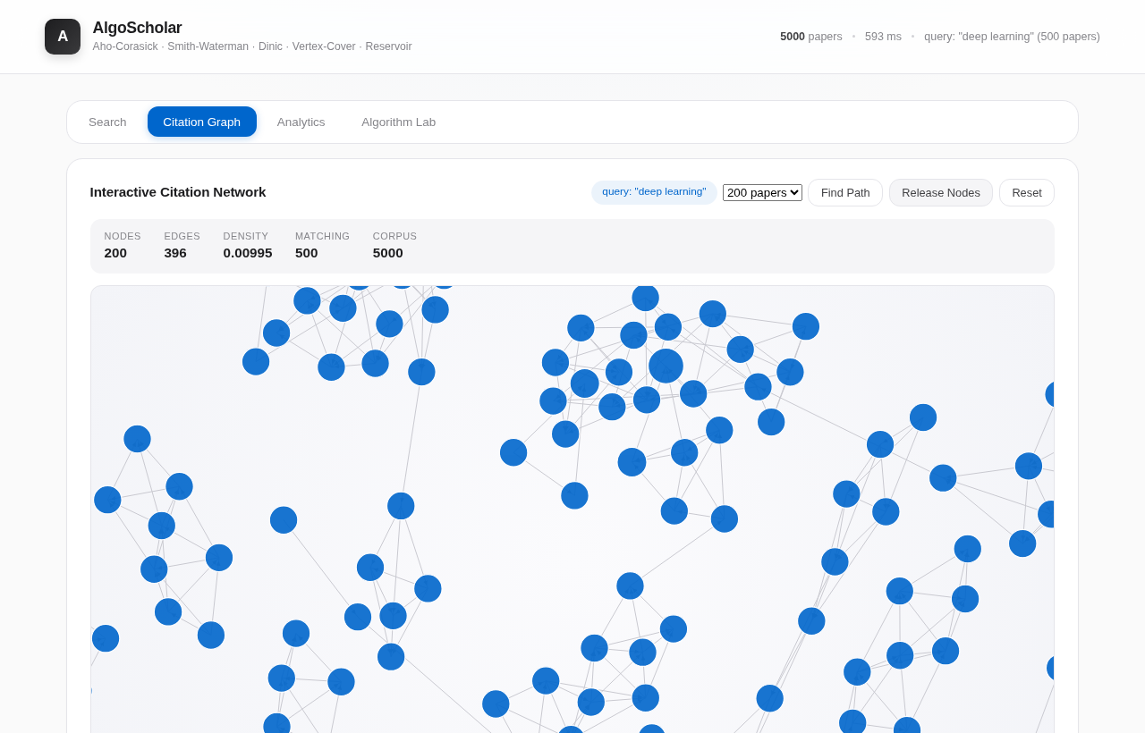
Figure 7: Citation Graph tab: interactive network of 200 papers matching the query.
The analytics tab (Figure 8) reports the graph metrics for the current subgraph together with the degree and PageRank distributions and the citation timeline.
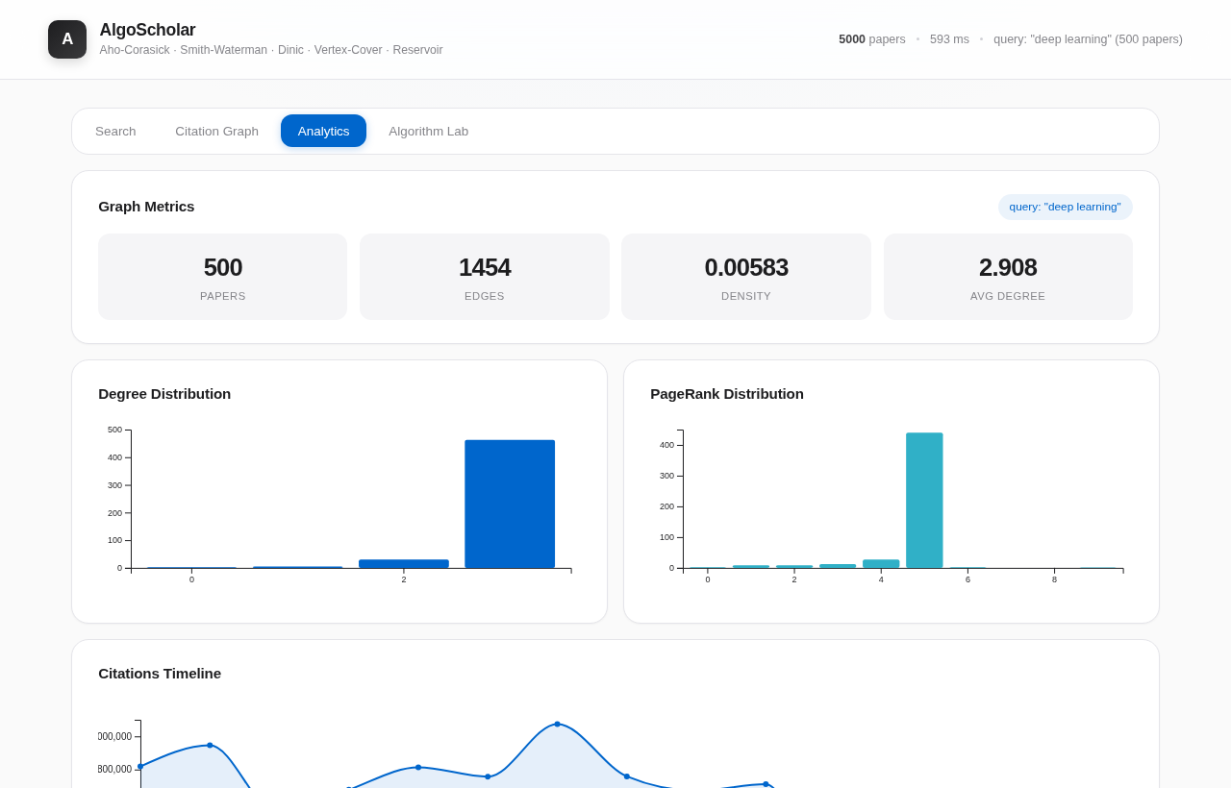
Figure 8: Analytics tab: graph metrics, degree distribution and PageRank distribution.
The Algorithm Lab (Figure 9) lists every algorithm with its family, purpose and complexity, and below the table it provides an editable demonstration for each of them.
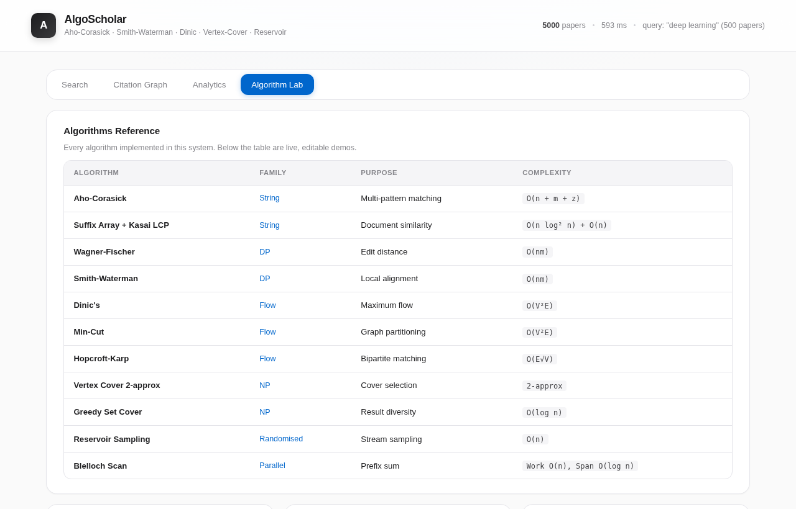
Figure 9: Algorithm Lab: reference table of the implemented algorithms.

Conclusion and Future Work
This project built AlgoScholar, a research paper recommender in which eleven algorithms from the DSA-3 syllabus are implemented from scratch and used in one working application. Papers are retrieved with a BM25 inverted index and re-ranked by a hybrid score that combines Smith-Waterman fuzzy matching, PageRank on a keyword-derived citation graph, a citation-trend score and a prefix-sum boost. On the 5,000-paper corpus the index builds in 0.19 s, the graph and PageRank in under 0.1 s, BM25 retrieval takes about 1 ms, and the full hybrid pipeline answers in 0.07 to 0.8 s. Twelve of fourteen correctness checks passed, and the measured running times follow the theoretical complexities of the algorithms. The web interface lets a user search, explore the citation network, inspect graph statistics and run every algorithm on their own input.
The current version has limitations. The citation graph is a proxy built from shared keywords because the data set has no reference lists. The corpus contains many repeated titles, and no labelled relevance judgements exist, so ranking quality has not been measured with precision or nDCG. The Blelloch scan returns values shifted by its first element. The Aho-Corasick flag is computed but not used in the score, PageRank mass from nodes without outgoing links is not redistributed (the scores sum to 0.959 instead of 1), and the pure-Python Smith-Waterman step makes 500-candidate queries take more than half a second. Future work can address these points:
- Replace the keyword-based graph with real citation data from a scholarly source, and add co-author and venue information.
- Collect labelled queries and evaluate the ranking with precision@k and nDCG, then tune the five weights instead of fixing them by hand.
- Fix the first-element error in the Blelloch scan, handle dangling nodes in PageRank, and include the Aho-Corasick exact-match flag in the score.
- Reduce latency by limiting Smith-Waterman to the best 100 candidates, caching frequent queries and running the alignments in parallel.
- Add semantic search with text embeddings, per-user profiles and a persistent database so that the system can scale beyond the in-memory corpus.

References
- W. Ammar et al., "Construction of the Literature Graph in Semantic Scholar," Proc. NAACL-HLT 2018 (Industry Papers), 84-91 (2018).
- S. Robertson and H. Zaragoza, "The Probabilistic Relevance Framework: BM25 and Beyond," Foundations and Trends in Information Retrieval, 3(4), 333-389 (2009).
- T. F. Smith and M. S. Waterman, "Identification of common molecular subsequences," Journal of Molecular Biology, 147(1), 195-197 (1981).
- L. Page, S. Brin, R. Motwani, and T. Winograd, "The PageRank Citation Ranking: Bringing Order to the Web," Stanford InfoLab Technical Report (1999).
- G. E. Blelloch, "Prefix Sums and Their Applications," Technical Report CMU-CS-90-190, Carnegie Mellon University (1990).
- A. V. Aho and M. J. Corasick, "Efficient string matching: an aid to bibliographic search," Communications of the ACM, 18(6), 333-340 (1975).
- U. Manber and G. Myers, "Suffix arrays: a new method for on-line string searches," SIAM Journal on Computing, 22(5), 935-948 (1993).
- T. Kasai, G. Lee, H. Arimura, S. Arikawa, and K. Park, "Linear-time longest-common-prefix computation in suffix arrays and its applications," Proc. CPM 2001, LNCS 2089, 181-192 (2001).
- R. A. Wagner and M. J. Fischer, "The string-to-string correction problem," Journal of the ACM, 21(1), 168-173 (1974).
- E. A. Dinic, "Algorithm for solution of a problem of maximum flow in networks with power estimation," Soviet Mathematics Doklady, 11, 1277-1280 (1970).
- J. E. Hopcroft and R. M. Karp, "An n^5/2 algorithm for maximum matchings in bipartite graphs," SIAM Journal on Computing, 2(4), 225-231 (1973).
- T. H. Cormen, C. E. Leiserson, R. L. Rivest, and C. Stein, Introduction to Algorithms, 4th ed., MIT Press (2022).
- V. Chvatal, "A greedy heuristic for the set-covering problem," Mathematics of Operations Research, 4(3), 233-235 (1979).
- J. S. Vitter, "Random sampling with a reservoir," ACM Transactions on Mathematical Software, 11(1), 37-57 (1985).
- Pallets Projects, "Flask Documentation (version 3.0)," https://flask.palletsprojects.com (2024).
- M. Bostock, V. Ogievetsky, and J. Heer, "D3: Data-Driven Documents," IEEE Transactions on Visualization and Computer Graphics, 17(12), 2301-2309 (2011).
- D. Gusfield, Algorithms on Strings, Trees, and Sequences, Cambridge University Press (1997).

