AI recommends energy-efficient PWM duty cycle STM32H7 + DC Motor
A Project Based Learning Report Submitted in partial fulfilment of the requirements for the award of the degree

of

Bachelor of Technology
in The Department of CSE
Course name : EMBEDDED SYSTEM DESIGN AND IOT
Course code : 25EC2206E

Submitted by
2510030031: Tippani Aniketh Reddy
2510030033: Karri Sri Sai Prashanth
2510030072: Kolla Arun Yadav
2510030171: Suraram Ashwithnath Reddy

Under the guidance of
Dr Jitendra Sharma


Department of Computer Science and Engineering
Koneru Lakshmaiah Education Foundation, Aziz Nagar
Aziz Nagar – 500075
OCT - 2026.
Abstract
Brushed DC motors are widely used in embedded drives, yet the PWM duty cycle chosen for them is usually fixed by trial and error, which wastes electrical energy when the motor is driven harder than the task needs. This project presents AI Recommends Energy-Efficient PWM Duty Cycle, an interactive browser-based virtual laboratory in which a student builds and wires an STM32H743ZI (Arm Cortex-M7, 480 MHz) + MOSFET driver + 12 V brushed DC motor circuit, writes STM32 HAL-style C configuration code, validates the design, simulates it, and obtains an energy-optimal duty-cycle recommendation.
The system is implemented in React 19 and Vite and consists of a drag-and-drop circuit builder with a twelve-part component library, a rule-based validation engine that blocks unsafe circuits (for example direct MCU-to-motor drive, missing common ground or missing flyback protection), an embedded C editor with a configuration parser, and a deterministic fourth-order Runge-Kutta (RK4) simulation of the motor's electrical and mechanical equations with PWM current ripple, power, efficiency, temperature and energy estimates. Results are shown on a live dashboard, a virtual oscilloscope, transient graphs, a UART serial console, a netlist view and CSV/JSON/report export. The AI optimizer is a model-based search: it simulates 101 candidate duty cycles (0 to 100 %), discards those that miss the target speed or exceed limits, and recommends the lowest-energy feasible duty.
For a 1000 RPM target (±2.5 %), the optimizer recommends 76 % duty. Compared with an over-driven 90 % baseline (1202 RPM, 23.35 W) it delivers 978 RPM at 17.44 W, a 25.3 % reduction in energy over a 10-minute window, and a live re-simulation at 76 % settles at about 981 RPM. All 55 checks of the project's automated test suite covering 13 laboratory scenarios pass. The results are model-based estimates, not measurements from physical hardware.
Keywords: STM32H743ZI, PWM duty cycle, brushed DC motor, energy efficiency, model-based optimization, RK4 simulation, virtual laboratory

List of Figures
Fig. 1. Software architecture and data flow of the virtual laboratory. 7
Fig. 2. Reference hardware connections modelled by the laboratory (STM32H743ZI, MOSFET driver, DC motor, ACS712 sensor, 12 V supply). 8
Fig. 3. Flow of the model-based duty-cycle optimizer. 12
Fig. 4. Laboratory Home page with workflow indicator, start buttons and learning scenarios. 14
Fig. 5. Laboratory Guide dialog with wiring instructions, safety rules and keyboard shortcuts. 14
Fig. 6. Circuit Builder with an empty canvas, the component library, the empty inspector and live validation errors. 15
Fig. 7. STM32H743ZI board placed and selected; the inspector shows its specifications and pins. 16
Fig. 8. Reference circuit: STM32H743ZI, MOSFET driver, DC motor, 12 V supply, ACS712 sensor and ground node with 13 colour-coded wires. 16
Fig. 9. Inspector for the brushed DC motor with adjustable electro-mechanical parameters. 17
Fig. 10. Inspector for the MOSFET driver module showing its pins and connections. 17
Fig. 11. Validation report for the reference circuit: all eight checks pass. 18
Fig. 12. Validation failure after the driver is removed: ERR_NO_DRIVER with a suggested fix. 19
Fig. 13. C Code Editor with the STM32 HAL program and the live configuration extraction panel. 20
Fig. 14. Parser error for an out-of-range duty cycle (120 %). 20
Fig. 15. Live Motor Output at 40 % duty: speed, current, voltage, power, efficiency and energy. 21
Fig. 16. Virtual oscilloscope showing PWM, motor voltage and ripple current at 40 % duty. 22
Fig. 17. Transient graphs of speed, current, voltage, power and energy at the optimized 76 % duty. 23
Fig. 18. UART serial console with time-stamped initialisation messages and telemetry. 24
Fig. 19. Circuit Status & Nets: safety-rule cards and the union-find netlist. 25
Fig. 20. Experiment Results & Export with CSV, JSON and report options and a telemetry preview. 26
Fig. 21. AI Optimizer, Case A: baseline 40 % duty, recommendation 76 % duty. 27
Fig. 22. AI Optimizer, Case B: over-driven 90 % baseline, recommendation 76 % duty saves 25.3 % energy. 27
Fig. 23. Duty-cycle sweep evaluated by the optimizer: (a) speed, (b) power and current, (c) efficiency. 28
Fig. 24. Recommendation applied: the optimizer now shows 76 % as both baseline and recommendation. 29
Fig. 25. C Code Editor after applying the recommendation: duty_percent = 76.0f. 29
Fig. 26. Live Motor Output after the recommended duty (76 %) is applied. 30

List of Tables
TABLE I. Main software modules of the project 8
TABLE II. Hardware component library 9
TABLE III. Wiring of the reference circuit (13 wires) 9
TABLE IV. Validation rules implemented in the engine 10
TABLE V. Constructs recognised by the C configuration parser 10
TABLE VI. Parameters used in all experiments 12
TABLE VII. Automated laboratory scenarios (npm test) 13
TABLE VIII. Optimizer results for the two baseline cases (target 1000 RPM, ±2.5 %, 10 min) 28
TABLE IX. Selected points of the duty-cycle sweep (target 1000 RPM, ±2.5 %) 28
TABLE X. Optimizer prediction compared with the live simulation 30

Table of Contents
1. Introduction 6
2. Methodology 7
a. System Overview and Workflow 7
b. Technology Stack and Software Modules 8
c. Component Library and Reference Circuit 8
d. Circuit Topology Validation Engine 9
e. Embedded C Firmware and Configuration Parser 10
f. DC Motor and PWM Mathematical Model 11
g. AI (Model-Based) Duty-Cycle Optimizer 11
h. Simulation Control, Telemetry and Export 12
3. Experiments 12
a. Experimental Setup 12
b. Laboratory Scenarios and Automated Test Suite 12
c. Design of the Optimization Experiments 13
4. Results 13
a. Laboratory Home Page and Help Guide 13
b. Circuit Builder: Component Library, Canvas and Inspector 14
c. Circuit Validation Report 18
d. Embedded C Code Editor and Live Configuration Extraction 19
e. Simulation Controls and Live Motor Output 20
f. Virtual Oscilloscope 21
g. Transient Graphs 22
h. UART Serial Console 23
i. Circuit Status and Nets 24
j. Experiment Results and Export 25
k. AI Optimizer Results 26
l. Verification of the Recommended Duty Cycle 29
m. Discussion 30
5. Conclusion and Future Work 30
References 31

AI Recommends Energy-Efficient PWM Duty Cycle: STM32H7 + DC Motor

Introduction
Electric motor drives are found throughout industry and in everyday devices, so the efficiency with which a motor is driven matters, and even small improvements add up when multiplied over many machines and long operating hours [3], [7]. In embedded systems the most common way to control a small brushed DC motor is pulse-width modulation (PWM): a microcontroller timer switches a power transistor on and off at a fixed frequency, and the fraction of each period for which the switch is on (the duty cycle) sets the average voltage applied to the motor. Because the motor's speed is roughly proportional to this average voltage, the duty cycle is the single most important firmware parameter of a basic drive. In practice, however, the value is often hard-coded by trial and error, and a value that is larger than necessary makes the motor draw more current and dissipate more heat than the application requires.
The STM32H743ZI is a high-performance Arm Cortex-M7 microcontroller running at up to 480 MHz with advanced-control timers (TIM1) that can generate precise PWM signals and 16-bit ADCs that can read current-sense signals [1], [2]. It cannot, however, drive a motor directly: a GPIO pin can supply only a few tens of milliamps, whereas a 12 V brushed motor with 2.2 Ω armature resistance can draw a stall current of about 5.45 A. A correct design therefore needs a MOSFET driver stage, a separate motor supply sharing a common ground with the controller, and protection against the voltage spike that appears when current through the motor's inductance is suddenly interrupted (inductive flyback). Beginners frequently get exactly these points wrong, and real hardware mistakes can destroy a development board. Hardware laboratories are also costly, limited in number and unavailable outside lab hours.
This project addresses both problems with a virtual embedded systems and power electronics laboratory that runs entirely in a web browser. The student places real component models (STM32H743ZI board, MOSFET driver, DC motor, power supply, current sensor, flyback diode, ground node and others) on a canvas and connects their pins with colour-coded wires. A validation engine then checks the circuit against electrical safety rules and explains every violation with a suggested fix. The student configures the firmware through a STM32CubeMX/HAL-style C program in which the PWM duty cycle, target speed, current limit and PWM frequency are defined. A deterministic motor simulation, based on the armature-circuit and rotor equations of a permanent-magnet DC motor [4], [7] and solved with a fourth-order Runge-Kutta method [5], reproduces how the motor would respond, and a set of virtual instruments displays the result.
The distinctive feature of the project is the AI optimizer for energy-efficient duty-cycle selection. Instead of guessing, the student asks the optimizer for the PWM duty cycle that reaches a desired speed with the least energy. The optimizer is a model-based AI method: it explores the whole space of possible duty cycles using the physics model of the motor, rejects candidates that cannot achieve the required speed or that violate voltage and current limits, and recommends the lowest-energy candidate. The recommendation can be applied to the C source with one click and then verified in the simulator.
The main objectives of the project are:
- to provide an interactive circuit builder in which an STM32H7 microcontroller, MOSFET driver, DC motor, power supply and protection components can be placed, wired and configured;
- to validate circuit topology automatically with safety rules and clear, actionable error messages;
- to read PWM duty cycle, target RPM, current limit and PWM frequency from embedded C code and apply them to the simulation;
- to simulate the DC motor and PWM drive deterministically and present speed, current, voltage, power, efficiency and energy through several instruments;
- to recommend an energy-optimal PWM duty cycle with an AI (model-based) optimizer and let the user apply and verify it; and
- to verify the whole workflow through an automated test suite of 13 laboratory scenarios.
It is important to state the scope clearly. The laboratory is a simulation: it does not compile or execute C code, it does not generate firmware binaries and it is not a full SPICE-level electrical solver. The C parser recognises only the supported configuration constants, the validation is rule-based, and all electrical results are model-based estimates computed in the browser. These limits are shown inside the application itself. The remainder of this report is organised as follows: Section 2 explains the methodology (architecture, component library, validation, firmware parser, motor model and optimizer); Section 3 describes the experimental setup and test scenarios; Section 4 presents and explains the output screens of every feature together with the numerical results; and Section 5 concludes the work and suggests future improvements.

Methodology

System Overview and Workflow
The laboratory follows the six-step workflow shown in the progress bar of the application: (1) select components, (2) wire them, (3) validate the circuit, (4) write the program, (5) simulate, and (6) study the results. Every step is a separate screen, and the shared state (placed components, wires, C source, simulation data) lives in a single React context so that a change made in one screen is immediately visible in all others. Fig. 1 shows the software architecture. The user interface layer contains the five views; the context layer owns the state and runs the simulation loop; and four independent engine modules perform the actual computation: topology validation, C configuration parsing, motor simulation and optimization. The circuit and the C code are saved in the browser's localStorage so that work is restored when the page is reopened.
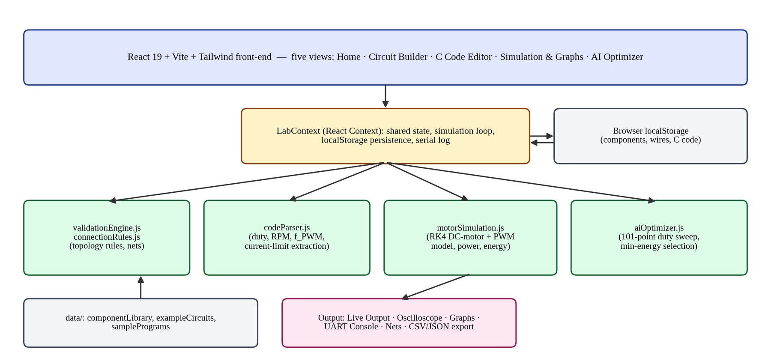
- Software architecture and data flow of the virtual laboratory.
The reference hardware that the laboratory models is shown in Fig. 2. The STM32H743ZI generates a 20 kHz PWM signal on PA8 (TIM1_CH1), which feeds the logic input of an opto-isolated MOSFET driver. The driver switches the 12 V motor supply onto the armature of the brushed DC motor. An ACS712 Hall-effect current sensor is placed in series with the motor return path, and its analogue output is read by ADC1 on PA0 to provide current feedback. All grounds are tied to a common ground bus, which is essential for the PWM signal to have a valid reference.
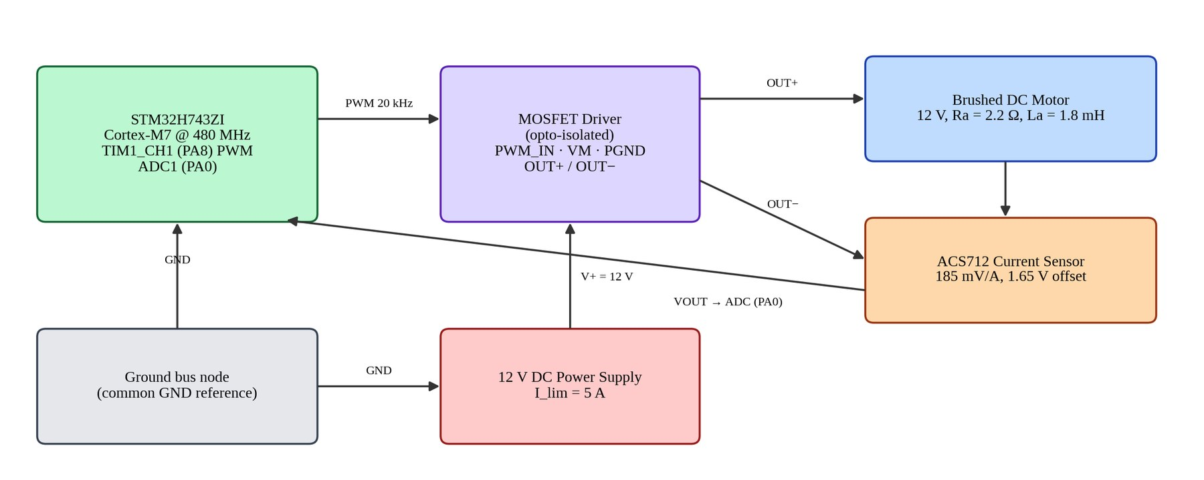
- Reference hardware connections modelled by the laboratory (STM32H743ZI, MOSFET driver, DC motor, ACS712 sensor, 12 V supply).

Technology Stack and Software Modules
The application is a single-page web application with no server component. It is written in JavaScript with React 19 and bundled with Vite; styling uses Tailwind CSS 4, icons come from lucide-react and the celebration animation on applying a recommendation uses canvas-confetti [8]-[10]. The core logic is deliberately separated from the user interface so that it can be tested from the command line. Table I lists the main modules and their responsibilities.
- Main software modules of the project
Module (src/) | Responsibility
context/LabContext.jsx | Central state: components, wires, selection, C code, simulation controls, telemetry history, serial log, localStorage persistence.
data/componentLibrary.js | Catalogue of 12 components with pins, pin types, voltages and default electrical parameters.
data/exampleCircuits.js, samplePrograms.js | Verified reference circuit (6 components, 13 wires) and three example STM32 programs (standard, low-power ECO, high-load).
engine/validationEngine.js, connectionRules.js | Rule-based topology checks, pin-type compatibility and union-find netlist construction.
engine/codeParser.js | Extracts duty cycle, target RPM, current limit and PWM frequency from C code; reports range errors and warnings.
engine/motorSimulation.js | RK4 DC-motor model with PWM ripple, power, efficiency, temperature and energy.
engine/aiOptimizer.js | Duty-cycle sweep and lowest-energy feasible selection.
components/ (circuit, editor, simulation, optimizer, home, common) | React views: builder, properties panel, validation report, code editor, six result tabs, optimizer and help guide.
test-scenarios.js | Command-line test suite of 13 laboratory scenarios (npm test).

Component Library and Reference Circuit
The component library contains twelve parts divided into seven categories: microcontrollers, motors, drivers, protection, power, sensors and tools. Each part has a graphical symbol, a set of pins with a pin type (PWM, ADC, GPIO, UART, power, ground, driver input, motor terminal and so on), a nominal voltage and default electrical parameters that the user can edit in the properties panel. Table II summarises the library.
- Hardware component library
Component | Category | Key pins / default parameters
STM32H743ZI Board | Microcontroller | 8 pins: PA8 (TIM1_CH1 PWM), PA0 (ADC1), PB0 (GPIO), PA9/PA10 (USART), 3.3 V, 5 V, GND; Cortex-M7 @ 480 MHz
Generic STM32H7 MCU | Microcontroller | 5 pins: PWM_OUT, ADC_IN, GPIO_PIN, VDD, GND; LQFP-64 package
Brushed DC Motor | Motor | M+, M-; 12 V, Ra = 2.2 Ω, La = 1.8 mH, Ke = Kt = 0.048, J = 0.0006 kg·m², B = 0.0005, load 0.04 N·m, stall current 5.45 A
MOSFET Driver Module | Driver | PWM_IN, LOGIC_GND, VCC_LOGIC, V+, PGND, OUT+, OUT-; opto-isolated, integrated flyback protection
N-Channel MOSFET (IRLZ44N) | Driver | Gate, drain, source; TO-220 logic-level low-side switch, Vds max 55 V, Rds(on) 28 mΩ, Vgs(th) 2 V, 12 A
Flyback Diode (1N5819) | Protection | Anode, cathode; 1N5819 Schottky, forward drop 0.45 V, 40 V reverse; clamps the inductive spike across the motor
DC Power Supply | Power | V+, V-; adjustable benchtop source, 12 V, current limit 5 A, 15 mV ripple
Ground Bus Node | Power | Star-ground junction with several ground ports for the MCU and power returns
Dual Power Rail | Power | Distribution strip with several VCC and common-GND tap points, 12 V
Current Sensor (ACS712) | Sensor | IP+, IP-, VCC, VOUT, GND; ACS712-05B, 185 mV/A, 1.65 V at zero current, ±5 A
Voltage Sensor (0-25 V) | Sensor | VIN+, VIN-, V_SIGNAL; 5:1 divider scales 0-25 V to the 0-3.3 V ADC range
Virtual Oscilloscope | Tool | CH1, CH2, GND probes; default 50 µs/div, 1 V/div and 5 V/div

The verified reference circuit (loaded with the Restore Reference Circuit button) uses six components and thirteen wires: the STM32H743ZI board, the MOSFET driver, the brushed DC motor, a 12 V DC power supply, an ACS712 current sensor and a ground bus node. Table III lists the connections. The signal path is PA8 to the driver's PWM_IN; the 3.3 V rail of the board supplies the driver logic and the sensor; the motor loop runs from the driver's OUT+ to the motor, through the sensor's current path and back to OUT-; and the sensor output returns to PA0 for current feedback.
- Wiring of the reference circuit (13 wires)
No. | From | To | Purpose
1 | STM32 PA8 | Driver PWM_IN | TIM1_CH1 PWM control (3.3 V logic)
2 | STM32 GND | Ground bus port 1 | MCU system ground
3 | Driver LOGIC_GND | Ground bus port 2 | Common ground reference
4 | PSU V+ | Driver V+ (POWER_VM) | 12 V motor high-side rail
5 | PSU V- | Driver PGND | Power return
6 | Driver OUT+ | Motor M+ | Armature positive
7 | Driver OUT- | Sensor IP+ | Motor low side to shunt
8 | Sensor IP- | Motor M- | Completes the motor series loop
9 | Sensor VOUT | STM32 PA0 (ADC1) | Current feedback signal
10 | STM32 3.3 V | Sensor VCC | Sensor power
11 | Sensor GND | Driver LOGIC_GND | Sensor ground
12 | STM32 3.3 V | Driver VCC_LOGIC | Driver logic supply
13 | PSU V- | Ground bus port 1 | Supply return tied to common ground

Circuit Topology Validation Engine
Before a simulation is allowed to run, the validation engine analyses the circuit. It first builds a netlist with a union-find (disjoint-set) algorithm: every wire merges the nets of its two pins, so that all pins that are electrically connected end up in one named net (NET_1, NET_2, and so on). Rules are then evaluated on pins, components and nets, and each rule produces a result with a severity (error, warning or pass), a code, a plain-language message, the components involved and a suggested fix. Errors block the simulation; warnings do not. Table IV groups the implemented rules.
- Validation rules implemented in the engine
Group | Example codes | What is checked
Presence | ERR_NO_MCU, ERR_NO_MOTOR, ERR_NO_DRIVER, ERR_NO_POWER_SUPPLY | The workspace must contain a microcontroller, a motor, a power-switching stage and a power supply.
PWM and logic | ERR_PWM_NOT_CONNECTED, ERR_LOGIC_LEVEL_INCOMPATIBLE, ERR_PIN_TYPE_MISMATCH | PA8 PWM must reach the driver input; 3.3 V logic must meet the driver input requirement; incompatible pin types cannot be joined.
Direct-drive protection | ERR_UNSAFE_DIRECT_DRIVE | A motor connected straight to an MCU GPIO is blocked because the 5.45 A stall current exceeds the 20 mA pin limit.
Grounding | ERR_FLOATING_GROUND, ERR_SUPPLY_COMMON_GROUND, ERR_DRIVER_PGND_DISCONNECTED | Controller ground and power ground must share one reference net.
Power and ratings | ERR_DRIVER_VM_DISCONNECTED, ERR_MOTOR_OVERVOLTAGE, ERR_DRIVER_VOLTAGE_RATING, ERR_MOSFET_VOLTAGE_RATING, ERR_POWER_VOLTAGE_CONFLICT, ERR_PSU_SHORT, ERR_MCU_POWER_SHORT | Supply connected to the driver, voltage within motor and driver ratings, no conflicting rails or shorts.
Motor loop | ERR_MOTOR_TERMINALS_DISCONNECTED, ERR_WIRE_ENDPOINT_INVALID, WARN_DUPLICATE_WIRE | Both motor terminals must be connected; invalid or duplicate wires are reported.
Flyback protection | ERR_MISSING_FLYBACK_DIODE, ERR_FLYBACK_DIODE_WIRING, ERR_REVERSED_DIODE, WARN_DIODE_NOT_ACROSS_MOTOR, ERR_LOW_SIDE_MOSFET_WIRING | A discrete low-side MOSFET needs a correctly oriented diode across the motor; the integrated driver module has built-in protection.
Sensor and properties | ERR_CURRENT_SENSOR_INCOMPLETE, ERR_COMPONENT_PROPERTY_INVALID | The ACS712 must be completely connected; edited parameters must be physically valid.
Pass messages | OK_PWM_CONNECTED, OK_LOGIC_LEVEL_COMPATIBLE, OK_COMMON_GROUND, OK_MOTOR_POWER, OK_MOTOR_CONNECTED, OK_FLYBACK_INTEGRATED, OK_MOTOR_VOLTAGE_RATING, OK_CURRENT_TELEMETRY | Positive confirmations shown when a rule is satisfied (8 pass for the reference circuit).

Embedded C Firmware and Configuration Parser
The code editor holds a STM32CubeMX/HAL-style main.c program. Three example programs are provided: the standard example (40 % duty), a low-power ECO mode and a high-load / fast-ramp mode. The browser does not compile or run the C code; instead, a parser scans the source for a fixed set of configuration literals and passes the values to the motor model. Table V lists the recognised constructs and the ranges that are enforced. Brace balance is checked, and the HAL calls HAL_TIM_PWM_Start, SetPWMDutyCycle and ReadMotorCurrent_ADC are looked for so that the user is warned when they are missing. When the optimizer recommendation is applied, the parser's companion function rewrites only the duty_percent assignment in the source, preserving the rest of the program.
- Constructs recognised by the C configuration parser
Setting | Recognised form | Accepted range / default | Error code
PWM duty cycle | duty_percent, duty_cycle or pwm_duty = literal; | 0 to 100 % | ERR_DUTY_OUT_OF_RANGE
Target speed | target_rpm = literal; | > 0 and ≤ 3500 RPM | ERR_TARGET_RPM_OUT_OF_RANGE
Current limit | max_current_limit = literal; | > 0 and ≤ 100 A (default 3.5 A) | ERR_CURRENT_LIMIT_OUT_OF_RANGE
PWM frequency | #define PWM_TIMER_FREQ_HZ value | 100 Hz to 200 kHz (default 20 kHz) | ERR_PWM_FREQUENCY_OUT_OF_RANGE
Syntax | Balanced { } braces | - | ERR_UNBALANCED_BRACES
HAL calls | HAL_TIM_PWM_Start, SetPWMDutyCycle | Warnings only | WARN_PWM_START_NOT_FOUND, WARN_DUTY_FUNCTION_NOT_FOUND

In the default program the timer is configured with PWM_TIMER_FREQ_HZ = 20 000 and an auto-reload value of 24 000, which corresponds to a 480 MHz timer clock divided by 24 000 and gives a 20 kHz carrier above the audible range. The compare value that sets the duty cycle is the duty fraction multiplied by the auto-reload value.

DC Motor and PWM Mathematical Model
The motor model is the standard permanent-magnet DC motor [4], [7]. The armature circuit has resistance Ra and inductance La and sees the back-EMF Ke·ω, and the rotor has inertia J, viscous friction B and a constant load torque TL. The applied armature voltage is the average value of the PWM waveform, which is the supply voltage multiplied by the duty fraction D. The state equations are:
V_{app} = V_{s} · D (1)
L_{a} · di/dt = V_{app} − R_{a} · i − K_{e} · ω (2)
J · dω/dt = K_{t} · i − B · ω − T_{L} (3)
The two coupled differential equations (2) and (3) are integrated with the classical fourth-order Runge-Kutta method [5] with adaptive sub-stepping: every frame is divided into sub-steps of at most 0.2 ms, which is well below the electrical time constant L_{a}/R_{a} = 1.8 mH / 2.2 Ω ≈ 0.82 ms, so the solution remains stable. The current is kept non-negative and below the programmed current limit, and a stiction clamp prevents the rotor from moving backwards under load. This clamp is the reason why the motor does not turn at very low duty cycles (below about 16 % in the sweep of Fig. 23): the torque K_{t}·i is smaller than the load torque. The speed in RPM is ω·60/2π.
Because the motor is fed with a switched waveform, the model also estimates the peak-to-peak current ripple, its RMS value and the extra copper loss it causes, and from these the electrical input power, the useful mechanical power at the shaft, the efficiency, the temperature and the energy:
ΔI_{pp} = V_{s} · D · (1 − D) / (f_{PWM} · L_{a}) (4)
I_{rms} = √( I² + ΔI_{pp}² / 12 ) (5)
P_{elec} = V_{app} · I + R_{a} · (I_{rms}² − I²) (6)
P_{mech} = T_{L} · ω , η = P_{mech} / P_{elec} × 100 % (7)
E = ∫ P_{elec} dt , T = 25 + 1.8 · (P_{elec} − P_{mech}) °C (first-order lag) (8)
For example, at D = 0.76 with f_{PWM} = 20 kHz the ripple is ΔI_{pp} = 12 × 0.76 × 0.24 / (20 000 × 0.0018) ≈ 0.06 A, small compared with the 1.9 A average current, which justifies the use of a high carrier frequency. The virtual oscilloscope draws the PWM voltage and the triangular ripple current from these quantities.

AI (Model-Based) Duty-Cycle Optimizer
The optimizer answers the question: what is the smallest-energy duty cycle that still reaches the target speed? It is a model-based AI method in the sense of search over a simulated model of the plant; it uses no training data or neural network, so its result is deterministic and explainable. Fig. 3 shows the procedure. For each of the 101 candidate duty cycles from 0 % to 100 % in 1 % steps, the motor model is simulated for 2.4 s with a 20 ms step, and the last 0.4 s is averaged to obtain the steady-state speed, current, electrical power, mechanical power and efficiency. A candidate is feasible if its applied voltage does not exceed the motor's rated voltage, its current does not exceed the current limit and its speed is within the chosen tolerance of the target (default ±2.5 %). The energy over the selected window (default 10 min) is the power multiplied by the window length (equation 8), and the feasible candidate with the smallest energy is recommended. Because speed increases with duty and so does power, the optimizer in effect selects the lowest duty that reaches the tolerance band.
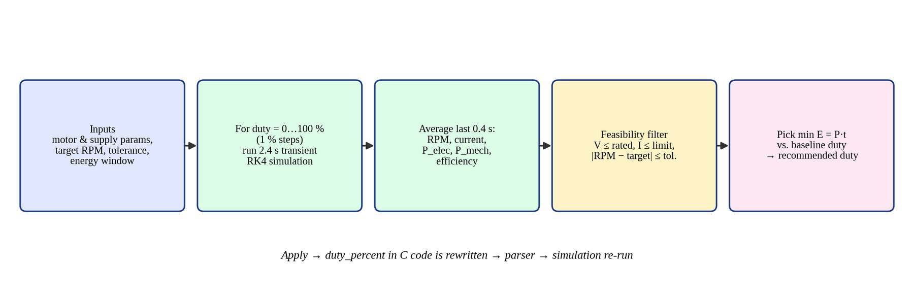
- Flow of the model-based duty-cycle optimizer.
The result also contains a baseline comparison: the duty cycle currently written in the C code is simulated in the same way, and the energy change between baseline and recommendation is reported in watt-hours and as a percentage, together with natural-language reasoning lines that explain how the recommendation was reached. The user can then press Apply Recommended Duty Cycle to write the value into the C source.

Simulation Control, Telemetry and Export
The simulation runs in the browser using the animation-frame loop. The Run, Pause/Resume, Stop, Step (50 ms) and Reset controls are provided; the simulation can only start if both the circuit and the program validate. Elapsed time per frame is clamped to avoid large jumps when the browser tab is in the background. A telemetry sample (time, speed, current, voltage, power, energy and efficiency) is stored every 100 ms in a buffer of the most recent samples that feeds the graphs and the export, and one UART line summarising duty, RPM and current is written to the serial console for every simulated second. The experiment can be exported as a CSV telemetry file, a JSON circuit layout and a formatted laboratory summary.

Experiments

Experimental Setup
All experiments were performed in software. The application was built with Vite and served locally; the screenshots in this report were captured from the running application in a headless Chromium browser at a window width of 1280 to 1600 pixels, and the automated test suite was run with Node.js 22 using the command npm test. The numerical values of the motor and supply that were used in every experiment are those of the default component parameters and are listed in Table VI.
- Parameters used in all experiments
Parameter | Symbol | Value
Supply voltage | V_{s} | 12 V (current limit of the supply 5 A; program limit 3.5 A)
Armature resistance | R_{a} | 2.2 Ω
Armature inductance | L_{a} | 1.8 mH
Back-EMF and torque constants | K_{e}, K_{t} | 0.048 V/(rad/s), 0.048 N·m/A
Rotor inertia | J | 0.0006 kg·m²
Viscous friction | B | 0.0005 N·m·s/rad
Load torque | T_{L} | 0.04 N·m
PWM frequency | f_{PWM} | 20 kHz (TIM1, auto-reload 24 000 at 480 MHz)
Target speed | - | 1000 RPM
Speed tolerance / energy window | - | ±2.5 % / 10 min
Default duty cycle in the C program | D | 40 %

Laboratory Scenarios and Automated Test Suite
The project includes a command-line test suite that exercises the same engine modules used by the interface through thirteen scenarios taken from the laboratory curriculum. The scenarios start from an empty workspace and gradually build, break, repair, simulate and optimise the circuit. Table VII lists them. All 55 checks inside the thirteen scenarios pass, which gives confidence that the validation rules, parser, motor model, optimizer and persistence behave as described in this report.
- Automated laboratory scenarios (npm test)
No. | Scenario | Purpose | Result
1 | Blank workspace | Validator reports the missing essential components. | Pass
2 | Add STM32H7 and DC motor | Missing driver and supply are still reported. | Pass
3 | Direct MCU PWM connection | Unsafe direct motor drive from a GPIO pin is blocked. | Pass
4 & 5 | Add driver, supply, ground and flyback diode | Circuit becomes valid as protection is added. | Pass
6 | Validate complete reference circuit | All rule checks pass for the reference design. | Pass
7 | Run with sample program | Parser extracts settings and the simulation runs. | Pass
8 | Change duty cycle in code | Motor response follows the new duty cycle. | Pass
9 | Remove an essential wire | Validator detects the broken connection. | Pass
10 | Increase motor load torque | Model responds to a heavier mechanical load. | Pass
11 | AI energy optimizer | Recommends 76 % duty with 25.3 % lower energy than a 90 % baseline. | Pass
12 | Simulation control primitives | Run, pause, step and reset behave correctly. | Pass
13 | LocalStorage serialisation | Circuit and code are saved and restored. | Pass

Design of the Optimization Experiments
Two optimizer experiments were designed. In Case A the program keeps its default duty cycle of 40 %; this tests what the optimizer does when the baseline is too weak to reach the target. In Case B the duty cycle in the program is changed to 90 %, representing a designer who over-drives the motor to be safe; this tests the energy saving that the optimizer can achieve. In both cases the target is 1000 RPM with a ±2.5 % tolerance and a 10-minute energy window. In addition, the complete 0 to 100 % duty sweep that the optimizer evaluates internally was extracted from the engine and plotted so that the reason for the recommendation can be seen. Finally, the recommended duty was applied to the C code and the simulation was run again in the interface to verify the prediction.

Results
This section presents the output of every screen of the application, in the order of the laboratory workflow, and explains each feature that the screen provides. All screenshots were produced by running the project; the numerical values quoted in the text are those displayed on screen or computed by the project's own engine.

Laboratory Home Page and Help Guide
Fig. 4 shows the Laboratory Home page, which is the entry point of the application. The header carries the project title, the badge STM32H7 + DC Motor Lab and the top navigation with the five views (Laboratory Home, Circuit Builder, C Code Editor, Simulation & Graphs, AI Optimizer). Under it, the six-step lab workflow indicator (Components, Wiring, Validation, Program, Simulation, Results) turns each step green as the student completes it. While a simulation is running, the navigation bar also shows the live motor speed as a badge, so the speed is visible from every screen. The hero panel offers two starting points: Build Circuit from Scratch, which opens an empty workspace, and Restore Reference Circuit, which loads the verified design. Below the hero, three cards summarise the laboratory workflow (select and wire hardware, validate and write C code, simulate and optimise), and the Curriculum Learning Scenarios section describes guided experiments such as the Direct MCU Drive Trap and Inductive Flyback Protection.
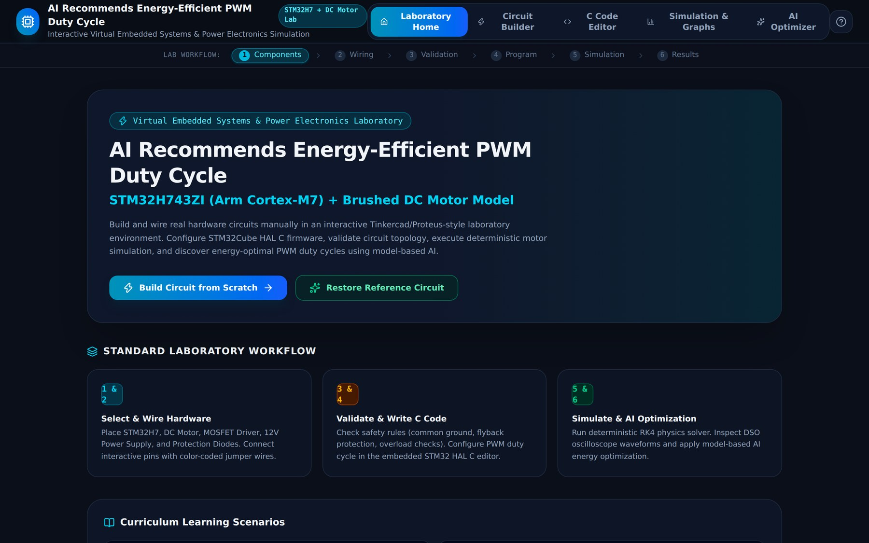
- Laboratory Home page with workflow indicator, start buttons and learning scenarios.
The question-mark button in the header opens the Laboratory Guide (Fig. 5). It explains how to connect pins (click a pin pad, a glowing draft wire follows the cursor, click the destination pin; Esc cancels), summarises the safety rules that are enforced (common ground, no direct drive, flyback protection), reminds the student how the duty_percent value in the C program is parsed, and lists the keyboard shortcuts: Delete/Backspace deletes the selected component or wire, R rotates the component by 90 degrees, Esc cancels a wire draft or deselects, and the scroll wheel zooms the workspace.
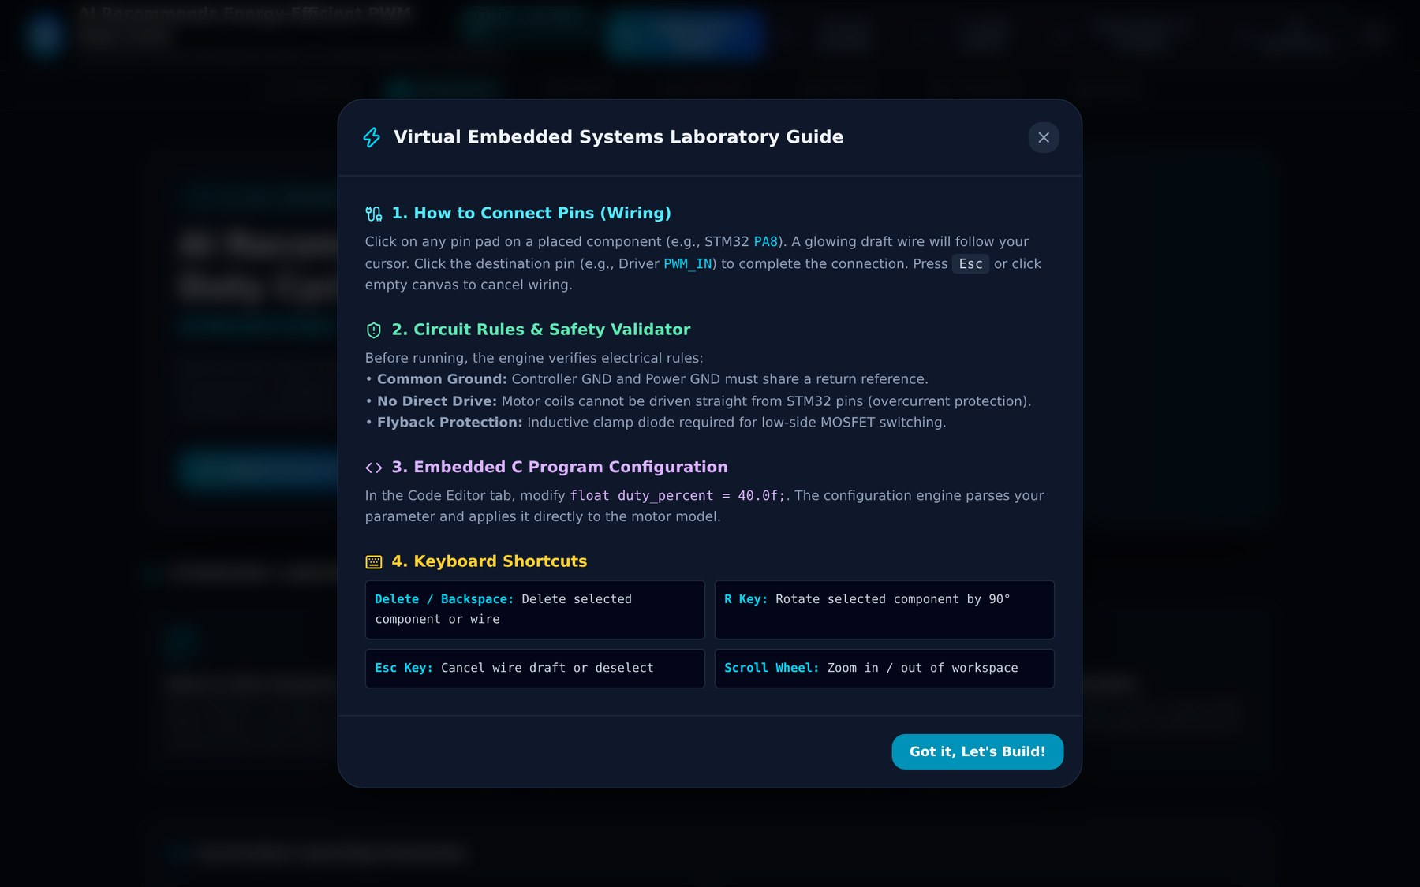
- Laboratory Guide dialog with wiring instructions, safety rules and keyboard shortcuts.

Circuit Builder: Component Library, Canvas and Inspector
Fig. 6 shows the Circuit Builder with an empty workspace. The screen has three working areas and a status bar. On the left is the Hardware Component Library with a search box, category filter chips (All, Microcontrollers, Motors, motor drivers and so on) and a card for each part showing its name, subtitle, description, number of exposed pins and pin names. A component can be dragged onto the canvas or placed by clicking the plus button. In the centre is the Circuit Canvas, which shows the live count of components and wires and provides zoom-out, zoom-in and fit controls, a Grid Snap toggle for tidy placement, and a Restore Example Circuit button. On the right is the Inspector & Properties panel. At the bottom, the validation panel updates after every edit; for an empty canvas it reports three blocking errors (microcontroller, motor and supply missing), each with its error code and a Suggested Fix.
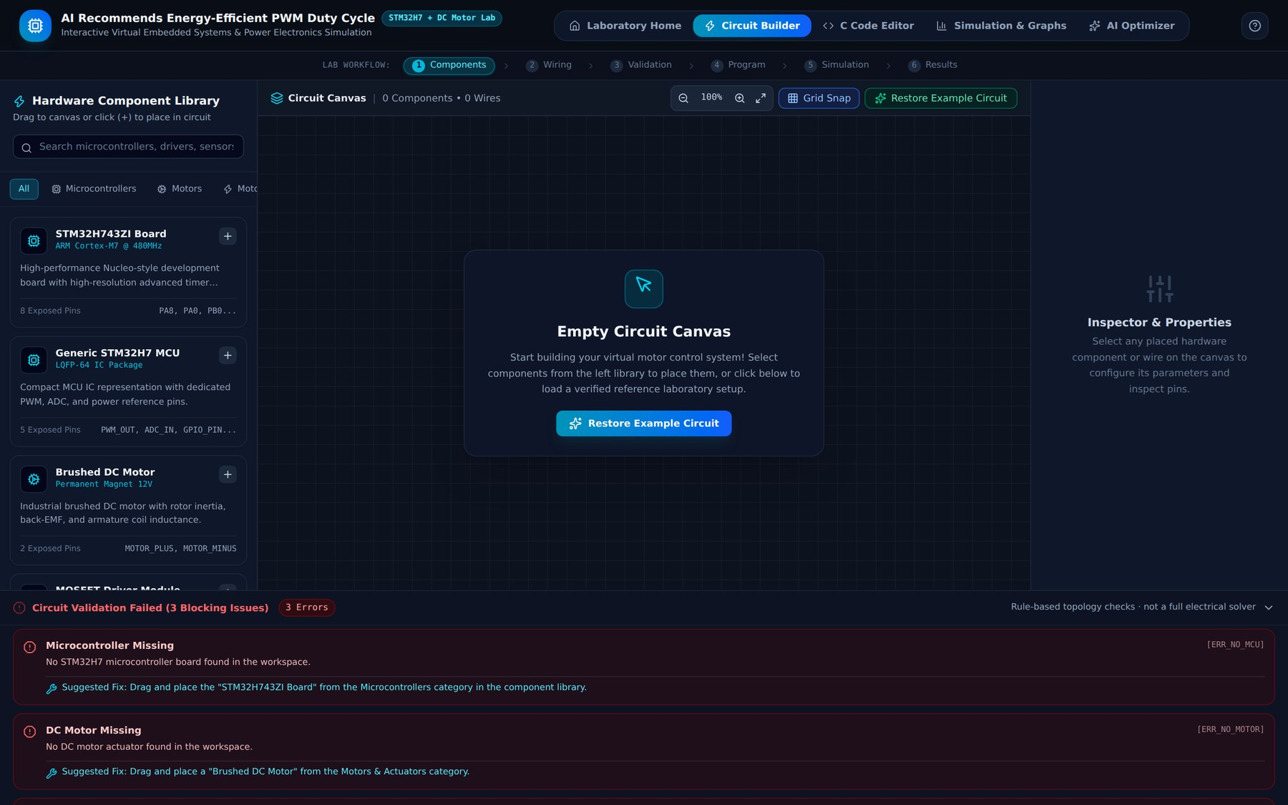
- Circuit Builder with an empty canvas, the component library, the empty inspector and live validation errors.
When a component is placed and selected (Fig. 7), it is outlined on the canvas and the canvas toolbar gains Rotate and Delete buttons. The inspector then shows the component's specification and a list of all exposed pins with their electrical type, voltage and direction. For the STM32H743ZI board these are the ARM Cortex-M7 core at 480 MHz, TIM1 (advanced timer) as the PWM source and 3.3 V CMOS I/O logic, and the eight pins PA8 (TIM1_CH1 PWM), PA0 (ADC1_IN16), PB0 (GPIO), PA9 (USART1_TX), PA10 (USART1_RX), 3.3 V, 5 V and GND. The validation panel has already changed: only two blocking issues remain (motor and driver missing), which shows that validation is continuous.
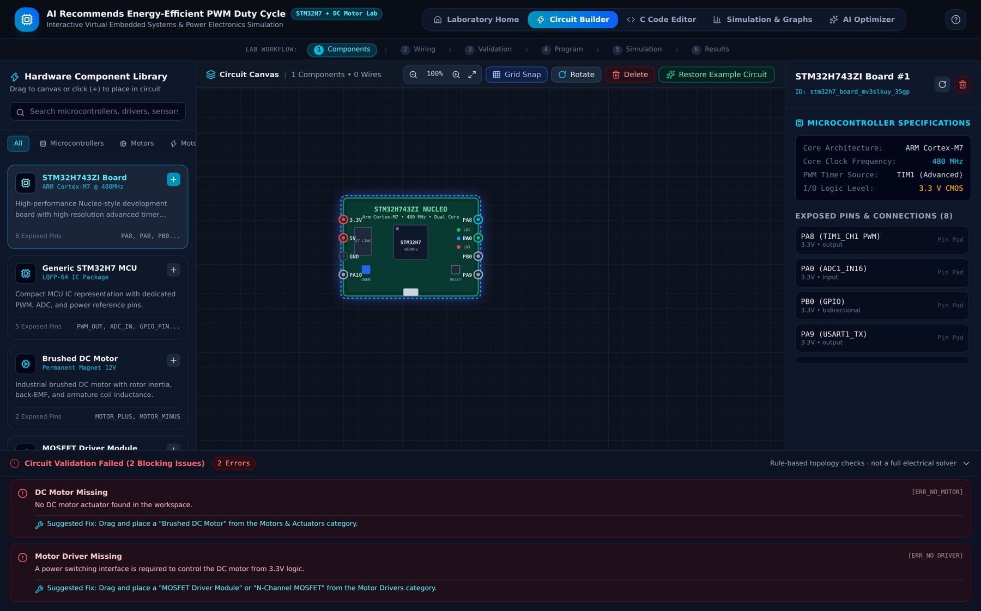
- STM32H743ZI board placed and selected; the inspector shows its specifications and pins.
Fig. 8 shows the complete reference circuit with six components and thirteen wires at 85 % zoom. Wires are colour-coded by signal type: cyan for the PWM control signal, grey for grounds, red for the 12 V motor rail, orange for 3.3 V supplies, blue for the motor current loop and green for the analogue current feedback. Pin pads on each component are colour-coded in the same way. Wires are created by clicking a source pin and then a destination pin; incompatible pin types are rejected by the connection rules, and removing a component also removes the wires attached to it. The first two steps of the workflow indicator are ticked and the status bar reports that eight checks passed.
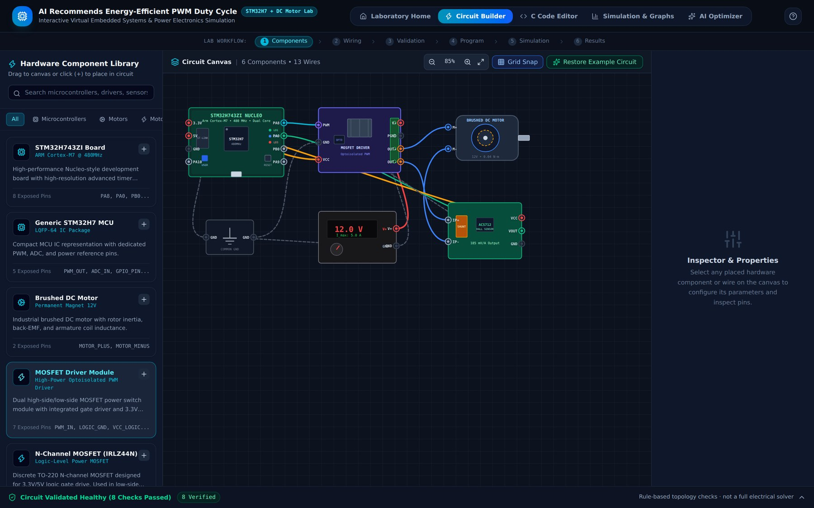
- Reference circuit: STM32H743ZI, MOSFET driver, DC motor, 12 V supply, ACS712 sensor and ground node with 13 colour-coded wires.
Selecting the motor (Fig. 9) opens its electro-mechanical parameters in the inspector as sliders: armature resistance Ra (2.2 Ω), armature inductance La (1.8 mH), mechanical load torque (0.04 N·m) and back-EMF constant Ke (0.048 V/(rad/s)). Changing a slider changes the model used by the simulation and the optimizer, so the student can experiment with a heavier load or a different motor. The motor's two terminals, M+ (armature positive) and M- (armature negative), are listed below. Selecting the MOSFET driver (Fig. 10) lists its seven pins (PWM IN, logic GND, 3.3 V logic reference, motor supply V+, power ground and the two outputs) and their connection state.
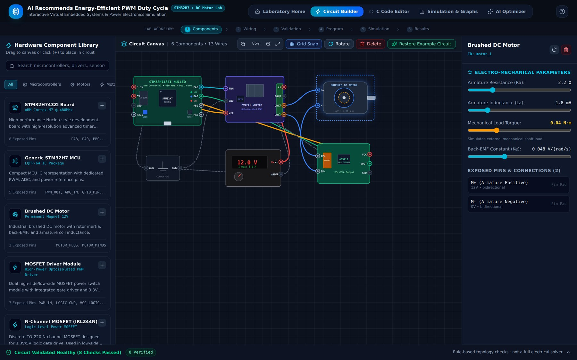
- Inspector for the brushed DC motor with adjustable electro-mechanical parameters.
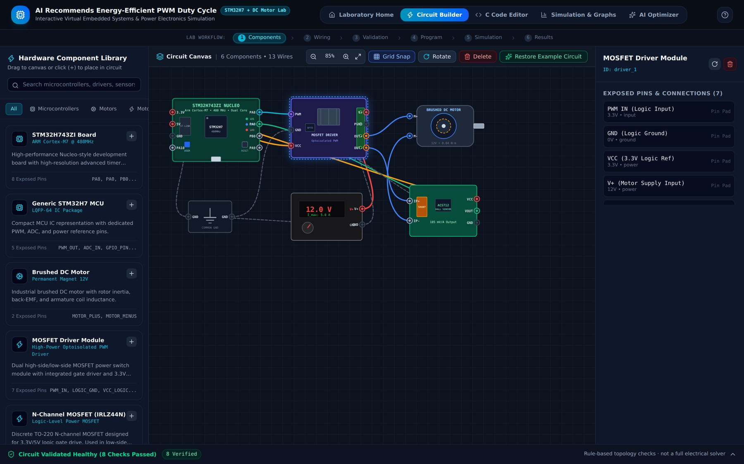
- Inspector for the MOSFET driver module showing its pins and connections.

Circuit Validation Report
The validation panel at the bottom of the builder is the visible output of the rule engine. For the reference circuit (Fig. 11) it reports Circuit Validated Healthy (8 Checks Passed) and, when expanded, lists each passed rule as a card with a title, a description, the rule code and the components involved: PWM control signal verified (OK_PWM_CONNECTED), PWM logic level compatible (OK_LOGIC_LEVEL_COMPATIBLE), common ground topology verified (OK_COMMON_GROUND) and the remaining checks for motor connection, motor power, motor voltage rating, integrated flyback protection and current telemetry. A reminder in the panel states that these are rule-based topology checks and not a full electrical solver.
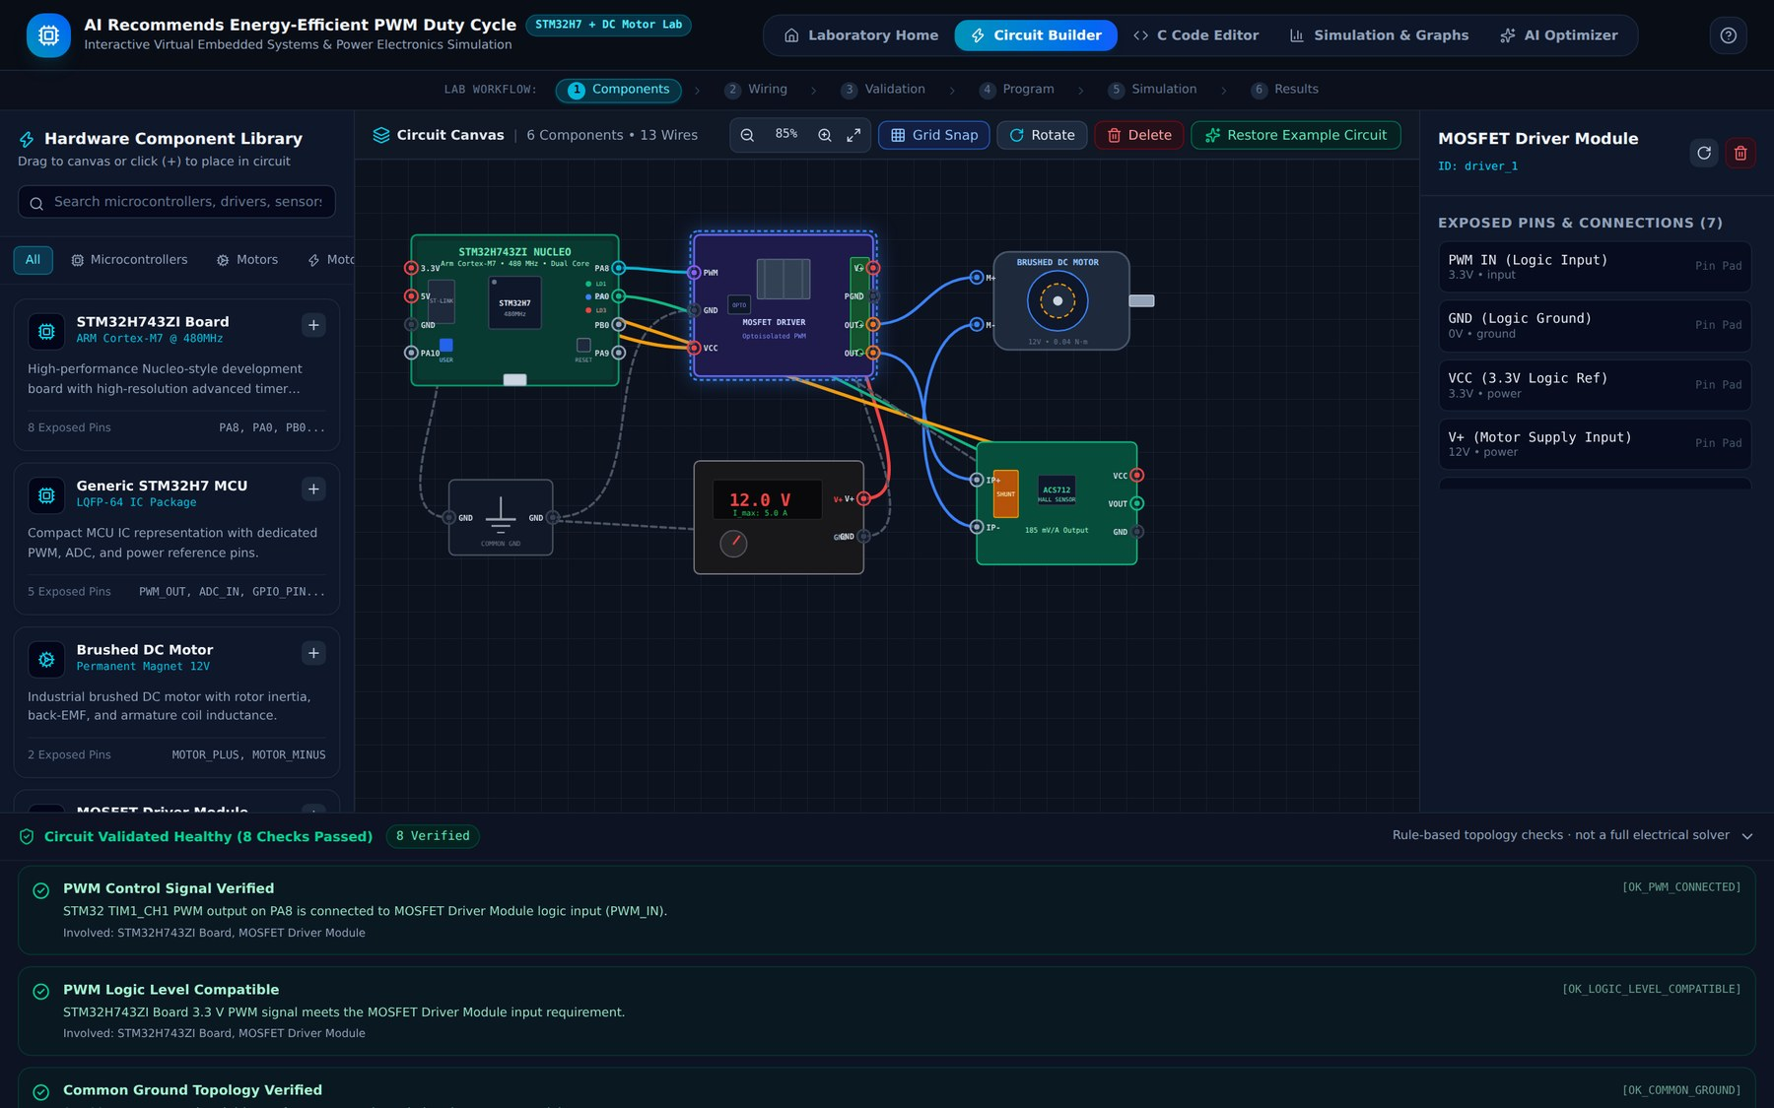
- Validation report for the reference circuit: all eight checks pass.
Fig. 12 shows the effect of breaking the design. After the MOSFET driver is deleted, the component count falls to five and the wires attached to the driver disappear (five wires remain); the panel turns red and reports Circuit Validation Failed (1 Blocking Issue) with the card Motor Driver Missing, the code ERR_NO_DRIVER, the explanation that a power switching interface is required to control the motor from 3.3 V logic, and a suggested fix. Every error follows this format of problem, code and fix, which turns the validator into a teaching tool. While errors exist, the simulation cannot be started.
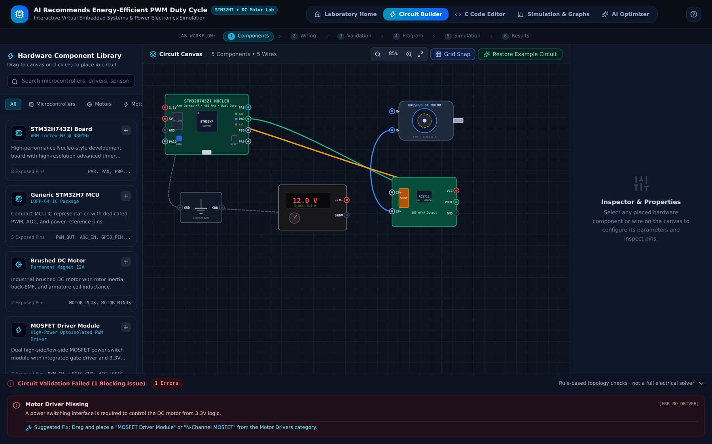
- Validation failure after the driver is removed: ERR_NO_DRIVER with a suggested fix.

Embedded C Code Editor and Live Configuration Extraction
The C Code Editor (Fig. 13) presents the main.c program of the STM32H743ZI with line numbers and syntax colouring. The toolbar offers three example programs (Load Example Program, Low-Power ECO Mode and High Load / Fast Ramp Mode), Copy Code, Download .c and Reset Code. The program defines the 20 kHz PWM frequency and the timer auto-reload value, declares the TIM, ADC and UART handles, and contains the three operational parameters that the laboratory interprets: duty_percent = 40.0f, target_rpm = 1000.0f and max_current_limit = 3.50f. The right-hand Live Configuration Extraction panel re-parses the code on every keystroke. It states that the parser is not a C compiler, shows the message Supported settings ready for model simulation, lists the parsed execution settings (PWM duty cycle 40.0 %, target speed 1000 RPM, PWM frequency 20 000 Hz, current trip limit 3.50 A) and verifies the presence of the HAL API calls HAL_TIM_PWM_Start, SetPWMDutyCycle() and ReadMotorCurrent_ADC().
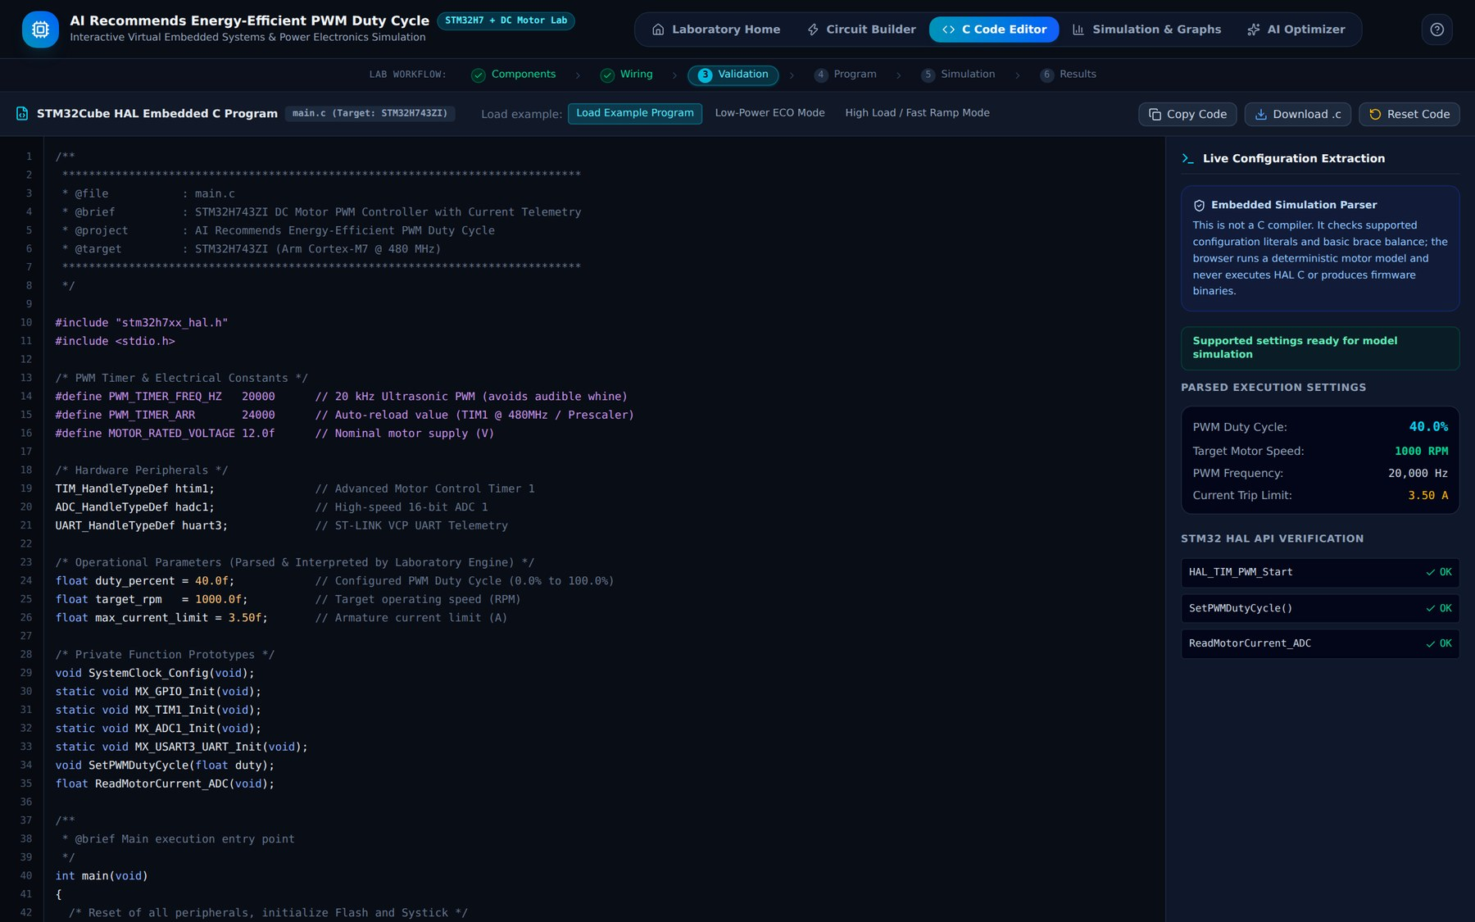
- C Code Editor with the STM32 HAL program and the live configuration extraction panel.
Fig. 14 demonstrates the program validation. When the duty cycle in the source is edited to 120.0f, the parser rejects it with the error ERR_DUTY_OUT_OF_RANGE (the duty cycle must lie between 0 % and 100 %) and points to the offending line, and the settings are not applied to the simulation. Range errors for target speed, current limit and PWM frequency, unbalanced braces and unsupported duty patterns are reported in the same way, while missing HAL calls only raise warnings.
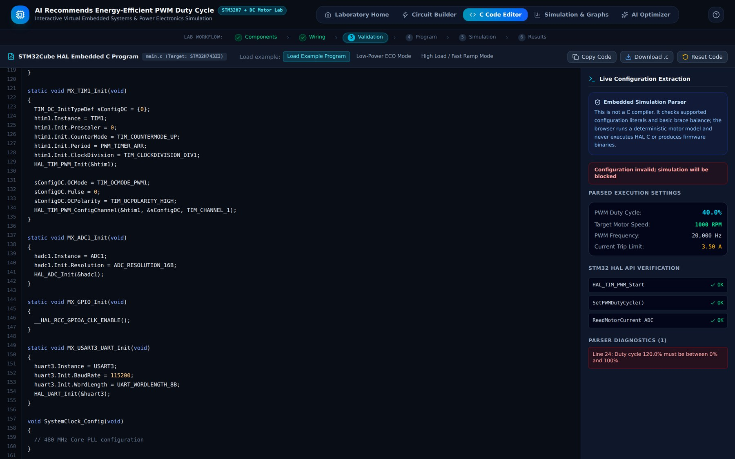
- Parser error for an out-of-range duty cycle (120 %).

Simulation Controls and Live Motor Output
The Simulation & Graphs screen (Fig. 15) has a control bar and six result tabs. The control bar contains Run Simulation (which becomes Pause/Resume while running), Stop, Step (50 ms) for single-step inspection, Reset, the two buttons Validate Circuit and Validate Program, and a RUNNING status indicator. The first tab, Live Motor Output, is a dashboard of the motor state. An animated rotor shows the spinning motor with its N and S poles and the current PWM duty (40.0 %), and below it the angular speed (41.8 rad/s) and the armature temperature (26.4 °C) are displayed. Six metric cards show motor speed (399 RPM), armature current (1.27 A, against the 3.50 A cut-off), applied terminal voltage (4.80 V on the 12 V bus), electrical input power (6.09 W), mechanical shaft power (1.67 W) and estimated efficiency (27.5 %), each with a bar gauge. The Cumulative Electrical Energy panel integrates the power over time in mWh and joules. These figures agree with equations (1) to (7): 12 V × 0.40 = 4.80 V and P_{mech} = 0.04 N·m × 41.8 rad/s = 1.67 W.
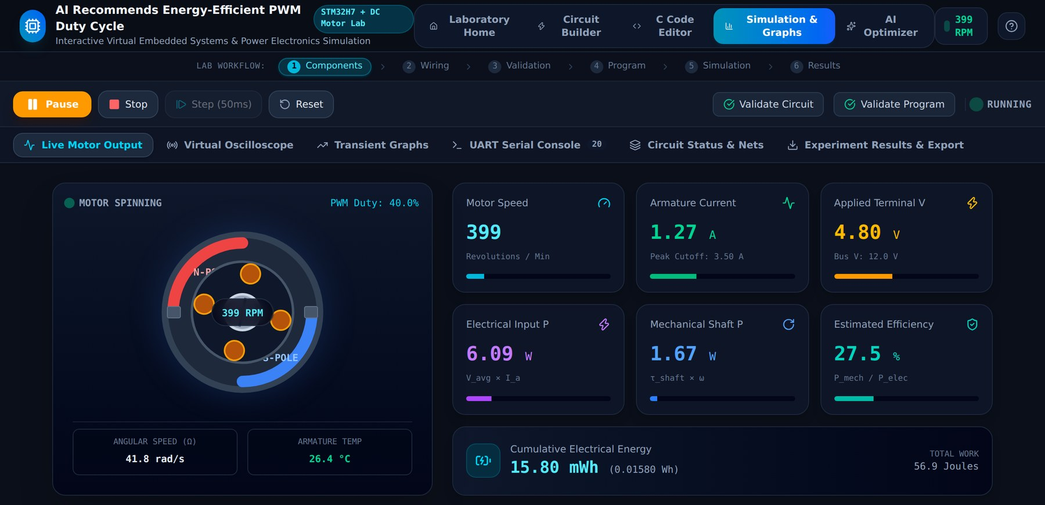
- Live Motor Output at 40 % duty: speed, current, voltage, power, efficiency and energy.

Virtual Oscilloscope
The Virtual Oscilloscope tab (Fig. 16) is modelled on a high-speed digital storage oscilloscope (DSO-H743) and is labelled Model Signal View because the traces are drawn from the simulation model. It shows three channels: CH1 the PA8 PWM logic signal (3.3 V), CH2 the motor coil voltage (12 V) and CH3 the estimated inductive current ripple. The trigger is the rising edge of TIM1_CH1. The on-screen readout shows the timebase (50 µs/div), the PWM frequency (20.0 kHz) and the duty and on-time (40.0 %, Ton = 20.0 µs), which equals 0.40 × 50 µs. The controls underneath allow each channel to be hidden or shown, the horizontal timebase to be set to 20, 50 or 100 µs/div, and the vertical scale of CH1 and CH2 to be changed. Students can therefore see how the pulse width changes when the duty cycle in the code is changed and how the triangular current ripple follows the switching.
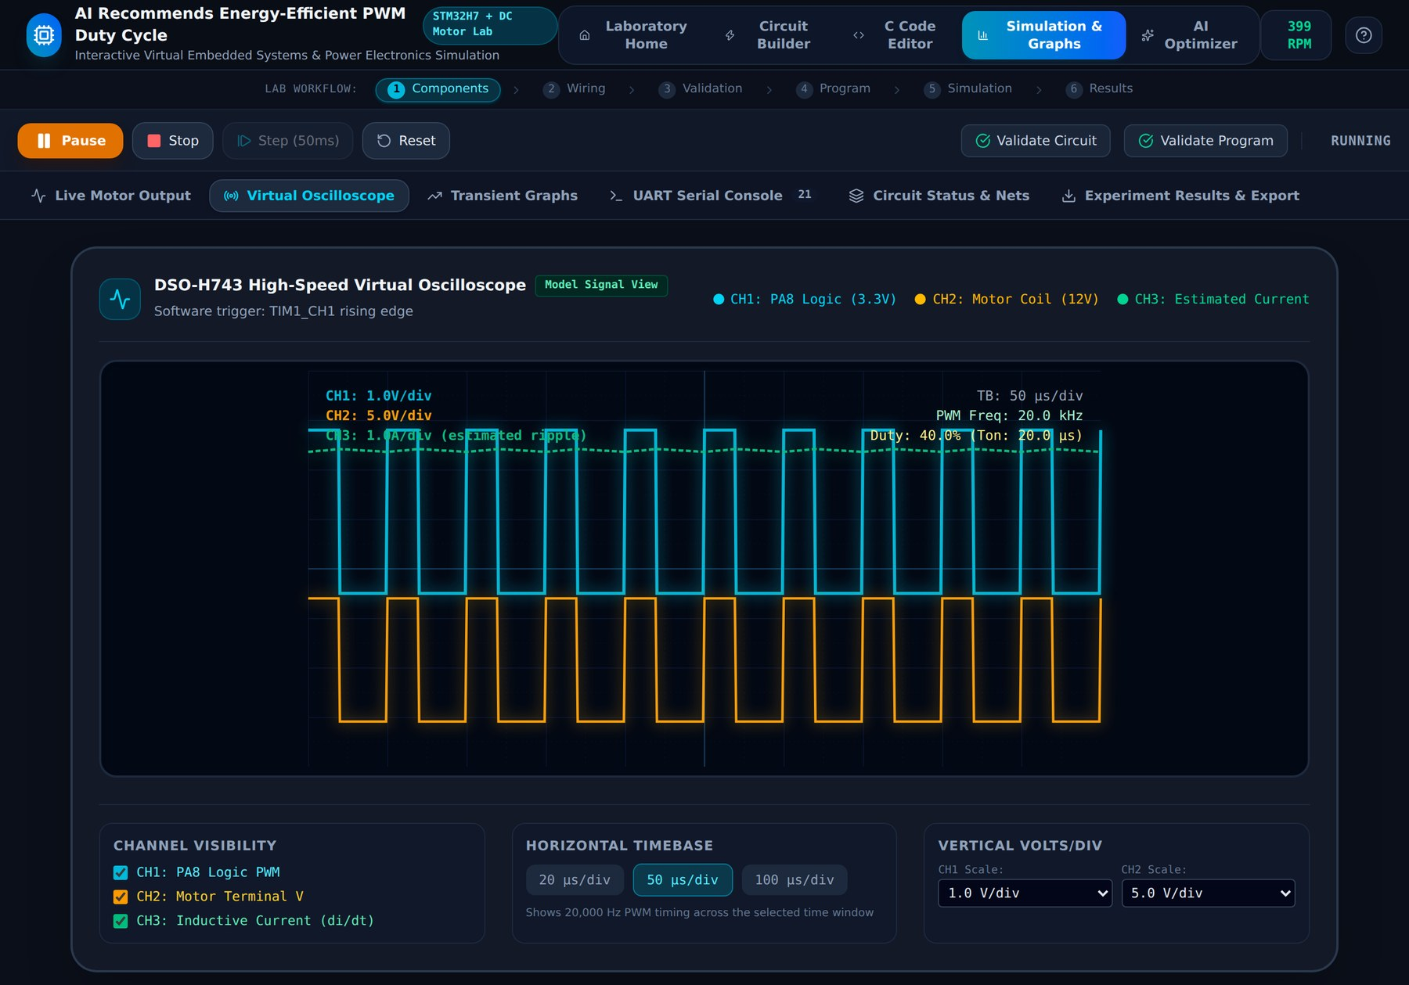
- Virtual oscilloscope showing PWM, motor voltage and ripple current at 40 % duty.

Transient Graphs
The Transient Graphs tab (Fig. 17) plots the time response recorded during the simulation. Five charts are available: rotor speed against time with a dashed line at the 1000 RPM target, armature current against time, armature voltage against time, electrical power draw against time and cumulative energy against time. The filter buttons All 4 Charts, RPM Only, Current Only, Power Only and Energy Only focus on one quantity, and the number of stored samples is displayed. Four summary cards at the bottom (latest speed, armature current, power consumption and conversion efficiency) give the current values. The figure shows the run at the recommended 76 % duty: the speed rises from rest and settles near 981 RPM, the current shows the typical start-up peak and settles at 1.9 A, the voltage is constant at 9.1 V and the energy grows linearly once the power is constant.
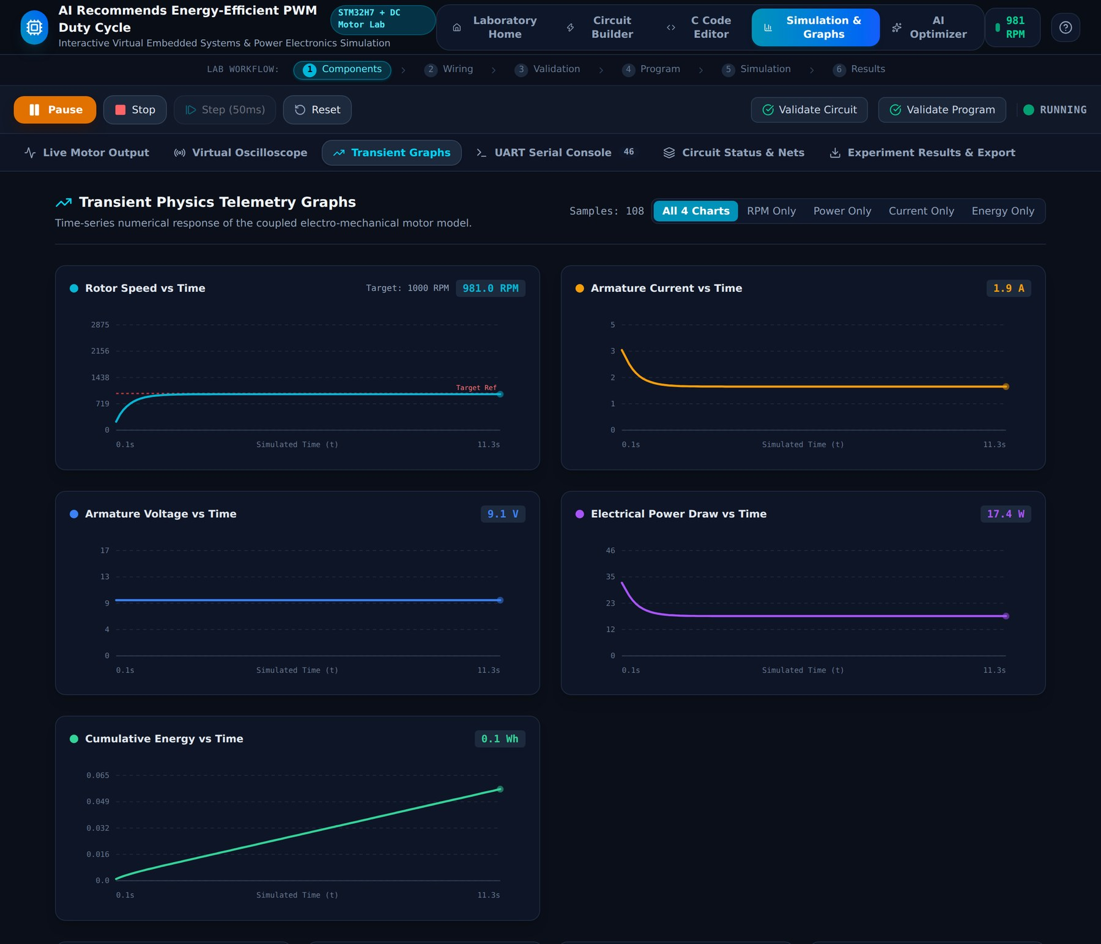
- Transient graphs of speed, current, voltage, power and energy at the optimized 76 % duty.

UART Serial Console
The UART Serial Console tab (Fig. 18) imitates the USART1 telemetry terminal of the board (115 200 baud, 8-N-1). It lists time-stamped messages: laboratory initialisation notices, workspace actions (such as adding a component or restoring the reference circuit), the start-up sequence (validation completed, PWM output configured, motor driver connection validated, initialising motor model, starting PWM simulation) and one telemetry line per simulated second of the form Duty 40.0 % | 399 RPM | 1.27 A. Each line carries an INFO, WARN or ERR badge. The toolbar offers a search box, the filter buttons ALL, INFO, WARN and ERR, and buttons to copy, download or clear the log; the footer shows the buffer length, the present speed and current, and an Auto-Scroll option. The tab header displays the number of lines in the buffer.
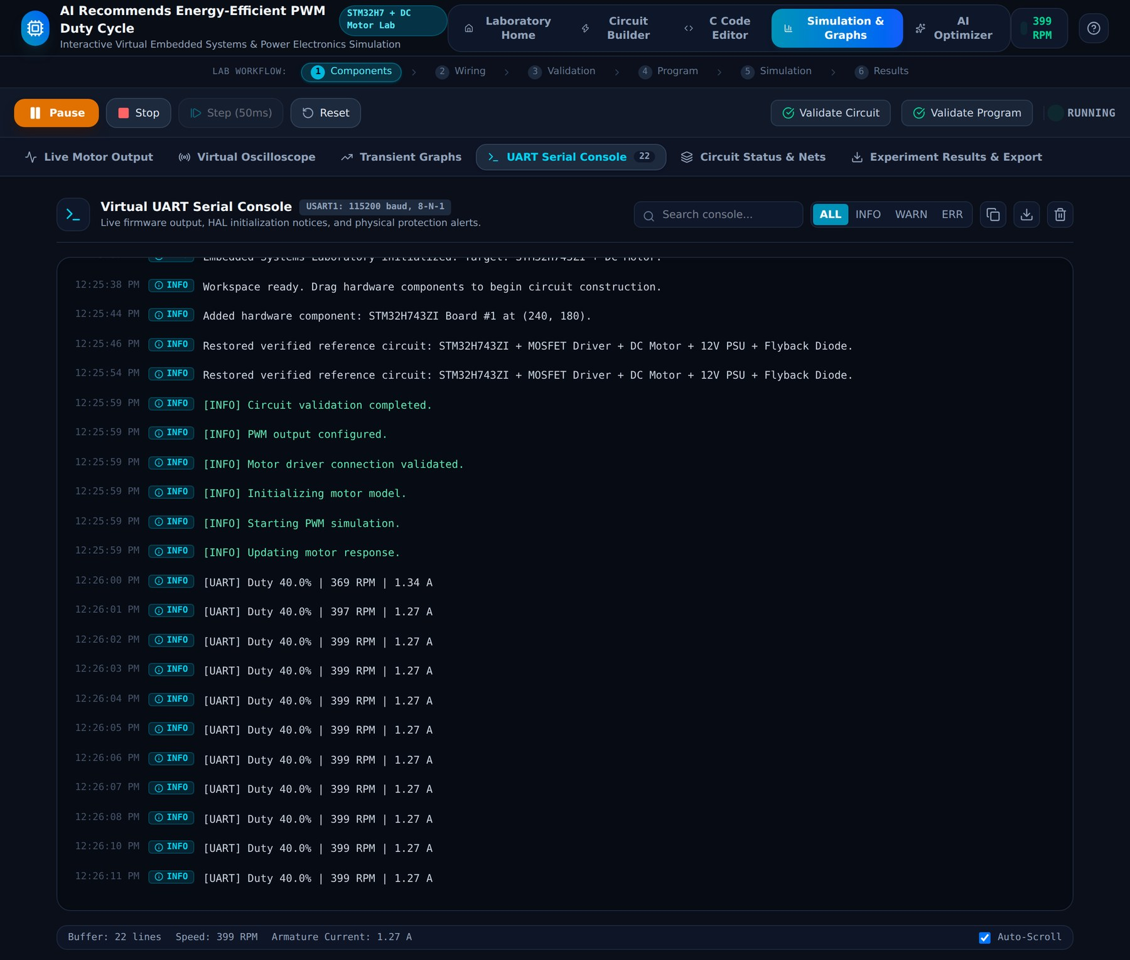
- UART serial console with time-stamped initialisation messages and telemetry.

Circuit Status and Nets
The Circuit Status & Nets tab (Fig. 19) summarises the verified topology. The banner Circuit Topology: Fully Verified & Safe states the numbers of components placed (6), wires drawn (13) and connected nets (12). Below it, six embedded hardware safety rules are shown as cards with a Verified badge: microcontroller presence, power stage isolation, PWM timer routing, common ground return, freewheeling diode clamp and no direct MCU overload. The Active Electrical Netlist table, produced by the union-find algorithm, lists every net with its identifier, pin count and the connected nodes, for example NET_1 joining STM32 PA8 to the driver's PWM_IN and NET_14 joining the driver's OUT+ to the motor's positive terminal. This view lets the student confirm that the wires drawn correspond to the intended electrical nodes.
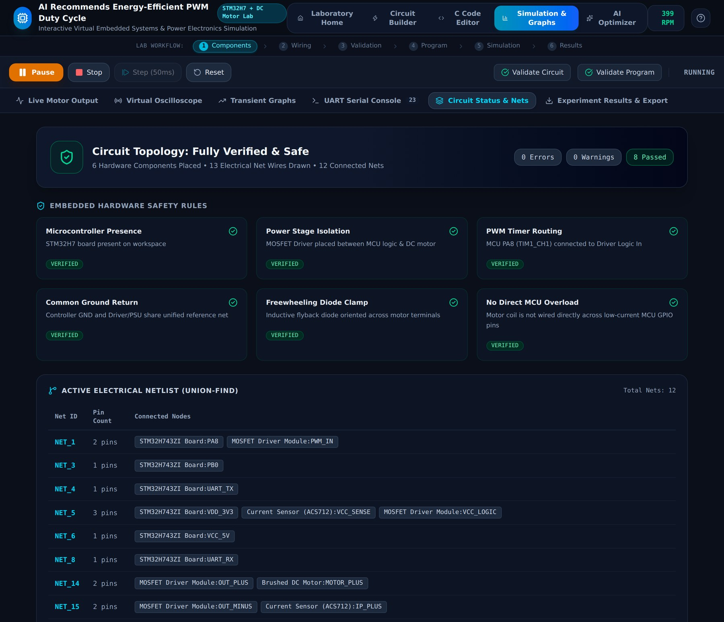
- Circuit Status & Nets: safety-rule cards and the union-find netlist.

Experiment Results and Export
The Experiment Results & Export tab (Fig. 20) lets the student take the data away. Three cards are offered: Export Telemetry CSV downloads the time-stamped samples held in memory (speed, current, voltage, power, energy and efficiency); Circuit Layout JSON exports the netlist, component coordinates, properties and the embedded C firmware (6 components and 13 wires in the example); and Copy Formatted Report places a laboratory summary with steady-state electrical parameters, thermal metrics and safety findings on the clipboard. The page states that the exported values are a browser-based model estimate. Below the cards, the Telemetry Data Preview table shows the ten most recent samples.
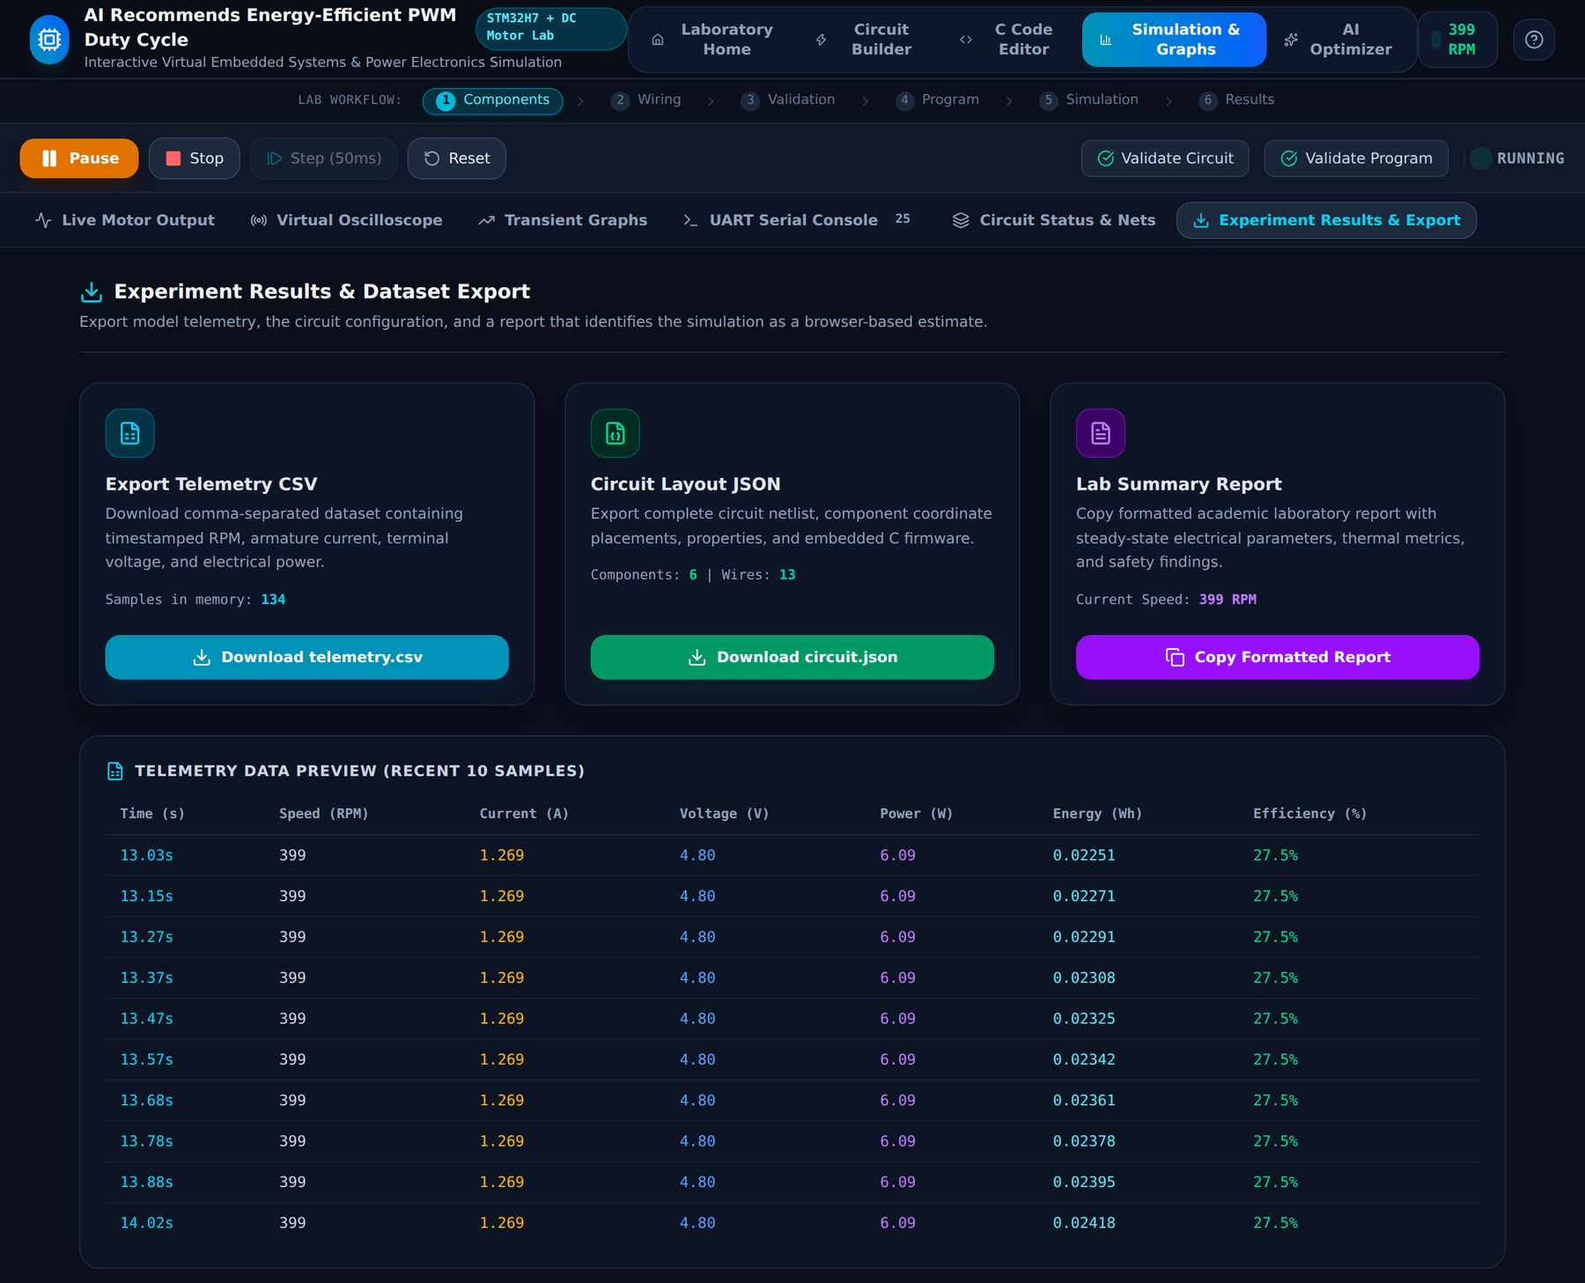
- Experiment Results & Export with CSV, JSON and report options and a telemetry preview.

AI Optimizer Results
The AI Optimizer screen (Fig. 21) has three sliders: Target Rotor Speed (here 1000 RPM), Speed Tolerance (±2.5 %) and Energy Window (10 min). The current duty from the C code is displayed at the top right. When any slider moves, the optimizer re-runs automatically. The large result card names the Lowest-Energy Feasible Point and the recommended duty cycle, the simulated speed at that duty and the estimated energy change relative to the baseline, and carries the Apply Recommended Duty Cycle button. The Baseline and Recommendation Comparison table lists the duty, predicted speed, target error, current, power and energy for both operating points. Further rows give the number of feasible candidates (3 of 101), the current limit and the motor supply, and the Model-Based Reasoning list explains in words how the answer was obtained.
In Case A, with the default 40 % duty in the code, the optimizer recommends 76 % (Fig. 21). The baseline reaches only 398 RPM, which is 602 RPM below the target, while the recommended point reaches 978 RPM, 22 RPM from the target. The energy over ten minutes is therefore larger (2.906 Wh against 1.018 Wh), and the screen labels it 185.5 % higher. This does not mean that the optimizer wastes energy: the baseline uses less energy only because it fails to deliver the required speed, and the optimizer reports exactly that trade-off.
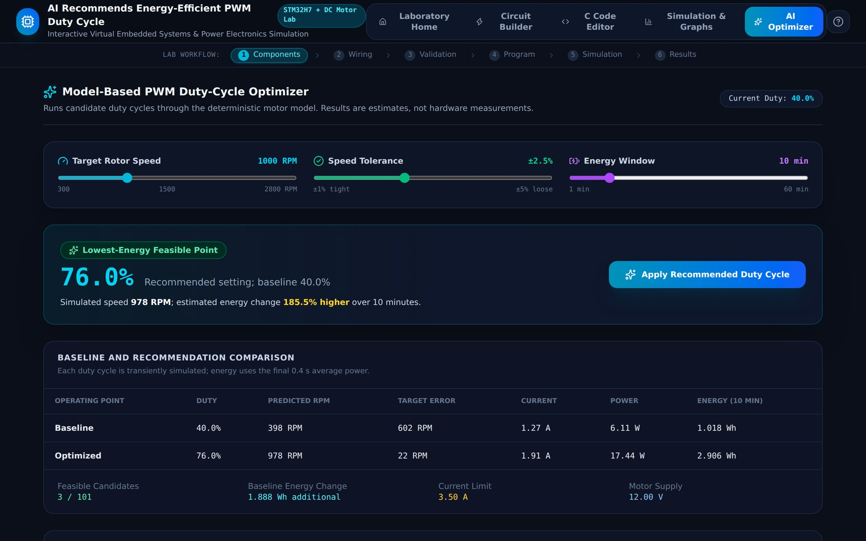
- AI Optimizer, Case A: baseline 40 % duty, recommendation 76 % duty.
In Case B, the duty in the code is changed to 90 % (Fig. 22). The baseline now over-shoots the target at 1202 RPM (202 RPM error) and draws 2.16 A and 23.35 W, or 3.892 Wh over ten minutes. The optimizer again recommends 76 %, which gives 978 RPM at 1.91 A and 17.44 W (2.906 Wh). The estimated energy is 25.3 % lower, a saving of 0.985 Wh over the window, while the target speed is still met within the tolerance. Table VIII compares the two cases.
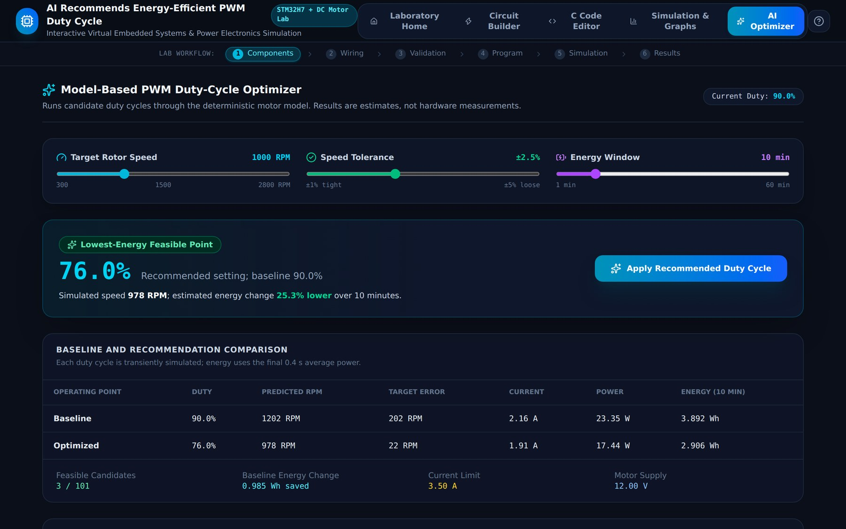
- AI Optimizer, Case B: over-driven 90 % baseline, recommendation 76 % duty saves 25.3 % energy.
- Optimizer results for the two baseline cases (target 1000 RPM, ±2.5 %, 10 min)
Case | Operating point | Duty (%) | Speed (RPM) | Current (A) | Power (W) | Energy (Wh)
A | Baseline | 40 | 398 | 1.27 | 6.11 | 1.018
A | Recommended | 76 | 978 | 1.91 | 17.44 | 2.906
B | Baseline | 90 | 1202 | 2.16 | 23.35 | 3.892
B | Recommended | 76 | 978 | 1.91 | 17.44 | 2.906

The sweep in Fig. 23 and Table IX explains why 76 % is chosen. In panel (a), speed is zero below about 16 % duty (stiction), then rises almost linearly with duty and crosses the 1000 RPM target at about 76 to 77 %; the green band marks the ±2.5 % tolerance, inside which only 76, 77 and 78 % are feasible. Panel (b) shows that power and current increase with duty, so the lowest feasible duty is also the lowest-energy one. Panel (c) shows that efficiency is highest (about 27 %) near 40 % duty and falls at higher duty because the copper loss grows with the square of the current while the mechanical output, which is the fixed load torque times speed, grows only linearly. The optimizer therefore does not simply maximise efficiency, which would pick a duty that fails to reach the target; it minimises energy under the speed constraint.
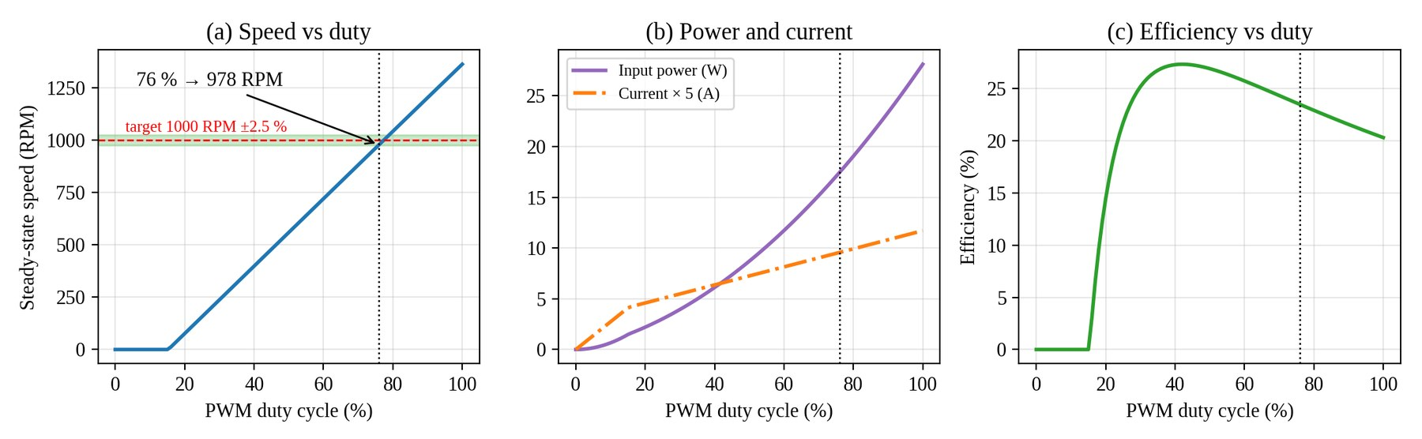
- Duty-cycle sweep evaluated by the optimizer: (a) speed, (b) power and current, (c) efficiency.
- Selected points of the duty-cycle sweep (target 1000 RPM, ±2.5 %)
Duty (%) | Speed (RPM) | Current (A) | Power (W) | Efficiency (%) | Feasible
10 | 0 | 0.55 | 0.65 | 0.0 | No
20 | 76 | 0.92 | 2.20 | 14.5 | No
30 | 237 | 1.09 | 3.94 | 25.2 | No
40 | 398 | 1.27 | 6.11 | 27.3 | No
50 | 559 | 1.45 | 8.70 | 26.9 | No
60 | 720 | 1.63 | 11.72 | 25.7 | No
70 | 881 | 1.81 | 15.16 | 24.3 | No
76 | 978 | 1.91 | 17.44 | 23.5 | Yes
80 | 1042 | 1.98 | 19.04 | 22.9 | No
90 | 1202 | 2.16 | 23.35 | 21.6 | No
100 | 1362 | 2.34 | 28.10 | 20.3 | No

Pressing the apply button writes the recommended value into the C program. As Fig. 24 shows, the result card changes to Applied to C Configuration, the baseline becomes 76 %, the energy change reads 0.0 % and a short confetti animation confirms the action. The C Code Editor (Fig. 25) now contains float duty_percent = 76.0f while the rest of the program is unchanged, and the parsed PWM duty cycle in the right panel is updated to 76.0 %.
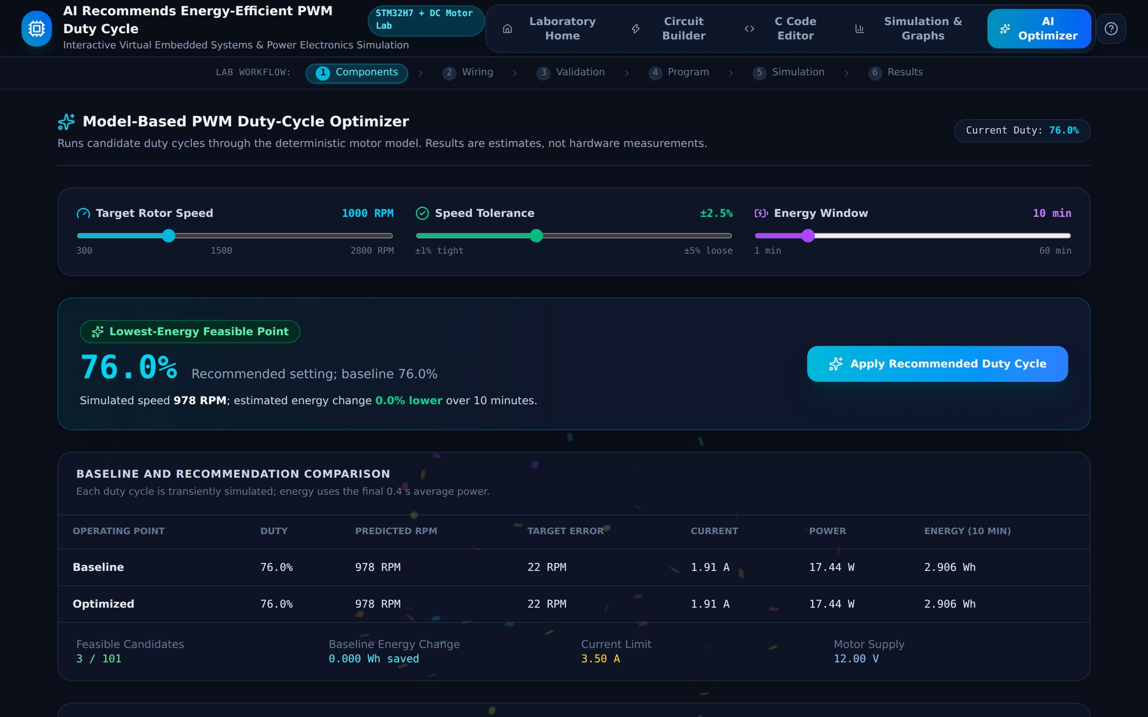
- Recommendation applied: the optimizer now shows 76 % as both baseline and recommendation.
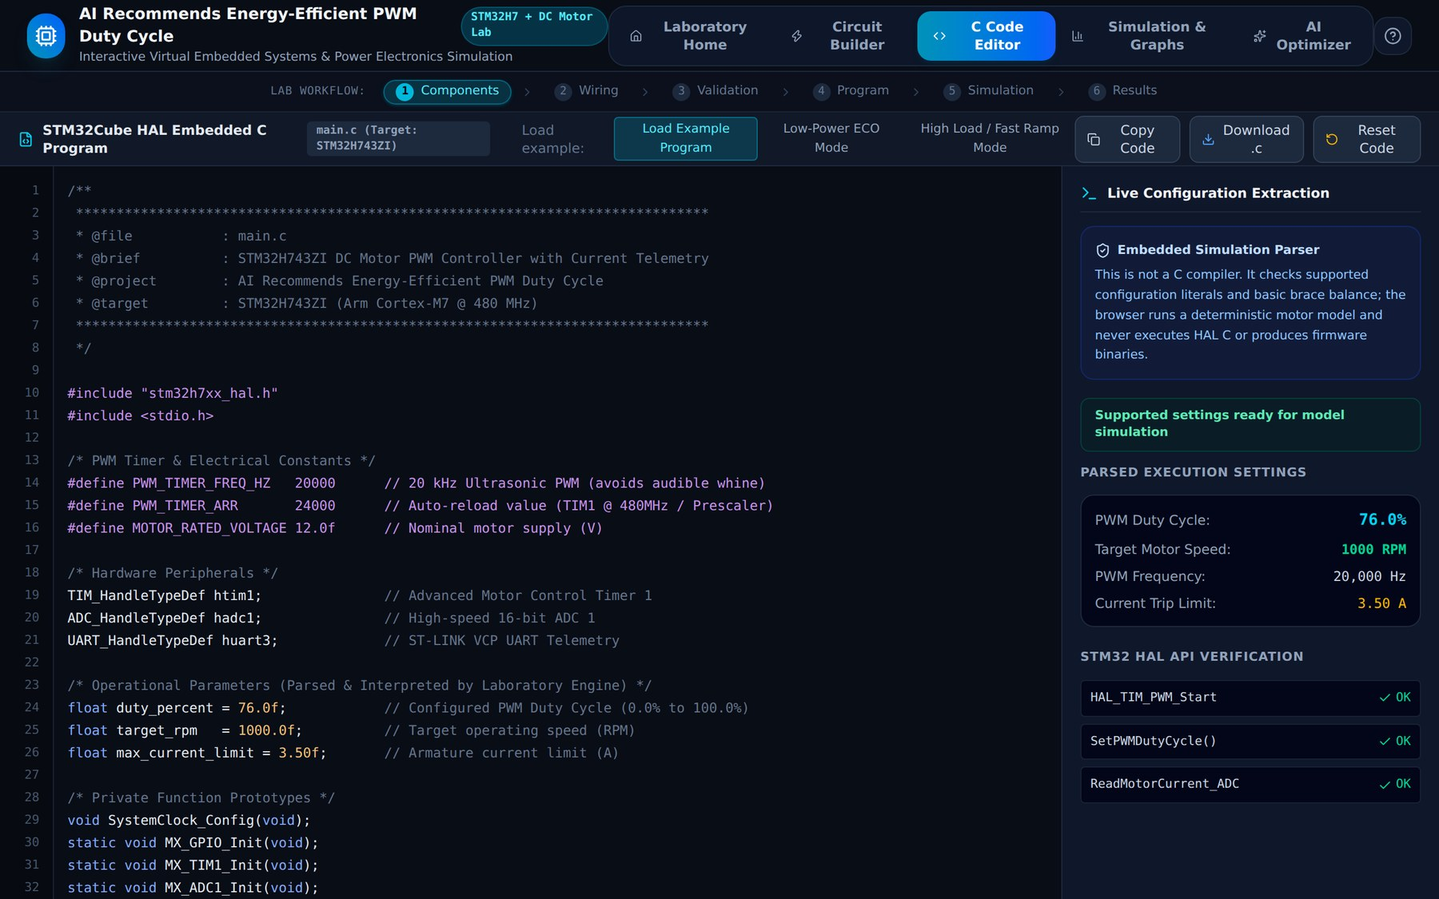
- C Code Editor after applying the recommendation: duty_percent = 76.0f.

Verification of the Recommended Duty Cycle
To check that the optimizer's prediction is consistent with the simulator, the circuit was run again with the 76 % duty (Fig. 26 and Fig. 17). The live dashboard shows 981 RPM, 1.90 A, 9.12 V terminal voltage, 17.36 W input power, 4.11 W shaft power and 23.7 % efficiency, with the armature temperature rising to 29.6 °C. Table X compares these values with the predictions made by the optimizer for both duty cycles. The differences are below 1 %, as the optimizer uses the same model with a coarser 20 ms step and averages the last 0.4 s of a 2.4 s transient. The 76 % setting reaches the 1000 RPM target within 2 % and uses 17.4 W, which, compared with the over-driven 90 % setting, is the 25.3 % reduction reported above.
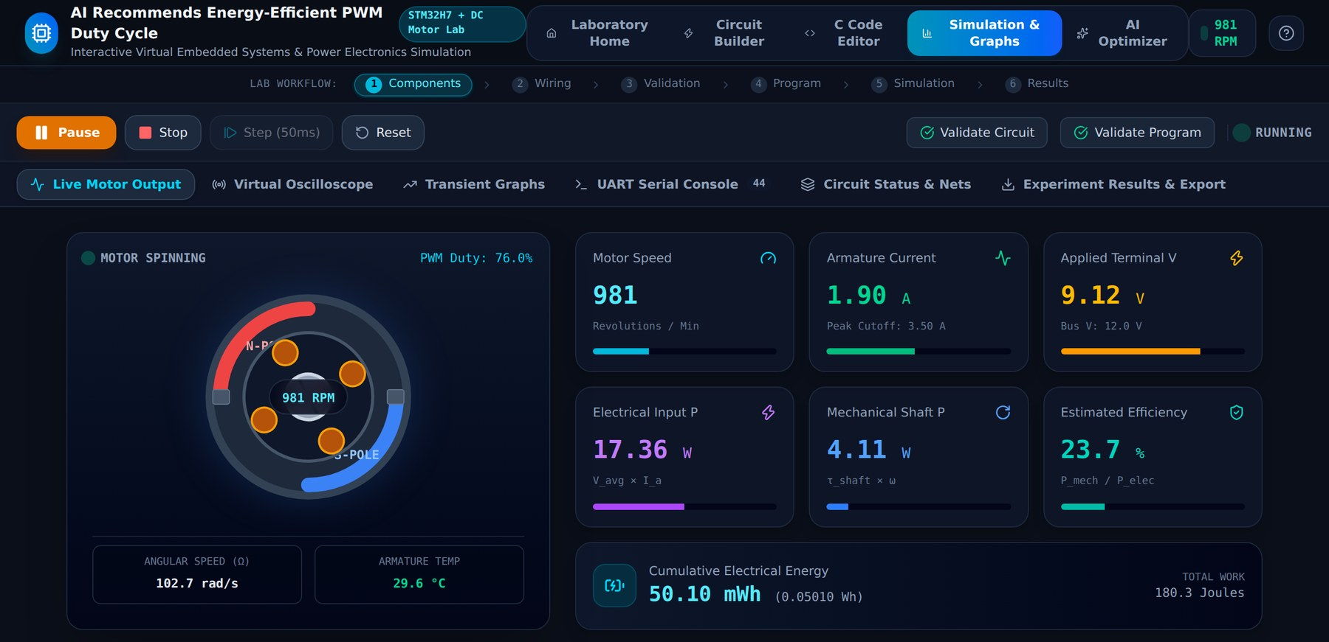
- Live Motor Output after the recommended duty (76 %) is applied.
- Optimizer prediction compared with the live simulation
Duty (%) | Source | Speed (RPM) | Current (A) | Power (W) | Efficiency (%)
40 | Optimizer prediction | 398 | 1.27 | 6.11 | 27.5
40 | Live simulation | 399 | 1.27 | 6.09 | 27.5
76 | Optimizer prediction | 978 | 1.91 | 17.44 | 23.5
76 | Live simulation | 981 | 1.90 | 17.36 | 23.7

Discussion
The results show that the laboratory covers the complete design flow of a PWM motor drive in one environment. The validation engine prevented the unsafe designs listed in the curriculum, the parser connected the firmware parameters to the physics model, the instruments made the PWM waveform, the current ripple and the transient response visible, and the optimizer turned the model into a concrete recommendation. Two points should be stated clearly. First, the energy saving depends on the baseline: a baseline that is too low to reach the target (Case A) cannot be improved in energy terms without increasing the speed, and the 25.3 % saving applies to an over-driven baseline (Case B). Second, all values are model estimates with constant load torque and ideal switching; real motors have brush drop, temperature-dependent resistance and switching losses that are not modelled, so the recommended duty should be treated as a starting point for hardware testing.

Conclusion and Future Work
This project implemented a browser-based virtual laboratory for energy-efficient PWM control of a brushed DC motor with an STM32H743ZI. A student can place and wire the hardware, receive explanatory safety validation, edit the STM32 HAL-style firmware parameters, simulate the motor with an RK4 model, observe the behaviour on a live dashboard, an oscilloscope, transient graphs, a UART console and a netlist view, export the data, and obtain an energy-optimal duty-cycle recommendation from a model-based AI optimizer. For a 1000 RPM target, the optimizer recommended 76 % duty, which reached 978 RPM (981 RPM in the live run) and used 25.3 % less energy than an over-driven 90 % baseline. The 55 automated checks over 13 scenarios pass, and the optimizer's predictions agree with the live simulation within 1 %.
The work has limitations that define its future scope. The C code is parsed, not compiled, and only four configuration constants are understood; the electrical validation is rule-based rather than a circuit solver; the motor model assumes a constant load torque and ideal switches; and the optimizer searches only the duty cycle. Future work could (i) add a real C front end or a WebAssembly firmware emulator, (ii) include closed-loop control with a PI speed controller and current limiting from the ADC feedback, (iii) model variable loads, brush drop, temperature-dependent resistance and switching losses, (iv) optimise PWM frequency together with duty cycle and add learned models trained on measurements, and (v) validate the predictions against a physical STM32H7 and motor test bench.

References
- STMicroelectronics, "RM0433: STM32H742, STM32H743/753 and STM32H750 Value line advanced Arm-based 32-bit MCUs," Reference Manual.
- STMicroelectronics, "STM32H743xI/G: 32-bit Arm Cortex-M7 480 MHz MCUs, datasheet," DS12110.
- N. Mohan, T. M. Undeland and W. P. Robbins, Power Electronics: Converters, Applications, and Design, 3rd ed. Hoboken, NJ, USA: Wiley, 2003.
- P. C. Krause, O. Wasynczuk, S. D. Sudhoff and S. Pekarek, Analysis of Electric Machinery and Drive Systems, 3rd ed. Hoboken, NJ, USA: Wiley-IEEE Press, 2013.
- J. C. Butcher, Numerical Methods for Ordinary Differential Equations, 3rd ed. Chichester, U.K.: Wiley, 2016.
- Allegro MicroSystems, "ACS712: Fully Integrated, Hall Effect-Based Linear Current Sensor IC with 2.1 kVRMS Isolation," datasheet.
- R. Krishnan, Electric Motor Drives: Modeling, Analysis, and Control. Upper Saddle River, NJ, USA: Prentice Hall, 2001.
- Meta Platforms, Inc., "React: The library for web and native user interfaces," documentation, https://react.dev.
- Vite contributors, "Vite: Next generation frontend tooling," documentation, https://vite.dev.
- Tailwind Labs, "Tailwind CSS," documentation, https://tailwindcss.com.
- STMicroelectronics, "UM2217: Description of STM32H7 HAL and low-layer drivers," User Manual.

