**Entry : Data analysis interview challenge.**

**Challenge**

Analyze the above dataset, and share your insights. Insights about the following are

mandatory. Also, share any other insights you think we should know.

● Paid vs Unpaid - Difference in behaviour in the first week.

● Per-user targets we should aim to increase conversion percentage.

● Any other insights

**Data used**

1. user_purchase_data.csv

2. track_subscription_data.csv

**Challenge 1**

Paid vs Unpaid - Difference in behaviour in the first week.

**Assumptions:-**

I assume that the behaviour is the purchase behaviour of the user. Also the first week is the first 7 days of joining date for each user.

**Analysis:-**

I have identified the paid and unpaid users using the column ‘date_of_first_purhcase‘ from the user purchased data (user_purchase_data.csv).

|  |  |
| --- | --- |
| Purchased within a week | 478 |
| Not purchased yet | 424 |
| Purchased after a week | 98 |

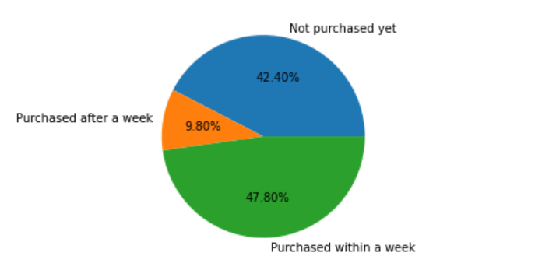

**Conclusion**:-

From the analysis out of the 1000 users 47.80% users purchased with in the week of join date. And 42.40% is not purchased yet. 9.80% users purchased after a week.

**Challenge** 2

Per-user targets we should aim to increase conversion percentage.

**Assumption**:- I assume that conversion percentage is the % of paid and unpaid users and the per user target is the number of subscriptions that we aim to increase the % of paid/purchase users.

**Analysis**:-

I have merged the to data files user_purchase_data.csv and track_subscription_data.csv using the column user id . the data is restricted to users who are purchased and subscribed at least one Course category. I have computed the average subscriptions per purchased user.

**Conclusion**

The average subscriptions per purchased user is 1.9 so we should aim at least 2 subscriptions per new user purchase.

The jupyter notebook with python codes that I used for the above analysis is in :



The pip requirements are:

pip install pandas

pip install datetime

pip install matplotlib