Code 1: 1. Write a JavaScript program which accepts a string as input and swap the case of each character.  
For example, if you input 'The Quick Brown Fox' the output should be 'tHEqUICKbROWNfOX'.  
  
  
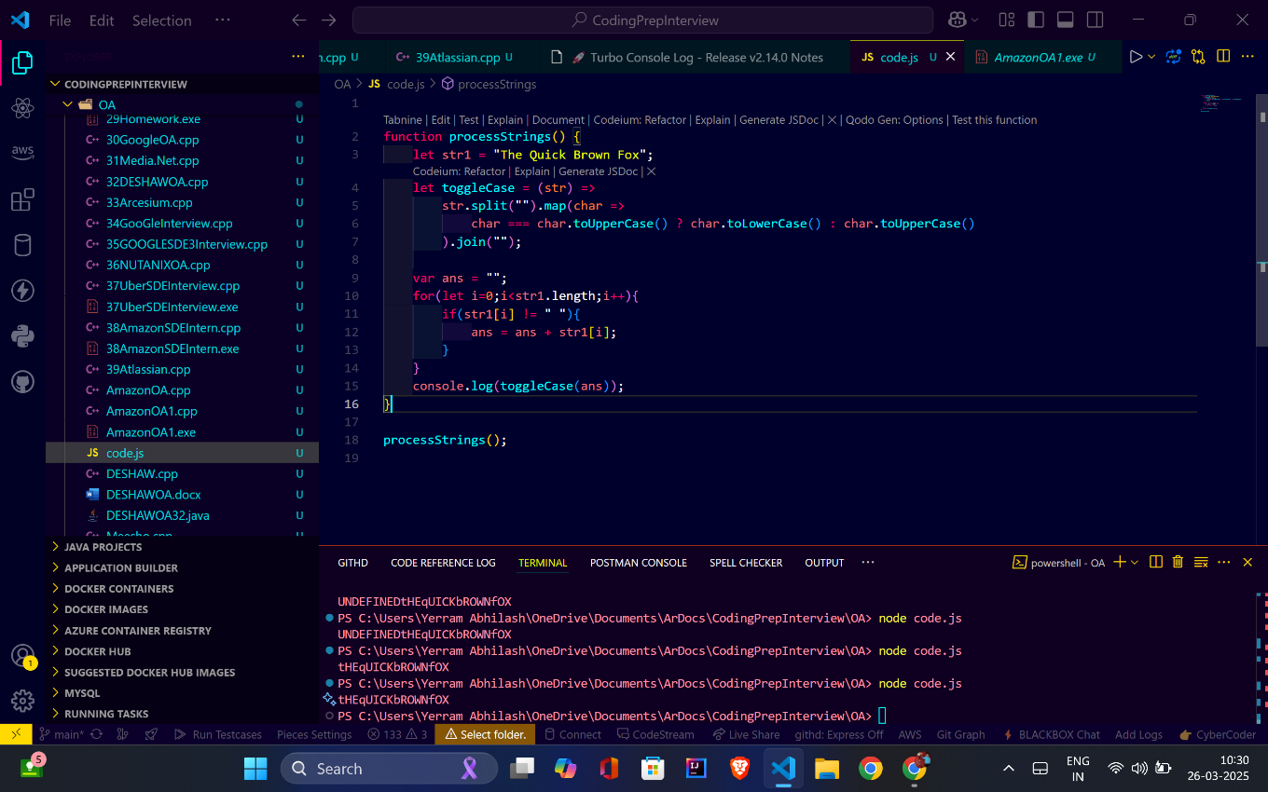

Code 2: Write a JavaScript program to find the most frequent item of an array.

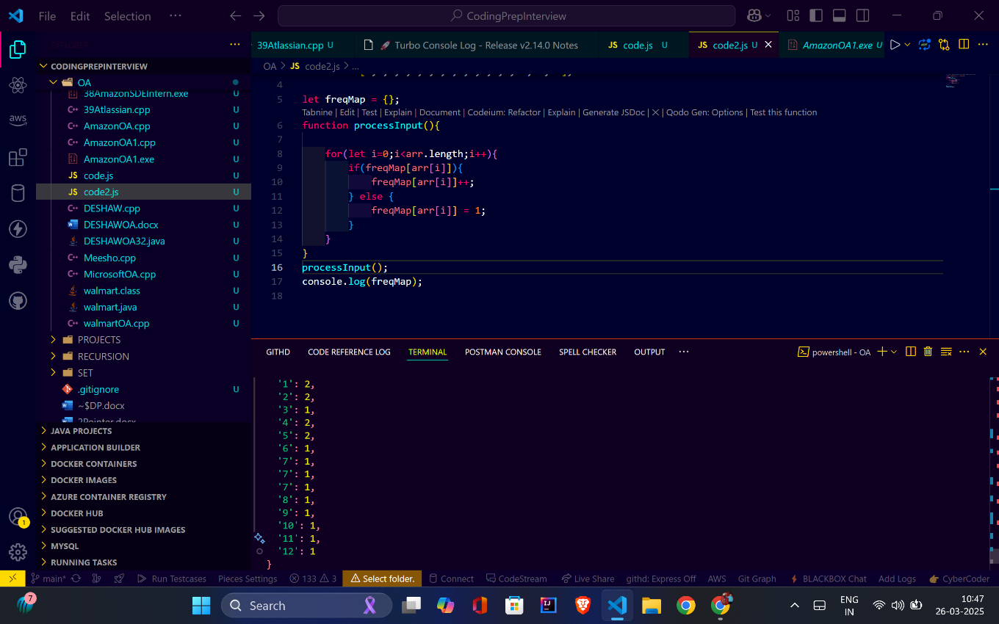

Code3:  3. Write a JavaScript program to remove duplicate items from an array.

