* This framework is built on **Appium Studio (Experitest**) and Selenium **Test NG**
* IDE used is **Eclipse**
* Platform :- **Andriod**
* Device Used :- Motoral – Moto G3 (Real) Device

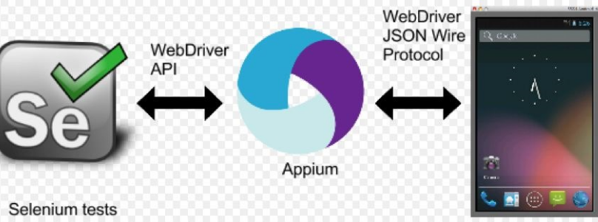

A particular test is triggered from eclipse, which invokes Appium Studio. Appium studio then invokes the application and starts execution.

* App Under Test: - ebay
  + Steps covered
    - Open the ebay app.
    - Sign in to the ebay app.
    - Search a mobile phone to buy.
    - Select a phone to buy.
    - Click on Buy Now
    - Exit
* Pre-requisites:-
  + Appium Studio should be installed.
  + Jar of selenium, See+Test and Test NG should be added
  + Eclipse id should be present.
  + ebay app should be installed in the device.
  + Device driver should be installed so that Appium studio is able to connect to the mobile device.