Motion Activated Security Camera using Raspberry Pi and Android

Arup Debnath Ibnul Hayat khan
Deperment Of CSE Deperment of CSE
Southeast University Southeast University
Dhaka,Bangladesh Dhaka,Bangladesh
arupdebn@gmail.com ibnulhaytkhan@gmail.com
Md. Sazid Hossain Sadia Bente Awal
Deperment Of CSE Deperment of CSE
Southeast University Southeast University
Dhaka,Bangladesh Dhaka,Bangladesh
sazidhossain1@gmail.com 109sadia@gmail.com

Abstract: Even when needed, having a security camera system may sometimes be impossible due to the extensive costs for installation. The Raspberry Pi is a credit card sized computer that has the capability to become a camera security system when its own camera board is used. It contains the PIR motion sensor which enables the Pi’s camera and save the image as well as view live streaming from the camera. One android Application is used to get the notification on motion detection. A python script, then directs the Pi to send notifications along with attached captured image to an Android app through cloud server every time motion is detected For push notifications Firebase cloud messaging is used .With these components, a cost effective and efficient security camera system is made and reported here.
Keywords—RaspberryPi, PIR sensor, Camera Module, Android app, Cloud

Introduction
Starting from small houses to huge industries, surveillance plays very vital role to fulfill our safety aspects as Burglary and theft have always been a problem. In big industries personal security means monitoring the people’s changing information like activities, behavior for the purpose of protecting, managing and influencing confidential details. Surveillance means watching over from a distance by means of electronic equipment such as CCTV cameras [3] but it is costly for normal residents to set up such kind of system and also it does not inform the user immediately when the burglary happens. Most importantly, security can be a
Necessity today and the Pi has the ability to become a camera security system with a cost under 80dollars. Regular security systems lead up to prices within the range of thousands. Who would want to buy a single camera for over 100 dollars just to setup on their front door, when they can buy a 29 dollar camera which even notifies them in their cellphone? You would never have to worry about looking back through recordings because the Pi Security System would send you a push notifications whenever someone comes by your home. Most of all the Pi Security Camera system is very user friendly. Anyone who has the required materials can do it with a few additional installations of files and save themselves a great amount of money. Not to mention, they would gain an efficient security system.

Why android?
The main theme is the appearance of smart phone. As a smart phone appears in market, controller has tremendous change in design and installment. Smart phone has remarkable power in computation as well as a very convenient operation such as camera monitoring or wireless internet access by WIFI, with the help this powerful smart phone applications, the system becomes smarter and more intelligent [5]. Various application programs are open to market or developed. Android OS provides free SDK (Software Development Kit) which operates camera, speaker, audio, and Ethernet and it also has a merit of open source. Furthermore, in an integrated development environment called Eclipse an Emulator is provided.[1]
Moreover, Internet of Things (loT) is an ongoing development of the internet by which everyday 'things' objects have communication capabilities which allow them to send and receive data. IoT based application can be used remotely to view the activity and get notification when motion is detected.

System overview

The aim is to make a smart surveillance system which can be monitored by owner remotely through android application. As it is connected with the system with IOT, system will send the push notification to android device when an intrusion is detected inside the room. It is required to develop and implement and affordable low cost web-camera based surveillance system for remote security monitoring. Authorized user can access to their monitoring system remotely via internet with the use a mobile phone and monitor the situation on application. This entire work is done on raspberry pi with Raspbian operating system ported on it.[3]

Surveillance System consists of mainly two parts:

Hard-wired surveillance systems: These systems use wires to connect the cameras, motion detectors, power supply and LAN cable/WIFI with the pi.

Remote Access Systems: These systems have the capability to monitor and control a security system from a location away from the surveillance area through android device.
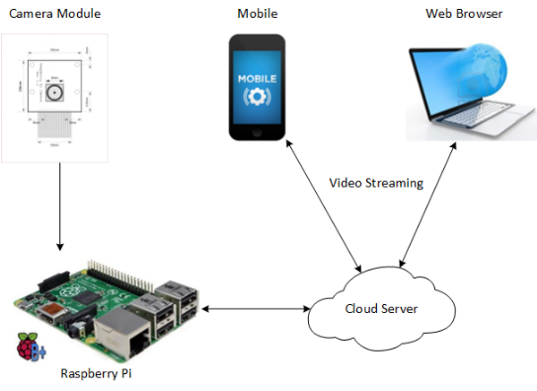

Fig 1: System Block Diagram[2]

The block diagram shows that the project is divided into two sections. The raspberry pi will be somewhere at a remote place, in surveillance area, spying the activities. And the controlling of it will be done from any part of the world through android application. The system consists of an USB camera to capture the image from the crime scene.

components description

The functions of the various components are given below:

RasPI Camera: Raspi Camera capture images and Videos and saved it to the SD card and then those files are send to the cloud.

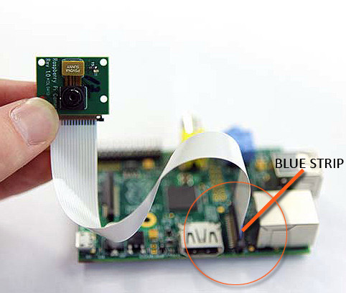

Raspberry Pi: Raspberry pi is a small credit-card sized computer capable of performing various functionalities such as in surveillance systems, military applications, etc.[4]
• SD Card Slot is used to install OS/booting/long term
storage .The total memory of the SD card is about
8GB.
• Micro USB Power Port provides 700mA at 5A.
• RCA Video Out is connected to display if HDMI output
is not used. It is mainly used to carry audio and video
signals. They are otherwise called as A/V jacks.
• Audio Out Digital audio is obtained if HDMI is used
to obtain stereo audio. Here analogue RCA connection
is used.
• Ethernet Port is used to connect to the Internet. It also
plays a role in updating, getting new software easier.
• HDMI OUT(High Definition Multimedia Interface) is
used with HDTVs and monitors with HDMI input.
Also HDMI-HDMI is used here.
• BROADCOM BCM 2835: It is otherwise defined as
System on chip .It is a 700 MHz Processor. It has a
Video core IV GPU.
• GPIO allows us to control and interact with real world .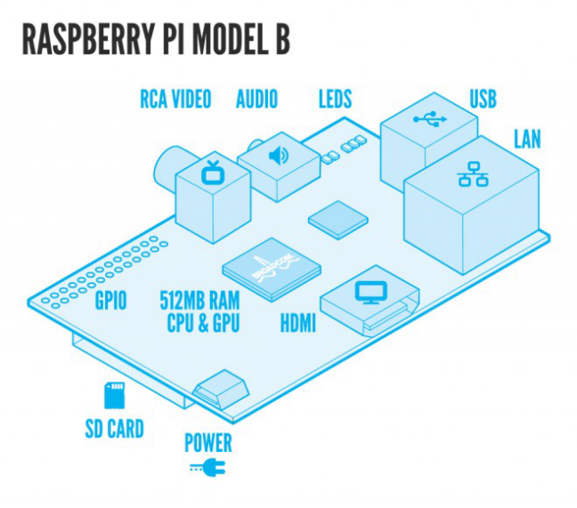
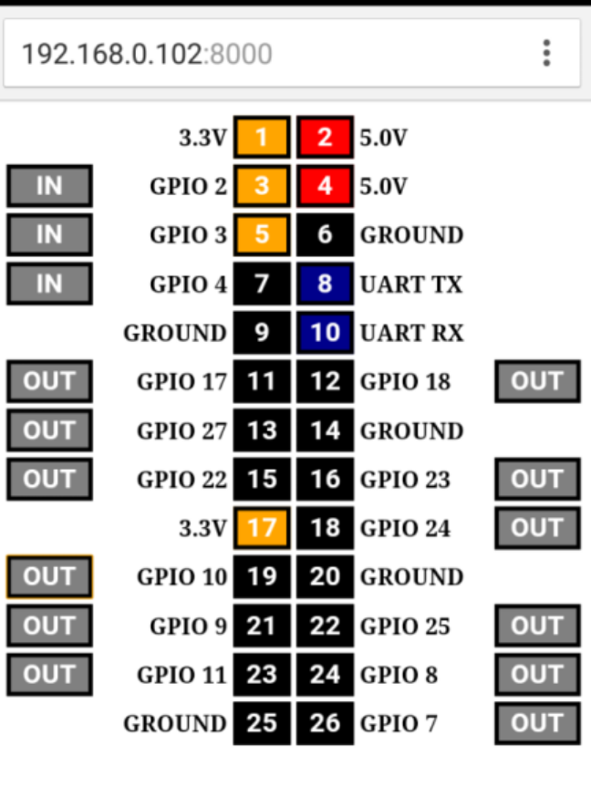

Android device: To view the captured images and video remotely and also receive the notification message. Our apk is supported in every Android devices over 4.2

PIR sensor: Detect the motion in surveillance area. Passive Infrared sensor is to detect the motion of human being, as a human passes through this sensor, the temperature in the background will rise from room temperature to the body temperature and thus the motion or human will be detected.

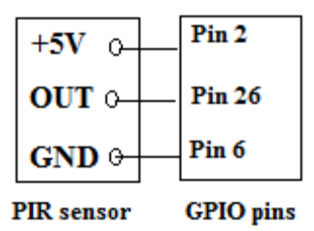
Fig- PIR interfacing with RasPI

project implementation

Step 1: Setting up Raspberry Pi
After getting Raspberry Pi, SD Card is needed to be written with its desired OS. After getting ready with SD Card insert it into Raspberry Pi Micro USB Power Cable is attached with it along with Raspberry Pi with monitor through HDMI cable. Connect Keyboard & Mouse with it. Also provide the DC power supply to Pi.

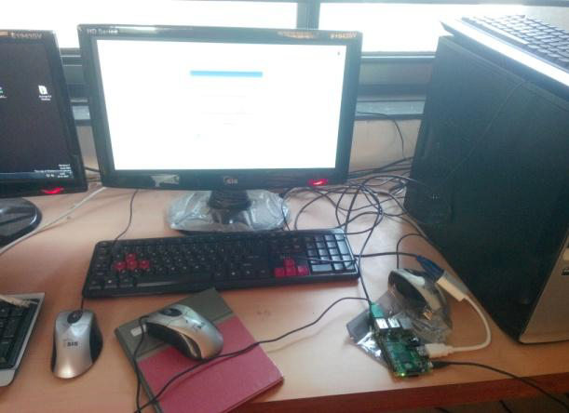
Fig- Raspberry Pi installation

Step 2: Operating raspberry pi without monitor display, keyboard and mouse.
Raspberry pi is needed to be attached with internet through RJ-45 cable, power supply and USB camera without need of any PC. Through PuTTy raspberry pi can be programmed and then works in standalone mode. PuTTY can be installed in Laptop and through IP address of raspberry pi it can access command window of pi

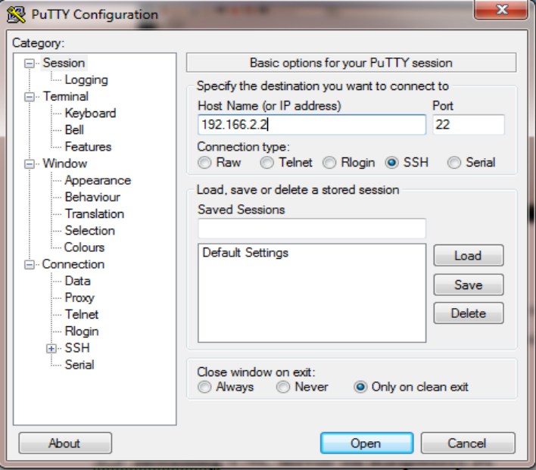
Fig-PuTTY configuration

Step 3: Installing VNC server on Raspberry Pi
To install VNC following command are used.
$ sudo apt-get update
$ sudo apt-get install tightvncserver
Step 4: Client Side (Laptop)
Downloading of VNC client and dynamically enter IP address of Raspberry Pi to operate pi through PC.As with SSH, since this is working over network, Pi could be situated anywhere, as long as it is connected to network.
Step 5: Running VNC server at start up in Raspberry Pi
To ensure that VNC starts automatically, it enable the system working remotely with GUI display of Pi. Now it requires hardware connection of PI and sensor as shown in figure.

motion detection algorithm

Motion Detection: The python script continouesly checking for getting HIGH input of PIR , if there is any HIGH input then the motion flag is set, triggering all the events and snapshots generation will begin. The problem with these motion detection methods is that neither detects slow moving objects, determined by the sensitivity of the threshold.
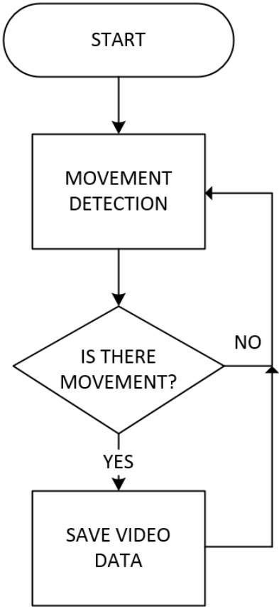

application and notification user interface
When the motion is detected, sensor data will trigger out and it will send one notification to android application used here is “Smart Security”.
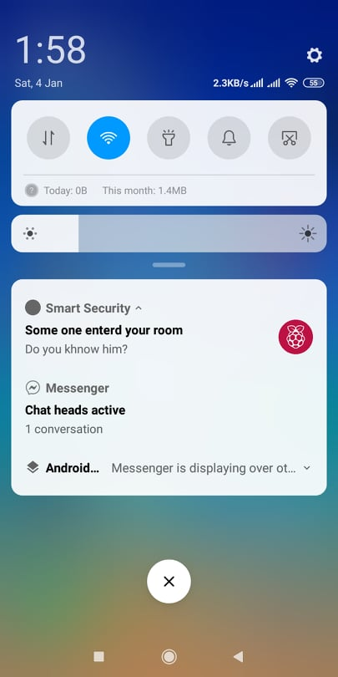
It will that any intrusion is there inside the surveillance area and make the user aware of the situation and on movement it will send images to that particular Android devices.

use of project
The purpose of the project is to make a system, which
Would detect and take snapshots and videos of the motion
When detected and upload to an external server. The major
Use of the 'Motion Detection' is at homes, buildings and also
For surveillance for security for example of server rooms.
This equipment when made on a large scale would be
Much cheaper and would cost under 60$ which is relatively
Very cheap to current products which have similar capabilities. The notification can also be done via text messages on mobiles using a text gateway on the Raspberry Pi. The options are unlimited for notification and storage of the files depending on the user's requirements, presently almost everyone has an Internet connection at home and all the members in the family are away during the day, as security systems are not affordable this system would be great alternative to implement.

Conclusion and future work
Thus we have designed a smart surveillance system capable
of recording/capturing video/image and transmitting to a
smart phone.It is advantageous as it offers reliability and
privacy on both sides. It is authenticated and encrypted on
the reciever side,hence it offers only the person concerned
to view the details .Neccesary action can be taken in short
span of time in the case of emergency conditions such as
elderly person falling sick,military areas,smart
homes,offices,industries etc.,Future work is to locate the
number of persons located exactly on that area and their
position so that accurate information can be obtained on.
In future we plan to improve the Motion Detection algorithm.Because the algorithm depends on threshold value, it’s mean the performance of the algorithm can be enhanced by considering certain conditions. If we have a good solutions to get a good threshold value and then the algorithm can detect moving objects precisely, including slow moving or tiny objects.

.

References

[1] Yong-ik Yoon, Jee-ae Chun, Tracking System for mobile user Based on CCTV. Information Networking (ICOIN), 2014 International Conference on, Phuket, 10-12 Feb. 2014, pp. 374-378.
[2] Aamir Nizam Ansari \ Mohamed Sedkyl, Neelam Sharma2, Anurag Tyagil lFaculty of Computing, Engineering and Sciences, Staffordshire University, Stoke-on-Trent, United Kingdom” An Internet of Things Approach for Motion Detection using Raspberry Pi” presented at the International Conference on Intelligent Computing and Internet of Things (IC1T),2015.

[3] Serkan Akbas,Mehmet Akif Efe & Suat Ozdemir
“Performance Evaluation of PIR Sensor Deployment
in Critical Area Surveillance Networks” , 2014 IEEE
International Conference on Distributed
[4] Raspberry Pi. Raspberry Pi, n.d. Web. Oct.
2013. http://www.raspberrypi.org

