Fig. 1. Block diagram of the proposed medical blockchain system.

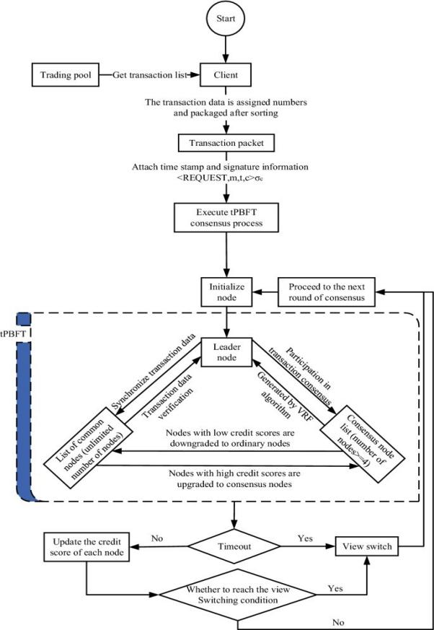

**Reference:** ([Song Tang](https://www.nature.com/articles/s41598-022-08587-1" \l "auth-Song-Tang-Aff1-Aff2-Aff3), [Zhiqiang Wang](https://www.nature.com/articles/s41598-022-08587-1" \l "auth-Zhiqiang-Wang-Aff1-Aff2-Aff3), [Jian Jiang](https://www.nature.com/articles/s41598-022-08587-1" \l "auth-Jian-Jiang-Aff4), [Suli Ge](https://www.nature.com/articles/s41598-022-08587-1" \l "auth-Suli-Ge-Aff1-Aff2) & [GaiFang Tan](https://www.nature.com/articles/s41598-022-08587-1" \l "auth-GaiFang-Tan-Aff1-Aff2)) Improved PBFT algorithm for high-frequency trading scenarios of alliance blockchain.

<https://www.nature.com/articles/s41598-022-08587-1>

Fig. 2. Blockchain-Based Medical Record Flowchart. (Proposed Paper)

START

USER LOGIN

VALIDATE RECORD FORMAT

NODES VOTE (pBFT CONSENSUS)

REJECTED

APPROVED

BLOCK REJECTED

UPDATE BLOCKCHAIN

END

ADD BLOCK TO DB

ADD MEDICAL RECORDS(DOCTORS ONLY)

ROLE BASED ACCESS

Fig. 3. Block diagram of the proposed medical blockchain system. (Proposed Paper)

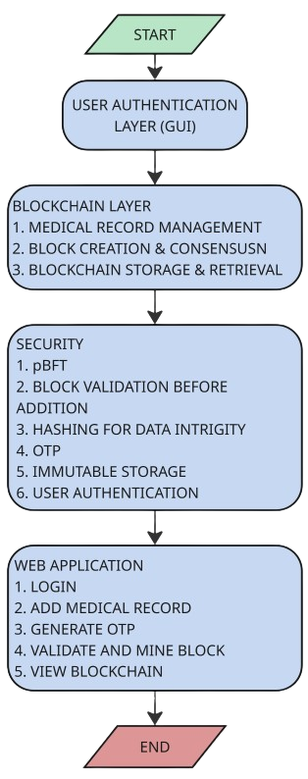

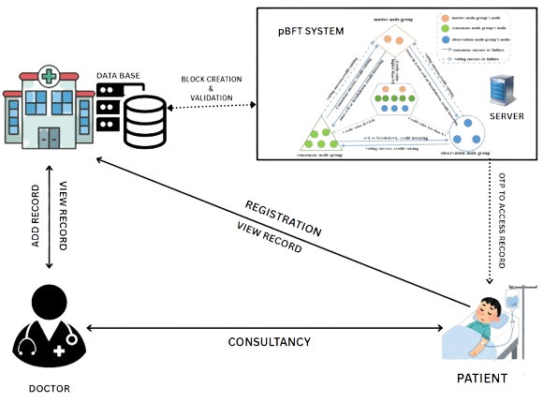

Fig. 4. System Architecture. (Proposed Paper)

Fig. 5. Comparison between EnergyConsumption and Success Rate.

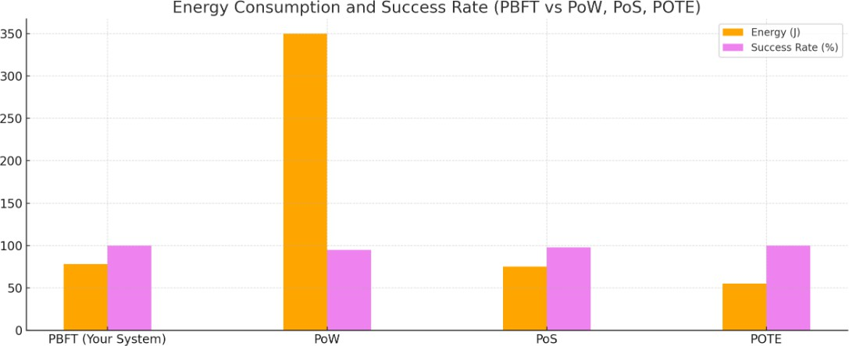

Fig. 6. Comparison between Latency and TPS Comparison

