The Programmer’s Manual for TaskForce Flashcards

Table of Contents

**Requirements Documentation**

1. Introduction

1.1 Purpose

1.2 Scope

1.3 Definitions, Acronyms, and Abbreviations

1.4 References

1.5 Overview

2. Overall Description

2.1 Product Perspectives

2.2 Product Functions

2.3 User Characteristics

2.4 Constraints

2.5 Assumptions and Dependencies

3. Specific Requirements

3.1 External interface requirements

3.1.1 User interfaces

3.1.2 Hardware interfaces

3.1.3 Software interfaces

3.2 Functional requirements

3.2.1 Deck Management

3.2.2 Flashcard Management

3.2.3 Study Management

**Design Documentation**

## 2.1 Architecture Diagrams

## 2.2 Pseudocode

## 2.3 Decision Tables

## 2.4 Control Diagrams

**Source code Documentation**

**Testing Documentation**

**Known Bugs and Issues**

# Requirement Documentation

## 1. Introduction

### 1.1 Purpose

The purpose of this software requirement specification document is to provide guidelines to future users on how to operate the Flashcards program. Flashcards is an application targeted to students to help with retention when studying.

### 1.2 Scope

This application would allow users:

* Create, manage, and study flashcard decks
* Organize cards by subjects and topics
* Assign difficulty levels to cards
* Study options: difficulty selection, shuffling, and card side choice

### 1.3 Definitions, Acronyms, and Abbreviations

* API – Application program Interface
* IDE – Integrated Development Environment
* JDK - Java Development Kit
* OS - Operating System
* Deck/Set: A collection of related flashcards. Both terms are used interchangeably.

### 1.4 References

1. IEEE Std 830-1998, IEEE Recommended Practice for Software Requirements Specifications

### 1.5 Overview

The rest of the document would contain an overall description that describes the application and its target audiences, the specific requirements the software would need to function properly such as different dependencies that the application would require and an appendix that includes any other information pertaining to software usability and correctness.

## 2. General Description

### 2.1 Product Perspectives

As students are always learning something new in our classes, we need a system for recalling what we have learned. The flashcard software aims to help with recollection. By creating a system of cards where we connect a keyword to a definition, we hope to make learning and studying more enjoyable for students.

### 2.2 Product Functions

The product is a user-friendly flashcard application for personal study purposes. It provides functionality for building and managing flashcard decks and offers various study options to enhance learning effectiveness.

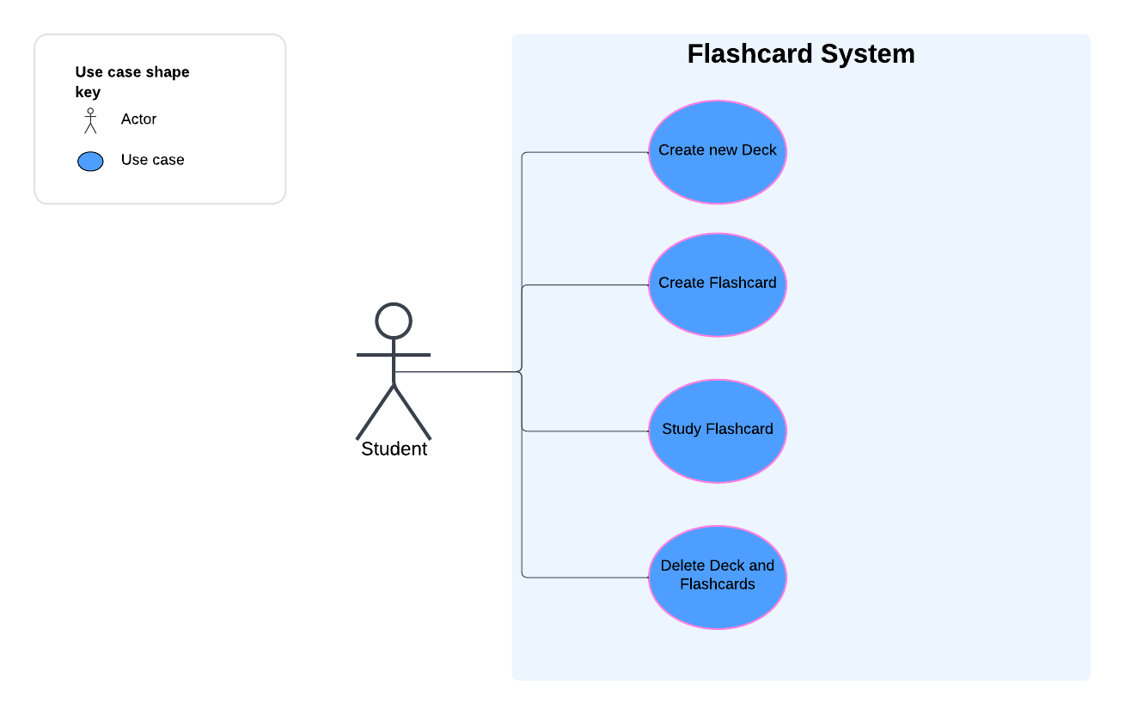

### 2.3 User Characteristics

* Target audience is students needing a method to revise knowledge.
* Users should be familiar with technical applications ranging from beginners to advanced users.

### 2.4 Constraints

Some possible constraints to the system are:

* The application will be developed for the Windows platform only. So, any user would have to own a Windows OS to fully utilize the application.
* Development will be done using Java with Eclipse or IntelliJ IDEs
* Users would have to have a JDK of 15 and above.
* The application will operate as a standalone program without external system interactions

### 2.5 Assumptions and Dependencies

* The user would need a Java compiler to use the user interface.
* User is literate to be able to add and read information from cards.
* Users would allow applications to store some files on the system's memory.

## 3. Specific Requirements

### 3.1 External interface requirements

#### 3.1.1 User interface

* Users would have an interactive UI.
* The main screen would have a menu tab to help users interact with the deck by sorting and filtering.

#### 3.1.2 Hardware interfaces

The app would make use of the device keyboard and monitor for adding and modifying decks and cards.

#### 3.1.3 Software interfaces

There is no additional software interface apart from the app’s API.

### 3.2 Functional requirements

#### 3.2.1 Deck Management

1. Users shall be able to create a new flashcard deck by using a name to identify it.
2. Users shall be able to organize decks by subjects and topics.

#### 3.2.2 Flashcard Management

1. Users shall be able to create a two-sided card. One side with answers separated by spaces and the other with the question with blanks.
2. Users shall be able to add, modify, and update cards within a deck.

#### 3.2.3 Study Management

Users shall be able to shuffle cards within a deck, so they can pick a random card to study.

# Design Documentation

## Architecture Diagrams

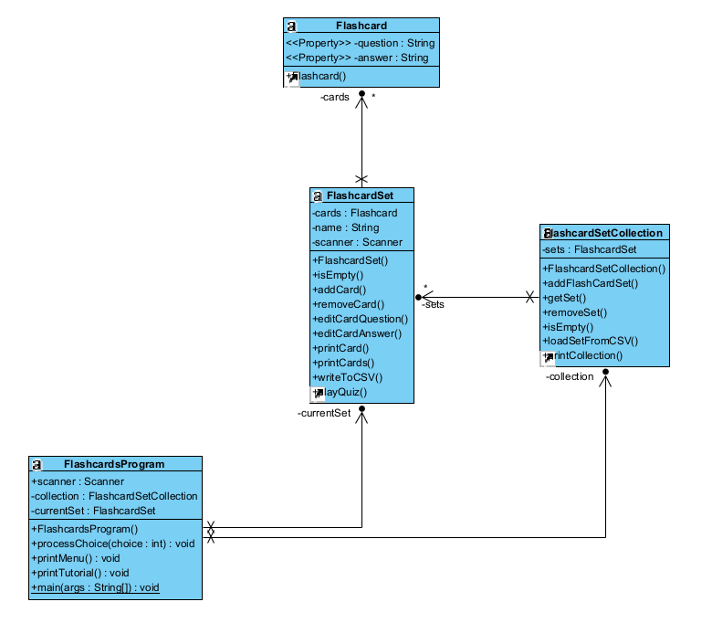

## Pseudocode

## Decision Tables

## Control Diagrams

### 4.1 Activity Diagram

# Source code Document

Present within the source code.

# Testing Documentation

| Test Case # | Requirement Tested | Rationale | Input(s) | Expected Output | Pass/Fail |
| --- | --- | --- | --- | --- | --- |
| 1 | 3.2.1.1 | user should be able to select option to create new set of flashcards | user enters "1" when prompted to select a choice from the menu options | prompt to enter name of set | P |
| 2 | 3.2.1.1 | user should be able to choose to make just newly created set the current working set or not | user enters name for newly created set | prompt "Would you like to make this the current set? (y/n)" | P |
| 3 | 3.2.1.1 | operations should be available for newly created | “y” OR “yes” | displays menu options | P |
| 4 | 3.2.1.1 | user should be able to access menu options in light of the decision to not make newly created set the current working set | “n” OR “no” | displays menu options | P |
| 5 | 3.2.1.1 | when in a current working set, user should still be able to create a new set and decide whether to change current working deck to the newly created deck | user enters "1" when prompted to select a choice from the menu options | prompts to enter name of set | P |
| 6 | 3.2.1.2 | user should be able to view all created sets | user enters "12" when prompted to select a choice from the menu options | a list of sets created | P |
| 7 | 3.2.1.2 | user should be able to change which is the current working set | user enters "2" when prompted to select a choice from the menu options | prompt to enter which set to make the current working set | P |
| 8 | 3.2.1.2 | user should be able to identify the current working set | user enters "7" when prompted to select a choice from the menu options | program returns "Yor are currently in the set named: {set name}" | P |
| 9 | 3.2.1.2 | user should be able to identify all cards within a particular set | user enters "8" when prompted to select a choice from the menu option | list of cards with there contents; OR the feedback "There are no cards in this set" | P |
| 10 | 3.2.1.2 | user should be able to save a current set and its cards | user enters "9" when prompted to select a choice from the menu options | Feedback "Set successfully saved to file" if saved or "There are no cards in this deck - nothing to save" if empty of cards | P |
| 11 | 3.2.1.2 | user should be able to load a deck from a csv file | user enters "10" when prompted to select a choice from the menu options | prompt to enter the name of the file | P |
| 12 | 3.2.1.2 | user should be able to delete a deck | user enters "11" when prompted to select a choice from the menu options | list of decks created and prompt to enter number for deck to delete; a follow up confirmation | P |
| 13 | 3.2.2.1 | user should be able to create a new card in a current working set | user enters "3" when prompted to select a choice from the menu options | feedback "You must first have a set loaded" if user is not any current working set; Otherwise, prompts user for card's question and answer | P |
| 14 | 3.2.2.2 | user should be able to delete a flashcard from a current working deck | user enters "4" when prompted to select a choice from the menu options | list of cards with their contents (question and answer) and prompt on corresponding number for card to be deleted | P |
| 15 | 3.2.2.2 | user should be able to edit contents (question and answer) of flashcards in a current working set | user enters "6" when prompted to select a choice from the menu options | list of cards with their contents (question and answer) and prompt on corresponding number for card to be edited | P |
| 16 | 3.2.3.1 | user should be able to quiz themself on cards in the current working deck | user enters "5" when prompted to select a choice from the menu options | displays a question and prompts "Your guess:" for user's answer; responds correct or incorrect to user's answer | P |

# Known Bugs and Issues

1. bug 1:File I/O Issues
2. bug 2:Case sensitivity
3. bug 3:Exception handling( Error message, Uncaught exceptions)
4. bug 4:Unit test failure
5. bug 5: Lagging