User Manual

# Table of Content

1. System Requirement

2. Installation Steps

3. Application Overview

4. Features

5. Functionality

# 1. System Requirements

* **Operating System**: Windows, macOS, or Linux
* **Java Version**: Java 23 or higher

# 2. Installation Instructions

## 2.1 Installation instructions for Application

1. Download the Flash Card App file from the official source.
2. Double-clicking on it should begin the installation process like in the picture below.
3. You would be prompted to know if you would like a desktop shortcut for the application and where you would like the application documents to be saved.
4. Clicking next would extract all documents and the application to the specified folder.
5. You should now be able to access the application on your start menu by searching “Flashcard” or by the shortcut on your desktop if you opted for one.

## 2.2 Installation Instructions for JDK 23

1. If you are unable to run the application, you should check your Java version to see if it is version 23. You can do this by typing ‘java -version’ on the command line. If it isn’t version 23 follow the next instructions.
2. Navigate to <https://www.oracle.com/java/technologies/downloads/>.
3. Click on Windows and download the right modification for your system.
4. You may be prompted to login. If you have an account, login using your login credentials. If not, create an account, each account is free.
5. Verify your account using the link sent to the email address provided.
6. Your download should begin after you login.
7. Click on the downloaded file and follow the installation instructions.

# 3. Application Overview

* **Menu:** This shows all functions that the application can perform.
* **Decks/Sets**: Organize flash cards into subject-specific groups based on content.
* **Collection**: A group of sets/decks.

# 4. Features

* **Create and Customize Flash Cards**: Create new, Add questions, and answers
* **Categorize Flash Cards into Sets/Decks**: Organize flash cards by topics.
* **Study Modes**: Choose between study, quiz, or spaced repetition modes.
* **Options:** Delete, revise, add more or less to your current deck.

# 5. Functionality – Using the Application

To select any function from the menu within the application, you must input the number in front of the function and press enter. For example, to change the set of flashcards I'm working with, I’ll input 2 and press enter.

## 5.1 Creating a new Set of Flashcards

1. When you open the application for the first time, you are shown a tutorial and the menu options.
2. To create a new set of flashcards, type in 1 under select a choice and press enter.
3. This would then prompt you for the name of the set, input the name you want and press enter.
4. A prompt would ask if you would like to use this set. This is basically knowing if you would like to use the flashcards in this set/deck.
5. Type in ‘y’ or ‘yes’ for Yes and ‘n’ or ‘no’ for No.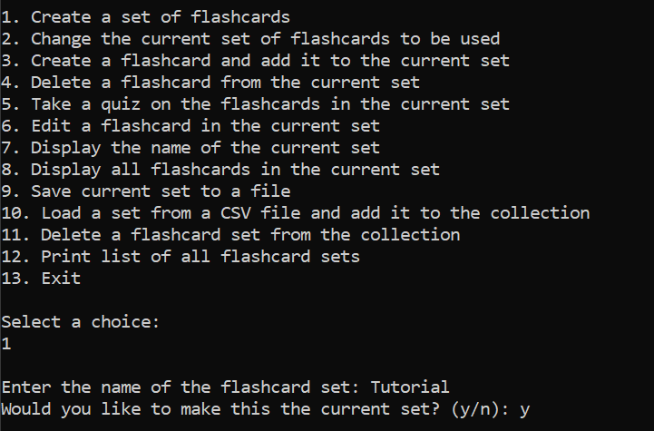
6. If you type yes, whatever flashcards you make or edit would be in the set.
7. If you type no, the set would not change to the newly created set.

## 5.2 Changing the set of a flashcard

1. This function helps you move into another deck. You can select it by typing 2 and enter after the menu options.
2. The application would then show you a list of sets in the collection.
3. You select the set you want to use by typing the number beside the name.

For example, to use the test set in the image, I would type 2 and enter.

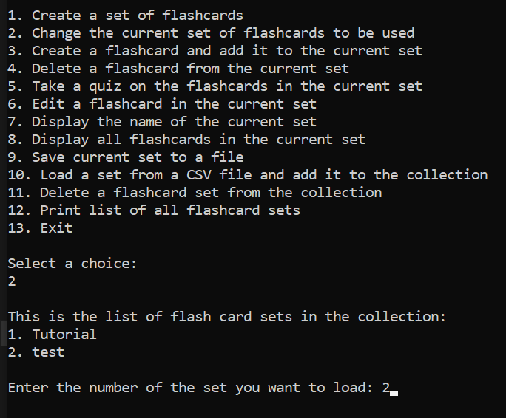

## 5.3 Loading a Set from a CSV File

1. After the menu options, type in 10 and enter under select choice.
2. This would then prompt you to enter the name of the CSV file. The file must be saved in the same folder that your application is saved.
3. You would then be prompted to make the loaded set your current set, i.e. do you want to use the cards in the file to just load? You can answer yes, ‘y’, or no, ‘n’ then enter.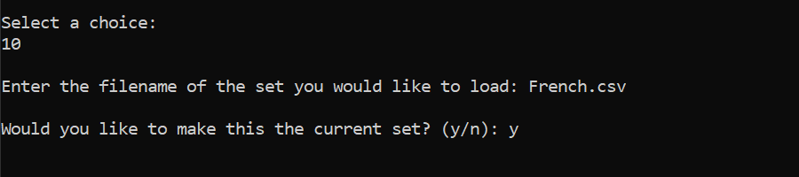

## 5.4 Deleting a Flashcard Set

1. You can Navigate to this function by inputting the 11 and pressing enter.
2. It would then print the list of loaded sets in the application and ask you for the number of the set you want to delete.
3. Once you have inputted that, it displays a message telling you if the deletion was successful and what was deleted.

## 5.5 Creating Flash Cards

1. After the menu options, type in 3 and enter under select a choice.
2. If you have not selected a set to work with, it will show an error telling you this and display the menu again. You could then create a new set or change the set, or load a set (refer to 5.1, 5.2 or 5.3). Then begin from point 1.



1. If you were already within the set, it would prompt you for the question. Fill in the question and press enter. Then fill in the answer and press enter.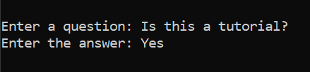
2. This automatically saves the flashcard to the set.
3. You should save the current set as a file, by inputting 9 and enter, after the menu. This would create a csv file with the name of the set in your application folder. If you already have a csv file with that name, the application would automatically replace that file with the current set.

## 5.6 Studying Flashcards

1. Navigate to this function by typing 5 and enter after the menu.
2. This would then begin to randomly loop through each card by showing the question and asking for an answer.
3. If you input the right answer, it shows the next question. If not, it asks you if you want to go to the next question or stop studying.
4. When you reach the end of the flashcards, it automatically moves back to the menu.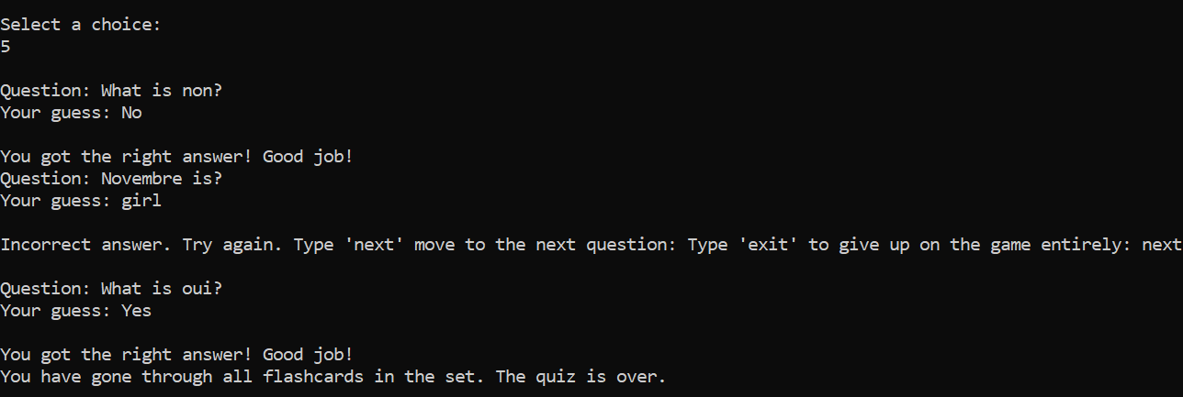

## 5.7 Editing Flashcards

1. Navigate to this function by typing 6 and enter after the menu.
2. This would then show the list of flashcards within the set.
3. You can edit a flashcard by inputting the number of the flashcard. If I want to edit question 1, I input 1 and press enter. It would display the question and answer on that flashcard.
4. It would then ask you if you want to edit the question or answer. You type ‘q’ for the question and ‘a’ for the answer.
5. For whichever one you choose, you then input the new question or answer and press enter.
6. It would then give you a notification if you were able to successfully change it.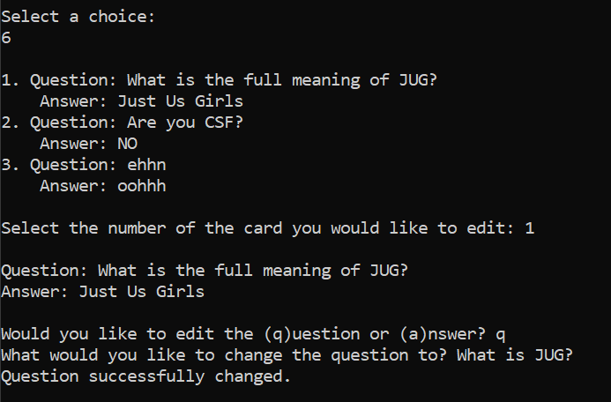
7. You should save the current set as a file, by inputting 9, after the menu. This would create a csv file with the name of the set in your application folder. If you already have a csv file with that name, the application would automatically replace that file with the current set.

## 5.8 Deleting Flashcards

1. Navigate to this function by typing 4 and enter after the menu.
2. This would then show the list of flashcards within the set.
3. You can delete a flashcard by inputting the number of the flashcard. If I want to delete flashcard 1, I input 1 and press enter.
4. A notification of successful deletion would display.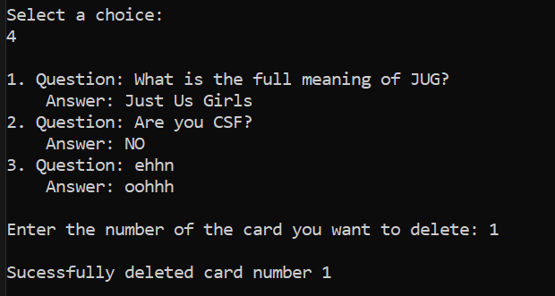
5. You should save the current set as a file, by inputting 9, after the menu. This would create a csv file with the name of the set in your application folder. If you already have a csv file with that name, the application would automatically replace that file with the current set.

## 5.9 Display Functions

There are 3 display functions for the application.

* **Displaying cards** in the set. Input 8 and press enter.
* **Displaying sets** that have been loaded to or created in the application.Input 12 and press enter.
* **Displaying the name of the current set** you are in. Input 7 and press enter.