# Guide on how to add content to the website

*Dear partner,   
the fun of adding content to our website togethersciene.eu is about to start.   
We are looking forward to seeing your content and learning about all your activities.  
Please read and follow these instructions.*

***Language note****:   
For now the website is only in English. Please only add English content. There is the option of translating the main parts of the website in other languages. We will get in touch with the partners that have showed interest in this.*

***Work in progress:*** *Not only the website but also this document is a living document which we are continuously improving. If you have any problems or questions don’t hesitate to get in touch with Waag Society via email:* [*pauline@waag.org*](mailto:pauline@waag.org)*.*

# Table of content:

1. Togetherscience.eu
2. General information on using to the website
3. Preparations and adding data:  
   Metadata: adding locations of events or type of activities.  
   Changing the details of your partner page
4. Adding pages:  
   Creating an event page  
   Creating an experiment page  
   Creating a blog page

# 1. Togetherscience.eu

Explore  
Explore the website via this link: <http://129.194.69.29>. Before 1 December this ip-adres will be linked to our url: togetherscience.eu

Contribute to:  
Every partner will be able to contribute by adding events and blogs. Further everyone can change the details of their organisations detailed partner page. Finally we invite everyone to add workshop or experiment instructables to our Experiment page. Or contribute to the library by adding interesting reads, articles etc.  
  
Website description  
On the homepage the upcoming events will be visible in the right column. The large column will show highlights of blogs, news and experiments. Scrolling down you will end up at the activity stream in which all twitter and instagram activities using the #DITscience will be shown.  
  
The main menu is divided into

* **Events**: under which all upcoming events will be shown on a map or in a list. The past events are visible as well by clicking on ‘past events.’
* **Experiments**: Here everyone can upload instructables of great experiments, workshops and other inspiring events. Functioning as a knowledge sharing platform, visitors will be able to get find inspiration, do an experiment based on one of our instructables or host their own workshop. You can add a download to the text block in the form of a pdf.
* **Blog**: here we can post blogs and news items on anything we find interesting or relevant: the report on a past event, a press release, actualities etc.
* **About:** here first the visitor lands on a general about page on DITOs. Additionally via the submenu you can click on contact, partners and library. Under partners a detail page of every partner can be found. Each partner is responsible for the content of this page, in which you can tell something about your organisations, your role in the project, link to your own channels etc. Under library we can upload documents such as deliverables, articles and other things to read.

# 2. General information on using the website:

# Terminology

**Kirby CMS**: The content management system used by this website.

**Panel**: The backend where content of the website is managed

**Dashboard**: The home page for the content management panel.

# Dashboard

Via this link you can access the backend of the website:

http://129.194.69.29/panel/

# Kirby CMS formatting – text

All pages have a text field, here you can add a variety of content types such as titles, lists, links, images, and files. These are written in Markdown, an open text formatting format created for the web.   
  
It is possible to copy and paste text in the text fields. If you want to add more content, be creative with how the text is shown or add other media you can explore the instructions below:

Basic formatting:

To make text bold, select the text and press the [B] icon below the field.

To make text italic, select the text and a press the [i] icon below the field.

To add a link, write (link: http://example.com text: This is a link)

Files:

To add an image or file click “Add” next to Files in the left column, then you can select an image or document from your computer. After the upload is complete you can drag the image/document from the Files list into the text field.

Explore more:

For the full documentation and to learn more about the potential of adding text in Kirby see: <https://getkirby.com/docs/content/text>

# URL’s – important when creating a new page (event, blog)

Pages automatically receive a URL based on the title of the page you are creating, however:

* Sometimes a url is already taken by another page (for example when an event has the same name) if so please add the date (separated by a dash, i.e. title-event-or-blog-16-11) to the end of the page URL when Adding a page.
* After creating a page, please never ever change its URL *after* making the page visible, otherwise pages may never be found again at some point in the future.
* Instead of deleting pages, set Visibility to invisible in the left column.

# 3. Preparations and adding data.

Workflow:  
To create a new event page it is required to fill in information on what type of activity it is and where it takes place (geographically). In this sections you find instructions on how to add locations, activities and change the details of your partner page.

Metadata

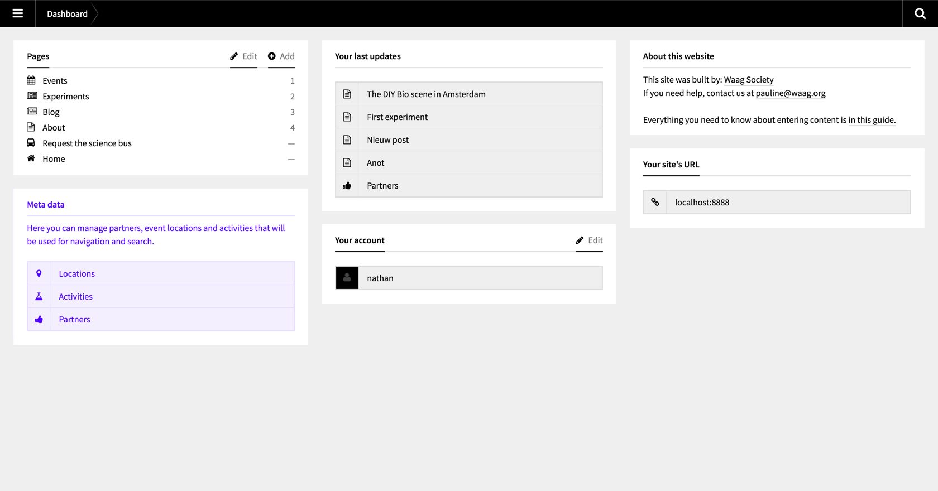  
See the Metadata block marked in purple in this image left below in the panel.

# Locations

It is required to add a location to every Event and detailed Partner page. This makes it possible to see our activities on the map. It’s important to add a *new* Location page prior to adding an Event, otherwise these pages will not be published.

To add a new location:

1. Go to the Panel Dashboard and click on *Locations* in the Meta Data block.
2. Click “Add” next to Pages on the left column
3. Name the Location in the pop-up that follows (the field for the URL-appendix is generated by Kirby CMS), then click “Add”.
4. Enter the following form fields:

**Title**: The name of the Location

**Description**: Describe the location briefly

**Photo**: Upload a photograph depicting this location (optional, don’t upload a logo).

**Address**: The street and number

**City**: The city

**Country**: The country

**URL**: The location website (optional)

**Location**: Here you need to enter the address once again to find it on the map, a marker appears on the spot which you’ll be able to adjust if need be. Below the map the geographical markers appear, you don’t need to fill these in manually.

**SEO Title**: By default pages will be indexed by search engines using the page title. If needed the title displayed in search results can be adjusted here.

1. Press “Save”
2. If you want to publish the page, press “Status: invisible” in the column on the left, then press enter to change the page visibility.

# Activities

**Caution**: All activity types as defined in our event and planning documents are added to the website. This means that most likely you are able to select the type of activity you are organising in the new event you are adding to the website. To keep search results relevant it is important that the amount activity types we add to the website remains limited. Before adding activity types to the website please check in the *Event* page if your type of event is already added. In case you have to add an activity type follow the instruction below:

It is required to define a type of activity which is used in every Event page. This makes it possible filter events by type of activity. It’s important to add a *new* Activity type prior to adding an Event page, otherwise an Event will not be published.

To add a new activity type:

1. Go to the Panel Dashboard and click on *Activities* in the Meta Data block.
2. Click “Add” next to Pages on the left column
3. Name the Activity type in the pop-up that follows (the field for the URL-appendix is generated by Kirby CMS), then click “Add”.
4. Enter the following form fields:

**Title**: The name of the Activity.

**Description**: Describe the activity briefly

1. Press “Save”
2. If you want to make the activity public, press “Status: invisible” in the column on the left, then press enter to change the page visibility.

# Partners

On the homepage under About, every partner has a detailed partners page. It is up to each partner to add content to these pages. Follow the instructions below:

To edit your partner page:

1. Go to the Panel Dashboard and click on *Partners* in the Meta Data block.
2. Click on the name of your organisation in the left column to edit its contents.
3. You may change the following form fields:

**Title**: Don’t change this (!)

**Description**: Describe your organisation briefly

**Text**: Add information about your organisation

**Logo**: The logo of your organisation

**Location**: Select the location of your organisation, *remember*, this Location has to be added in the Locations page prior.

**URL**: The website of your organisation

**SEO Title**: By default pages will be indexed by search engines using the page title. If needed the title displayed in search results can be adjusted here.

1. Press “Save”
2. You can see a preview of your partner page by pressing “Open preview” in the left column

Your Account

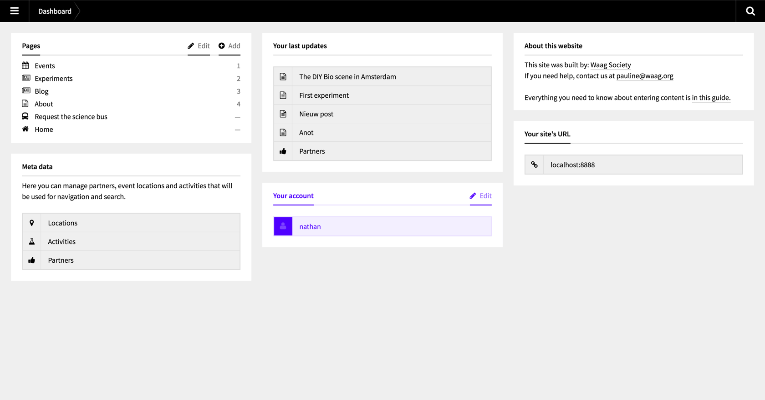See the *Your account* block marked in purple in this image in the middle left of the panel.

Here you edit your account, or create a new account for your collegeaus that also need acces to the panel of togetherscience.eu.

# 4. Adding pages.

See the *Pages* block marked in purple in this image left above in the panel. Here you add or change pages that are visible on the front end of the website. *Keep in mind!* be cautious, everything you add or change here is visible for the public.

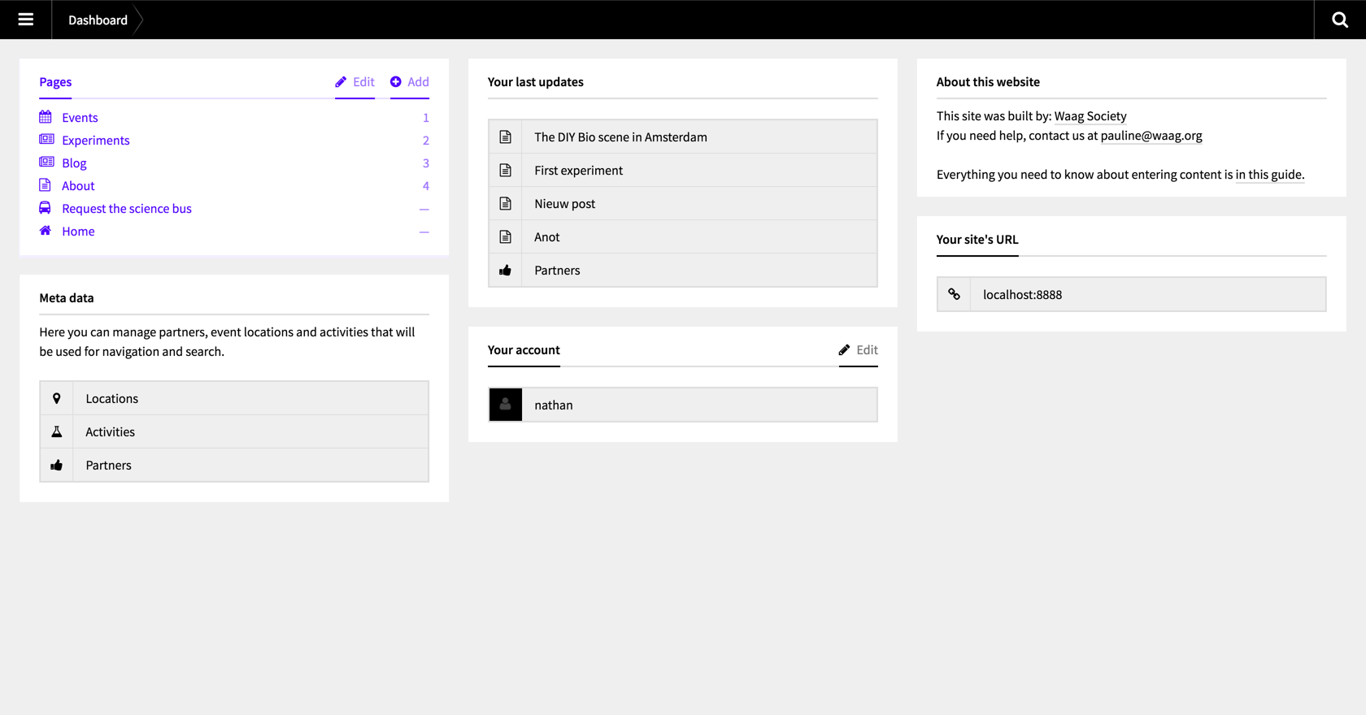

## Prepare yourself before adding content

Before adding content to the website it is best to prepare the following material

* Text: (of blog, event)
* Image: To create a visually pleasing website and give visitors an idea of the event or content described please add a nice image with the following requirements: *The optimal size is 1200 x 1600. Max optimals file-size is 400kb.*
* External link: Eventbrite, Meetup or any other external page where visitors can make reservations or buy tickets. You are able to pase this link in the *Event* page.
* Add geographical location to the website: in case of an event we want it to become visible on the right location on the map. For this you first have to add the location in the Metadata on the panel.

# Events

*Locations reminder*  
Before you create an event, make sure that the Location of your event is added in the Metadata, these can be found under Dashboard; Meta Data. If the locations is not added correctly you won’t be able to upload your event page as it won’t be visible on the map.

To add a new event:

1. Go to the Panel Dashboard and click on *Events* in the Pages block.
2. Click “Add” next to Pages on the left column
3. Name the Event in the pop-up that follows (the field for the URL-appendix is generated by Kirby CMS, if more than one events have the same name, please post-fix the URL with the date, separated by dashes, i.e.: a-url-for-an-event-16-11), then click “Add”.
4. Enter the following form fields:

**Title**: The name of the Event

**Description**: Describe the event briefly

**Partner**: Select a partner from the drop-down list.

**Location**: Select a location from the drop-down list.

**Activity**: Select an activity type from the drop-down list, the activity needs to be present in Dashboard; Meta Data; Activities or the page won’t be published.

**Text**: Information about this event.

**Image**: Upload an image that relates to the event (optional). The optimal image size is 1200 x 1600. Max optimal file – size is 400kb.

**Tags**: Here you can add tags for the event, these can be used to filter related events.

**Start date**: The start date of the event.

**Start time**: The start time of the event.

**End date**: The end date for the event.

**End time**: The end time for the event (optional).

**Link**: It is possible to add an external link to a third party, for example an reservartion/payment page about this event.

**Price**: The entry fee for this event, enter 0 if the event is free.

**Currency**: The currency for the entry fee

**Reservation**: Select this checkbox if a reservation is required to attend.

**SEO Title**: By default pages will be indexed by search engines using the page title. If needed the title displayed in search results can be adjusted here.

1. Press “Save”
2. If you want to make the event public, press “Status: invisible” in the column on the left, then press enter to change the page visibility.

You can always return to this page and edit its contents, click “Open preview” in the left column to see your event page on the website.

# Experiments

To add a new experiment page:

1. Go to the Panel Dashboard and click on *Experiments* in the Pages block.
2. Click “Add” next to Pages on the left column
3. Name the Experiment page in the pop-up that follows (the field for the URL-appendix is generated by Kirby CMS, if more than one experiments have the same name, please post-fix the URL with the date, separated by dashes, i.e.: a-url-for-an-event-16-11), then click “Add”.
4. Enter the following form fields:

**Title**: The name of the Experiment

**Description**: Describe the experiment briefly

**Author**: The name of the author.

**Date**: The publication date for the experiment.

**Main Post Image**: Upload an image. Image requirements: The optimal size is 100 x 1600. Max optimal file-size is 400 kb. Select the image (round circle right of it) to make it visible above the experiment page.

**Text**: Information about this experiment.

**Tags**: Here you can add tags for the event, these can be used to filter related experiments.

**SEO Title**: By default pages will be indexed by search engines using the page title. If needed the title displayed in search results can be adjusted here.

**SEO Description**: By default pages will be indexed by search engines using the page description. If needed the description displayed in search results can be adjusted here.

1. Press “Save”
2. If you want to make the experiment public, press “Status: invisible” in the column on the left, then press enter to change the page visibility.

You can always return to this page and edit its contents, click “Open preview” in the left column to see your experiments page on the website.

# Blog

To add a new blog post.

1. Go to the Panel Dashboard and click on *Events* in the Pages block.
2. Click “Add” next to Pages on the left column
3. Name the Blog post in the pop-up that follows (the field for the URL-appendix is generated by Kirby CMS, if more than one events have the same name, please post-fix the URL with the date, separated by dashes, i.e.: a-url-for-an-event-16-11), then click “Add”.
4. Enter the following form fields:

**Title**: The name of the Blog post

**Description**: Describe the blog post briefly

**Author**: The name of the author.

**Date**: The publication date for the experiment.

**Main Post Image**: Upload an image that is displayed on the blog page, press Select next to the image to make it visible above the experiment page.

**Text**: The blog contents.

**Tags**: Here you can add tags for the blog post, these can be used to filter related blog posts.

**SEO Title**: By default pages will be indexed by search engines using the page title. If needed the title displayed in search results can be adjusted here.

**SEO Description**: By default pages will be indexed by search engines using the page description. If needed the description displayed in search results can be adjusted here.

1. Press “Save”
2. If you want to make the blog post public, press “Status: invisible” in the column on the left, then press enter to change the page visibility.

You can always return to this page and edit its contents, click “Open preview” in the left column to see your event page on the website.