|  |
| --- |
|  |
| HOLOGRAPHIC DATA STORAGE |
| THE L.N.M Institute of Information Technology |
|  |
| **ANURAG KALYA(Y12UC040) & ARJUN DESHWAL(Y12UC045)** |
| **September 19, 2014** |

|  |
| --- |
|  |

**ABSTRACT**

Holographic data storage has the potential for high density data storage with fast optical access and very high data transfer rates. Recent progress in consumer electronics provides liquid crystal TVs as spatial light modulators (SLM) and CCDs from video camcorders with excellent performance at an interesting price point. This progress in the component area and recent development of improved recording materials has encouraged the renewal of interest in holographic data storage. This presentation attempts an up-to-date review of the status of holographic data storage and highlights the open technical issues. For holographic data storage to be of technical interest it has to compete with established storage techniques on the basis of cost per megabyte and performance.

Key performance parameters are data rate, access time and storage density. For a large capacity holographic storage device, high density of the stored data at low media cost would of course translate into low cost per megabyte. All of this has to be provided reliably, i.e. at a bit-error-rate that compares favorably with conventional storage techniques on media with archival quality. Holographic storage demonstrations have shown the potential for the error free read out of a data page of one thousand by one thousand pixels in one millisecond for a data rate of one Gigabit per second.

**HOLOGRAMS:**

A hologram is a recording of the optical interference pattern that forms at the intersection of two coherent optical beams. Typically, light from a single laser is split into two paths, the signal path and the reference path. Figure 1 shows this holographic recording arrangement. The beam that propagates along the signal path carries information, whereas the reference is designed to be simple to reproduce. A common reference beam is a plane wave: a light beam that propagates without converging or diverging. The two paths are overlapped on the holographic medium and the interference pattern between the two beams is recorded.

A key property of this interferometric recording is that when it is illuminated by a readout beam, the signal beam is reproduced. In effect, some of the light is diffracted from the readout beam to “reconstruct” a weak copy of the signal beam. If the signal beam was created by reflecting light off a 3D object, then the reconstructed hologram makes the 3D object appear behind the holographic medium. When the hologram is recorded in a thin material, the readout beam can differ from the reference beam used for recording and the scene will still appear.

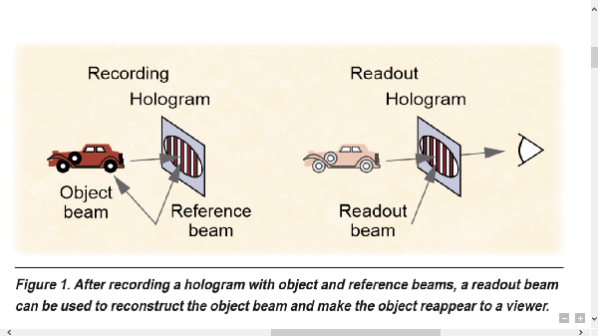

**VOLUME HOLOGRAMS:**

When a hologram is recorded in thick material, the portion of incident light diffracted into the direction of the object beam (the diffraction efﬁciency) depends on the similarity between the readout beam and the original reference beam. A small difference in either the wavelength or angle of the readout beam is sufﬁcient to make the hologram effectively disappear. The sensitivity of the reconstruction process to these small variations in the beam increases, approximately linearly, with material thickness. Therefore, by using thick recording media, designers can exploit this angular or wavelength readout sensitivity to record multiple holograms. To record a second, angularly multiplexed hologram, for instance, the angle of the reference beam is changed sufficiently so that the reconstruction of the ﬁrst hologram effectively disappears. The new incidence angle is used to record a second hologram with a new object beam. The two holograms can be independently accessed by changing the readout laser beam angle back and forth. For a 2-cm hologram thickness, the angular sensitivity is only 0.0015 degrees. Therefore, it becomes possible to store thou- sands of holograms within the allowable range of reference arm angles (typically 20–30 degrees). The maximum number of holograms stored at a single location to date is 10,000.

**STORING & RETRIEVING DIGITAL DATA:**

To use volume holography as a storage technology, the digital data to be stored must be imprinted onto the object beam for recording, then retrieved from the reconstructed object beam during readout. The input device for the system is called a spatial light modulator, or SLM. The SLM is a planar array of thousands of pixels; each pixel is an independent optical switch that can be set to either block or pass light. The out- put device is a similar array of detector pixels, such as a charge-coupled device (CCD) camera or CMOS pixel array. The object beam often passes through a set of lenses that image the SLM pixel array onto the output pixel array, as Figure 2 shows.

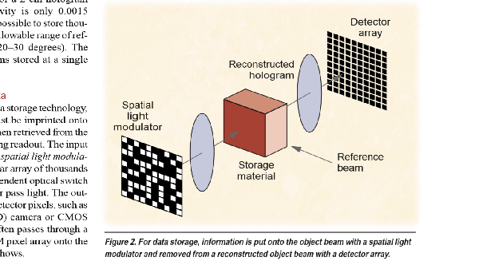

**METHODS OF OPTICAL DATA STORAGE:**

Optical data storage techniques are categorized in three basic groups.

**Surface or 2D recording**

• **CD/DVD** — Data are stored in reﬂective pits and scanned with a focused laser. Disks are easily replicated from a master.

• **CD-Recordable**—Reﬂective pit are thermally recorded by focused laser. This type is usually lower density than read-only versions. Researchers have proposed blue lasers and “electron-trapping” materials to achieve density improvements.

• **Magneto-optic disks** — Spots are recorded with a combination of magnetic ﬁeld and focused laser.

• **Near-field optical recording** — Higher 2D density than with conventional surface recording is achieved by placing a small light source close to the disk. Light throughput and readout speed are issues.

• **Optical tape** — Parallel optical I/O has the advantages of magnetic tape without the long-term interaction between tape layers wound on the spool. Flexible photosensitive media is an issue.

**Volumetric recording**

• **Holographic** — Data are stored in interference fringes with massively parallel I/O. Suitable recording material is still needed.

• **Spectral hole burning** — This technique addresses a small subset of molecules throughout the media by using a tunable narrowband laser. Alternatively, all subsets are addressed with ultrashort laser pulses. It may add a fourth storage dimension to holography but requires cryogenic temperatures and materials development.

**Bit-by-bit 3D recording**

• **Sparsely layered disks** — The focus of the CD laser is changed to hit interior layers. DVD standard already includes two layers per side.

• **Densely layered disks** — A tightly focused beam is used to write small marks in a continuous or layered material; read with confocal (depth-ranging) microscope.

• **2-photon** — Two beams of different wave-lengths mark writes, then read in parallel using ﬂuorescence. Material sensitivity is an issue.

**STORAGE MATERIALS:**

Photosensitive materials for volume holography are generally classiﬁed as either read-write or write-once.

**Read-write materials**

Most holographic read-write materials are inorganic photorefractive crystals doped with transition metals such as iron or rare-earth ions such as praseodymium, grown in large cylinders in the same way as semiconductor materials. Large samples can be cut and polished, making thick holograms possible. These materials react to the light and dark regions of an interference pattern by transporting and trapping photo-ionized electrons.

Through the linear electro-optic effect exhibited by these crystals, the electrical fields created by the trapped charge give rise to an index or phase grating suitable for diffracting light. Thus, the spatial variations in light intensity present in the interference pattern become identical variations in the index of refraction. The trapped charge can be rearranged by subsequent illumination, which makes it possible to erase recorded holograms and replace them with new ones. However, the ease of charge re-excitation also results in the gradual erasure of stored holograms during normal readout. In the dark, the lifetime of these holograms ranges from months to years as the trapped charge slowly leaks away.

Recorded holograms can be “ﬁxed” through thermal or electronic processes. The ﬁxing process affects all the stored holograms within a volume simultaneously. Thus, individual pages of data cannot be erased and replaced this way.

An alternative for achieving nonvolatile storage in photorefractive materials is to record at a light wavelength not normally absorbed by the crystal except in the presence of a third “gating” beam of different wavelength. This beam is present only during the recording and is switched off for readout.

Organic photorefractive polymers have also been developed. These materials provide more opportunity for performance tuning because you can fabricate them using a wide variety of constituents. However, these materials tend to be limited in thickness and require large applied voltages.

**Write-once materials**

Writing permanent volume holograms generally involves irreversible photochemical reactions, triggered by the bright regions of the optical interference pattern. For example, a photopolymer material will polymerize (bind short monomer chains together to form long molecular chains) in response to optical illumination. In contrast, the molecules in a photochromic material undergo a change in their absorption behavior. Such materials are inexpensive to make in quantity. However, both types can have problems reproducing the object beam faithfully—the photopolymer because of shrinkage, the photochromic because of oversensitivity to average local intensity.

Careful system design can minimize these problems. One advantage of a photopolymer is that after recording, any leftover monomers can be disposed of with- out affecting the recorded holograms. A photochromic material, however, requires a separate chemical or optical step to disable the unused absorbing molecules after the holograms are recorded.

Currently available versions of these write-once materials are thin (approximately 100 µm)—the difﬁculties in making thick samples include insufﬁcient optical quality or excessive absorption. As we will show later, however, new multiplexing techniques for thin materials have made write-once photopolymers one of the leading candidates for the ﬁrst holographic memory products.

**Dynamic range**

In the readout process, the reconstructed hologram is imaged onto the output detector array, where the digital data is extracted from the detected signal. Noise can cause errors to occur during the detection process in various ways. The basic trade-off in volume holography is caused by the ﬁxed noise ﬂoor and the ﬁnite dynamic range of the recording material. In other words,

• The electronic detection process at the camera contributes the same amount of noise, no matter how bright the hologram, and

• as the number of holograms or the readout rate increases, the amount of power diffracted into each hologram reconstruction decreases.

Even if all other noise sources are negligible, there will be a certain hologram strength at which the signal-to-noise ratio is inadequate for error-free detection. The number of detected electrons per pixel can be written as

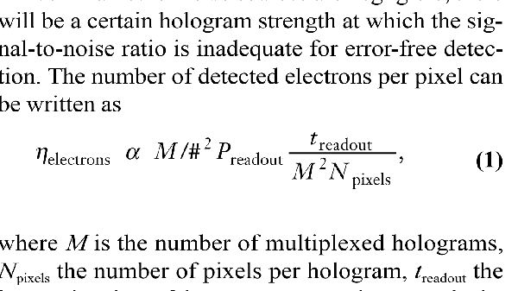where M is the number of multiplexed holograms, Npixels the number of pixels per hologram, treadout the integration time of the camera, Preadout the power in the readout beam, and M/# a material/system constant, which measures dynamic range. The storage capacity is MNpixel and the readout rate is Npixel/treadout. An increase in either of these parameters leads to a decrease in the number of signal electrons. Given the minimum acceptable number of signal electrons per pixel, we can maximize the capacity and readout rate by increasing Preadout or M/#. Different processes determine the M/# constant in photorefractives and write-once media. In a photorefractive crystal, the holograms’ recording exposures must be carefully scheduled to record equal-strength holograms. The first hologram is made quite strong. This first hologram erases slowly while the other holograms are stored, and ﬁnishes at the same strength as the weakly written final hologram. Alternatively, all the holograms can be cycled several times. The equalized diffraction efﬁciency falls as one over the square of the number of holograms, with the M/# as the proportionality coefﬁcient:

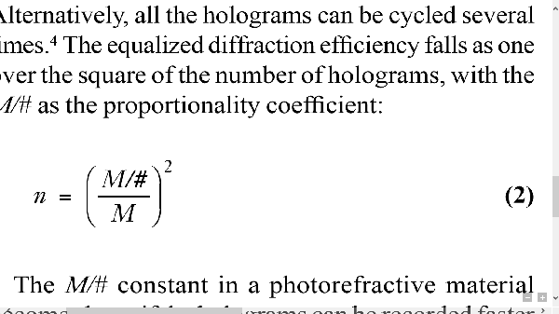The M/# constant in a photorefractive material becomes large if the holograms can be recorded faster than they erase. In iron-doped lithium niobate, a typical M/# might be 1. This implies that to store 1,000 holograms with 1 million pixels and read each in 1 millisecond, we need about 1W in the reference beam. A write-once material has much in common with photographic film: After a finite amount of input energy, the material is completely exposed. Each hologram gets its share of the dynamic range as it is recorded, preserving the bright and dark regions of the interference fringes. For instance, in a photopolymer material, the photosensitivity saturates as the available supply of monomers is exhausted. It turns out that the diffraction efﬁciency of individual holograms, when M of them are multiplexed in a saturable medium such as a photopolymer, also follows the (M/#/M)2 relationship. The most commonly used polymer is DuPont’s HRF-150. The 100-micron-thick version has a M/# of 6.5, which reduces the required readout power by a factor of 40.

**SIGNAL PROCESSING:**

Signal processing works by considering the storage device as an imperfect transmission “channel” for data that tends to smear together the signal energy from multiple bits of user data. Knowledge of how this intermixing occurs can be applied at the output end to eliminate the crosstalk and reproduce the originally transmitted bit sequence. In a telecommunications application or a bit-serial storage device like a hard drive or DVD disk, the smearing takes place between signals adjacent in time. In holographic storage, the smearing occurs spatially in two dimensions, as light intended for a particular CCD pixel diffracts into neighboring pixels.

Signal processing techniques for holographic storage are therefore 2D extensions of the 1D techniques developed for bit-serial devices. Examples of signal processing techniques used in holographic memories are adaptive thresholding and normalization, equalization, ﬁltering, and partial response precoding at the input.

**MODULATION CODES:**

A modulation code dictates the way in which bits of information are encoded into the channel as data signals. They are selected to facilitate the detection process and hence improve overall performance. For instance, in bit-serial devices, modulation codes are used to set upper and lower bounds on the frequency at which the signal level changes. In holographic storage, modulation codes are used to avoid pixel combinations that are prone to distortion and to create easy-to-detect pixel patterns.

A convenient encoding that facilitates detection is the organization of binary data into small blocks of pixels, such that the number of bright pixels is constant (usually half the pixels). The simplest example is differential encoding, in which 2 pixels convey 1 bit of information. This technique was used for storing digital data by the group at Stanford University. Several modulation codes with higher code rate and performance, and thus higher complexity, have since been developed for holographic storage. These codes have been used to demonstrate as many as 1,200 superimposed holograms in lithium niobate (LiNbO3) at a raw BER of 10-8.

**SYSTEM CONFIGURATIONS:**

The storage capacity for the simple, angle-multiplexed memory is simply the product of the number of holograms superimposed times the number of pixels in each page. The number of pixels per page is currently limited to roughly one million. The dynamic range (M/#) of available materials and the desire for a reasonable readout rate limit the number of holograms to about 1,000. Therefore, the capacity of a single angle-multiplexed holographic memory module is only 1 Gbit.

In most cases, we must increase the capacity to at least 1 terabit to have a system that is competitive with alternative technologies. We can accomplish this by constructing a large memory consisting of multiple 1-Gbit modules. This technique is called spatial multiplexing, because multiple “stacks” of holograms are stored in different spatial locations of the recording material. Spatial multiplexing has several conﬁguration options: holographic random-access memory (HRAM), compact modular holographic memory, and holographic 3D disks.

**1) Holographic random-access memory:**

One approach for spatial multiplexing steers the reference and object beams to a stationary block of material containing multiple storage locations, as Figure 3 shows. With non mechanical optical scanners, the HRAM system can very rapidly steer the optical beams. Most non-mechanical beam steerers use either an acousto-optic deﬂector or a one-dimensional liquid crystal SLM. By using large lenses (not shown in Figure 3), the information stored at separate locations can be directed back to a single detector array. An HRAM system can read out holograms from any location in an essentially random sequence. To maximize the number of holograms in each location, designers generally envision HRAM systems with thick read-write materials such as photorefractive crystals. Researchers at Caltech built a 16-location HRAM system capable of 10,000 holograms per location; researchers at Rockwell demonstrated an HRAM system with no moving parts. To construct a Tbit memory using this approach, we need 1,000 spatial locations (arranged in 2D as a 33 ×33 array), with each location storing 1 Gbit. The main challenge in building such a system is the optics that have to simultaneously transfer data from each of the 1,000 recording sites on the recording material to a single detector array. This will require considerable engineering improvements over present systems.

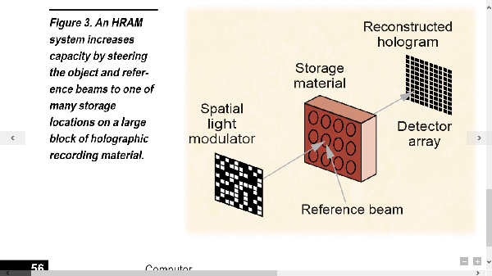

**Applications:**

The HRAM system is best matched to applications with high capacity and fast readout rate demands, yet with relatively infrequent changes to the stored data. Video-on-demand and Web servers fit well here: movie and Web content change infrequently, yet multiple users are continuously accessing enormous amounts of content in a fairly random order.

An alternative method for reaching 1 Tbit in storage capacity is a jukebox-type apparatus. Blocks of material, each containing 1 Gbit or more, are brought into position in front of the reference beam optics for readout. The access time to a hologram is either 1 millisecond if the hologram is in the current material block, or several seconds if it is in a separate block. This can be reduced somewhat by having several readout stations. A principal advantage of increasing the capacity in this way is in the cost per megabyte of storage. For a one-block HRAM system, the cost is dominated by the components: camera, SLM, laser, beam steerers, and optics. The advantages provided by the lack of moving parts are probably enough to support this cost per megabyte only for military applications. For the commercial market, however, the cost per megabyte drops rapidly as more blocks are used, until the cost of the material becomes dominant.

**2) Compact modular holographic memory:**

One drawback in the HRAM system is that the number of rapidly accessible locations is limited by the beam-steering optics. Rather than bring the beams to the storage material, another approach is to bring the pixel arrays for data input and output to the storage material. In fact, by applying a unique feature of the stored holograms, the same pixel array can be used for both input and output. Upon readout, instead of bringing back the same reference beam used during recording, its “phase conjugate” is directed to the storage location. This new readout beam reconstructs the phase conjugate of the signal beam, which returns along the original signal path back to the SLM. Because of this, a phase conjugate signal beam allows the use of a cheap imaging lens, or even no lens at all. If each pixel of the SLM is not only a light modulator but also a detector, then the entire storage device can be fabricated from identical compact modules with no moving parts. One such module is shown in Figure 4. With several modules, the memory resembles a board of DRAM, with holography increasing the amount of data stored per RAM chip.

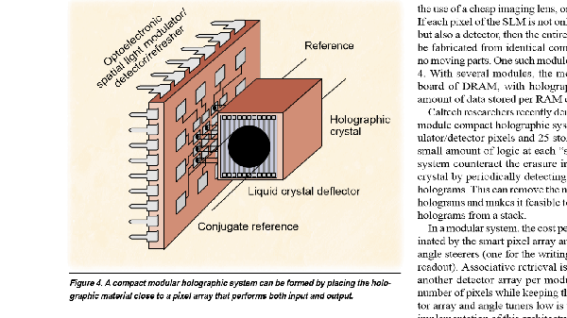

In a modular system, the cost per megabyte is dominated by the smart pixel array and the two compact angle steerers (one for the writing beam, one for the readout). Associative retrieval is possible, but adds another detector array per module. Increasing the number of pixels while keeping the cost of the detector array and angle tuners low is the key to practical implementation of this architecture.

**3) Holographic 3D disks**

A third approach to spatial multiplexing leaves the optics and components stationary and moves the storage material. The simplest method to do this employs a disk conﬁguration. The disk is constructed with a thick layer (approximately 1 mm) of the holographic material. Multiple holograms can be stored at each location on the disk surface. These locations are arranged along radial tracks, with the motion of the head selecting a track, and the disk rotation providing access along each track. As the medium thickness increases, the number of holograms that can be stored increases (and therefore the surface density goes up). However, the surface area that is illuminated also increases (and therefore the surface density goes down). Typically, it would be desirable to fabricate disks of 1-mm thickness, yielding a density of approximately 100 bits per squared micron. Even though the data is still stored in 3D, in the disk conﬁguration the surface density, not the volume density, is what matters for most practical purposes.

Angle multiplexing can be used to multiplex holograms on the holographic disk in a manner similar to the HRAM architecture. However, the angle scanner would make the readout head too large and heavy for rapid access to holograms on different radial tracks. A single, simple reference beam that could attain the same density without a bulky beam deﬂector would be more convenient. This can be done by making the reference beam a spherical or converging beam.

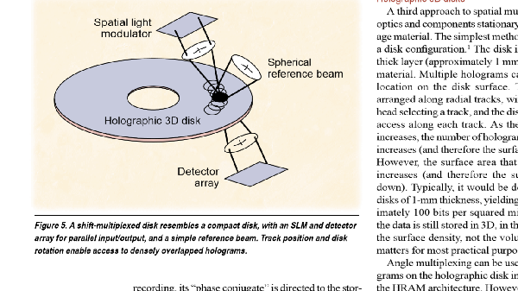

Holographic disks can be configured as either a WORM or a ROM system. A WORM system incorporates an SLM, turning the read head into a read- write head. The recording procedure is complicated by the chemical reactions in the photopolymers that are the recording material for the 3D disk. These reactions are not driven by light so much as triggered by it. Once begun (within an illuminated region), the reaction continues after the optical exposure stops. Because each hologram position in a shift-multiplexed WORM disk overlaps many others, the entire disk has to be recorded without stopping in order to reach the maximum capacity.

ROM applications, where the user buys a written disk (movies, audio, a computer game) and owns a simple read-only unit, may be best suited for the shift- multiplexed disk. The ROM system requires a master disk that is very similar to the WORM disk. Since the mastering device is not sold to users, it can be a large, expensive apparatus. The master disk is copied by bringing a blank disk in contact with the master and illuminating the two disks together.

**CONCLUSION**

Holographic storage is a promising candidate for next-generation storage. Recent research has demonstrated that holographic storage systems with desirable properties can be engineered. The next step is to build these systems at costs competitive with those of existing technologies and to optimize the storage media. If suitable recording materials become available from the research efforts currently under way, we envision a significant role for holographic storage.

**REFERENCES**

<http://en.wikipedia.org/wiki/Holographic_data_storage>

<http://www.slideshare.net/likanpatra/holographic-data-storage-25637770>

<http://en.wikipedia.org/wiki/Holography>