Assignment#7

Q1. Design the below given form using Java Swing to accept user-id and password and check for authentic user (Use JDBC). Also impose the restriction of at least 8 characters in password field and the password field should contain one numeric and one special character.

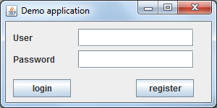

Q2. Create a Swing form to enter the guest details who visits the LNMIIT guest house. The following details may be expected from the guest at the time of check-in: Name, address, id-proof code, mobile number, purpose of visit along with check-in date and checkout date and room number. The check-in date should be automatically filled as the system date and should not be editable. Apply all validations such as name should contain only alphabets and mobile number should contain 10 digits.

The Swing form should also contain a button to view the details of any Guest on the basis of Name or Mobile number. If search is on the basis of “name” then the Swing form should have previous and next buttons to navigate backward and forward record.