PIZZA SALES SQL QUERIES
A. KPI’s
1. Total Revenue:
SELECT SUM(total_price) AS Total_Revenue FROM pizza_sales; 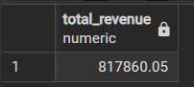
2. Average Order Value
SELECT (SUM(total_price)/ COUNT(DISTINCT order_id)) AS Average_Order_Value FROM pizza_sales;
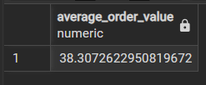
3. Total Pizzas Sold
SELECT SUM(quantity) AS Total_Pizzas_Sold FROM pizza_sales;

4. Total Orders
SELECT COUNT( DISTINCT order_id) AS Total_Orders FROM pizza_sales;

5. Average Pizzas Per Order
SELECT CAST(CAST(SUM(quantity) AS DECIMAL(10,2))/ CAST(COUNT( DISTINCT order_id) AS DECIMAL(10,2))AS DECIMAL (10,2))
AS Average_Pizzas_Per_Order FROM pizza_sales;
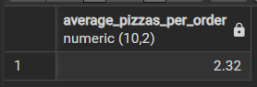

B. Daily Trend for Total Orders
SELECT
TO_CHAR(order_date, 'Day') AS order_day,
COUNT(DISTINCT order_id) AS total_orders
FROM pizza_sales
GROUP BY TO_CHAR(order_date, 'Day') ORDER BY TO_CHAR(order_date, 'Day');
Output:
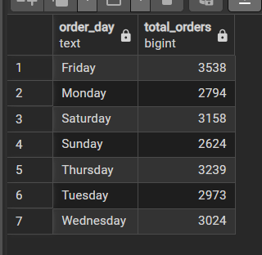

C. Hourly Trend for Orders
SELECT EXTRACT(HOUR FROM order_time) AS order_hours, COUNT(DISTINCT order_id) AS total_orders
FROM pizza_sales
GROUP BY EXTRACT(HOUR FROM order_time);
Output
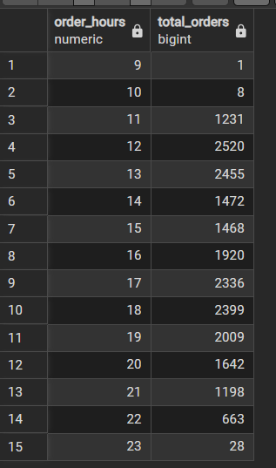
D. % of Sales by Pizza Category
SELECT pizza_category, SUM(total_price) AS Total_Revenue,
ROUND(100*SUM(total_price)/(SELECT SUM(total_price) FROM pizza_sales),2) AS Pecentage_of_total
FROM pizza_sales
GROUP BY pizza_category;
Output
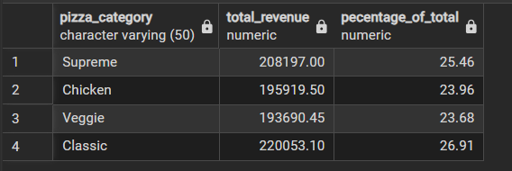
E. % of Sales by Pizza Size
SELECT pizza_size, SUM(total_price) AS Total_Revenue , ROUND(100*SUM(total_price)/( SELECT SUM(total_price) FROM pizza_sales),2) AS Pecentage_of_total
FROM pizza_sales
GROUP BY pizza_size
ORDER BY Pecentage_of_total DESC;
Output
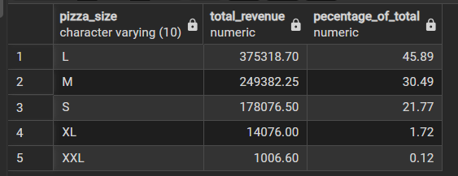

F. Total Pizzas Sold by Pizza Category
SELECT pizza_category, SUM(quantity) AS pizzas_sold, ROUND(100*SUM(quantity)/ (SELECT SUM(quantity) FROM pizza_sales),2) AS Pecentage_of_total
FROM pizza_sales GROUP BY pizza_category;
Output
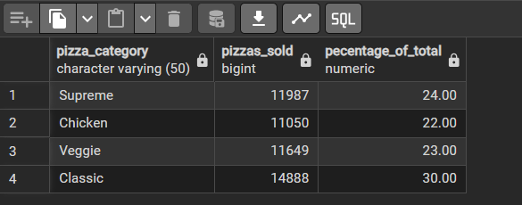
G. Top 5 Best Sellers by Total Pizzas Sold
SELECT pizza_name, SUM(quantity) AS Total_Pizzas_Sold FROM pizza_sales
GROUP BY pizza_name
ORDER BY COUNT(quantity) DESC LIMIT 5;
Output
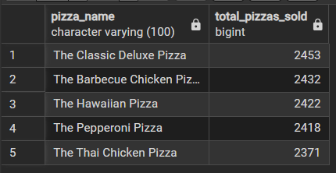

H. Bottom 5 Best Sellers by Total Pizzas Sold
SELECT pizza_name, SUM(quantity) AS Total_Pizzas_Sold FROM pizza_sales
GROUP BY pizza_name
ORDER BY COUNT(quantity) ASC LIMIT 5;
Output
