
VEHICLE RENTAL SYSTEM
Database Management System Project Report
Implementation Phase: Design, Database and Java Desktop Application
Submitted by
Arush Chaudhary - 25BCE0754
Prachurjya P. Kalita - 25BCE2337
Sangram Umesh Waghade - 25BCE0737
Submitted to: Dr. Pooja Chaudhary
Course: Database Management Systems (DBMS)
Academic Year: 2026–2027
Abstract
The Vehicle Rental System is a database application for renting cars, bikes and scooters. Customer, employee, vehicle, category, pricing, booking and payment data are stored in a MySQL database, and a Java Swing desktop application connected through JDBC gives customers and employees their own interfaces. The central rule is that a vehicle can never have two overlapping active bookings; it is enforced inside MySQL by triggers that lock the vehicle row, so it holds even under concurrent requests.
Keywords: DBMS, MySQL, JDBC, Java Swing, ER Diagram, Normalisation, Triggers, Transactions, Referential Integrity.

1. INTRODUCTION

1.1 Problem Statement
A rental business handles many vehicles, customers, rental periods and prices. Without a central database it is hard to know which vehicles are free, to spot conflicting reservations and to calculate charges consistently. The key problem is preventing the same vehicle from being booked by two customers for overlapping periods, even when both request it at the same moment, while keeping what customers may do separate from what staff may do.

1.2 Objectives
- Design a relational database normalised to Third Normal Form (3NF).
- Prevent overlapping active bookings for the same vehicle, including under concurrent requests.
- Calculate charges from category- and duration-based pricing rules and keep payment and refund records.
- Build a Java desktop application over JDBC with secure, role-based access for customers and employees.
- Record every SQL statement executed by the application in a query log.

1.3 Scope and Roles
Customers sign up, search available vehicles, request bookings, pay after an employee confirms, and cancel before pick-up. Employees (Manager or Rental Operator) confirm, add, update, cancel and delete bookings (CRUD), view payments, add vehicles or mark them under maintenance, see a dashboard of monthly sales by vehicle type, the query log and an interactive ER diagram. Only a Manager can add staff. A real payment gateway, GPS tracking and insurance claims are outside the scope.

2. REQUIREMENT ANALYSIS

2.1 Functional Requirements
ID | Requirement | Description
FR-01 | Registration and login | Customers sign up; customers and employees log in with salted SHA-256 password hashes.
FR-02 | Role-based access | Separate screens for customers and employees; only managers manage staff.
FR-03 | Fleet and pricing | Add and edit vehicles, set status, keep daily rates and discounts by category and duration.
FR-04 | Availability search | List vehicles free for a period, filtered by type, fuel and transmission.
FR-05 | Booking (CRUD) | Customers request (Pending); employees create, confirm, update, complete, cancel, delete.
FR-06 | Conflict prevention | No overlapping non-cancelled bookings for the same vehicle.
FR-07 | Payments | Pay only after confirmation; refunds recorded automatically on cancellation.
FR-08 | Dashboard, log, ER viewer | Monthly sales by vehicle type, query log of every SQL statement, live ER diagram.

2.2 Key Business Rules
- Pending, Confirmed and Completed bookings block a vehicle; Cancelled bookings do not.
- A vehicle under maintenance or retired cannot be booked.
- The agreed rate, discount and total are stored with the booking, so later price changes never alter old bills.
- Successful payments may never exceed the booking total; bookings with payments are cancelled, never deleted.

2.3 Overlap Rule and Pricing
Rental periods are half-open intervals [StartDate, EndDate): a rental ending on 15 November leaves the vehicle free on 15 November. A new booking overlaps an existing one if:
ExistingStart < NewEnd AND ExistingEnd > NewStart
TotalAmount = Duration × AgreedDailyRate × (1 − DiscountPercent / 100)
Example: a car for 4 days falls in the 3–6 day tier, so 4 × ₹1,300 × 0.95 = ₹4,940.

2.4 Booking Life Cycle
Status | Set by | Meaning | Next allowed status
Pending | Customer (request) or employee | Requested; the vehicle is held for these dates | Confirmed, Cancelled
Confirmed | Employee | Approved; the customer can now pay | Completed, Cancelled
Completed | Employee | Vehicle returned | —
Cancelled | Customer (before pick-up) or employee | No longer blocks the vehicle; any payment is refunded | —

3. ER DIAGRAM DESIGN
The ER model uses Chen notation: rectangles for entities, ellipses for attributes (keys underlined) and diamonds for relationships. Compared with the analysis phase it adds the Employee entity, the HANDLES relationship and the password and vehicle-detail attributes.
Entity | Key attributes | Purpose
Customer | CustomerID, Email, Phone, DrivingLicenceNo, password salt and hash | Customer identity, contact details and online login
Employee | EmployeeID, Email, Designation, password salt and hash | Staff: Manager or Rental Operator
VehicleCategory | CategoryID, CategoryName | Car, Bike, Scooter
Vehicle | VehicleID, RegistrationNo, Make, Model, OperationalStatus, BodyType, FuelType | A rentable vehicle
PricingRule | PricingRuleID, MinDays, MaxDays, DailyRate, DiscountPercent, EffectiveFrom | Rates by category, duration and date
Booking | BookingID, StartDate, EndDate, BookingStatus, AgreedDailyRate, TotalAmount | The rental with its agreed price
Payment | PaymentID, Amount, PaymentMethod, PaymentStatus, TransactionRef | Payments and refunds of a booking

Relationship | Entities | Cardinality | Meaning
MAKES | Customer — Booking | 1 : N | A customer can make many bookings.
ASSIGNED TO | Booking — Vehicle | N : 1 | A vehicle has many bookings over time, without overlaps.
HAS | Booking — Payment | 1 : N | A booking can have several payments and refunds.
CLASSIFIES | VehicleCategory — Vehicle | 1 : N | Each vehicle belongs to one category.
DEFINES RATE | VehicleCategory — PricingRule | 1 : N | A category has several pricing tiers.
APPLIES TO | PricingRule — Booking | 1 : N | A rule is applied to many bookings.
HANDLES | Employee — Booking | 1 : N | An employee handles many bookings (partial: a pending booking has none).
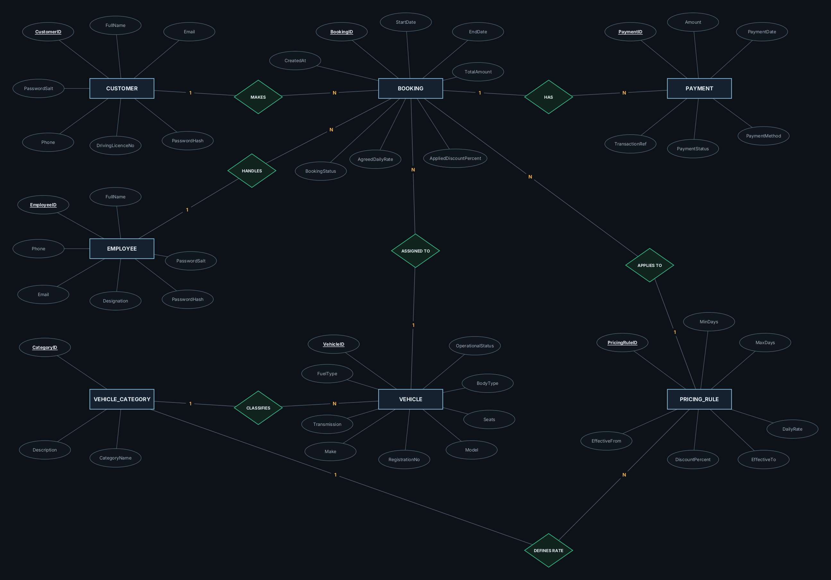
Figure 3.1: ER diagram of the Vehicle Rental System (Chen notation)

4. RELATIONAL MODEL
Each entity becomes a table, and every one-to-many relationship is mapped by placing the foreign key on the “many” side. QUERY_LOG is added for auditing.
Relation | Attributes (PK underlined in the diagram; FK marked)
CUSTOMER | CustomerID (PK), FullName, Email, Phone, DrivingLicenceNo, PasswordSalt, PasswordHash
EMPLOYEE | EmployeeID (PK), FullName, Email, Phone, Designation, PasswordSalt, PasswordHash
VEHICLE_CATEGORY | CategoryID (PK), CategoryName, Description
VEHICLE | VehicleID (PK), RegistrationNo, Make, Model, CategoryID (FK), OperationalStatus, BodyType, FuelType, Transmission, Seats
PRICING_RULE | PricingRuleID (PK), CategoryID (FK), MinDays, MaxDays, DailyRate, DiscountPercent, EffectiveFrom, EffectiveTo
BOOKING | BookingID (PK), CustomerID (FK), VehicleID (FK), PricingRuleID (FK), HandledBy (FK), StartDate, EndDate, BookingStatus, AgreedDailyRate, AppliedDiscountPercent, TotalAmount, CreatedAt
PAYMENT | PaymentID (PK), BookingID (FK), Amount, PaymentDate, PaymentMethod, PaymentStatus, TransactionRef
QUERY_LOG | LogID (PK), ExecutedAt, UserRole, UserEmail, QueryType, SqlText, RowsAffected, DurationMs, Status, ErrorMessage
All seven foreign keys use ON UPDATE CASCADE and ON DELETE RESTRICT, so rental and payment history cannot disappear through cascading deletes; vehicles are retired and bookings cancelled instead.
Foreign key | References | On update | On delete
VEHICLE.CategoryID | VEHICLE_CATEGORY(CategoryID) | CASCADE | RESTRICT
PRICING_RULE.CategoryID | VEHICLE_CATEGORY(CategoryID) | CASCADE | RESTRICT
BOOKING.CustomerID | CUSTOMER(CustomerID) | CASCADE | RESTRICT
BOOKING.VehicleID | VEHICLE(VehicleID) | CASCADE | RESTRICT
BOOKING.PricingRuleID | PRICING_RULE(PricingRuleID) | CASCADE | RESTRICT
BOOKING.HandledBy | EMPLOYEE(EmployeeID) | CASCADE | RESTRICT
PAYMENT.BookingID | BOOKING(BookingID) | CASCADE | RESTRICT

5. NORMALISATION
The starting point (UNF) is a single rental record holding customer, vehicle, category and pricing details, with all payments packed into one field. Decomposition removes the repetition:
Normal form | Requirement | How it is met
1NF | Atomic values, no repeating groups | Each payment is stored as its own row in PAYMENT.
2NF | No partial dependency on a key | Every relation has a single-attribute primary key.
3NF | No transitive dependency | Customer, employee, vehicle, category and pricing data each live in their own relation.
AgreedDailyRate and AppliedDiscountPercent in BOOKING are kept on purpose: they record the price agreed at booking time and depend on BookingID, not on the current pricing rule. BodyType in VEHICLE implies the category; this is a documented trade-off, and the application only offers body types that match the category.

6. DATABASE IMPLEMENTATION
The script vehicle_rental_system.sql creates the database vehicle_rental_db (MySQL 8.0.16 or later) with eight InnoDB tables, two stored procedures, five triggers, indexes and the sample data. Rules within one row are CHECK and UNIQUE constraints; rules that compare rows are triggers:
Object | Type | What it enforces
sp_validate_booking, trg_booking_bi / _bu | Procedure + triggers | Locks the vehicle row (SELECT … FOR UPDATE); rejects overlaps, non-operational vehicles and pricing rules that do not match.
chk_booking_formula | CHECK | TotalAmount = ROUND(DATEDIFF(EndDate, StartDate) × AgreedDailyRate × (1 − AppliedDiscountPercent / 100), 2)
sp_validate_pricing_rule, trg_pricing_rule_bi / _bu | Procedure + triggers | Pricing tiers of one category never overlap in days and dates.
trg_payment_bi | Trigger | Successful payments never exceed the booking total.
uq_… and chk_… constraints | UNIQUE, CHECK | Unique e-mail, phone, licence, registration; valid dates, statuses, methods and values.
Because the trigger locks the vehicle row inside the same transaction, a second request for the same vehicle waits for the first to finish and is then rejected if it overlaps, with the message “Booking rejected: vehicle already booked for an overlapping period.” An index on (VehicleID, StartDate, EndDate) supports this check and the availability search.

6.1 Sample Data
Table | Rows | Contents
VEHICLE_CATEGORY / PRICING_RULE | 3 / 9 | Car, Bike, Scooter; three duration tiers each (0%, 5%, 10% discount)
VEHICLE | 53 | 8 body types; 50 available, 3 under maintenance
CUSTOMER / EMPLOYEE | 35 / 2 | Demo logins; one Manager and one Rental Operator
BOOKING | 90 | 38 Completed, 30 Confirmed, 11 Pending, 11 Cancelled
PAYMENT | 101 | 90 Success, 6 Failed, 3 Refunded, 2 Pending

6.2 Pricing Plan
Category | 1–2 days | 3–6 days (5% off) | 7+ days (10% off)
Car | ₹1,500 | ₹1,300 | ₹1,100
Bike | ₹600 | ₹500 | ₹400
Scooter | ₹450 | ₹380 | ₹300
All rules are effective from 1 January 2025 with no end date; the rates are illustrative values for testing.

7. SYSTEM IMPLEMENTATION
Layer | Technology | Role
User interface (vrs.ui) | Java Swing, Java2D | Customer and employee screens, dark / light theme; database work on a background thread
Services (vrs.service) | Java 17+ | Business rules: Auth, Booking, Payment, Vehicle, Stats, Employee
Database access (vrs.db) | JDBC, MySQL Connector/J | One Db helper: PreparedStatements, transactions, query log
Database | MySQL 9.7 | Constraints, triggers and procedures, the final authority on integrity
Transactions: booking requests, payments and cancellations (with refund) run with auto-commit off and are committed or rolled back as one unit. Security: only SHA-256(salt + password) is stored, every statement uses PreparedStatement, which prevents SQL injection, and employees cannot sign themselves up. Query log: every statement is saved with its bound values, user, rows, time and result on a separate connection, so entries survive a rollback.
Availability search: vehicles that are operational and have no overlapping non-cancelled booking, priced by the matching rule:
SELECT v.VehicleID, v.Make, v.Model, v.BodyType, r.PricingRuleID, r.DailyRate, r.DiscountPercent
FROM VEHICLE v JOIN PRICING_RULE r ON r.CategoryID = v.CategoryID
AND ? >= r.MinDays AND (r.MaxDays IS NULL OR ? <= r.MaxDays)
AND ? >= r.EffectiveFrom AND (r.EffectiveTo IS NULL OR ? <= r.EffectiveTo)
WHERE v.OperationalStatus = 'Available'
AND NOT EXISTS (SELECT 1 FROM BOOKING b
WHERE b.VehicleID = v.VehicleID AND b.BookingStatus <> 'Cancelled'
AND b.StartDate < ? AND b.EndDate > ?)
ORDER BY r.DailyRate;

Booking workflow: the customer requests (Pending, vehicle held) → an employee confirms (recorded as HandledBy) → the customer pays → the employee completes. The dashboard chart uses:
SELECT v.BodyType, COUNT(*) AS Rentals, SUM(b.TotalAmount) AS Revenue
FROM BOOKING b JOIN VEHICLE v ON v.VehicleID = b.VehicleID
WHERE b.BookingStatus IN ('Confirmed', 'Completed')
AND b.StartDate >= ? AND b.StartDate < ?
GROUP BY v.BodyType;

8. USER INTERFACE
The interface is styled after modern rental websites, with a drawn symbol for each vehicle type instead of photographs and a light / dark mode switch. Screenshots use the sample data.
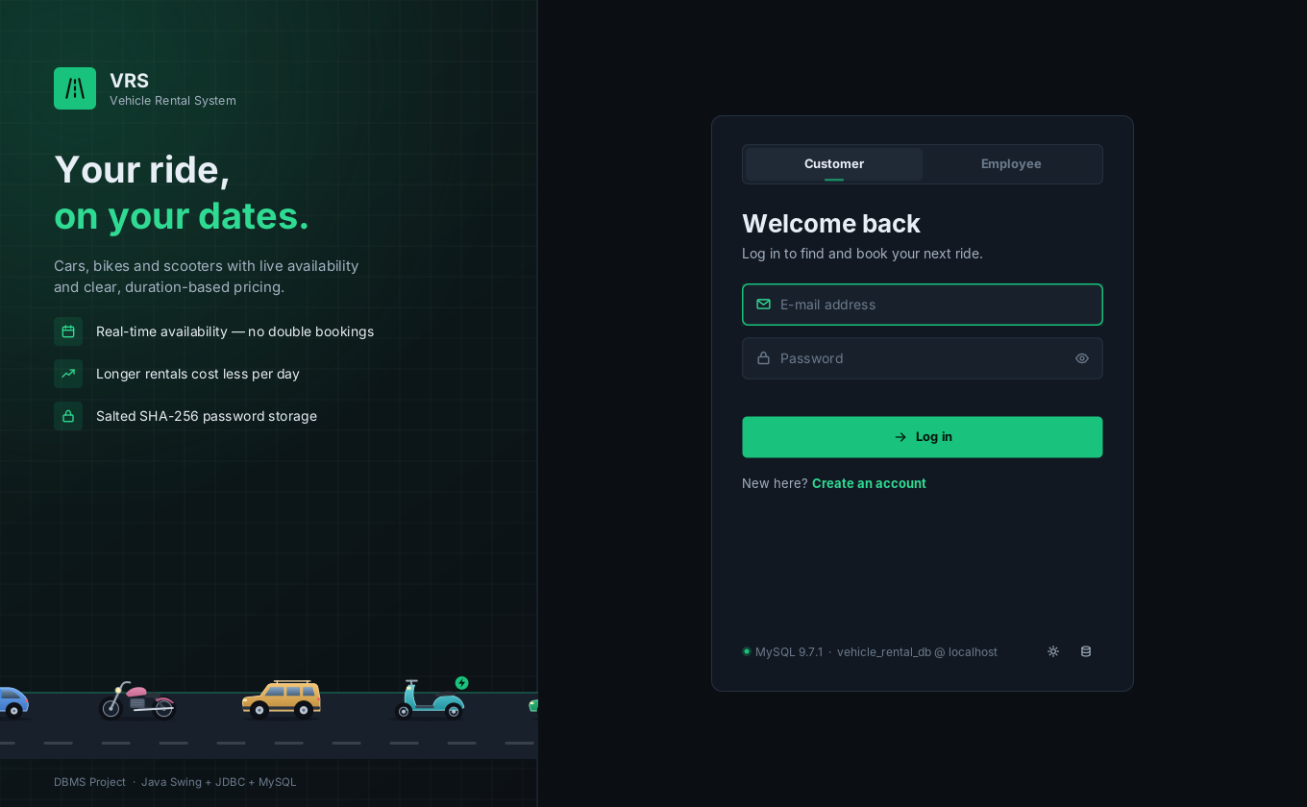  Figure 8.1: Login (customer / employee) | 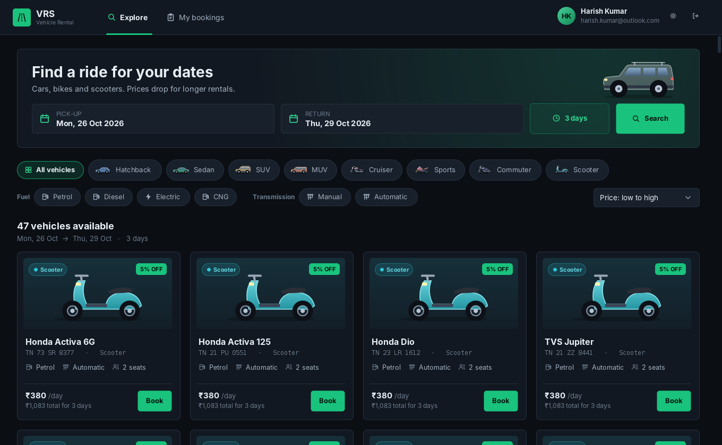  Figure 8.2: Customer – Explore
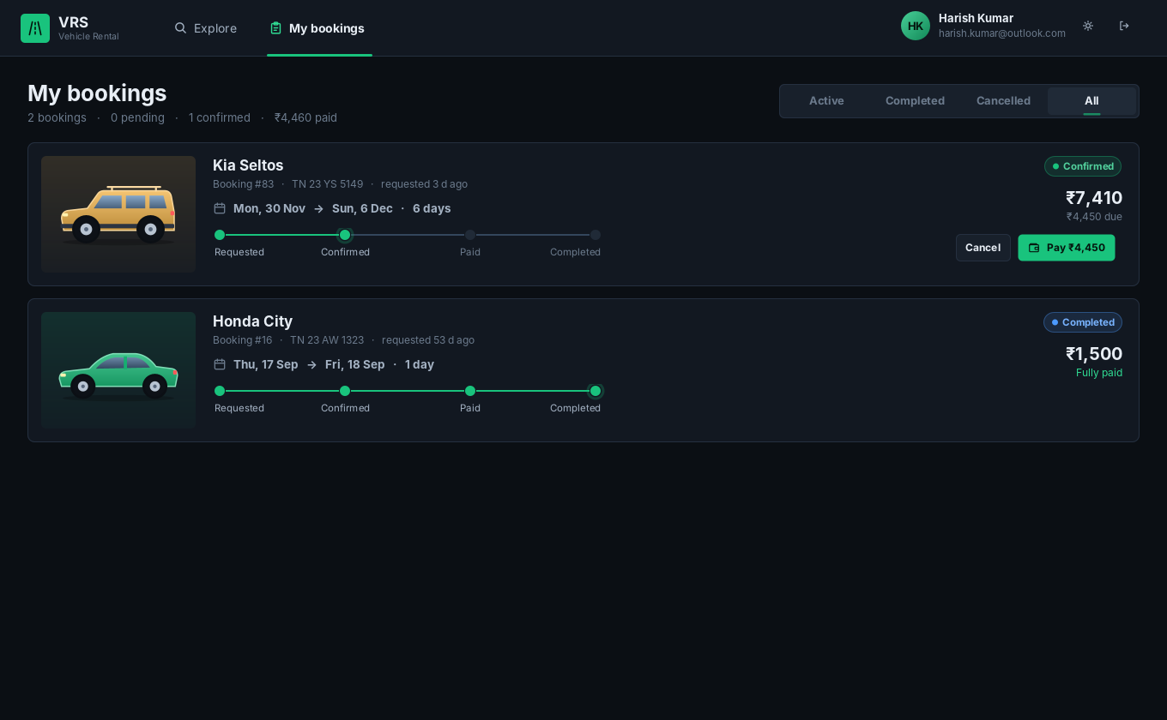  Figure 8.3: Customer – My bookings | 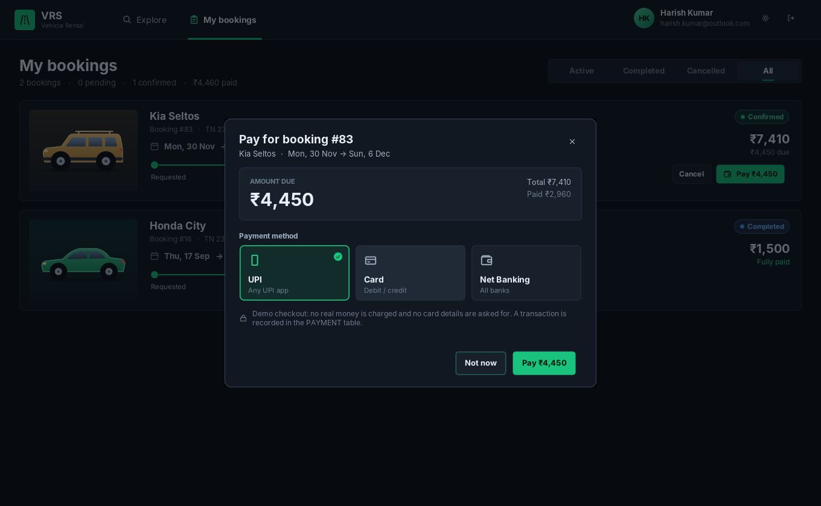  Figure 8.4: Payment after confirmation
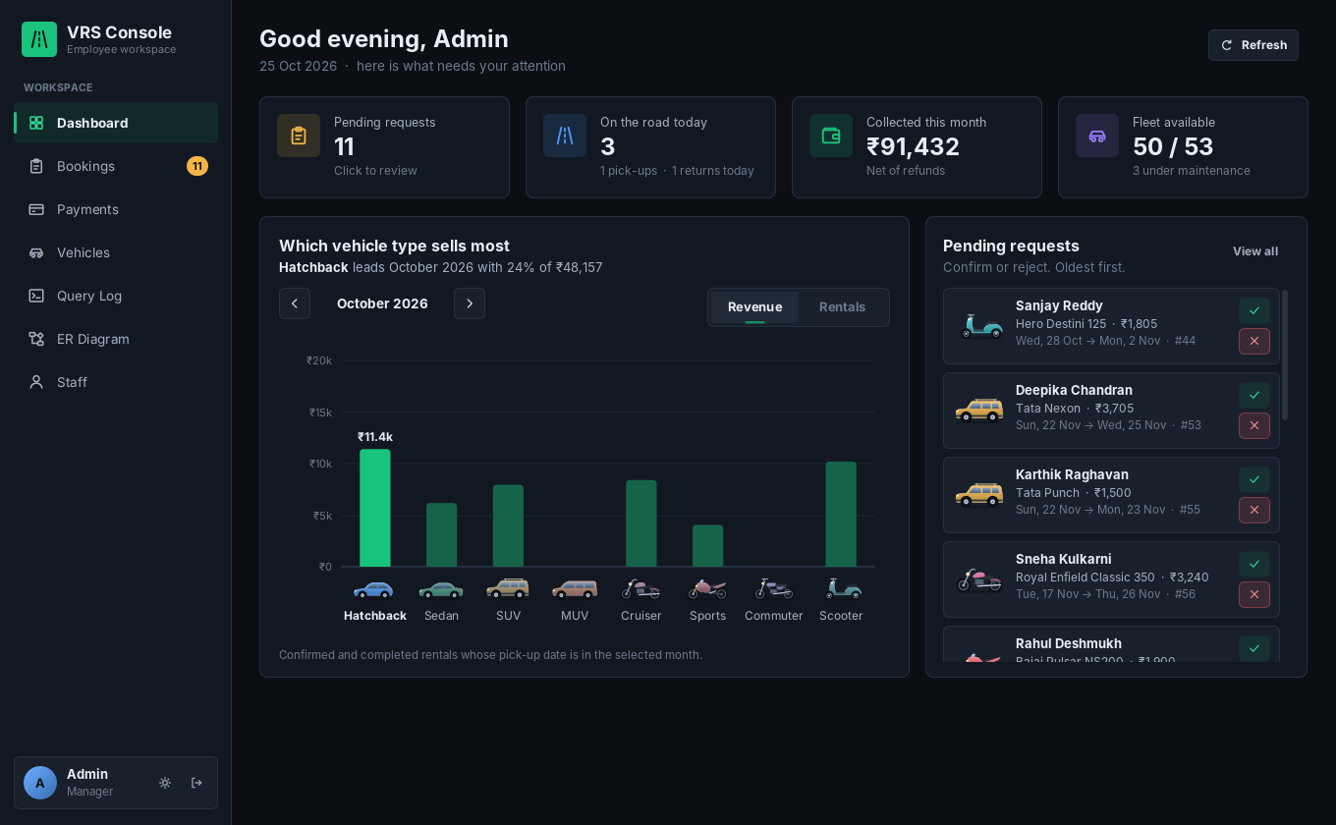  Figure 8.5: Employee – Dashboard | 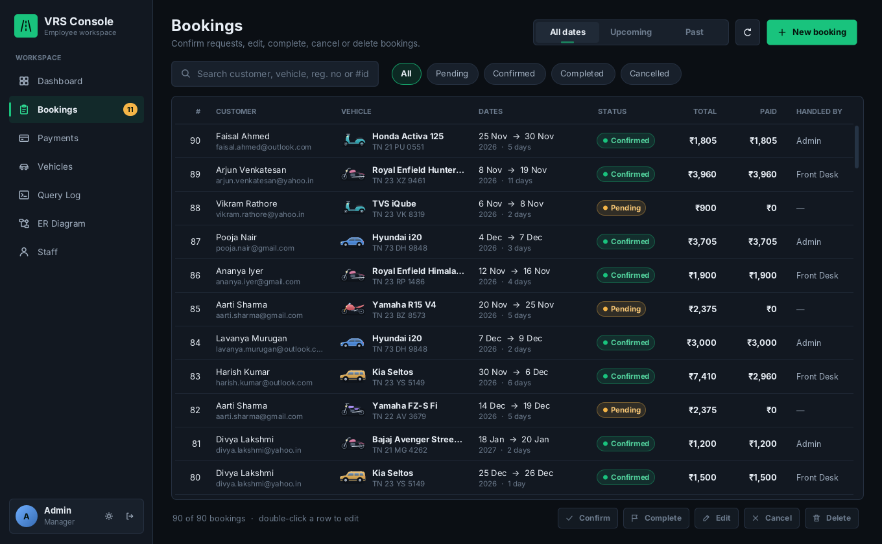  Figure 8.6: Employee – Bookings (CRUD)
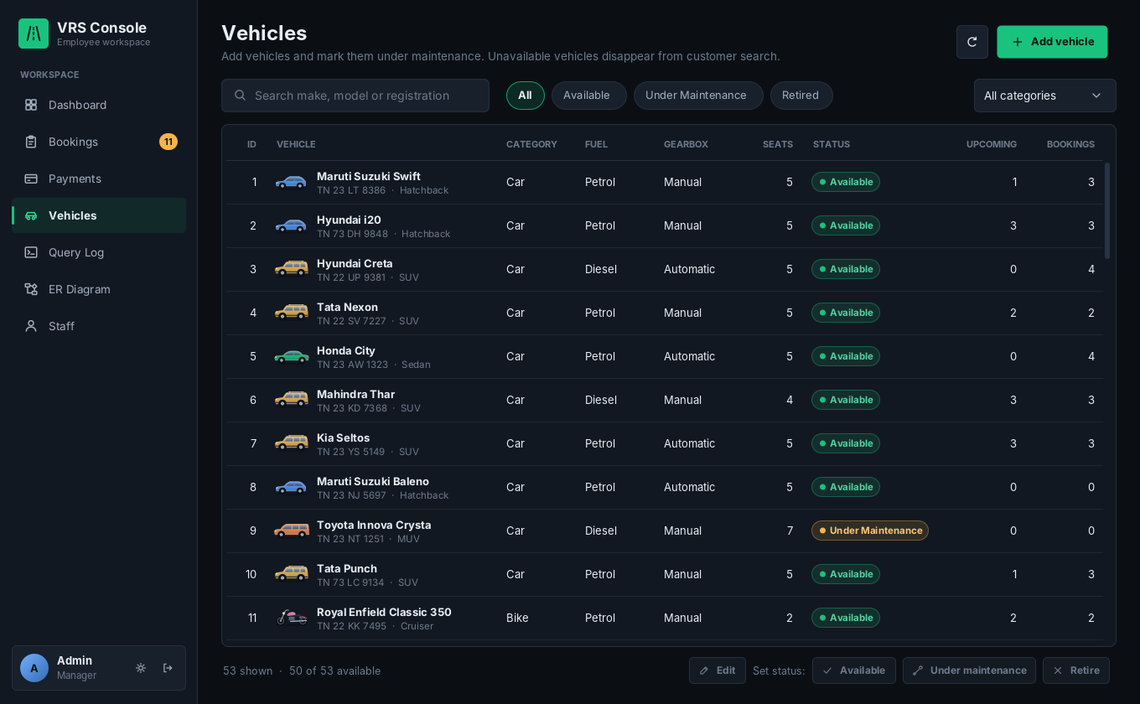  Figure 8.7: Vehicles and maintenance | 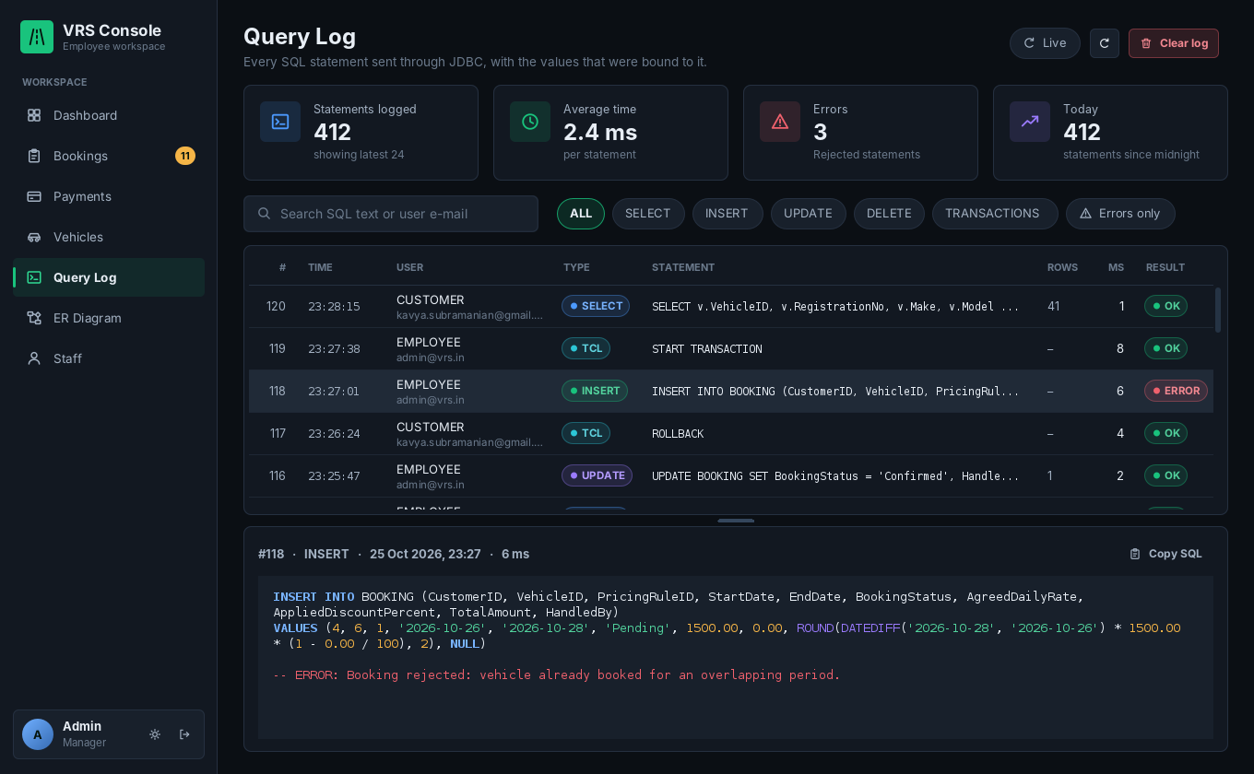  Figure 8.8: Query log
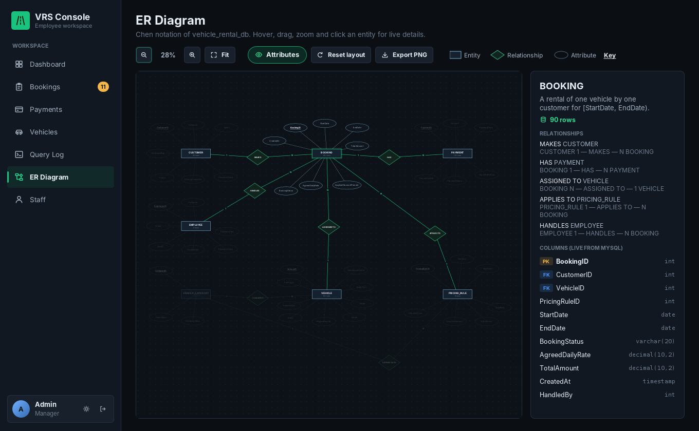  Figure 8.9: Interactive ER diagram | 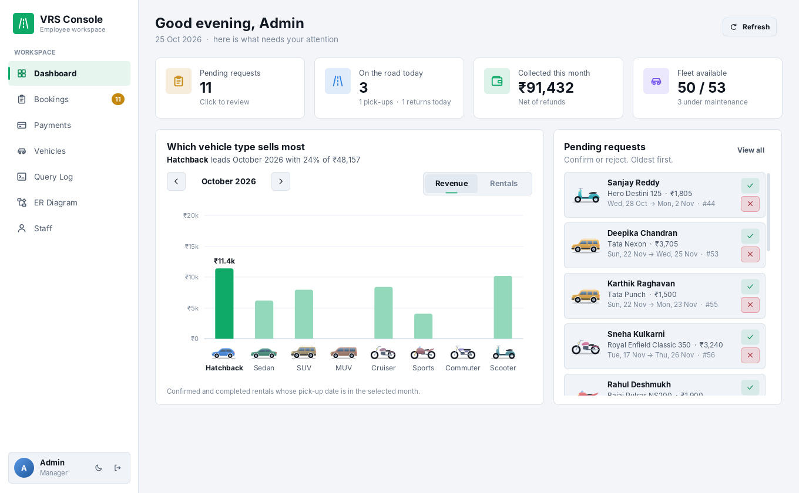  Figure 8.10: Light mode
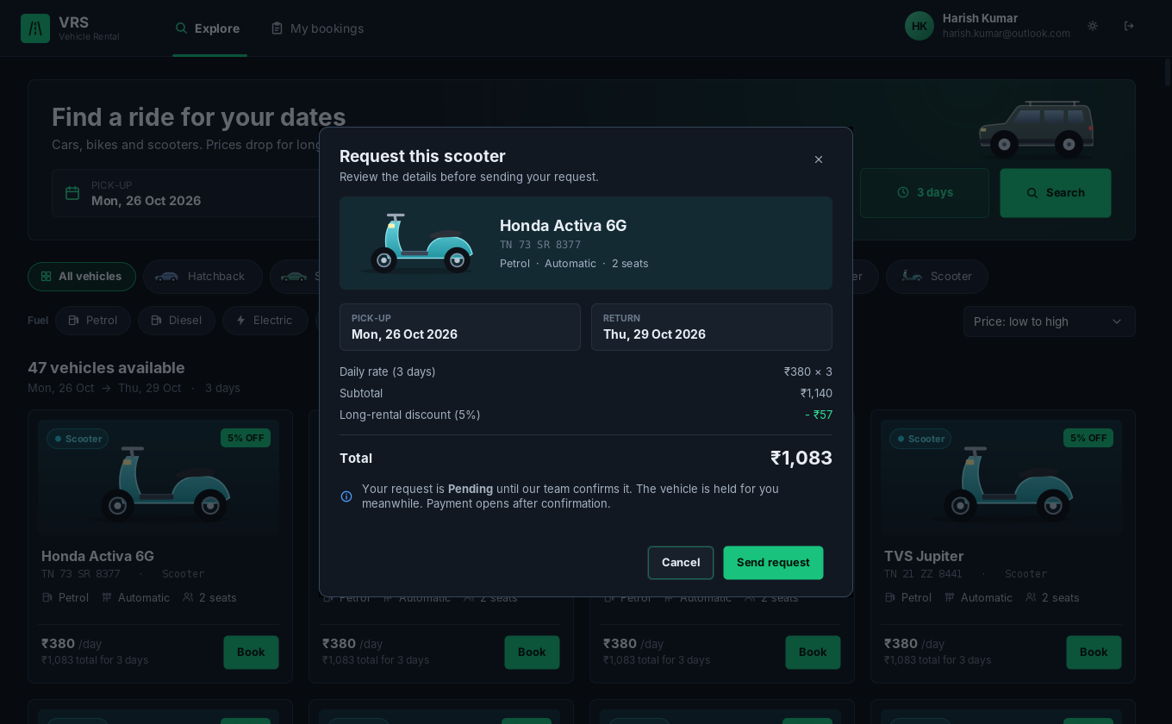  Figure 8.11: Booking request with price breakdown | 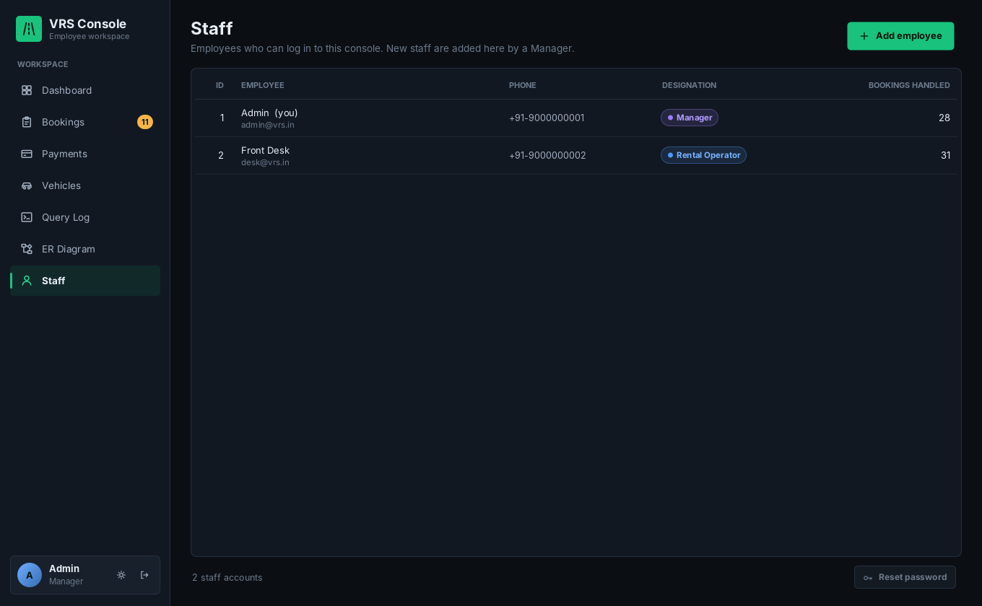  Figure 8.12: Staff management (Manager only)

9. TESTING
ID | Test | Expected result | Enforced by
TC-01 | Log in with a wrong password | “Wrong password” | AuthService
TC-02 | Rental Operator opens staff management | Page hidden; insert refused | EmployeeService
TC-03 | Book vehicle 6 for 25–27 Oct 2026 (held by #47) | Rejected: overlap | trg_booking_bi
TC-04 | Booking that starts on the day another ends | Accepted | Half-open interval
TC-05 | Two requests for one vehicle at the same time | One succeeds, one rejected | FOR UPDATE lock
TC-06 | Book a vehicle under maintenance | Rejected | sp_validate_booking
TC-07 | 4-day car booking | ₹4,940 | chk_booking_formula
TC-08 | Customer pays a Pending booking | Refused until confirmed | PaymentService
TC-09 | Payments above the booking total | Rejected | trg_payment_bi
TC-10 | Delete a booking that has payments | Refused; cancel instead | FK RESTRICT
TC-11 | Sign up with an e-mail that already exists | “Already registered” | uq_customer_email
TC-12 | Return date not after pick-up date | Rejected | chk_booking_dates
TC-13 | Cancel a paid booking | Cancelled; Refunded row added; vehicle free | BookingService transaction
TC-14 | Add a pricing rule overlapping an existing tier | Rejected | trg_pricing_rule_bi
TC-15 | Any action in the application | Statement, values, time and result in the log | Db + QueryLogger

10. CONCLUSION AND FUTURE WORK
The project delivers a working database application: seven entities and seven relationships map to eight normalised tables, and integrity is enforced in layers, with constraints for single rows, triggers and procedures across rows, and transactions with row locking for concurrent bookings. The Java Swing application gives customers and employees separate interfaces, and the query log and ER viewer make the database work visible.
Future work: a real payment gateway with e-mail / SMS alerts, pick-up locations, late fees and damage records, ratings and reviews, and a web or mobile client on the same database.

Important Design Decisions
- Half-open rental intervals allow back-to-back rentals without ambiguity.
- Pending requests block the vehicle, so two customers can never be promised the same dates.
- Conflicts are checked in the database with triggers and row locking, not only in the application.
- Payment only after confirmation, and bookings with payments are cancelled with a refund record rather than deleted.
- Employees cannot self-register; only a Manager creates staff accounts.
- QUERY_LOG has no foreign keys and is written on a separate connection, so the audit trail survives rollbacks.

References
- Elmasri, R., and Navathe, S. B. Fundamentals of Database Systems, 7th ed. Pearson, 2016.
- Silberschatz, A., Korth, H. F., and Sudarshan, S. Database System Concepts, 7th ed. McGraw Hill, 2019.
- Oracle. MySQL Reference Manual and Connector/J Developer Guide. https://dev.mysql.com/doc/

Running the Application
Import sql/vehicle_rental_system.sql into MySQL, open the project in IntelliJ IDEA with the Connector/J jar added as a library, run Main.java and enter the MySQL password once. Demo accounts:
Role | E-mail | Password
Employee (Manager) | admin@vrs.in | Admin@123
Employee (Rental Operator) | desk@vrs.in | Staff@123
Customer | any sample customer, e.g. kavya.subramanian@gmail.com | Password@123

