Abstract

Performance evaluation of Terapixel rendering
Cloud Computing

The objective of this report is to analyse performance of Terapixel rendering in super computers. The dataset was created from application checkpoint and system metric output from the production of a terapixel image.
For this project, Jupyter notebook was used for carrying out the data analysis and for creating graphical and numerical summaries. The following questions were answered during this analysis:
- Which Event takes the most time for completion?
- Any relation between GPU metrics like temperature, power drawn, GPU utilization etc.
- GPUs that draw most power
- GPUs that show highest temperature rise for different events
- Event and their average drawn power.
- GPU temperature Vs. drawn power by different events.

The following are the highlights of the analysis:
Render takes longest time to complete, it also draws the most power. GPUs that drew most power were identified and further analysis on their temperature was done.
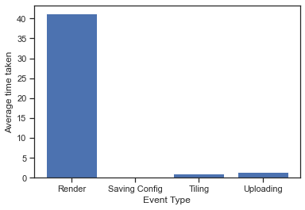
Fig1. Average completion time of different events
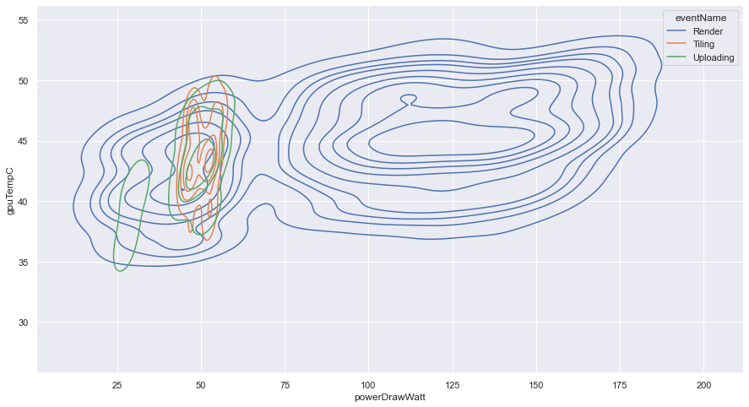
Fig2. Power Drawn Vs. Temperature during Events

Hence, the event Render needs to be optimised for time and used power. The GPUs that draw most power and recorded higher temperatures require maintenance or replacement if possible.

