Problem: Time Comparison of Iterative vs. Recursive Factorial

Objective
To implement factorial calculation using both the Iterative and Recursive methods, and to compare their execution time in C for N = 15, repeated over 1,000,000 runs.

Code
#include <stdio.h>
#include <time.h>

long long iterativeFactorial(int n) {
long long result = 1;
for (int i = 2; i <= n; i++) {
result *= i;
}
return result;
}

long long recursiveFactorial(int n) {
if (n <= 1) {
return 1;
}
return n * recursiveFactorial(n - 1);
}

int main() {
int n = 15;
int iterations = 1000000;
long long result;
clock_t start, end;

start = clock();
for (int i = 0; i < iterations; i++) {
result = iterativeFactorial(n);
}
end = clock();
double t_iterative = (double)(end - start) / CLOCKS_PER_SEC;

printf("Iterative Factorial(%d) = %lld\n", n, result);
printf("Iterative Time: %.6f seconds\n\n", t_iterative);

start = clock();
for (int i = 0; i < iterations; i++) {
result = recursiveFactorial(n);
}
end = clock();
double t_recursive = (double)(end - start) / CLOCKS_PER_SEC;

printf("Recursive Factorial(%d) = %lld\n", n, result);
printf("Recursive Time: %.6f seconds\n", t_recursive);

return 0;
}

Output
PS C:\Users\Arushi\Desktop\c language> ./factorial
Iterative Factorial(15) = 1307674368000
Iterative Time: 0.022814 seconds

Recursive Factorial(15) = 1307674368000
Recursive Time: 0.039251 seconds
PS C:\Users\Arushi\Desktop\c language>

Time Comparison: Iterative vs. Recursive Factorial
Metric. Iterative (for / while loop) Recursive (Function calling itself)
Time Complexity (Big-O) O(n) O(n)
Number of Operations n multiplications. n multiplications + n function calls
Space Complexity. O(1) (Constant memory) O(n) (Call stack memory)
Practical Execution Speed. Faster Slower

Time Comparison Chart
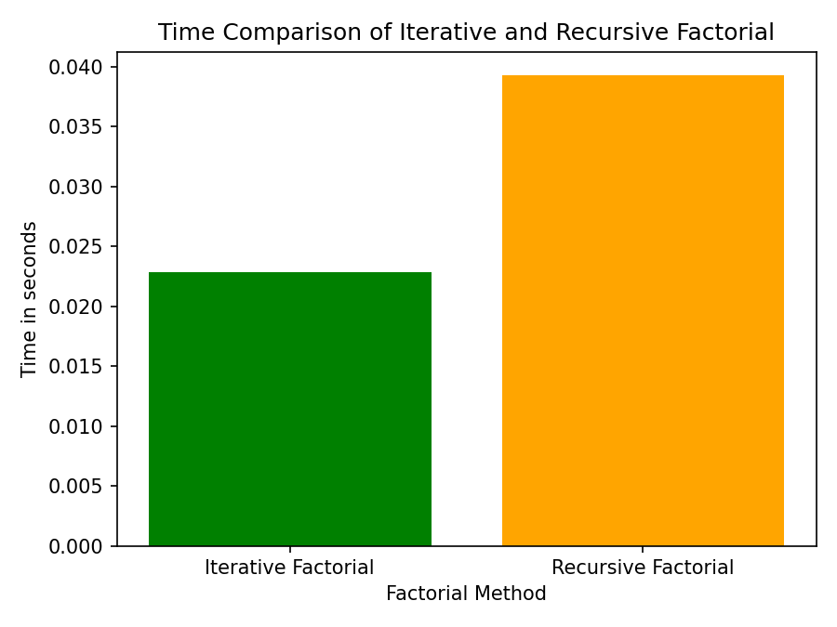

Conclusion
For small to moderate values of N, both methods produce identical results, but the iterative method is consistently faster because it avoids the overhead of repeated function calls. The recursive method, while cleaner and closer to the mathematical definition of factorial, incurs extra time and stack space for each call and risks stack overflow for very large N. In practice, the iterative approach is preferred for performance-critical or large-N scenarios, while recursion is favored for readability and simplicity in smaller problems.

