Screen Attack Detection for Biometric PAD
Technical report
Arushi Agrawal | September 2026

Summary
The task was a detector that scores a single face image for whether it was photographed off a screen, to be graded on images we have not seen. The data was 1000 bona fide images and 23 attacks. Most of the work went into understanding what those 23 images could teach a model, and what they could teach it by mistake.
What the data turned out to be. Every attack has a bona fide twin with the same filename: each attack is a phone photo of a Mac screen showing one specific bona fide image, all taken in one 24-minute session with two phones. The bona fide images are an aligned public face set with no camera metadata, so here "bona fide" means an original file, not a live person in front of a camera. Image size, file size, and metadata separated the two classes perfectly; they never reach the model. Zooming into the attacks at full resolution shows the screen's pixel grid as a fine weave over the face. In the Fourier spectrum that weave becomes a regular pattern of bright dots, which real photos never have. But the grid is only visible in the handful of attacks photographed close enough; from further back it averages away and the image looks real. The attacks also have about 2.5 times more pixels per face than the bona fide images. A model can score perfectly on that difference without learning anything about screens.
What was built. First a classical baseline: six hand-crafted features, one for each physical cue the literature uses (blur, texture, colour, fine energy, moire, reflection), into a logistic regression. It reached AUC 0.80, and fell to chance when trained on one phone and tested on the other. Then a small neural network that scores 36 small squares cut from the face at the image's own resolution and averages the answers. It scored a perfect AUC 1.00 straight away, which was treated as a warning. Three tests followed. Shrinking the attacks down to the bona fide pixel count at test time dropped it to 0.88, so part of the score was the pixel-count difference. Resizing every face to the same size before training removed that difference and still gave 0.96, but that model failed across phones: with the grid shrunk away, what was left to learn were colour and noise habits of each camera. The fix was to keep full resolution but, during training, randomly shrink each square by up to two thirds, so the network sees attacks at bona fide pixel density often enough that the pixel count stops being a tell. That model keeps AUC 1.00, holds 0.95 when attacks are shrunk, and transfers across phones at 0.99 and 1.00. With both handicaps at once, an unseen phone and shrunk attacks, it holds 0.75 and 0.91 while the alternatives fall to a coin flip. It is the one shipped.
What it looks at, and where it fails. Removing colour from an image does not change its score, so the model is not using colour; it detects the fine screen texture the camera managed to resolve. It misses attacks taken from far enough away that no texture was captured. It over-flags real faces under harsh lighting or with fabric textures near the face. A fifth of the data was locked away before any model was trained and scored once at the end; it agreed with everything above, and showed that the stricter the threshold, the closer it sits to the weakest attacks.
Recommendation. Use a threshold of 0.43. It flags about one real user in twenty and passed no attack on any held-out data. The detector runs at 0.35 to 1.1 seconds per image on a laptop CPU. The biggest untested risk is bona fide images captured live through a phone, which this dataset cannot represent. The first thing to do with more time is to characterise the cues the attacks carry and generate more attacks from those cues, then collect live bona fide captures through the same cameras.

1. How the problem was set up
Given problem statement. Build a small PAD prototype that reads face images and outputs an attack score per image. The solution may be tested on a hidden set of images. Inference should be easy to build and run. Framing, method, and trade-offs are ours to choose and justify.
What that fixes. Single still images, so no blink, motion, or pulse cues. A continuous score rather than a label, so the threshold is the deployer's decision and the model is judged on how well it orders images. A prototype, so a clean and explainable pipeline beats a fragile high score. A hidden test set, so transfer to unseen images is the graded quantity.
Assumptions I made.
- The attack type is screen replay only. Print attacks, masks, and any other instrument are out of scope, and the model's score on them is undefined.
- The hidden set contains the same attack type under different cameras, distances, and subjects. Every later choice about splits, augmentation, and validation is built for that case.
- "Bona fide" in this dataset means an original digital file, because that is what it contains. If the hidden set has real users captured live through a phone, this assumption fails. It is the largest stated risk.
- A missed attack is worse than a wrongly flagged real user. A flagged user can retry; a passed attacker is a security breach. The operating point is therefore chosen by capping friction and then minimising attacks passed, not the other way round.
- This is treated as a security problem throughout: a shortcut in the data is not a nuisance but an attack surface, and every test asks what an adversary could exploit, not only what the average error is.
- Latency is not a constraint for the prototype. Time per image is measured and reported, but nothing was traded for speed.
- Each image contains one frontal face large enough to detect. Anything else falls back to a centre crop, is scored anyway, and is marked face-found false in the output.
- The capture protocol is not ours to change. The model has to cope with whatever resolution, distance, and lighting the image arrives with. In a real deployment, minimum face size and lighting gates would reject many of the hard cases before scoring.
- Score direction is 0 to 1, higher means attack. Written down because a flipped convention is the commonest PAD handover bug.
Metrics. APCER is the fraction of attacks accepted; BPCER is the fraction of real users rejected. Each is divided by its own class, so neither depends on how many attacks the test set happens to contain. The headline is APCER at a fixed BPCER of 5 percent, because that matches how a deployer thinks: cap the friction, then ask how secure that leaves you. AUC is used to compare models. EER is reported because reviewers expect it. Every number carries a bootstrap interval, because with 19 development attacks one attack is 5 percent and a single value would look more precise than it is.

2. What the data taught us
Before any model, the 1023 files were inspected one property at a time. Each finding changed a decision, and the decision is stated with it.
Finding 1: every attack is a re-capture of a specific bona fide image. All 23 attack filenames also exist in the bona fide folder, with different bytes. Each attack is a phone photo of a screen showing that exact bona fide image. Decision: identity, pose, and background cannot be the signal, and an attack and its twin must always land on the same side of any split.
Finding 2: the bona fide images are a public face set, not captures. All 1000 are exactly 1024 by 1024, carry no camera metadata, have sequential five-digit ids, and are aligned with the eyes at a fixed height. Decision: the boundary this data can teach is "original file versus re-captured file," not "live person versus screen." Stated as the largest risk.
Finding 3: the attacks come from one session, two phones, one display. The EXIF shows an iPhone 15 (14 images) and a Samsung A12 (9), all within 24 minutes on one morning. At least seven show a macOS Preview toolbar. The phone is the verification camera, not the attacker's device. Decision: phone is the condition to hold out in validation, never a feature.
Finding 4: size, file size, and metadata separate the classes perfectly. Bona fide is 1024 square with no tags; attacks are 21 different sizes between 1723 and 5712 pixels, 4 to 37 MB, with full EXIF. A logistic regression on those five numbers scores AUC 1.00. Decision: the loading pipeline crops to the face and cuts fixed-size patches, and only pixel arrays leave it. After it, those five numbers are identical for every image.
Finding 5: zoomed in, a close-range attack has a signature. At full resolution the closest captures show a fine woven pixel grid over the face, magenta and green moire bands, and refresh banding. In the Fourier spectrum the grid becomes a lattice of bright dots; a real photo falls off smoothly. The lattice is unmistakable in about four attacks, faint in a few more, and absent in the rest. Decision: whatever the model sees must keep native resolution, because resizing a 3000-pixel face to 224 or 512 pixels erases this.
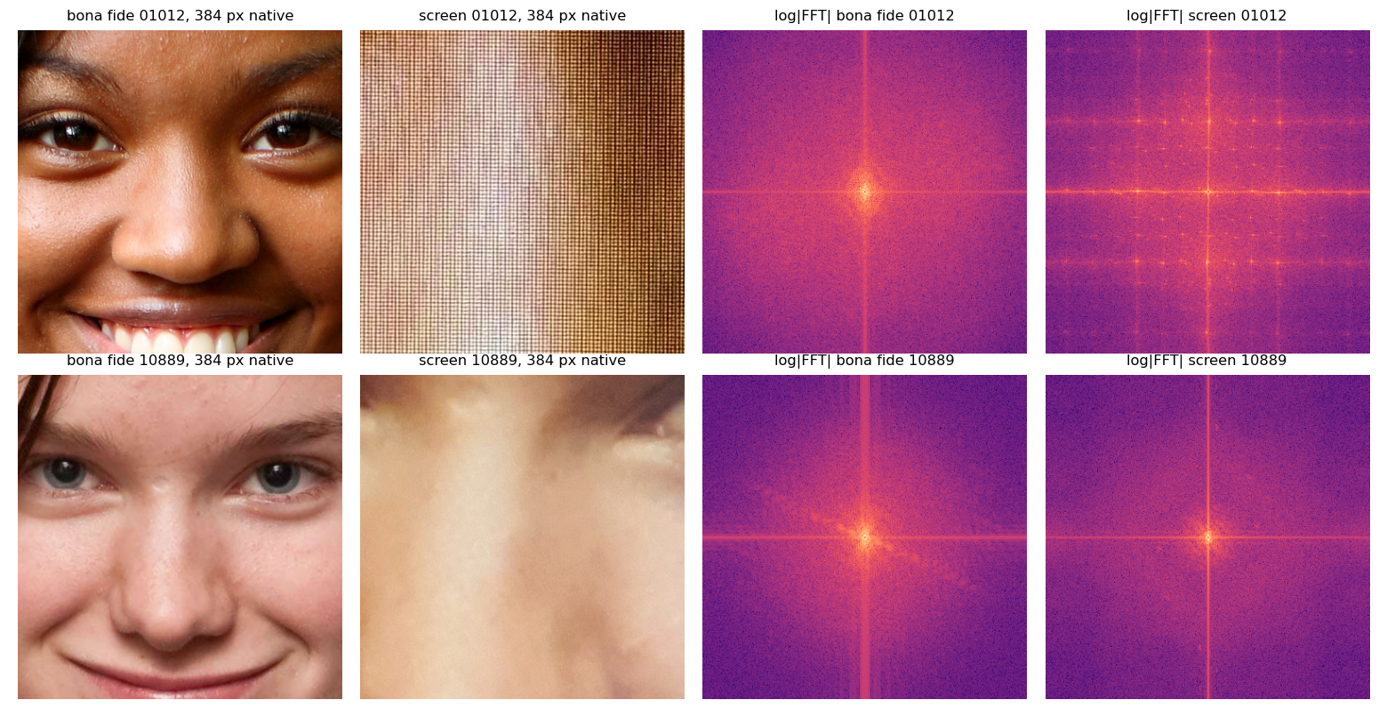
Figure 1. Fixed 384-pixel windows at native resolution and their log spectra. Top: a close-range attack, grid resolved, lattice of dots. Bottom: a far-range attack, no lattice; this is the kind that looks real.
Finding 6: the signature is only there when the camera was close enough to record it. A screen grid is very fine. For the camera to capture it, each screen pixel has to land on at least a couple of camera pixels. Step back, and several screen pixels fall on one camera pixel and average into smooth colour. Sorting the 23 attacks by how strong the grid is, the six strongest were all taken with the iPhone's rear camera, and the Samsung images are the weakest, because the Samsung saves a smaller, more heavily smoothed image. The grid gets stronger the more camera pixels there are on the face (correlation 0.52), and does not depend on exposure or lighting. Decision: attacks taken from further away, or with a lower-resolution camera, are expected to be the hard cases, and the model is judged on them explicitly.
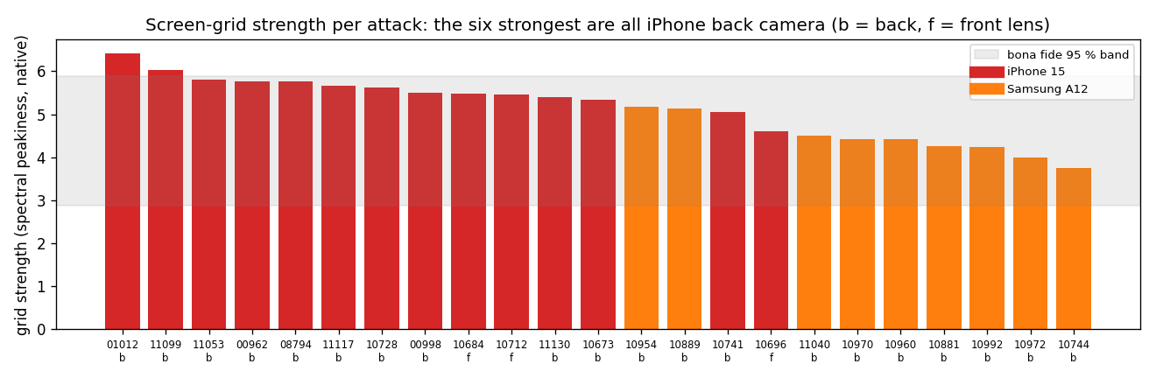
Figure 2. Grid strength per attack (spectral peakiness of the native-resolution window), coloured by phone. Grey band: where 95 percent of bona fide images fall.
Finding 7: the attacks have 2.5 times more pixels per face. Median face region 2155 pixels across versus 865. A 128-pixel patch shows 6 percent of an attack face but 15 percent of a bona fide face, so pores look larger and smoother in attack patches. No resizing rule removes this; it lives in pixel content. Decision: treated as a confound to be tested directly, not assumed away. The tests are in section 3.
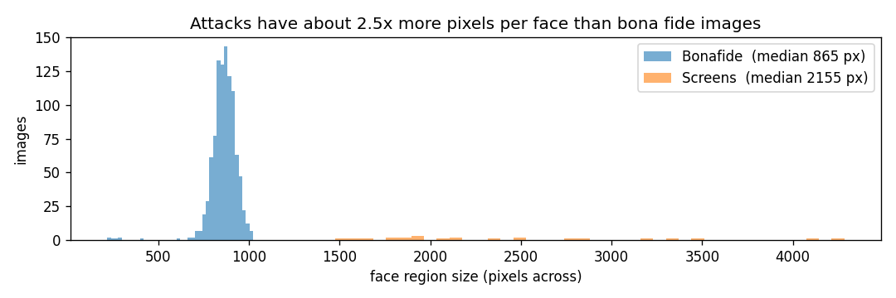
Figure 3. Face-region size per image. The gap is a fact about how the dataset was made, not about screens.
Finding 8: the camera leaves a fingerprint in the pixels. Samsung attacks have more residual energy and chroma spread; iPhone attacks more noise and clearer grid peaks. Colour cast, the most phone-consistent classical signal, is still phone-dependent. Decision: augmentation simulates camera variation, and the phone-transfer test is the arbiter of whether a model learned the screen or the camera.

3. Method

3.1 Shared preprocessing
Two steps, identical at training and inference, shared by both models.
1. Open the image, apply the rotation tag, keep only the pixel array. No metadata survives.
2. Find the face with OpenCV's Haar cascade. If none is found, take a square from the image centre and set face_found to false in the output so the deployer can retry the capture. This happened on one attack and four bona fide images here. The cascade misses profiles and heavy occlusion, so it is the weak link; a modern detector is listed under more time.
One leak was caught while building this: the default cascade returned a patch of dress fabric instead of a child's face on one image; a second cascade fixed it.

3.2 Splits
Designed for the hidden set, not for a good number. An attack and its twin always share a fold. Five folds, stratified by class and by phone. Fold 4 was locked before any model existed and read once at the end. Folds 0 to 3 are the development set, scored by 4-fold cross-validation so every image gets one score from a model that never saw it. No separate test set was carved out: a fifth of 23 attacks is five, on which APCER can only move in steps of 20 percent, and the assignment's hidden set is a better test than that. The phone-transfer protocol trains on one phone's attacks and tests on the other's, both directions, with a fixed bona fide test subset.
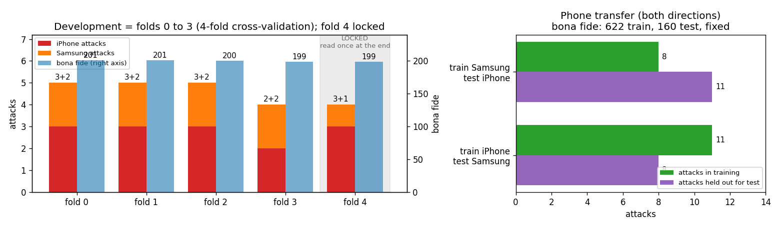
Figure 4. Left: the five folds, attacks per phone and bona fide per fold; fold 4 shaded as locked. Right: the phone-transfer protocol.
Thresholds and hyperparameters are chosen inside training folds only, or fixed in advance; how, exactly, is in Appendix B.

3.3 Classical baseline
Its input. From the shared steps, the whole face with margin is resized to 512 by 512 pixels, and six features are computed on that. This is the standard classical setup, and it is where the baseline loses the screen grid on most attacks.
Six features, one per physical cue, and the intuition behind each. The hand-crafted detectors from the PAD literature (2004 to 2016) were implemented from their papers and computed on a 512-pixel face crop. Many more could have been considered; the literature offers dozens of image-quality, texture, and frequency measures. To keep the baseline simple and readable, the six most obvious were kept, one for each physical mechanism the literature has used, so that nothing is duplicated. The recipe of several hand-crafted measures into one simple classifier follows Galbally et al. 2014 and Wen et al. 2015.
Feature | Intuition | Expected for a screen | What happened
Sharpness (Laplacian variance), Galbally 2014 | Re-photographing through a lens blurs | Lower | Inverted. Attacks scored sharper, because reaching 512 px shrinks them 5x and bona fide 2x, which piles moire energy into fine detail. A resolution artefact.
Surface texture (LBP histogram distance), Maatta 2011 | Screen surface differs from skin | Further from bona fide | Nothing after a 5x downsample. The method that started software PAD needs the resolution it was designed for.
Colour cast (chroma spread, Cr), Boulkenafet 2016 | A display renders colour differently from skin | Wider | The most consistent signal across both phones.
Fine energy (high-frequency ratio), Li 2004 | Screen texture adds fine energy | Higher | Right direction.
Moire (grid peaks at native resolution), Garcia 2015 | The pixel grid is a lattice in the spectrum | Higher | Precise but rare: fires on the obvious moire images, never on a real face, and on nothing else.
Reflection (specular ratio), Wen 2015 | Glass reflects the room | Higher | Backwards. Bona fide had more, from flash highlights and teeth in the source photos, which re-capture dulls.

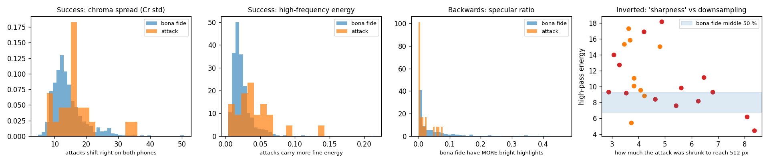
Figure 5. Four of the six features. Two succeed (chroma spread, high-frequency energy), one is backwards (specular ratio), and sharpness is inverted by how much each attack had to be shrunk to reach 512 px.
Each feature on its own. Before combining them, each of the six was thresholded on bona fide alone at 5 percent BPCER, the weakest possible use of a feature. The best single one, sharpness, catches 5 of 23 attacks. Their union catches 12 but rejects 23 percent of real images to do it, because each detector adds its own false rejections. Eleven attacks evade all six, and they include images with colour banding a human can see. This is a floor, not a verdict on classical PAD: one feature at a time, never trained on an attack, on a 512-pixel crop that loses the grid.
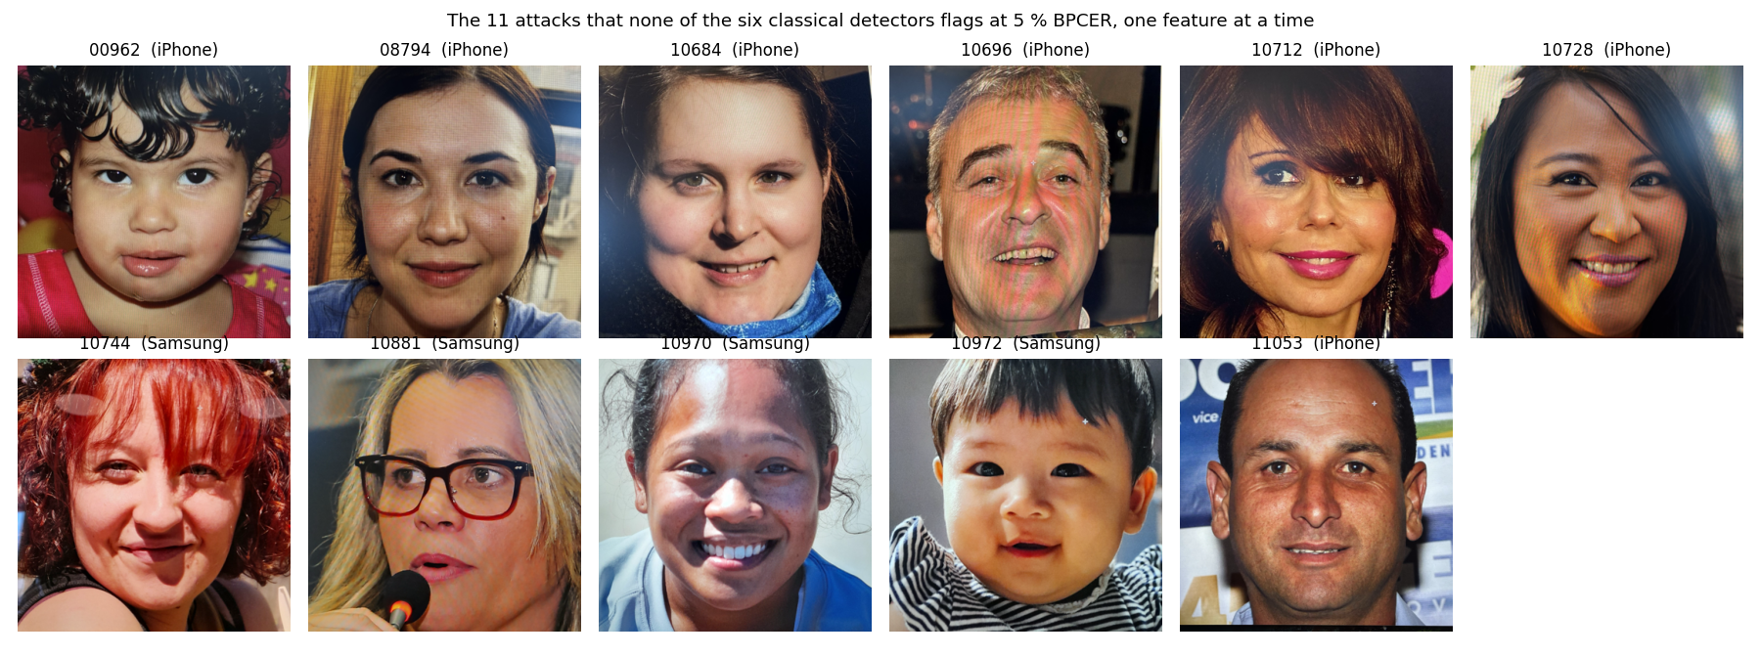
Figure 6. The eleven attacks that no single feature flags at 5 percent BPCER.
All six together. Fed into one logistic regression on the development folds, the six reach AUC 0.80. Its weights are sensible: grid peaks and fine energy carry the most, colour cast next. Where the moire is visible, the grid detector is decisive and never fires on a real face. But it misses 15 of 19 attacks at 5 percent BPCER, and trained on one phone and tested on the other it is at chance (AUC 0.59 and 0.52). Its third-largest weight is on specular highlights with the wrong sign, a property of the source photos, so part of what it learned is what the public photos look like rather than what a screen looks like. What it catches are the close-range captures where the grid is obvious to a human, plus one Samsung image with a strong colour cast; what it misses are the smooth, well-lit attacks, and the real faces it calls attacks are textured, wrinkled, or patterned. The 512-pixel crop is a genuine limitation: it erases the grid before the features see it, so this is the floor for classical PAD, not its ceiling. Two lessons carried forward: a model needs the fine structure that only survives at native resolution, and it must not be allowed to learn the camera.
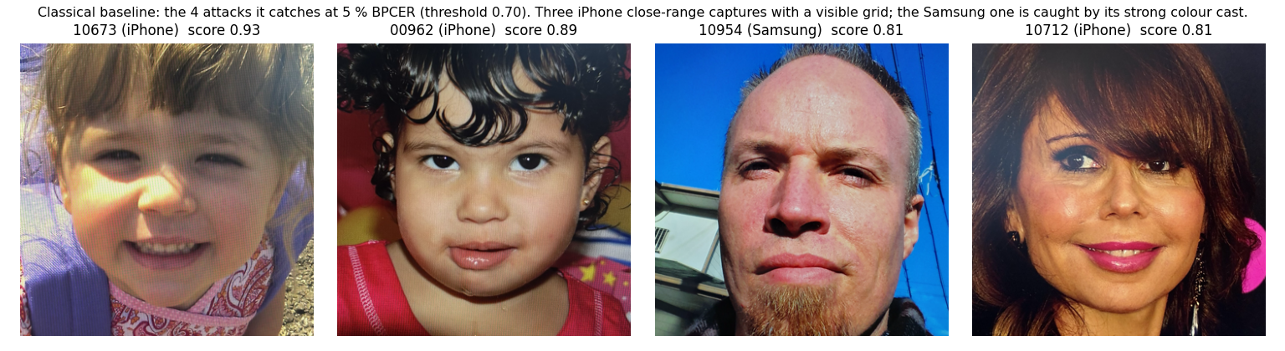
Figure 7. What the classical baseline catches at 5 percent BPCER: four attacks. Three are iPhone close-range captures with a visible grid; the Samsung one is caught by its colour cast.
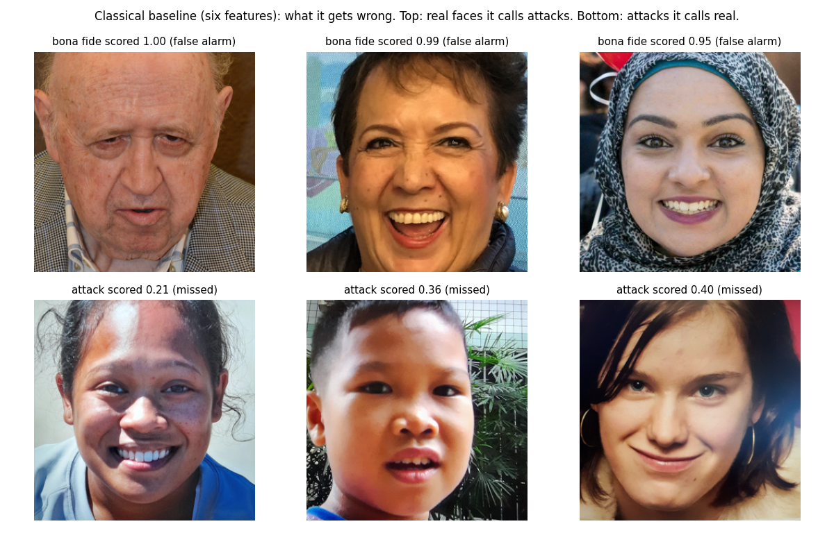
Figure 8. What it gets wrong. Top: real faces it scores highest, all textured or patterned. Bottom: attacks it scores lowest, all smooth and well lit.

3.4 Patch CNN
Its input. From the shared steps, three more:
1. Cut a square around the face at the image's own resolution, 1.3 times the face width. No resizing. The rule is relative to the face, so it gives 865 pixels on a bona fide image and about 2155 on an attack, because the attacks simply have more pixels per face.
2. Take 36 patches of 128 by 128 pixels from that square on a fixed 6 by 6 grid, spread evenly from edge to edge. Always 36, whatever the image size; why the count is fixed, and a check that the pixels between patches do not matter, are in Appendix A.
3. Score each patch with the network; the image score is the mean of the 36.
The model. A MobileNetV3-small network, the smallest of the standard ImageNet backbones, with its ImageNet weights kept and its first seven blocks frozen so that the generic edge and texture filters stay as they are; only the later blocks and a new single-output head are trained. It is applied to each 128-pixel patch separately and outputs one number per patch, the probability that the patch was photographed off a screen. The image score is the mean of its 36 patch probabilities. Training uses the 19 development attacks and 801 bona fide images: three epochs, three random patch positions per image per epoch, and each attack image repeated twenty times so that roughly a third of the patches the network sees are attacks. Every training patch is randomly altered with the same rules for both classes: mirror, small rescale, tilt, brightness, contrast, saturation, white balance, sensor noise, mild blur, JPEG recompression, and, before all of those, a random shrink by a factor between 1.0x and 0.35x taken from a larger source crop, never an upscale. In one line: shrink by up to two thirds, then jitter colour, focus, noise, and compression; same rules for both classes. Inference uses the fixed grid at native resolution with no augmentation. The whole thing trains in about ten minutes on a laptop CPU.
The reason for each choice.
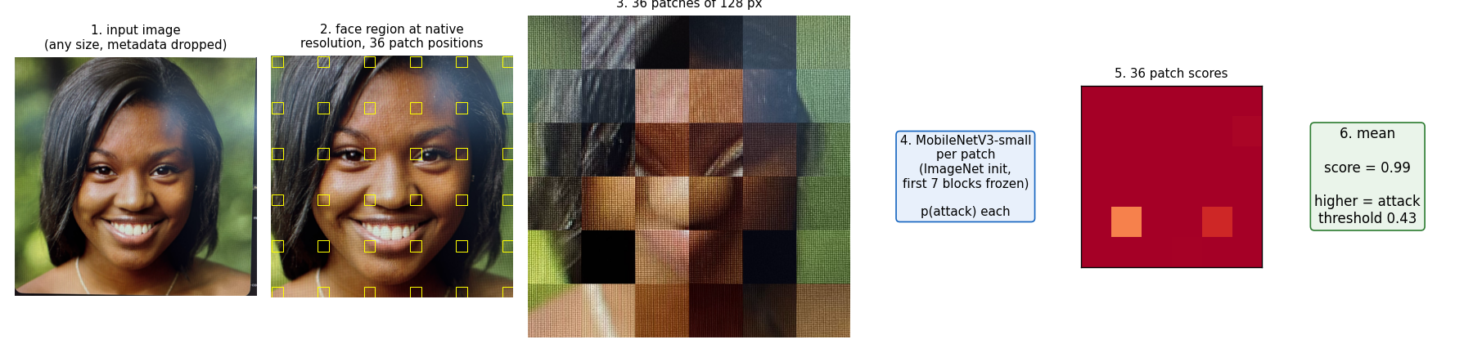
Figure 9. From input image to score. Patch scores are shown for a close-range attack; every patch sees the grid.
Choice | Alternatives considered | Reason | Evidence
Patches at native resolution, not a resized whole face | Whole-face CNN at 224 px; foundation-model features | The grid, banding, and fine noise live at the camera's pixel scale; a 224-pixel face erases them | Finding 5; the classical features at 512 px lost the grid
128-pixel patches, 36 per image, fixed grid | Fewer or more patches; random positions at test | Enough patches to land on hair and edges where far-range attacks still show texture; a constant count cannot leak class | 9 patches match 36 on AUC; far-range misses hinge on edge patches
Mean of patch scores | Max, top-k, median | Max fires on hat weave and highlights in real faces and passes 8 of 19 attacks once the threshold rises to compensate; mean and median are equal | Trade-off study, section 6
MobileNetV3-small, ImageNet weights, first seven blocks frozen | Larger backbone; full fine-tuning | Small enough for 19 attacks not to be memorised and for a laptop CPU; frozen early layers keep generic edge and texture filters | 35 patches/s training vs 23 fully fine-tuned; no accuracy difference on development folds
Attack images repeated 20x per epoch | Class weights; SMOTE | Repetition with fresh random patches and augmentation gives real variety; SMOTE interpolates pixels into ghost faces | Standard for patch-based PAD
Capture-variation augmentation, same rules for both classes | None; class-specific | Simulates another phone's colour, focus, noise and compression so the network cannot learn one camera; label-blind so it cannot leak | Phone transfer 0.99 and 1.00 vs 0.59 and 0.52 for the baseline
Random downscale 1.0x to 0.35x in training, native at inference | Resize every face to one size (tested, collapsed across phones) | The network sees attacks at bona fide pixel density often enough that pixel count stops being a tell, while the grid remains available whenever the camera recorded it | Section 4: 0.95 under shrinking vs 0.90 without; transfer intact
Threshold left to the deployer, three reference values shipped | Fixed threshold | The operating point is a security-versus-friction decision that belongs to the product (section 1) | Section 6

Anomaly detection trained on bona fide only was also run in three feature spaces as the no-attack-labels reference; it is reported in section 4 and explained in section 7.

4. Results
Every number is on images the model never trained on: the 19 attacks and 801 bona fide of the development set, each scored by a model that did not see it. Bootstrap intervals are in Appendix C.

4.1 The four models that matter
Scored on the images as they are, original size.
Model | AUC | Attacks missed at 5 % BPCER, of 19 | Attacks missed at 0 % BPCER, of 19 | What it showed
Classical baseline, six features | 0.80 | 15 | 19 | Hand-crafted cues catch only the obvious attacks.
Anomaly detection, trained on real images only | 0.80 | 11 | 16 | It learns what real images look like and flags anything different. Our real images are a varied photo collection, so "different" mostly means an unusual photo, not a screen; and the attacks are copies of those same photos with a faint grid added, so they do not look different enough. To learn the grid it has to be shown attacks.
Patch CNN, no augmentation or shrinking | 1.00 | 0 | 0 | Perfect, which a model exploiting the pixel gap would also be. Not to be trusted on its own.
Final model: patch CNN, augmented and shrunk in training for the pixel-density gap | 1.00 | 0 | 5 | Same score at original size. Thinner margin at the strict end.

Scored with the pixel gap removed: every attack shrunk to bona fide pixel density at test time, model unchanged.
Model | AUC | Attacks missed at 5 % BPCER, of 19 | Attacks missed at 0 % BPCER, of 19 | What it showed
Patch CNN, no augmentation or shrinking | 0.88 | 10 | 17 | Part of its perfect score was the pixel gap.
Final model | 0.95 | 5 | 16 | Keeps most of its score when attacks lose their resolution advantage. The five it misses are the far-range Samsung captures.

Neither table is the truth on its own. The first is the operating condition, and it flatters any model that can use the pixel gap. The second removes the gap but also erases the real screen grid, exactly as standing further back would, so it is a lower bound for far-range attacks. The truth sits between them, and the camera swap in 4.2 is the tie-breaker. 0 % BPCER means the threshold is set just above the highest-scoring real face, so no real user is flagged; the column counts attacks that pass at that point.
The strict end. At zero flagged real users, the unaugmented model misses nothing while the final model misses 5. The augmentation that makes the final model robust to camera and resolution changes also raised the scores of three textured, harshly lit real faces, and they now sit above the weakest attacks. On the shrink test both models collapse at that operating point. That is the price of robustness, and it is why the recommended threshold is 5 percent BPCER rather than zero.
Three other recipes were tried between the third row and the fourth; their numbers are in Appendix C. Capture augmentation alone transfers across cameras but drops further under the shrink test. Resizing every face to one size reached AUC 0.96 on the development folds but collapsed on the camera swap, which is how we learned that once the grid is gone, what remains to learn is the camera. Drawing every training patch's size from one face-relative range for both classes, so that bona fide patches are sometimes upscaled to attack density, seemed the more principled way to close the pixel gap; it reached 0.98 on the development folds and also collapsed on the camera swap (0.82 and 0.59). Upscaling creates no texture, so the model learned "genuine fine texture means attack," and fine texture as a camera renders it is exactly what differs between phones. Shrinking only, which never manufactures a texture difference, is the version that transfers.

4.2 The unseen-camera test
The development folds saturate for every network, so they cannot choose between models. The camera swap can: train on one phone's attacks, test on the other's, both directions. A model that survives it learned something both cameras record, which can only be the screen.
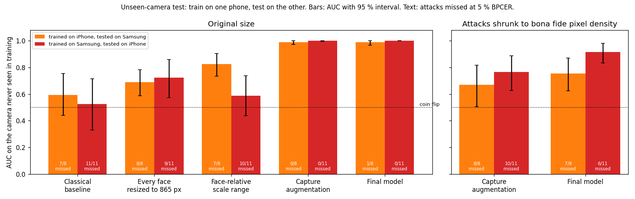
Figure 10. Train on one phone, test on the other. Left, attacks at original size: the classical baseline falls to a coin flip, the two resizing recipes fall most of the way back, the two that keep original resolution transfer at 0.99 and 1.00. Right, the same swap with the attacks shrunk: the final model keeps 0.75 and 0.91.
The left panel keeps the pixel gap: the held-out phone's attacks still have 2.5 times the pixels of bona fide. So it shows the model does not depend on one camera's processing, not that it can do without the resolution advantage. The right panel removes both at once, unseen camera and shrunk attacks, the harshest test in this report. The final model holds AUC 0.75 and 0.91 and misses most attacks at 5 percent BPCER; the capture-augmentation model falls to 0.67 and 0.77. The shrink-aware training bought something real, and the far-range case on a new camera is where the model is weakest. This is the pair of results the final model was chosen on.
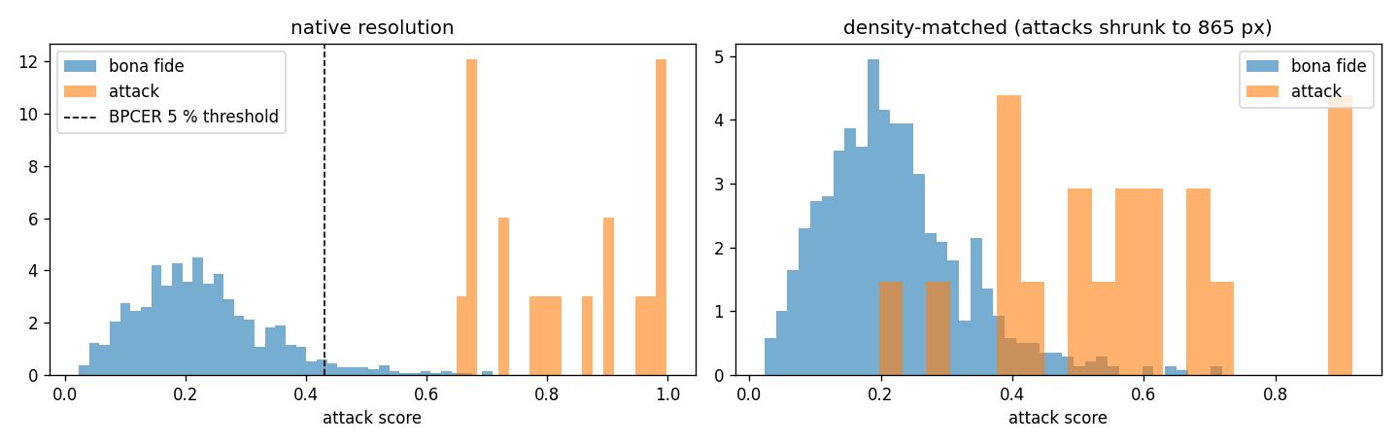
Figure 11. Final model scores on the development set. Left: original resolution; the dashed line is the 5 percent BPCER threshold. Right: the same model with attacks shrunk to bona fide pixel density; the attack scores slide left into the bona fide tail.
The attacks that get through. Under the shrink test the final model misses five. All five are Samsung captures, and all five sit in the bottom third of the grid-strength ranking in Figure 2: their faces are 1500 to 1900 pixels across, the smallest in the attack set, and the Samsung's processing has already smoothed what grid there was. At original size they score 0.68 to 0.73, the weakest attacks in the set but still above the threshold. Shrinking removes the little texture they had, and the scores fall to 0.20 to 0.40, below any real face with a hat or a highlight. The intuition is simple: these are the attacks where the camera never really recorded the screen, and the model is being asked to detect something that is not in the pixels.
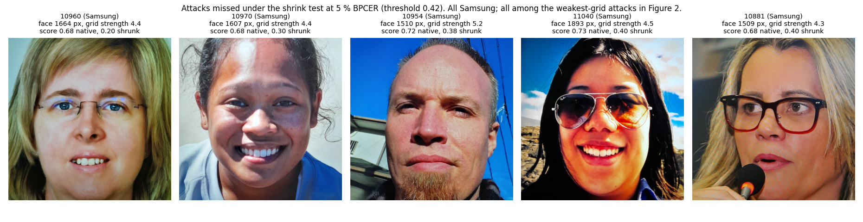
Figure 12. The five attacks missed under the shrink test, with face size, grid strength, and score before and after shrinking.

4.3 The locked fold
A fifth of the data, 4 attacks and 199 bona fide, was set aside before any model existed and never touched. The final recipe, trained on the 820 development images and frozen with its thresholds fixed, scored it once, at original size: AUC 0.999. At the 5 percent threshold, 5 of 199 real users were flagged and all 4 attacks caught. At the 1 percent threshold, 1 real user was flagged and 1 attack, scoring 0.55, was missed. The thresholds carried over without adjustment, and the strict end is where the margin runs out.
The same fold with the pixel gap removed. Scoring the locked fold with its attacks shrunk, same model, same thresholds: AUC 0.88, and at the 5 percent threshold 4 of 199 real users flagged and 3 of 4 attacks passed. Only the close-range iPhone capture keeps its score (0.99 to 0.82); the other three fall from 0.56 to 0.85 down to 0.21 to 0.32. This is harsher than the development shrink test (5 of 19 passed) and consistent with it: with four attacks, one close-range capture is the difference. It is the honest reading of the locked fold, and it says the same thing as everything before it: at original size the model is near perfect, and far-range attacks are where it fails.
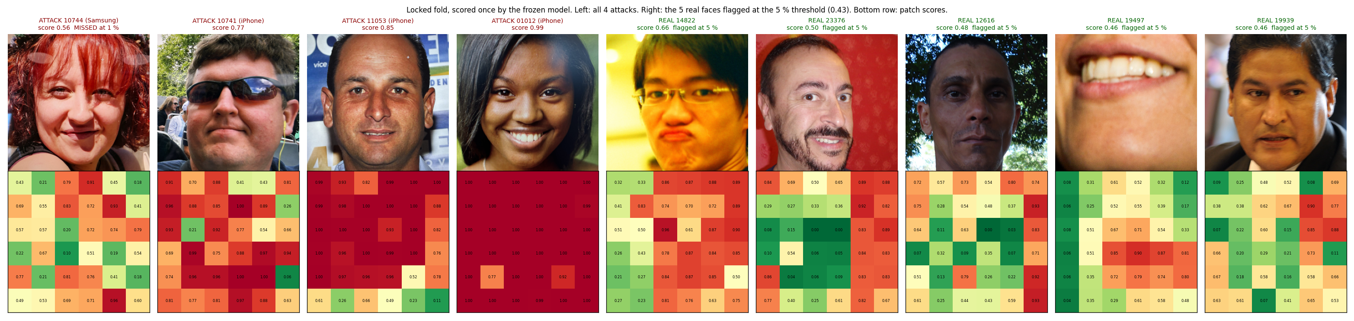
Figure 13. Everything the locked fold contained that matters: its four attacks and the five real faces the 5 percent threshold flagged, each with its patch map.
Reading the locked fold. The four attacks behave exactly as the development set predicted. The two iPhone close-range captures score 0.85 and 0.99 with the grid in every patch. The iPhone image with sunglasses scores 0.77 with its high patches on the hair and the frames. The one Samsung attack scores 0.56, the same far-range pattern as the five above, and it is the one the strict threshold misses. Of the five real faces flagged at 5 percent, one is under yellow stage lighting and one is a flash-lit portrait against a red wall, the same two failure patterns as section 5; two are ordinary faces scored just over the line at 0.46 and 0.48; and one is a face-detector miss: the crop is a mouth, and the model fires on the teeth. So the detector weakness produces false alarms as well as bad crops, which is one more reason it is the first engineering change to make.

4.4 Why I believe these numbers, and where I don't
Three reasons to believe them, each tied to a choice made earlier.
- The split makes the easy cheats impossible or visible. Pairs travel together, so the model cannot score "have I seen this face." The camera swap makes learning the camera visible, and the test has teeth: the classical baseline collapsed to chance on it. The final model passed it.
- The model was chosen on the hard tests, not on the number it was best at. Every network scored 1.00 on the development folds; that column never decided anything. The shrink test, the camera swap, and their combination did. The combination is the honest floor: 0.75 and 0.91, with most far-range attacks passing on a new camera.
- A locked fifth of the data, untouched throughout, agreed at the end, at thresholds fixed beforehand.
Three reasons for caution, each tied to the data.
- Nineteen attacks. Every attack-side figure moves in steps of 5 percent, and the locked fold has four, so it confirms direction, not magnitude.
- One display, one room, one day, one operator. Camera transfer is tested. Display, lighting, and attacker transfer are not.
- The bona fide images are files, not live captures. This is the largest gap between our tests and the real one, and nothing in the data can close it.
Every number above belongs to the model trained on the 820 development images. The shipped weights were trained with the same recipe on all 1023 images and have not been separately validated; an in-sample check shows their scores sit where the thresholds expect.

5. What the model is keying on
A network has no hand-crafted features to read off, so two tools were used instead. First, cue ablation: re-score every development image with one physical cue removed, and measure how much the attack score drops. Second, patch-score maps: the 36 patch probabilities drawn over the face, which show where on the face the model sees a screen. Both use out-of-fold scores.
Cue ablation. Four cues, each removed by one transformation.
Cue removed | How | Drop in attack score, iPhone | Drop, Samsung | Effect on bona fide
Fine structure and density | shrink the face square to 865 px | 0.23 | 0.29 | none
Fine detail | blur, sigma 1.5 | 0.09 | 0.08 | slightly up
Noise | 5 by 5 median filter | 0.07 | 0.10 | slightly up
Colour | convert to grayscale | 0.00 | slightly up | up 0.06

The dominant cue is fine-scale structure that disappears when the image is shrunk: the pixel grid, moire, and aliasing. Fine detail and noise are secondary and overlap with it. Colour is not used to detect attacks at all.
Why colour is not used, and why that is the right outcome. Moire has a pattern, the beat between screen grid and sensor grid, and a tint, the rainbow that comes from that pattern landing differently on the red, green, and blue sensor sites. Grayscale removes the tint but leaves the pattern as brightness stripes. The model reads the pattern. Two things pushed it there: the training augmentation randomly shifts brightness, saturation, and white balance on every patch, so colour was an unreliable signal to learn; and the tint depends on which phone took the photo while the pattern does not. Real PAD systems do use colour, classical ones heavily, and colour carries real information such as display gamut and skin chromaticity. But colour is also the cue most tied to the camera and the lighting, which is what the classical baseline collapsed on across phones. With data from more displays and cameras, letting the model lean on colour a little more would be reasonable. Removing colour from a bona fide image slightly raises its score, so colour helps the model recognise real skin rather than detect screens.
Where on the face it looks. A close-range attack lights up every patch at 1.00; the grid is everywhere. A far-range attack lights up hair, glasses frames, and background edges at 0.8 to 0.95, and scores the smooth skin of cheeks and forehead at 0.1 to 0.4. The model finds the screen in texture it can resolve, and far-range smooth skin looks like skin. That is the whole far-range problem in one picture. A real face under harsh yellow stage lighting scores 0.71, with its high patches on highlight edges and saturated regions. A typical real face scores under 0.05 everywhere.
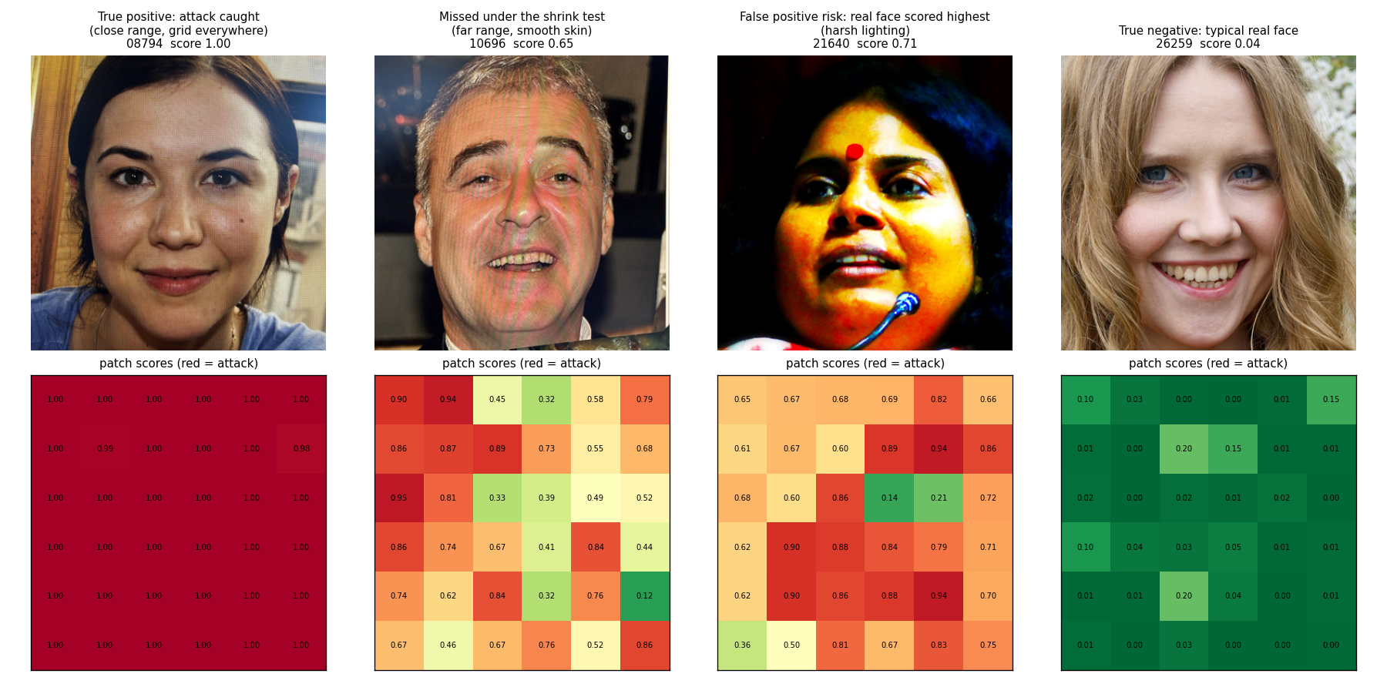
Figure 14. Four cases with their patch maps, scored out-of-fold. Left to right: an attack caught, an attack that is missed once shrunk, the real face the model likes least, a typical real face.
The recurring false alarms. Three real faces sit at the top of the bona fide list for every model tried: a stage-lit face, a dark face under a woven hat with sunglasses, and a flash-lit face with a colour cast. Their high-scoring patches sit on fabric weave and highlight edges. Harsh lighting and repetitive texture near the face are the false-alarm risk, and real users will bring both.
What this means for the tests in section 4. The cue ablation and the camera swap agree. The model's dominant cue is resolved screen texture, which any camera records if it is close enough; that is why it transfers across phones. Its secondary cues are gone once the image is shrunk; that is why the shrink test costs it, and why the far-range attack on a new camera is the worst case.

6. Where it breaks

6.1 The attacker's view
A detector is only as good as the cheapest way around it, so the failures below are ordered by what an attacker who understood this model would try first.
- Step back or defocus. The model needs resolved screen texture. An attacker who holds the display far enough away, or slightly out of focus, removes the cue at source. This is the cheapest attack and the model's real weakness; the shrink test in section 4 is a rehearsal of it. What stops it is not the model but the capture protocol: a minimum face size in the frame forces the screen close.
- Use a high-density display. A phone screen at 450 pixels per inch has a finer grid than a laptop; against a low-resolution verification camera it may never resolve. The attacks here came off a Mac. Untested, and a real gap.
- Remove the obvious. Metadata, file size, and image dimensions were deliberately made irrelevant, so an attacker gains nothing by stripping or resizing a file. A model that had leaned on any of them would have been trivially defeated; that is why the shortcut audit in section 2 was a security step, not a tidiness step.
- Work the false-alarm pattern in reverse. The model reads texture as attack and colour as skin. An attacker cannot easily remove the grid from a re-capture, but they can bring smooth lighting and avoid fabric near the face. Marginal.
- Bring a different attack. A print, a mask, a video with motion: out of scope, score undefined. A deployment needs other detectors for those.
The model fails in the safe direction in two places by design: an image with no detectable face is still scored and flagged rather than passed, and the recommended threshold is set by capping friction and then minimising attacks passed, never the reverse.

6.2 Failure modes
Each is one paragraph: what breaks, what the evidence was, and what would catch it in deployment.
Far-range attacks. The model detects screen texture the camera resolved. Photograph the screen from far enough away, or with a low-resolution camera, and no texture is recorded; the image is smooth skin with a faint colour cast, and the model has little to work with. Evidence: with attacks shrunk to bona fide pixel density, 5 of 19 pass at 5 percent BPCER on the development set, and on an unseen camera with shrunk attacks, most pass. In deployment, a minimum face-size gate forces the attacker to bring the screen close, which is exactly where the texture appears; that gate does more for this failure than any change to the model.
Real users captured live. Every bona fide image here is an original file from a public set. A real user's phone selfie will carry sensor noise, a colour cast, hand-held framing, and mild blur, all of which this model has only ever seen on attacks. Nothing in the data can measure how it would score them. This is the largest risk in the report, and it is a property of the dataset, not of the model. The fix is data: bona fide captures through the same phones and conditions as the attacks.
Displays, lighting, and attackers not seen. All 23 attacks come from one Mac screen, one room, one morning, one operator. Camera transfer was tested and passed. Transfer to a tablet, a TV, an OLED phone, a different room, or someone else's way of holding the screen was not tested, and a different display has a different grid pitch, refresh, and colour rendering. The model is expected to generalise on the physics, but that is expectation, not evidence.
Harsh lighting and fabric textures near the face. The three real faces the model likes least share stage lighting, a woven hat, and a flash-lit colour cast. Their high-scoring patches sit on highlight edges and repetitive weave. At the recommended threshold they are not flagged, but they are what a false alarm looks like, and real users will bring both. A lighting quality gate before scoring reduces the first; the second is a model limitation.
The strict end of the threshold. The weakest attacks score 0.65 to 0.68; the 1 percent BPCER threshold is 0.59; three real faces score above the weakest attack. On the locked fold the 1 percent threshold missed one of four attacks. Any product that needs friction below 2 percent is operating inside the model's margin, and the report recommends 5 percent for that reason.
The face detector. The Haar cascade is the weakest component. It misses profile faces and heavy occlusion, and on one image returned a patch of fabric before a second cascade fixed it. When no face is found the image is scored on a centre crop and flagged; if the hidden set has faces off-centre, that crop may not contain them. It also produces false alarms: on the locked fold one of the five real faces flagged at 5 percent was a crop of a mouth, and the model fired on the teeth. A modern detector is the first engineering change to make.
Other attack types. Print attacks, masks, and anything else were never seen. The score on them is undefined, not low.
What the model does not know it does not know. The score is a probability in name only. On a shifted input, a live selfie or a new display, it may be confidently wrong in either direction. The face-found flag and the score distribution over a batch are the two signals a deployer has to notice drift; there is no built-in uncertainty estimate.

7. Operating point and cost
The score is continuous; the threshold is the deployer's. Three reference thresholds ship in config.json, read off the out-of-fold development scores and applied unchanged to the locked fold. The table gives counts rather than rates because "5 in 199" reads differently from "2.5 percent".
Threshold chosen by | Score | Development: real flagged of 801 | Development: attacks passed of 19 | Locked fold: real flagged of 199 | Locked fold: attacks passed of 4
1 % BPCER | 0.59 | 8 | 0 | 1 | 1
2 % BPCER | 0.53 | 16 | 0 | 1 | 0
5 % BPCER (recommended) | 0.43 | 40 | 0 | 5 | 0
10 % BPCER | 0.37 | 80 | 0 | 18 | 0

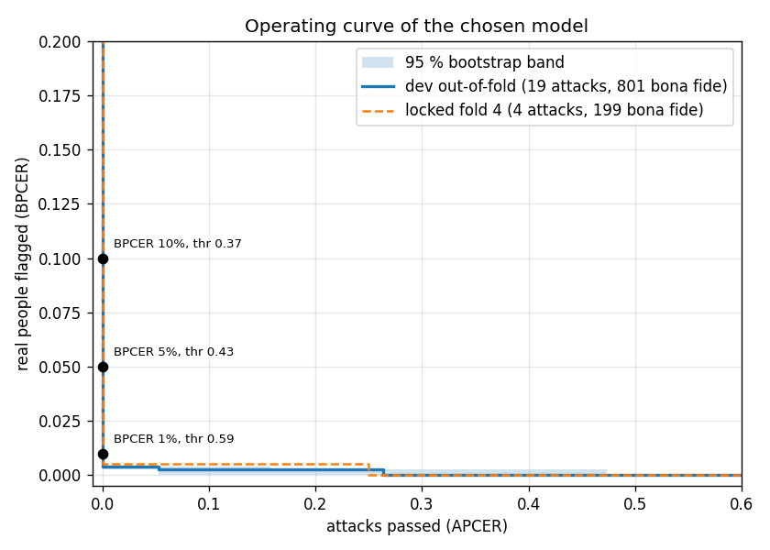
Figure 15. Real users flagged against attacks passed for every threshold. Solid: development set with bootstrap band. Dashed: locked fold. Dots: the shipped thresholds.
Recommendation. 0.43. It flags about one real user in twenty and passed no attack on either held-out set. 0.53 if friction matters more, at the cost of the far-range tail. Anything above 0.59 buys almost no friction and starts passing attacks: on the locked fold it misses one of four. This follows the assumption in section 1 that a passed attack costs more than a flagged user, who can retry.
Cost. 0.35 seconds per image at 1 megapixel and 1.1 seconds at 24 megapixels on a laptop CPU with four threads. The network is a fixed 0.25 seconds because every image yields 36 patches; the only part that grows is decoding the file. Threads barely help a single image, so throughput comes from scoring images in parallel. Two knobs were checked for trading time against accuracy. Nine patches instead of 36 give the same AUC at 40 percent of the time; 36 are kept because the far-range misses hinge on the few patches that land on hair and edges. Capping the input resolution is the one thing not to do: at 1500 pixels it costs nothing, at 865 it passes 5 of 19 attacks, at 512 it passes 9, and it saves no time because decoding happens first.

8. With more time and data
In order of expected value.
1. Characterise the attack cues and generate more attacks from them. Measure what the 23 attacks actually carry: grid period in camera pixels, banding frequency, colour shift, blur. Then apply those cues to bona fide images with a physics-based re-capture simulator, rendering the image onto a virtual pixel grid and re-sampling it through a camera model. The training distribution stays the same and the attack count grows from 23 to thousands, with control over distance and display. Validate only on real held-out attacks, never on synthetic ones.
2. Bona fide captured live through the same phones. Then both classes share a capture path, the pixel gap disappears, and the model has to find the screen because the camera no longer separates the classes. This is the only complete fix for the density gap and the only way to measure the live-user risk in section 6.
3. Several displays at several distances. Phone, tablet, laptop, monitor, OLED and LCD, close and far. Turns the physics argument for display transfer into evidence, and lets display be held out the way phone was.
4. A whole-face branch fused with the patch score. Flatness, uniform focus, colour gamut, and bezels are image-level cues the patches cannot see, and they are visible at any distance. This targets the far-range misses directly.
5. A modern face detector. The Haar cascade misses profiles and occlusion and produced one false alarm on the locked fold by cropping a mouth. A day's work.
6. Capture-protocol gates. Minimum face size and lighting checks before scoring. Not a model change, but they remove most of the far-range and harsh-lighting cases before the model sees them.
Roads not taken, briefly. Fine-tuning a GAN to generate attacks was considered and set aside: a generator trained on 23 images learns those 23 images, not the physics of moire, and a detector trained on its output learns to detect the generator; the physics-based simulator in item 1 is the version that does not have this problem. Whole-face networks at 224 pixels and foundation-model features were set aside because they erase the grid by design. Auxiliary depth supervision is the strongest literature approach with more data and needs depth labels this project did not have. Anomaly detection was run and failed for the reason given in section 4.

9. Deliverables and reproducibility
- infer.py: reads a folder (recursively) or a single file, scores every image Pillow can open whatever its extension (PNG, JPEG, HEIC, BMP, TIFF, WebP, GIF), and writes a CSV with two columns, file and score. Non-image files are skipped and listed, an image that fails keeps its row with a blank score, and the console reports counts, time per image, and any image scored without a detected face. Applies the section 3 pipeline unchanged. Thresholds are printed for reference and not applied.
- artefacts/: model.pt, the shipped weights trained on all 1023 images with the final recipe; model_dev.pt, the model every number in this report belongs to, trained on the 820 development images; config.json with patch size, count, aggregation, normalisation constants, and the three thresholds.
- pad/: the library. data.py (loading, face detection, native-resolution crop, patch grid, augmentation, the face cache), metrics.py (APCER, BPCER, EER, AUC, bootstrap), model.py (the network and tensor conversion, shared by training, analysis, and inference).
- scripts/: one file per step. make_splits.py (folds, locked test set, phone transfer), baselines.py (six classical features into logistic regression), train.py (every patch-CNN experiment, the freeze, and the ship run, one flag each), anomaly.py, error_analysis.py (cue ablation and patch maps), tradeoffs.py (operating points, latency, knobs), plot_phone_transfer.py. run_experiments.sh runs them in order, by stage.
- notebooks/: 01_data_analysis.ipynb is section 2 with every check shown; 02_experiments.ipynb is sections 4 and 5 with ranked galleries of every model's top scores and every missed attack with its patch map. Both read saved results and run in minutes.
- Folders and environment: data/ the dataset, not in the repository (README says where to put it); derived/ the splits, face boxes, and classical features; results/ every score file, result JSON, figure, and the four final-recipe fold models; docs/ this report, the working record, the brief, and an interview Q&A. Dockerfile, README, requirements.txt (full) and requirements-infer.txt (inference only). Python 3.9, pillow, pillow-heif, numpy, pandas, opencv-python-headless 4.x, scikit-learn, torch and torchvision on CPU.

Appendix A. Patch count and coverage
Why always 36 patches. In the first version, the number of patches per side was the square's width divided by 128, capped at six. Attack squares are all over 1474 pixels, so all 23 attacks got the full 36. But 51 bona fide squares were under 768 pixels, so they got 25, 16, 9, or fewer. A model that sees 36 inputs for every attack and sometimes fewer for a bona fide image has a cue that has nothing to do with screens. Fixing the count to 36 removed it. The six positions per axis are spread evenly from edge to edge, so on a large square the patches sit apart with gaps and on a small one they overlap; no padding is needed unless a square is smaller than one patch, and none is.
Coverage. Spacing the patches means not every pixel is scored: about 80 percent of a bona fide square and 13 percent of an attack square. The screen cues are spread over the whole face rather than confined to one spot, so sampling should be enough for them, and this was tested directly: a 10 by 10 grid of 100 patches, covering the whole bona fide square and 35 percent of an attack square, gives the same AUC (0.999 against 0.999 at native resolution, 0.943 against 0.945 with attacks shrunk) and changes one attack out of nineteen under shrinking, at 2.5 times the time per image. The sparse grid is kept.

Appendix B. How settings were chosen
Classical baseline. The six features are fixed formulas; nothing is learned in computing them. Turning six numbers into one score needs weights, and those are learned by a logistic regression on the training folds. Its one setting, the regularisation strength, is picked automatically by an inner 3-fold cross-validation on the training data of each fold, so the held-out fold never influences it.
Patch CNN. Its settings (3 epochs, 3 random patches per image per epoch, learning rate, first seven blocks frozen, attack images repeated 20 times) were fixed in advance from the compute budget of a laptop CPU and were never tuned. The experiments compared only the augmentation policy and the handling of resolution, and those were decided on the phone-transfer and shrink tests, not on the development score. The two inference-side knobs compared afterwards, patch count and aggregation, were compared out-of-fold and the defaults kept.
Both. Augmentation touches training patches only, with the same random rules for both classes. Every reported number is on clean, native-resolution images. Any threshold is read off out-of-fold development scores and applied unchanged to the locked fold.

Appendix C. Every number with its interval
Model | Protocol | AUC [95 % interval] | Attacks missed at 5 % BPCER
Classical baseline, six features | development | 0.795 [0.698, 0.875] | 15 of 19 (APCER 0.79 [0.63, 0.95])
 | train iPhone, test Samsung | 0.593 [0.441, 0.753] | 7 of 8 (APCER 0.88 [0.62, 1.00])
 | train Samsung, test iPhone | 0.524 [0.330, 0.715] | 11 of 11 (APCER 1.00 [1.00, 1.00])
Anomaly, mean patch embedding | development | 0.802 [0.693, 0.900] | 11 of 19 (APCER 0.58 [0.32, 0.79])
Patch CNN, no augmentation | development | 1.000 [1.000, 1.000] | 0 of 19 (APCER 0.00 [0.00, 0.00])
 | development, attacks shrunk | 0.877 [0.796, 0.944] | 10 of 19 (APCER 0.53 [0.26, 0.74])
Patch CNN, capture augmentation | development | 1.000 [0.999, 1.000] | 0 of 19 (APCER 0.00 [0.00, 0.00])
 | development, attacks shrunk | 0.897 [0.822, 0.957] | 8 of 19 (APCER 0.42 [0.21, 0.63])
 | train iPhone, test Samsung | 0.990 [0.972, 1.000] | 0 of 8 (APCER 0.00 [0.00, 0.25])
 | train Samsung, test iPhone | 0.998 [0.994, 1.000] | 0 of 11 (APCER 0.00 [0.00, 0.00])
 | train iPhone, test Samsung, attacks shrunk | 0.669 [0.504, 0.817] | 8 of 8 (APCER 1.00 [0.88, 1.00])
 | train Samsung, test iPhone, attacks shrunk | 0.766 [0.626, 0.887] | 10 of 11 (APCER 0.91 [0.45, 1.00])
Final model (wide shrinking) | development | 0.999 [0.998, 1.000] | 0 of 19 (APCER 0.00 [0.00, 0.00])
 | development, attacks shrunk | 0.945 [0.880, 0.986] | 5 of 19 (APCER 0.26 [0.05, 0.53])
 | train iPhone, test Samsung | 0.988 [0.967, 1.000] | 1 of 8 (APCER 0.12 [0.00, 0.38])
 | train Samsung, test iPhone | 1.000 [1.000, 1.000] | 0 of 11 (APCER 0.00 [0.00, 0.00])
 | train iPhone, test Samsung, attacks shrunk | 0.754 [0.623, 0.870] | 7 of 8 (APCER 0.88 [0.50, 1.00])
 | train Samsung, test iPhone, attacks shrunk | 0.914 [0.834, 0.979] | 6 of 11 (APCER 0.55 [0.09, 0.82])
Face-relative scale range | development | 0.976 [0.948, 0.993] | 2 of 19 (APCER 0.11 [0.00, 0.32])
 | development, attacks shrunk | 0.928 [0.864, 0.978] | 5 of 19 (APCER 0.26 [0.11, 0.47])
 | train iPhone, test Samsung | 0.824 [0.735, 0.904] | 7 of 8 (APCER 0.88 [0.50, 1.00])
 | train Samsung, test iPhone | 0.588 [0.439, 0.737] | 10 of 11 (APCER 0.91 [0.73, 1.00])
Every face resized to 865 px | development | 0.959 [0.912, 0.992] | 3 of 19 (APCER 0.16 [0.00, 0.32])
 | train iPhone, test Samsung | 0.688 [0.589, 0.783] | 8 of 8 (APCER 1.00 [1.00, 1.00])
 | train Samsung, test iPhone | 0.723 [0.575, 0.858] | 9 of 11 (APCER 0.82 [0.55, 1.00])
Final model, frozen | locked fold 4 | 0.999 [0.992, 1.000] | 0 of 4 (APCER 0.00 [0.00, 0.00])
 | locked fold 4, attacks shrunk | 0.876 (no bootstrap) | 3 of 4

Intervals are stratified bootstrap over 2000 resamples of attacks and bona fide separately.

