Screen Attack Detection Prototype
Framing, metrics, data, splits, baseline, input pipeline, experiments, final model
Arushi Agrawal | 5 September 2026 | working report, not final

Summary
The task is a small presentation attack detection (PAD) prototype that scores face images for screen replay attacks, with the strong hint that it will be graded on images we have not seen. This report walks through the project one decision at a time: framing, metrics, data, how the data is split, the baseline, the input pipeline, and the experiments. Each step ends with its decisions recorded so later choices can be traced back to a reason.
Five things to know before reading further
- The data is 1000 bona fide images and 23 screen attacks. Every attack is a phone photo of a screen showing one of the bona fide images, so the pairs differ only in the capture path.
- The bona fide images are a public aligned-face dataset, not live captures. The boundary we can learn is original photo versus re-captured photo.
- Image size, file size, and metadata separate the classes perfectly and have nothing to do with screens. They must be removed before any model sees the data.
- Sixteen classical PAD detectors from the literature were implemented. Fed to one classifier they reach AUC 0.82 and miss 12 of 19 attacks at 5 % BPCER, and their strongest signal is a resolution artefact.
- The headline metric is APCER at fixed BPCER, with the worst held-out capture condition reported rather than the average, because the hidden set will differ from ours.
- Validation is 4-fold cross-validation grouped by image pair and stratified by phone, with one fold locked until the end. The classical baseline collapses to chance when trained on one phone and tested on the other.
- The model under test is a patch CNN on 128 px patches at native resolution, because the screen cues live at the camera's pixel scale and are destroyed by resizing the face to 224 px.
- The chosen model transfers across cameras (AUC 0.99 and 1.00 with one phone held out) where the classical baseline collapses, and stays at AUC 0.95 when attacks are shrunk to bona fide pixel density. Far-range attacks remain its weakness.

Step 1. Problem framing
The brief is one sentence: build a small PAD prototype that reads images and outputs an attack score per image. The supporting document adds that the solution may be tested on a hidden set of images. Everything else is left to us, so the first job is to write down what the brief fixes, what it leaves open, and what we decided for each open point.

What the brief fixes
- Input: single images, not video. Temporal liveness cues such as blink or pulse are unavailable.
- Output: a continuous attack score per image, not a label. Thresholding is the deployer's decision, so we evaluate ranking quality and the error trade-off, not accuracy at one cutoff.
- Scale: a prototype. A clean, explainable, reproducible pipeline beats a fragile high score.
- Generalisation: a hidden test set. Transfer to unseen images is the graded quantity, not our own validation number.

What the brief leaves open, and what we decided
Open question | Decision
Which modality and attack types | Face PAD. Attack scope is whatever the data contains (screen replay). Any other attack type is stated as out of scope, not implied to be handled.
Score direction | Score in [0, 1], higher means more likely an attack. Written down because a flipped convention is the most common PAD handover bug.
Which error is worse | Not decided by us. Report the full trade-off and quote performance at conventional operating points; the deployer picks.
Deployment constraints | None given. Assume offline or server-side scoring with no hard latency budget, but record model size and time per image.
Input format | Inspect the data before deciding whether face detection is part of the pipeline (it is; see step 3).
What the hidden set looks like | Design for new capture conditions with the same attack type. Be explicit that new attack types are not covered.
Definition of done | A script that reads a folder and writes a CSV of scores, a Dockerfile, a short report, and a decision log.

Assumptions made in step 1
- The hidden set contains screen replay attacks and bona fide images of the same general kind, but possibly from different cameras, screens, subjects, and resolutions.
- No latency or on-device constraint applies to the prototype.
- Bona fide in this task means an original digital photo, because that is what the data provides (see step 3). If the hidden set uses live captures, this assumption fails and is the top stated risk.

The framed problem in one paragraph. Binary scoring of single face images as bona fide or screen replay attack, output in [0, 1] with higher meaning attack. Attack types limited to those in the training data and stated as such. Primary objective is transfer to unseen images under unseen capture conditions, so validation imitates that, every feature and model choice is filtered for shortcut risk, and the headline metric is the worst case across held-out conditions. Operating point left to the deployer.

Step 2. Metrics
Three different questions get confused under the word metric: what we report, what we use to pick between candidate models, and what the training loss optimises. They are kept separate.

Reported metrics (ISO/IEC 30107-3 vocabulary)
Metric | Meaning | Why it is here
APCER | Fraction of attacks wrongly accepted as real | The security failure. Reported per attack type, worst one flagged.
BPCER | Fraction of real users wrongly rejected | The friction failure.
APCER at fixed BPCER | Attack miss rate when friction is capped at 1 % or 5 % | The headline. Matches how a deployer thinks: fix the annoyance budget, ask how secure that leaves you.
EER | Point where APCER equals BPCER | Standard threshold-free summary. Reported because reviewers expect it; not an operating point anyone deploys at.
ROC AUC and DET curve | Ranking quality across all thresholds | For comparing candidate models. The curve matters more than the number: two models with equal AUC can differ in the low-BPCER region we care about.
Bootstrap confidence intervals | Range of the above under resampling | With 23 attacks every attack-side rate moves in steps of 4.3 %, so a point estimate alone would overstate precision.

Why not accuracy, precision, or recall
Recall on the attack class is one minus APCER, the same quantity. BPCER is the false positive rate, which precision and recall ignore. Precision depends on how many attacks are in the test set: the same detector shows 98 % precision on a balanced set and under 5 % precision when attacks are one in a thousand. APCER and BPCER are computed within each class, so they transfer to a hidden set with a different attack ratio. Accuracy at a single threshold hides the trade-off entirely and is dominated by the majority class.

Decisions
Purpose | Choice
Headline | APCER at BPCER 1 % and 5 %, plus EER, all with bootstrap intervals
Model comparison | Worst held-out-condition APCER at fixed BPCER; tie-break on mean AUC
Training objective | Weighted binary cross-entropy (a smooth proxy; APCER is monitored, not optimised directly)
Sanity checks | Reliability diagram across held-out conditions, to see whether the score is over-confident on new devices

Floors that every model must beat
- A constant score: AUC 0.5, EER 50 %. The trivial floor.
- A metadata-only scorer using image dimensions, file size, or EXIF. If this scores well, the dataset has a shortcut and every later number is suspect until the model is shown not to use it. Step 3 confirms it would score perfectly here.
- The classical hand-crafted detectors in step 3, which set the bar a learned model has to clear to justify its complexity.

Step 3. Data understanding

What is in the folder
 | Bona fide | Screen attacks
Count | 1000 | 23
Dimensions | 1024 x 1024, every image | 21 distinct sizes, 1723 to 5712 px, none square
File size | 0.9 to 2.1 MB | 4 to 37 MB
Metadata | None | Full EXIF, GPS, XMP, ICC profile
Filenames | 5-digit ids, 962 to 28090 | 23 ids, every one also present in bona fide
Capture | Unknown; tightly aligned face crops | iPhone 15 (14) and Samsung A12 (9), one 24-minute session on 18 June 2026

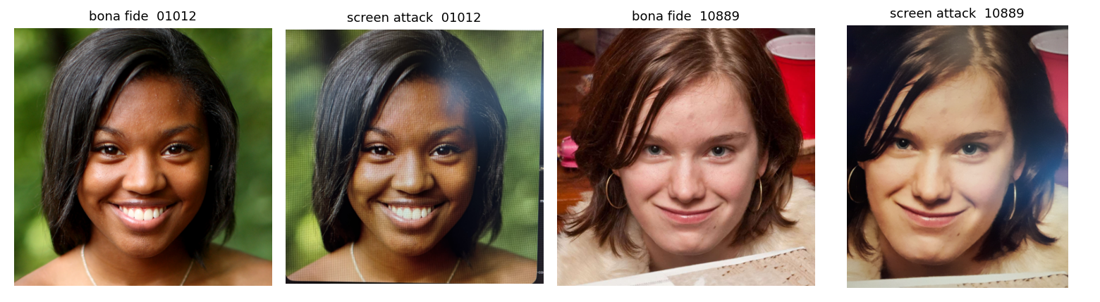
Figure 1. Two attack images with their bona fide twins. Same subject, same pose, same background; only the capture path differs.
What the bona fide images are. Tightly aligned faces with eyes at a consistent position, uniform size, no camera metadata, sequential ids. Everything about them says a public aligned-face dataset, not captures from the company's own camera. So in this data, bona fide does not mean a live person in front of a sensor. It means an original digital photo.
What the attack images are. Each is a hand-held phone photo of a screen displaying one specific bona fide image, hence the matching filenames. Twenty were hand-cropped afterwards to odd near-square sizes; three are untouched 48-megapixel frames. At least seven show a macOS Preview toolbar, so a Mac screen was one display. At full resolution the artefacts are obvious: a pixel grid and colour moiré, magenta and green casts, banding, reflections, and loss of skin pore detail. Photographed from further away or slightly out of focus, the grid vanishes and the image looks convincing.
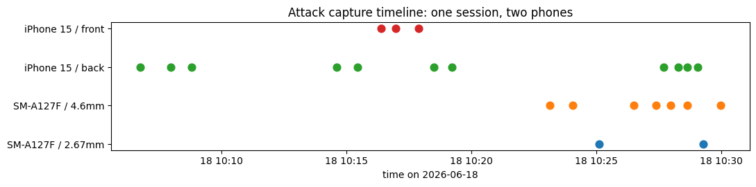
Figure 2. All 23 attacks were captured in one session with two phones. Capture phone is a nuisance variable, not a feature.

Shortcuts: what separates the classes but has nothing to do with screens
Property | Bona fide | Attack | Mitigation
Image dimensions | 1024 x 1024, always | 21 sizes, never 1024 | Resize everything to one size; never read dimensions
Aspect ratio | Exactly 1.0 | 0.85 to 1.33 | Face-detect, crop to a fixed square
Metadata | None | Always present | Strip on load; never read
File size | 0.9 to 2.1 MB | 4 to 37 MB | Never read
Framing | Precisely aligned | Hand-held, off-centre, UI chrome | Face-detect and crop, then verify with occlusion tests
Sharpness | Sharp, fine detail | Different (see below) | Partly physics, partly resolution; test on resampled bona fide
Colour cast | Neutral | Magenta or green tint | Partly physics; check against colour-jittered bona fide

Findings from the data itself
- Class balance is 1000 to 23. One attack is 4.3 % of its class. All attack-side rates are quantised at that step and need confidence intervals.
- Dimensions, metadata, and file size are perfect separators. A model that reads any of them gets a free perfect score on this data and an unknown score on the hidden set.
- Every attack is paired with its source image. Identity, pose, and background cannot be the signal. Pairs must stay on the same side of any train/validation split.
- The only held-out groups available are capture phone (14 vs 9), lens, cropped vs full frame, and visible toolbar vs not. All small, but holding out by phone is the most honest test we can run.
- If the hidden bona fide images are live phone captures, they will have metadata, odd sizes, hand-held framing, and a colour cast. Every shortcut then points the wrong way and real users get flagged. Nothing in this data lets us test that.

What the attacks look like at native resolution
The 2D Fourier transform rewrites an image as a sum of stripe patterns of every spacing and direction. Drawn as a picture, the centre is coarse shading, moving outward means finer detail, and brightness is strength. A natural photo fades smoothly from the centre. A screen's pixel grid is a perfectly regular pattern, so it appears as a lattice of sharp dots away from the centre.
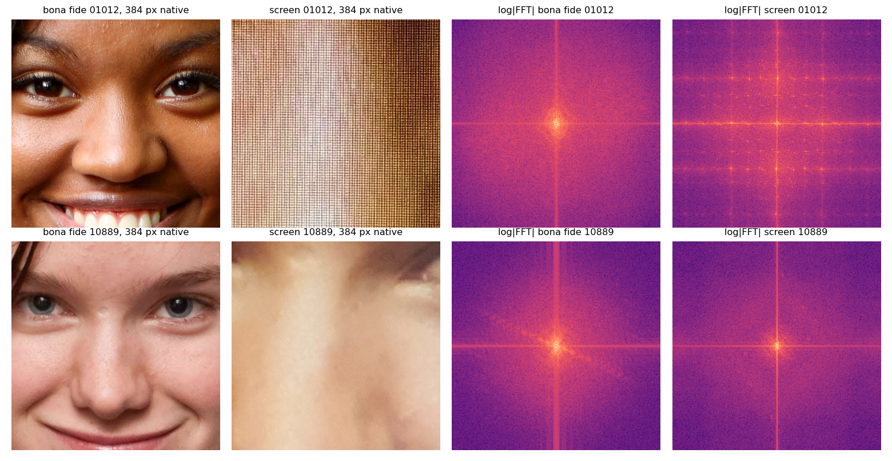
Figure 3. Fixed 384-pixel windows at native resolution and their log spectra. Top: a close-range attack with the grid resolved (lattice of dots). Bottom: a far-range attack with no lattice, which is the kind that looks real.
Findings from native-resolution texture
- The pixel grid is unmistakable in a handful of attacks and absent in most. It is a high-precision, low-recall cue.
- The cue only survives if native resolution is kept somewhere in the pipeline. Downsampling to a typical network input of 224 or 256 px destroys it.
- A fixed pixel window is the right unit for grid detection (grid period depends on camera-to-screen distance, not face size), but it covers a different fraction of the face in each class, so it is not a fair way to compare skin texture. Skin comparison uses a crop proportional to face size instead.

Classical PAD detectors as a baseline
Before training anything, sixteen hand-crafted detectors from the PAD literature (2004 to 2016) were implemented and applied. Each is one number computed from the face-normalised 512 px image, plus a rule. The rule is one-class: the threshold is the 2.5th and 97.5th percentile of the bona fide distribution, so BPCER is 5 % by construction, and an attack counts as flagged if it falls outside that band. Nothing is fitted to the attacks, so the miss rates are honest. AUC is reported in the direction the paper predicted, so a value below 0.5 means the attacks moved the opposite way.
Detector | Source | Predicted | AUC | Flagged / 23
High-pass residual energy | Galbally 2014 | lower | 0.27 | 8
Difference of Gaussians energy | Tan 2010 | lower | 0.26 | 7
Row banding (native) | refresh / rolling shutter | higher | 0.34 | 6
Laplacian variance | Galbally 2014 | lower | 0.31 | 5
Pixel noise | Galbally 2014 | higher | 0.70 | 4
Cr chroma spread | Boulkenafet 2016 | unspecified | 0.65 | 4
High-frequency energy ratio | Li 2004 | higher | 0.76 | 4
Cb chroma spread | Boulkenafet 2016 | unspecified | 0.74 | 2
Spectral peakiness (native) | Garcia 2015, Patel 2015 | higher | 0.72 | 2
Saturation spread | Wen 2015 | lower | 0.42 | 2
Colour diversity | Wen 2015 | lower | 0.30 | 2
LBP chroma distance | Boulkenafet 2016 | higher | 0.59 | 2
Specular ratio | Wen 2015 | higher | 0.36 | 1
Spectral peakiness (512 px) | Garcia 2015 | higher | 0.61 | 1
LBP gray distance | Maatta 2011 | higher | 0.52 | 1
Saturation mean | Wen 2015 | lower | 0.45 | 0

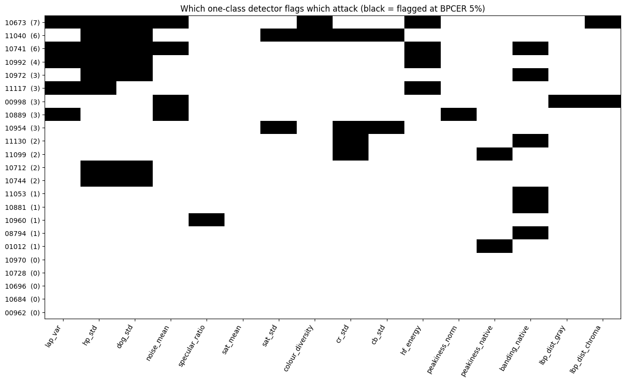
Figure 4. Which detector flags which attack at 5 % BPCER. Black is flagged. The number after each id is how many detectors caught it. Five attacks are caught by nothing.
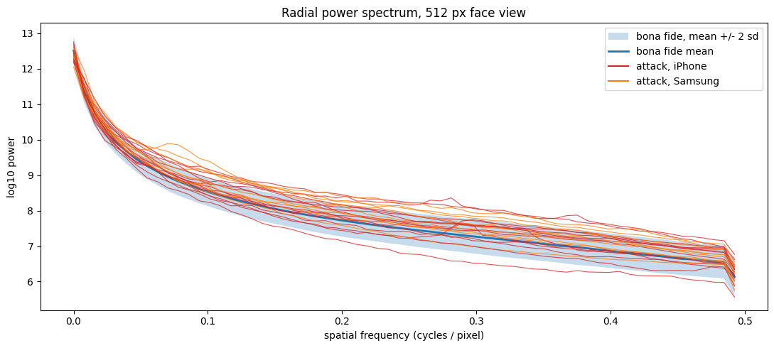
Figure 5. Power by spatial frequency for the 512 px face view. The band is where 95 % of bona fide images fall. Attack lines sit above it at high frequency: they have more fine-scale energy than any real photo, and isolated bumps are the pixel grid surviving downsampling.
Classical baseline: what it achieves
- Best single detector: 8 of 23 attacks at 5 % BPCER. The union of all sixteen flags 18 of 23 but rejects 44 % of bona fide images, so it is not a usable operating point.
- All sixteen features into one logistic regression (step 5, development folds): AUC 0.82 [0.73, 0.91], 12 of 19 attacks missed at 5 % BPCER. Trained on one phone and tested on the other: AUC 0.69 and 0.44. The features learned the camera, not the screen.
- Five attacks evade every detector (ids 00962, 10684, 10696, 10728, 10970). These are the far-range, slightly soft captures. They are the probe set for every later model.
- Chroma spread (Cr, Cb) is the only signal that behaves consistently across both capture phones. It is real but weak on its own.
- A learned model must beat AUC 0.82 on the development folds and, more importantly, must not collapse on the phone-transfer check. Those numbers, not a literature figure, are the bar.

The sharpness result is backwards, and that is a warning
- Every paper predicts replay attacks are blurrier than bona fide. Here they are sharper (AUC 0.27 in the predicted direction).
- Cause: the face crop downsamples attacks about 5x but bona fide about 2x, and heavy downsampling of a moiré-covered image concentrates aliased energy into the fine-detail band. Within the attacks, sharpness falls as the downsampling factor rises (correlation about -0.5).
- So the strongest classical signal is partly "photographed at 12 to 48 megapixels". A hidden set at a different resolution will not reproduce it. Any model that keys on sharpness has to be tested on bona fide images put through the same downsampling factor before it is believed.
- Capture phone also leaves a fingerprint: Samsung attacks have more residual energy and chroma spread, iPhone attacks more noise and clearer grid peaks. Phone must be a held-out group, never a feature.

Step 4. Splitting the data
The split has one job: make the validation number an honest forecast of the hidden-set number. Two properties of the data dictate how it must be done.
- Every attack has a bona fide twin. If the twin is in training and the attack in validation, the model can score "have I seen this face" instead of "is this a screen". Pairs always travel together.
- Two capture phones, one session. The hidden set will use a different camera at minimum. Phone is the condition to hold out.
- 23 attacks. A single held-out split would validate on about 5 attacks, so APCER could only take values in steps of 20 %. Every attack has to be validated at some point, which means cross-validation, not a single split.

The protocols, all stored in splits.csv
Protocol | What it is | Used for
Development 4-fold | Folds 0 to 3. Each holds out 4 or 5 attacks (mixed phones), their twins, and about 200 bona fide. Every attack validated once. | All model development and the headline numbers
Locked fold 4 | 4 attacks and 199 bona fide. Not loaded by any script during development. | Run once on the frozen final model, to check the development process did not fool itself
Phone transfer | Train on one phone's attacks, test on the other's, both directions, with a fixed bona fide validation subset. | The closest test we have to the hidden set

Fold | iPhone attacks | Samsung attacks | Bona fide
0 | 3 | 2 | 201
1 | 3 | 2 | 201
2 | 3 | 2 | 200
3 | 2 | 2 | 199
4 (locked) | 3 | 1 | 199

Rules written into the split file
- Pairs always share a fold. Fold 4 is untouched until the end.
- Any threshold, hyperparameter, or model choice is made inside the training folds only.
- Augmentation and any resampling (oversampling, SMOTE, synthetic attacks) happen after the split, inside the training fold. Validation folds are never resampled.
- There is no separate test set on purpose: with 23 attacks it would be too small to say anything, and the assignment's hidden set is a better test set than anything we could carve out.

What the split cannot test
- Even the phone-transfer check validates on attacks from the same room, same day, same display, same operator. It measures camera transfer only. A different screen, lighting, or attacker is untested.

Step 5. Baseline
A baseline is the simple thing you run before the real model, so that the real model's score means something. We keep one: the sixteen hand-crafted features from step 3 into a logistic regression. It is what a PAD team would have built ten years ago, it trains in seconds, and its weights can be read.

How it is computed
1. Each image goes through the loading pipeline (face crop, 512 px, no metadata) and becomes a row of sixteen numbers.
2. Four rounds: hold out one development fold, train on the other three, score the held-out fold. After four rounds every image has one score from a model that never saw it.
3. Inside each round the LBP reference histogram, the feature standardisation, and the regularisation strength are all fitted on the training images only.
4. The 820 scores are pooled and the step 2 metrics computed, with bootstrap intervals.
Run | AUC | APCER at BPCER 5 % | Attacks missed
Development 4-fold | 0.82 [0.73, 0.91] | 0.63 [0.42, 0.84] | 12 of 19
Train iPhone, test Samsung | 0.69 [0.57, 0.81] | 0.88 | 7 of 8
Train Samsung, test iPhone | 0.44 [0.23, 0.65] | 1.00 | 11 of 11

What the baseline establishes
- The bar: AUC 0.82 on the development folds, two thirds of attacks missed at 5 % friction.
- The classical features do not transfer across phones. Trained on Samsung and tested on iPhone the model is worse than chance. The features learned the camera, not the screen.
- Its largest weight is on "fewer bright colourless pixels", which is the flash highlights of the public photos disappearing after re-capture: a property of the bona fide photos, not of screens. That explains the collapse.
- Correction to step 3: the union of sixteen one-class detectors flagged 18 of 23 attacks, but rejected 44 % of bona fide images to do so. It was never a 5 % BPCER result. The honest classical figure is the one above.

Step 6. Input pipeline
Everything a model sees, at training and at inference, goes through pad_data.py. The same code path will run on the hidden set.

What happens to every image
1. Open, apply the EXIF rotation tag, convert to RGB, and rebuild from raw pixels so nothing but pixel values survives. Metadata is stored beside the pixels in the file, never in them, so this drops it completely.
2. Find the face with OpenCV's pre-trained Haar cascade. Found on 99.6 % of bona fide and 22 of 23 attacks; the rest fall back to the image centre.
3. Cut a square around the face at native resolution, 1.3 times the face width. The rule is relative to the face, so it does the same thing on any image size.
4. Produce exactly 36 patches of 128 x 128 pixels on a fixed grid for evaluation, or random positions for training. Patches overlap when the face region is small.
5. Optionally, a 256 px whole-face view for the anomaly experiment.
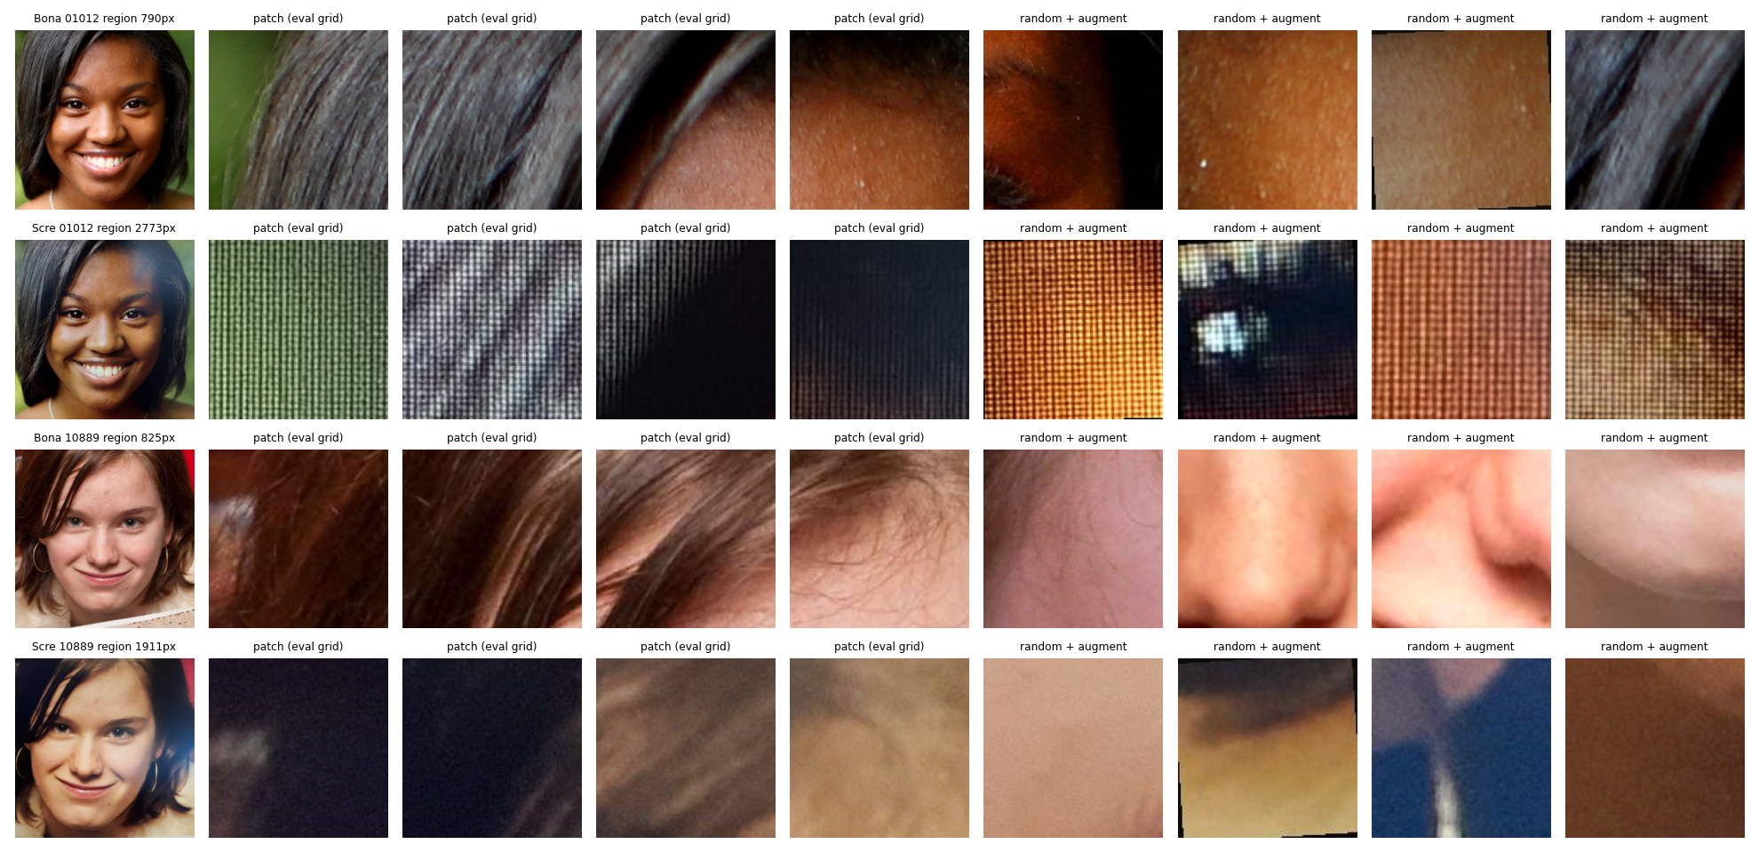
Figure 6. Two pairs through the pipeline: face region, four evaluation-grid patches, four random patches after augmentation. Top pair: close-range attack, grid visible in every patch. Bottom pair: far-range attack, patches are soft skin and nearly indistinguishable from bona fide.

Why patches at native resolution
The screen pixel grid, banding, and fine noise live at the camera's pixel scale. Resizing the whole face to 224 or 512 px averages them away (step 3). A 128 px patch keeps them. Patches also multiply the training data: 19 attack images become hundreds of attack patches.

Augmentation, applied to training patches of both classes
Mirror; rescale between 0.7x and 1.4x and crop back; tilt up to 5 degrees; brightness, contrast and saturation within 20 %; per-channel white balance shift; sensor noise; mild blur; JPEG recompression. Each simulates a way a different phone or distance would change the capture. Nothing adds a grid or a band, so bona fide images cannot acquire screen artefacts.
Leak check on what the model receives
- Every image yields the same tensor shape: 36 patches of 128 x 128 x 3. Width, height, aspect ratio, file size and metadata never reach the model.
- The patch count originally depended on face-region size, which would have given attacks 36 patches and 51 bona fide images fewer. Fixed: the count is constant.
- What still differs between the classes is inside the pixels, and it splits in two: the screen artefacts we want learned, and a resolution confound. The attacks were shot at 12 to 48 megapixels while the bona fide images are 1024 px, so a 128 px patch shows a smaller, smoother piece of face in attacks. No resizing rule removes that.

How the resolution confound is handled, and what it would take to remove it
- Rescale augmentation blurs the pore-scale cue. It narrows the gap, it does not close it.
- The phone-transfer check: the Samsung shot at lower pixel density than the iPhone, so transfer between them is partial evidence the model is not riding on resolution.
- A direct test (step 7): downsample the attack face regions to bona fide pixel density at evaluation time and watch the score. If it collapses, the model was keying on resolution.
- The only real fix is data where bona fide and attacks were captured through the same camera at the same resolution. That is a with-more-data item.

Step 7. Experiments
The model under test is a patch CNN: an ImageNet-pretrained MobileNetV3-small backbone with a single-output head, applied to each 128 px patch, giving one attack probability per patch. The image score is the mean of its 36 patch probabilities. The first seven feature blocks are frozen to fit the CPU budget (35 patches per second against 23 fully fine-tuned); each run trains for 3 epochs with 3 random patches per image per epoch. Imbalance is handled by repeating each attack image 20 times per epoch so roughly a third of training patches are attacks.
Experiment | Trained on | Question it answers
Anomaly detection | bona fide only | Can "unlike normal" find screens without any attack labels?
Patch CNN, no augmentation | development folds | What does the model reach when nothing stops it using resolution cues?
Patch CNN, rescale augmentation only | development folds | Does removing the pore-scale cue cost accuracy? If yes, the model was using it.
Patch CNN, full capture augmentation | development folds | Does simulating camera variation help transfer?
Density-matched evaluation | reuses the saved models | Direct test: downsample attacks to bona fide pixel density at test time and watch the score.
Phone transfer | one phone, tested on the other | Does the model survive a camera change?
Face-normalised resolution | development folds, all faces resized to 865 px | What is learnable when the density cue is removed by construction, at training and at test?
Wide downscale augmentation | development folds, native resolution | Can the model keep the native-resolution ceiling while learning to cope with attacks at bona fide density? Training patches are shrunk by 0.35x to 1.0x; inference stays native.

All experiments share the folds, the locked fold 4, the metrics module, and the input pipeline. Results are written to results/*.json with per-image scores beside them.

Results
Run | Protocol | AUC | APCER at BPCER 5 % | Missed
Classical baseline (step 5) | development 4-fold | 0.82 [0.73, 0.91] | 0.63 | 12 of 19
Patch CNN, no augmentation | development 4-fold | 1.00 [1.00, 1.00] | 0.00 | 0 of 19
Patch CNN, rescale only | development 4-fold | 1.00 [1.00, 1.00] | 0.00 | 0 of 19
Patch CNN, full augmentation | development 4-fold | 1.00 [1.00, 1.00] | 0.00 | 0 of 19
Patch CNN, full aug. | train iPhone, test Samsung | 0.99 [0.97, 1.00] | 0.00 | 0 of 8
Patch CNN, full aug. | train Samsung, test iPhone | 1.00 [0.99, 1.00] | 0.00 | 0 of 11
Classical baseline | train iPhone, test Samsung | 0.69 [0.57, 0.81] | 0.88 | 7 of 8
Classical baseline | train Samsung, test iPhone | 0.44 [0.23, 0.65] | 1.00 | 11 of 11
Patch CNN, no aug., density-matched | development 4-fold | 0.88 [0.80, 0.94] | 0.53 | 10 of 19
Patch CNN, full aug., density-matched | development 4-fold | 0.90 [0.82, 0.96] | 0.42 | 8 of 19
Patch CNN, face-normalised resolution | development 4-fold | 0.96 [0.91, 0.99] | 0.16 | 3 of 19
Patch CNN, face-normalised resolution | train iPhone, test Samsung | 0.69 [0.59, 0.78] | 1.00 | 8 of 8
Patch CNN, face-normalised resolution | train Samsung, test iPhone | 0.72 [0.58, 0.86] | 0.82 | 9 of 11
Patch CNN, wide downscale aug. | development 4-fold | 1.00 [1.00, 1.00] | 0.00 | 0 of 19
Patch CNN, wide downscale aug., density-matched | development 4-fold | 0.95 [0.88, 0.99] | 0.26 | 5 of 19
Patch CNN, wide downscale aug. | train iPhone, test Samsung | 0.99 [0.97, 1.00] | 0.13 | 1 of 8
Patch CNN, wide downscale aug. | train Samsung, test iPhone | 1.00 [1.00, 1.00] | 0.00 | 0 of 11
Anomaly, classical features | development 4-fold | 0.70 [0.58, 0.81] | 0.68 | 13 of 19
Anomaly, whole-face embedding | development 4-fold | 0.58 [0.47, 0.70] | 1.00 | 19 of 19
Anomaly, mean patch embedding | development 4-fold | 0.80 [0.69, 0.90] | 0.58 | 11 of 19

Reading the results
- The patch CNN saturates the development folds under every augmentation policy, so those folds can no longer tell policies apart. The decision has to come from the transfer and density tests.
- Phone transfer is the headline. Trained on one phone and tested on the other, the patch CNN keeps AUC 0.99 and misses no attacks at 5 % BPCER in either direction. The classical baseline on the same protocol collapses to 0.69 and 0.44. This is the first evidence the model learned the screen rather than the camera.
- The density-matched test is the honest ceiling for far-range attacks. Downsampling attacks to bona fide pixel density drops AUC to 0.90 and lets 8 of 19 through. That test removes the resolution confound and also physically erases the pixel grid, so it is a lower bound on far-range performance rather than a pure measure of the confound. Even so, AUC 0.90 with no resolution advantage beats the classical baseline with it.
- Two follow-up experiments separate the two effects. Face-normalised resolution, where every face is resized to 865 px at training and test, removes the density cue by construction: the model still reaches AUC 0.96 and misses only 3 of 19 on the development folds, so the earlier 0.90 understated what is learnable without the density gap. But the same model collapses on the phone transfer (AUC 0.69 and 0.72, like the classical baseline). Read together: the screen cues that survive downsampling are the ones that do not transfer across cameras (colour cast, noise texture), and the cues that transfer (grid, moire, banding) only exist at native resolution. Normalising resolution to the bona fide level trades a resolution shortcut for a camera shortcut.
- Wide downscale augmentation is the middle path and it works. Training patches are randomly shrunk by 0.35x to 1.0x so the model sees attacks at bona fide density during training, while inference stays native. It keeps the native ceiling (AUC 1.00, 0 missed), is the most robust of all models under the density test (AUC 0.95, 5 of 19 missed, against 8 for full augmentation and 10 for none), and keeps the phone-transfer strength (AUC 0.99 and 1.00, one Samsung attack missed at 5 % BPCER). This is the chosen model.
- The five attacks the chosen model misses under the density test are all Samsung, far-range captures. They are the error-analysis set for step 9.
- Anomaly detection does not work here, as predicted in the models-set-aside table. Its best variant reaches AUC 0.80 and still misses more than half the attacks; the whole-face embedding version is at chance. The supervised patch model is necessary.

Models considered and set aside
Model | Why not for this prototype
Whole-face CNN at 224 px | A 3000 px attack face squeezed to 224 px is a 13x downsample. Grid, banding and fine noise are gone before the network sees anything; what remains (colour cast, blur, framing) is what the classical model learned and failed to transfer.
Foundation-model features (DINOv2, CLIP) | Same resolution problem, plus a worse one: these models were trained to be invariant to blur, colour jitter and rescaling. Their features describe what is in the picture, not how it was captured. We need the opposite.
U-Net / pixel-wise supervision | A valid PAD approach (predict a per-pixel screen-ness map, average it). It is the patch method expressed as one network, with more capacity than 19 attacks can constrain. Worth revisiting as an explanation tool: a map of where on the face the model sees the screen.
Auxiliary depth supervision | Strong in the literature (screens are flat), but needs depth labels or pseudo-depth. Beyond a 4-day prototype; a with-more-time item.
Anomaly detection as the main model | Run as an experiment, not chosen. Our bona fide set is a public photo collection, so "unusual" means "not like a stock portrait", which would flag a real user's selfie. And every attack is a small perturbation of a normal image, which anomaly detectors are not built for. The sixteen one-class detectors in step 3 already showed this: 18 of 23 attacks caught at the cost of 44 % of bona fide.

Step 9. Error analysis and what the model keys on
Every development image was scored by the fold model that did not train on it, at native resolution and with one physical cue removed at a time: blur (removes fine detail), grayscale (removes colour), shrinking to 865 px (removes density and grid), a median filter (removes noise). The drop in attack score says how much of the score depended on that cue. A second tool is the map of the 36 patch scores drawn over the face, which shows where the model sees the screen. Both are in experiments.ipynb with every missed attack shown individually.
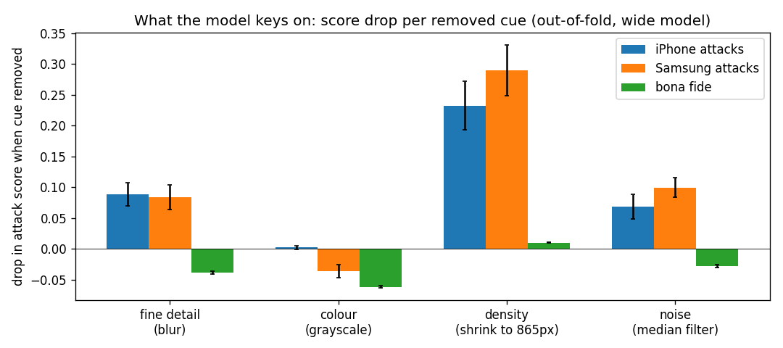
Figure 7. Mean drop in attack score when one cue is removed, per group. Shrinking (density plus grid) dominates; colour contributes nothing to attack detection and slightly helps recognise bona fide.
Cue removed | iPhone attacks | Samsung attacks | Bona fide
Density and grid (shrink) | 0.23 | 0.29 | 0.01
Fine detail (blur) | 0.09 | 0.08 | slightly up
Noise (median filter) | 0.07 | 0.10 | slightly up
Colour (grayscale) | 0.00 | slightly up | up 0.06

Errors and cues
- At native resolution no attack is missed at 1 % or 5 % BPCER, but the weakest attacks score 0.65 to 0.68 against a 1 % threshold of 0.59, and three bona fide images score above the weakest attack. The margin is thin.
- The five attacks that get through under the density test are all Samsung, and they were already the five weakest at native resolution. Their patch maps show the screen found in hair, glasses and edges at 0.8 to 0.95, and smooth skin at 0.1 to 0.4. Far-range smooth skin gives the model nothing.
- The dominant cue is fine-scale structure that vanishes when shrunk: grid, moire, aliasing. Colour is not used to detect attacks, which is the cue the classical model collapsed on across cameras.
- The bona fide images the model likes least share harsh lighting and fabric textures near the face. Real users will bring both, so this is a stated risk.
- Two follow-ups worth one run each: a whole-face branch for flatness and uniform focus, which patches cannot see, and a top-k patch aggregation, which would lift the far-range misses but also the hat-weave false alarms.

Step 8. The final model, in plain terms
In one sentence: a small neural network looks at 36 small squares cut from the face at full resolution, decides for each square whether it sees screen texture, and averages those 36 answers into one attack score.

What happens to one incoming image
1. Find the face and cut a square around it at the image's own resolution. No resizing.
2. Cut 36 patches of 128 x 128 pixels from that square on a fixed grid.
3. Run each patch through a MobileNetV3-small network, pretrained on ImageNet and fine-tuned by us, which outputs a number between 0 and 1: how much this patch looks like a photograph of a screen.
4. Average the 36 numbers. That is the image's attack score. Higher means attack.

How it was trained
- On the 19 development attacks and 801 bona fide images, folds 0 to 3, with attacks repeated so the network sees them often enough.
- Every training patch was randomly altered: mirrored, tilted, brightened, colour-shifted, blurred, noised, JPEG-compressed, and shrunk by anywhere from nothing to 0.35x. The shrink is what stops the model relying on attacks simply having more pixels.
- The first seven blocks of the network stay at their ImageNet weights; the rest is fine-tuned. Three epochs, three random patches per image per epoch, on a laptop CPU.

What it detects
Fine-scale texture the camera resolved from the screen: the pixel grid and moire above all, fine noise second. It does not use colour: removing colour from an attack leaves its score unchanged. It cannot use image size, file size, or metadata, because none of them reach it.
What we know about it
- Perfect on our own data (AUC 1.00, no attacks missed at 5 % BPCER), and still strong when trained on one phone and tested on the other (AUC 0.99 and 1.00), which is the closest test we have to the hidden set.
- Weakest on far-range captures where the grid was never recorded: with attacks shrunk to bona fide pixel density it lets 5 of 19 through at 5 % BPCER. Those five are all Samsung captures; the model finds the screen in hair and edges and has nothing on smooth skin.
- Its false-alarm risk is real faces under harsh lighting or with fabric textures near the face. Three bona fide images recur at the top of every model's bona fide list: a stage-lit face, a woven hat with sunglasses, a flash-lit face with a colour cast.
- The margin is thin at the strict end: the weakest attacks score 0.65 to 0.68 and the 1 % BPCER threshold is 0.59.

Locked fold 4, run once on the frozen model
- The final model was trained on all 820 development images and scored the 203 locked images (4 attacks, 199 bona fide) exactly once. AUC 0.999 [0.99, 1.00]; no attack missed at 5 % BPCER.
- At the thresholds fixed from development data, without re-tuning: the 5 % threshold gives BPCER 2.5 % and catches all 4 attacks; the 1 % threshold gives BPCER 0.5 % and misses 1 of 4. So the thresholds transfer to unseen images from the same source, and the strict operating point is where the margin runs out, as step 9 predicted.
- Four attacks is too few for the number to be a headline. Its job was to check that the development process had not fooled itself, and it agrees with the development folds.

Artefacts for inference
artefacts/model.pt (the weights), artefacts/config.json (patch size, count, aggregation, normalisation constants, and the operating thresholds derived from the out-of-fold development scores at 1 %, 5 % and 10 % BPCER). The inference script applies exactly the step 6 pipeline and writes one score per image; thresholds are provided but not applied, because the operating point is the deployer's decision (step 1).

Checklist against the brief
The brief asks for | Status | Where
How did you set the problem up? | done | Steps 1 and 2: framed as single-image screen-replay scoring, generalisation as the target, APCER at fixed BPCER as the headline
How did you convince yourself the results are real? | done | Step 4 splits (pairs together, phone held out, fold 4 locked), step 5 baseline, density and transfer tests in step 7, bootstrap intervals throughout
How much do you trust them? | done | Stated per result: development numbers saturate and are not trusted alone; transfer and density tests carry the weight; 19 attacks means wide intervals
What is your method keying on? | done | Step 9 cue ablation and patch-score maps: resolved screen texture, not colour
Where might it break? | done | Far-range captures, live bona fide captures, unseen displays, harsh lighting and fabric textures, the face detector
With more time and data, what would you do? | done | Bona fide captured through the same phones; several displays and distances; whole-face branch for far-range; stronger face detector; auxiliary depth
README | to do | setup, how to run, assumptions, dependencies
Dockerfile | to do | CPU image with the pinned environment; build and run infer.py
Inference code | written, tested on the locked fold | infer.py: folder of images in, CSV of scores out, using pad_data.py unchanged
Artefacts | done | artefacts/model.pt, artefacts/config.json with thresholds at 1 %, 5 % and 10 % BPCER
Short technical report | to condense | This document is the working record. The submitted report should be a short version organised around the five questions above, with this as an appendix
Repo and Google Drive doc | to do | put everything in a repo, report as a Drive doc, share the link

Step 10. Threshold, latency, and the trade-offs
All numbers here are for the chosen model and involve no retraining. Operating points are read off the 820 out-of-fold development scores and then applied unchanged to the locked fold as a spot check. The knobs are scored out-of-fold with the four development fold models.

Operating point: real people flagged versus attacks passed
Threshold chosen by | Score | Dev: real flagged of 801 | Dev: attacks passed of 19 | Fold 4: real flagged of 199 | Fold 4: attacks passed of 4
BPCER 0.5 % | 0.63 | 4 | 0 | 1 | 1
BPCER 1 % | 0.59 | 8 | 0 | 1 | 1
BPCER 2 % | 0.53 | 16 | 0 | 1 | 0
BPCER 5 % | 0.43 | 40 | 0 | 5 | 0
BPCER 10 % | 0.37 | 80 | 0 | 18 | 0
Zero attacks passed on dev | 0.65 | 3 | 0 | 1 | 1

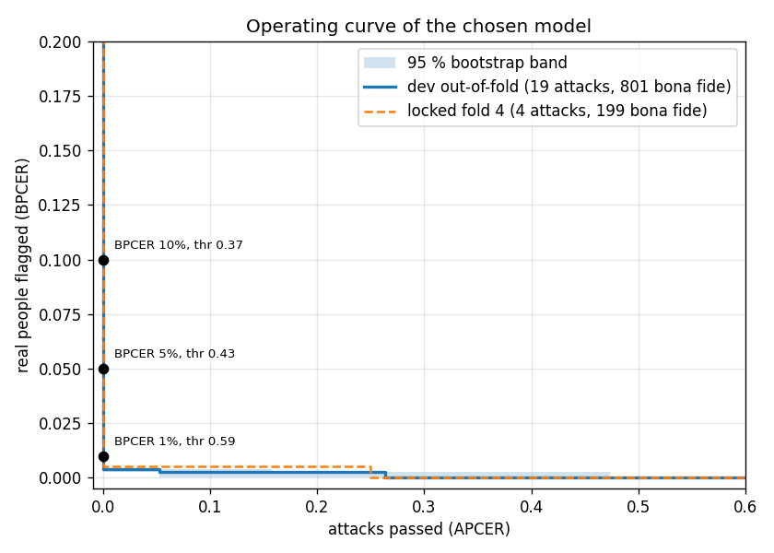
Figure 8. Operating curve: real people flagged against attacks passed, for every threshold. Solid: development out-of-fold with bootstrap band. Dashed: locked fold. Dots: the thresholds shipped in config.json.
Reading the operating point
- On the development scores every attack sits above every threshold down to 0.65, so the curve hugs the axis: the trade-off only starts at 3 real people flagged in 801. The bootstrap band is wide at the strict end because 19 attacks cannot pin down the tail.
- On the locked fold the thresholds transfer: 5 % gives 2.5 %, 1 % gives 0.5 %. One of the four attacks scores 0.55 and is missed by every threshold above 0.53. That single image is the honest picture of the strict end.
- Recommendation for the deployer: 0.43 (5 % BPCER) as the default, which flags about 1 real person in 20 and passed no attack in either set. 0.53 (2 % BPCER) if friction matters more, at the cost of the far-range tail. Anything above 0.59 buys almost no friction and starts passing attacks. All three are in config.json; infer.py reports them and applies none.

Latency: where the time goes
Input | Decode | Face detect | Crop and patches | Network (36 patches) | Total
1024 px, 1 MP (bona fide) | 0.02 s | 0.06 s | 0.01 s | 0.25 s | 0.35 s
1700 to 2700 px, 3 to 7 MP | 0.10 s | 0.06 s | 0.01 s | 0.26 s | 0.45 s
2800 to 4300 px, 8 to 16 MP | 0.23 s | 0.08 s | 0.01 s | 0.24 s | 0.57 s
5712 px, 24 MP | 0.63 s | 0.15 s | 0.02 s | 0.36 s | 1.10 s

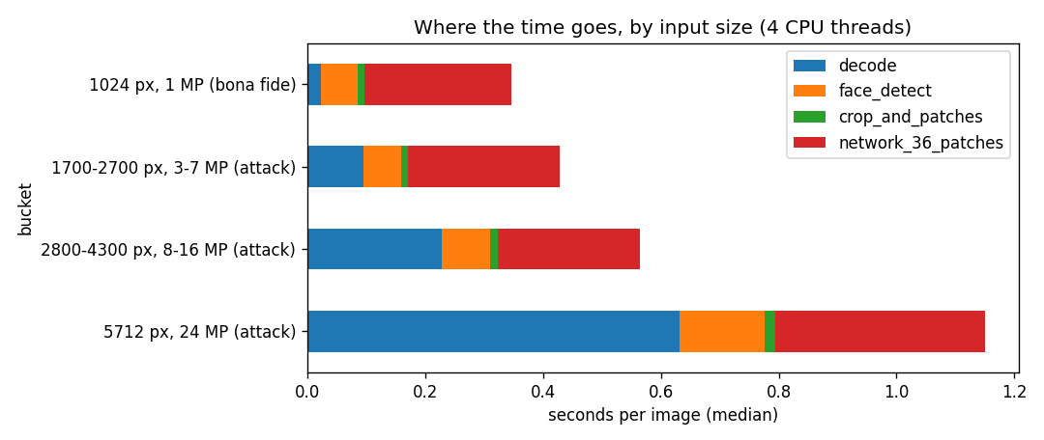
Figure 9. Median seconds per image on a laptop CPU with 4 threads. The network cost is constant because every image yields 36 patches; decode grows with megapixels.
- Between 0.35 and 1.1 seconds per image on a laptop CPU. The network is a fixed 0.25 s; the rest is PNG decoding, which scales with file size and is the only part that grows.
- Threads barely matter for one image (0.33 s at 1 thread, 0.28 s at 4): the batch of 36 patches is small. Throughput comes from scoring images in parallel, not from more threads per image.
- Face detection is 0.06 to 0.15 s and is the weakest link for quality, not for speed.

Time versus accuracy: the knobs
Knob | Setting | AUC | Attacks passed at 5 % BPCER | Seconds per image
Patches per image | 4 | 0.988 | 0 of 19 | 0.13
 | 9 | 0.999 | 0 of 19 | 0.15
 | 16 | 0.999 | 0 of 19 | 0.20
 | 36 (shipped) | 0.999 | 0 of 19 | 0.25
Input resolution cap | 512 px | 0.871 | 9 of 19 | 0.31
 | 865 px | 0.945 | 5 of 19 | 0.27
 | 1500 px | 0.998 | 0 of 19 | 0.24
 | native (shipped) | 0.999 | 0 of 19 | 0.25
Aggregation | mean (shipped) | 0.999 | 0 of 19 | 0.25
 | median | 0.999 | 0 of 19 | 0.25
 | top-9 mean | 0.994 | 0 of 19 | 0.25
 | top-4 mean | 0.984 | 1 of 19 | 0.25
 | max | 0.953 | 8 of 19 | 0.25

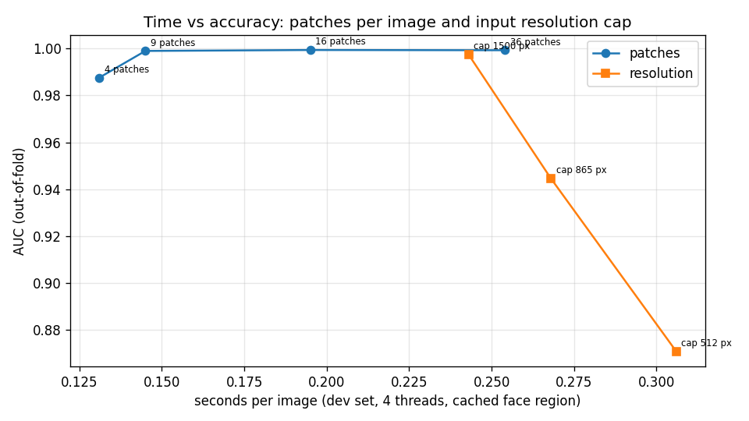
Figure 10. Patches per image and input resolution cap, plotted as seconds against AUC. Fewer patches cost little; lower resolution costs a lot.
What the knobs say
- Patches: 9 patches give the same AUC as 36 at 40 % of the time. Kept at 36 because the extra patches cost 0.1 s and buy stability of the score, not accuracy, and because the far-range misses depend on the few patches that land on hair and edges, which a 3 x 3 grid can skip.
- Resolution: this is the knob that matters. Capping the face region at 1500 px costs nothing; capping at 865 px passes 5 of 19 attacks; 512 px passes 9. Do not downscale inputs to save time; the time saved is nil (decode dominates and happens before the cap) and the accuracy lost is the screen grid.
- Aggregation: mean and median are equal. Top-k and max trade attack recall for false alarms in the wrong direction: max passes 8 of 19 because it also fires on hat weave and highlights in bona fide images and the threshold has to rise to compensate. The far-range misses will not be fixed by aggregation; they need cues the patches do not carry.
- Threads: no lever. Parallelise across images instead.

Roads not taken: other methods we could have chosen
Each was considered against the same three questions: does it use information that survives a camera change, can 23 attacks constrain it, and can it be built and explained in the time available. Where an idea is promising with more data, it is marked as such.

Generative models: fine-tuning a GAN or a diffusion model
Two distinct uses exist, and they should not be confused.
- As a data generator. Fine-tune a GAN or diffusion model on the 23 attacks to produce synthetic screen attacks, then train the detector on real plus synthetic. This is the textbook answer to a 23-example class, and it is the wrong first move here. A generator trained on 23 images cannot learn the physics of moire and banding; it learns the 23 images. Synthetic attacks would then carry the generator's own signature, and a detector trained on them learns to detect the generator. The literature result is consistent: GAN-augmented PAD helps when the seed set has hundreds of examples across several devices, and hurts or does nothing below that. A physics-based simulator of re-capture (render the image onto a virtual pixel grid, add refresh banding, colour-shift, re-sample through a camera model) is the version of this idea that does not need to learn from 23 images, and it is the one we would build first with more time.
- As an anomaly detector. Train a GAN on bona fide only and score how badly it reconstructs an input (AnoGAN and successors). Same objection as anomaly detection in step 7: our bona fide set is a public photo collection, so poor reconstruction means "not like a Flickr portrait", which would flag a real user's selfie. And the attacks are small perturbations of bona fide images, which reconstruction-based detectors absorb rather than reject.
- Verdict. Not for this prototype. Worth revisiting as a data generator once a few hundred attacks across several displays exist, and only with the synthetic samples held out of every validation set.

Other detector families
Method | What it would add | Why not now
Two-stream network: RGB patches plus their Fourier magnitude | Targets the grid directly in the frequency domain, where it is a lattice of peaks | The patch CNN already keys on resolved grid texture (step 9). A second stream doubles the capacity on 19 attacks. The cheapest next experiment if far-range recall must improve.
Whole-face branch fused with the patch score | Flatness, uniform focus, colour gamut, bezels: image-level cues patches cannot see | Candidate B from step 7. The right fix for the far-range misses; deferred because the patch model alone already met the bar and the fusion needs more attacks to tune.
Auxiliary depth supervision (CDCN family) | Forces the network to learn that screens are flat | Needs depth labels or pseudo-depth from a 3D face model. Beyond 4 days; the strongest literature approach with more time.
Domain-generalisation training (adversarial domain alignment, meta-learning across capture devices) | Explicitly penalises camera-specific features | Needs several source domains to align. We have two phones and one display. Becomes viable exactly when the data does.
Self-supervised pretraining on unlabelled face captures | A backbone that already knows what a phone camera's skin looks like, instead of ImageNet objects | No unlabelled captures were provided; the public bona fide set is the wrong domain. A day's work once live captures exist.
Vision transformer or foundation-model features (DINOv2, CLIP) | Strong general features | Trained at 224 px and trained to be invariant to blur, colour and rescaling: blind by design to the cues we need (step 7).
Pixel-wise supervision (U-Net style screen-ness map) | A per-pixel map of where the screen is, useful for explanation | The patch method expressed as one network, with more capacity than 19 attacks constrain. Worth adding as an explanation tool, not as the detector.
Classical features at native resolution, or a larger hand-crafted set, into gradient boosting | A stronger classical baseline | Would raise the step 5 bar somewhat; would not fix the camera-transfer collapse, which is a property of the features, not the classifier.
Ensembles and test-time augmentation | A few points of robustness for free at inference | Multiplies latency by the ensemble size. Reasonable once the operating point is chosen; not a substitute for a better single model.
Temporal liveness (blink, motion, remote pulse) | The strongest replay defence in practice | The input is single images. Out of scope by the brief.

Decisions carried forward
1. Loading pipeline, identical for training and inference: open, apply EXIF rotation, convert to RGB, rebuild from pixels, detect the face, crop a native-resolution square around it, 36 patches of 128 px. Centre crop as the fallback when no face is found.
2. Never used by any model: dimensions, aspect ratio, file size, metadata, patch count.
3. Splits: development 4-fold grouped by pair and stratified by phone; fold 4 locked; phone transfer as the honesty check; no separate test set by design.
4. Baseline to beat: classical AUC 0.82 on the development folds, and no collapse on the phone-transfer check.
5. Model: patch CNN with full capture-variation augmentation plus wide downscale (0.35x to 1.0x) on training patches, native resolution at inference, mean of 36 patch probabilities, class balance by repetition. Chosen on the phone-transfer and density-matched results, not on the saturated development folds.
6. Report framing: the learned boundary is original-versus-recaptured; live bona fide captures and unseen displays are the top stated risks; print attacks are out of scope.
Still to do: infer.py, the Dockerfile and the README; the short submitted report; the repo and Drive doc.

Reproducibility
Every number and figure comes from files in the project folder. data_analysis.ipynb is the step 3 analysis and runs end to end on the dataset. make_splits.py writes splits.csv and splits.json (seed 20260905). pad_metrics.py is the metrics module. baselines.py is step 5. pad_data.py is the step 6 pipeline and writes faces.csv and the face-region cache. train_patch_cnn.py and anomaly.py are the step 7 experiments; run_experiments.sh runs them in order. Environment: Python 3.9, pillow, numpy, pandas, matplotlib, scikit-learn, opencv-python-headless 4.x, torch and torchvision (CPU). The face detector is OpenCV's pre-trained Haar cascade, used only to locate the face; every attack-scoring model is trained here.

