Screen Attack Detection Prototype
Steps 1 to 3: problem framing, metrics, data understanding
Arushi Agrawal | 5 September 2026 | working report, not final

Summary
The task is a small presentation attack detection (PAD) prototype that scores face images for screen replay attacks, with the strong hint that it will be graded on images we have not seen. This report covers the three steps taken before any model is trained: framing the problem, choosing the metrics, and understanding the data. Each step ends with its decisions recorded so that later choices can be traced back to a reason.
Five things to know before reading further
- The data is 1000 bona fide images and 23 screen attacks. Every attack is a phone photo of a screen showing one of the bona fide images, so the pairs differ only in the capture path.
- The bona fide images are a public aligned-face dataset, not live captures. The boundary we can learn is original photo versus re-captured photo.
- Image size, file size, and metadata separate the classes perfectly and have nothing to do with screens. They must be removed before any model sees the data.
- Sixteen classical PAD detectors from the literature catch 18 of 23 attacks between them, but the best single one catches 8 and the strongest signal is a resolution artefact.
- The headline metric is APCER at fixed BPCER, with the worst held-out capture condition reported rather than the average, because the hidden set will differ from ours.

Step 1. Problem framing
The brief is one sentence: build a small PAD prototype that reads images and outputs an attack score per image. The supporting document adds that the solution may be tested on a hidden set of images. Everything else is left to us, so the first job is to write down what the brief fixes, what it leaves open, and what we decided for each open point.

What the brief fixes
- Input: single images, not video. Temporal liveness cues such as blink or pulse are unavailable.
- Output: a continuous attack score per image, not a label. Thresholding is the deployer's decision, so we evaluate ranking quality and the error trade-off, not accuracy at one cutoff.
- Scale: a prototype. A clean, explainable, reproducible pipeline beats a fragile high score.
- Generalisation: a hidden test set. Transfer to unseen images is the graded quantity, not our own validation number.

What the brief leaves open, and what we decided
Open question | Decision
Which modality and attack types | Face PAD. Attack scope is whatever the data contains (screen replay). Any other attack type is stated as out of scope, not implied to be handled.
Score direction | Score in [0, 1], higher means more likely an attack. Written down because a flipped convention is the most common PAD handover bug.
Which error is worse | Not decided by us. Report the full trade-off and quote performance at conventional operating points; the deployer picks.
Deployment constraints | None given. Assume offline or server-side scoring with no hard latency budget, but record model size and time per image.
Input format | Inspect the data before deciding whether face detection is part of the pipeline (it is; see step 3).
What the hidden set looks like | Design for new capture conditions with the same attack type. Be explicit that new attack types are not covered.
Definition of done | A script that reads a folder and writes a CSV of scores, a Dockerfile, a short report, and a decision log.

Assumptions made in step 1
- The hidden set contains screen replay attacks and bona fide images of the same general kind, but possibly from different cameras, screens, subjects, and resolutions.
- No latency or on-device constraint applies to the prototype.
- Bona fide in this task means an original digital photo, because that is what the data provides (see step 3). If the hidden set uses live captures, this assumption fails and is the top stated risk.

The framed problem in one paragraph. Binary scoring of single face images as bona fide or screen replay attack, output in [0, 1] with higher meaning attack. Attack types limited to those in the training data and stated as such. Primary objective is transfer to unseen images under unseen capture conditions, so validation imitates that, every feature and model choice is filtered for shortcut risk, and the headline metric is the worst case across held-out conditions. Operating point left to the deployer.

Step 2. Metrics
Three different questions get confused under the word metric: what we report, what we use to pick between candidate models, and what the training loss optimises. They are kept separate.

Reported metrics (ISO/IEC 30107-3 vocabulary)
Metric | Meaning | Why it is here
APCER | Fraction of attacks wrongly accepted as real | The security failure. Reported per attack type, worst one flagged.
BPCER | Fraction of real users wrongly rejected | The friction failure.
APCER at fixed BPCER | Attack miss rate when friction is capped at 1 % or 5 % | The headline. Matches how a deployer thinks: fix the annoyance budget, ask how secure that leaves you.
EER | Point where APCER equals BPCER | Standard threshold-free summary. Reported because reviewers expect it; not an operating point anyone deploys at.
ROC AUC and DET curve | Ranking quality across all thresholds | For comparing candidate models. The curve matters more than the number: two models with equal AUC can differ in the low-BPCER region we care about.
Bootstrap confidence intervals | Range of the above under resampling | With 23 attacks every attack-side rate moves in steps of 4.3 %, so a point estimate alone would overstate precision.

Why not accuracy, precision, or recall
Recall on the attack class is one minus APCER, the same quantity. BPCER is the false positive rate, which precision and recall ignore. Precision depends on how many attacks are in the test set: the same detector shows 98 % precision on a balanced set and under 5 % precision when attacks are one in a thousand. APCER and BPCER are computed within each class, so they transfer to a hidden set with a different attack ratio. Accuracy at a single threshold hides the trade-off entirely and is dominated by the majority class.

Decisions
Purpose | Choice
Headline | APCER at BPCER 1 % and 5 %, plus EER, all with bootstrap intervals
Model comparison | Worst held-out-condition APCER at fixed BPCER; tie-break on mean AUC
Training objective | Weighted binary cross-entropy (a smooth proxy; APCER is monitored, not optimised directly)
Sanity checks | Reliability diagram across held-out conditions, to see whether the score is over-confident on new devices

Floors that every model must beat
- A constant score: AUC 0.5, EER 50 %. The trivial floor.
- A metadata-only scorer using image dimensions, file size, or EXIF. If this scores well, the dataset has a shortcut and every later number is suspect until the model is shown not to use it. Step 3 confirms it would score perfectly here.
- The classical hand-crafted detectors in step 3, which set the bar a learned model has to clear to justify its complexity.

Step 3. Data understanding

What is in the folder
 | Bona fide | Screen attacks
Count | 1000 | 23
Dimensions | 1024 x 1024, every image | 21 distinct sizes, 1723 to 5712 px, none square
File size | 0.9 to 2.1 MB | 4 to 37 MB
Metadata | None | Full EXIF, GPS, XMP, ICC profile
Filenames | 5-digit ids, 962 to 28090 | 23 ids, every one also present in bona fide
Capture | Unknown; tightly aligned face crops | iPhone 15 (14) and Samsung A12 (9), one 24-minute session on 18 June 2026

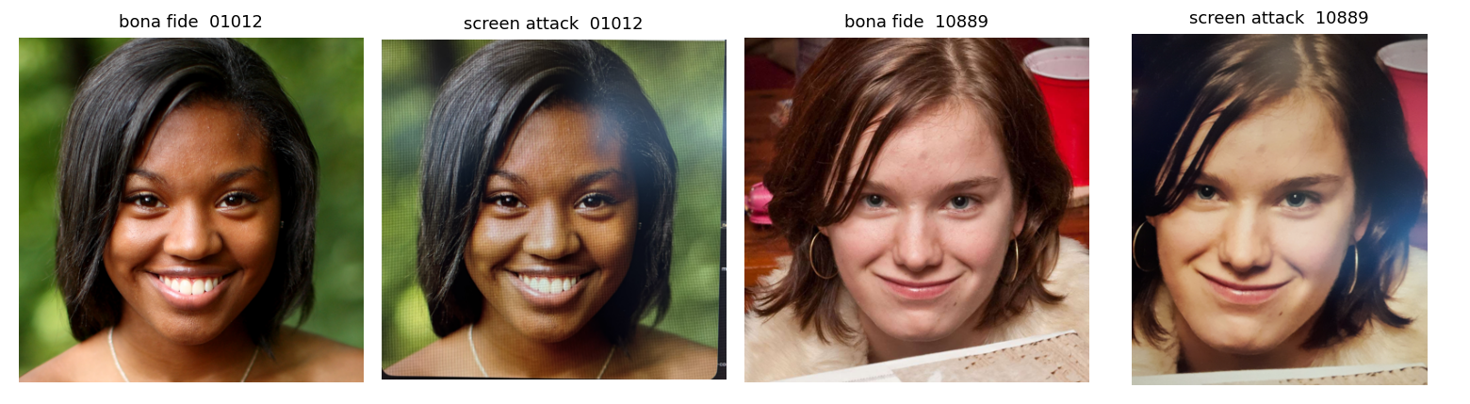
Figure 1. Two attack images with their bona fide twins. Same subject, same pose, same background; only the capture path differs.
What the bona fide images are. Tightly aligned faces with eyes at a consistent position, uniform size, no camera metadata, sequential ids. Everything about them says a public aligned-face dataset, not captures from the company's own camera. So in this data, bona fide does not mean a live person in front of a sensor. It means an original digital photo.
What the attack images are. Each is a hand-held phone photo of a screen displaying one specific bona fide image, hence the matching filenames. Twenty were hand-cropped afterwards to odd near-square sizes; three are untouched 48-megapixel frames. At least seven show a macOS Preview toolbar, so a Mac screen was one display. At full resolution the artefacts are obvious: a pixel grid and colour moiré, magenta and green casts, banding, reflections, and loss of skin pore detail. Photographed from further away or slightly out of focus, the grid vanishes and the image looks convincing.
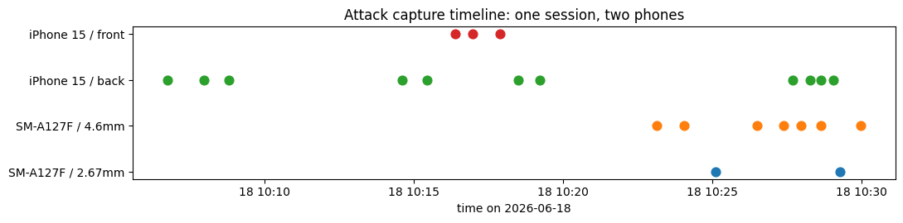
Figure 2. All 23 attacks were captured in one session with two phones. Capture phone is a nuisance variable, not a feature.

Shortcuts: what separates the classes but has nothing to do with screens
Property | Bona fide | Attack | Mitigation
Image dimensions | 1024 x 1024, always | 21 sizes, never 1024 | Resize everything to one size; never read dimensions
Aspect ratio | Exactly 1.0 | 0.85 to 1.33 | Face-detect, crop to a fixed square
Metadata | None | Always present | Strip on load; never read
File size | 0.9 to 2.1 MB | 4 to 37 MB | Never read
Framing | Precisely aligned | Hand-held, off-centre, UI chrome | Face-detect and crop, then verify with occlusion tests
Sharpness | Sharp, fine detail | Different (see below) | Partly physics, partly resolution; test on resampled bona fide
Colour cast | Neutral | Magenta or green tint | Partly physics; check against colour-jittered bona fide

Findings from the data itself
- Class balance is 1000 to 23. One attack is 4.3 % of its class. All attack-side rates are quantised at that step and need confidence intervals.
- Dimensions, metadata, and file size are perfect separators. A model that reads any of them gets a free perfect score on this data and an unknown score on the hidden set.
- Every attack is paired with its source image. Identity, pose, and background cannot be the signal. Pairs must stay on the same side of any train/validation split.
- The only held-out groups available are capture phone (14 vs 9), lens, cropped vs full frame, and visible toolbar vs not. All small, but holding out by phone is the most honest test we can run.
- If the hidden bona fide images are live phone captures, they will have metadata, odd sizes, hand-held framing, and a colour cast. Every shortcut then points the wrong way and real users get flagged. Nothing in this data lets us test that.

What the attacks look like at native resolution
The 2D Fourier transform rewrites an image as a sum of stripe patterns of every spacing and direction. Drawn as a picture, the centre is coarse shading, moving outward means finer detail, and brightness is strength. A natural photo fades smoothly from the centre. A screen's pixel grid is a perfectly regular pattern, so it appears as a lattice of sharp dots away from the centre.
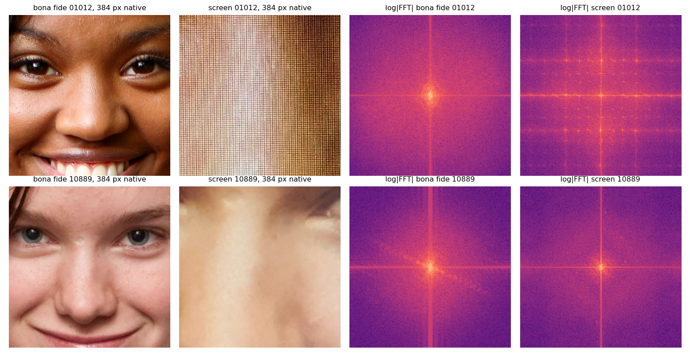
Figure 3. Fixed 384-pixel windows at native resolution and their log spectra. Top: a close-range attack with the grid resolved (lattice of dots). Bottom: a far-range attack with no lattice, which is the kind that looks real.
Findings from native-resolution texture
- The pixel grid is unmistakable in a handful of attacks and absent in most. It is a high-precision, low-recall cue.
- The cue only survives if native resolution is kept somewhere in the pipeline. Downsampling to a typical network input of 224 or 256 px destroys it.
- A fixed pixel window is the right unit for grid detection (grid period depends on camera-to-screen distance, not face size), but it covers a different fraction of the face in each class, so it is not a fair way to compare skin texture. Skin comparison uses a crop proportional to face size instead.

Classical PAD detectors as a baseline
Before training anything, sixteen hand-crafted detectors from the PAD literature (2004 to 2016) were implemented and applied. Each is one number computed from the face-normalised 512 px image, plus a rule. The rule is one-class: the threshold is the 2.5th and 97.5th percentile of the bona fide distribution, so BPCER is 5 % by construction, and an attack counts as flagged if it falls outside that band. Nothing is fitted to the attacks, so the miss rates are honest. AUC is reported in the direction the paper predicted, so a value below 0.5 means the attacks moved the opposite way.
Detector | Source | Predicted | AUC | Flagged / 23
High-pass residual energy | Galbally 2014 | lower | 0.27 | 8
Difference of Gaussians energy | Tan 2010 | lower | 0.26 | 7
Row banding (native) | refresh / rolling shutter | higher | 0.34 | 6
Laplacian variance | Galbally 2014 | lower | 0.31 | 5
Pixel noise | Galbally 2014 | higher | 0.70 | 4
Cr chroma spread | Boulkenafet 2016 | unspecified | 0.65 | 4
High-frequency energy ratio | Li 2004 | higher | 0.76 | 4
Cb chroma spread | Boulkenafet 2016 | unspecified | 0.74 | 2
Spectral peakiness (native) | Garcia 2015, Patel 2015 | higher | 0.72 | 2
Saturation spread | Wen 2015 | lower | 0.42 | 2
Colour diversity | Wen 2015 | lower | 0.30 | 2
LBP chroma distance | Boulkenafet 2016 | higher | 0.59 | 2
Specular ratio | Wen 2015 | higher | 0.36 | 1
Spectral peakiness (512 px) | Garcia 2015 | higher | 0.61 | 1
LBP gray distance | Maatta 2011 | higher | 0.52 | 1
Saturation mean | Wen 2015 | lower | 0.45 | 0

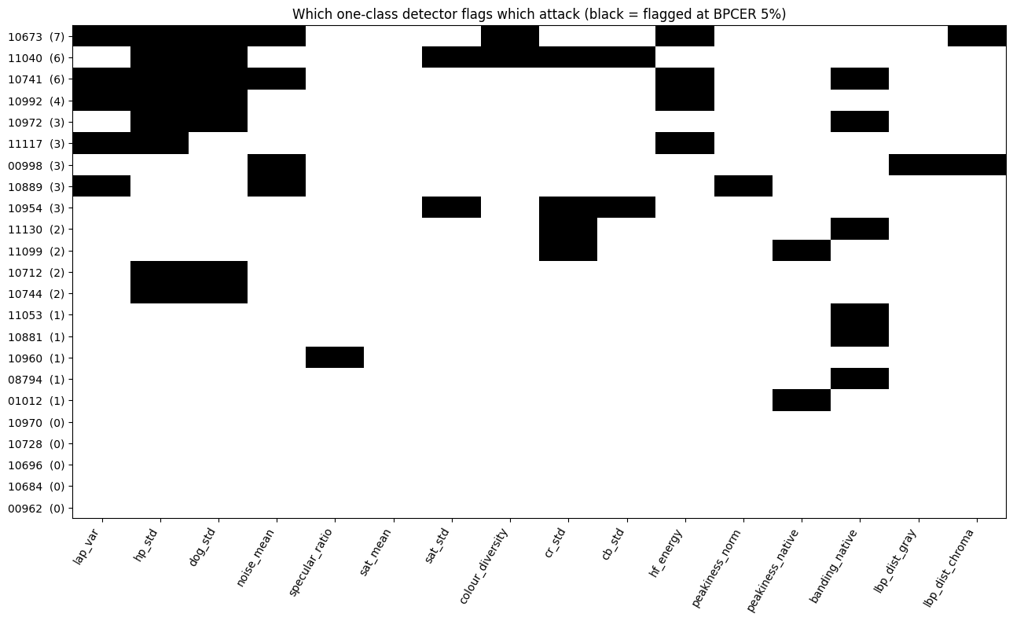
Figure 4. Which detector flags which attack at 5 % BPCER. Black is flagged. The number after each id is how many detectors caught it. Five attacks are caught by nothing.
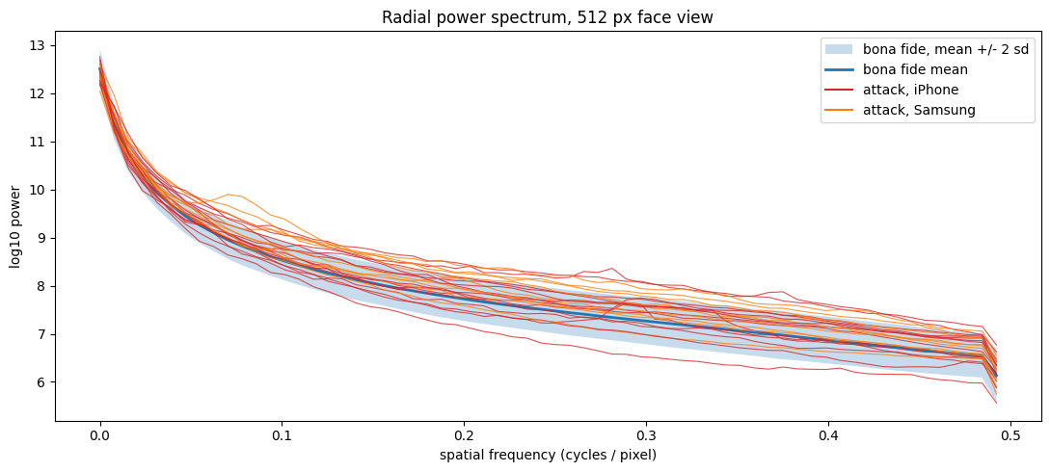
Figure 5. Power by spatial frequency for the 512 px face view. The band is where 95 % of bona fide images fall. Attack lines sit above it at high frequency: they have more fine-scale energy than any real photo, and isolated bumps are the pixel grid surviving downsampling.
Classical baseline: what it achieves
- Union of all sixteen detectors: 18 of 23 attacks flagged at 5 % BPCER. Best single detector: 8 of 23.
- Five attacks evade every detector (ids 00962, 10684, 10696, 10728, 10970). These are the far-range, slightly soft captures. They are the probe set for every later model.
- Chroma spread (Cr, Cb) is the only signal that behaves consistently across both capture phones. It is real but weak on its own.
- A learned model must beat 18 of 23 at 5 % BPCER on a phone-held-out split to justify its cost. That number, not a literature figure, is the bar.

The sharpness result is backwards, and that is a warning
- Every paper predicts replay attacks are blurrier than bona fide. Here they are sharper (AUC 0.27 in the predicted direction).
- Cause: the face crop downsamples attacks about 5x but bona fide about 2x, and heavy downsampling of a moiré-covered image concentrates aliased energy into the fine-detail band. Within the attacks, sharpness falls as the downsampling factor rises (correlation about -0.5).
- So the strongest classical signal is partly "photographed at 12 to 48 megapixels". A hidden set at a different resolution will not reproduce it. Any model that keys on sharpness has to be tested on bona fide images put through the same downsampling factor before it is believed.
- Capture phone also leaves a fingerprint: Samsung attacks have more residual energy and chroma spread, iPhone attacks more noise and clearer grid peaks. Phone must be a held-out group, never a feature.

Decisions carried forward
- Loading pipeline, identical for training and inference: open, apply EXIF rotation, convert to RGB, strip all metadata, detect the face, crop a fixed square around it, resize. Centre crop as the fallback when no face is found.
- Banned features: dimensions, aspect ratio, file size, metadata. A metadata-only baseline will be fitted to prove nothing leaks.
- Splits: by pair and by capture phone, never random by image. Detail in step 4.
- Two candidate input representations: a face-normalised downsampled view that keeps colour and shape, and native-resolution patches that keep the grid. Neither alone is enough; whether to combine them is the step 6 decision.
- Report framing: the learned boundary is original-versus-recaptured, and live bona fide captures are the top stated risk.
Next: step 4, the splitting strategy. With 23 positives it decides whether every later number means anything.

Reproducibility
All numbers and figures in this report come from data_analysis.ipynb in the project folder, which runs end to end on the dataset with pillow, numpy, pandas, matplotlib, and opencv-python-headless 4.x. Feature values are cached to classical_features.csv beside it. The face detector is OpenCV's pre-trained Haar cascade (alt2 first, default as fallback), used only to locate the face; every attack-scoring rule is implemented in the notebook.

