Angular 2.0 For JEE

Lab Book

Document Revision History

|  |  |  |  |
| --- | --- | --- | --- |
| Date | Revision No. | Author | **Summary of Changes** |
| March 2018 | 1 | Rahul Vikash | Created new lab book as per course contents |
|  |  |  |  |
|  |  |  |  |
|  |  |  |  |

Table of Contents

*Getting Started..……..…………………………………………………………………………… 4*

Overview 4

Setup Checklist for AngularJS 4

Instructions 4

Learning More 4

*Lab 1. TypeScript Angular Component & Data Binding 5*

*Lab 2. Angular Directives & Data Binding 7*

*Lab 3. Angular with Form 7*

*Appendices………………………………………………………………………………………… 11*

## Appendix A: Table of Figures ………………………………………………………… 11

Getting Started

## Overview

This lab book is a guided tour for learning Angular 2.0 For JEE version and above. It comprises ‘To Do’ assignments. Follow the steps provided to work out the ‘To Do’ assignments given.

## Setup Checklist for Angular 2.0

Here’s what is expected on your machine for the lab in order to work.

Minimum System Requirements

* Intel Pentium 90 or higher (P166 recommended)
* Microsoft Windows XP, Windows 7 or Windows 8
* Memory: 2GB of RAM (1GB or more recommended)
* Google Chrome 36.0 or Mozilla Firefox 31.0 or Internet Explorer 10 or above

Please ensure that the following is done:

* A text editor like Notepad or Notepad++ or Eclipse Luna is installed.
* Node.js install with node module

## Instructions

* Create a directory by your name in drive <drive>. In this directory, create a subdirectory angular_assgn. For each lab exercise create a directory as lab <lab number>.
* You may also look up the on-line help provided in https://v2.angular.io/docs/ts/latest/guide/setup.html

## Learning More

1. Typescript Angular Components & Data Binding

|  |  |
| --- | --- |
| Goals | * Understand the typescript & Angular data binding components |
| Time | 60 minutes |
|  |  |

* 1. Create Typescript class ,as per below mentioned diagram

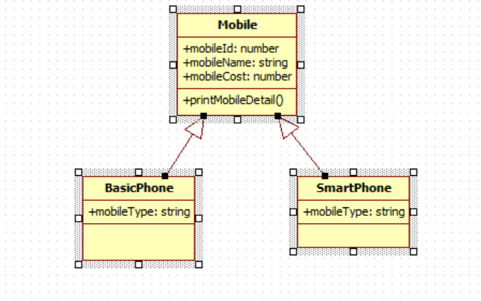

All 3 classes are in separate file. We have to add mobile details such as id, name, cost & type from different typescript file & print data in console

1. Get Data from array

## 1.2: Create a Angular Application & display the result shown below

## 

## When we put some data in ID, name, salary, department it will come automatically come below the submit button shown below

## 

When we click on Add employee alert box will open & display all data inserted as shown in given image

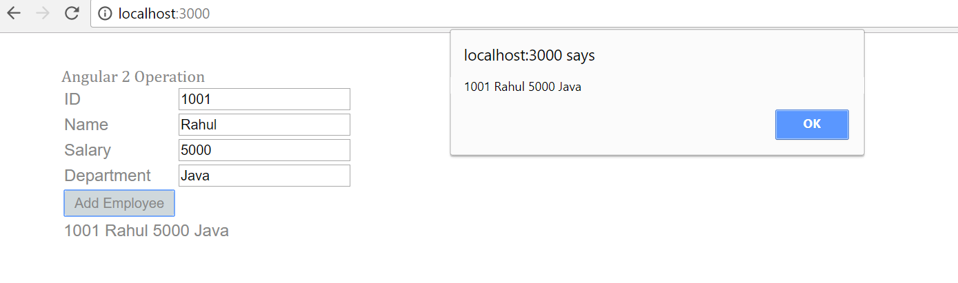

1. Angular Directives & Data Binding

|  |  |
| --- | --- |
| Goals | * Understand the Directives & Data Binding |
| Time | 180 minutes |

## 2.1. Creating a webpage to work with angular

## Create a web page in Angular & display the results shown below.

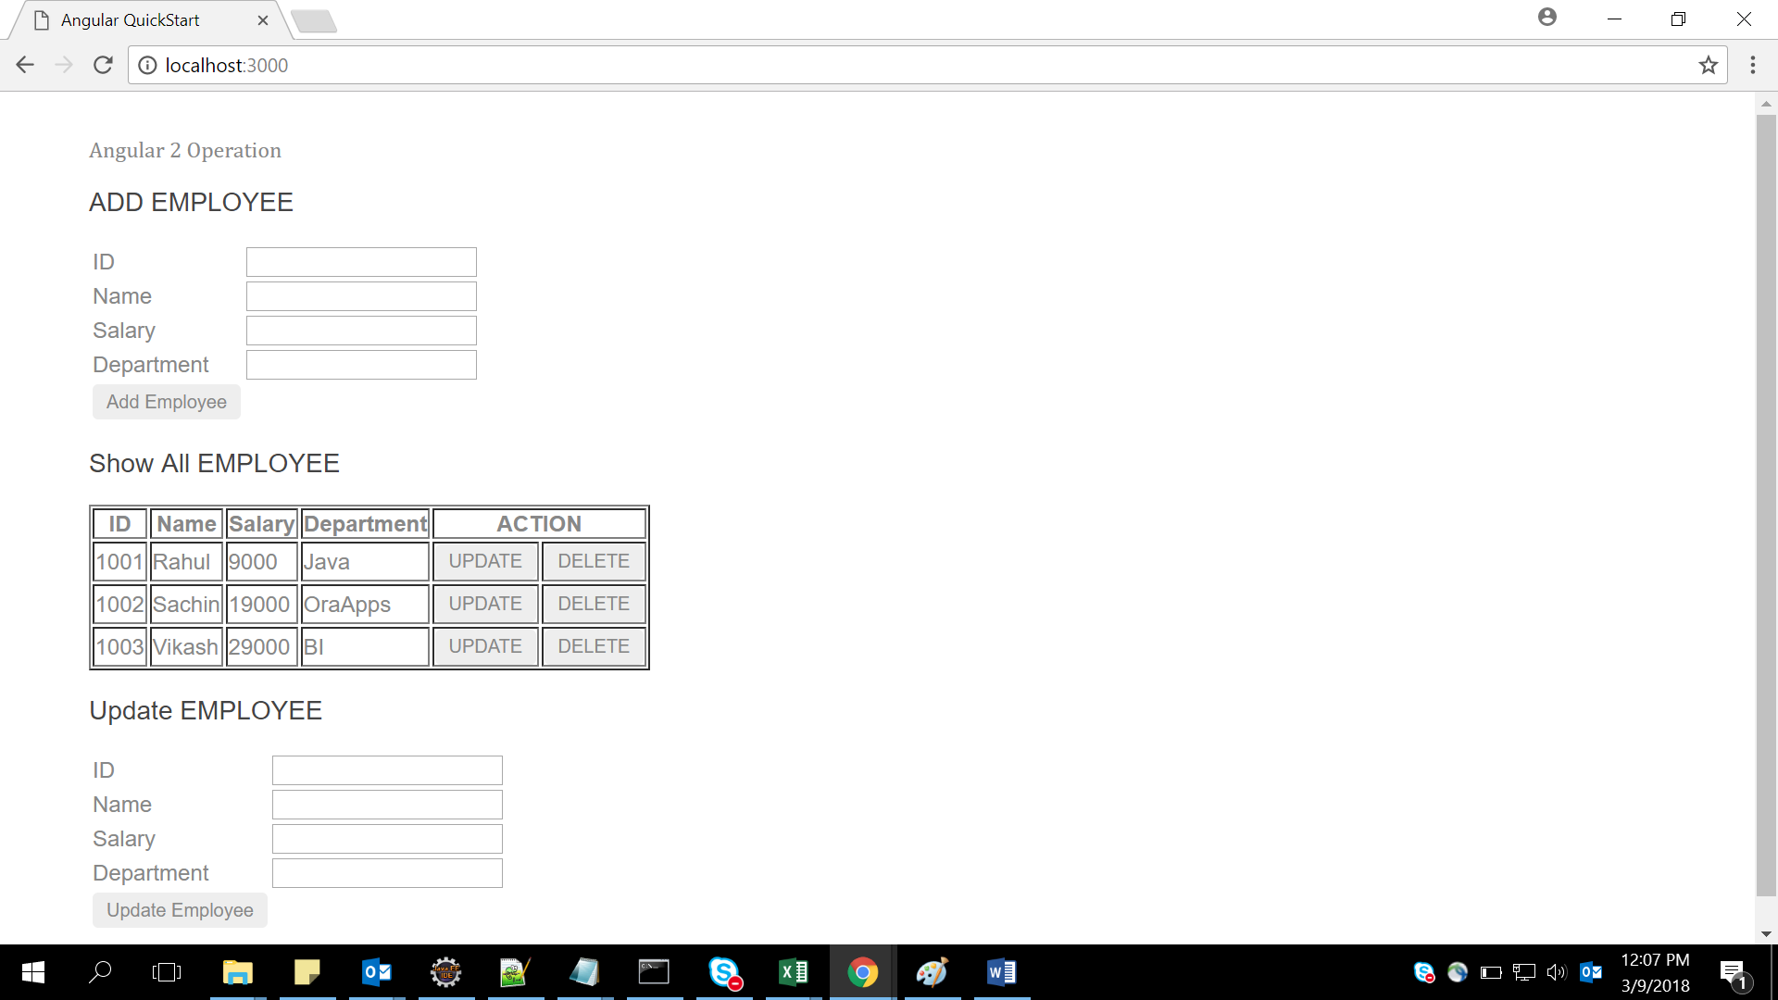

Show all data comes from array as below :

[

{empId:1001,empName:"Rahul",empSal:9000,empDep:"Java"},

{empId:1002,empName:"Sachin",empSal:19000,empDep:"OraApps"},

{empId:1003,empName:"Vikash",empSal:29000,empDep:"BI"},

];

When the user enter Id, name, salary & department in Add Employee & click button Add Employee data will come in Show All Employee & message will display as shown in figure below –example inserted id 1004,name rashi,salary 87000,department BI

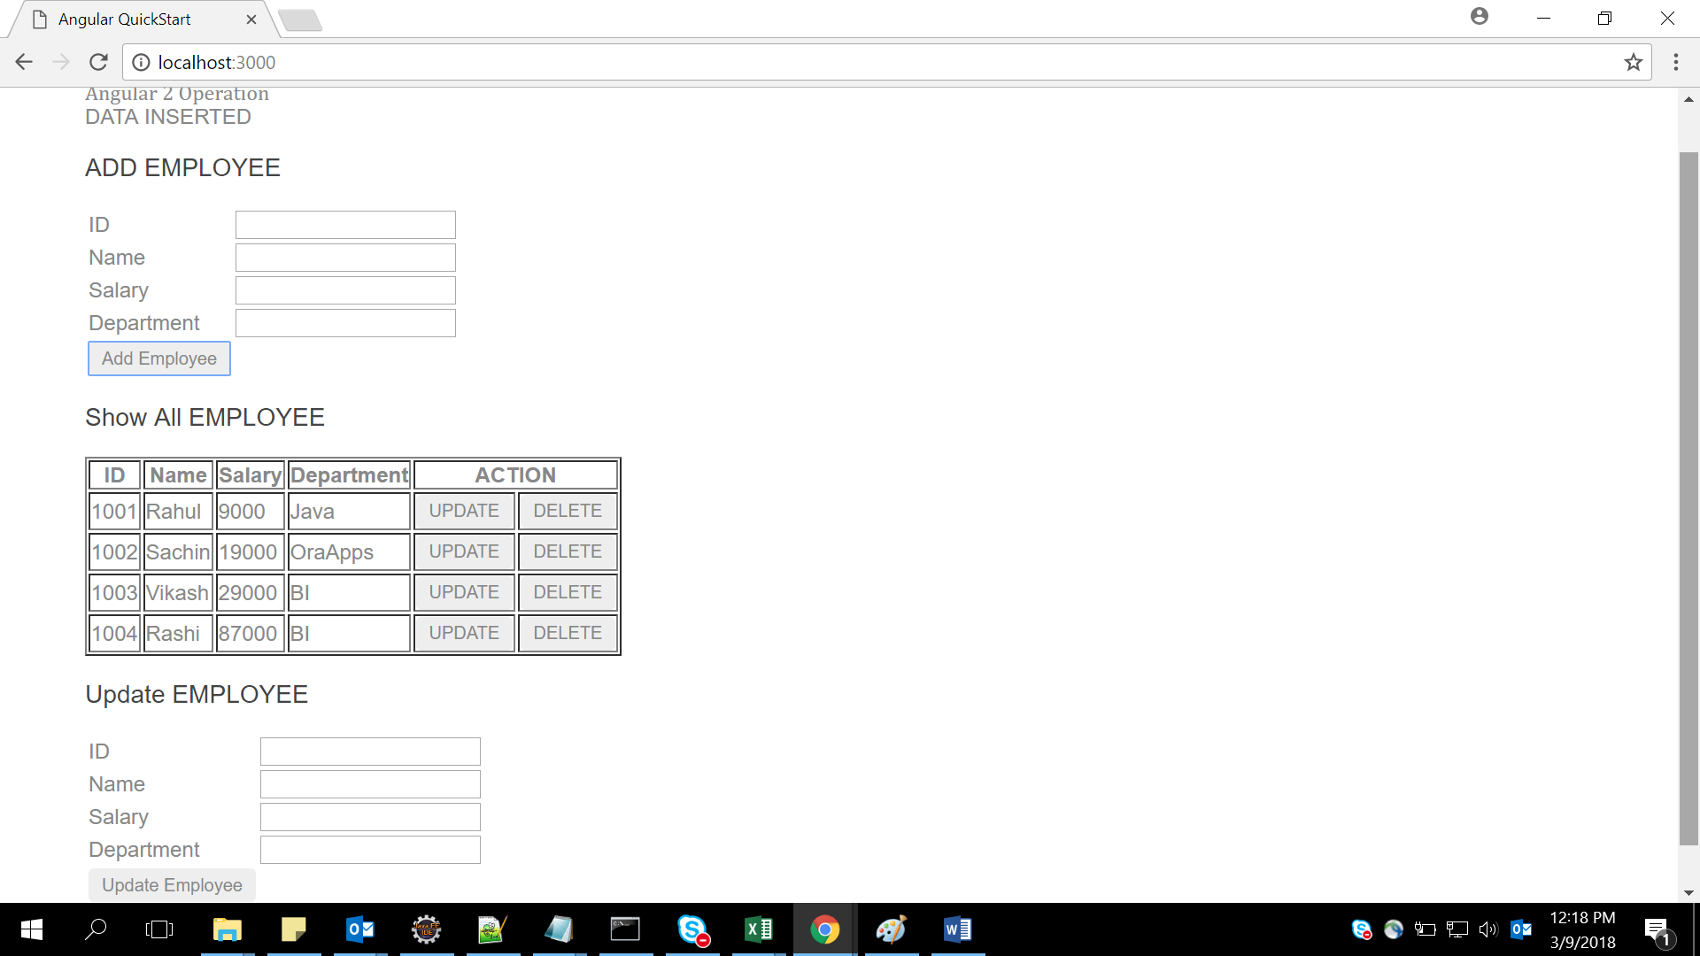

When we click button “Delete” that particular row will be deleted from Show All Employee & message will come ”DATA Deleted” as shown in below figure –Example delete rows 1003 by pressing delete button

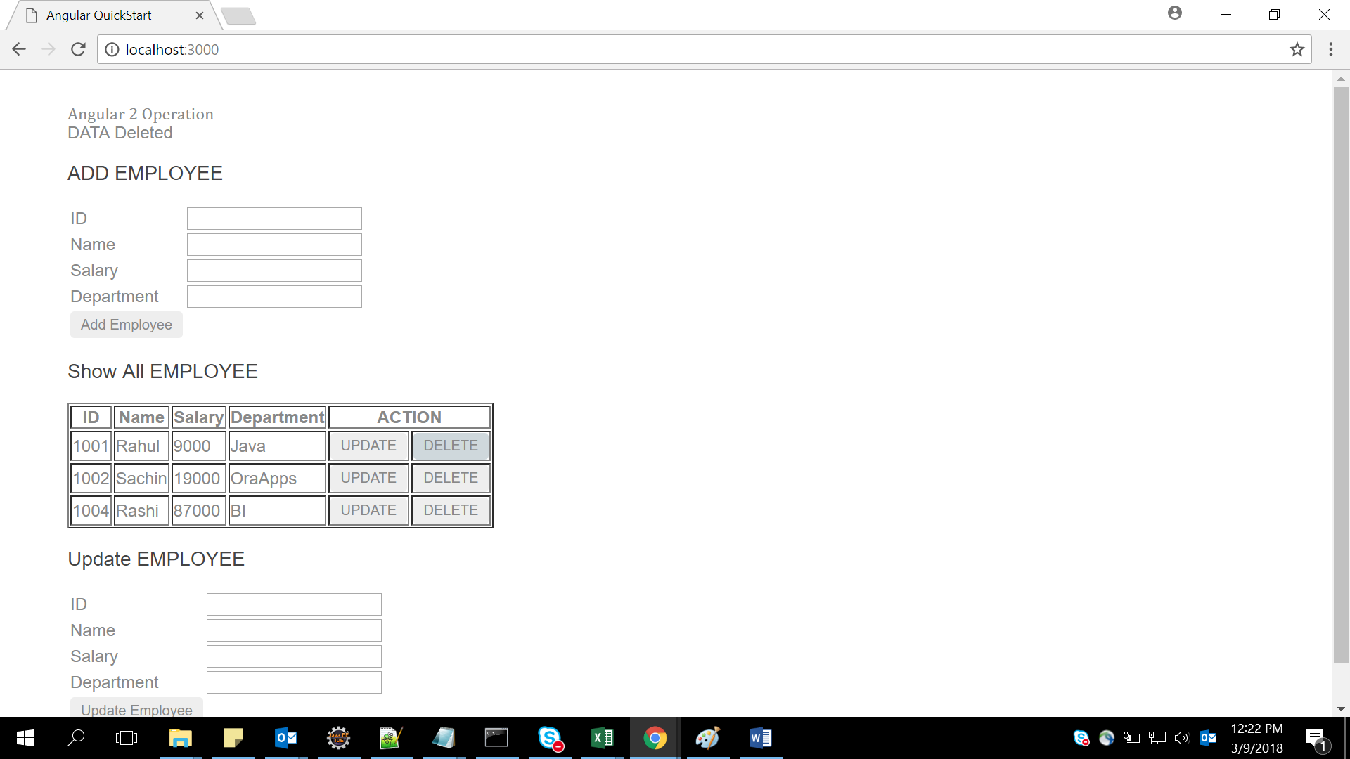

When we click button “Update” that particular row will be come in Update employee from Show All Employee & as shown in figure & when updated employee button click the data will update in show All employee & message will display

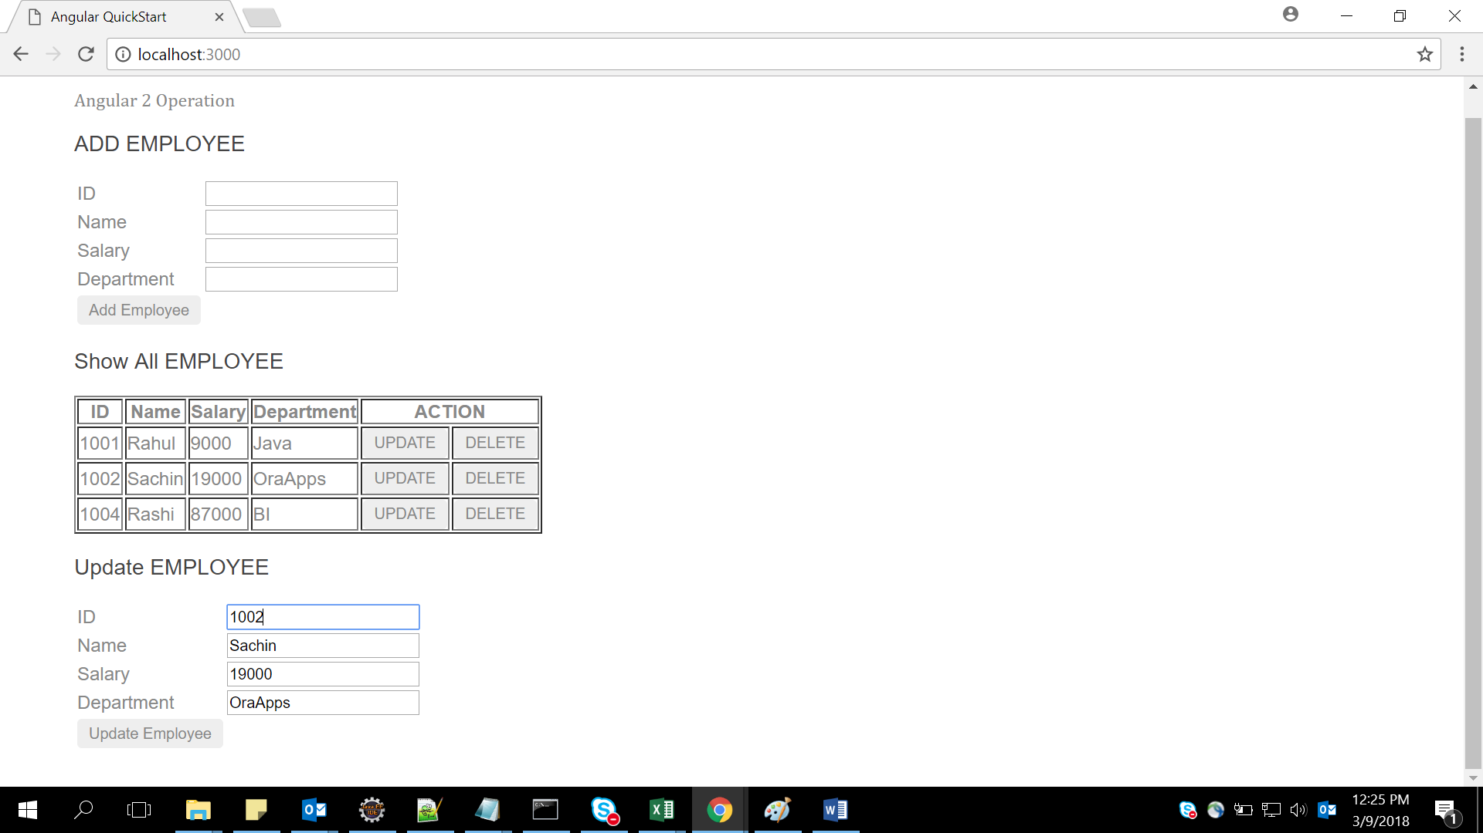

After Update employee button clicked data updated in show all employee & message came

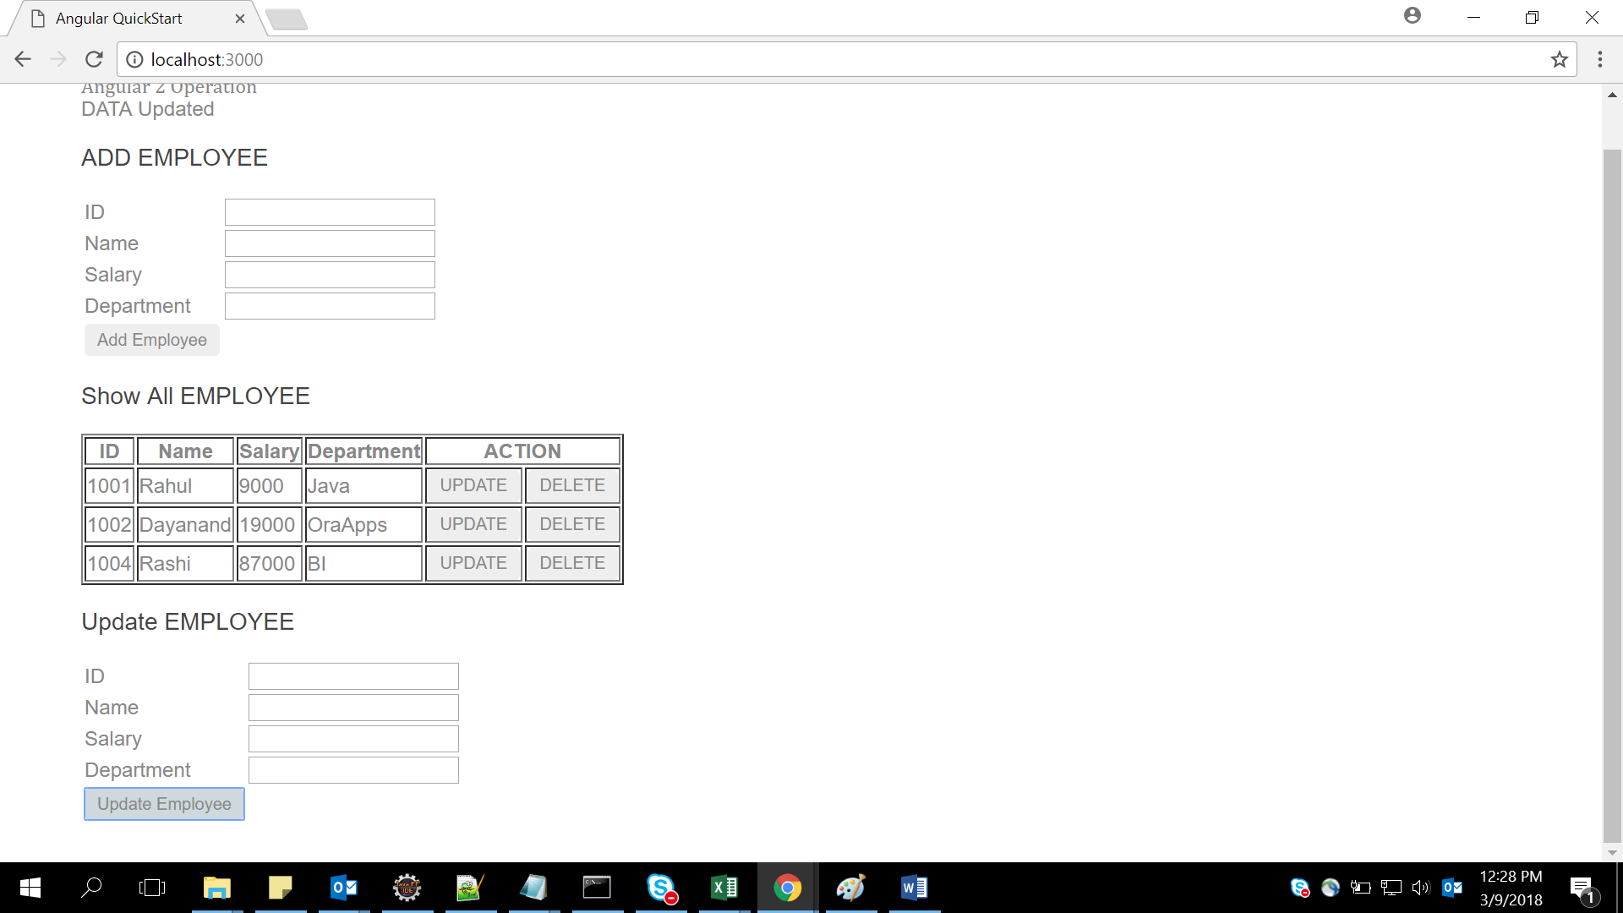

## 2.2. Creating a webpage to work with angular

Create a web page and display the results shown below :

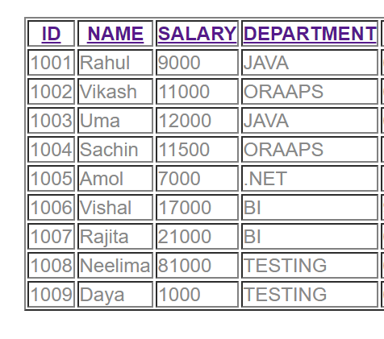

Click on any header --Id, name, salary, department it will display the list in sorted order of that header .

Suppose Clicking on **Name** header so we will get desired output

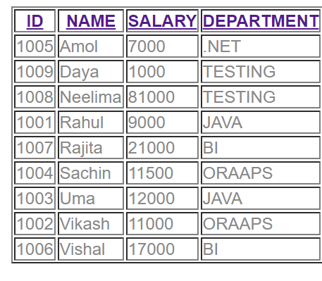

So by clicking any header data will come in sorted order.

Internal Array: [

{empId:1001,empName:'Rahul',empSal:9000,empDep:'JAVA',empjoiningdate:'6/12/2014'},

{empId:1002,empName:'Vikash',empSal:11000,empDep:'ORAAPS',empjoiningdate:'6/12/2017'},

{empId:1003,empName:'Uma',empSal:12000,empDep:'JAVA',empjoiningdate:'6/12/2010'},

{empId:1004,empName:'Sachin',empSal:11500,empDep:'ORAAPS',empjoiningdate:'11/12/2017'},

{empId:1005,empName:'Amol',empSal:7000,empDep:'.NET',empjoiningdate:'1/1/2018'},

{empId:1006,empName:'Vishal',empSal:17000,empDep:'BI',empjoiningdate:'9/12/2012'},

{empId:1007,empName:'Rajita',empSal:21000,empDep:'BI',empjoiningdate:'6/7/2014'},

{empId:1008,empName:'Neelima',empSal:81000,empDep:'TESTING',empjoiningdate:'6/17/2015'},

{empId:1009,empName:'Daya',empSal:1000,empDep:'TESTING',empjoiningdate:'6/17/2016'} ];

Lab 3: Angular with Form

|  |  |
| --- | --- |
| Goals | * Understand the Angular form |
| Time | 40 minutes |

3. Create a registration form and perform validations on the data entered in the fields. [***Can make use of Angular Template Driven Forms or Model driven Forms***]

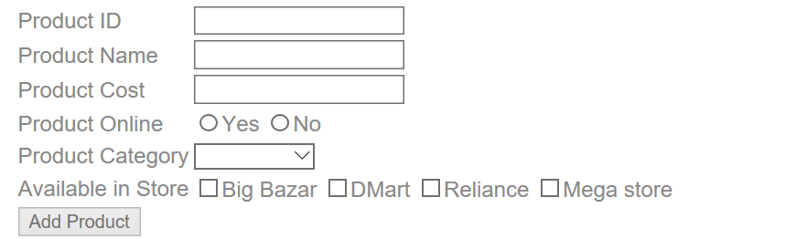

**Note:**

1. Make use of Angular 2 Forms-Model Driven.
2. Product category will be –Grocery, Mobile, Electronics & Cloths
3. When click on Add Product if all fields are validated the output will come on console
4. We can select multiple store in Available list

## Appendix A: Table of Figures

Figure 1 5

Figure 2 5

Figure 3 6

Figure 4 6

Figure 5 7

Figure 6 8

Figure 7 8

Figure 8 8

Figure 9 9

Figure 10 10

Figure 11 10