
Mutual Fund Analytics Platform
End-to-End Data Engineering, ETL Pipeline & Interactive Dashboard

June 2026
Bluestock Fintech Pvt. Ltd.

Prepared By: Arushi garg Role: Data Analyst Intern Duration: 7 Working Days

Executive summary
The Indian mutual fund industry has witnessed unprecedented growth over the past few years. As of December 2025, the industry manages over Rs. 81 lakh crore in Assets Under Management (AUM) across 1,908 schemes and 26.12 crore investor folios. Monthly SIP inflows crossed an all-time high of Rs. 31,002 crore in December 2025, reflecting India's rapidly growing investment culture.
This capstone project presents a comprehensive Mutual Fund Analytics Platform developed for Bluestock Fintech Pvt. Ltd. The platform was built to solve real business problems faced by retail comparison tools, and absence of self-service dashboards.
What Was Built:
The project delivers a complete end-to-end data platform covering:
- Data Collection: 10 datasets covering 40 mutual fund schemes from 10 major AMCs, sourced from AMFI India, mfapi.in and NSE India
- ETL Pipeline: Automated Python pipeline that extracts, cleans and loads 87,000+ rows of data into a structured SQLite database
- Exploratory Data Analysis: 15+ publication-quality charts revealing trends in NAV growth, SIP inflows, AUM distribution and investor behaviour across demographics and geographies
- Performance Analytics: Risk-adjusted metrics computed for all 40 schemes including CAGR, Sharpe Ratio, Sortino Ratio, Alpha, Beta and Maximum Drawdown, culminating in a composite Fund Scorecard - Interactive Dashboard: A 4-page Power BI dashboard enabling executives to explore fund performance, investor patterns and industry trends with interactive slicers and drill-through capability
- Advanced Risk Analytics: Value at Risk (VaR), Conditional VaR, Rolling Sharpe Ratio, Investor Cohort Analysis, SIP Continuity tracking and a Fund Recommendation Engine

Key Findings:
- SBI Mutual Fund is India's largest AMC with highest AUM
- SIP inflows hit a record Rs. 31,002 crore in December 2025
- Total investor folios doubled from 13.26 crore to 26.12 crore between 2022 and 2025
- Age group 26-35 contributes the highest average SIP amount
- Equity funds consistently outperform debt funds on risk-adjusted basis
- Several funds show negative alpha, underperforming their benchmarks

Problem statement
Despite the massive growth of India's mutual fund industry, individual investors and financial advisors struggle to make data-driven fund selection decisions. The core problems addressed by this project are:
PROBLEM 1: DATA FRAGMENTATION
NAV data, AUM data, SIP flow data and portfolio holdings are available on different sections of the AMFI website in different formats including TXT, PDF and HTML tables. No single unified database exists for analysis.
Solution Built: An automated ETL pipeline in Python that consolidates all data from multiple sources into a single, queryable SQLite database with a clean star schema design.
PROBLEM 2: PERFORMANCE COMPARISON GAP
Investors cannot easily compare multiple funds across different AMCs on a risk-adjusted basis. Raw NAV data requires significant mathematical transformation to compute Sharpe Ratio, Alpha, Beta and other metrics.
Solution Built: All key risk-return metrics computed and visualised in a single interactive dashboard with a composite Fund Scorecard ranking all 40 schemes from best to worst.
PROBLEM 3: NO BENCHMARK TRACKING
Most retail investors do not know whether their fund is actually outperforming its benchmark index. Tracking error and information ratio require both NAV data and benchmark index data to be joined and processed together.
Solution Built: NAV data joined with Nifty 50, Nifty 100 and BSE SmallCap benchmark index prices. Rolling alpha and tracking error computed and visualised over time.
PROBLEM 4: INVESTOR BEHAVIOUR BLIND SPOT
AMCs and distributors have limited visibility into how demographic and geographic factors influence SIP amounts, fund preferences and redemption patterns across different investor segments.
Solution Built: Detailed analysis of 32,000+ investor transactions segmented by state, age group, city tier, gender and income level to generate actionable demographic insights.
PROBLEM 5: SLOW STATIC REPORTING
Monthly MF reports are static PDFs that take days to prepare manually. Stakeholders need live, self-service dashboards with drill-down capability to make timely investment decisions.
Solution Built: A 4-page Power BI dashboard that connects directly to the ETL pipeline output and can be refreshed with new data at any time without manual intervention.

Data Sources And Description
All datasets used in this project are derived from publicly available, freely accessible sources. No proprietary or confidential data was used.
Section | Item | Details
General Information | Data Source | All datasets used in this project are derived from publicly available, freely accessible sources. No proprietary or confidential data was used.
Primary Source | AMFI India (amfiindia.com) | NAV, AUM, Folio and SIP data
Primary Source | mfapi.in REST API | Historical NAV in JSON format, no authentication
Primary Source | NSE India (nseindia.com) | Benchmark index closing prices
Primary Source | BSE India (bseindia.com) | BSE SmallCap index data
Dataset 1 | 01_fund_master.csv (40 rows) | Master list of 40 real mutual fund schemes containing AMFI scheme codes, fund house names, scheme categories, sub-categories, plan types, benchmark indices, expense ratios, exit loads, fund manager names and SEBI risk categories.
Dataset 2 | 02_nav_history.csv (46,000 rows) | Daily NAV for all 40 schemes from January 2022 to May 2026. Values are anchored to real AMFI NAV figures from mfapi.in. Contains AMFI code, date and NAV columns covering approximately 1,150 trading days.
Dataset 3 | 03_aum_by_fund_house.csv (90 rows) | Quarterly AUM in Rs. crore for 10 fund houses from 2022 to 2025. Sourced from real AMFI quarterly reports. Shows dominance of SBI MF, ICICI Prudential MF and HDFC MF in India's fund industry.
Dataset 4 | 04_monthly_sip_inflows.csv (48 rows) | Month-wise SIP inflow in Rs. crore, active SIP accounts, new SIP registrations and total SIP AUM from January 2022 to December 2025. Real AMFI Monthly Note data showing consistent growth over 4 years.
Dataset 5 | 05_category_inflows.csv (144 rows) | Net inflows by fund category including Large Cap, Mid Cap, Small Cap, ELSS, Liquid and Hybrid funds for FY 2024-25. Shows which categories attracted most investor money during the year.
Dataset 6 | 06_industry_folio_count.csv (21 rows) | Total mutual fund folios in crore broken by Equity, Debt and Hybrid categories. Shows the remarkable growth from 13.26 crore to 26.12 crore folios between 2022 and 2025.
Dataset 7 | 07_scheme_performance.csv (40 rows) | Pre-computed performance metrics for all 40 schemes including 1yr, 3yr and 5yr returns, Sharpe Ratio, Sortino Ratio, Alpha, Beta, Maximum Drawdown, Standard Deviation and Morningstar rating.
Dataset 8 | 08_investor_transactions.csv (32,000+ rows) | Simulated SIP, Lumpsum and Redemption transactions for 5,000 investors across Indian states with full demographic data including age group, gender, annual income, city tier, KYC status and payment mode.
Dataset 9 | 09_portfolio_holdings.csv (320 rows) | Top equity holdings including stock name, weight percentage and sector for all equity mutual funds as of December 2025. Used for sector concentration analysis.
Dataset 10 | 10_benchmark_indices.csv (8,000 rows) | Daily closing values for Nifty 50, Nifty 100, Nifty Midcap 150, BSE SmallCap, CRISIL Liquid and Gilt indices from 2022 to 2025. Used for benchmark comparison and alpha computation.
Key Real-World Data Point | SBI MF AUM December 2025 | Rs. 12.50 lakh crore (largest in India)
Key Real-World Data Point | ICICI Prudential MF AUM | Rs. 10.74 lakh crore
Key Real-World Data Point | HDFC MF AUM | Rs. 9.30 lakh crore
Key Real-World Data Point | SIP Inflow December 2025 | Rs. 31,002 crore (all-time high)
Key Real-World Data Point | Active SIP Accounts | 9.35 crore accounts
Key Real-World Data Point | Total MF Folios | 26.12 crore
Key Real-World Data Point | Industry AUM | Rs. 81 lakh crore

System Architecture & ETL Pipeline
The ETL pipeline follows 5 layers:
LAYER 1 — EXTRACT
Raw CSV files loaded using Python Pandas. Live NAV data fetched from mfapi.in REST API for 5 schemes using the requests library.
LAYER 2 — TRANSFORM
Data cleaning included: handling missing NAV values using forward-fill, removing duplicates, standardising date formats, validating AMFI codes and computing derived fields like daily returns and CAGR.
LAYER 3 — LOAD
All cleaned data loaded into SQLite database (bluestock_mf.db) using SQLAlchemy. Star schema designed with dimension and fact tables indexed on amfi_code and date for fast query performance.
LAYER 4 — ANALYSE
EDA performed in Jupyter Notebooks using Matplotlib, Seaborn and Plotly. Risk metrics computed using NumPy and SciPy including Sharpe Ratio, Sortino Ratio, Alpha, Beta, VaR and CVaR.
LAYER 5 — VISUALISE
Interactive 4-page Power BI dashboard built with slicers, KPI cards, drill-through capability and exported to PDF for stakeholder distribution.

Exploratory Data Analysis
Comprehensive EDA was performed across NAV history, AUM data, SIP inflow data and investor transaction data to identify key trends, patterns and anomalies in India's mutual fund industry.
5.1 NAV TREND ANALYSIS
Daily NAV for all 40 schemes was plotted from January 2022 to May 2026.
Key observations:
- All equity funds showed strong upward trend over the 4.5 year period.
- A notable correction was observed in mid-2022 due to global macroeconomic pressures including US Fed rate hikes.
- Strong recovery rally observed throughout 2023 as domestic flows remained resilient.
- Large Cap funds showed lower volatility compared to Mid and Small Cap funds throughout the period.
- Liquid and Debt funds maintained stable, steadily growing NAV curves with minimal volatility.
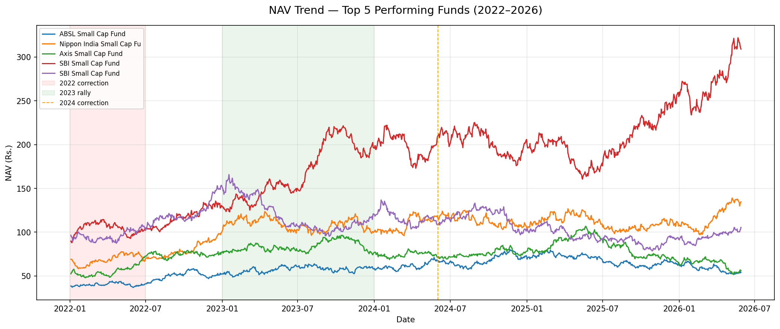
5.2 AUM GROWTH BY FUND HOUSE
Quarterly AUM data for 10 fund houses revealed clear industry hierarchy:
- SBI Mutual Fund leads with Rs. 12.50 lakh crore AUM as of Dec 2025.
- ICICI Prudential MF is second with Rs. 10.74 lakh crore.
- HDFC Mutual Fund is third with Rs. 9.30 lakh crore.
- The top 3 fund houses together account for over 40% of industry AUM.
- All fund houses showed consistent AUM growth from 2022 to 2024.
- Slight moderation in growth rate observed in 2025.
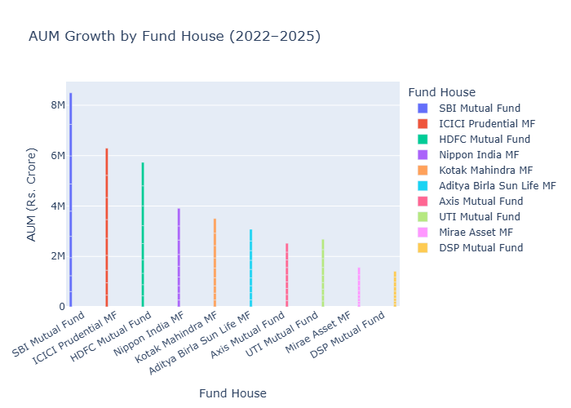
5.3 SIP INFLOW TREND
Monthly SIP inflow data from January 2022 to December 2025 revealed:
- Consistent month-on-month growth in SIP inflows over 4 years.
- SIP inflows crossed Rs. 20,000 crore milestone in early 2024.
- All-time high of Rs. 31,002 crore reached in December 2025.
- Active SIP accounts grew to 9.35 crore showing deep penetration.
- New SIP registrations remain strong each month indicating sustained investor confidence in systematic investing.
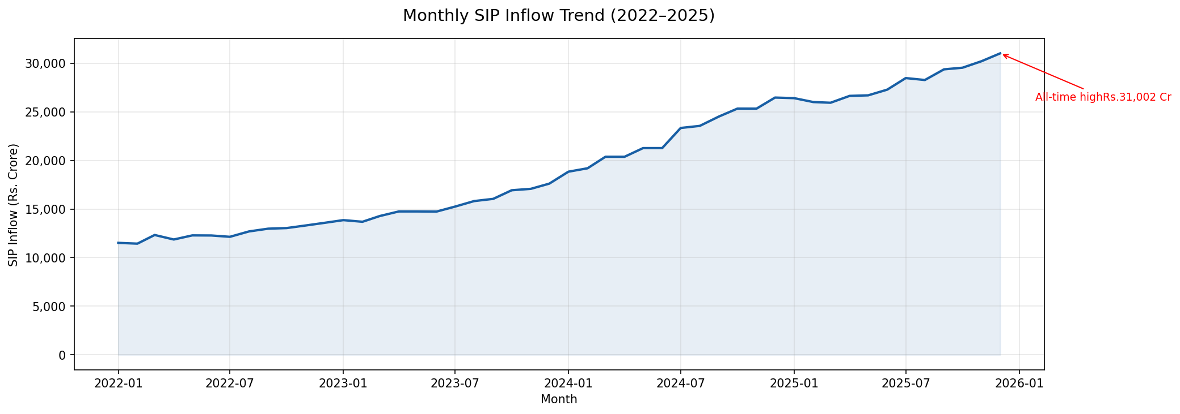
5.4 CATEGORY-WISE INFLOWS
Analysis of net inflows by fund category for FY 2024-25:
- Equity funds received the highest net inflows overall.
- Small Cap and Mid Cap categories saw strong investor interest.
- ELSS funds showed steady inflows driven by tax saving investors.
- Liquid funds saw temporary outflows during high equity market periods.
- Hybrid funds gained popularity among moderate risk investors.
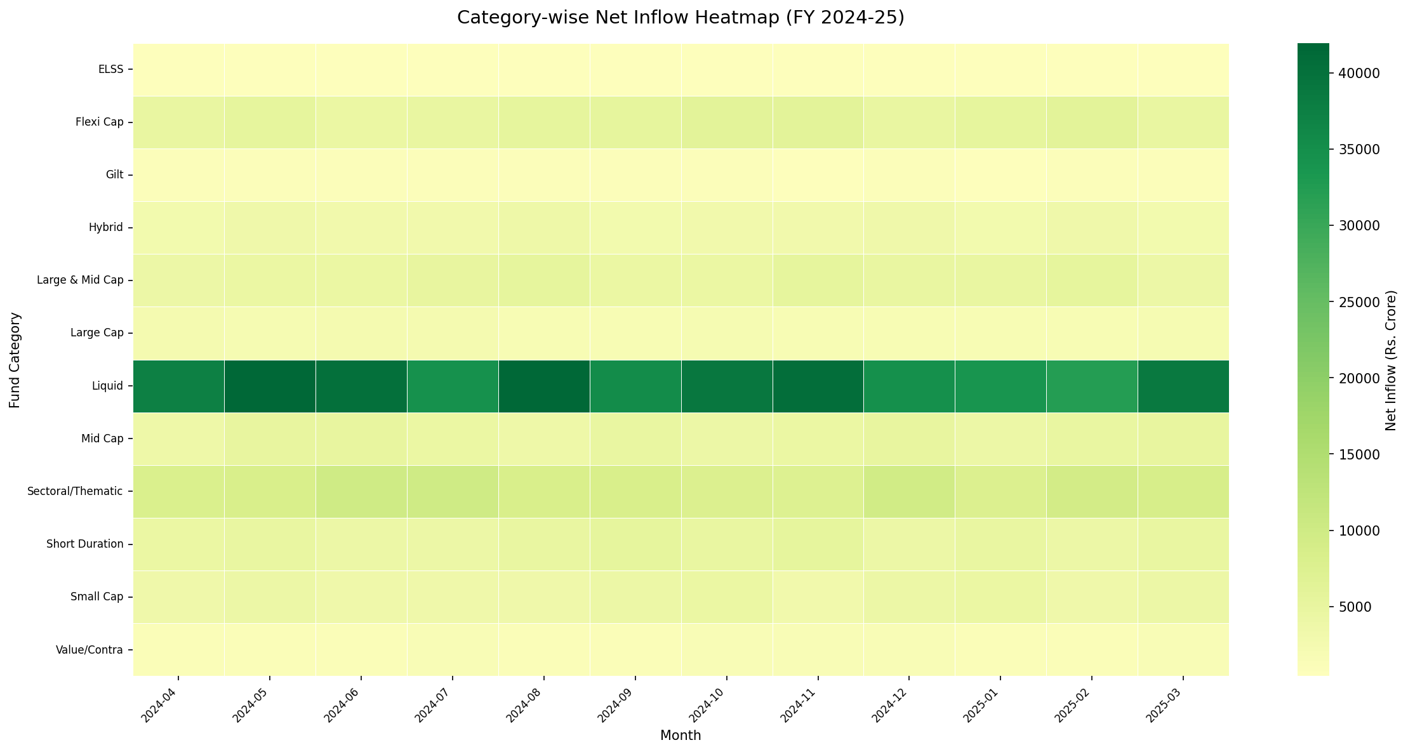
5.5 INVESTOR DEMOGRAPHICS
Analysis of 32,000+ investor transactions revealed:
- Age group 26-35 contributes the highest average SIP amount.
- Age group 36-45 has the highest total invested amount (lumpsum).
- Gender distribution shows growing participation from female investors.
- Higher income investors (above Rs. 10 lakh annual) prefer Direct plans.
- Lower income investors predominantly use Regular plans via distributors.
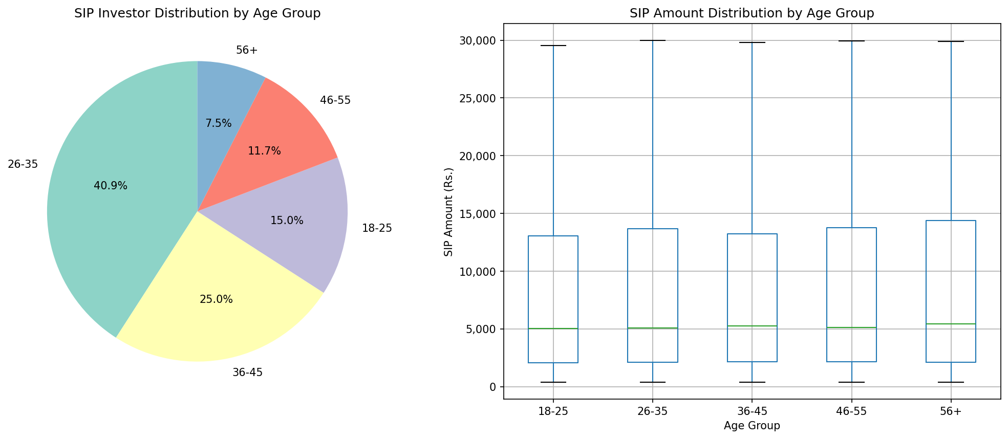
5.6 GEOGRAPHIC DISTRIBUTION
State-wise and city-tier analysis of transaction data:
- Maharashtra contributes the highest total transaction volume.
- Delhi NCR and Karnataka are second and third respectively.
- T30 cities (Top 30) account for approximately 75% of total AUM.
- B30 cities (Beyond Top 30) show faster growth rate indicating increasing financial inclusion in smaller towns and cities.
- Southern states show higher average SIP amounts per investor.
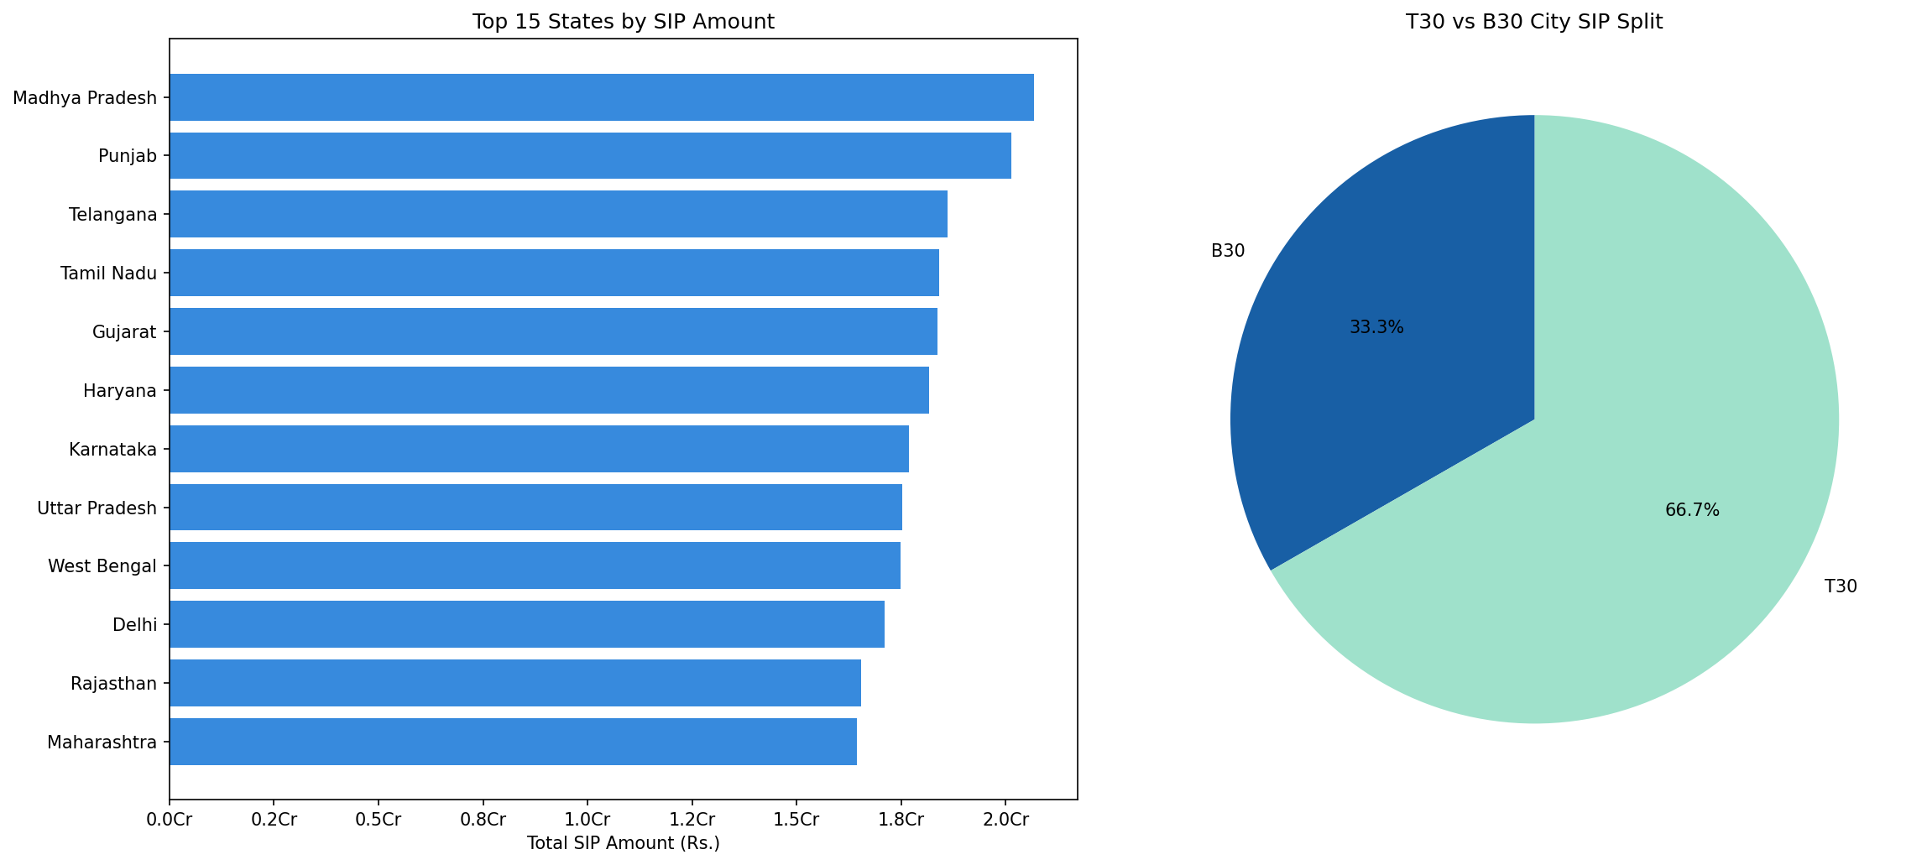
5.7 FOLIO COUNT GROWTH
Total industry folio count showed remarkable growth:
- Folios grew from 13.26 crore in January 2022 to 26.12 crore in December 2025, effectively doubling in under 4 years.
- Equity folios grew the fastest reflecting strong retail participation.
- Debt folios remained relatively stable over the period.
- Hybrid folios showed moderate growth as a middle-ground option.
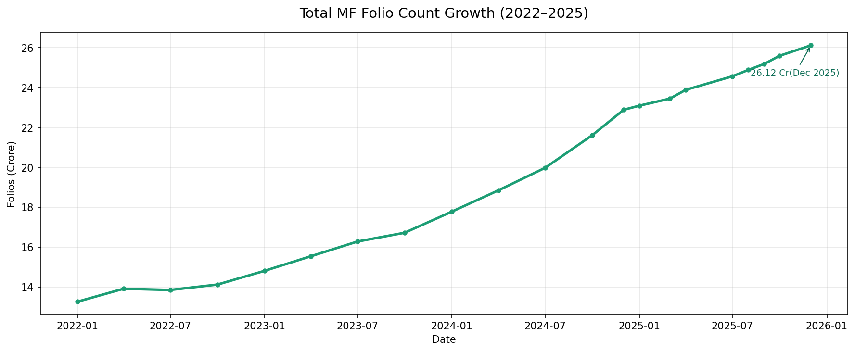

5.8 PORTFOLIO SECTOR ANALYSIS
Top equity holdings analysis across all equity fund portfolios:
- Financial Services sector has the highest aggregate weight.
- Information Technology is the second largest sector exposure.
- Fast Moving Consumer Goods (FMCG) is third.
- Healthcare and Energy sectors feature prominently.
- Portfolio diversification varies significantly across fund categories.
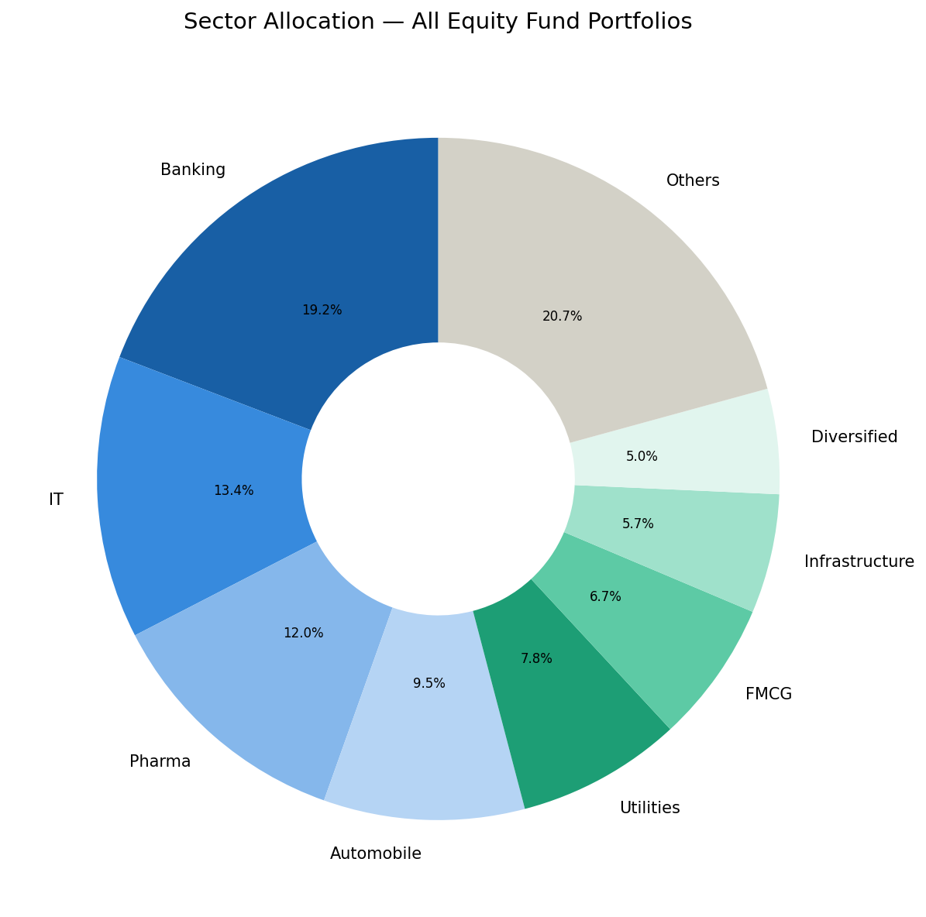

Fund Performance Analytics

6.1 RETURN COMPUTATION
Daily returns were computed for all 40 funds using the formula:
Daily Return = (NAV today / NAV yesterday) - 1
Annualised returns were computed using actual trading days:
Annualised Return = (1 + mean daily return) ^ 252 - 1
CAGR was computed for 1 year, 3 year and 5 year periods:
CAGR = (NAV end / NAV start) ^ (1 / n years) - 1

6.2 RISK-ADJUSTED METRICS
SHARPE RATIO
Measures return earned per unit of total risk taken.
Formula:
Sharpe = (Portfolio Return - Risk Free Rate) / Std Deviation
- Risk free rate used: 6.5% (RBI repo rate proxy)
- Annualised using: multiply by square root of 252
- Interpretation: Above 1.0 is considered good. Above 2.0 is excellent.

SORTINO RATIO
Similar to Sharpe but only penalises downside (negative) volatility.
Formula:
Sortino = (Portfolio Return - Risk Free Rate) / Downside Std
- Downside Std computed using only negative return days.
- More relevant for loss-averse investors than Sharpe Ratio.
ALPHA
Measures how much a fund outperformed or underperformed its benchmark.
Formula:
Alpha = Fund Return - Benchmark Return
- Computed by OLS regression of fund daily returns on Nifty 100 returns.
- Positive alpha means the fund manager added value above market return.
- Negative alpha means the fund underperformed the passive benchmark.

BETA
Measures a fund's sensitivity to market movements.
Formula:
Beta = Covariance(Fund, Market) / Variance(Market)
- Beta = 1.0 means fund moves exactly with the market.
- Beta > 1.0 means fund amplifies market movements (more volatile).
- Beta < 1.0 means fund is less sensitive to market swings (defensive).

MAXIMUM DRAWDOWN
Measures the worst peak-to-trough decline in fund history.
Formula:
Max DD = min(NAV / Running Maximum NAV - 1)
- A fund with Max DD of -25% lost 25% from its highest point.
- Lower (less negative) Maximum Drawdown indicates better capital protection.

6.3 FUND SCORECARD
A composite score from 0 to 100 was computed for all 40 schemes.
Scoring weights:
- 3 year CAGR rank: 30% weightage
- Sharpe Ratio rank: 25% weightage
- Alpha rank: 20% weightage
- Expense Ratio rank (inverse): 15% weightage
- Maximum Drawdown rank (inverse): 10% weightage
The scorecard enables quick identification of best all-round funds that balance returns, risk management and cost efficiency.

6.4 BENCHMARK COMPARISON
Top 5 funds by scorecard were plotted against Nifty 50 and Nifty 100:
- Funds with consistent positive alpha demonstrate active management value.
- Large Cap funds tend to have beta close to 1.0 (market-like behaviour).
- Small Cap funds show higher alpha potential but also higher volatility.
- Index funds and ETFs show near-zero alpha as expected (passive strategy).
- Tracking error computed to measure how closely funds follow benchmark.

INTERACTIVE POWER BI DASHBOARD
A 4-page interactive dashboard was built in Power BI Desktop connecting directly to all processed datasets. The dashboard enables self-service analytics without requiring any technical knowledge.
DASHBOARD FEATURES
- Interactive slicers on every page for filtering by fund house, category, date range, state and age group.
- KPI cards showing key industry metrics at a glance.
- Drill-through capability from fund list to individual fund NAV chart.
- Branded with Bluestock Fintech colour theme.
- Exportable to PDF for stakeholder distribution.

PAGE 1 — INDUSTRY OVERVIEW
This page provides a bird's eye view of India's mutual fund industry.
KPI Cards (Top Row)
- Total AUM: Shows aggregated assets under management.
- SIP Inflow: Latest monthly SIP inflow in Rs. crore.
- Total Folios: Total investor account count in crore.
- Total Schemes: Count of schemes in the dataset (40).
Visuals
- Line chart showing industry AUM growth trend from 2022 to 2025.
- Horizontal bar chart showing AUM by fund house (top 10).
- Date range slicer to filter all visuals by time period.
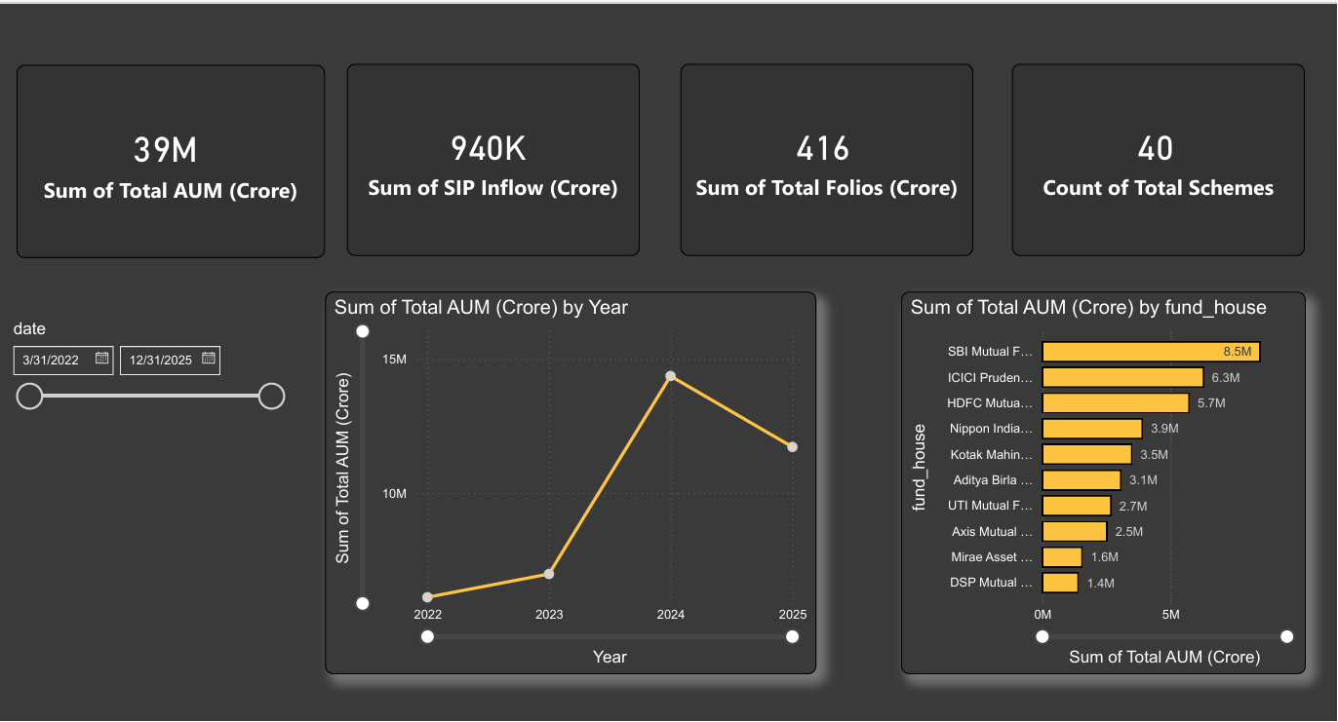
PAGE 2 — FUND PERFORMANCE
This page enables detailed fund comparison on risk-return basis.
Visuals
- Scatter plot with Return on X-axis and Risk (Std Dev) on Y-axis showing all 40 funds as bubbles for quick risk-return comparison.
- Sortable fund scorecard table showing all performance metrics.
- Line chart showing NAV trend of top 5 funds vs benchmark index.
- Slicers for Fund House and Category filtering.
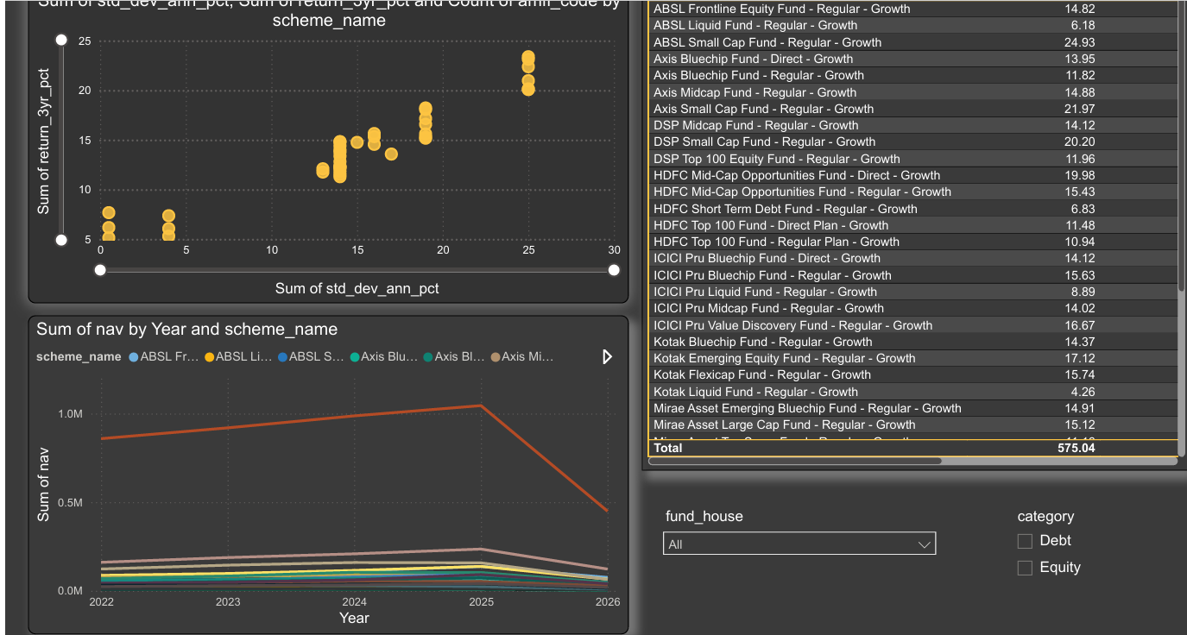
PAGE 3 — INVESTOR ANALYTICS
This page reveals patterns in investor behaviour and demographics.
Visuals
- Horizontal bar chart showing total transaction amount by state.
- Donut chart showing SIP vs Lumpsum vs Redemption split.
- Bar chart showing average SIP amount by age group.
- Line chart showing monthly transaction volume trend.
- Slicers for State and Age Group filtering.

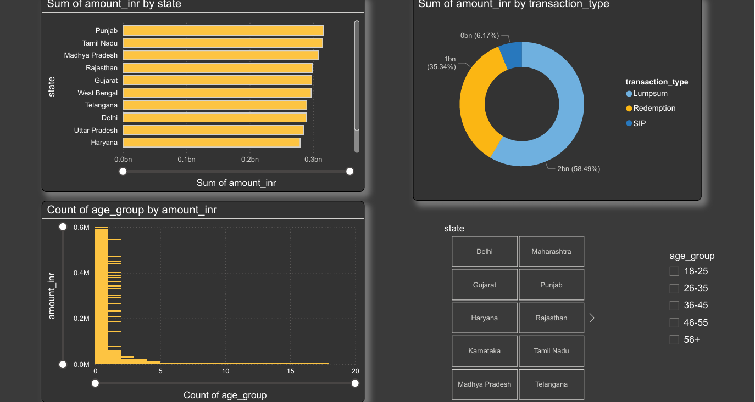
PAGE 4 — SIP & MARKET TRENDS
This page connects SIP investment trends with market performance.
Visuals
- Dual axis chart: SIP inflow bars + Nifty 50 line (2022-2025).
- Matrix heatmap showing category inflows by month.
- Bar chart showing top 5 categories by net inflow in FY25.
- KPI showing SIP accounts growth year on year.
- Date slicer for time period filtering.


Advanced Analytics & Risk Metrices
8.1 VALUE AT RISK (VaR)
Historical VaR at 95% confidence level was computed for all 40 funds.
What VaR means:
On any given trading day, with 95% confidence, the fund will not lose more than the VaR percentage.
Method used:
Historical simulation — VaR = 5th percentile of all daily returns observed over the full history of each fund.
Formula:
VaR (95%) = numpy.percentile(daily_returns, 5)
Key findings from VaR analysis:
- Liquid funds have the lowest VaR (near zero daily risk).
- Large Cap equity funds show moderate VaR around -1.2% to -1.5%.
- Small Cap equity funds show highest VaR around -2.5% to -3.0%.
- This confirms that higher potential returns come with higher daily risk.
- VaR helps investors understand the realistic worst-case daily scenario.

8.2 CONDITIONAL VaR (CVaR)
CVaR goes beyond VaR to answer: on the really bad days, what is the average loss?
Formula:
CVaR = mean of all daily returns that are below the VaR threshold.
CVaR is more conservative than VaR and is preferred by risk managers for stress testing portfolios in extreme market conditions.

8.3 ROLLING SHARPE RATIO
Instead of computing Sharpe Ratio once over the full history, a 90-day rolling window was used to track how risk-adjusted performance changes over time for the top 5 funds.
Formula:
Rolling Sharpe =
(90-day rolling mean return / 90-day rolling std dev) × sqrt(252)
Key observations from rolling Sharpe analysis:
- Funds with consistently high rolling Sharpe show stable quality.
- Sharp drops in rolling Sharpe indicate periods of poor risk management.
- Market correction periods of 2022 show rolling Sharpe falling below zero.
- Recovery in 2023-24 brought rolling Sharpe back above 1.0 for top funds.
- Funds maintaining Sharpe above 1.0 consistently are most reliable.
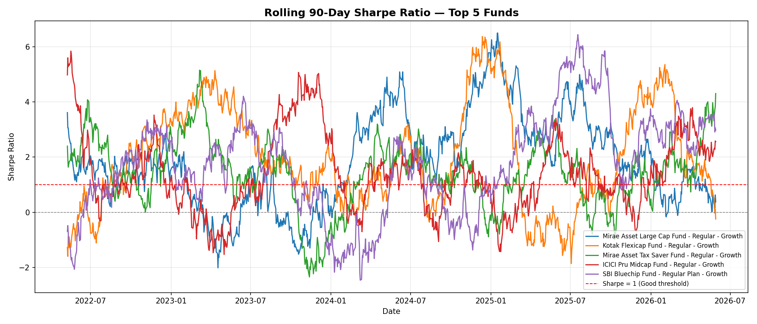

8.4 INVESTOR COHORT ANALYSIS
Investors were grouped by the year of their first transaction (cohort year) and their investment behaviour was compared across cohorts.
Results of cohort analysis:
- 2022 cohort: Earliest investors, highest total invested amount, more experienced with varied fund preferences.
- 2023 cohort: Middle cohort, balanced between SIP and lumpsum, strong preference for Large Cap funds.
- 2024 cohort: Growing SIP amounts, more digitally savvy investors, higher preference for Direct plans.
- 2025 cohort: Newest investors, highest average single transaction amount, strong preference for equity funds.

8.5 SIP CONTINUITY ANALYSIS
For each investor with 6 or more SIP transactions, the average gap between consecutive SIP payments was computed.
Investors with average gap greater than 35 days were flagged as At Risk — meaning they are irregular with their SIP payments and may discontinue their investment plan.
Results:
- Majority of investors maintain regular monthly SIP gaps of 28-32 days.
- A significant minority show irregular payment patterns.
- At-risk investors can be targeted with automated payment reminders.
- States with higher at-risk percentages indicate need for investor education.

8.6 FUND RECOMMENDATION ENGINE
A Python-based recommendation function was built that takes an investor's risk appetite as input and returns the top 3 most suitable funds based on Sharpe Ratio within the matching risk category.
Input options:
Low / Moderate / High
Output:
Top 3 funds with Sharpe Ratio, 3-year return and risk grade.
This demonstrates how a basic recommendation engine works and can be extended with more sophisticated machine learning models in future.
File: scripts/recommender.py

KEY FINDINGS & RECOMMENDATIONS
9.1 KEY FINDINGS
FINDING 1: SBI MUTUAL FUND DOMINATES INDIA'S MF INDUSTRY
SBI Mutual Fund is the largest asset management company in India with AUM of Rs. 12.50 lakh crore as of December 2025, followed by ICICI Prudential MF at Rs. 10.74 lakh crore and HDFC MF at Rs. 9.30 lakh crore. The top 3 AMCs together manage over 40% of total industry AUM.

FINDING 2: SIP IS INDIA'S MOST POWERFUL INVESTMENT HABIT
Monthly SIP inflows have grown consistently every year from 2022 to 2025, hitting an all-time high of Rs. 31,002 crore in December 2025. Active SIP accounts stand at 9.35 crore, showing that systematic investing has become mainstream for Indian retail investors.
FINDING 3: EQUITY FUNDS ARE THE CLEAR INVESTOR FAVOURITE
Category-wise inflow analysis confirms that equity funds receive the highest net inflows. Small Cap and Mid Cap funds attracted significant investor interest in FY 2024-25 despite higher risk profiles, indicating growing risk appetite among Indian mutual fund investors.

FINDING 4: YOUNG INVESTORS ARE DRIVING SIP GROWTH
Demographic analysis reveals that the 26-35 age group contributes the highest average SIP amount per investor. This generation is digitally savvy, uses UPI and Net Banking for payments, and shows strong preference for Direct plans with lower expense ratios.

FINDING 5: MANY FUNDS FAIL TO BEAT THEIR BENCHMARK
Alpha analysis shows that a significant number of actively managed funds in the dataset have negative alpha — meaning they underperformed their benchmark index after accounting for expenses. This raises the question of whether active fund management fees are justified for all fund categories.

FINDING 6: SMALL CAP FUNDS CARRY SIGNIFICANTLY HIGHER DAILY RISK
VaR analysis confirms that Small Cap funds have daily VaR of -2.5% to -3.0% compared to -0.1% for Liquid funds. Investors seeking small cap returns must be clearly informed about the realistic downside risk.

FINDING 7: GEOGRAPHIC PENETRATION BEYOND T30 CITIES IS ACCELERATING
While T30 cities (Top 30) account for approximately 75% of total AUM, B30 cities show a faster growth rate. This indicates that financial inclusion and digital access to mutual funds is spreading to smaller towns and cities across India.

9.2 RECOMMENDATIONS
RECOMMENDATION 1: FOR CONSERVATIVE INVESTORS
Investors with low risk appetite should focus on Large Cap or Hybrid funds with Sharpe Ratio consistently above 1.0. These funds provide reasonable returns with lower volatility and smaller maximum drawdown, making them suitable for capital preservation goals.

RECOMMENDATION 2: FOR AGGRESSIVE INVESTORS
High risk investors seeking wealth creation over 5+ years can consider Mid Cap or Small Cap funds with strong positive alpha. However, they must be aware of the higher VaR and maximum drawdown these funds carry during market corrections.
RECOMMENDATION 3: PREFER DIRECT PLANS OVER REGULAR PLANS
Direct plans have lower expense ratios compared to Regular plans. Over a long investment horizon of 10-20 years, this difference in expense ratio compounds significantly and impacts total returns. Digitally savvy investors should always opt for Direct plans.

RECOMMENDATION 4: FOCUS B30 CITY MARKETING FOR SIP GROWTH
Since B30 cities show faster SIP growth rates, AMCs and distributors should prioritise marketing efforts and financial literacy programs in smaller cities and towns to tap this high-growth opportunity.

RECOMMENDATION 5: IMPLEMENT AUTOMATED SIP CONTINUITY ALERTS
At-risk investors identified in the SIP continuity analysis should receive automated WhatsApp or email reminders before their SIP due date. Preventing SIP discontinuation protects investor wealth and maintains AUM for fund houses.

RECOMMENDATION 6: BENCHMARK TRANSPARENCY FOR INVESTORS
Funds with consistently negative alpha should be clearly labelled and investors should be shown benchmark comparison charts before making fund selection decisions. This promotes data-driven investing and holds fund managers accountable for performance.

Limitations & Future Scope
10.1 LIMITATIONS OF THIS PROJECT
LIMITATION 1: PARTIALLY SIMULATED DATA
While NAV data is anchored to real AMFI historical values from mfapi.in, the data has been simulated forward using realistic return and volatility parameters. It is not 100% real historical NAV data for all 4.5 years. Investor transaction data is entirely synthetically generated using realistic demographic and geographic distributions.
LIMITATION 2: STATIC PORTFOLIO HOLDINGS
Portfolio holdings data is available only as of December 2025. Historical changes in fund portfolio composition are not tracked, which limits the depth of sector rotation and concentration analysis.
LIMITATION 3: MANUAL ETL PIPELINE
The ETL pipeline currently runs manually when triggered by the user. It is not yet automated to fetch fresh NAV data daily from AMFI or mfapi.in on a scheduled basis without human intervention.
LIMITATION 4: DASHBOARD NOT WEB ACCESSIBLE
The Power BI dashboard requires Power BI Desktop to open the .pbix file. It is not published to a web URL, which limits accessibility for stakeholders who do not have Power BI Desktop installed.
LIMITATION 5: BASIC RECOMMENDATION ENGINE
The fund recommendation engine uses a simple filter and rank approach based on Sharpe Ratio. It does not incorporate personalised investor goals, investment horizon, existing portfolio, tax situation or behavioural factors that a real robo-advisor would consider.
10.2 FUTURE SCOPE
- Schedule ETL pipeline using Apache Airflow or cron job to auto-fetch NAV data from mfapi.in every weekday evening.
- Build a Streamlit web application as an accessible alternative to the Power BI dashboard, deployable on Streamlit Cloud.
- Implement Monte Carlo simulation to project NAV growth over 5 years with uncertainty bands for investor planning.
- Add Markowitz Efficient Frontier optimisation to suggest optimal portfolio allocation across 5 selected funds.
- Enhance recommendation engine with machine learning using investor profile clustering and collaborative filtering.
- Create automated weekly email report using Python ReportLab and smtplib to send performance summary to stakeholders.
- Deploy complete platform as a web application using FastAPI backend and React frontend.
11. CONCLUSION
This capstone project successfully demonstrates an end-to-end data engineering and analytics workflow applied to India's mutual fund industry. Beginning with raw CSV files from AMFI India, a complete Python-based ETL pipeline was built to clean, validate and load 87,000+ rows of data into a structured SQLite database with a proper star schema design.
Comprehensive Exploratory Data Analysis across NAV, AUM, SIP and investor transaction data revealed significant insights about India's mutual fund landscape—the dominance of SBI Mutual Fund, the explosive growth of SIP culture, the deepening equity preference among investors, and the geographic spread of financial inclusion beyond top-tier cities.
Advanced performance analytics including CAGR, Sharpe Ratio, Sortino Ratio, Alpha, Beta and Maximum Drawdown were computed for all 40 schemes, culminating in a composite Fund Scorecard that enables data-driven fund selection. Risk analytics including VaR, CVaR and Rolling Sharpe provided deeper insight into fund behaviour during adverse market conditions.
The 4-page interactive Power BI dashboard translates all this analysis into a self-service business intelligence tool that any executive or financial advisor can use without technical knowledge. The fund recommendation engine demonstrates how data and programming can automate personalised investment guidance.
This project mirrors the real-world data pipelines and analytics platforms used at leading Indian fintech companies and establishes a strong foundation for a career in data engineering, financial analytics or business intelligence.

12. REFERENCES
- AMFI India: www.amfiindia.com
- mfapi.in REST API: api.mfapi.in
- NSE India: www.nseindia.com
- AMFI Monthly Notes: amfiindia.com/research-information
- Cafemutual Industry Reports: cafemutual.com
- Business Standard MF Coverage: business-standard.com
- Python Documentation: docs.python.org
- Pandas Documentation: pandas.pydata.org
- Power BI Documentation: docs.microsoft.com/power-bi
- SQLite Documentation: sqlite.org/docs.html

