1:

a.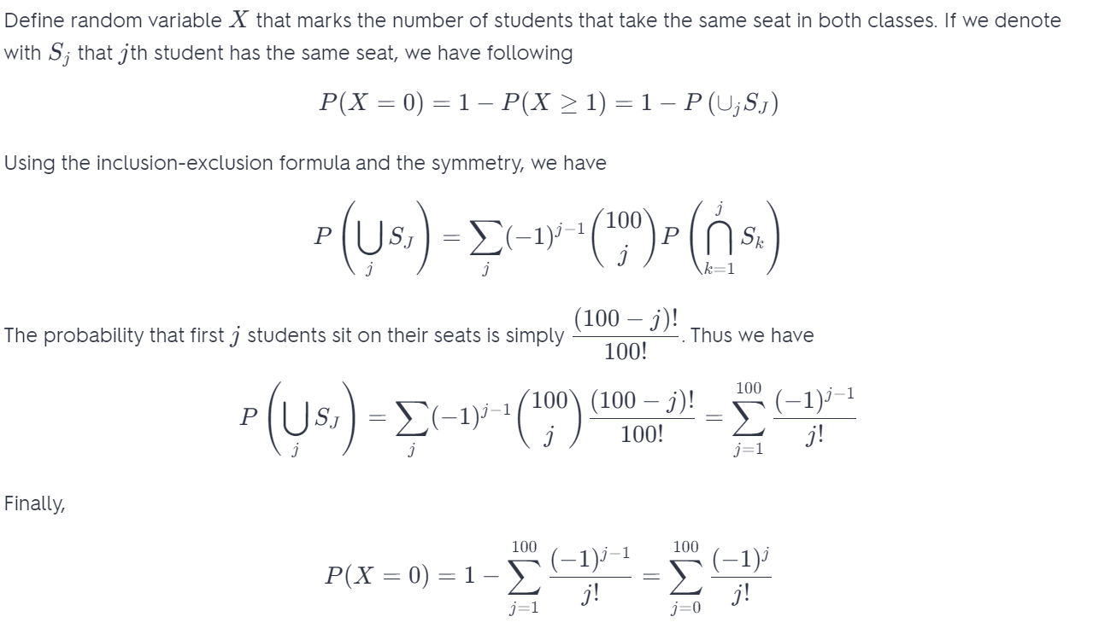

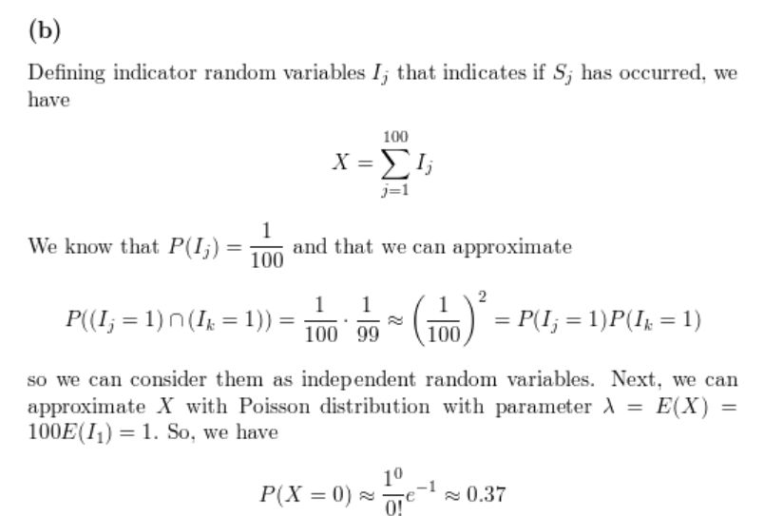

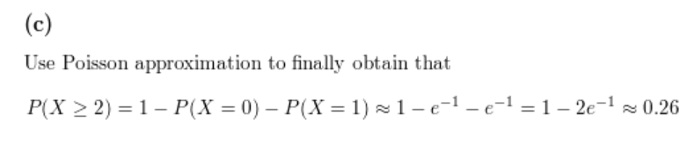

2:

This is probably the ugliest solution possible to this problem but here goes. Let’s first consider a special case where there are only 2 people (Alice and Bob) and 2 seats on the airplane. Alice picks a seat at random. The only way Bob gets to pick his designated seat is if Alice correctly picks hers. Since there are only 2 choices for Alice she picks her own seat correctly with probability 1/21/2

Therefore P(P( Bob gets his seat)=P()=P(Alice chooses her own seat)=1/2)=1/2

Now lets consider one more special case where we now have 3 people (Alice, Bob and Carlos) boarding the flight in that order and Alice picking a random seat first up. In this scenario, Carlos gets to sit on his designated seat in one of the following two possibilities:

• Alice picks her own seat

• Alice picks Bob’s seat and Bob picks Alice’s seat.

In all other cases the probability of Carlos picking his seat is 0. So we have :

P(P( Carlos gets his seat )=P()=P( Alice picks her own seat )+P()+P( Alice picks Bob’s seat )∗P()∗P( Bob picks Alice’s seat))

This reduces to :

P(P( Carlos gets his seat )=1/3+(1/3)∗(1/2)=(1/3+1/6)=1/2.