**Network Management Automation through Virtualization**

Arusyak D. Manasyan

Institute for Informatics and Automation Problems of NAS RA e-mail:armanasyan@iiap.sci.am

# **Abstract**

The aim of the study was to develop methods for automating network management by analyzing its virtual counterpart. The paper substantiates the relevance of this approach, identifies the advantages and disadvantages, highlights the existing problems, and suggests ways to solve them. As a result, a technique for automating network management was proposed by its virtualization.

**Keywords:** network, automation, virtualization, SDN (Software-Defined Network), OpenDaylight (Software), OpenFlow (Protocol).

# **1.Introduction**

The more devices are connected to the network, the more inconvenience will be with the costs of using them. And until the network system is automated, this problem will be constant. Organizations will spend a lot of money to buy powerful network devices, but network management will not become easier. That is why a study of network automation and virtualization was carried out, their current applications were discussed and solutions to existing problems were proposed.

As network traffic continues to grow, companies increasingly require large-scale network configurations. The move to cloud computing continues as enterprise customers and their applications rely more and more on network efficiency, so networks are expected to be highly reliable with minimal downtime. As the number of devices on the network increases, so does the need for uninterrupted, flexible, fast, and efficient communication between them. To do this, it is necessary to obtain a large number of network devices that will be of high quality, have great features, such as a large amount of memory, many interfaces, powerful processors, and all this is associated with high costs, which is one of the main prerequisites for the emergence automation and virtualization concepts.

For service providers, automation is a key strategy to improve network agility and reliability while controlling operating and capital costs. Therefore, it is necessary to automate the work with network equipment. Automation of daily network tasks, and functions, as well as automated monitoring of iterative processes increases the availability of network services.

Network virtualization technologies have long been used to build IT infrastructure. Any router, to one degree or another, supports network virtualization functions by setting up VLAN, VPN. And hypervisors, for example, can virtualize physical ports, by "sharing them among dozens of virtual machines."

Some experts describe the current state of the networking industry as "critical". The market-dominant closed (proprietary) solutions are "boxes" for applications, and the interoperability of solutions from different vendors is best provided at the interface level. Networks are extremely complex, making them difficult to scale, manage, and trust. Obviously, this slows down the further development of networks and programs running in them. Therefore, a number of solutions for network automation have been developed,and we talked about SDN in our research work.

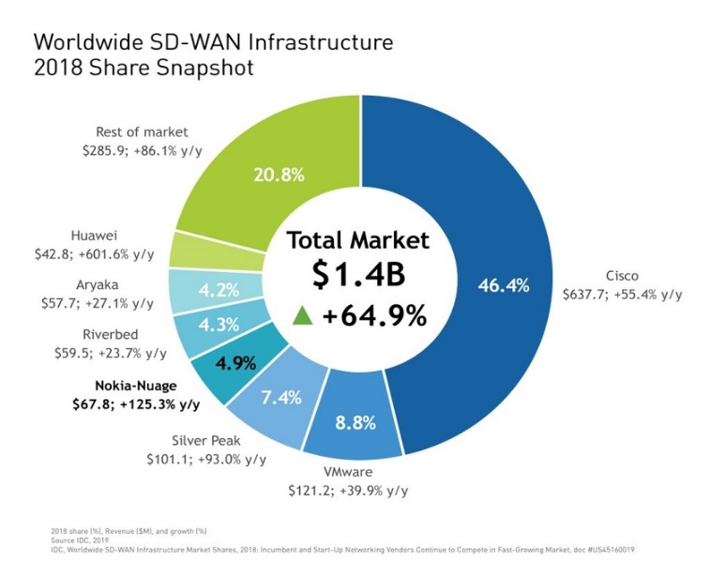

Fig . 1 ․ The largest manufacturers of SD-WAN solutions, according to IDC[1]

Today, network automation solutions allow you to perform a wide range of tasks, including network planning - design, including scenario planning - backup management, device testing - configuration testing, deployment of deployed physical devices - services, as well as virtual device deployment - provisioning devices, systems network collection real-time data related to applications, network topology, traffic, services, data analysis, including active artificial intelligence, machine learning analysis, to get an idea of ​​the current and future, network behavior, check configuration compliance, to ensure that all network devices and service requirements, software updates, including backing up software if necessary, fixing closed network issues, including troubleshooting, and complex, difficult to detect Troubleshooting activities, detailed analysis of reports, panels, alarms, warnings, compliance with security requirements, monitoring of the network and its services, service level to maintain customer satisfaction.

**2. Methods and Applications**

The research methodology includes the study of epistemological issues, programs (OpenDaylight), protocols (OpenFlow) in the field of networks, using scientific literature, and research articles. The research aims to present an example of an automated network as a result of the analysis based on the studied materials. Below is the physical network represented by the GNS3 simulator, which is fully operational, we will get the virtualized version of the following network, but the initial settings must be done one way or another.

This article provides a brief overview of virtual networks and network performance evidence.The physical network shown below is represented by a fully running GNS3 simulator. It contains hosts, routers (Mikrotik) and a virtual switch - OpenvSwitch.

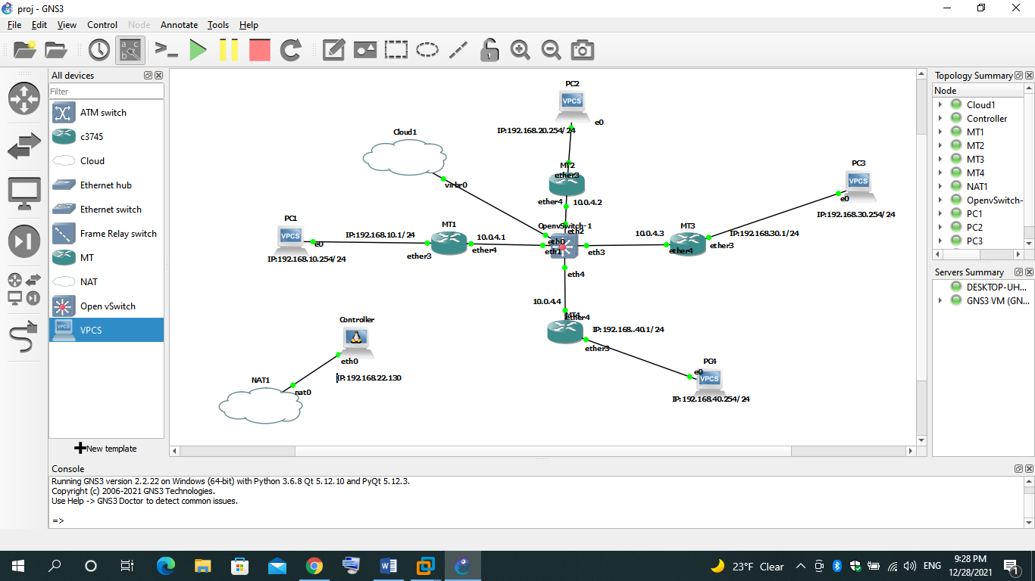 Fig . 2 ․ Network presented with GNS3 simulator

Here are the settings of one of the devices, almost the same as the rest:

/routing OSPF instance

set [ find default=yes ] router-id=10.255.255.1

/IP address

add address=10.0.4.1/24 interface=ether4 network=10.0.4.0

add address=192.168.10.1/24 interface=ether3 network=192.168.10.0

/routing OSPF network

add area=backbone network=10.0.4.0/24

add area=backbone network=192.168.10.0/24

Here are the minimum settings that make the network complete.

For network virtualization, as mentioned at the beginning, we implemented an SDN solution. We have demonstrated the use of SDN with the OpenDaylight software, which is a software platform for SDN.

To work with our controller, to connect it to our physical network, we downloaded and activated the following components:

opendaylight-user@root>feature:install odl-restconf odl-l2switch-switch odl-mdsal-apidocs odl-dlux-all

They provide the graphical user interface of OpenDaylight software, and the necessary tools and devices. After activating them, immediately after setting the appropriate settings in our physical OpenvSwitch network, we see a virtualized version of our network.

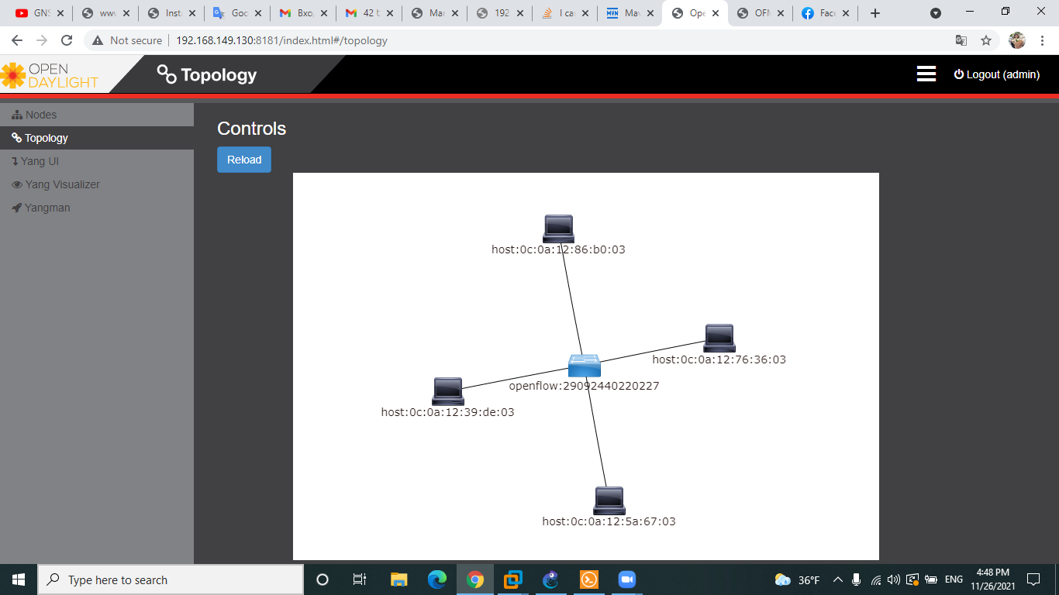To establish a "controller" connection in our physical network, we have previously configured the OpenvSwitch OpenFlow device by giving it the IP address of the controller by typing the following command: **ovs-vsctl set-controller br0 tcp: 192.168.22.130:6633**, where 192.168.22.130 is the IP address of the controller and it can be different for different devices, 6633 is the connection port and the protocol that controls data transfer over TCP. Thanks to this, it was able to communicate with other devices.

Fig ․3 ․ Example of a virtual network in OpenDaylight

Fig. 3 shows a virtualized version of the physical network in OpenDaylight. The picture clearly shows all the devices in our network that are connected to the OpenFlow protocol support device, OpenvSwitch. It is thanks to the OpenFlow protocol that our SDN controller sees our entire physical network.

OpenFlow is a protocol for managing data processing, which is transmitted over the network through routers and switches using the SDN technology. Fast packet forwarding (data forwarding) on ​​a classic router or switch and high-level routing decisions (control operations) are made on the same device. The OpenFlow switch separates these two functions. Data redirection is performed by the switch itself, while routing decisions are entrusted to a separate controller, usually a standard server.

The GUI (graphical user interface) of OpenDaylight[4]] is good but very limited. If we want to control and (or) customize our SDN controller, we need to use the RESTCONF API. The NETCONF was developed by IETF to facilitate network automation.

opendaylight yang ui rest api http getAfter clicking on the network topology, Yang automatically shows us the CONFREST API URL it uses to get this information:

Fig․ 4․ CONFREST API URL

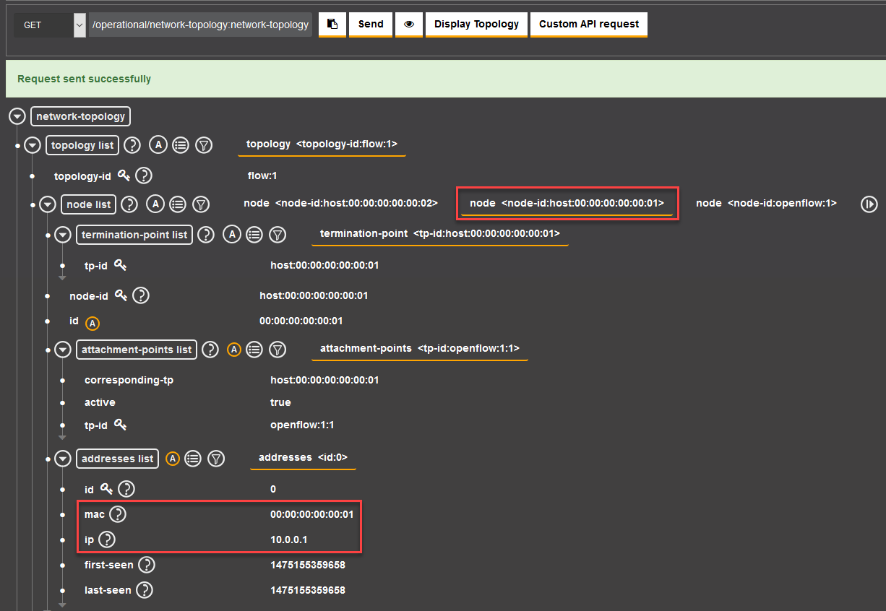By clicking the send button(Fig.4) we can see the topology of our operational network.

Fig. 5․ Operating network topology

In Figure 4 we can see information about our current topology, including the MAC (Media Access Control) and IP addresses of our hosts. So you do not need to enter the device to see them every time, but you can see them from one control panel of SDN.

**3․Analyses and Discussion**

As a result of the research, we obtained an example of a virtual network, which allows you to easily manage the network from a single control panel, SDN[2].

As the SDN technology[2] is based on an intelligent controller, it allows you to automatically redistribute traffic. It turned out that the device allows you to centrally change the settings of network equipment in branches, monitor the network status, load and quality of channels online, and solve problems. This ensures the transparency of data transmission networks and reduces the burden on IT professionals serving the network.

The study also showed that the SDN[3] solution involves the automatic networking of private networks, and the transmission of information through all available channels without losing the speed and quality of applications. For example, in the past, only expensive VPN channels were used to transmit audio or video without distortion. Now, thanks to SDN, we can only use the Internet and LTE as a backup. In this way, customers can save on telecommunication bill payments and solve VPN reservation issues in a simple and cheap way. Unlike other virtualization technologies, the open-source SDN solution is more promising. SDN[4] already provides companies with many options to choose from OpenFlow, NETCONF, OVSDB, switches that support the API library, as well as enterprise software that utilizes these protocols. Like any other infrastructure, the SDN infrastructure is built on open standards. This open ecosystem accelerates network innovation. Although the traditional approach to building a network infrastructure still prevails due to the negative impact of mental inertia and crisis events, SDN already allows you to effectively solve problems in a virtual physical environment.

By automating the network, we get the following benefits and services: reduced problems, reduced costs, increased network flexibility, reduced network outages, increased number of strategic employees, advanced analysis, and network management capabilities.

# **4. Conclusion**

As a result of the research, we came to the conclusion that automation improves the speed of IT operations in response to analytical change. The ability to monitor operations, just as needed, provides greater visual control of the network, and transparency of processes within it. Network automation improves work efficiency, reduces human error, increases access to network services, and provides better customer service. Research has shown that the SDN solution includes the automatic integration of private networks, and the transmission of information over all available channels, without loss of application speed and quality. As a result of the study, it became clear that network automation can be implemented regardless of its type, which facilitates its transition. Network virtualization is a more all-encompassing version of virtualization that makes it possible to convert physical network hardware into software that can easily be transitioned to different domains as needed, increasing flexibility and scalability for the network. So I think it is the best choice for our network.

**5.References**

[1] (2022) Worldwide SD-WAN infrastructure picture website. [Online]. Available (30.03.2022 11:50): <https://www.tadviser.ru/images/thumb/9/96/IDC_SD-WAN_market_share_snapshot_blog_II-1024x876.jpg/840px-IDC_SD-WAN_market_share_snapshot_blog_II-1024x876.jpg>

[2] [Jim Doherty](https://learning.oreilly.com/search/?query=author%3A%22Jim%20Doherty%22&sort=relevance&highlight=true), “SDN and NFV Simplified: A Visual Guide to Understanding Software Defined Networks and Network Function Virtualization,” [Addison-Wesley Professional](https://learning.oreilly.com/library/publisher/uuid/1495afeb-554e-4ba9-84fb-f260848d173e), March 2016. Available (30.03.2022 13.10):

<https://learning.oreilly.com/library/view/sdn-and-nfv/9780134307398/>

[3] The SDN website. [Online]. Available (30.03.2022 11:44): <https://www.tadviser.ru/index.php/%D0%A1%D1%82%D0%B0%D1%82%D1%8C%D1%8F:SD-WAN_(Software_Defined)_%D0%9F%D1%80%D0%BE%D0%B3%D1%80%D0%B0%D0%BC%D0%BC%D0%BD%D0%BE-%D0%BE%D0%BF%D1%80%D0%B5%D0%B4%D0%B5%D0%BB%D1%8F%D0%B5%D0%BC%D0%B0%D1%8F_WAN-%D1%81%D0%B5%D1%82%D1%8C>

[4] The SDN website. [Online]. Available (30.03.2022 12:00):

<https://habr.com/ru/company/hpe/blog/255363/>"

**Ցանցի ղեկավարման ավտոմատացում վիրտուալացման միջոցով**

Արուսյակ Դ․ Մանասյան

ՀՀ ԳԱԱ Ինֆորմատիկայի և ավտոմատացման պրոբլեմների ինստիտուտ

*e-mail:armanasyan@iiap.sci.am*

**Ամփոփում**

Հետազոտության նպատակն էր մշակել ցանցի ղեկավարման ավտոմատացման մեթոդներ՝ վերլուծելով դրա վիրտուալ անալոգը: Աշխատանքում հիմնավորվում է այս մոտեցման արդիականությունը, վեր են հանվում առավելություններն ու թերությունները, ընդգծվում են առկա խնդիրները և առաջարկվում են դրանց լուծման ուղիներ։ Արդյունքում առաջարկվել է ցանցի ղեկավարման ավտոմատացման տեխնիկա՝ դրա վիրտուալացման միջոցով:

**Բանալի բառեր՝**ցանց, ավտոմատացում, վիրտուալացում, SDN (Ծրագրակողմնորոշված ցանց), OpenDaylight (Ծրագրային ապահովում), OpenFlow (Արձանագրություն)։

**Автоматизация управления сетью за счет виртуализации**

Арусяк Д. Манасян

Институт проблем информатики и автоматизации НАН РА

*e-mail:armanasyan@iiap.sci.am*

**Аннотация**

Цель исследования заключалась в разработке методов автоматизации управления сетью путем анализа ее виртуального аналога. В работе обосновывается актуальность такого подхода, выявляются преимущества и недостатки, подчеркиваются существующие проблемы и предлагаются пути их решения. В результате была предложена методика автоматизации управления сетью посредством ее виртуализации.

**Ключевые слова:** сеть, автоматизация, виртуализация, SDN (Программно-определяемая сеть), OpenDaylight (Программное обеспечение), OpenFlow (Протокол).