 Vot tipa tak. Srazu vidno, chto pervuju chast“ pisala ti.

Mojet stoit vkluchit“ paru primerov poprosche, tipa: imeem 3 proiderov i nastravaem routeri na backup i na posilku paketov http po 1 kanalu i zagruzku bol“shix failov cherez drugogo.

**ANALYZES OF NETWORK AUTOMATION WITH NETWORK VIRTUALIZATION**

**Arusyak Davit Manasyan**

**NATIONAL UNIVERSITY OF ARCHITECTURE AND CONSTRUCTION OF ARMENIA**

# **Abstract**

The research discusses Analyzes of Network Automation With Network Virtualization. Research has been doneA study was conducted, their current applications were discussed, the advantages and disadvantages were identified, the topicality, the existing problems in this field and their solutions were presented. As a result of the research, a new version of network automation virtualization was proposed.

**Keywords ․**network, automation, virtualization, SDN (Software-Oriented Network), OpenDaylight (Software), OpenFlow (Protocol).

# **Introduction**

There are millions of network devices in the world that need to be configured, updated, and certified to work. Maintenance of such a system of equipment is quite difficult and requires a lot of time, effort and human resources. Current trends, such as the increase in the number of devices connected to the Internet, the exponential growth of information volumes, the development of cloud technologies, BYOD[[1]](https://translate.googleusercontent.com/translate_f" \l "_ftn1)․ Big data is changing the way we look at corporate telecommunications. As network traffic continues to grow, businesses need more and more network configuration. As the transition to cloud computing continues, enterprise customers and their applications are becoming more and more dependent on network efficiency, so networks are expected to be highly reliable with minimal downtime. As the number of devices in the network increases, so does the need to provide seamless, flexible, fast, and efficient communication between them. To do this, you need to get a large number of network devices that will be quality, have great capabilities such as large memory, many interfaces, powerful processors, and all this is associated with high costs, which is one of the main prerequisites for the emergence of automation and virtualization concepts.

 For service providers, automation is a key strategy to improve network flexibility and reliability while controlling operating and capital costs. Therefore, it is necessary to automate the work with network equipment. Network automation is a process of configuring, managing, testing, deploying, and operating physical and virtual devices on a network. By automating day-to-day networking tasks, functions as well as automated monitoring iterative processes, access to network services increases.

# **Results and Discussion**

 The greater the number of devices connected to the network, the greater the inconvenience of using them and costs. And until the network system is not automated, this problem will be continuous. Organizations will spend a lot of money on good network devices. Some experts describe the current state of the network industry as "critical". The predominant closed (proprietary) solutions on the market are "black boxes" for applications, and the interoperability of different vendors solutions is best ensured at the interface level. Networks are extremely complex, which makes them difficult to scale, manage, and trust. It is obvious that this hinders the further development of the networks and programs operating in them.

Network virtualization technologies have long been used to build IT infrastructure. Almost any router supports network virtualization functions to some extent: VLAN (Virtual Local Area Network), VPN (Virtual Private Network). And hypervisors (a program or hardware diagram that allows several operating systems to run on the same computer in parallel), for example, can virtualize physical ports to share them between dozens of virtual machines .

SDN[[2]](https://translate.googleusercontent.com/translate_f" \l "_ftn2) the solution involves automatic network private networking, transmitting information through all available channels without losing the speed and quality of applications. For example, in the past, only expensive VPN channels were used to transmit audio or video without distortion. Now, thanks to SDN, we can only use Internet and LTE(Long-Term Evolution) as a backup. This way, customers can save on paying bills from telecom operators, solve the problem of booking VPN channels in a simple and cheap way.

Unlike other virtualization technologies, analysts say the open SDN solution is more promising. SDN already provides companies with many options to choose from OpenFlow, NETCONF(Network Configuration Protocol ), OVSDB(Open vSwitch documentation) and switches that support the extended API(Application Programming Interface) library, as well as enterprise software that utilizes these protocols. Like any other infrastructure, the SDN infrastructure is built to open standards. This open ecosystem accelerates network innovation. Although the traditional approach to building network infrastructure still prevails due to the negative impact of thinking inertia and crisis events, SDN already allows for efficient problem-solving in the virtual-physical environment. The experience of large Internet companies has shown the ability to adapt large-scale network infrastructure to ever-changing requirements. But many companies have been slow to implement their SDN strategy, believing they need to completely redesign their network equipment.

Part of this concern stems from the common misconception that SDN is a product. In fact, it's more of a network design approach as a new paradigm for adapting their management, monitoring, and, ultimately, the business tasks implemented by applications. Switching to SDN is a step-by-step process that takes into account the business applications of the network. While some products, such as SDN switches, support OpenFlow, there is no need to completely replace the network infrastructure.

SDN[[3]](https://translate.googleusercontent.com/translate_f" \l "_ftn3) the technology is based on an intelligent controller that automatically redistributes traffic. In addition, the device allows you to centrally change the network equipment settings in the branches, monitor the network status, channel load, quality online and solve emerging problems. This ensures the transparency of data transmission network operations and reduces the burden on IT professionals serving the network.

The volume of the global software market for the software-wide deployment of software networks In 2020, the global market for equipment for the deployment of large-scale software networks (SDNs) has increased by 32%, which is half the growth rate of 2019. This was reported by the research company Dell'Oro Group, without mentioning the absolute values.

Experts only predict that by 2025 the market under consideration will reach $ 4 billion, growing by an average of 24% per year.

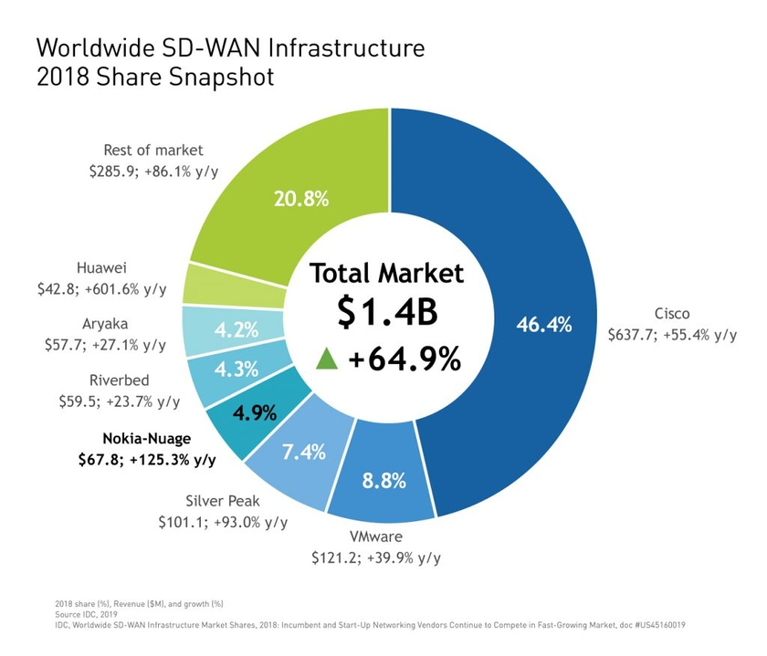A report by Dell'Oro Group states that Cisco remains the largest maker of hardware and software by 2020 to deploy a wide range of software-defined networks. They are followed by VMware, Fortinet, Versa Networks and HPE / Silver Peak (listed by market share).

Fig . 1 ․ The largest manufacturers of SD-WAN solutions, according to IDC

According to analysts, the global market for software-defined networks (data centers (SDN, SD-WAN and SDDC technologies)) will reach 160.8 billion dollars by 2024, compared to 51.7 billion dollars in 2019. The annual growth rate is expected to be 25.5%.

**Applications and methods**

The research methodology includes the study of cognitive issues in the field of networks, programs (OpenDaylight), protocols (OpenFlow), using scientific literature, conducting research of articles. The research aims to present an example of an automated network as a result of the analysis based on the studied materials.

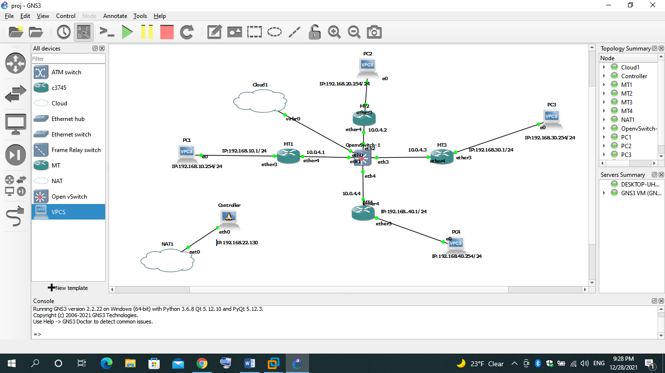Below is a physical network represented by the GNS3 simulator, which is fully operational, we will get the following virtualized version of the network.

Fig . 2 ․ Network presented with GNS3 simulator

We will implement the SDN solution with OpenDaylight software (Figure ․ 3), which is a software platform for SDN.

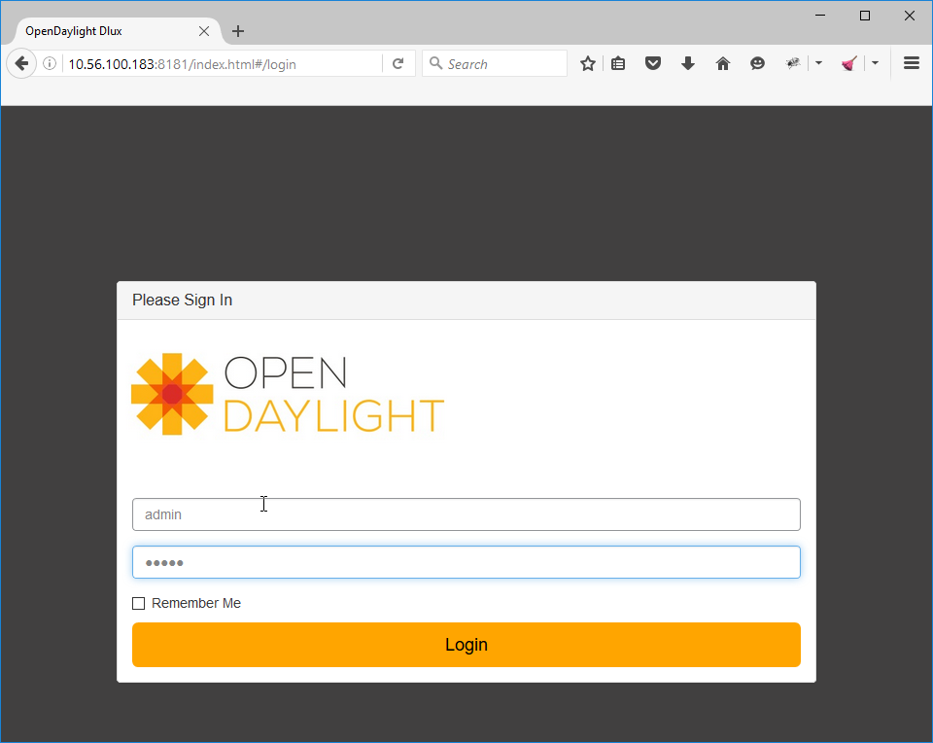Fig.3․ OpenDaylight software access screen

OpenDaylight controller is JVM software and can run on any operating system and hardware as long as it supports Java. The controller is the implementation of the SoftwareSoftware-Defined (SDN) concept. The controller comes with some basic functionality, but if we want to do something useful, we need to add some extra functionality. In this article, we wil, use some basic GUI, RESTCONF API and L2 connection functions to learn MAC addresses. We will need to install the following functions:

opendaylight-user@root>feature:install odl-restconf odl-l2switch-switch odl-mdsal-apidocs odl-dlux-all

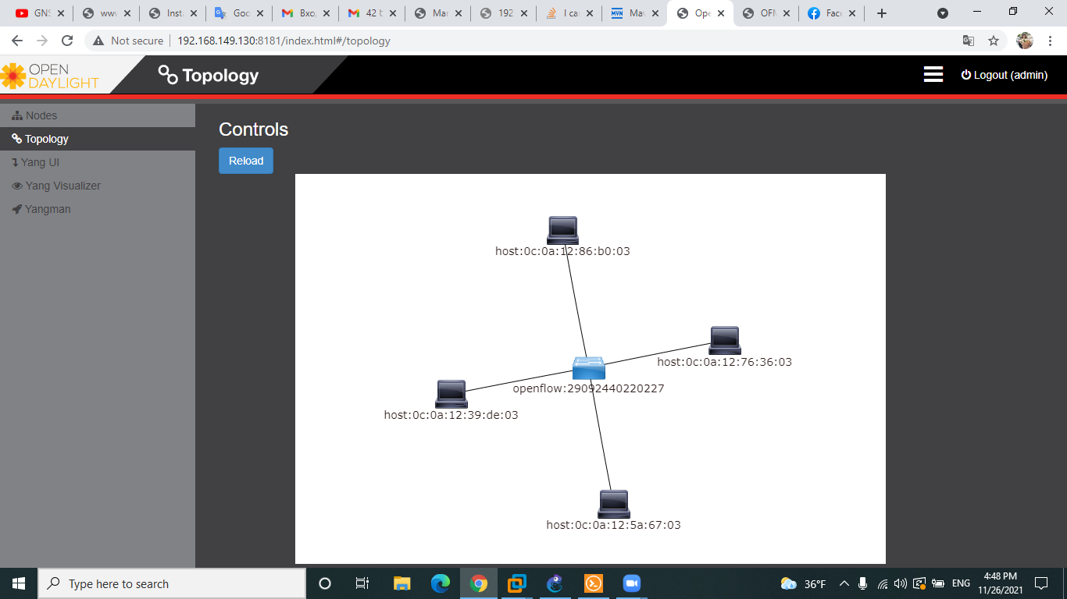

Fig ․4 ․ Example of a virtual network in OpenDaylight

Figure 4 shows the virtualized version of the physical network with all the devices connected to the OpenFlow protocol support device, Openvswitch. It is thanks to the OpenFlow protocol that our SDN controller sees our entire physical network. OpenFlow is a protocol for managing data processing, which is transmitted over the network through routers and switches, using SDN technology. Fast packet forwarding (data forwarding) on ​​a classic router or switch and High-level routing decisions (control operations) are made on the same device. The OpenFlow switch separates these two functions. Data redirection is performed by the switch itself, while routing decisions are entrusted to a separate controller, usually a standard server.

In the left corner of the image, we see several fields: nodes, topology, yang UI and etc. Each of them has its role and importance in network management. For example, in the topology field, we see our physical network, because we pre-configured the OpenFlow device by giving it the IP address (internet protocol) of the controller, which allowed it to communicate with other devices, in the nodes field we see packets passing through network devices, the number of received and lost packets, block diagram, numbers ports of used devices. The GUI (graphical user interface) of OpenDaylight[[4]](https://translate.googleusercontent.com/translate_f#_ftn5) is good but very limited. If we want to control and (or) customize our SDN controller, we need to use the RESTCONF API (this is an API over HTTP that allows us to retrieve data from YANG). The NETCONF[[5]](https://translate.googleusercontent.com/translate_f" \l "_ftn5) is a management protocol that allows us to define, manage, and delete network device configurations. It uses XML for data encryption and RPC for transport. It can be used as an alternative to CLI to configure our devices. NETCONF can also be used to obtain statistics from our network devices. In addition to NETCONF, we use a data modeling language for NETCONF called YANG. YANG is uses a hierarchical structure makes it easier for people to understand.

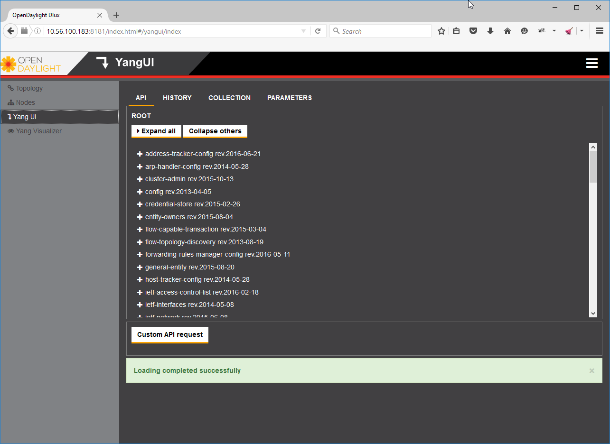Fig․5 ․ Yang UI:

opendaylight yang ui rest api http getAfter clicking on the network topology, Yang automatically shows us the CONFREST API URL it uses to get this information:

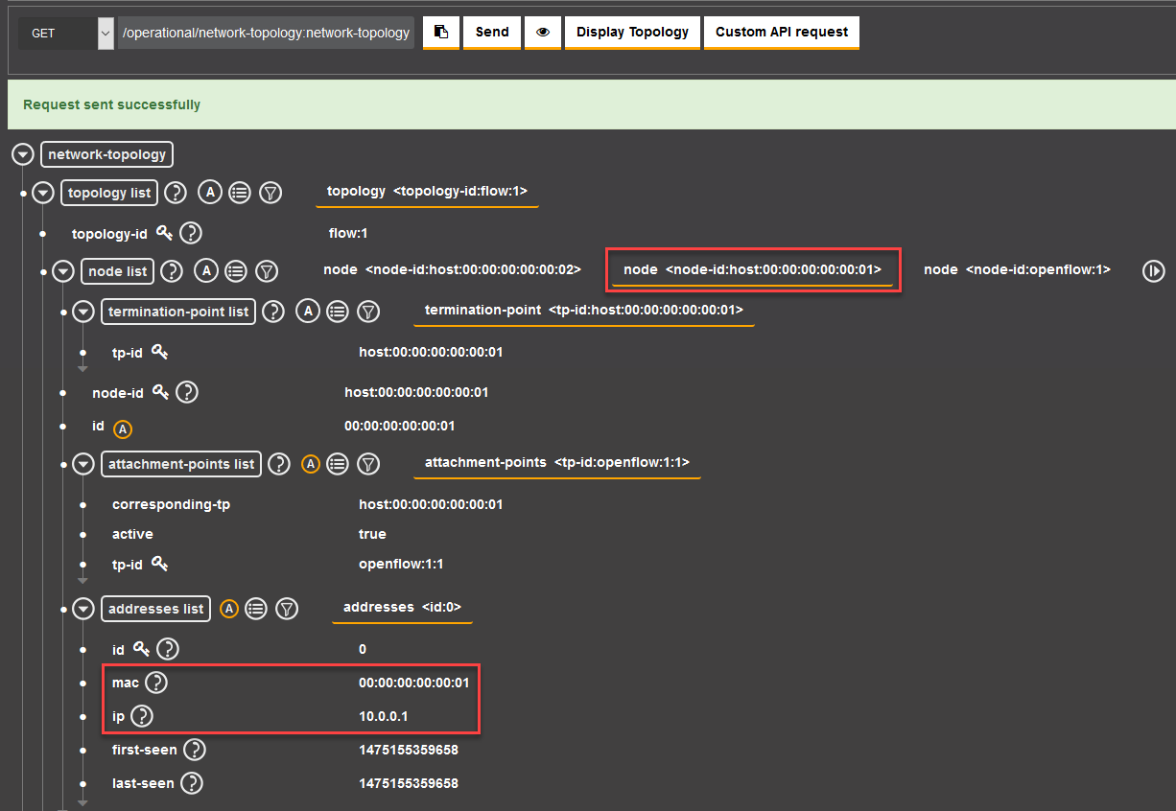By clicking the send button we can see the topology of our operational network:

Fig ․6 ․ Operating network topology

In Figure 6 we can see information about our current topology, including our hosts' MAC ( Media Access Control ) and IP addresses.

# **Conclusion**

No one argues anymore that SDN is needed, all the contradictions are transferred to the implementation.

In fact, now everyone understands what to expect from SDN in terms of "introducing SDN / OpenFlow in practice", developing new equipment, developing new services. I am sure that the scope of SDN will not change anymore! All vendors understand SDN in completely different ways. Completely different protocols, different approaches to implementation, then somehow centralized management appeared, it is possible to create services on your own, etc., but the devices are not open-portable.

Network automation can be carried out regardless of its type. Using artificial intelligence (AI) - machine learning, advanced network automation solutions analyze metadata - use the power of model-based network programming to learn about network behavior, provide active information - make recommendations to network operators. These advanced automation solutions can be configured to take corrective action on their own, allowing network problems to be fixed in a closed-loop, sometimes before they occur. In this way, network automation improves work efficiency, reduces human error, enhances access to network services, and provides better customer service.

Today, network automation solutions allow you to perform a wide range of tasks, including network planning - design, including scenario planning - backup management, device testing - configuration testing, deployment of deployed physical devices - services, and virtual device deployment - device provisioning, systems, collecting real-time network data related to applications, network topology, traffic, services, data analysis, including active artificial intelligence, machine learning analysis, to get an idea of ​​the current and future, network behavior, check configuration compliance to ensure correct operation requirements, software updates, including backing up the software when necessary, fixing closed network issues, including troubleshooting, as well as complex, hard-to-find troubleshooting, detailed analysis of reports, pane whether lei, alarms, warnings, security compliance, monitoring of the network and its services, service levels to maintain customer satisfaction. Organizations gain the following benefits by automating their networks and services: task reduction, cost reduction, increased network agility, reduced network downtime, increased strategic staffing, enhanced analysis and network management capabilities.

Automation increases the speed of IT operations in response to analytical changes. The ability to control operations and adjust as needed provides greater visual control over the network and transparency of processes within it.

# **List of literature**

1. [https://www.itweek.ru/infrastructure/article/detail.php?ID=175872](https://translate.google.com/translate?hl=ru&prev=_t&sl=hy&tl=en&u=https://www.itweek.ru/infrastructure/article/detail.php%3FID%3D175872)
2. [https://www.tadviser.ru/index.php/%D0%A1%D1%82%D0%B0%D1%82%D1%8C%D1%8F:SD-WAN\_(Software\_Defined)\_%D0%9F % D1% 80% D0% BE% D0% B3% D1% 80% D0% B0% D0% BC% D0% BC% D0% BD% D0% BE-% D0% BE% D0% BF% D1% 80% D0% B5% D0% B4% D0% B5% D0% BB% D1% 8F% D0% B5% D0% BC% D0% B0% D1% 8F\_WAN-% D1% 81% D0% B5% D1% 82% D1 % 8C:](https://translate.google.com/translate?hl=ru&prev=_t&sl=hy&tl=en&u=https://www.tadviser.ru/index.php/%25D0%25A1%25D1%2582%25D0%25B0%25D1%2582%25D1%258C%25D1%258F:SD-WAN_(Software_Defined)_%25D0%259F%25D1%2580%25D0%25BE%25D0%25B3%25D1%2580%25D0%25B0%25D0%25BC%25D0%25BC%25D0%25BD%25D0%25BE-%25D0%25BE%25D0%25BF%25D1%2580%25D0%25B5%25D0%25B4%25D0%25B5%25D0%25BB%25D1%258F%25D0%25B5%25D0%25BC%25D0%25B0%25D1%258F_WAN-%25D1%2581%25D0%25B5%25D1%2582%25D1%258C)
3. [https://networklessons.com/cisco/ccna-routing-switching-icnd2-200-105/introduction-to-sdn-opendaylight](https://translate.google.com/translate?hl=ru&prev=_t&sl=hy&tl=en&u=https://networklessons.com/cisco/ccna-routing-switching-icnd2-200-105/introduction-to-sdn-opendaylight)

**Links**

[[1]](https://translate.googleusercontent.com/translate_f#_ftnref1) <https://www.itweek.ru/infrastructure/article/detail.php?ID=175872>

[[2]](https://translate.googleusercontent.com/translate_f#_ftnref2) https://www.tadviser.ru/index.php/%D0%A1%D1%82%D0%B0%D1%82%D1%8C%D1%8F:SD-WAN\_(Software\_Defined)\_% D0% 9F% D1% 80% D0% BE% D0% B3% D1% 80% D0% B0% D0% BC% D0% BC% D0% BD% D0% BE-% D0% BE% D0% BF% D1 % 80% D0% B5% D0% B4% D0% B5% D0% BB% D1% 8F% D0% B5% D0% BC% D0% B0% D1% 8F\_WAN-% D1% 81% D0% B5% D1% 82% D1% 8C:

[[3]](https://translate.googleusercontent.com/translate_f#_ftnref3) https://www.tadviser.ru/index.php/%D0%A1%D1%82%D0%B0%D1%82%D1%8C%D1%8F:SD-WAN\_(Software\_Defined)\_% D0% 9F% D1% 80% D0% BE% D0% B3% D1% 80% D0% B0% D0% BC% D0% BC% D0% BD% D0% BE-% D0% BE% D0% BF% D1 % 80% D0% B5% D0% B4% D0% B5% D0% BB% D1% 8F% D0% B5% D0% BC% D0% B0% D1% 8F\_WAN-% D1% 81% D0% B5% D1% 82% D1% 8C:

[[4]](https://translate.googleusercontent.com/translate_f#_ftnref4) <https://networklessons.com/cisco/ccna-routing-switching-icnd2-200-105/introduction-to-sdn-opendaylight>

[[5]](https://translate.googleusercontent.com/translate_f#_ftnref5) https://networklessons.com/cisco/ccna-routing-switching-icnd2-200-105/introduction-to-sdn-opendaylight

**Content**

[**Abstract** 1](#_Toc93134726)

[**Introduction** 1](#_Toc93134727)

[**Results and Discussion** 2](#_Toc93134728)

[**Conclusion** 8](#_Toc93134729)

[**List of literature** 9](#_Toc93134730)

[**Links** 9](#_Toc93134731)