**NAMA : ANDI RUSMIATI**

**NIM : D121191079**

**DEPARTEMEN : TEKNIK INFORMATIKA C 2019**

**Program ATM**

Project yang saya buat adalah ATM dimana pada gambar dibawah ini adalah tampilan menu utama or main class pada project saya dengan nama file AtmNumNum.java

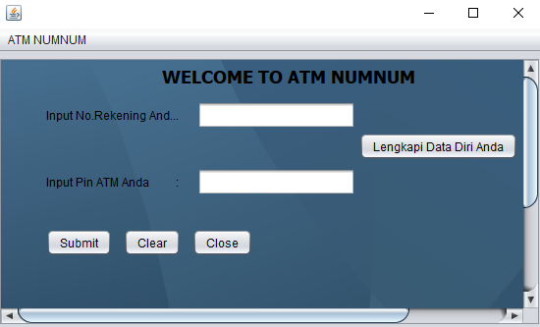

Pada class AtmNumNum.java terdapat 2 inputan user yang diperlukan. User hanya tinggal menginput nomor rekening dan juga pin atm mereka. Apabila telah menginput nomor rekening dan juga pin atm, maka user tinggal mengklik tombol submit untuk lanjut ke menu atau proses selanjutnya. Namun apabila user melakukan kesalahan dalam inputannya, maka user tinggal menekan tombol reset untuk melakukan inputan ulang. Dan apabila user ingin keluar dari program, maka user cukup menekan tombol close.

Sedangkan pada menu bar, terdapat menu informasi.

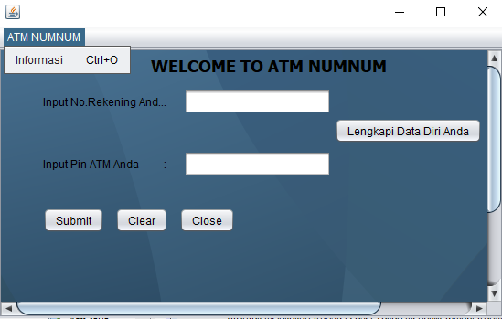

Jika user mengklik menu tersebut, maka user akan beralih ke menu yang berisikan tutorial menggunakan atm tersebut seperti dibawah ini

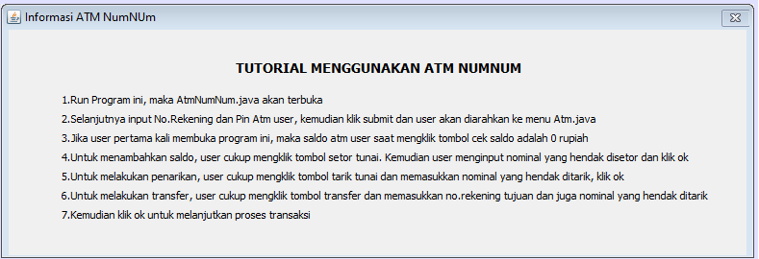

Kembali ke main class, saat user mengklik tombol submit setelah menginput nomor rekening dan pin atm, maka user akan dialihkan ke menu Atm.java. Dalam class ini, terdapat beberapa menu yang telah disediakan yaitu CekSaldo, Transfer, Setor Tunai, dan juga Tarik Tunai.

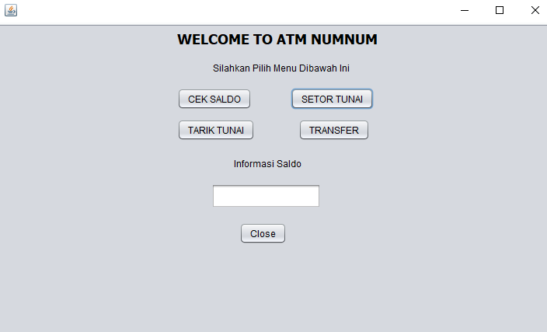

Jika user baru pertama kali menjalankan program ini, maka apabila user mengklik tombol cek saldo, maka akan muncul dialog message yang menyatakan bahwa saldo anda masih 0.

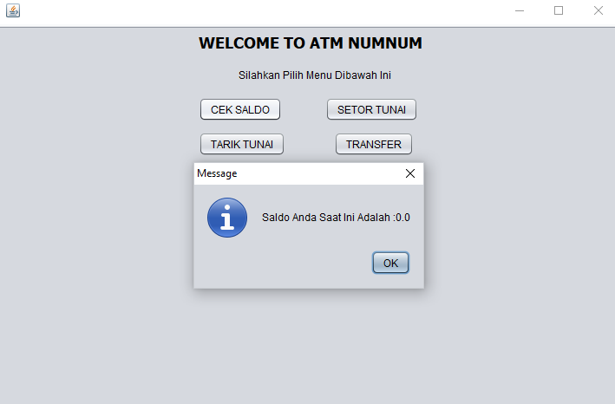

Agar saldo anda bisa bertambah, maka user cukup mengklik tombol setor tunai. misal saja seperti gambar dibawah ini akan muncul kotak dialog untuk menginput nominal tunai yang akan user setor.

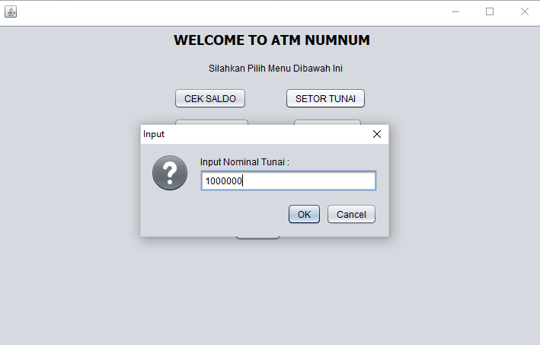

Setelah menginput nominal tunai, user cukup mengklik tombol ok dan cancel untuk membatalkan proses. Apabila user mengklik tombol ok, maka akan muncul kotak dialog yang menyatakan bahwa saldo anda saat ini adalah ... (sesuai nominal tunai yang user setor).

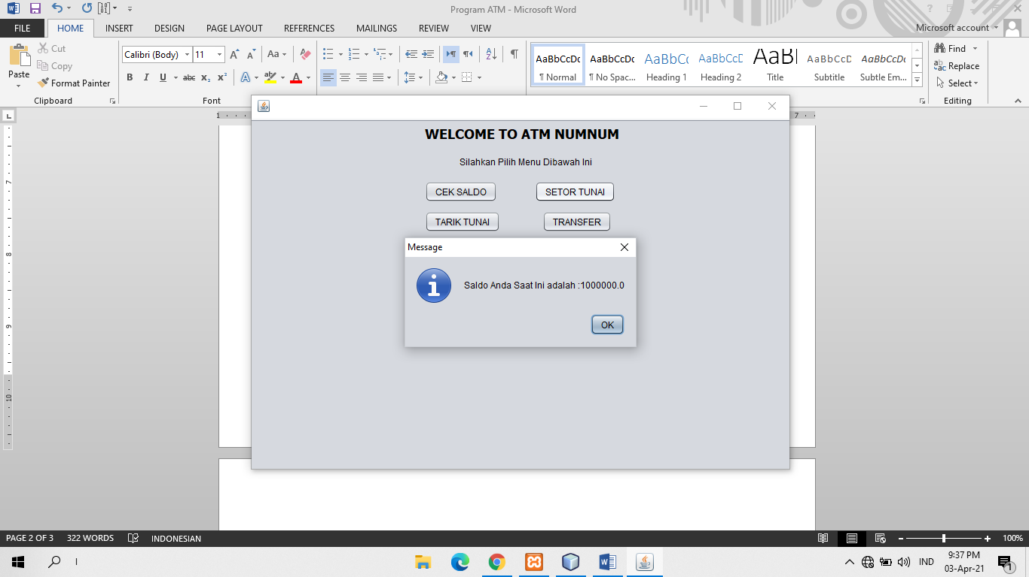

Selanjutnya klik ok, maka nominal saldo anda akan muncul pada textfield yang telah disediakan.

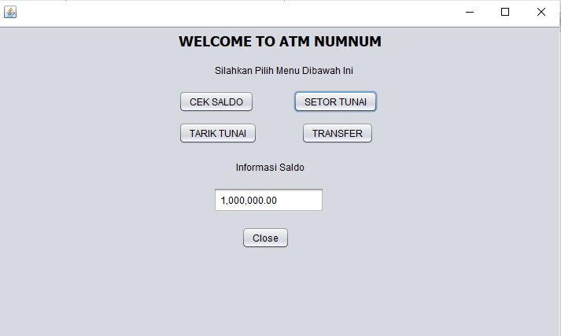

Jika user ingin melakukan tarik tunai, maka user cukup mengklik tombol tarik tunai. setelah user mengklik tombol tersebut, maka akan muncul kotak dialog input nominal tunai yang hendak user tarik.

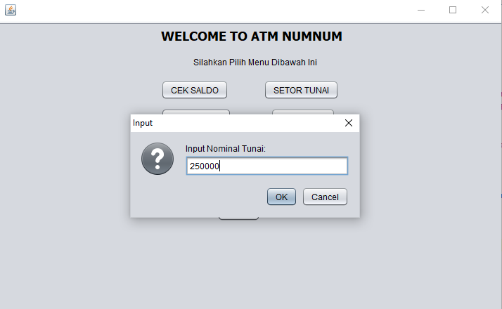

Setelah itu klik ok untuk melanjutkan atau cancel untuk membatalkan proses transaksi.

Apabila user mengklik tombol ok, maka proses transaksi akan di proses dan apabila telah berhasil, maka saldo anda akan otomatis berkurang dan akan muncul kota dialog seperti dibawah ini.

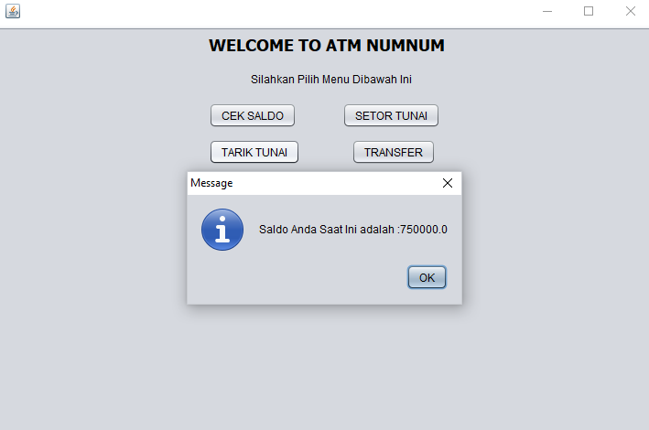

Terakhir, apabila user ingin melakukan transfer, maka user cukup mengklik tombol transfer. Setelah mengklik tombol transfer, maka akan muncul kotak dialog input nomor rekening tujuan seperti dibawah ini.

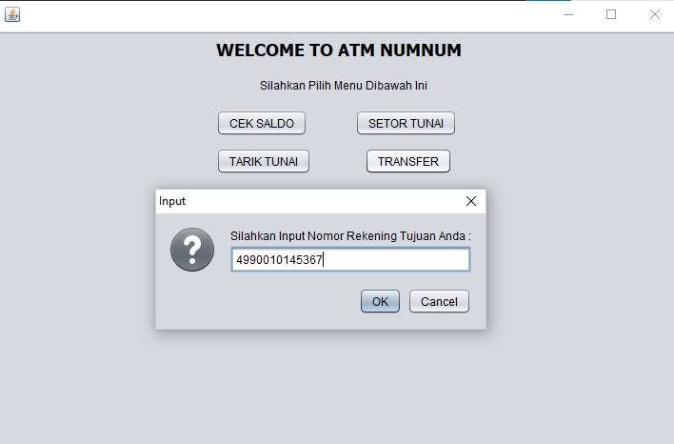

Setelah menginput nomor rekening tujuan, klik ok untuk melanjutkan atau cancel untuk membatalkan proses transaksi.

Apabila user mengklik tombol ok, maka akan muncul kotak dialog input nominal tunai yang hendak ditransfer seperti dibawah ini.

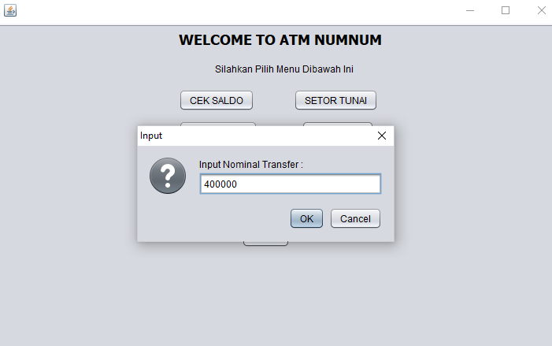

Setelah menginput nominal transfer, klik ok untuk melanjutkan maka proses transaksi akan di proses dan apabila telah berhasil, maka saldo anda akan otomatis berkurang dan akan muncul kota dialog seperti dibawah ini.

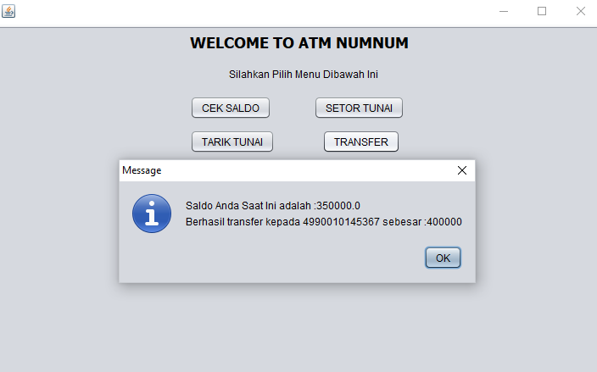

Dan untuk keluar dari program ini, user cukup mengklik tombol close.

Kemudian, kembali ke mainClass AtmNumNum.java, apabila user mengklik tombol lengkapi data diri anda, maka user akan dialihkan ke menu input data diri seperti dibawah ini

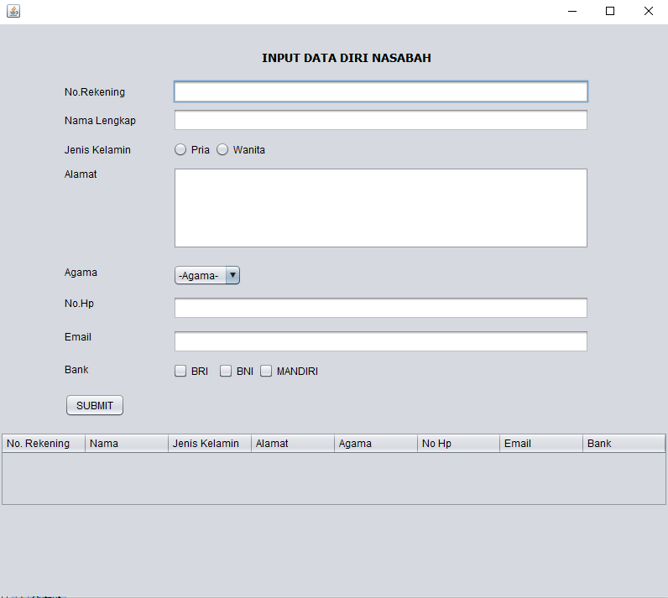

Kemudian isi data pada tempat yang telah disediakan dan klik submit. Data yang telah diisi akan tersimpan dalam file database yang telah dihubungkan

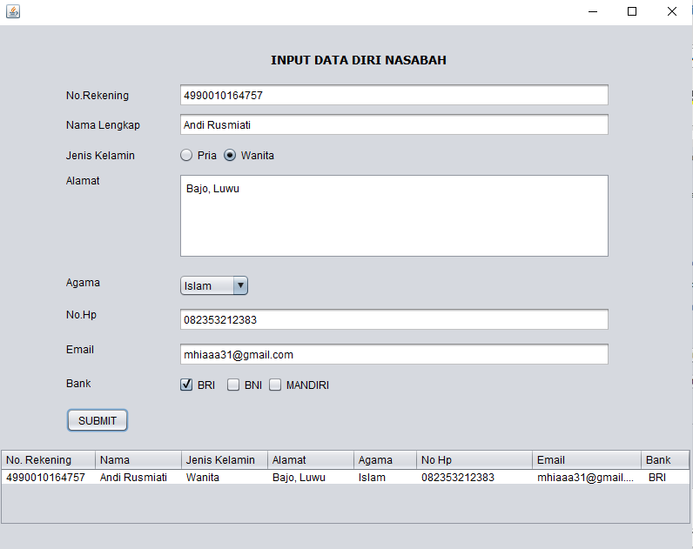

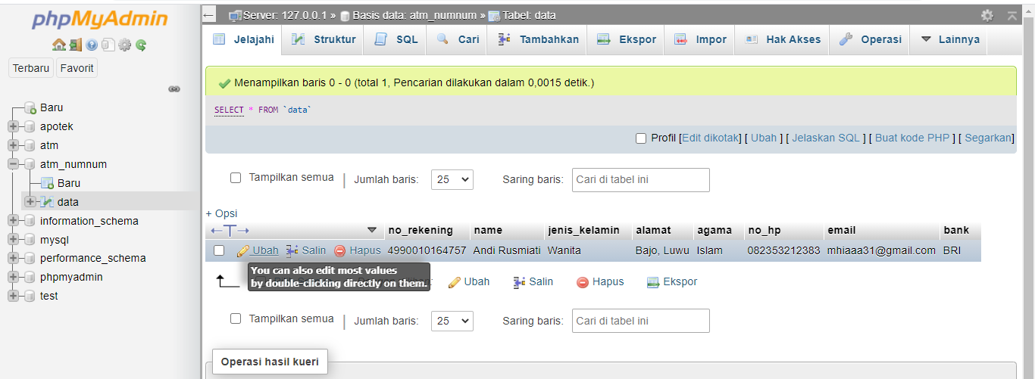

LAMPIRAN

**AtmNumNum.java**

import java.awt.event.ActionEvent;

import java.awt.event.ActionListener;

import java.sql.Connection;

import java.sql.DriverManager;

import java.sql.ResultSet;

import java.sql.SQLException;

import java.util.logging.Level;

import java.util.logging.Logger;

import javax.swing.JOptionPane;

/*

* To change this license header, choose License Headers in Project Properties.

* To change this template file, choose Tools | Templates

* and open the template in the editor.

*/

/**

*

* @author VITARACOM

*/

public class AtmNumNUm extends javax.swing.JFrame {

/**

* Creates new form AtmNumNUm

*/

public AtmNumNUm() {

initComponents();

}

/**

* This method is called from within the constructor to initialize the form.

* WARNING: Do NOT modify this code. The content of this method is always

* regenerated by the Form Editor.

*/

@SuppressWarnings("unchecked")

// <editor-fold defaultstate="collapsed" desc="Generated Code">

private void initComponents() {

jScrollPane1 = new javax.swing.JScrollPane();

jDesktopPane1 = new javax.swing.JDesktopPane();

jLabel1 = new javax.swing.JLabel();

jLabel2 = new javax.swing.JLabel();

norek = new javax.swing.JTextField();

pin = new javax.swing.JPasswordField();

submit = new javax.swing.JButton();

clear = new javax.swing.JButton();

close = new javax.swing.JButton();

jLabel3 = new javax.swing.JLabel();

jButton1 = new javax.swing.JButton();

jMenuBar1 = new javax.swing.JMenuBar();

jMenu1 = new javax.swing.JMenu();

input = new javax.swing.JMenuItem();

setDefaultCloseOperation(javax.swing.WindowConstants.EXIT_ON_CLOSE);

jDesktopPane1.setBackground(new java.awt.Color(240, 240, 240));

jLabel1.setText("Input No.Rekening Anda : ");

jLabel2.setText("Input Pin ATM Anda :");

norek.addActionListener(new java.awt.event.ActionListener() {

public void actionPerformed(java.awt.event.ActionEvent evt) {

norekActionPerformed(evt);

}

});

submit.setText("Submit");

submit.addActionListener(new java.awt.event.ActionListener() {

public void actionPerformed(java.awt.event.ActionEvent evt) {

submitActionPerformed(evt);

}

});

clear.setText("Clear");

clear.addActionListener(new java.awt.event.ActionListener() {

public void actionPerformed(java.awt.event.ActionEvent evt) {

clearActionPerformed(evt);

}

});

close.setText("Close");

close.addActionListener(new java.awt.event.ActionListener() {

public void actionPerformed(java.awt.event.ActionEvent evt) {

closeActionPerformed(evt);

}

});

jLabel3.setFont(new java.awt.Font("Tahoma", 1, 18)); // NOI18N

jLabel3.setText("WELCOME TO ATM NUMNUM");

jButton1.setText("Lengkapi Data Diri Anda");

jButton1.addActionListener(new java.awt.event.ActionListener() {

public void actionPerformed(java.awt.event.ActionEvent evt) {

jButton1ActionPerformed(evt);

}

});

jDesktopPane1.setLayer(jLabel1, javax.swing.JLayeredPane.DEFAULT_LAYER);

jDesktopPane1.setLayer(jLabel2, javax.swing.JLayeredPane.DEFAULT_LAYER);

jDesktopPane1.setLayer(norek, javax.swing.JLayeredPane.DEFAULT_LAYER);

jDesktopPane1.setLayer(pin, javax.swing.JLayeredPane.DEFAULT_LAYER);

jDesktopPane1.setLayer(submit, javax.swing.JLayeredPane.DEFAULT_LAYER);

jDesktopPane1.setLayer(clear, javax.swing.JLayeredPane.DEFAULT_LAYER);

jDesktopPane1.setLayer(close, javax.swing.JLayeredPane.DEFAULT_LAYER);

jDesktopPane1.setLayer(jLabel3, javax.swing.JLayeredPane.DEFAULT_LAYER);

jDesktopPane1.setLayer(jButton1, javax.swing.JLayeredPane.DEFAULT_LAYER);

javax.swing.GroupLayout jDesktopPane1Layout = new javax.swing.GroupLayout(jDesktopPane1);

jDesktopPane1.setLayout(jDesktopPane1Layout);

jDesktopPane1Layout.setHorizontalGroup(

jDesktopPane1Layout.createParallelGroup(javax.swing.GroupLayout.Alignment.LEADING)

.addGroup(jDesktopPane1Layout.createSequentialGroup()

.addGroup(jDesktopPane1Layout.createParallelGroup(javax.swing.GroupLayout.Alignment.LEADING)

.addGroup(jDesktopPane1Layout.createSequentialGroup()

.addGap(46, 46, 46)

.addGroup(jDesktopPane1Layout.createParallelGroup(javax.swing.GroupLayout.Alignment.LEADING)

.addGroup(jDesktopPane1Layout.createSequentialGroup()

.addComponent(submit)

.addPreferredGap(javax.swing.LayoutStyle.ComponentPlacement.UNRELATED)

.addComponent(clear)

.addPreferredGap(javax.swing.LayoutStyle.ComponentPlacement.UNRELATED)

.addComponent(close))

.addGroup(jDesktopPane1Layout.createSequentialGroup()

.addGroup(jDesktopPane1Layout.createParallelGroup(javax.swing.GroupLayout.Alignment.LEADING)

.addComponent(jLabel1, javax.swing.GroupLayout.PREFERRED_SIZE, 136, javax.swing.GroupLayout.PREFERRED_SIZE)

.addComponent(jLabel2))

.addGap(18, 18, 18)

.addGroup(jDesktopPane1Layout.createParallelGroup(javax.swing.GroupLayout.Alignment.LEADING, false)

.addComponent(norek)

.addComponent(pin, javax.swing.GroupLayout.DEFAULT_SIZE, 161, Short.MAX_VALUE)))))

.addGroup(jDesktopPane1Layout.createSequentialGroup()

.addGap(164, 164, 164)

.addComponent(jLabel3)))

.addContainerGap(241, Short.MAX_VALUE))

.addGroup(javax.swing.GroupLayout.Alignment.TRAILING, jDesktopPane1Layout.createSequentialGroup()

.addGap(0, 0, Short.MAX_VALUE)

.addComponent(jButton1)

.addGap(137, 137, 137))

);

jDesktopPane1Layout.setVerticalGroup(

jDesktopPane1Layout.createParallelGroup(javax.swing.GroupLayout.Alignment.LEADING)

.addGroup(jDesktopPane1Layout.createSequentialGroup()

.addContainerGap()

.addComponent(jLabel3)

.addGap(14, 14, 14)

.addGroup(jDesktopPane1Layout.createParallelGroup(javax.swing.GroupLayout.Alignment.BASELINE)

.addComponent(jLabel1, javax.swing.GroupLayout.PREFERRED_SIZE, 25, javax.swing.GroupLayout.PREFERRED_SIZE)

.addComponent(norek, javax.swing.GroupLayout.PREFERRED_SIZE, javax.swing.GroupLayout.DEFAULT_SIZE, javax.swing.GroupLayout.PREFERRED_SIZE))

.addGap(4, 4, 4)

.addComponent(jButton1)

.addGap(8, 8, 8)

.addGroup(jDesktopPane1Layout.createParallelGroup(javax.swing.GroupLayout.Alignment.BASELINE)

.addComponent(jLabel2)

.addComponent(pin, javax.swing.GroupLayout.PREFERRED_SIZE, javax.swing.GroupLayout.DEFAULT_SIZE, javax.swing.GroupLayout.PREFERRED_SIZE))

.addGap(34, 34, 34)

.addGroup(jDesktopPane1Layout.createParallelGroup(javax.swing.GroupLayout.Alignment.BASELINE)

.addComponent(submit)

.addComponent(clear)

.addComponent(close))

.addContainerGap(211, Short.MAX_VALUE))

);

jScrollPane1.setViewportView(jDesktopPane1);

jMenu1.setText("ATM NUMNUM");

input.setAccelerator(javax.swing.KeyStroke.getKeyStroke(java.awt.event.KeyEvent.VK_O, java.awt.event.InputEvent.CTRL_MASK));

input.setText("Informasi");

input.addActionListener(new java.awt.event.ActionListener() {

public void actionPerformed(java.awt.event.ActionEvent evt) {

inputActionPerformed(evt);

}

});

jMenu1.add(input);

jMenuBar1.add(jMenu1);

setJMenuBar(jMenuBar1);

javax.swing.GroupLayout layout = new javax.swing.GroupLayout(getContentPane());

getContentPane().setLayout(layout);

layout.setHorizontalGroup(

layout.createParallelGroup(javax.swing.GroupLayout.Alignment.LEADING)

.addComponent(jScrollPane1, javax.swing.GroupLayout.DEFAULT_SIZE, 553, Short.MAX_VALUE)

);

layout.setVerticalGroup(

layout.createParallelGroup(javax.swing.GroupLayout.Alignment.LEADING)

.addComponent(jScrollPane1, javax.swing.GroupLayout.Alignment.TRAILING, javax.swing.GroupLayout.DEFAULT_SIZE, 296, Short.MAX_VALUE)

);

pack();

}// </editor-fold>

private void norekActionPerformed(java.awt.event.ActionEvent evt) {

// TODO add your handling code here:

}

private void submitActionPerformed(java.awt.event.ActionEvent evt) {

// TODO add your handling code here:

String noRek = this.norek.getText().trim();

String Pin = String.valueOf(this.pin.getPassword());

if(noRek.equalsIgnoreCase("") && Pin.equalsIgnoreCase("")){

JOptionPane.showMessageDialog(null, "Your NoRekening or Pin Its Wrong!");

}else{

Atm frm = new Atm();

frm.setVisible(true);

this.setVisible(false);

}

}

private void clearActionPerformed(java.awt.event.ActionEvent evt) {

// TODO add your handling code here:

norek.setText("");

pin.setText("");

}

private void closeActionPerformed(java.awt.event.ActionEvent evt) {

// TODO add your handling code here:

dispose();

}

private void inputActionPerformed(java.awt.event.ActionEvent evt) {

// TODO add your handling code here:

jDesktopPane1.removeAll();

informasi frm=new informasi();

jDesktopPane1.add(frm);

frm.setVisible(true);

}

private void jButton1ActionPerformed(java.awt.event.ActionEvent evt) {

// TODO add your handling code here:

this.dispose();

dataDiri ActList = new dataDiri();

ActList.setVisible(true);

}

/**

* @param args the command line arguments

*/

public static void main(String args[]) {

/* Set the Nimbus look and feel */

//<editor-fold defaultstate="collapsed" desc=" Look and feel setting code (optional) ">

/* If Nimbus (introduced in Java SE 6) is not available, stay with the default look and feel.

* For details see http://download.oracle.com/javase/tutorial/uiswing/lookandfeel/plaf.html

*/

try {

for (javax.swing.UIManager.LookAndFeelInfo info : javax.swing.UIManager.getInstalledLookAndFeels()) {

if ("Nimbus".equals(info.getName())) {

javax.swing.UIManager.setLookAndFeel(info.getClassName());

break;

}

}

} catch (ClassNotFoundException ex) {

java.util.logging.Logger.getLogger(AtmNumNUm.class.getName()).log(java.util.logging.Level.SEVERE, null, ex);

} catch (InstantiationException ex) {

java.util.logging.Logger.getLogger(AtmNumNUm.class.getName()).log(java.util.logging.Level.SEVERE, null, ex);

} catch (IllegalAccessException ex) {

java.util.logging.Logger.getLogger(AtmNumNUm.class.getName()).log(java.util.logging.Level.SEVERE, null, ex);

} catch (javax.swing.UnsupportedLookAndFeelException ex) {

java.util.logging.Logger.getLogger(AtmNumNUm.class.getName()).log(java.util.logging.Level.SEVERE, null, ex);

}

//</editor-fold>

/* Create and display the form */

java.awt.EventQueue.invokeLater(new Runnable() {

public void run() {

new AtmNumNUm().setVisible(true);

}

});

}

// Variables declaration - do not modify

private javax.swing.JButton clear;

private javax.swing.JButton close;

private javax.swing.JMenuItem input;

private javax.swing.JButton jButton1;

private javax.swing.JDesktopPane jDesktopPane1;

private javax.swing.JLabel jLabel1;

private javax.swing.JLabel jLabel2;

private javax.swing.JLabel jLabel3;

private javax.swing.JMenu jMenu1;

private javax.swing.JMenuBar jMenuBar1;

private javax.swing.JScrollPane jScrollPane1;

private javax.swing.JTextField norek;

private javax.swing.JPasswordField pin;

private javax.swing.JButton submit;

// End of variables declaration

}

**Atm.java**

import javax.swing.JOptionPane;

/*

* To change this license header, choose License Headers in Project Properties.

* To change this template file, choose Tools | Templates

* and open the template in the editor.

*/

/**

*

* @author VITARACOM

*/

public class Atm extends javax.swing.JFrame {

double saldo, output;

int tunai;

String jawab;

/**

* Creates new form Atm

*/

public static String norek;

public Atm() {

initComponents();

}

public Atm(int saldo){

this.saldo = saldo;

}

/**

* This method is called from within the constructor to initialize the form.

* WARNING: Do NOT modify this code. The content of this method is always

* regenerated by the Form Editor.

*/

@SuppressWarnings("unchecked")

// <editor-fold defaultstate="collapsed" desc="Generated Code">

private void initComponents() {

jLabel1 = new javax.swing.JLabel();

jLabel2 = new javax.swing.JLabel();

cek = new javax.swing.JButton();

transfer = new javax.swing.JButton();

tarikTunai = new javax.swing.JButton();

closeAtm = new javax.swing.JButton();

setor = new javax.swing.JButton();

jLabel4 = new javax.swing.JLabel();

hasil = new javax.swing.JTextField();

jMenuBar1 = new javax.swing.JMenuBar();

setDefaultCloseOperation(javax.swing.WindowConstants.EXIT_ON_CLOSE);

jLabel1.setFont(new java.awt.Font("Tahoma", 1, 18)); // NOI18N

jLabel1.setText("WELCOME TO ATM NUMNUM");

jLabel2.setText("Silahkan Pilih Menu Dibawah Ini");

cek.setText("CEK SALDO");

cek.addActionListener(new java.awt.event.ActionListener() {

public void actionPerformed(java.awt.event.ActionEvent evt) {

cekActionPerformed(evt);

}

});

transfer.setText("TRANSFER");

transfer.addActionListener(new java.awt.event.ActionListener() {

public void actionPerformed(java.awt.event.ActionEvent evt) {

transferActionPerformed(evt);

}

});

tarikTunai.setText("TARIK TUNAI");

tarikTunai.addActionListener(new java.awt.event.ActionListener() {

public void actionPerformed(java.awt.event.ActionEvent evt) {

tarikTunaiActionPerformed(evt);

}

});

closeAtm.setText("Close");

closeAtm.addActionListener(new java.awt.event.ActionListener() {

public void actionPerformed(java.awt.event.ActionEvent evt) {

closeAtmActionPerformed(evt);

}

});

setor.setText("SETOR TUNAI");

setor.addActionListener(new java.awt.event.ActionListener() {

public void actionPerformed(java.awt.event.ActionEvent evt) {

setorActionPerformed(evt);

}

});

jLabel4.setText("Informasi Saldo");

jMenuBar1.setAutoscrolls(true);

jMenuBar1.setName("Atm NumNum"); // NOI18N

setJMenuBar(jMenuBar1);

javax.swing.GroupLayout layout = new javax.swing.GroupLayout(getContentPane());

getContentPane().setLayout(layout);

layout.setHorizontalGroup(

layout.createParallelGroup(javax.swing.GroupLayout.Alignment.LEADING)

.addGroup(javax.swing.GroupLayout.Alignment.TRAILING, layout.createSequentialGroup()

.addContainerGap(230, Short.MAX_VALUE)

.addGroup(layout.createParallelGroup(javax.swing.GroupLayout.Alignment.LEADING)

.addGroup(layout.createParallelGroup(javax.swing.GroupLayout.Alignment.LEADING)

.addGroup(javax.swing.GroupLayout.Alignment.TRAILING, layout.createParallelGroup(javax.swing.GroupLayout.Alignment.LEADING)

.addGroup(layout.createSequentialGroup()

.addGroup(layout.createParallelGroup(javax.swing.GroupLayout.Alignment.LEADING)

.addComponent(cek)

.addComponent(tarikTunai))

.addGap(46, 46, 46)

.addGroup(layout.createParallelGroup(javax.swing.GroupLayout.Alignment.LEADING)

.addGroup(layout.createSequentialGroup()

.addGap(10, 10, 10)

.addComponent(transfer))

.addComponent(setor)))

.addGroup(layout.createSequentialGroup()

.addGap(46, 46, 46)

.addComponent(jLabel2)))

.addGroup(javax.swing.GroupLayout.Alignment.TRAILING, layout.createSequentialGroup()

.addComponent(jLabel4)

.addGap(93, 93, 93)))

.addComponent(jLabel1))

.addGap(226, 226, 226))

.addGroup(layout.createSequentialGroup()

.addGroup(layout.createParallelGroup(javax.swing.GroupLayout.Alignment.LEADING)

.addGroup(layout.createSequentialGroup()

.addGap(274, 274, 274)

.addComponent(hasil, javax.swing.GroupLayout.PREFERRED_SIZE, 141, javax.swing.GroupLayout.PREFERRED_SIZE))

.addGroup(layout.createSequentialGroup()

.addGap(310, 310, 310)

.addComponent(closeAtm)))

.addContainerGap(javax.swing.GroupLayout.DEFAULT_SIZE, Short.MAX_VALUE))

);

layout.setVerticalGroup(

layout.createParallelGroup(javax.swing.GroupLayout.Alignment.LEADING)

.addGroup(layout.createSequentialGroup()

.addContainerGap()

.addComponent(jLabel1)

.addGap(18, 18, 18)

.addComponent(jLabel2)

.addGap(18, 18, 18)

.addGroup(layout.createParallelGroup(javax.swing.GroupLayout.Alignment.BASELINE)

.addComponent(cek)

.addComponent(setor))

.addPreferredGap(javax.swing.LayoutStyle.ComponentPlacement.UNRELATED)

.addGroup(layout.createParallelGroup(javax.swing.GroupLayout.Alignment.LEADING)

.addComponent(tarikTunai)

.addComponent(transfer))

.addGap(21, 21, 21)

.addComponent(jLabel4)

.addGap(18, 18, 18)

.addComponent(hasil, javax.swing.GroupLayout.PREFERRED_SIZE, 32, javax.swing.GroupLayout.PREFERRED_SIZE)

.addGap(18, 18, 18)

.addComponent(closeAtm)

.addContainerGap(182, Short.MAX_VALUE))

);

pack();

}// </editor-fold>

private void cekActionPerformed(java.awt.event.ActionEvent evt) {

// TODO add your handling code here:

JOptionPane.showMessageDialog(rootPane, "Saldo Anda Saat Ini Adalah :" + saldo);

output = saldo;

saldo = output;

jawab = String.format(" %,.2f ",saldo);

hasil.setText(jawab);

}

private void transferActionPerformed(java.awt.event.ActionEvent evt) {

// TODO add your handling code here:

String tujuan = JOptionPane.showInputDialog("Silahkan Input Nomor Rekening Tujuan Anda :");

tunai = Integer.parseInt(JOptionPane.showInputDialog("Input Nominal Transfer : "));

if(saldo <= tunai){

JOptionPane.showMessageDialog(rootPane, "Maaf Saldo Anda Tidak Mencukupi!");

}else{

output = saldo - tunai;

saldo = output;

jawab = String.format(" %,.2f ", saldo);

hasil.setText(jawab);

JOptionPane.showMessageDialog(rootPane,"Saldo Anda Saat Ini adalah :"+ saldo+ "\n"+ "Berhasil transfer kepada "+tujuan+" sebesar :"+ tunai);

}

}

private void tarikTunaiActionPerformed(java.awt.event.ActionEvent evt) {

// TODO add your handling code here:

tunai = Integer.parseInt(JOptionPane.showInputDialog("Input Nominal Tunai: "));

output = saldo - tunai;

saldo = output;

jawab = String.format(" %,.2f ", saldo);

hasil.setText(jawab);

JOptionPane.showMessageDialog(rootPane,"Saldo Anda Saat Ini adalah :"+ saldo+ "\n");

}

private void closeAtmActionPerformed(java.awt.event.ActionEvent evt) {

// TODO add your handling code here:

dispose();

}

private void setorActionPerformed(java.awt.event.ActionEvent evt) {

// TODO add your handling code here:

tunai = Integer.parseInt(JOptionPane.showInputDialog("Input Nominal Tunai : "));

JOptionPane.showMessageDialog(rootPane, "Saldo Anda Saat Ini adalah :"+ (saldo + tunai));

output = saldo + tunai;

saldo = output;

jawab = String.format(" %,.2f ", saldo);

hasil.setText(jawab);

}

/**

* @param args the command line arguments

*/

public static void main(String args[]) {

/* Set the Nimbus look and feel */

//<editor-fold defaultstate="collapsed" desc=" Look and feel setting code (optional) ">

/* If Nimbus (introduced in Java SE 6) is not available, stay with the default look and feel.

* For details see http://download.oracle.com/javase/tutorial/uiswing/lookandfeel/plaf.html

*/

try {

for (javax.swing.UIManager.LookAndFeelInfo info : javax.swing.UIManager.getInstalledLookAndFeels()) {

if ("Nimbus".equals(info.getName())) {

javax.swing.UIManager.setLookAndFeel(info.getClassName());

break;

}

}

} catch (ClassNotFoundException ex) {

java.util.logging.Logger.getLogger(Atm.class.getName()).log(java.util.logging.Level.SEVERE, null, ex);

} catch (InstantiationException ex) {

java.util.logging.Logger.getLogger(Atm.class.getName()).log(java.util.logging.Level.SEVERE, null, ex);

} catch (IllegalAccessException ex) {

java.util.logging.Logger.getLogger(Atm.class.getName()).log(java.util.logging.Level.SEVERE, null, ex);

} catch (javax.swing.UnsupportedLookAndFeelException ex) {

java.util.logging.Logger.getLogger(Atm.class.getName()).log(java.util.logging.Level.SEVERE, null, ex);

}

//</editor-fold>

/* Create and display the form */

java.awt.EventQueue.invokeLater(new Runnable() {

public void run() {

new Atm().setVisible(true);

}

});

}

// Variables declaration - do not modify

private javax.swing.JButton cek;

private javax.swing.JButton closeAtm;

private javax.swing.JTextField hasil;

private javax.swing.JLabel jLabel1;

private javax.swing.JLabel jLabel2;

private javax.swing.JLabel jLabel4;

private javax.swing.JMenuBar jMenuBar1;

private javax.swing.JButton setor;

private javax.swing.JButton tarikTunai;

private javax.swing.JButton transfer;

// End of variables declaration

}

**dataDiri.java**

import java.sql.Connection;

import java.sql.DriverAction;

import java.sql.DriverManager;

import java.sql.ResultSet;

import java.sql.SQLException;

import java.sql.Statement;

import java.util.logging.Level;

import java.util.logging.Logger;

import javax.swing.JOptionPane;

import javax.swing.table.DefaultTableModel;

/*

* To change this license header, choose License Headers in Project Properties.

* To change this template file, choose Tools | Templates

* and open the template in the editor.

*/

/**

*

* @author VITARACOM

*/

public class dataDiri extends javax.swing.JFrame {

DefaultTableModel tabelModel;

String jenis_kelamin,agama, bank = "";

/**

* Creates new form dataDiri

*/

public dataDiri() {

initComponents();

tabelModel = (DefaultTableModel) tabelHasil.getModel();

tampil();

}

/**

* This method is called from within the constructor to initialize the form.

* WARNING: Do NOT modify this code. The content of this method is always

* regenerated by the Form Editor.

*/

@SuppressWarnings("unchecked")

// <editor-fold defaultstate="collapsed" desc="Generated Code">

private void initComponents() {

buttonGroup1 = new javax.swing.ButtonGroup();

buttonGroup2 = new javax.swing.ButtonGroup();

jLabel1 = new javax.swing.JLabel();

jLabel2 = new javax.swing.JLabel();

norek = new javax.swing.JTextField();

jLabel3 = new javax.swing.JLabel();

name = new javax.swing.JTextField();

jLabel4 = new javax.swing.JLabel();

pria = new javax.swing.JRadioButton();

wanita = new javax.swing.JRadioButton();

jLabel5 = new javax.swing.JLabel();

jScrollPane1 = new javax.swing.JScrollPane();

alamat = new javax.swing.JTextArea();

jLabel6 = new javax.swing.JLabel();

Boxagama = new javax.swing.JComboBox<>();

jLabel7 = new javax.swing.JLabel();

no_hp = new javax.swing.JTextField();

jLabel8 = new javax.swing.JLabel();

email = new javax.swing.JTextField();

jLabel9 = new javax.swing.JLabel();

bri = new javax.swing.JCheckBox();

bni = new javax.swing.JCheckBox();

submit = new javax.swing.JButton();

jScrollPane2 = new javax.swing.JScrollPane();

tabelHasil = new javax.swing.JTable();

mandiri = new javax.swing.JCheckBox();

setDefaultCloseOperation(javax.swing.WindowConstants.EXIT_ON_CLOSE);

jLabel1.setFont(new java.awt.Font("Tahoma", 1, 14)); // NOI18N

jLabel1.setText("INPUT DATA DIRI NASABAH");

jLabel2.setText("No.Rekening");

norek.addActionListener(new java.awt.event.ActionListener() {

public void actionPerformed(java.awt.event.ActionEvent evt) {

norekActionPerformed(evt);

}

});

jLabel3.setText("Nama Lengkap");

jLabel4.setText("Jenis Kelamin");

buttonGroup1.add(pria);

pria.setText("Pria");

pria.addActionListener(new java.awt.event.ActionListener() {

public void actionPerformed(java.awt.event.ActionEvent evt) {

priaActionPerformed(evt);

}

});

buttonGroup1.add(wanita);

wanita.setText("Wanita");

wanita.addActionListener(new java.awt.event.ActionListener() {

public void actionPerformed(java.awt.event.ActionEvent evt) {

wanitaActionPerformed(evt);

}

});

jLabel5.setText("Alamat");

alamat.setColumns(20);

alamat.setRows(5);

jScrollPane1.setViewportView(alamat);

jLabel6.setText("Agama");

Boxagama.setModel(new javax.swing.DefaultComboBoxModel<>(new String[] { "-Agama-", "Islam", "Kristen", "Hindu", "Buddha", "Katolik", " " }));

Boxagama.addActionListener(new java.awt.event.ActionListener() {

public void actionPerformed(java.awt.event.ActionEvent evt) {

BoxagamaActionPerformed(evt);

}

});

jLabel7.setText("No.Hp");

jLabel8.setText("Email");

jLabel9.setText("Bank");

bri.setText("BRI");

bri.addActionListener(new java.awt.event.ActionListener() {

public void actionPerformed(java.awt.event.ActionEvent evt) {

briActionPerformed(evt);

}

});

bni.setText("BNI");

bni.addActionListener(new java.awt.event.ActionListener() {

public void actionPerformed(java.awt.event.ActionEvent evt) {

bniActionPerformed(evt);

}

});

submit.setText("SUBMIT");

submit.addActionListener(new java.awt.event.ActionListener() {

public void actionPerformed(java.awt.event.ActionEvent evt) {

submitActionPerformed(evt);

}

});

tabelHasil.setModel(new javax.swing.table.DefaultTableModel(

new Object [][] {

},

new String [] {

"No. Rekening", "Nama", "Jenis Kelamin", "Alamat", "Agama", "No Hp", "Email", "Bank"

}

));

jScrollPane2.setViewportView(tabelHasil);

mandiri.setText("MANDIRI");

mandiri.addActionListener(new java.awt.event.ActionListener() {

public void actionPerformed(java.awt.event.ActionEvent evt) {

mandiriActionPerformed(evt);

}

});

javax.swing.GroupLayout layout = new javax.swing.GroupLayout(getContentPane());

getContentPane().setLayout(layout);

layout.setHorizontalGroup(

layout.createParallelGroup(javax.swing.GroupLayout.Alignment.LEADING)

.addGroup(layout.createSequentialGroup()

.addGap(77, 77, 77)

.addGroup(layout.createParallelGroup(javax.swing.GroupLayout.Alignment.LEADING)

.addGroup(layout.createSequentialGroup()

.addGroup(layout.createParallelGroup(javax.swing.GroupLayout.Alignment.LEADING)

.addComponent(jLabel2)

.addComponent(jLabel3)

.addComponent(jLabel4)

.addComponent(jLabel5)

.addComponent(jLabel6)

.addComponent(jLabel7)

.addComponent(jLabel8)

.addComponent(jLabel9))

.addGap(44, 44, 44)

.addGroup(layout.createParallelGroup(javax.swing.GroupLayout.Alignment.LEADING)

.addGroup(layout.createSequentialGroup()

.addComponent(bri)

.addPreferredGap(javax.swing.LayoutStyle.ComponentPlacement.UNRELATED)

.addComponent(bni)

.addPreferredGap(javax.swing.LayoutStyle.ComponentPlacement.RELATED)

.addComponent(mandiri)

.addContainerGap(javax.swing.GroupLayout.DEFAULT_SIZE, Short.MAX_VALUE))

.addGroup(layout.createSequentialGroup()

.addGroup(layout.createParallelGroup(javax.swing.GroupLayout.Alignment.TRAILING)

.addComponent(email)

.addComponent(no_hp, javax.swing.GroupLayout.Alignment.LEADING, javax.swing.GroupLayout.DEFAULT_SIZE, 496, Short.MAX_VALUE)

.addGroup(javax.swing.GroupLayout.Alignment.LEADING, layout.createSequentialGroup()

.addGroup(layout.createParallelGroup(javax.swing.GroupLayout.Alignment.TRAILING)

.addGroup(javax.swing.GroupLayout.Alignment.LEADING, layout.createSequentialGroup()

.addComponent(pria)

.addPreferredGap(javax.swing.LayoutStyle.ComponentPlacement.RELATED)

.addComponent(wanita))

.addComponent(Boxagama, javax.swing.GroupLayout.Alignment.LEADING, javax.swing.GroupLayout.PREFERRED_SIZE, 82, javax.swing.GroupLayout.PREFERRED_SIZE))

.addGap(0, 0, Short.MAX_VALUE))

.addComponent(norek, javax.swing.GroupLayout.Alignment.LEADING)

.addComponent(name, javax.swing.GroupLayout.Alignment.LEADING)

.addComponent(jScrollPane1, javax.swing.GroupLayout.Alignment.LEADING))

.addGap(94, 94, 94))))

.addGroup(layout.createSequentialGroup()

.addComponent(submit)

.addGap(0, 0, Short.MAX_VALUE))))

.addComponent(jScrollPane2, javax.swing.GroupLayout.Alignment.TRAILING)

.addGroup(javax.swing.GroupLayout.Alignment.TRAILING, layout.createSequentialGroup()

.addContainerGap(javax.swing.GroupLayout.DEFAULT_SIZE, Short.MAX_VALUE)

.addComponent(jLabel1)

.addGap(282, 282, 282))

);

layout.setVerticalGroup(

layout.createParallelGroup(javax.swing.GroupLayout.Alignment.LEADING)

.addGroup(layout.createSequentialGroup()

.addGap(31, 31, 31)

.addComponent(jLabel1)

.addGap(18, 18, 18)

.addGroup(layout.createParallelGroup(javax.swing.GroupLayout.Alignment.BASELINE)

.addComponent(jLabel2)

.addComponent(norek, javax.swing.GroupLayout.PREFERRED_SIZE, javax.swing.GroupLayout.DEFAULT_SIZE, javax.swing.GroupLayout.PREFERRED_SIZE))

.addPreferredGap(javax.swing.LayoutStyle.ComponentPlacement.RELATED)

.addGroup(layout.createParallelGroup(javax.swing.GroupLayout.Alignment.BASELINE)

.addComponent(jLabel3)

.addComponent(name, javax.swing.GroupLayout.PREFERRED_SIZE, javax.swing.GroupLayout.DEFAULT_SIZE, javax.swing.GroupLayout.PREFERRED_SIZE))

.addPreferredGap(javax.swing.LayoutStyle.ComponentPlacement.UNRELATED)

.addGroup(layout.createParallelGroup(javax.swing.GroupLayout.Alignment.BASELINE)

.addComponent(jLabel4)

.addComponent(pria)

.addComponent(wanita))

.addPreferredGap(javax.swing.LayoutStyle.ComponentPlacement.UNRELATED)

.addGroup(layout.createParallelGroup(javax.swing.GroupLayout.Alignment.LEADING)

.addComponent(jLabel5)

.addComponent(jScrollPane1, javax.swing.GroupLayout.PREFERRED_SIZE, javax.swing.GroupLayout.DEFAULT_SIZE, javax.swing.GroupLayout.PREFERRED_SIZE))

.addGroup(layout.createParallelGroup(javax.swing.GroupLayout.Alignment.LEADING)

.addGroup(layout.createSequentialGroup()

.addGap(19, 19, 19)

.addComponent(jLabel6))

.addGroup(layout.createSequentialGroup()

.addGap(18, 18, 18)

.addComponent(Boxagama, javax.swing.GroupLayout.PREFERRED_SIZE, javax.swing.GroupLayout.DEFAULT_SIZE, javax.swing.GroupLayout.PREFERRED_SIZE)))

.addPreferredGap(javax.swing.LayoutStyle.ComponentPlacement.UNRELATED)

.addGroup(layout.createParallelGroup(javax.swing.GroupLayout.Alignment.LEADING)

.addComponent(jLabel7)

.addComponent(no_hp, javax.swing.GroupLayout.PREFERRED_SIZE, javax.swing.GroupLayout.DEFAULT_SIZE, javax.swing.GroupLayout.PREFERRED_SIZE))

.addPreferredGap(javax.swing.LayoutStyle.ComponentPlacement.UNRELATED)

.addGroup(layout.createParallelGroup(javax.swing.GroupLayout.Alignment.LEADING)

.addComponent(jLabel8)

.addComponent(email, javax.swing.GroupLayout.PREFERRED_SIZE, javax.swing.GroupLayout.DEFAULT_SIZE, javax.swing.GroupLayout.PREFERRED_SIZE))

.addGroup(layout.createParallelGroup(javax.swing.GroupLayout.Alignment.LEADING)

.addGroup(layout.createSequentialGroup()

.addGap(11, 11, 11)

.addComponent(jLabel9))

.addGroup(layout.createSequentialGroup()

.addPreferredGap(javax.swing.LayoutStyle.ComponentPlacement.UNRELATED)

.addGroup(layout.createParallelGroup(javax.swing.GroupLayout.Alignment.BASELINE)

.addComponent(bri)

.addComponent(bni)

.addComponent(mandiri))))

.addGap(18, 18, 18)

.addComponent(submit)

.addGap(18, 18, 18)

.addComponent(jScrollPane2, javax.swing.GroupLayout.PREFERRED_SIZE, 89, javax.swing.GroupLayout.PREFERRED_SIZE)

.addContainerGap(107, Short.MAX_VALUE))

);

pack();

}// </editor-fold>

private void bniActionPerformed(java.awt.event.ActionEvent evt) {

// TODO add your handling code here:

if(bni.isSelected()){

bank = bank +" "+ bni.getText() +" ";

}else{

bank = "";

}

}

private void norekActionPerformed(java.awt.event.ActionEvent evt) {

// TODO add your handling code here:

}

private void submitActionPerformed(java.awt.event.ActionEvent evt) {

// TODO add your handling code here:

try {

// TODO add your handling code here

Connection cn = DriverManager.getConnection("jdbc:mysql://localhost/atm_numnum","root","");

cn.createStatement().executeUpdate("insert into data value"+"('"+norek.getText()+"','"+name.getText()+"','"+jenis_kelamin+"','"+alamat.getText()+"','"+agama+"','"+no_hp.getText()+"','"+email.getText()+"','"+bank+"')");

tampil();

} catch (SQLException ex) {

Logger.getLogger(data.class.getName()).log(Level.SEVERE, null, ex);

}

}

private void priaActionPerformed(java.awt.event.ActionEvent evt) {

// TODO add your handling code here:

if(pria.isSelected())

{

jenis_kelamin = pria.getText();

}

}

private void wanitaActionPerformed(java.awt.event.ActionEvent evt) {

// TODO add your handling code here

if(wanita.isSelected())

{

jenis_kelamin = wanita.getText();

}

}

private void BoxagamaActionPerformed(java.awt.event.ActionEvent evt) {

// TODO add your handling code here:

if(Boxagama.getSelectedItem() == "Islam"){

agama = "Islam";

}

if(Boxagama.getSelectedItem() == "Kristen"){

agama = "Kristen";

}

if(Boxagama.getSelectedItem() == "Hindu"){

agama = "Hindu";

}

if(Boxagama.getSelectedItem() == "Katolik"){

agama = "Katolik";

}

if(Boxagama.getSelectedItem() == "Buddha"){

agama = "Buddha";

}

}

private void briActionPerformed(java.awt.event.ActionEvent evt) {

// TODO add your handling code here:

if(bri.isSelected()){

bank = bank +" "+ bri.getText() +" ";

}else{

bank = "";

}

}

private void mandiriActionPerformed(java.awt.event.ActionEvent evt) {

// TODO add your handling code here:

if(mandiri.isSelected()){

bank = bank +" "+ mandiri.getText() +" ";

}else{

bank = "";

}

}

/**

* @param args the command line arguments

*/

public static void main(String args[]) {

/* Set the Nimbus look and feel */

//<editor-fold defaultstate="collapsed" desc=" Look and feel setting code (optional) ">

/* If Nimbus (introduced in Java SE 6) is not available, stay with the default look and feel.

* For details see http://download.oracle.com/javase/tutorial/uiswing/lookandfeel/plaf.html

*/

try {

for (javax.swing.UIManager.LookAndFeelInfo info : javax.swing.UIManager.getInstalledLookAndFeels()) {

if ("Nimbus".equals(info.getName())) {

javax.swing.UIManager.setLookAndFeel(info.getClassName());

break;

}

}

} catch (ClassNotFoundException ex) {

java.util.logging.Logger.getLogger(dataDiri.class.getName()).log(java.util.logging.Level.SEVERE, null, ex);

} catch (InstantiationException ex) {

java.util.logging.Logger.getLogger(dataDiri.class.getName()).log(java.util.logging.Level.SEVERE, null, ex);

} catch (IllegalAccessException ex) {

java.util.logging.Logger.getLogger(dataDiri.class.getName()).log(java.util.logging.Level.SEVERE, null, ex);

} catch (javax.swing.UnsupportedLookAndFeelException ex) {

java.util.logging.Logger.getLogger(dataDiri.class.getName()).log(java.util.logging.Level.SEVERE, null, ex);

}

//</editor-fold>

/* Create and display the form */

java.awt.EventQueue.invokeLater(new Runnable() {

public void run() {

new dataDiri().setVisible(true);

}

});

}

// Variables declaration - do not modify

private javax.swing.JComboBox<String> Boxagama;

private javax.swing.JTextArea alamat;

private javax.swing.JCheckBox bni;

private javax.swing.JCheckBox bri;

private javax.swing.ButtonGroup buttonGroup1;

private javax.swing.ButtonGroup buttonGroup2;

private javax.swing.JTextField email;

private javax.swing.JLabel jLabel1;

private javax.swing.JLabel jLabel2;

private javax.swing.JLabel jLabel3;

private javax.swing.JLabel jLabel4;

private javax.swing.JLabel jLabel5;

private javax.swing.JLabel jLabel6;

private javax.swing.JLabel jLabel7;

private javax.swing.JLabel jLabel8;

private javax.swing.JLabel jLabel9;

private javax.swing.JScrollPane jScrollPane1;

private javax.swing.JScrollPane jScrollPane2;

private javax.swing.JCheckBox mandiri;

private javax.swing.JTextField name;

private javax.swing.JTextField no_hp;

private javax.swing.JTextField norek;

private javax.swing.JRadioButton pria;

private javax.swing.JButton submit;

private javax.swing.JTable tabelHasil;

private javax.swing.JRadioButton wanita;

// End of variables declaration

public void tampil() {

int row=tabelHasil.getRowCount();

for (int a=0;a<row;a++){

tabelModel.removeRow(0);

}

try {

Connection cn = DriverManager.getConnection("jdbc:mysql://localhost/atm_numnum","root","");

ResultSet rs = cn.createStatement().executeQuery("SELECT *FROM data");

while(rs.next()){

String data[]={rs.getString(1),rs.getString(2),rs.getString(3),rs.getString(4),rs.getString(5),rs.getString(6),rs.getString(7),rs.getString(8)};

tabelModel.addRow(data);

}

} catch (SQLException ex) {

Logger.getLogger(data.class.getName()).log(Level.SEVERE, null, ex);

}

}

}

**Informasi.java (Internal Jframe)**

/*

* To change this license header, choose License Headers in Project Properties.

* To change this template file, choose Tools | Templates

* and open the template in the editor.

*/

/**

*

* @author VITARACOM

*/

public class informasi extends javax.swing.JInternalFrame {

/**

* Creates new form informasi

*/

public informasi() {

initComponents();

}

/**

* This method is called from within the constructor to initialize the form.

* WARNING: Do NOT modify this code. The content of this method is always

* regenerated by the Form Editor.

*/

@SuppressWarnings("unchecked")

// <editor-fold defaultstate="collapsed" desc="Generated Code">

private void initComponents() {

jLabel6 = new javax.swing.JLabel();

jLabel1 = new javax.swing.JLabel();

jLabel2 = new javax.swing.JLabel();

jLabel3 = new javax.swing.JLabel();

jLabel4 = new javax.swing.JLabel();

jLabel5 = new javax.swing.JLabel();

jLabel7 = new javax.swing.JLabel();

jLabel8 = new javax.swing.JLabel();

setClosable(true);

setTitle("Informasi ATM NumNUm");

jLabel6.setFont(new java.awt.Font("Tahoma", 1, 14)); // NOI18N

jLabel6.setText("TUTORIAL MENGGUNAKAN ATM NUMNUM");

jLabel1.setText("1.\tRun Program ini, maka AtmNumNum.java akan terbuka");

jLabel2.setText("2.\tSelanjutnya input No.Rekening dan Pin Atm user, kemudian klik submit dan user akan diarahkan ke menu Atm.java");

jLabel3.setText("3.\tJika user pertama kali membuka program ini, maka saldo atm user saat mengklik tombol cek saldo adalah 0 rupiah");

jLabel4.setText("4.\tUntuk menambahkan saldo, user cukup mengklik tombol setor tunai. Kemudian user menginput nominal yang hendak disetor dan klik ok");

jLabel5.setText("5.\tUntuk melakukan penarikan, user cukup mengklik tombol tarik tunai dan memasukkan nominal yang hendak ditarik, klik ok");

jLabel7.setText("6.\tUntuk melakukan transfer, user cukup mengklik tombol transfer dan memasukkan no.rekening tujuan dan juga nominal yang hendak ditarik");

jLabel8.setText("7.\tKemudian klik ok untuk melanjutkan proses transaksi");

javax.swing.GroupLayout layout = new javax.swing.GroupLayout(getContentPane());

getContentPane().setLayout(layout);

layout.setHorizontalGroup(

layout.createParallelGroup(javax.swing.GroupLayout.Alignment.LEADING)

.addGroup(javax.swing.GroupLayout.Alignment.TRAILING, layout.createSequentialGroup()

.addContainerGap(javax.swing.GroupLayout.DEFAULT_SIZE, Short.MAX_VALUE)

.addComponent(jLabel6)

.addGap(234, 234, 234))

.addGroup(layout.createSequentialGroup()

.addGap(55, 55, 55)

.addGroup(layout.createParallelGroup(javax.swing.GroupLayout.Alignment.LEADING)

.addComponent(jLabel8)

.addComponent(jLabel7)

.addComponent(jLabel5)

.addComponent(jLabel4)

.addComponent(jLabel3)

.addComponent(jLabel2)

.addComponent(jLabel1))

.addContainerGap(40, Short.MAX_VALUE))

);

layout.setVerticalGroup(

layout.createParallelGroup(javax.swing.GroupLayout.Alignment.LEADING)

.addGroup(layout.createSequentialGroup()

.addGap(31, 31, 31)

.addComponent(jLabel6)

.addGap(18, 18, 18)

.addComponent(jLabel1)

.addPreferredGap(javax.swing.LayoutStyle.ComponentPlacement.RELATED)

.addComponent(jLabel2)

.addPreferredGap(javax.swing.LayoutStyle.ComponentPlacement.RELATED)

.addComponent(jLabel3)

.addPreferredGap(javax.swing.LayoutStyle.ComponentPlacement.RELATED)

.addComponent(jLabel4)

.addPreferredGap(javax.swing.LayoutStyle.ComponentPlacement.RELATED)

.addComponent(jLabel5)

.addPreferredGap(javax.swing.LayoutStyle.ComponentPlacement.RELATED)

.addComponent(jLabel7)

.addPreferredGap(javax.swing.LayoutStyle.ComponentPlacement.RELATED)

.addComponent(jLabel8)

.addContainerGap(35, Short.MAX_VALUE))

);

pack();

}// </editor-fold>

// Variables declaration - do not modify

private javax.swing.JLabel jLabel1;

private javax.swing.JLabel jLabel2;

private javax.swing.JLabel jLabel3;

private javax.swing.JLabel jLabel4;

private javax.swing.JLabel jLabel5;

private javax.swing.JLabel jLabel6;

private javax.swing.JLabel jLabel7;

private javax.swing.JLabel jLabel8;

// End of variables declaration

}