RDC proposal figures

Ali Ruth

2025-06-06

## I. Proposals received 2017-2025

| year submitted | submissions |
| --- | --- |
| 2017 | 26 |
| 2018 | 30 |
| 2019 | 15 |
| 2020 | 18 |
| 2021 | 15 |
| 2022 | 14 |
| 2023 | 18 |
| 2024 | 14 |
| 2025 | 5 |

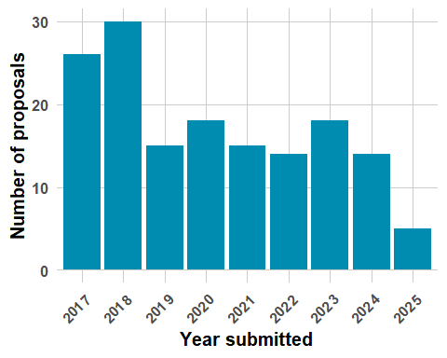

## II. Datasets requested by year

| Survey | Total_requests |
| --- | --- |
| NHIS | 69 |
| NHANES | 78 |
| NHCS | 5 |

| year_submitted | NHIS | NHANES | NHCS |
| --- | --- | --- | --- |
| 2017 | 13 | 6 | 0 |
| 2018 | 12 | 18 | 0 |
| 2019 | 9 | 5 | 1 |
| 2020 | 9 | 9 | 0 |
| 2021 | 6 | 10 | 0 |
| 2022 | 2 | 11 | 3 |
| 2023 | 10 | 9 | 0 |
| 2024 | 6 | 7 | 1 |
| 2025 | 2 | 3 | 0 |

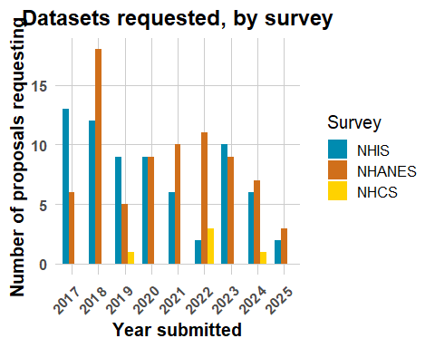

| Linkage | Total_requests |
| --- | --- |
| LMF | 98 |
| CMS | 35 |
| HUD | 29 |
| ESRD | 7 |
| SSA | 2 |
| VA | 1 |

| year_submitted | LMF | CMS | HUD | ESRD | SSA | VA |
| --- | --- | --- | --- | --- | --- | --- |
| 2017 | 14 | 6 | 4 | 0 | 1 | 0 |
| 2018 | 22 | 7 | 3 | 0 | 0 | 0 |
| 2019 | 8 | 3 | 6 | 0 | 0 | 0 |
| 2020 | 10 | 2 | 7 | 0 | 1 | 0 |
| 2021 | 10 | 3 | 2 | 4 | 0 | 0 |
| 2022 | 12 | 2 | 0 | 2 | 0 | 0 |
| 2023 | 11 | 5 | 2 | 1 | 0 | 0 |
| 2024 | 9 | 5 | 3 | 0 | 0 | 1 |
| 2025 | 2 | 2 | 2 | 0 | 0 | 0 |

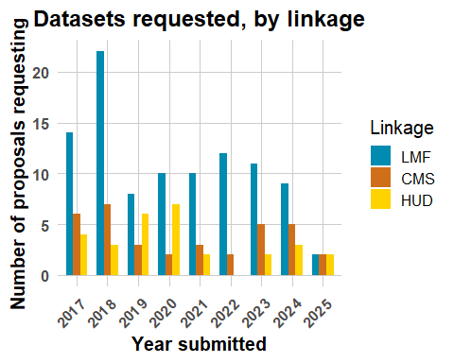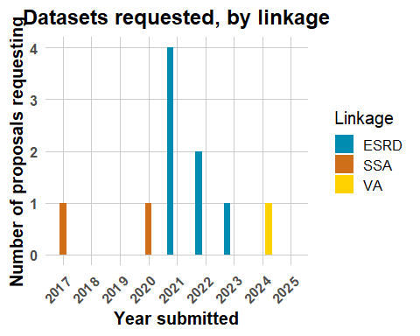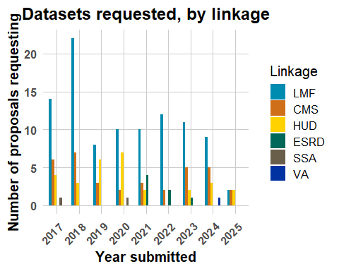

## III. Date of file creation by the RDC

| year_submitted | files_created |
| --- | --- |
| 2017 | 14 |
| 2018 | 11 |
| 2019 | 7 |
| 2020 | 5 |
| 2021 | 6 |
| 2022 | 3 |
| 2023 | 8 |
| 2024 | 7 |
| 2025 | 1 |

