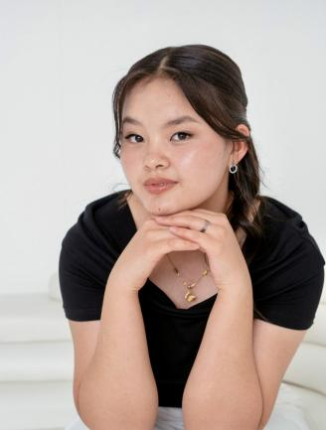**Aruuzhan**

**Kaparbekova**

Email aruuzhan50@gmail.com

Phone +996705492300

**Personal information**

Date of birth: 10/07/09

Citizenship: Kyrgyz Republic

Gender: Female

Education: Secondary

**Education**

СОШ Искра 1-3 grade

СОШ Гимназия им. Д.П.Зубкова 4-6 grade

Tokmok "Umut" high school 7-9 grade

**Extra-curricular activities**

Co-founder of a volunteer organization **mpower.kg**

Mentor in the mentoring program **xcelerate.mentorship**

Quarterfinalist of **Technovation Girls program 24-25**

Semi-finalist of **FLEX 25-26**

Informarics Olimiad 7-9 grade

**Hobbies**

Reding books

Cooking