Assignment 5 WEB Technologies
By: Berdibek Ali Serikuly MT-2502
1st test on our Registration page: no input
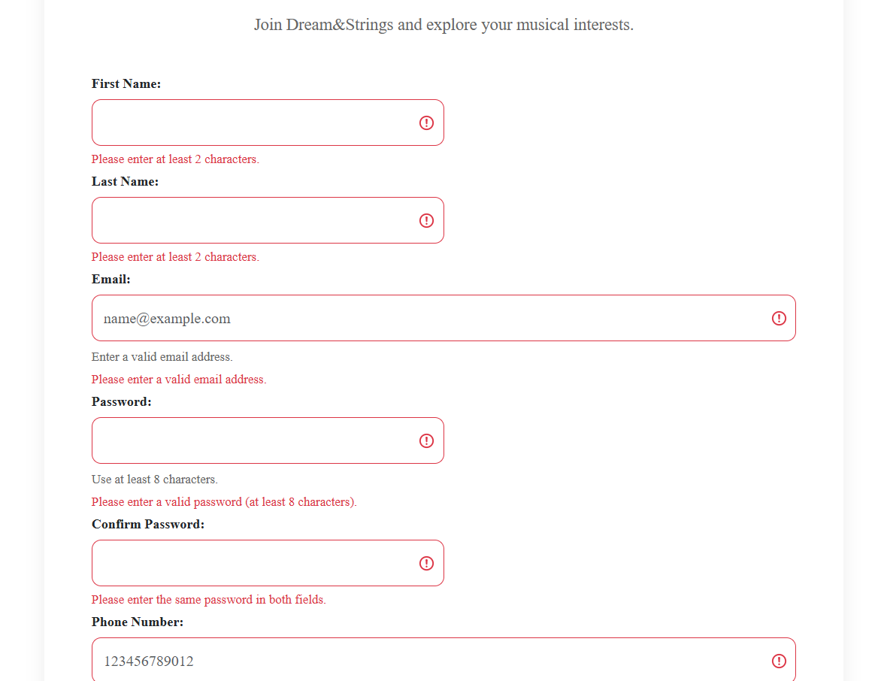
We can clearly see that no input gives us multiple errors

2nd Test: submitting wrong email
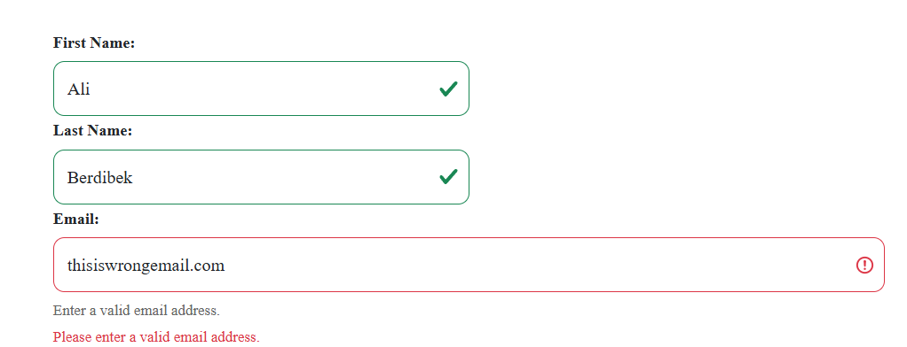
Without @ sign it shows error and asks for valid email address

3rd test:
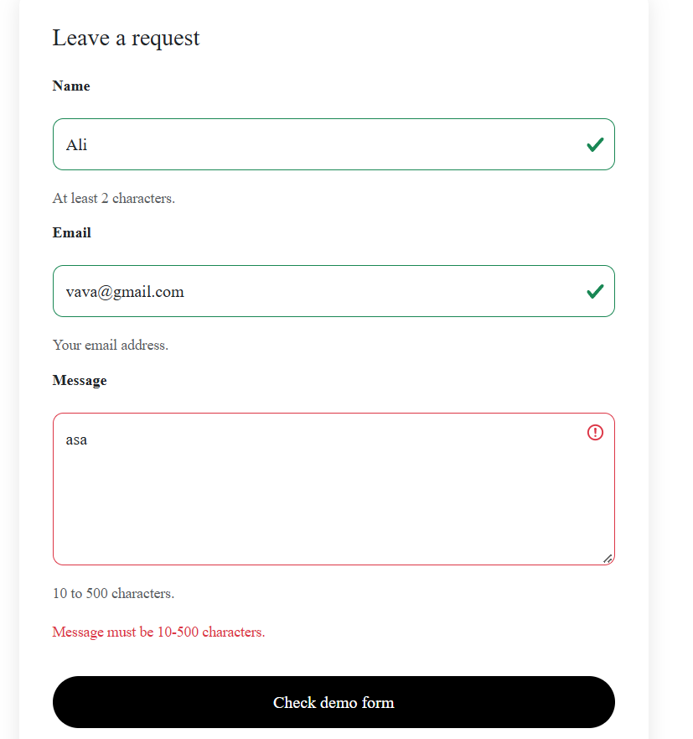
Here we can see another error that appears because we wrote a message shorter than 10 characters

4th test: entering different passwords
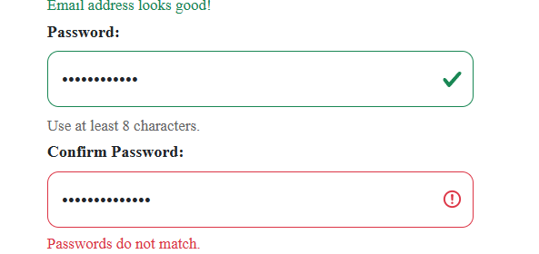
We can notice that system see the difference between passwords, which gives us another error as a result

5th test: not choosing a country
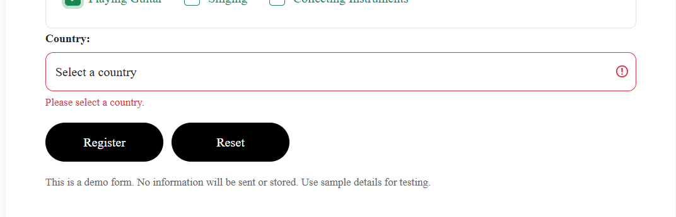
6th test: everything was submitted in correct format
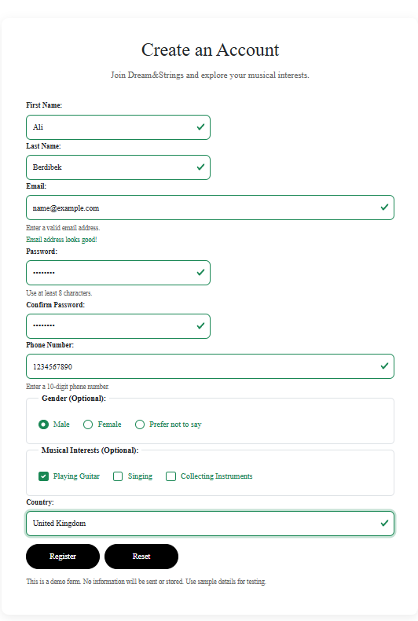



7th test: pressing on reset erases all data submitted in the page
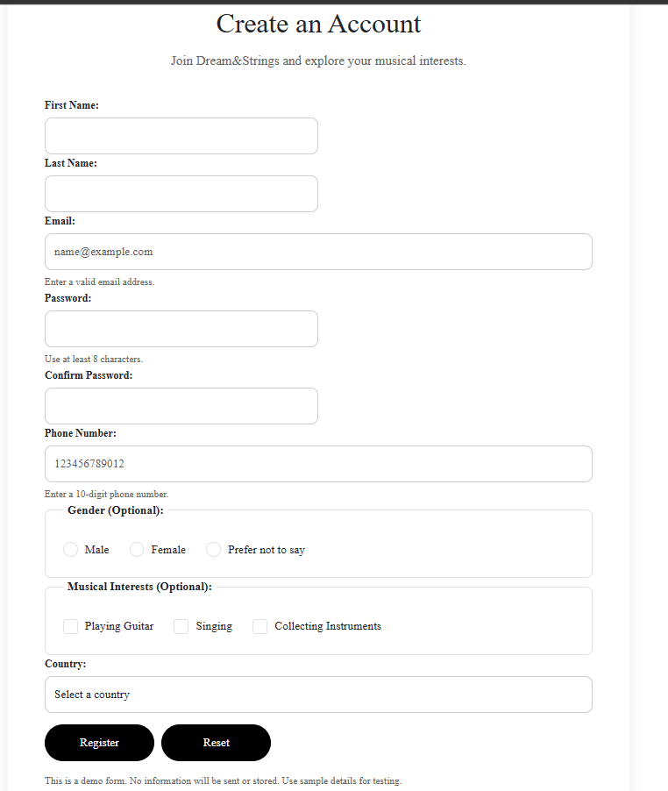

Conclusion: I tested all the pages that my teammates made for their functionality. Everything works perfectly fine. I also did minor help to them with the coding part.

