PRACTICAL WORK №7–10
Data Sorting, Filtering, SQL Queries and Joining Tables
Topics №7–10 · University Database
Student: Khismetova Aruzhan
Document: practicalwork7_10_KhismetovaAruzhan
Software: Microsoft Excel (Windows) · DB Browser for SQLite (Windows)

Contents of this document
This single document contains: the full assignment text, completed work for Parts 1–4, Windows screenshots of every step, a short report after each part, answers to the six individual questions, SQL query listing, and the conclusion.
1. Purpose of the practical work
To develop skills in sorting, filtering, searching and analyzing data, writing SQL queries, using aggregate functions and joining information from multiple tables.
2. Software and resources
• Microsoft Excel (Windows 11)
• DB Browser for SQLite (Windows 11)
• University_Database.xlsx (Students, Groups, Teachers, Subjects, Exams, Grades)
3. Database structure
Tables: Groups, Teachers, Subjects, Students, Exams, Grades. Relationships: Students.group_id → Groups.group_id; Subjects.teacher_id → Teachers.teacher_id; Exams.subject_id → Subjects.subject_id; Grades.student_id → Students.student_id; Grades.exam_id → Exams.exam_id.
Dataset: 15 students, 4 groups, 5 teachers, 6 subjects, 6 exams, 30 grades.
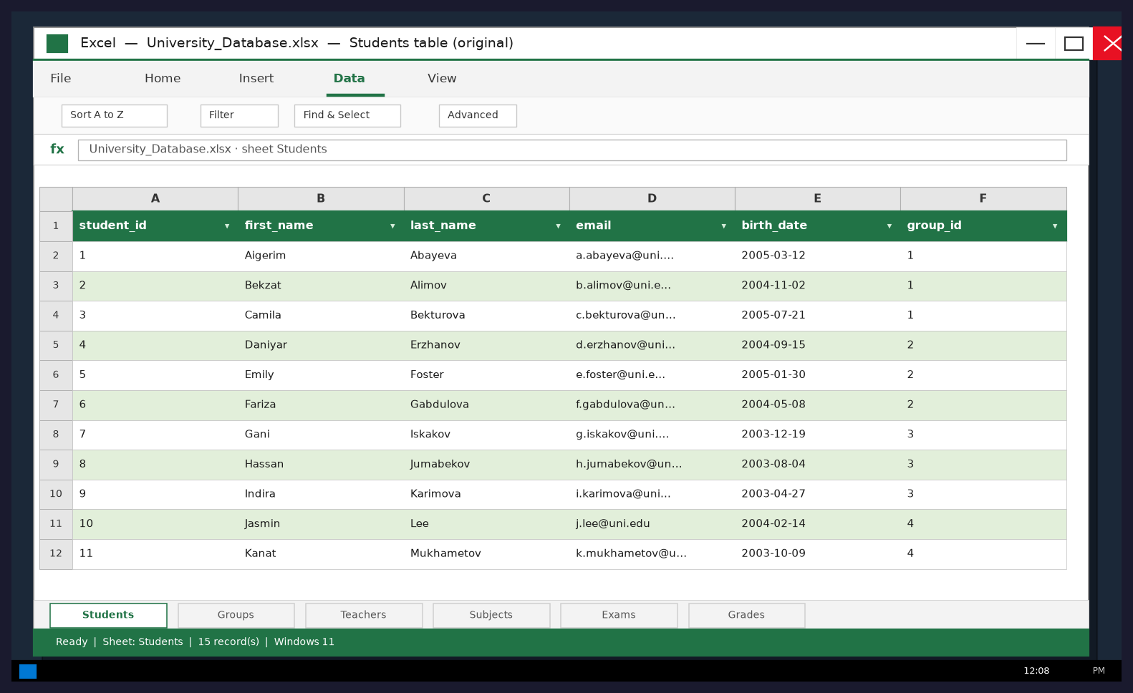
Figure 0. Original Students table in Microsoft Excel (Windows).
4. Part 1 — Sorting, filtering and searching (Topic №7)
Task description (from assignment): Open your Students table in Excel. Sort students alphabetically by last name. Sort students by group. Filter the table to display students from one selected group. Search for a student by ID or last name. Filter records using two conditions. Save the results and take screenshots of your work.
4.1 Sort students alphabetically by last name
Assignment: Sort students alphabetically by last name.
Performed in Excel (Windows): Data → Sort → Column last_name → A to Z.
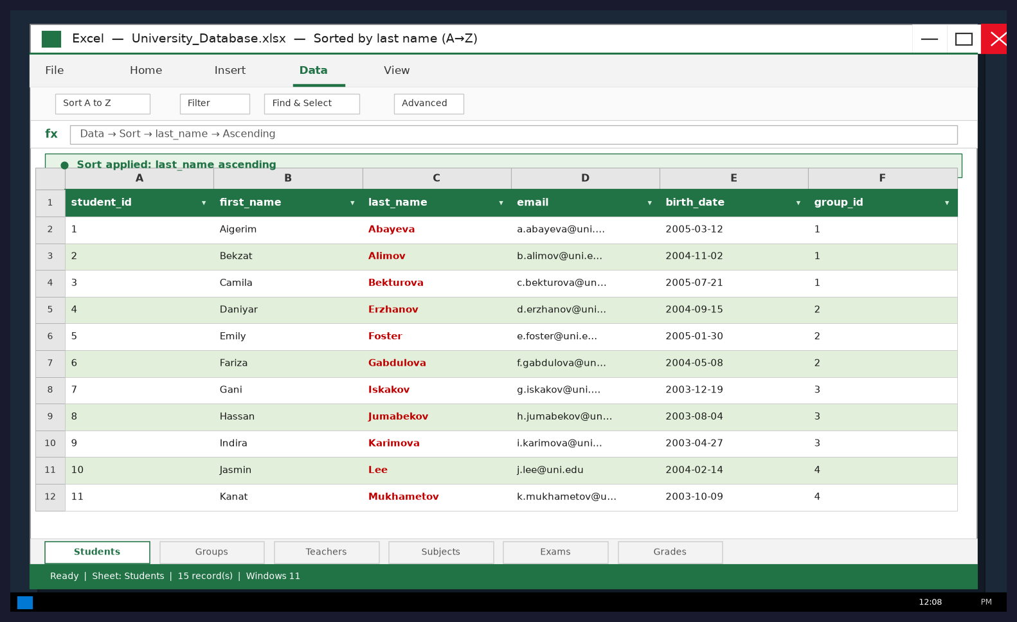
Figure 1. Windows Excel — Students sorted by last_name ascending.
4.2 Sort students by group
Assignment: Sort students by group.
Performed: Data → Sort → group_id ascending (then last_name).
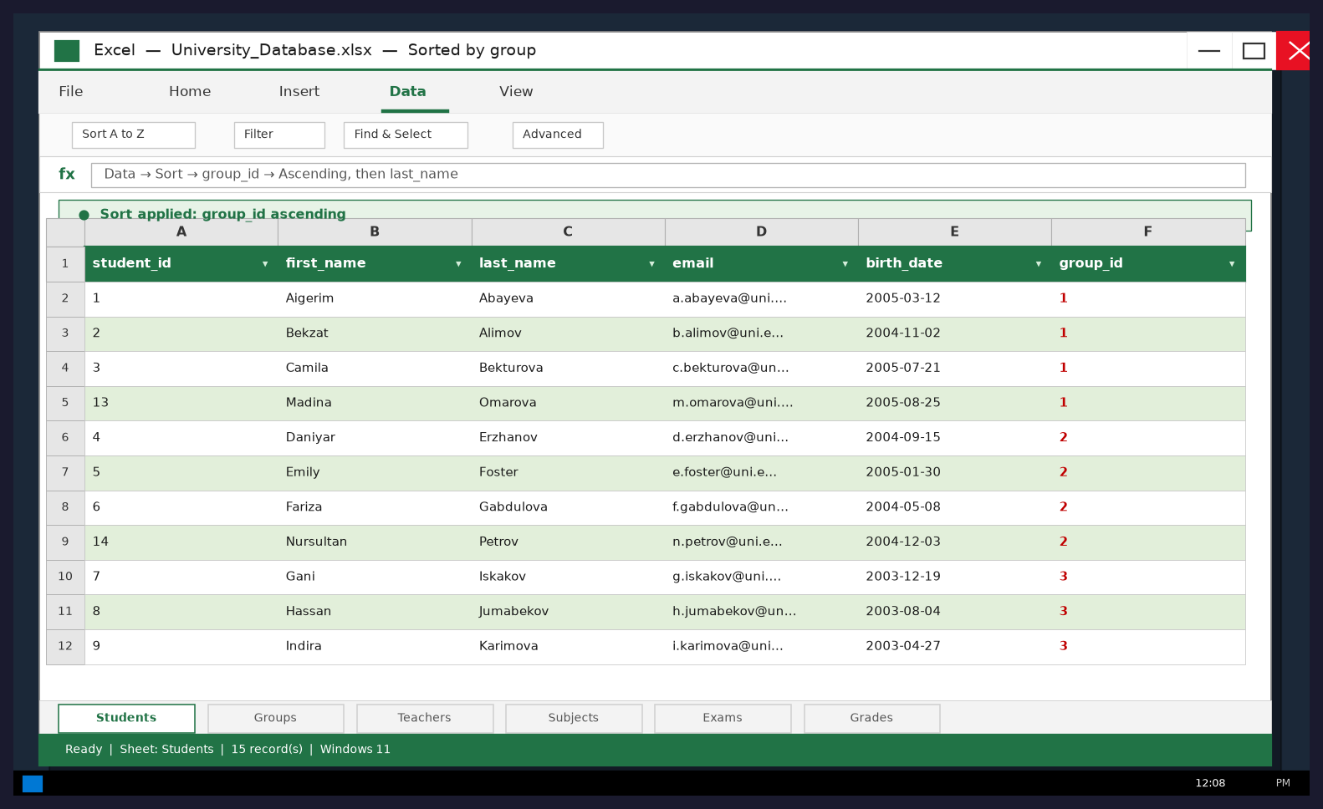
Figure 2. Windows Excel — Students sorted by group_id.
4.3 Filter students from one selected group
Assignment: Filter the table to display students from one selected group.
Selected group: CS-101 (group_id = 1). AutoFilter applied. 4 students shown.
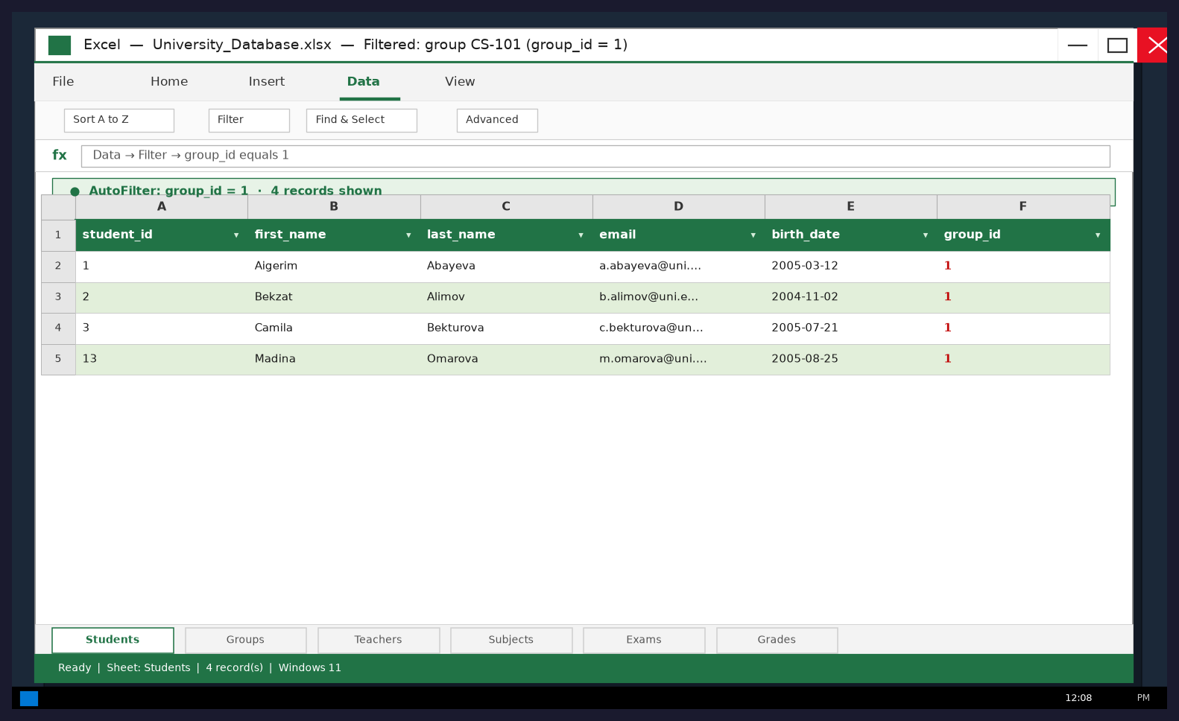
Figure 3. Windows Excel — AutoFilter group_id = 1 (CS-101).
4.4 Search for a student by ID or last name
Assignment: Search for a student by ID or last name.
Find & Select → Find: last_name = Karimova / student_id = 9 → Indira Karimova.
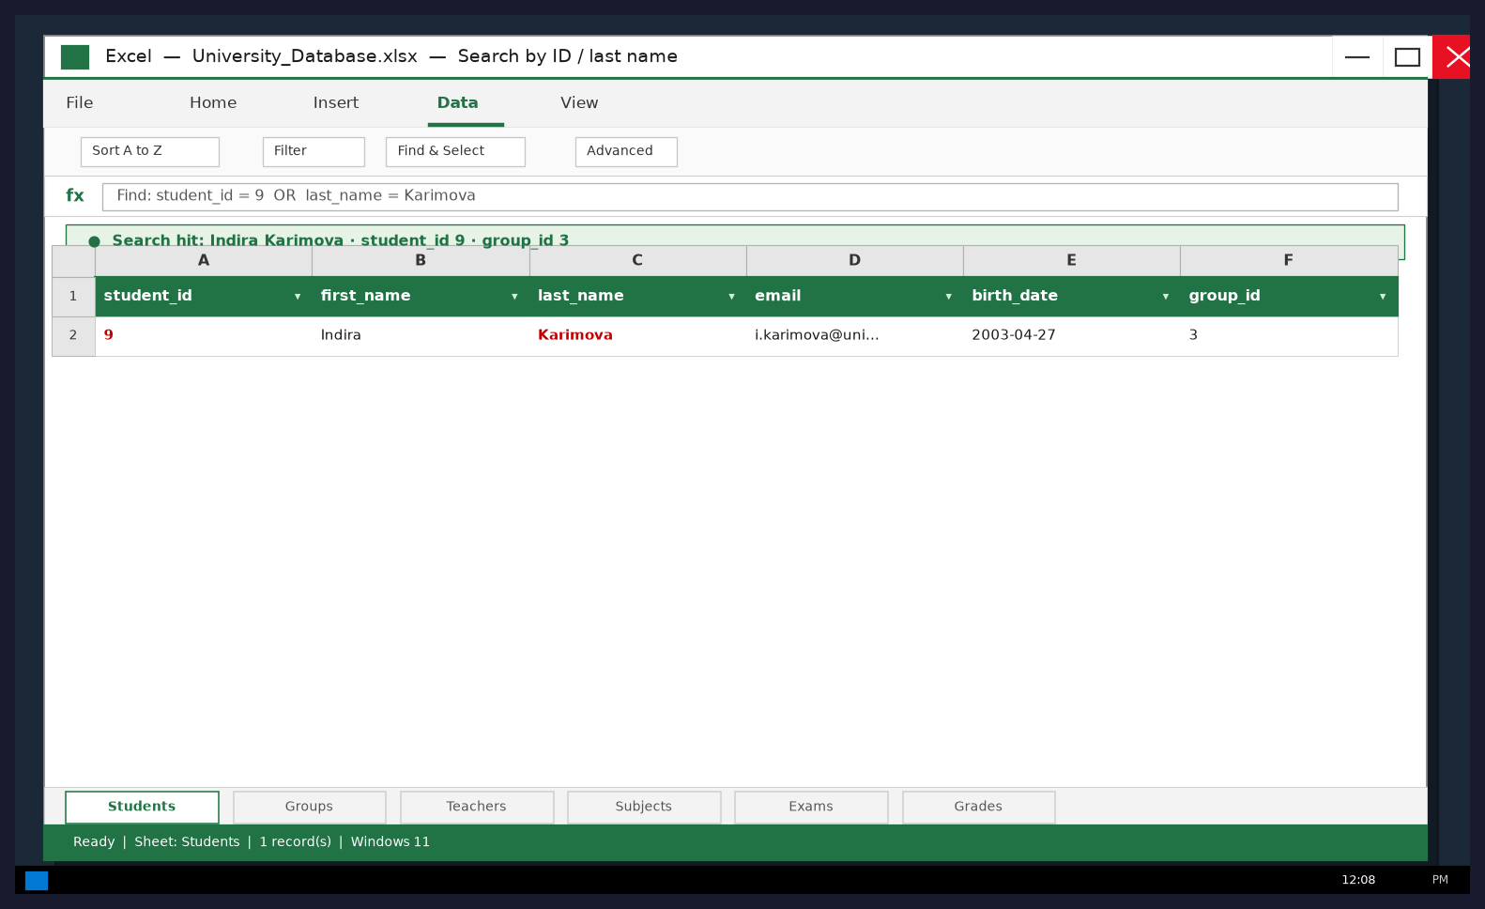
Figure 4. Windows Excel — Search result for Karimova.
4.5 Filter using two conditions
Assignment: Filter records using two conditions.
Advanced Filter: group_id = 3 AND last_name ≥ 'I' → Iskakov, Karimova.
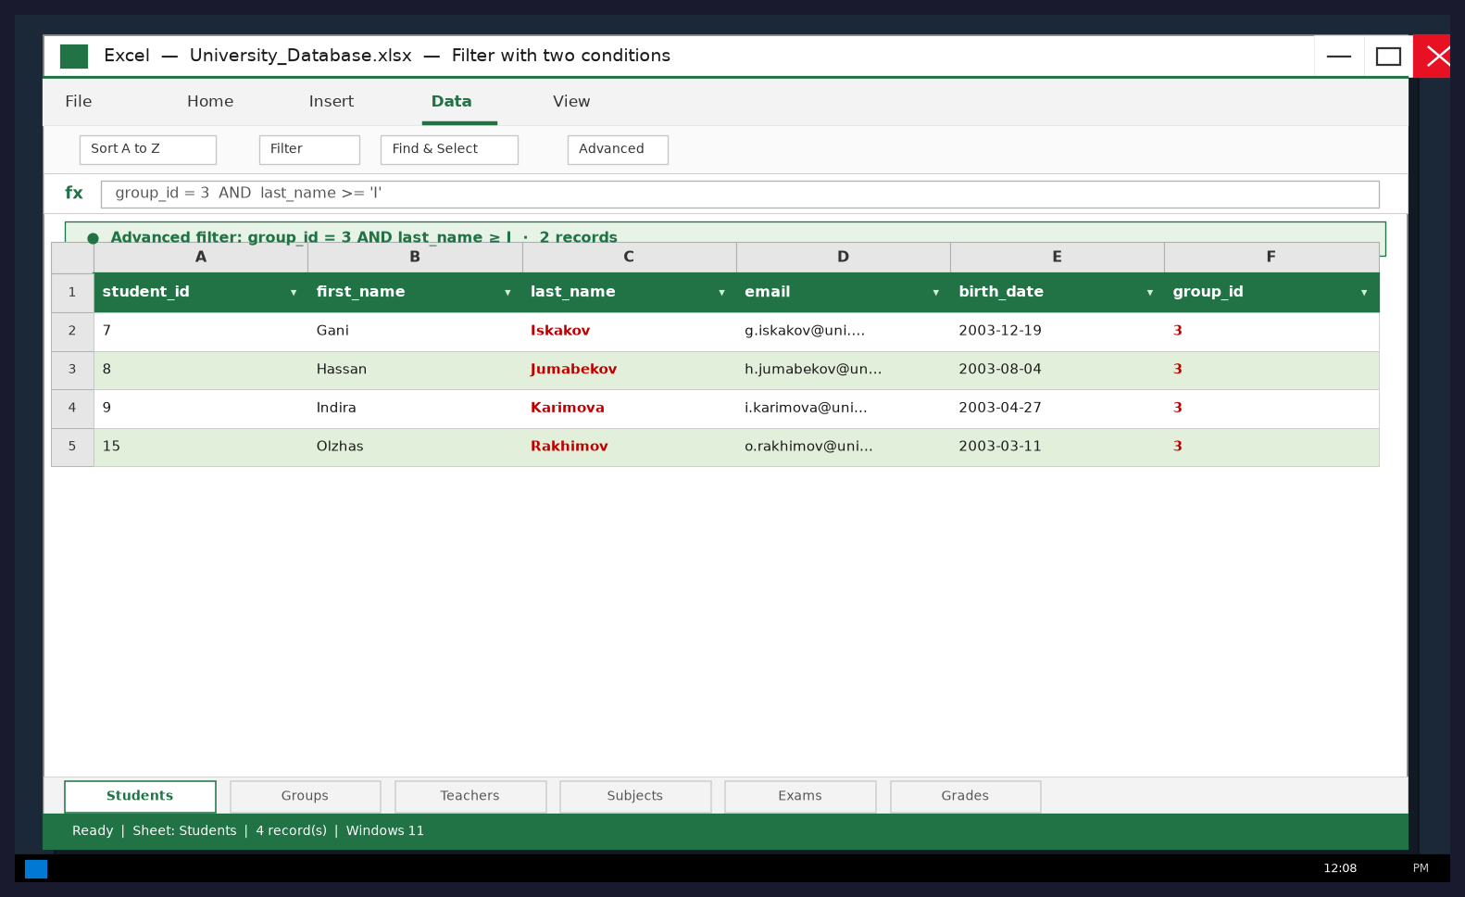
Figure 5. Windows Excel — Two-condition filter.
Report — Part 1
Sorting rearranges all rows by a chosen key without removing data. Filtering hides rows that do not match criteria, so only a subset is visible. Searching locates a specific value (student_id or last_name). Combined filters (group + name range) narrow the dataset further. Excel AutoFilter and Sort on Windows are suitable for interactive exploration before SQL.
5. Part 2 — Introduction to SQL (Topic №8)
Task description (from assignment): Import or create your university tables in an SQL database. Write and execute: display all Students; display student_id, first_name, last_name; display all Groups; display subject names.
Environment: DB Browser for SQLite on Windows 11. Database file: university.db.
5.1 Display all records from the Students table
Assignment: Display all records from the Students table.
SELECT * FROM Students;
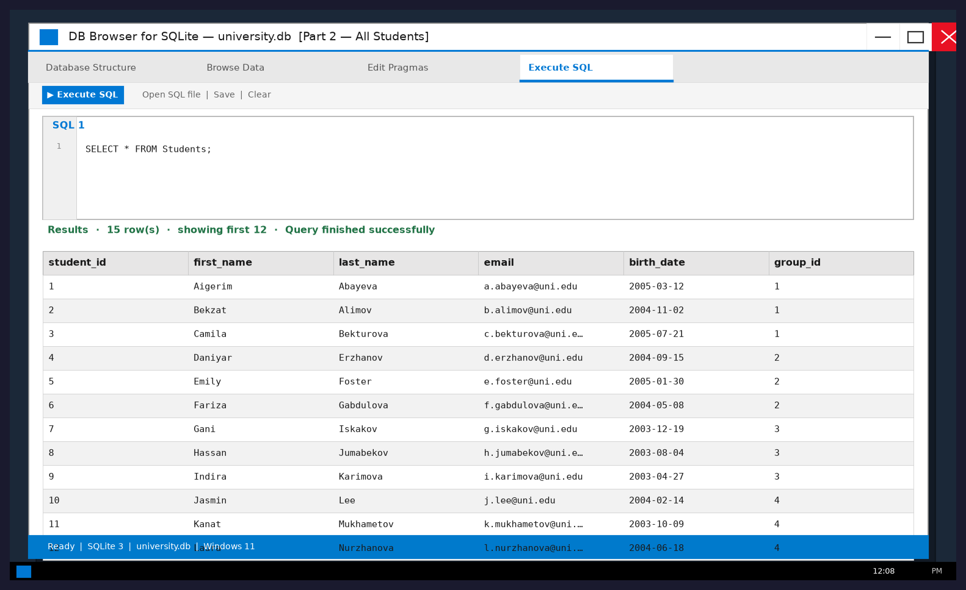
Figure 6. Windows DB Browser — SELECT * FROM Students;
5.2 Display student IDs, first names and last names
Assignment: Display only student IDs, first names and last names.
SELECT student_id, first_name, last_name FROM Students;
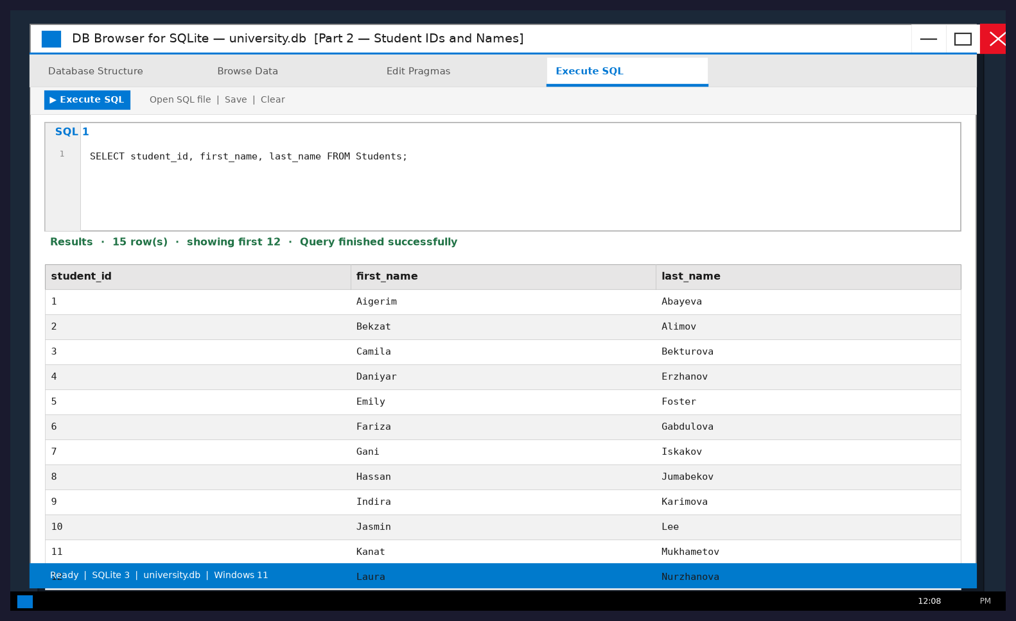
Figure 7. Windows DB Browser — projection of student_id, first_name, last_name.
5.3 Display all records from the Groups table
Assignment: Display all records from the Groups table.
SELECT * FROM Groups;
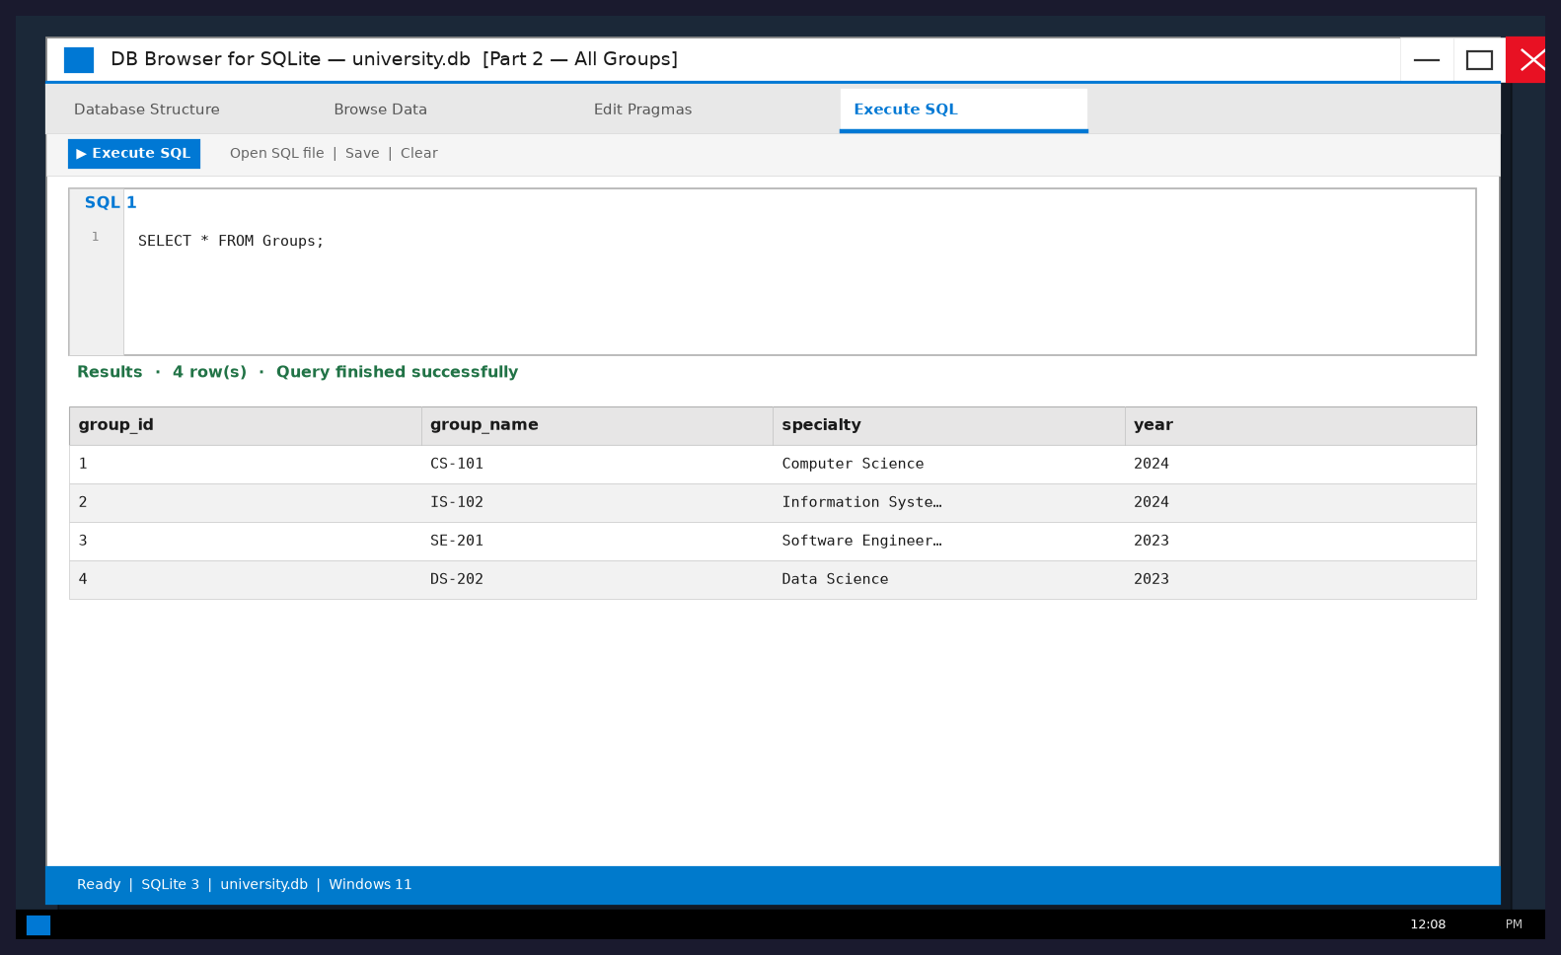
Figure 8. Windows DB Browser — SELECT * FROM Groups;
5.4 Display the names of all subjects
Assignment: Display the names of all subjects from the Subjects table.
SELECT subject_name FROM Subjects;
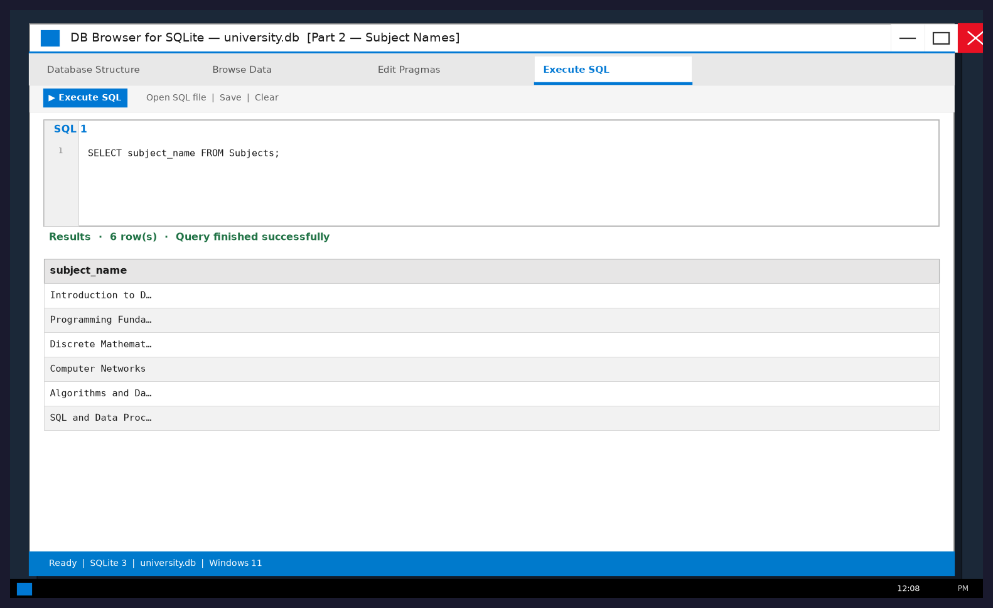
Figure 9. Windows DB Browser — SELECT subject_name FROM Subjects;
Report — Part 2
SQL is used to define, query and manage relational data. SELECT * returns every column; listing specific columns returns only needed fields. PRIMARY KEY and FOREIGN KEY enforce relationships before filtering and aggregation.
6. Part 3 — SQL queries and aggregate functions (Topic №9)
Task description (from assignment): Display students of a selected group (WHERE); display students alphabetically (ORDER BY); COUNT total students; COUNT students per group (GROUP BY); find MAX, MIN and AVG grade.
6.1 WHERE — students of a selected group
Assignment: Display students belonging to a selected group using WHERE.
SELECT * FROM Students WHERE group_id = 1;
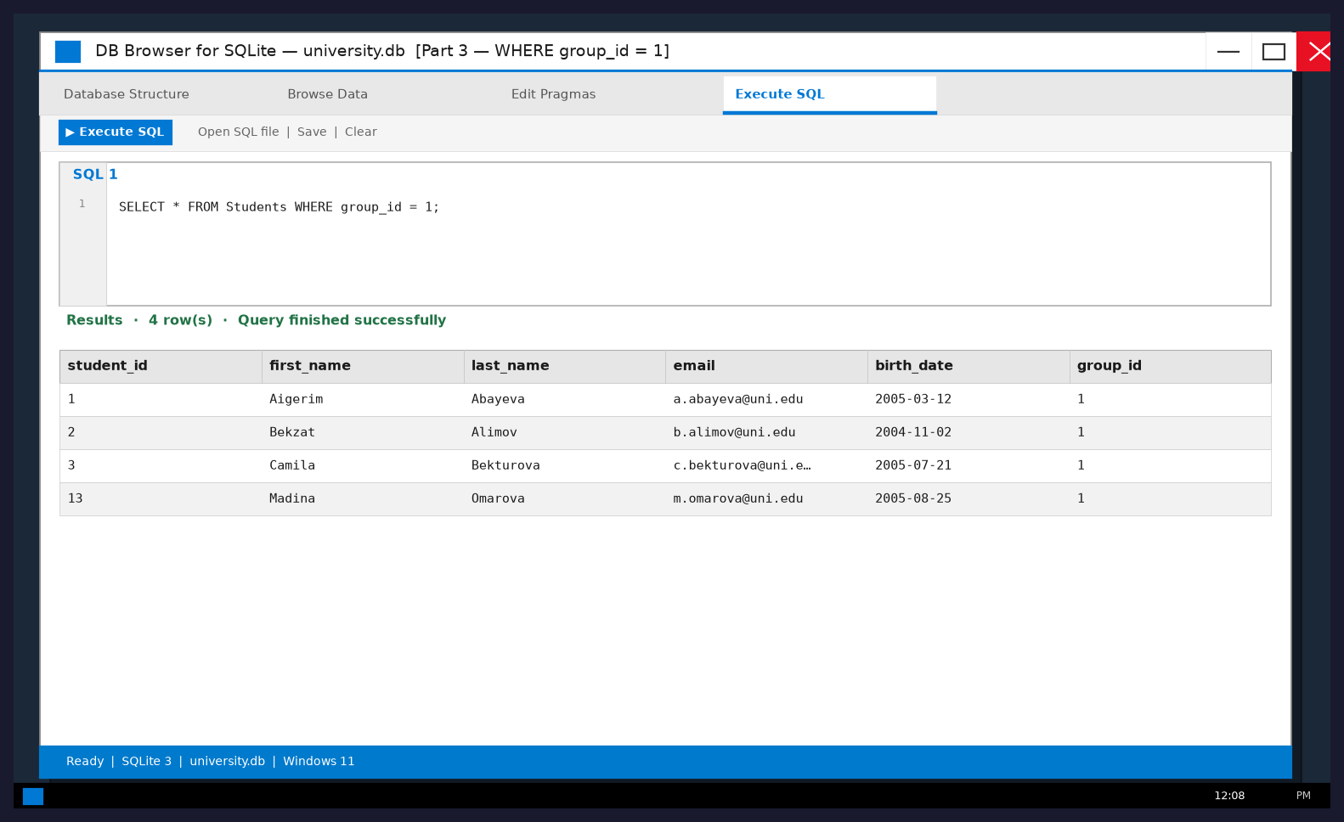
Figure 10. WHERE group_id = 1.
6.2 ORDER BY — alphabetical order
Assignment: Display students in alphabetical order using ORDER BY.
SELECT * FROM Students ORDER BY last_name ASC;
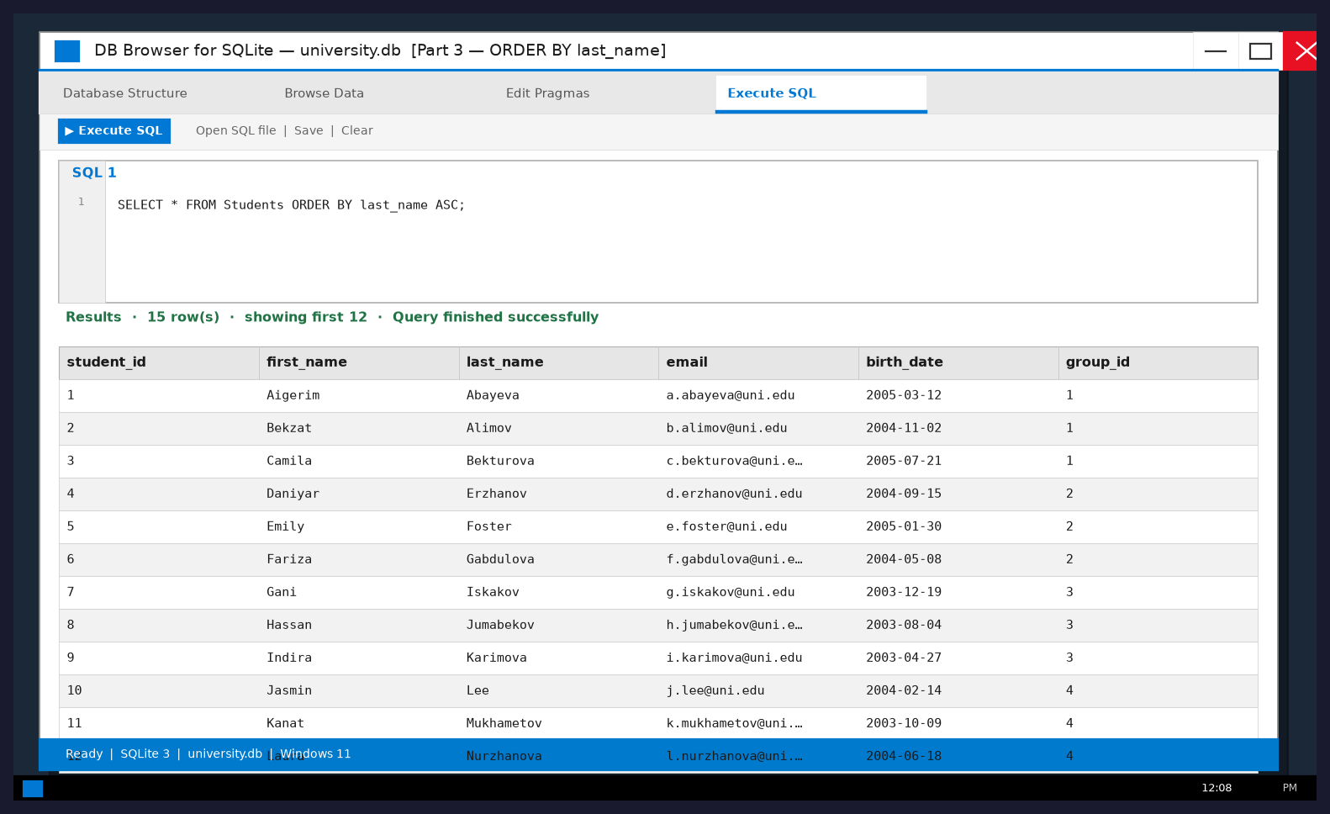
Figure 11. ORDER BY last_name ASC.
6.3 COUNT — total number of students
Assignment: Count the total number of students using COUNT().
SELECT COUNT(*) AS total_students FROM Students;
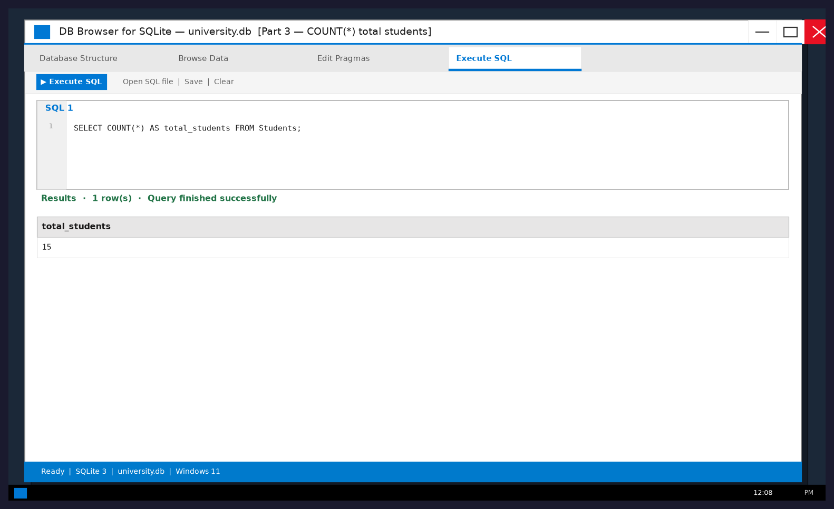
Figure 12. Total students = 15.
6.4 GROUP BY — students in each group
Assignment: Count the number of students in each group using GROUP BY.
SELECT group_id, COUNT(*) AS student_count FROM Students GROUP BY group_id;
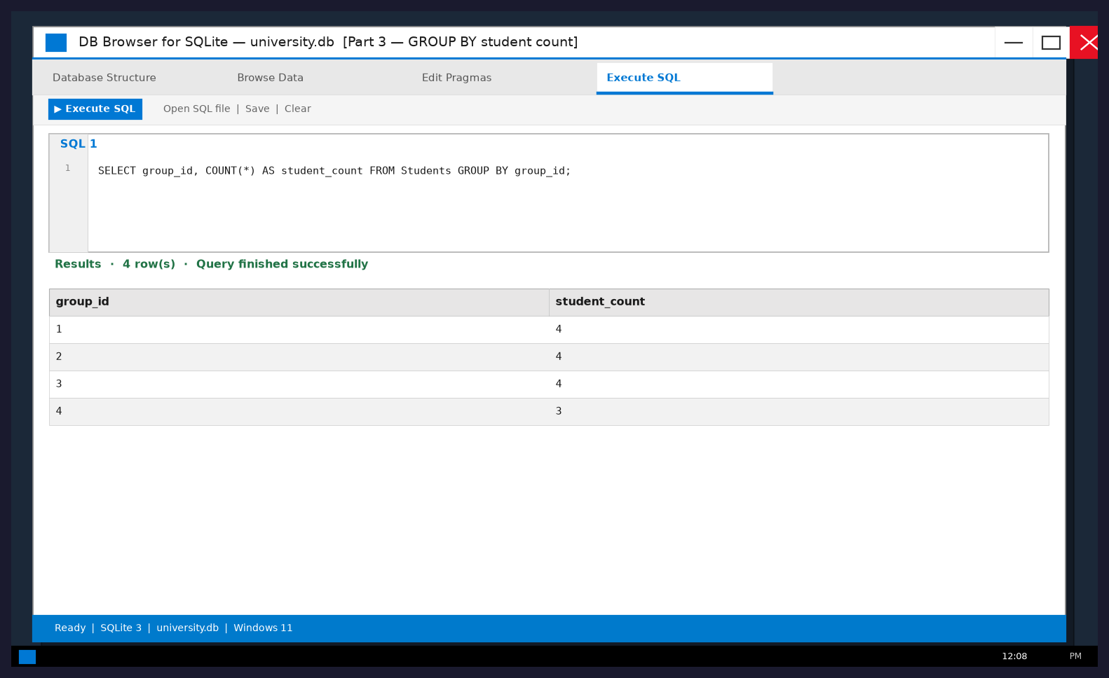
Figure 13. Student count by group_id.
6.5 MAX grade
Assignment: Find the maximum grade using MAX().
SELECT MAX(grade) AS max_grade FROM Grades;
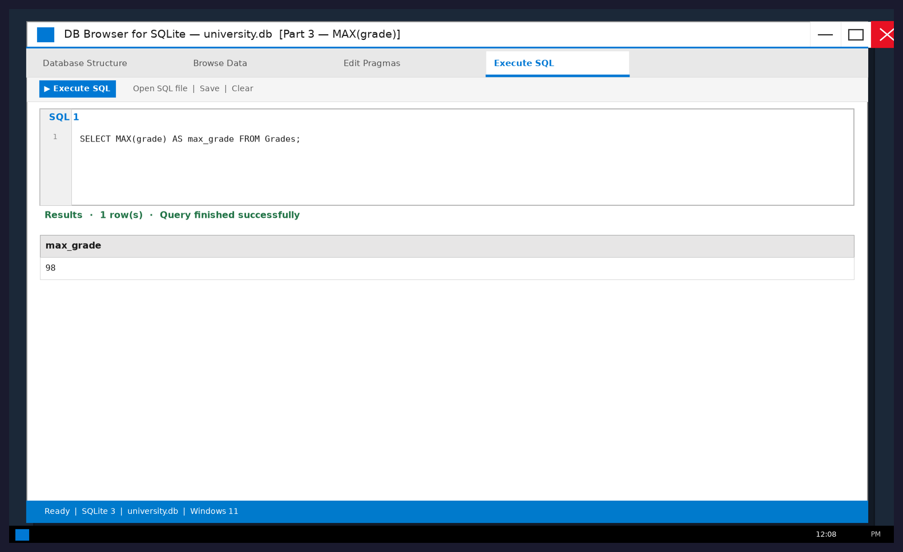
Figure 14. MAX(grade) = 98.
6.6 MIN grade
Assignment: Find the minimum grade using MIN().
SELECT MIN(grade) AS min_grade FROM Grades;
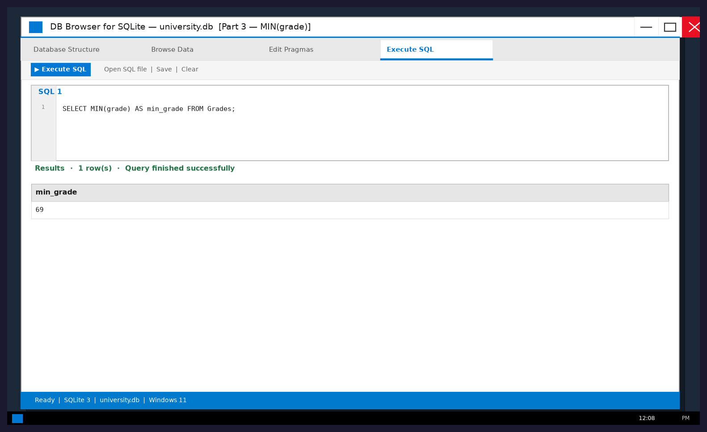
Figure 15. MIN(grade) = 69.
6.7 AVG grade
Assignment: Calculate the average grade using AVG().
SELECT ROUND(AVG(grade), 2) AS average_grade FROM Grades;
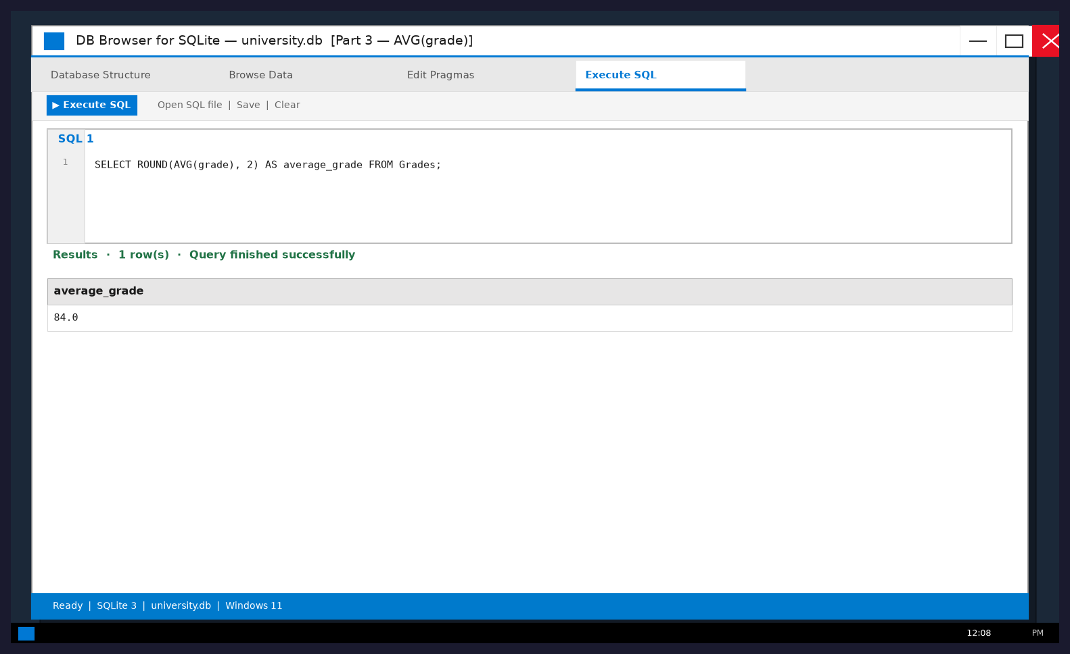
Figure 16. AVG(grade) = 84.0.
Report — Part 3
WHERE filters rows. ORDER BY only changes presentation order. COUNT, MAX, MIN and AVG summarize many values. GROUP BY partitions data so aggregates are computed per group. Result: 15 students; grades from 69 to 98; average 84.0.
7. Part 4 — Joining tables using JOIN (Topic №10)
Task description (from assignment): Join Students and Groups to show name + group name. Join Students and Grades. If Subjects is linked, join to show student, subject and grade. Explain connecting columns. Compare JOIN result with original tables.
7.1 INNER JOIN Students and Groups
Assignment: Join Students and Groups to display each student's name and group name.
Connecting columns: Students.group_id = Groups.group_id.
SELECT Students.first_name, Students.last_name, Groups.group_name
FROM Students
INNER JOIN Groups ON Students.group_id = Groups.group_id
ORDER BY Groups.group_name, Students.last_name;
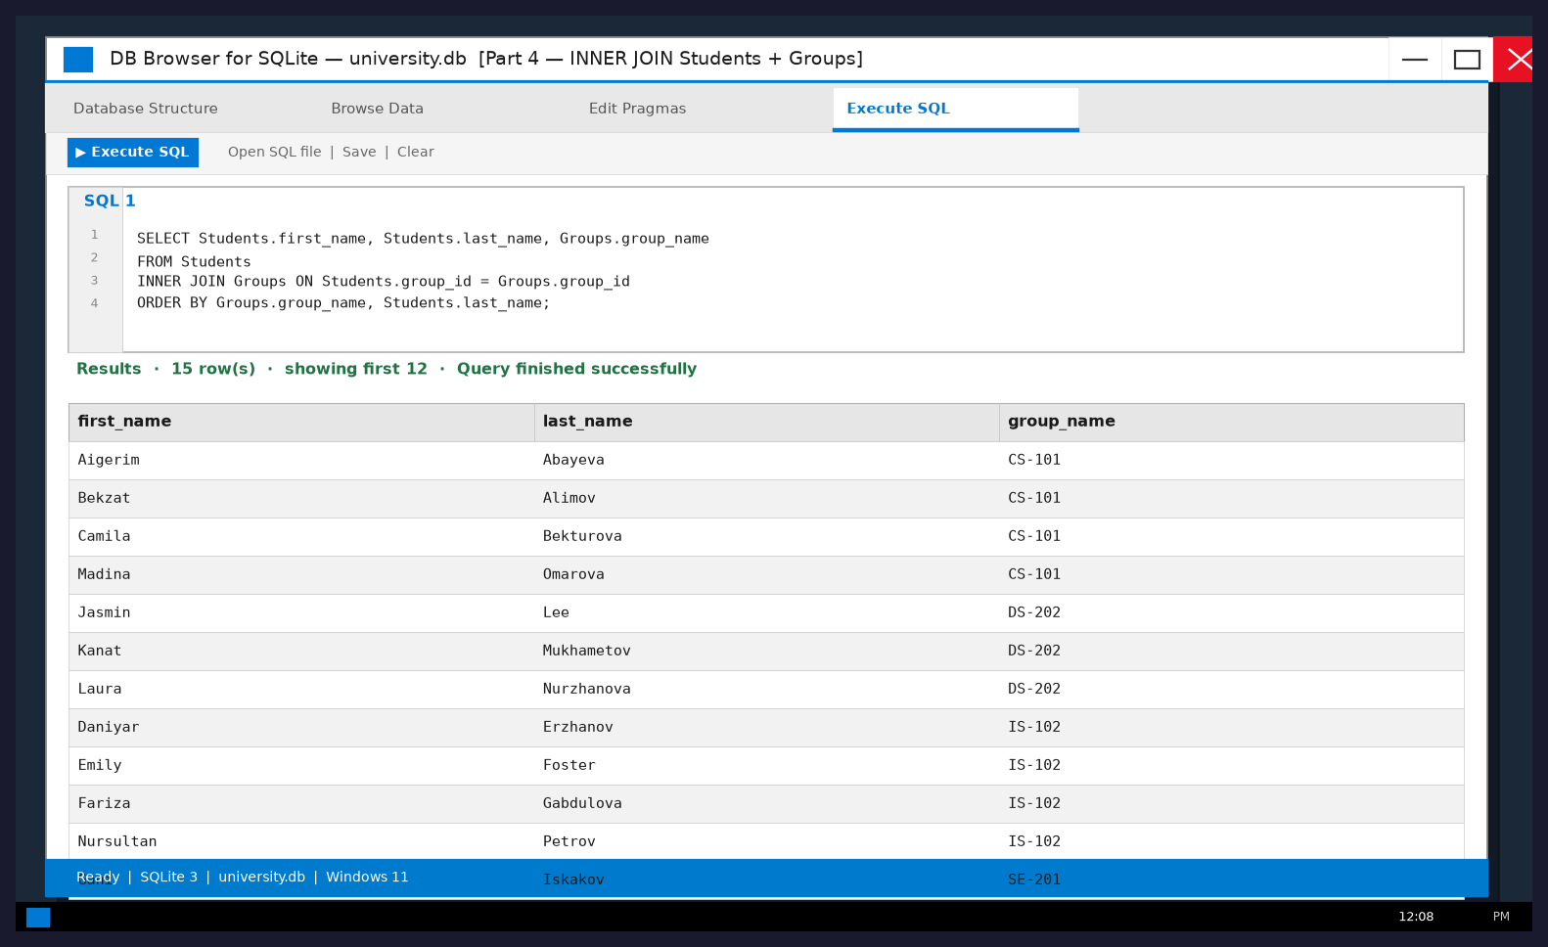
Figure 17. INNER JOIN Students + Groups.
7.2 INNER JOIN Students and Grades
Assignment: Join Students and Grades to display students and their grades.
Connecting columns: Students.student_id = Grades.student_id.
SELECT Students.first_name, Students.last_name, Grades.grade
FROM Students
INNER JOIN Grades ON Students.student_id = Grades.student_id
ORDER BY Students.last_name, Grades.grade DESC;
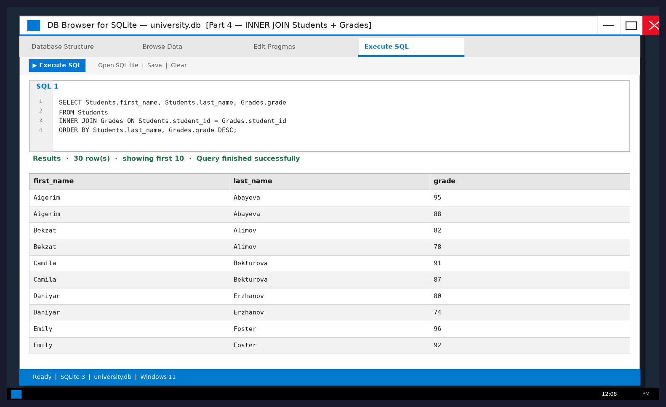
Figure 18. INNER JOIN Students + Grades.
7.3 JOIN Students, Grades, Exams and Subjects
Assignment: Join tables to display student names, subjects and grades.
Connecting columns: Students.student_id = Grades.student_id; Grades.exam_id = Exams.exam_id; Exams.subject_id = Subjects.subject_id.
SELECT Students.first_name, Students.last_name, Subjects.subject_name, Grades.grade
FROM Students
INNER JOIN Grades ON Students.student_id = Grades.student_id
INNER JOIN Exams ON Grades.exam_id = Exams.exam_id
INNER JOIN Subjects ON Exams.subject_id = Subjects.subject_id
ORDER BY Students.last_name, Subjects.subject_name;
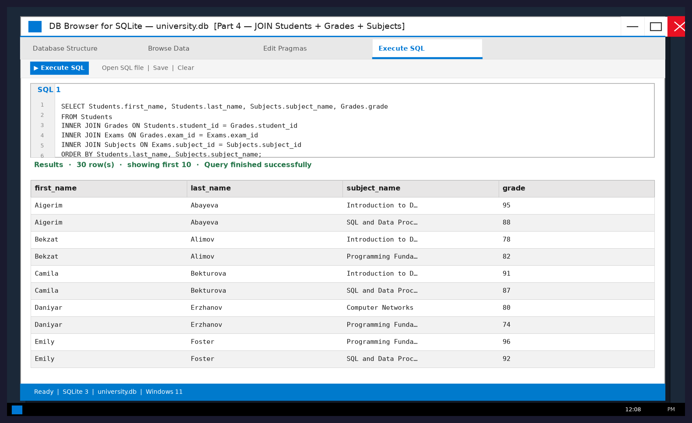
Figure 19. Windows DB Browser — student names, subjects and grades.
7.4 LEFT JOIN comparison + connecting columns
Assignment: Explain which columns connect the tables. Compare JOIN with original tables.
Compared with the original Students / Grades sheets alone, the JOIN result shows readable combined information without repeating master data. INNER JOIN keeps only matching rows; LEFT JOIN keeps all left-table rows.
SELECT Students.first_name, Students.last_name, Grades.grade
FROM Students
LEFT JOIN Grades ON Students.student_id = Grades.student_id
ORDER BY Students.last_name;
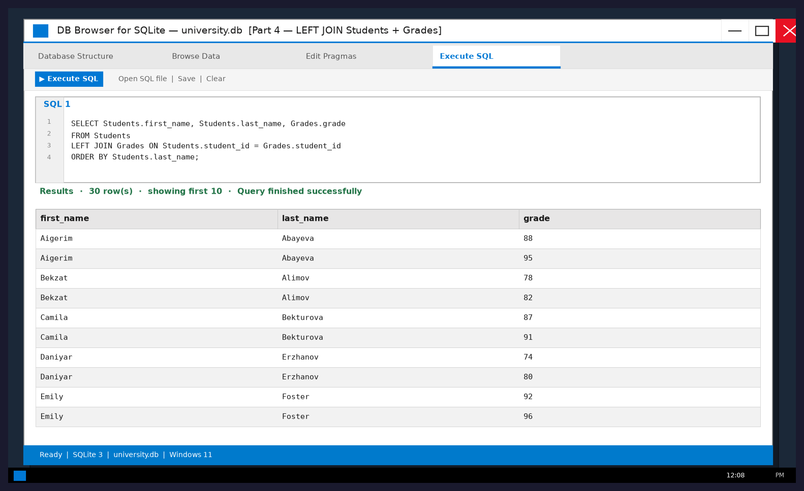
Figure 20. Windows DB Browser — LEFT JOIN Students + Grades.
Report — Part 4
JOIN combines rows from multiple tables using matching key values. Compared with looking at Students or Grades alone, a JOIN result shows denormalized, human-readable information (name + group, or name + subject + grade) without duplicating master data in every sheet. INNER JOIN omits non-matching rows; LEFT JOIN preserves the left side and fills missing right-side columns with NULL. In this dataset every student has grades, so INNER and LEFT results contain the same people, but the pattern is ready for incomplete data.
8. Individual assignment — answers to six questions
Prepare a short report answering these questions (from assignment).
Question 1. What is the difference between sorting and filtering?
Sorting changes the order of rows according to one or more columns (for example A→Z by last_name) but keeps all records. Filtering temporarily hides rows that do not satisfy a condition (for example group_id = 1), so only matching records are shown.
Question 2. What is SQL used for?
SQL is used to create and modify database structures, insert and update data, and — most importantly for this work — to query relational tables with SELECT, WHERE, ORDER BY, GROUP BY, aggregate functions and JOIN.
Question 3. What is the difference between WHERE and ORDER BY?
WHERE selects which rows are included in the result based on conditions. ORDER BY does not remove rows; it only arranges the final result set (ASC or DESC) by chosen columns.
Question 4. Why do we use GROUP BY and aggregate functions?
Aggregate functions (COUNT, SUM, AVG, MIN, MAX) compute summary values from many rows. GROUP BY partitions the data so those summaries are calculated separately for each group (for example student count per group_id).
Question 5. What is the purpose of JOIN?
JOIN retrieves related information stored in different tables by matching key columns (foreign key = primary key), producing a combined result such as student name with group name or subject and grade.
Question 6. What is the difference between INNER JOIN and LEFT JOIN?
INNER JOIN returns only rows that have a match in both tables. LEFT JOIN returns all rows from the left table and matching rows from the right table; if there is no match, right-table columns are NULL.
9. Appendix — full SQL script used in this work
All queries below were executed in DB Browser for SQLite on Windows. The complete script is also saved as sql/university_queries.sql.
Part 2 — All Students
SELECT * FROM Students;
Part 2 — Student IDs and Names
SELECT student_id, first_name, last_name FROM Students;
Part 2 — All Groups
SELECT * FROM Groups;
Part 2 — Subject Names
SELECT subject_name FROM Subjects;
Part 3 — WHERE group_id = 1
SELECT * FROM Students WHERE group_id = 1;
Part 3 — ORDER BY last_name
SELECT * FROM Students ORDER BY last_name ASC;
Part 3 — COUNT(*) total students
SELECT COUNT(*) AS total_students FROM Students;
Part 3 — GROUP BY student count
SELECT group_id, COUNT(*) AS student_count FROM Students GROUP BY group_id;
Part 3 — MAX(grade)
SELECT MAX(grade) AS max_grade FROM Grades;
Part 3 — MIN(grade)
SELECT MIN(grade) AS min_grade FROM Grades;
Part 3 — AVG(grade)
SELECT ROUND(AVG(grade), 2) AS average_grade FROM Grades;
Part 4 — INNER JOIN Students + Groups
SELECT Students.first_name, Students.last_name, Groups.group_name
FROM Students
INNER JOIN Groups ON Students.group_id = Groups.group_id
ORDER BY Groups.group_name, Students.last_name;
Part 4 — INNER JOIN Students + Grades
SELECT Students.first_name, Students.last_name, Grades.grade
FROM Students
INNER JOIN Grades ON Students.student_id = Grades.student_id
ORDER BY Students.last_name, Grades.grade DESC;
Part 4 — JOIN Students + Grades + Subjects
SELECT Students.first_name, Students.last_name, Subjects.subject_name, Grades.grade
FROM Students
INNER JOIN Grades ON Students.student_id = Grades.student_id
INNER JOIN Exams ON Grades.exam_id = Exams.exam_id
INNER JOIN Subjects ON Exams.subject_id = Subjects.subject_id
ORDER BY Students.last_name, Subjects.subject_name;
Part 4 — LEFT JOIN Students + Grades
SELECT Students.first_name, Students.last_name, Grades.grade
FROM Students
LEFT JOIN Grades ON Students.student_id = Grades.student_id
ORDER BY Students.last_name;
10. Conclusion
After completing this practical work, students should be able to sort and filter large datasets, search for information, write basic SQL queries, summarize data using aggregate functions and retrieve related information from multiple tables using JOIN.
In this submission the Students dataset was sorted and filtered in Microsoft Excel on Windows (alphabetical sort, sort by group, one-group filter, search by ID/name, two-condition filter). The university schema was implemented in SQLite and opened in DB Browser for SQLite on Windows. Basic SELECT queries, WHERE, ORDER BY, GROUP BY and aggregate functions (COUNT, MAX, MIN, AVG) were executed successfully. INNER JOIN and LEFT JOIN combined Students with Groups, Grades and Subjects, showing how foreign keys connect tables. Excel is convenient for quick visual exploration; SQL provides precise, repeatable multi-table analysis.
11. Deliverables (all included in / with this package)
1. Updated University_Database.xlsx — data/University_Database.xlsx
2. SQL script containing all queries — sql/university_queries.sql (also in §9)
3. Screenshots showing executed queries and results — embedded above (Windows UI)
4. Short report with answers to the six questions — §8 of this document
5. Report after each assignment part — Report — Part 1…4 sections above
6. Conclusion — §10 of this document

