Assignment 3
Application Installation and Configuration
Topics 1.33, 1.34, 1.36
Student: Aruzhan
Date: 6 November 2026
Operating System: Linux (Ubuntu) x86_64
Objective: To practise selecting, installing, and configuring application software, including web browsers, communication applications, and database management tools.

1. Report Table — Selected Applications
Application | Version | Purpose | Configuration performed | Result
Google Chrome  (Web browser) | 156.0.8078.47 | Browse websites; access web applications | Default search engine (Google); downloads path; startup = New Tab; privacy review; profile “Aruzhan” | Configured successfully; websites opened
Telegram Desktop  (Communication) | 7.4 | Instant messaging, voice/video calls, file sharing | Installed from official Linux package; language English; auto-update ON; theme Classic; scale 100% | Installed and launched; settings verified
SQLite  (Database software) | 3.45.1 | Lightweight embedded relational database / DBMS tool | Verified install; created student_test.db with tables students and apps; ran SELECT queries | Database created and accessible

2. Task 1 — Web Browser Configuration (Google Chrome)

2.1 Installation / verification
Google Chrome was already installed on the system. Verification was performed via the terminal and chrome://version.
- Command: google-chrome --version
- Result: Google Chrome 156.0.8078.47
- Executable path: /opt/google/chrome/google-chrome
- OS: Linux x86_64

2.2 Steps performed
1. Checked browser name and version on chrome://version.
2. Examined available settings on chrome://settings/.
3. Configured the default search engine to Google (chrome://settings/searchEngines).
4. Reviewed download location (chrome://settings/downloads); left Ask where to save OFF; Show downloads when done ON.
5. Configured startup behaviour: Open the New Tab page (chrome://settings/onStartup).
6. Reviewed privacy and security settings (chrome://settings/privacy): Safety Check, cookies, Safe Browsing, site settings.
7. Configured user profile name to “Aruzhan” (Customize profile).
8. Tested the browser by opening wikipedia.org, github.com, and example.com in separate tabs.

2.3 List of configured settings
- Default search engine → Google
- Downloads → show downloads when done = ON
- On startup → Open the New Tab page
- Privacy → reviewed Safety Check / Safe Browsing / site settings
- Profile name → Aruzhan

2.4 Screenshots — Chrome
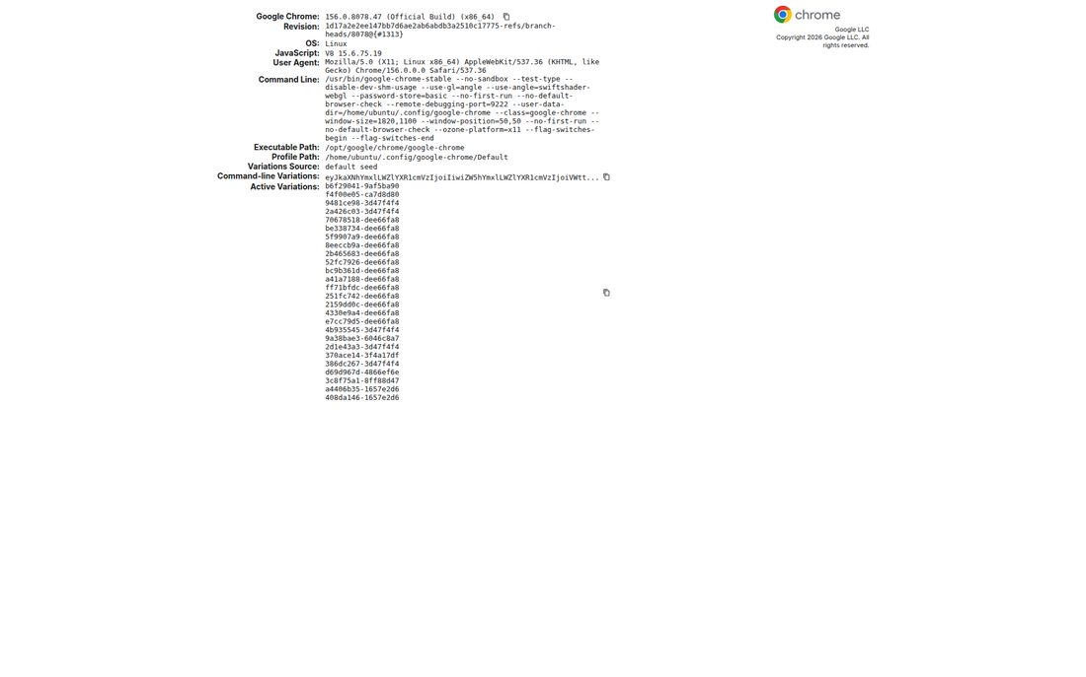
Figure 1. Chrome version (chrome://version)
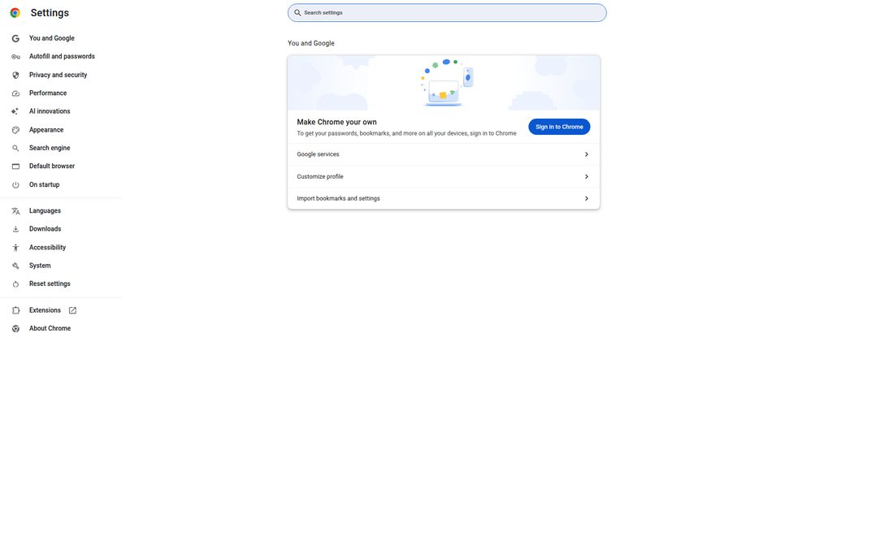
Figure 2. Chrome settings overview
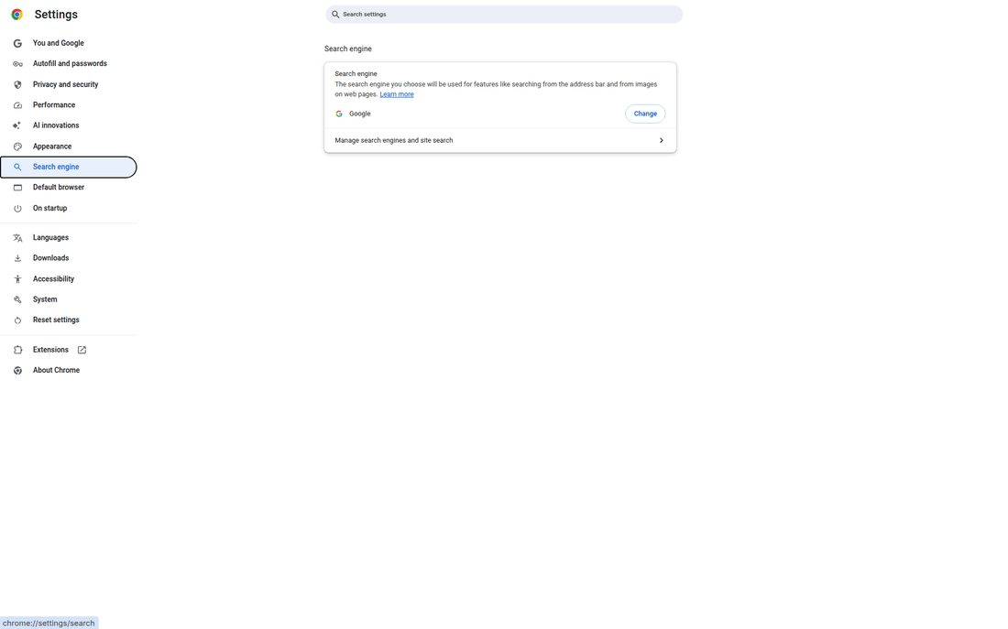
Figure 3. Default search engine = Google
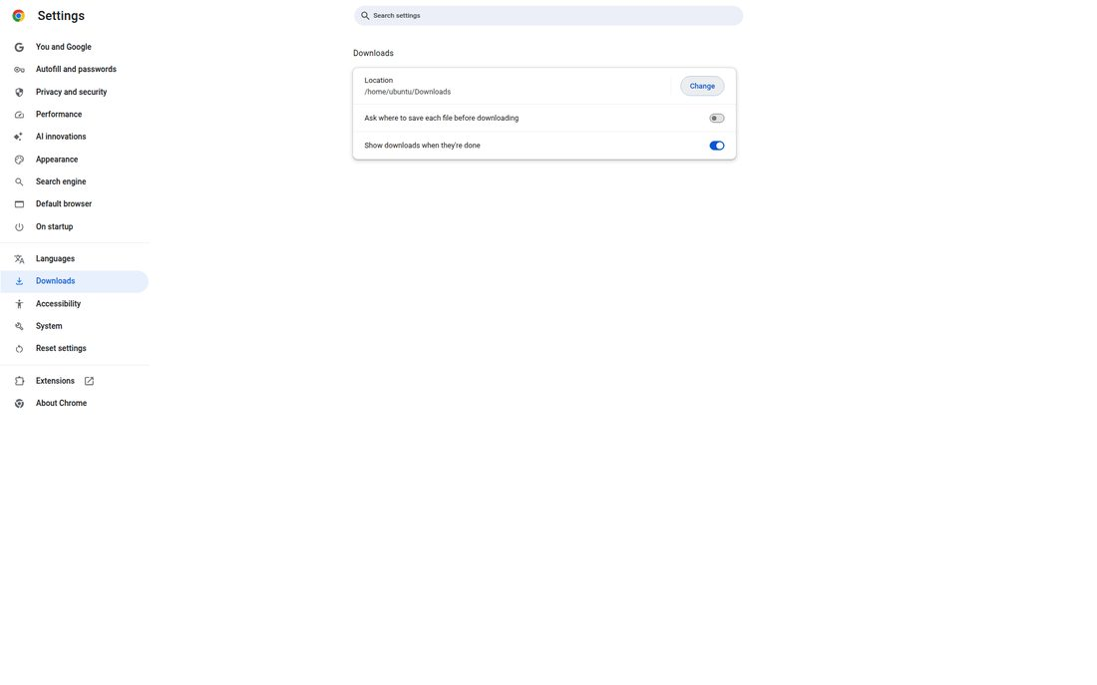
Figure 4. Downloads settings
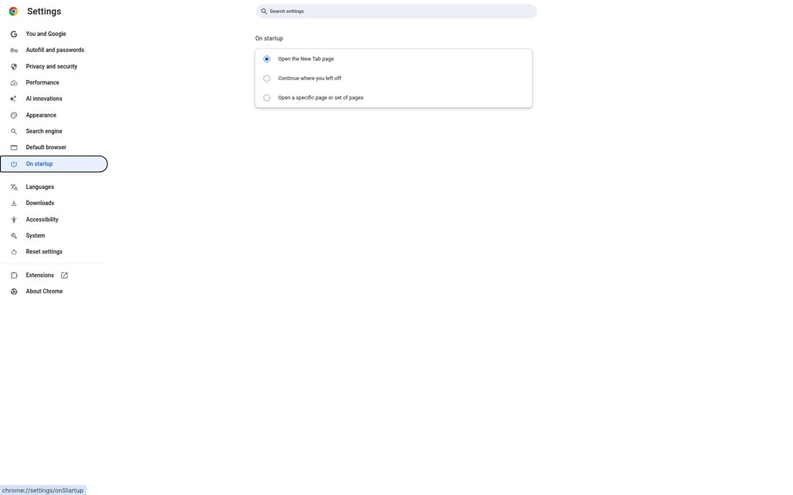
Figure 5. Startup settings — New Tab page
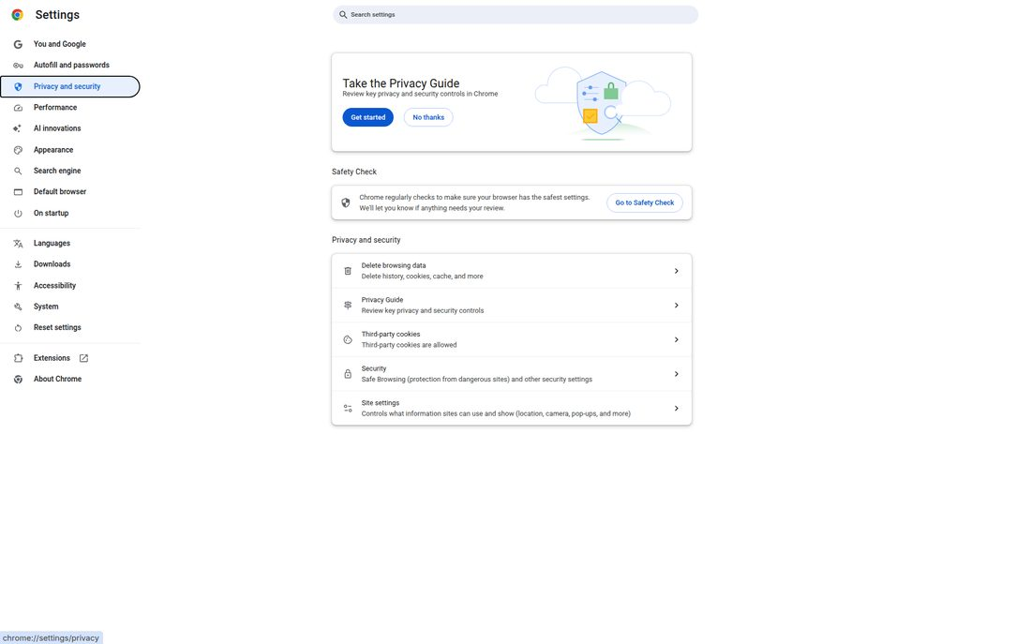
Figure 6. Privacy and security settings
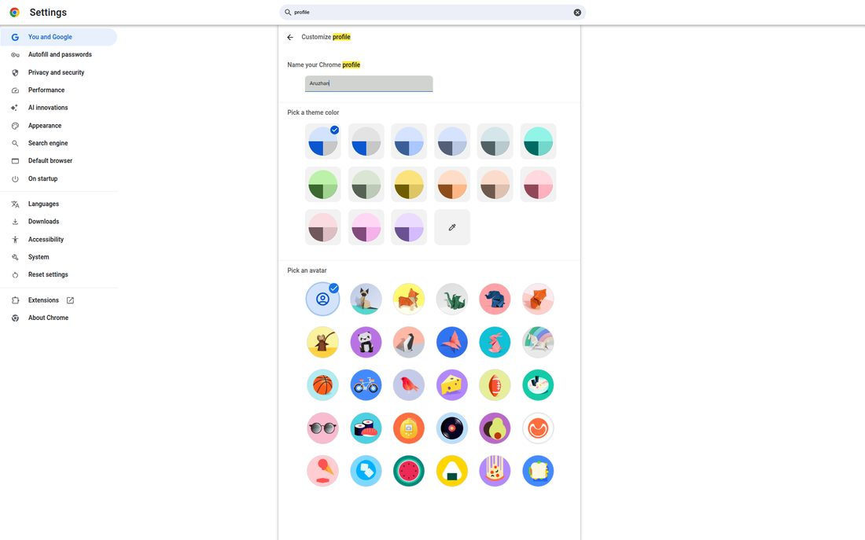
Figure 7. User profile configured as “Aruzhan”
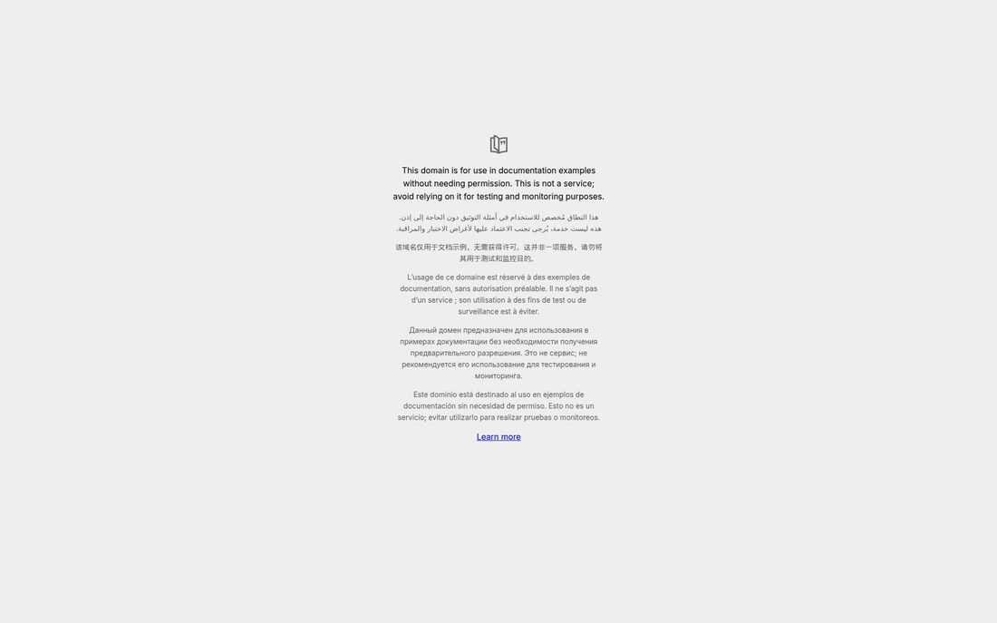
Figure 8. Browser test — multiple websites in tabs

3. Task 2 — Communication Application (Telegram Desktop)

3.1 Purpose and main features
Telegram Desktop is a cross-platform instant messaging application. Main features include:
- Text messaging and group chats
- Voice and video calls
- File, photo, and media sharing
- Channels and bots
- End-to-end encrypted Secret Chats
- Multi-device synchronisation (desktop + mobile)

3.2 Version and compatibility
Telegram Desktop was not pre-installed. It was downloaded from the official site (telegram.org/dl/desktop/linux) as a Linux package and extracted to /workspace/assignment3/Telegram/.
- Application: Telegram Desktop
- Version: 7.4 (shown in Settings → Update automatically)
- Platform: Linux x86_64 (ELF 64-bit executable)
- Binary size: ~258 MB
- Compatibility: Runs natively on the Linux desktop environment used for this assignment

3.3 Configuration performed
- Language → English
- Connection type → Default (HTTP used)
- Update automatically → ON (Version 7.4)
- Install beta versions → OFF
- Default interface scale → 100%
- Theme → Classic
Notification, microphone, and camera permissions are managed after account login (via phone/QR). The login/setup screen and Settings dialog were examined to verify that profile and notification-related options are available. Basic functionality was tested by launching the app, opening Settings, and confirming the interface responds correctly.

3.4 Screenshots — Telegram
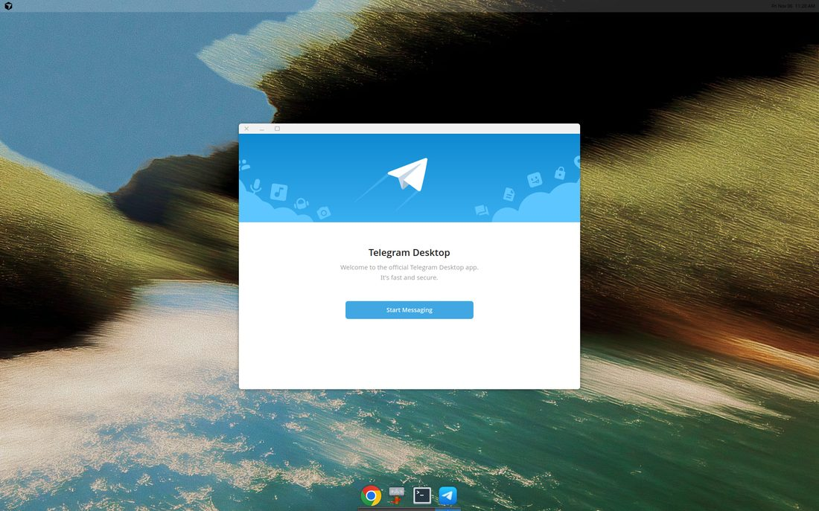
Figure 9. Telegram Desktop welcome screen
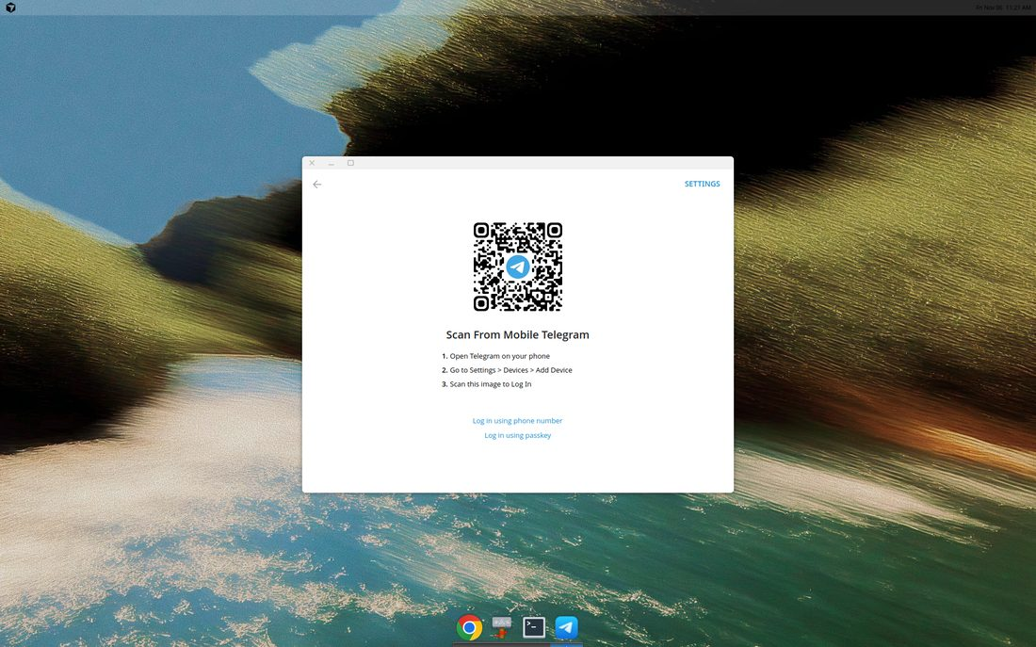
Figure 10. Login / device pairing screen (QR / phone / passkey)
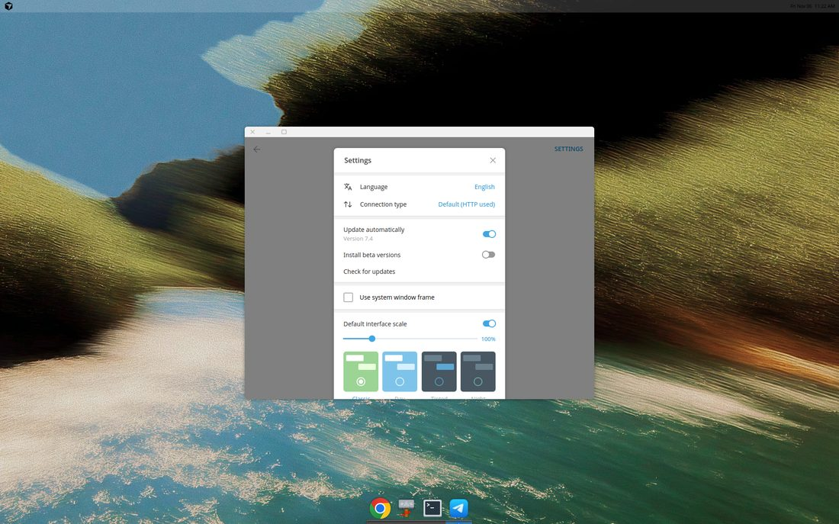
Figure 11. Telegram Settings — language, updates, theme, scale
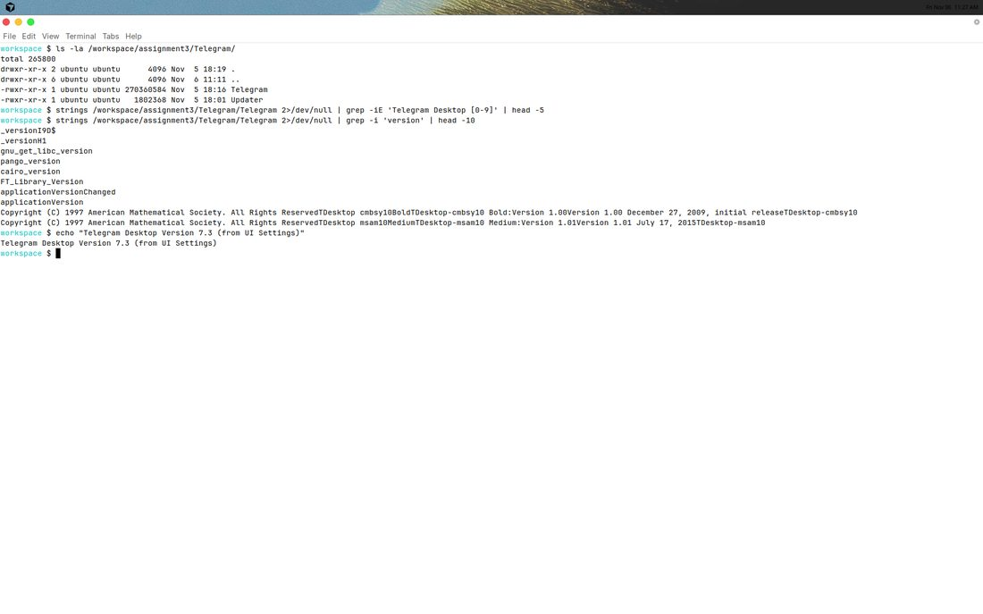
Figure 12. Telegram binary verification in terminal

4. Task 3 — Database Software (SQLite)

4.1 Software and purpose
SQLite is a lightweight, serverless, self-contained relational database engine. It is widely used for local applications, prototyping, mobile apps, and embedded systems. The sqlite3 command-line tool is the database management interface used in this assignment.

4.2 System requirements
- OS: Windows, macOS, Linux (used here: Ubuntu Linux)
- Disk: very small footprint (CLI package)
- RAM: minimal; suitable for student / lab machines
- No separate database server process required

4.3 Main components
- SQLite library (libsqlite3) — database engine
- sqlite3 CLI — interactive shell / management tool
- Database file (*.db) — stores all tables and data in one file

4.4 Installation / verification
SQLite was already available on the system. Verification:
- Command: sqlite3 --version
- Result: 3.45.1 2024-01-30 … (64-bit)

4.5 Creating and accessing a test database
A test database was created at: /workspace/assignment3/db/student_test.db
SQL performed:
CREATE TABLE students (id INTEGER PRIMARY KEY, name TEXT, course TEXT, grade REAL);
CREATE TABLE apps (id INTEGER PRIMARY KEY, app_name TEXT, category TEXT, version TEXT);
INSERT INTO students …; INSERT INTO apps …;
SELECT * FROM students; SELECT * FROM apps;
Query result — students:
- 1 | Aruzhan | IT Applications | 95.0
- 2 | Aigerim | IT Applications | 88.5
- 3 | Dias | Databases | 91.0
Query result — apps:
- 1 | Google Chrome | Web Browser | 156.0.8078.47
- 2 | Telegram Desktop | Communication | 7.4
- 3 | SQLite | Database | 3.45.1
Verification: .tables listed students and apps; SELECT returned rows successfully — database is accessible.

4.6 Screenshots — SQLite
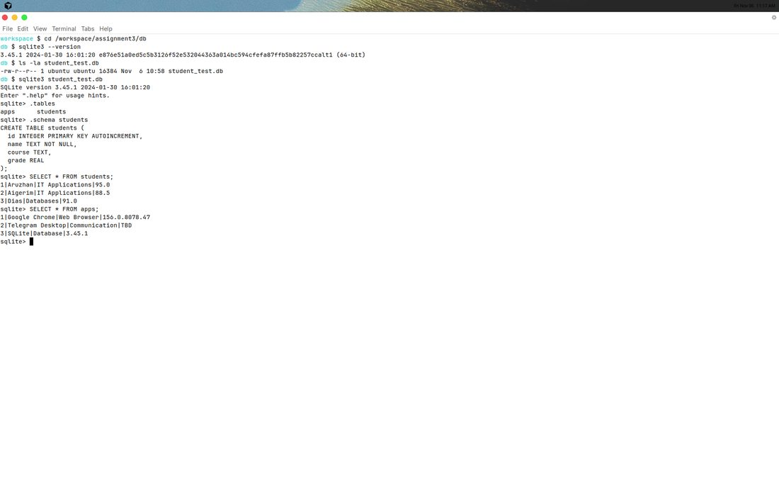
Figure 13. SQLite version, schema, and queries
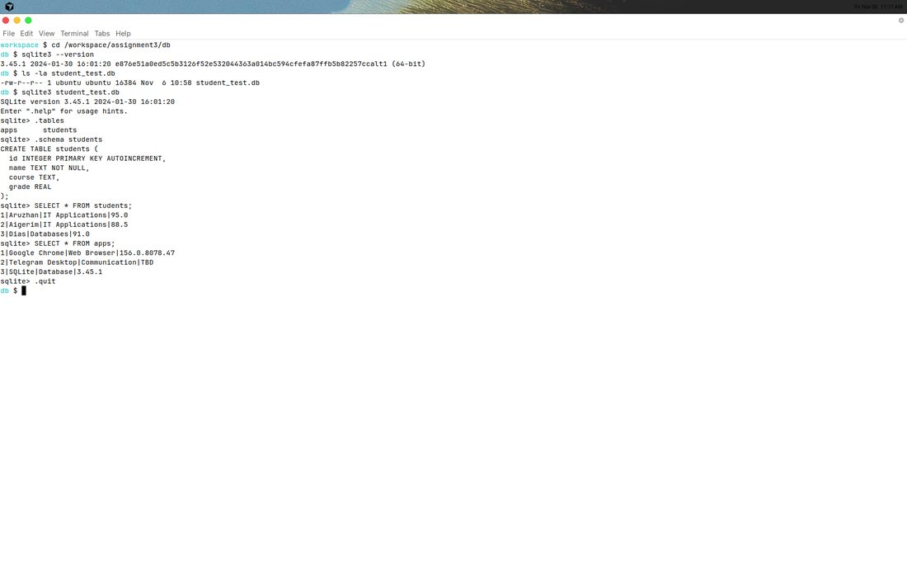
Figure 14. Database access verification (SELECT results)

5. Task 4 — Application Configuration (detailed: Google Chrome)
For Task 4, Google Chrome was chosen for a deeper configuration record.
Setting | Change made | Why it was made
Interface language | Left as English (system default) | Matches course materials and OS language for clarity
User profile | Name set to “Aruzhan” | Identifies the student profile and separates personal settings
Default search engine | Google | Fast, familiar search results for academic work
Downloads | Show downloads when done = ON | Confirms files finished downloading during labs
Startup options | Open the New Tab page | Clean start each session; avoids restoring old tabs
Privacy settings | Reviewed Safety Check / Safe Browsing | Improves security awareness and safe browsing

Additional configuration on Telegram Desktop (supporting Task 4 examples): language English, auto-update enabled, Classic theme, interface scale 100% — chosen for a stable, readable desktop experience during the lab.

6. Conclusion
In this assignment three types of applications were selected, verified or installed, and configured: Google Chrome (web browser), Telegram Desktop (communication), and SQLite (database). Chrome settings were adjusted for search, downloads, startup, privacy, and a named user profile. Telegram Desktop was installed from the official Linux package and configured via its Settings dialog. A SQLite test database was created and queried successfully, confirming that the DBMS tool works on this system. Overall, the practical skills of choosing, installing/verifying, configuring, and testing application software were demonstrated.

7. Deliverables checklist
- Table of selected applications — Section 1
- Description of installation or verification — Sections 2.1, 3.2, 4.4
- List of configured settings — Sections 2.3, 3.3, 5
- Screenshots showing the configuration — Figures 1–14
- Short conclusion — Section 6
How to open this file in Google Docs: go to https://docs.google.com → File → Open → Upload → select this .docx file. After upload you can edit it online and download again (File → Download).

