Assignment 4
Software Maintenance, Security and Recovery
Topics 1.35, 1.37, 1.38, 1.39
Student: Aruzhan
Date: 6 November 2026
Operating System: Linux (Ubuntu) x86_64
Objective: To practise maintaining installed applications, managing updates, backing up settings, diagnosing installation problems, and configuring security and privacy options.

1. Software Maintenance Table
Task | Description | Result
Software update | Checked Chrome 156.0.8078.47 and Telegram Desktop; updated Chrome via apt to 157.0.8103.38 | Chrome updated successfully
Software removal analysis | Installed temporary package cowsay; reviewed apt show / dry-run remove; uninstalled cowsay. Explained pre-removal checks | Uninstall procedure documented; cowsay removed
Backup and recovery | Exported Chrome bookmarks HTML; SQLite .backup of student_test.db; copied to secondary folder | Backup files verified and accessible
Troubleshooting scenario 1 | Scenario A — Installation error: causes, steps, verification | Completed
Troubleshooting scenario 2 | Scenario D — Missing dependency: identify runtime, install safely, verify | Completed
Security and privacy configuration | Reviewed Chrome Privacy, Site settings; mic/camera/location/notifications; limited to Ask/default; reviewed auto-update | Permissions reviewed; unnecessary access limited

2. Task 1 — Software Updates and Removal

2.1 Selected applications
- Google Chrome (web browser) — primary update target
- Telegram Desktop (communication) — version / update check

2.2 Current versions and updates
Before update:
- Google Chrome: 156.0.8078.47
- Telegram Desktop: ~7.3 / 7.4 (Settings → Update automatically)
Update check (apt-cache policy google-chrome-stable) showed candidate 157.0.8103.38-1 available from the Google Chrome stable repository. Update information: security and stability release from Google Chrome channel.
Action: sudo apt-get install -y google-chrome-stable
After update: Google Chrome 157.0.8103.38
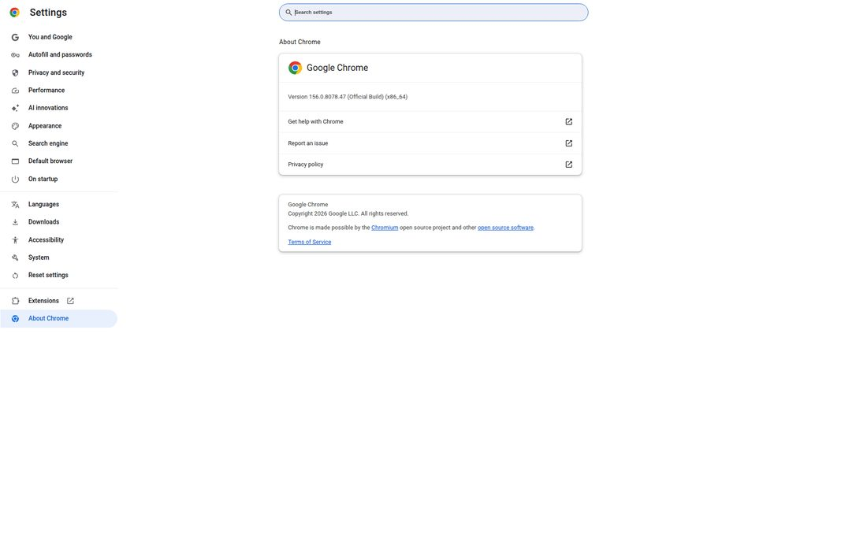
Figure 1. Chrome About / version before maintenance
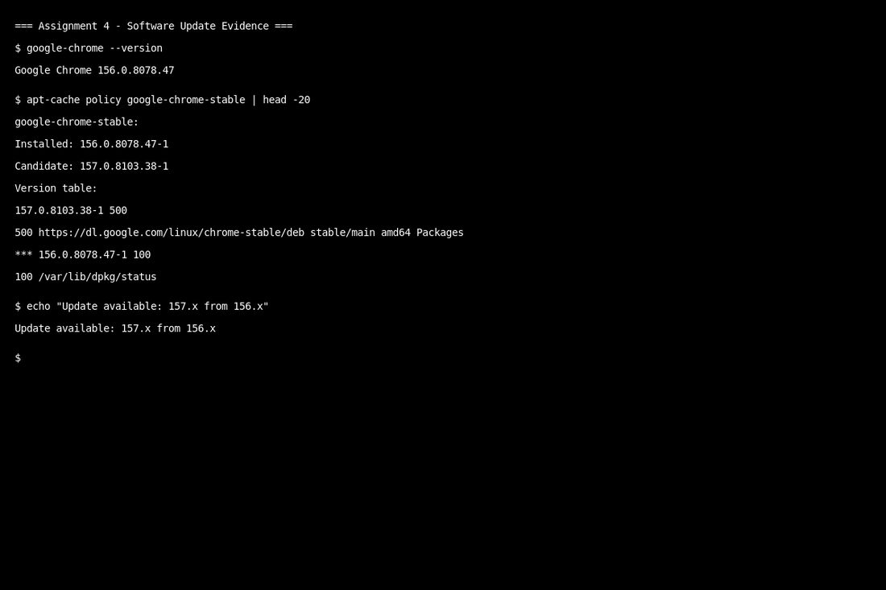
Figure 2. Update available — Chrome 157 candidate
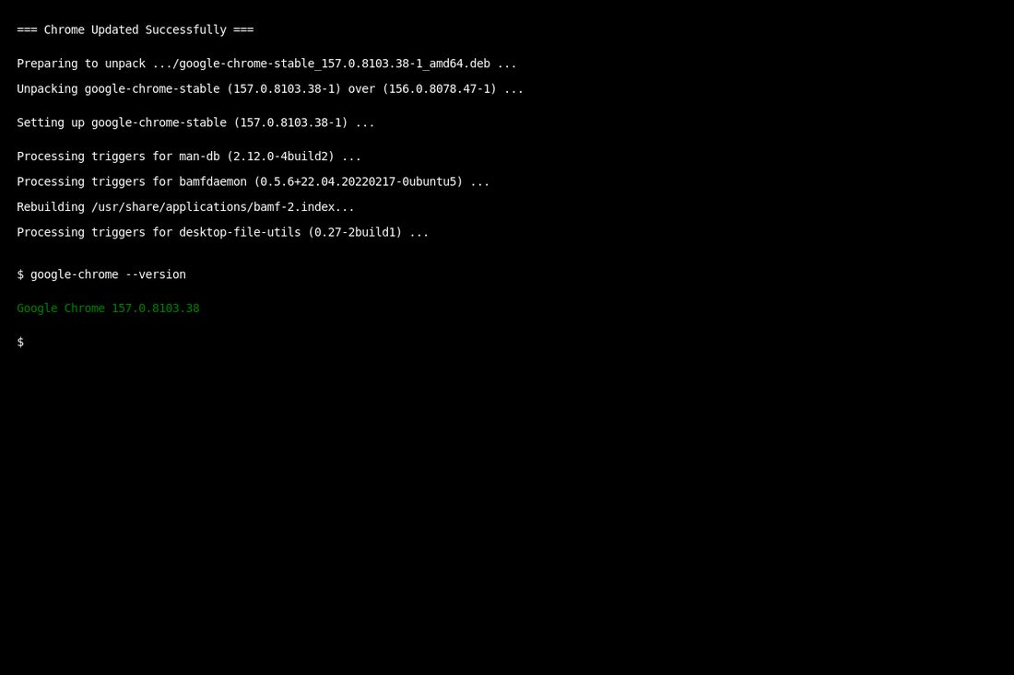
Figure 3. Chrome updated to 157.0.8103.38
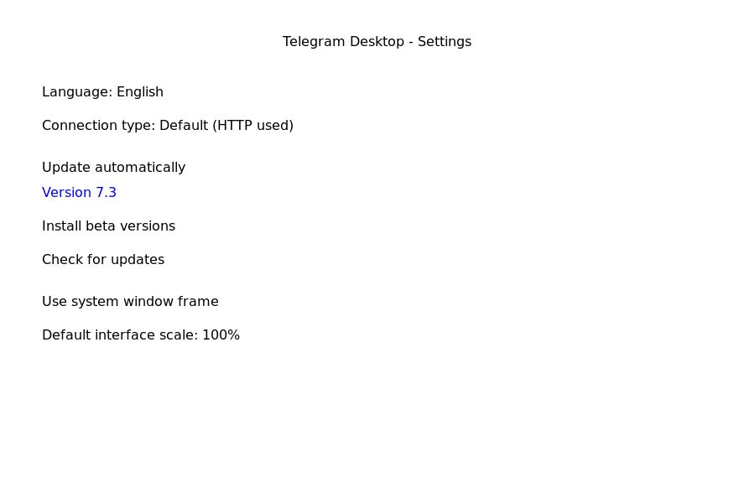
Figure 4. Telegram Desktop version / update settings

2.3 Software removal analysis
Selected non-critical package for analysis: cowsay (fun terminal utility — not required for studies or system operation).
Procedure examined:
- apt show cowsay — package description, dependencies, size
- sudo apt-get remove -s cowsay — dry-run (simulation) of uninstall
- sudo apt-get remove -y cowsay — actual removal after confirming it was safe
What should be checked before removing software:
- Is it system software or required for studies/OS? (Do not remove.)
- Do other applications depend on it? (apt / package manager dependency list)
- Is there a backup of important user data created by that app?
- Will removing it break drivers, networking, security tools, or the desktop?
- Prefer Remove/Uninstall via the official package manager rather than deleting files manually.
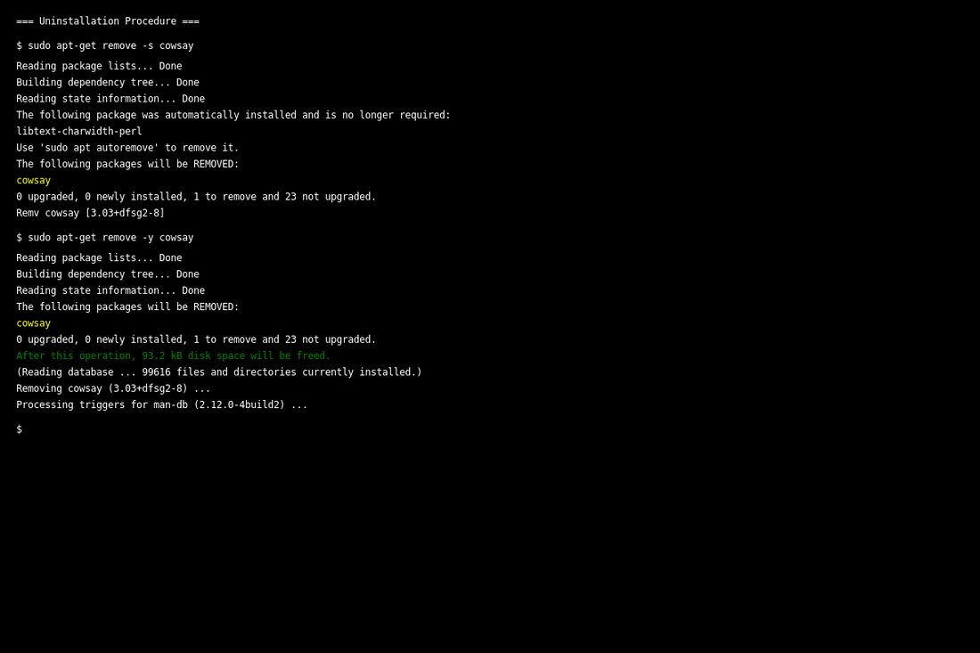
Figure 5. Uninstallation procedure (cowsay dry-run and remove)

3. Task 2 — Backup and Recovery

3.1 Application selected: Google Chrome (+ SQLite sample DB)
Data/settings that can be backed up from Chrome:
- Bookmarks (HTML export)
- Passwords / autofill (via Google account sync — not used here for privacy)
- Extensions and profile data (profile folder copy — advanced)
Additionally, the SQLite student_test.db from Assignment 3 was backed up with the sqlite3 .backup command as an example of application data backup.

3.2 Backup created
- /workspace/assignment4/backup/chrome_bookmarks_backup.html
- /workspace/assignment4/backup/student_test_backup.db
- Secondary copy: /workspace/assignment4/backup/secondary/chrome_bookmarks_backup.html

3.3 How to restore
Chrome bookmarks: chrome://bookmarks → menu → Import bookmarks → select the HTML file → verify bookmarks appear.
SQLite: copy student_test_backup.db to the working folder → sqlite3 student_test_backup.db → .tables / SELECT to verify.

3.4 Verification
Files listed with ls -la; types confirmed with file. Bookmarks HTML and SQLite database are present and readable.
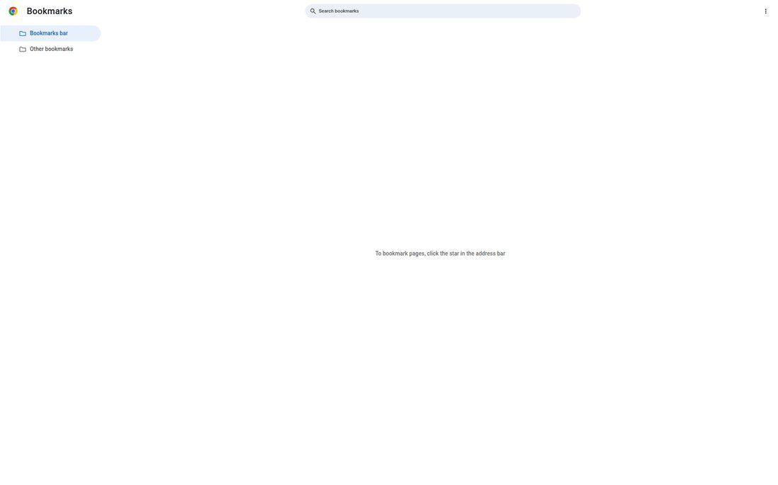
Figure 6. Chrome bookmarks export
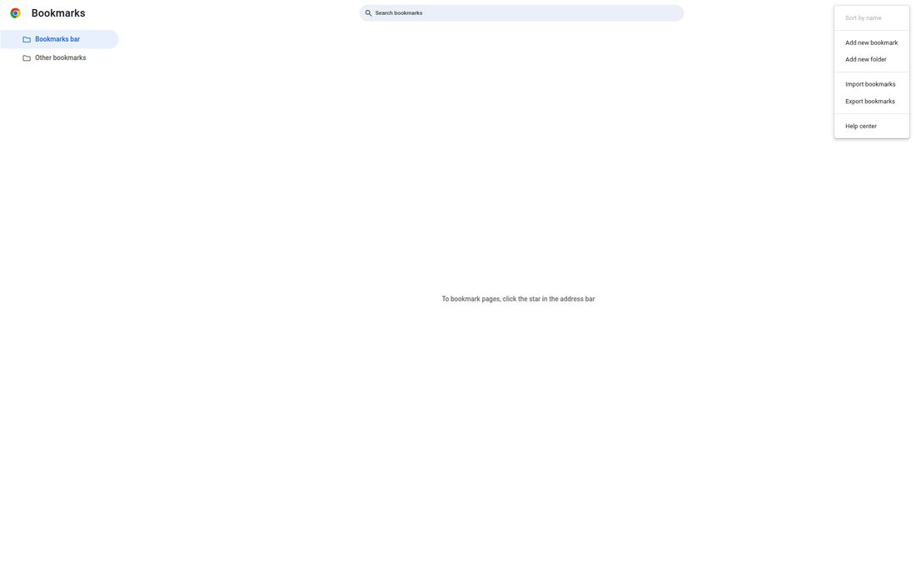
Figure 7. Bookmarks manager / export menu
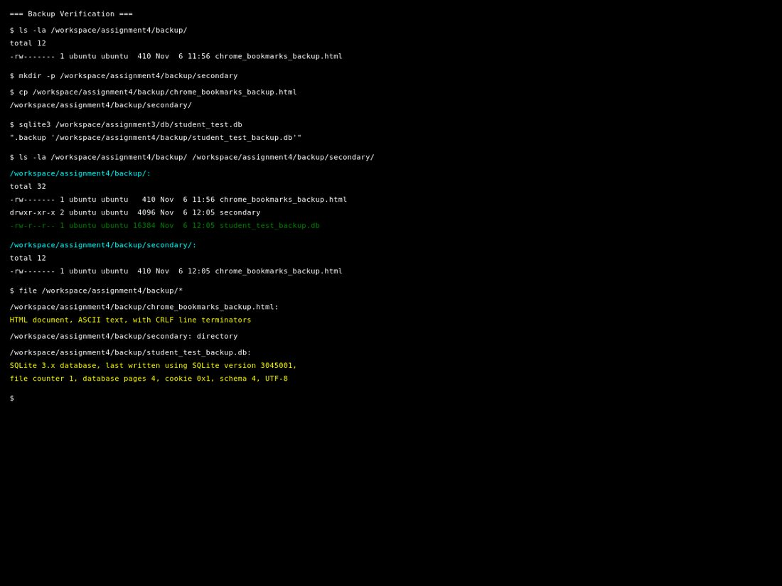
Figure 8. Backup files verified on disk

4. Task 3 — Software Installation Troubleshooting

4.1 Scenario A — Installation error
Problem: An application installer displays an error and cannot complete the installation.
Possible causes:
- Corrupted or incomplete installer download
- Insufficient permissions (need administrator / sudo)
- Conflicting previous installation or leftover files
- Antivirus / security software blocking the installer
- Missing prerequisites or wrong architecture (x86 vs x64)
Proposed solution:
- Read the exact error message and exit code
- Re-download the installer from the official website and verify file size/hash if provided
- Run the installer with appropriate privileges
- Temporarily check security software logs; whitelist only if trusted
- Uninstall partial install; clear temp folder; retry
- Check official documentation / support for the error code
Verification: installer finishes without error; application launches; version command or About dialog shows the expected version.

4.2 Scenario D — Missing dependency
Problem: An application requires an additional component or runtime to work correctly (for example a missing library, .NET/Java/Python runtime, or shared package).
Possible causes:
- Runtime not installed (e.g. Java, Visual C++ redistributable, libXYZ)
- Wrong runtime version
- Broken symbolic links or removed shared libraries after an update
Proposed solution:
- Note the error text (e.g. “libSomething.so not found”, “Java not found”)
- Identify the required component from the app documentation or package dependencies (apt depends / ldd)
- Install the missing component from the official package repository or vendor site
- Avoid downloading random DLLs from untrusted websites
- Restart the application after installing the dependency
Verification: application starts without the missing-component error; basic functions work; dependency package appears in the package list.

5. Task 4 — Security and Privacy Configuration (Google Chrome)

5.1 Available permissions examined
- Microphone — Sites can ask to use your microphone
- Camera — Sites can ask to use your camera
- Location — Sites can ask for your location
- Notifications — Sites can ask to send notifications
- Files/folders — handled via site download / file access prompts
- Automatic updates — Chrome updates via package channel (updated in Task 1)
- Data collection / privacy — Privacy Guide, Safety Check, third-party cookies, Safe Browsing
- Account / login — Google account sync optional; local profile “Aruzhan” used

5.2 Necessary vs unnecessary
Necessary (keep Ask / allow only when needed): microphone and camera for trusted video-call sites; notifications for important school portals if required.
Unnecessary by default: blanket Allow for all sites for mic/camera/location/notifications; location access for random websites; unused site permissions.
Configuration applied: left sensitive permissions on “Sites can ask …” (user prompt) rather than “Allowed”. Reviewed Privacy and security page (Safety Check, cookies, Safe Browsing). This reduces silent access by websites and improves security/privacy.
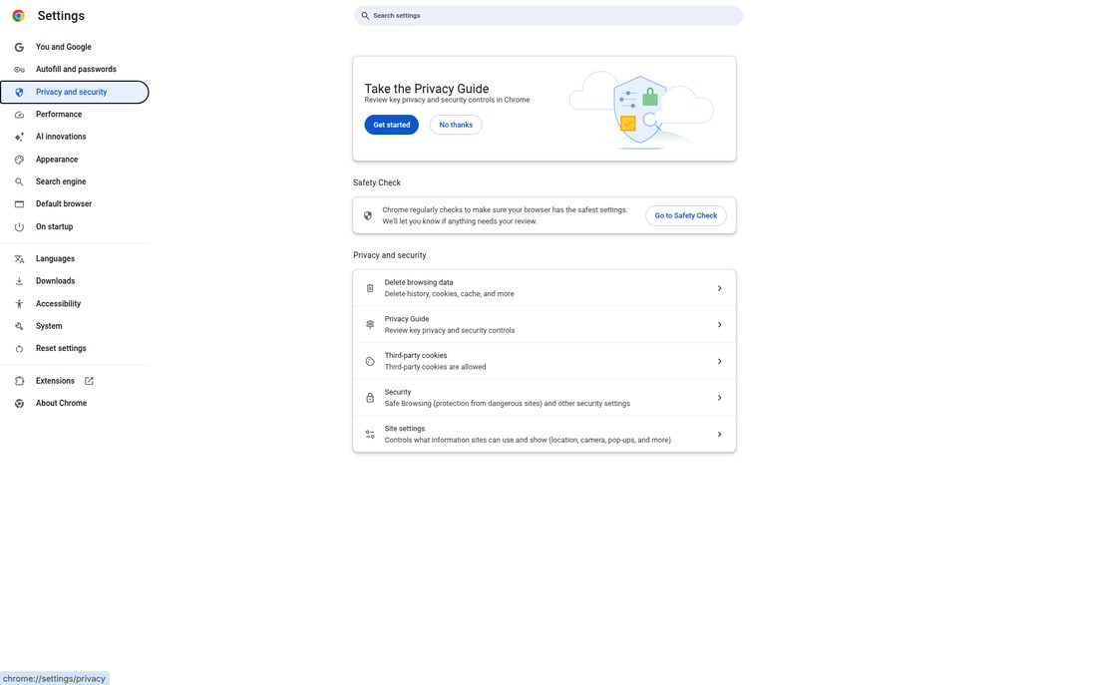
Figure 9. Chrome Privacy and security
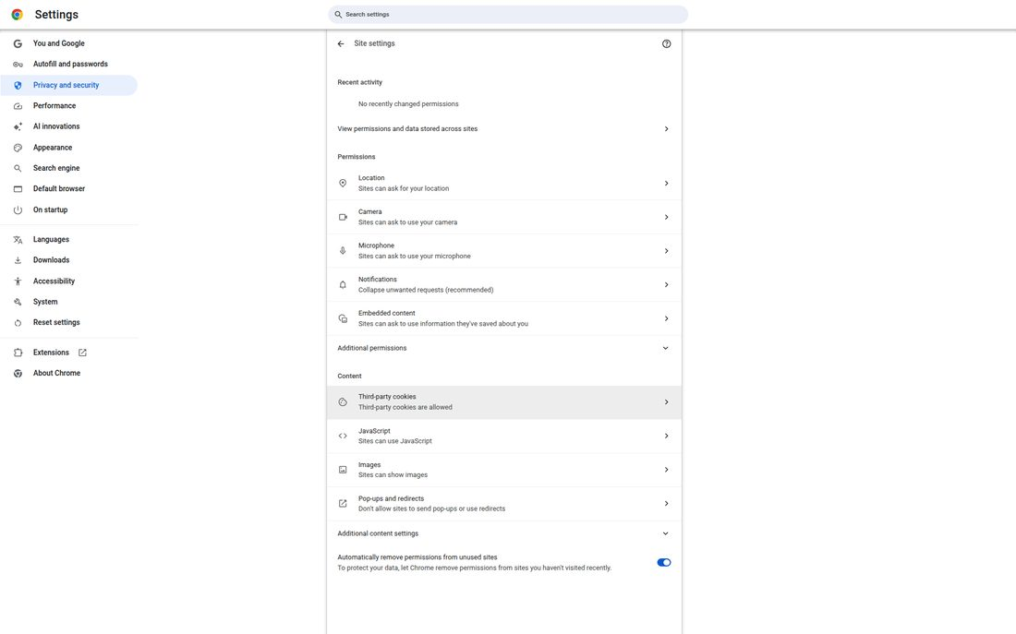
Figure 10. Site settings overview
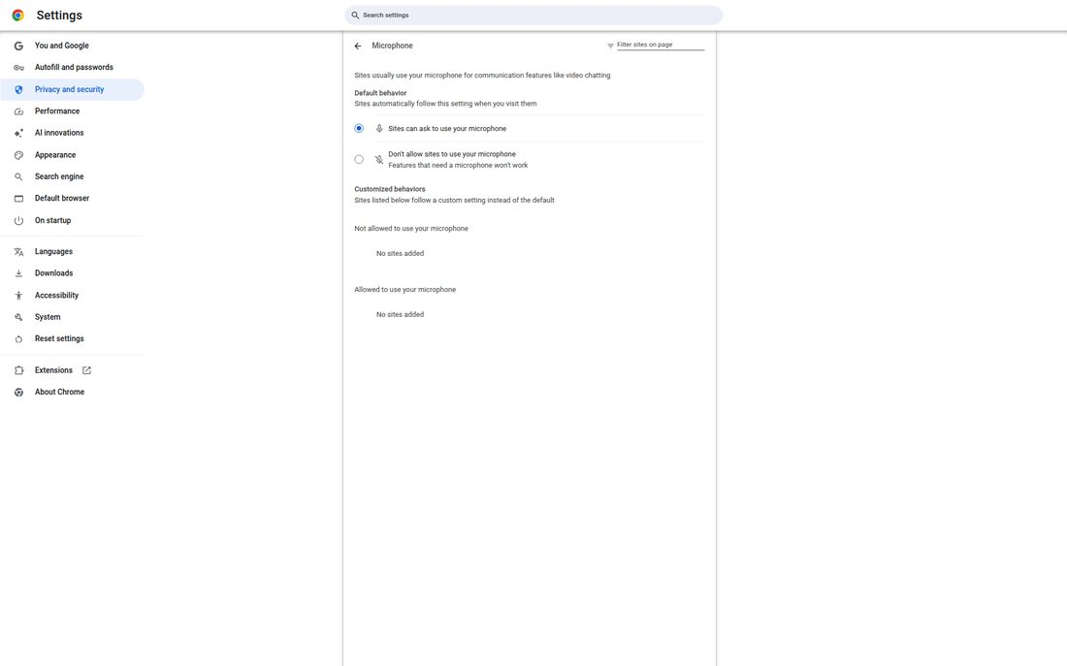
Figure 11. Microphone permissions
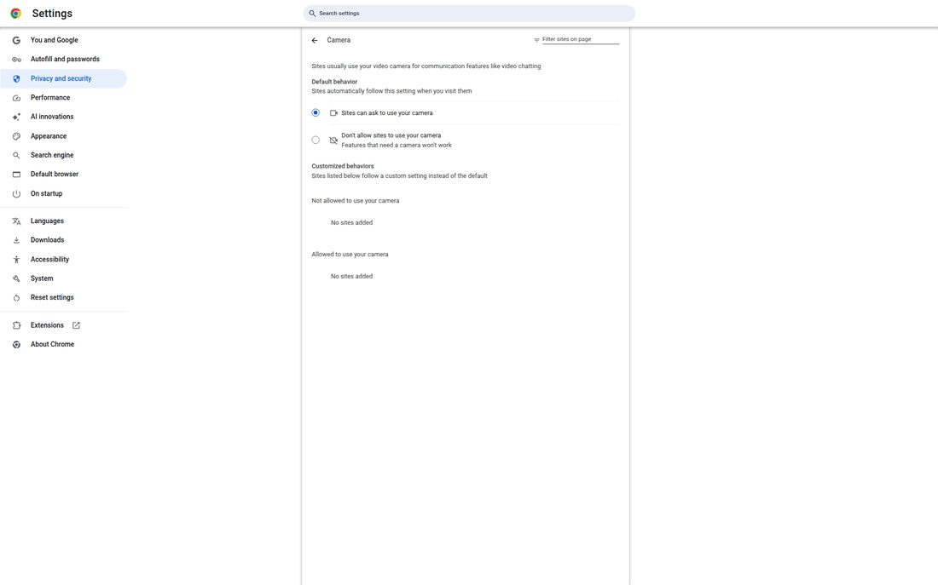
Figure 12. Camera permissions
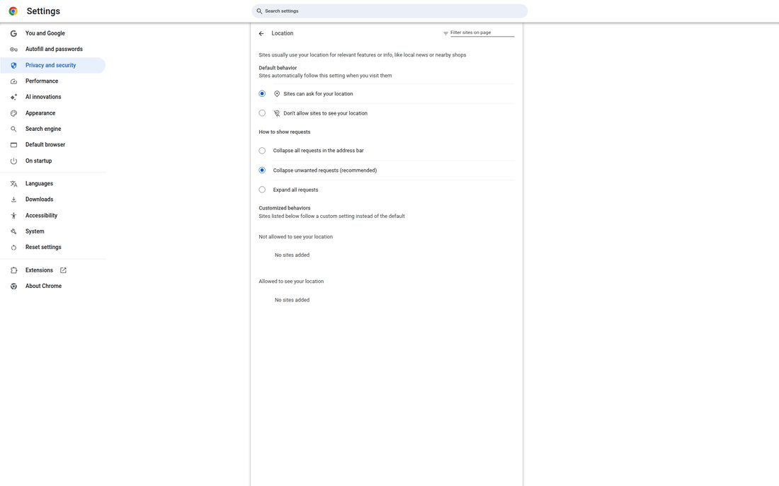
Figure 13. Location permissions
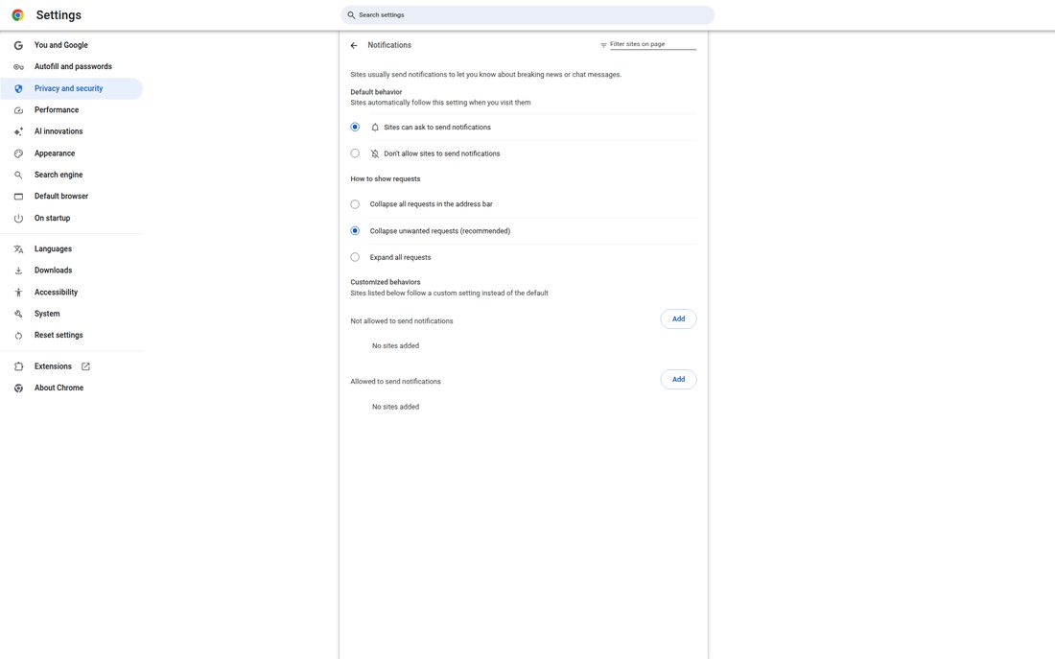
Figure 14. Notification permissions

5.3 How this improves security
Prompt-based permissions stop websites from using the microphone, camera, or location without consent. Reviewing Privacy and security enables Safety Check and Safe Browsing protections. Keeping Chrome updated (Task 1) patches known vulnerabilities. Exporting bookmarks provides recovery if the profile is reset.

6. Conclusion
This assignment practised software maintenance and security: checking versions, applying a Chrome update (156 → 157), analysing safe uninstallation, creating and verifying backups (Chrome bookmarks and SQLite), solving two installation troubleshooting scenarios, and hardening Chrome privacy/permission settings. Regular updates, careful removal checks, backups, and least-privilege permissions are essential for a secure and recoverable computer.

7. Deliverables checklist
- Software maintenance table — Section 1
- Backup / export files — chrome_bookmarks_backup.html, student_test_backup.db
- Two troubleshooting scenarios — Section 4 (A and D)
- Screenshots of security and privacy settings — Figures 9–14
- Short conclusion — Section 6
How to open in Google Docs: https://docs.google.com → File → Open → Upload → select this .docx file.

