PRACTICAL WORK №7–10
Data Sorting, Filtering, SQL Queries and Joining Tables
University Database · Topics 7–10
Student: Aruzhan

1. Purpose
The purpose of this practical work is to develop skills in sorting, filtering and searching large datasets in Excel, writing SQL queries, using aggregate functions, and joining related tables to retrieve combined information from a university database.
2. Database structure
The University_Database.xlsx / SQLite database contains six related tables: Groups, Teachers, Subjects, Students, Exams and Grades. Students.group_id → Groups.group_id; Subjects.teacher_id → Teachers.teacher_id; Exams.subject_id → Subjects.subject_id; Grades.student_id → Students.student_id; Grades.exam_id → Exams.exam_id.
Dataset size: 15 students, 4 groups, 5 teachers, 6 subjects, 6 exams, 30 grade records.
3. Part 1 — Sorting, filtering and searching (Topic №7)
The Students sheet was opened in Excel. Sorting, AutoFilter and Find were applied as required.
3.1 Sort alphabetically by last name
Data → Sort → Column: last_name → Order: A to Z. Result: Abayeva … Rakhimov.
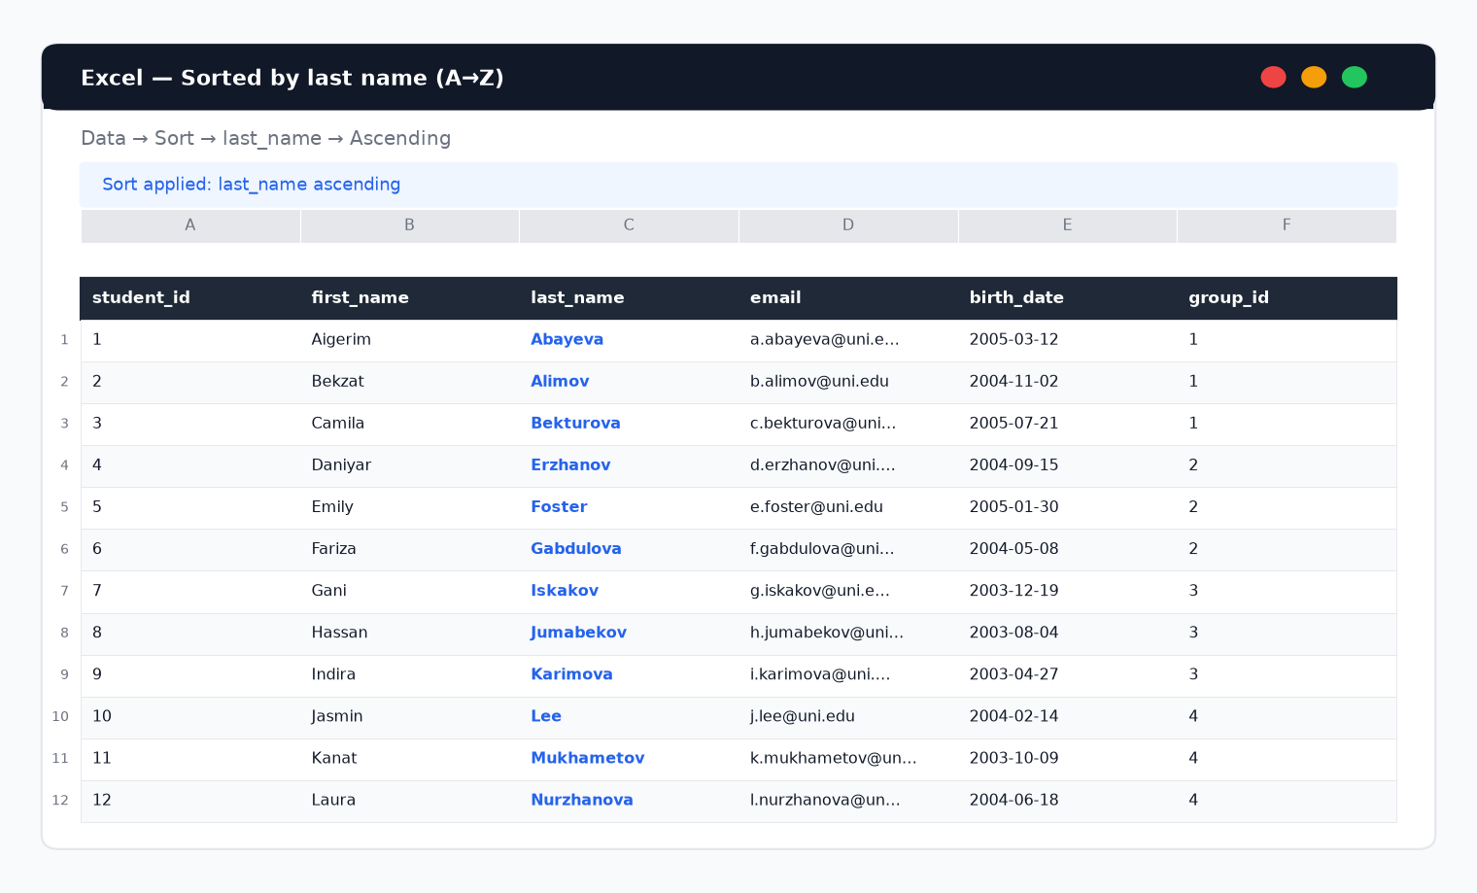
Figure 1. Students sorted by last_name ascending.
3.2 Sort by group
Data → Sort → Column: group_id (then last_name). Groups appear in order 1–4.
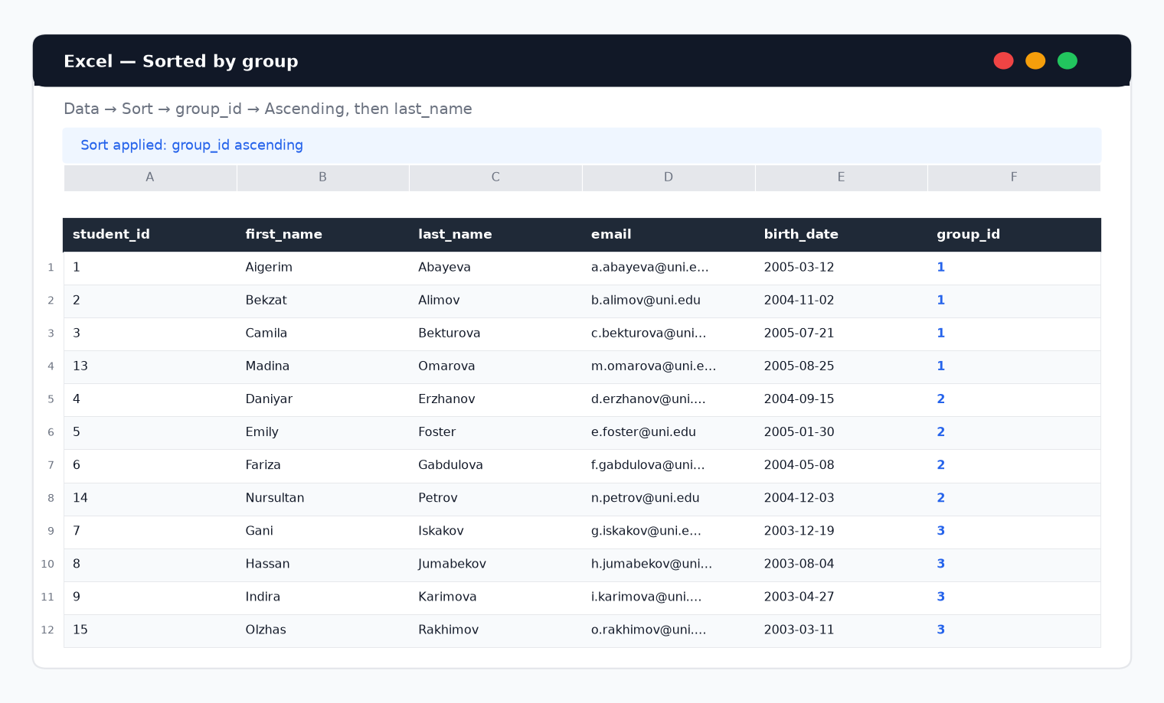
Figure 2. Students sorted by group_id.
3.3 Filter one selected group
AutoFilter on group_id = 1 (CS-101). Four students remain visible.
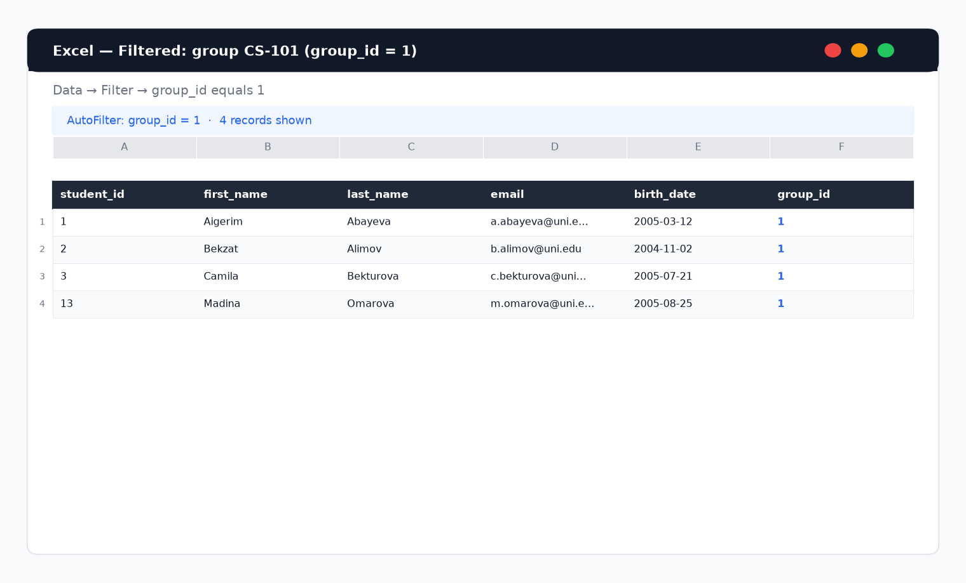
Figure 3. Filtered view for group CS-101.
3.4 Search by ID or last name
Find: student_id = 9 / last_name = Karimova → Indira Karimova, group SE-201.
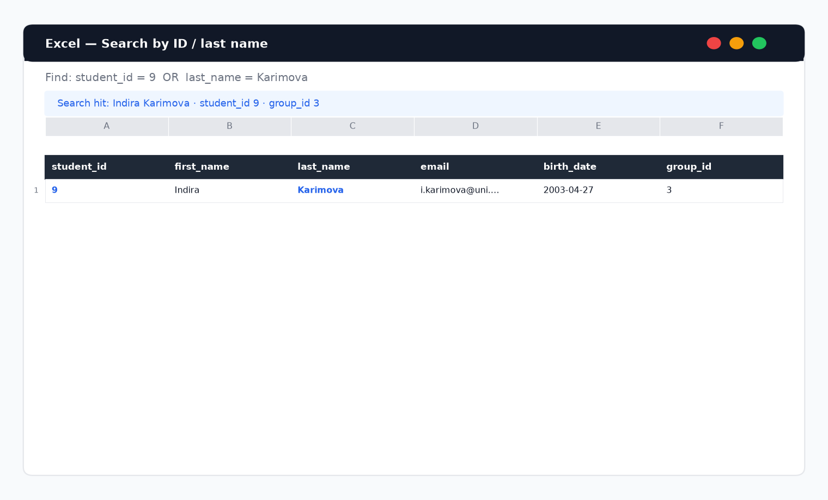
Figure 4. Search result for Karimova.
3.5 Filter with two conditions
Advanced filter: group_id = 3 AND last_name ≥ 'I' → Iskakov, Karimova.
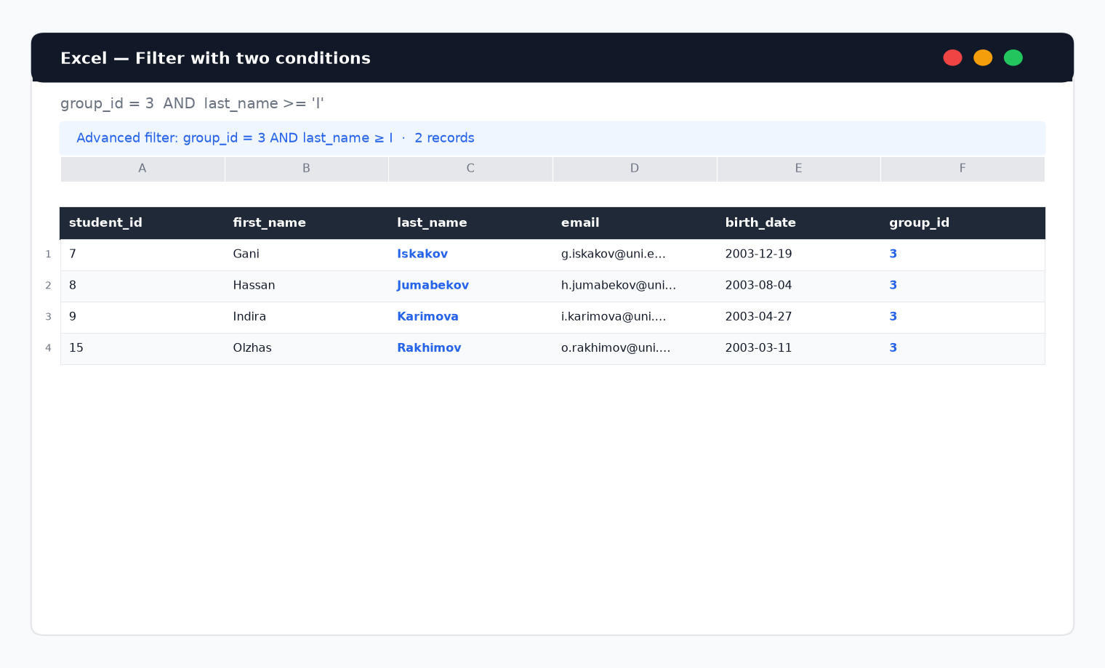
Figure 5. Two-condition filter result.
Report — Part 1
Sorting rearranges all rows by a chosen key without removing data. Filtering hides rows that do not match criteria, so only a subset is visible. Searching locates a specific value (for example student_id or last_name) inside the sheet. Combined filters (group + name range) narrow the dataset further for analysis. Excel AutoFilter and Sort are suitable for interactive exploration of the Students table before moving to SQL.
4. Part 2 — Introduction to SQL (Topic №8)
Tables were created in SQLite with foreign keys. Basic SELECT queries were executed.
Part 2 — All Students
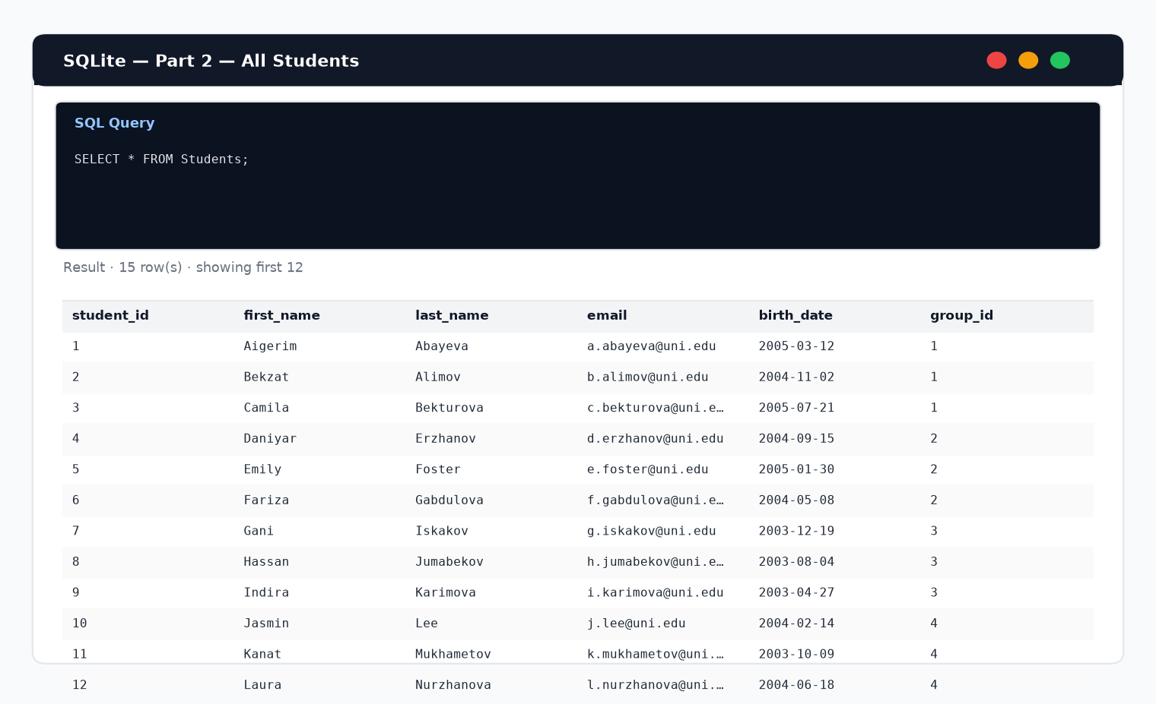
Figure 6. SELECT * FROM Students;
Part 2 — Student IDs and Names
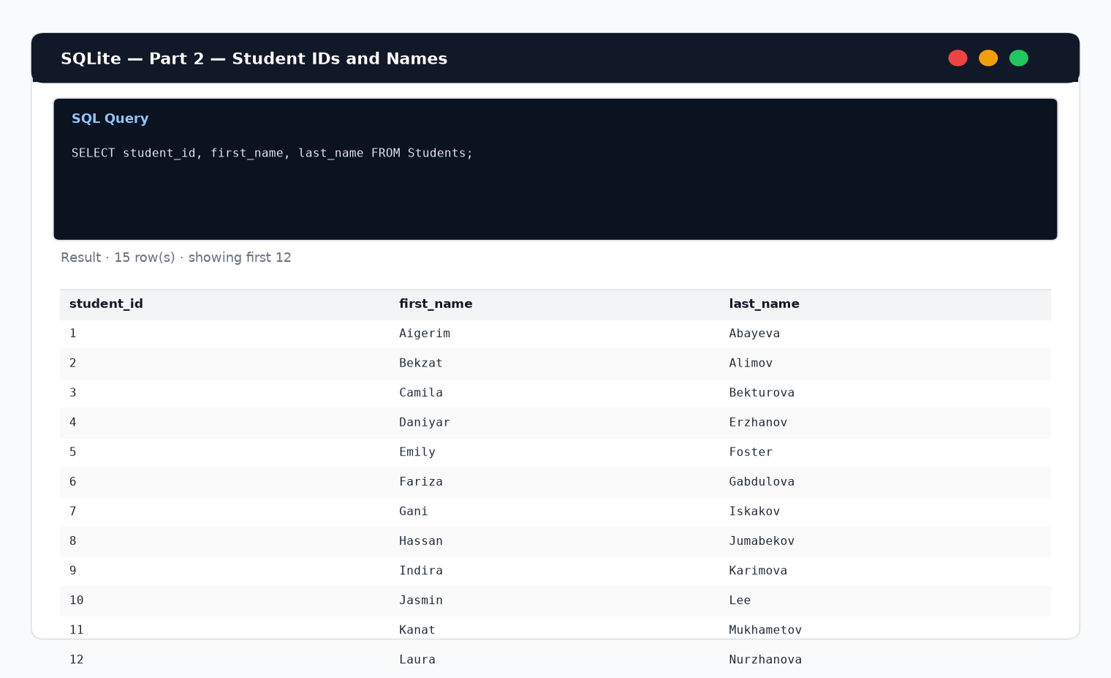
Figure 7. Projection: student_id, first_name, last_name.
Part 2 — All Groups
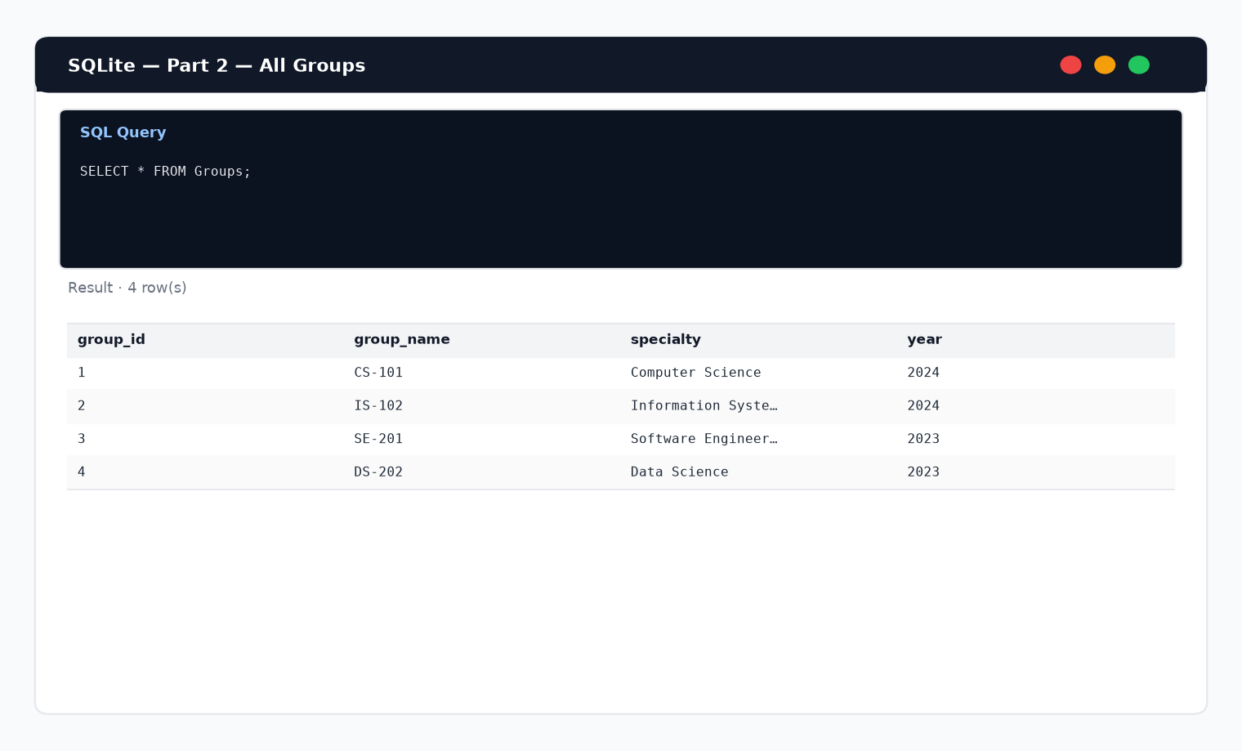
Figure 8. SELECT * FROM Groups;
Part 2 — Subject Names
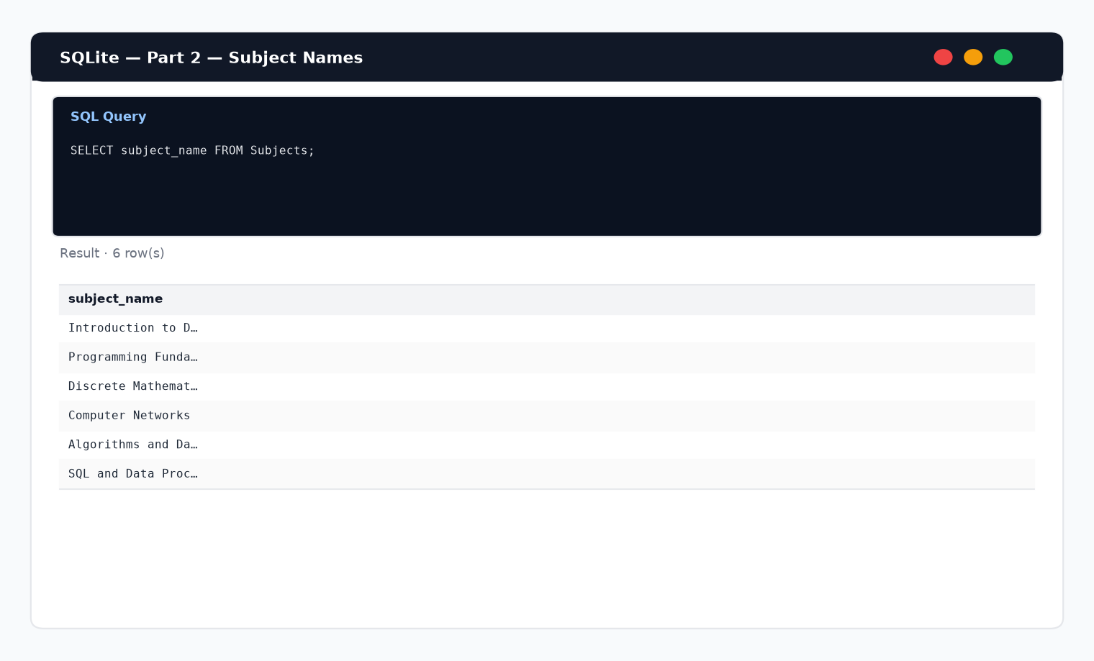
Figure 9. Subject names from Subjects.
Report — Part 2
SQL (Structured Query Language) is used to define, query and manage relational data. SELECT * returns every column; listing specific columns (projection) returns only the fields needed. Creating tables with PRIMARY KEY and FOREIGN KEY enforces relationships and integrity before more advanced filtering and aggregation.
5. Part 3 — SQL queries and aggregate functions (Topic №9)
5.1 WHERE — students of group 1
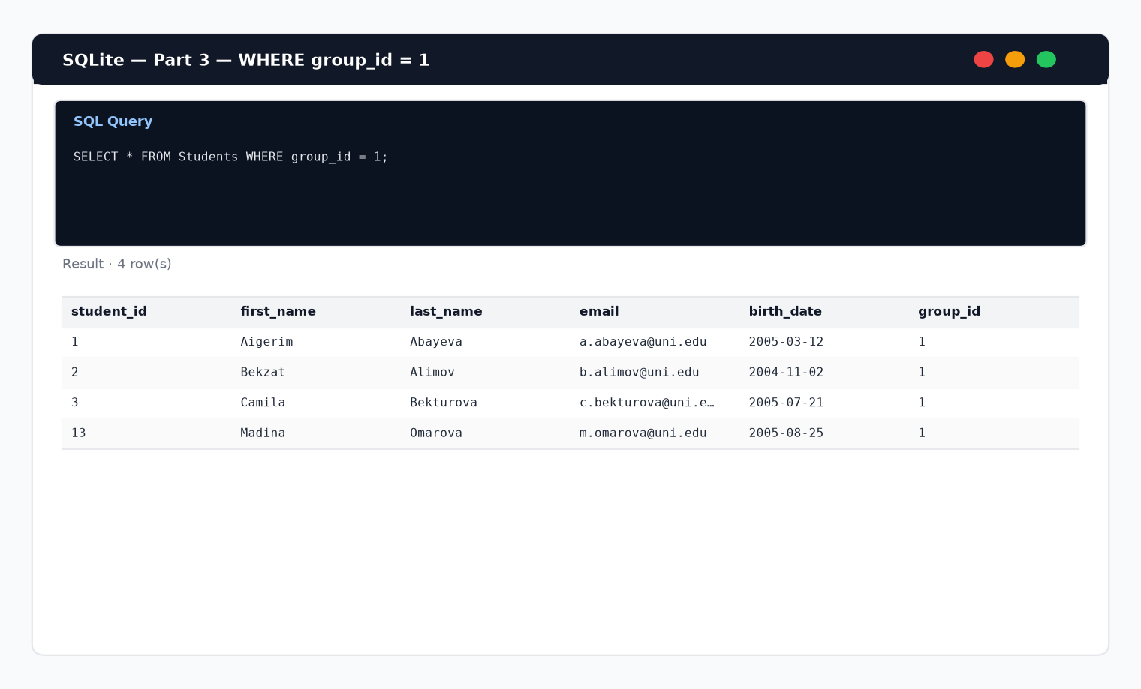
Figure 10. WHERE group_id = 1.
5.2 ORDER BY — alphabetical last names
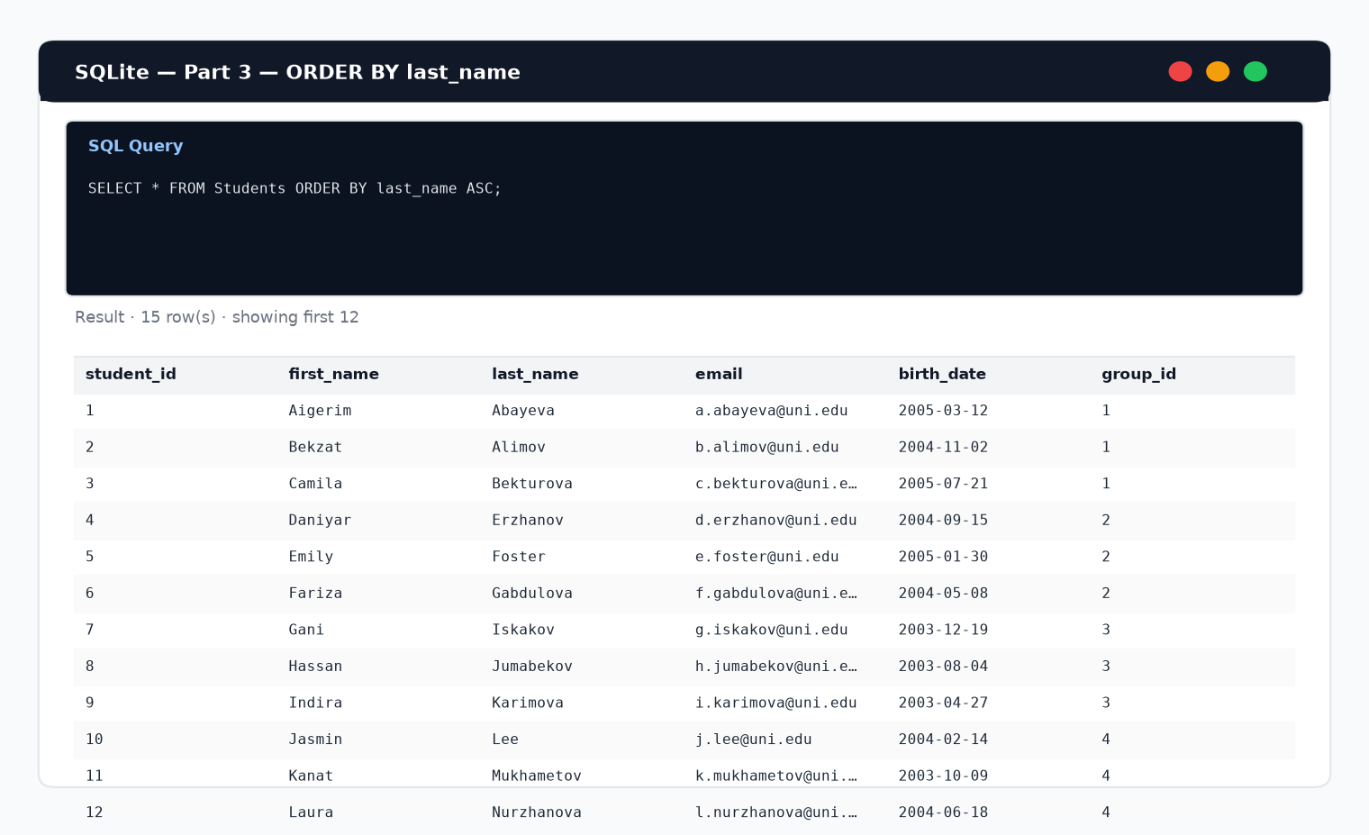
Figure 11. ORDER BY last_name ASC.
5.3 COUNT — total students
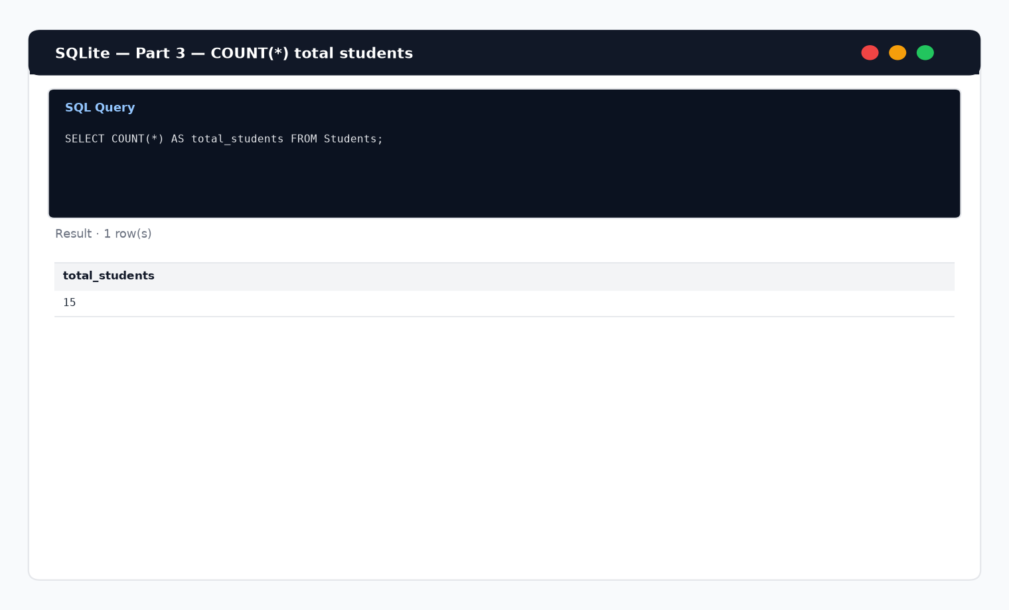
Figure 12. Total students = 15.
5.4 GROUP BY — students per group
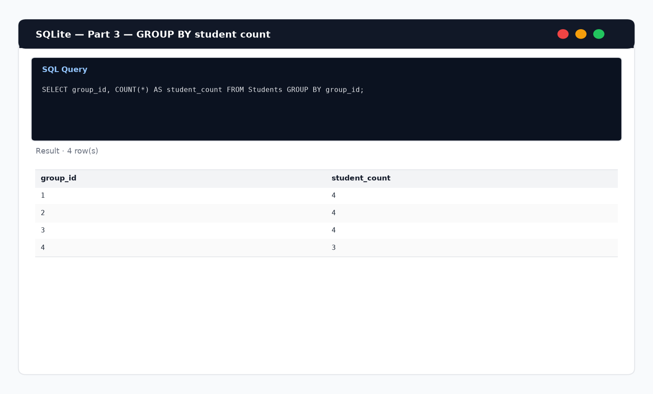
Figure 13. Student count by group_id.
5.5 MAX / MIN / AVG grades
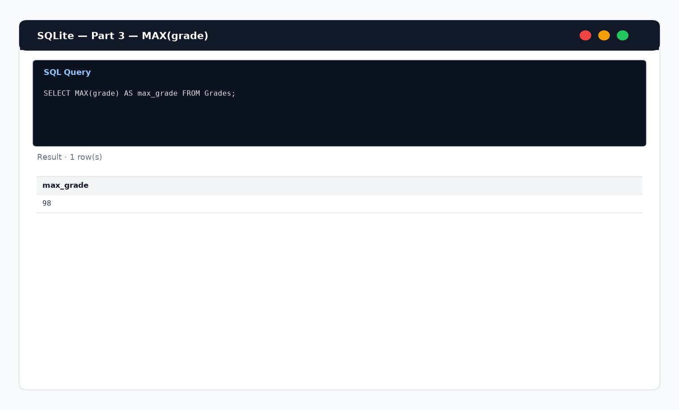
Figure 14. MAX(grade) = 98.
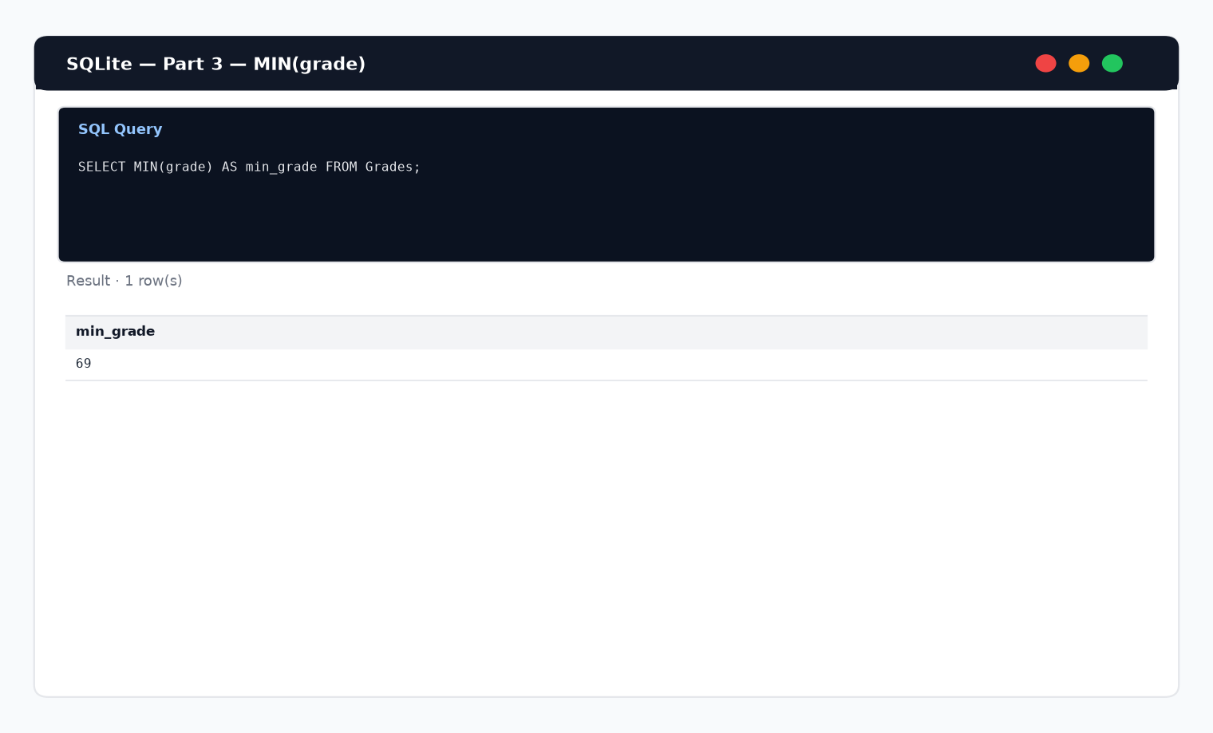
Figure 15. MIN(grade) = 69.
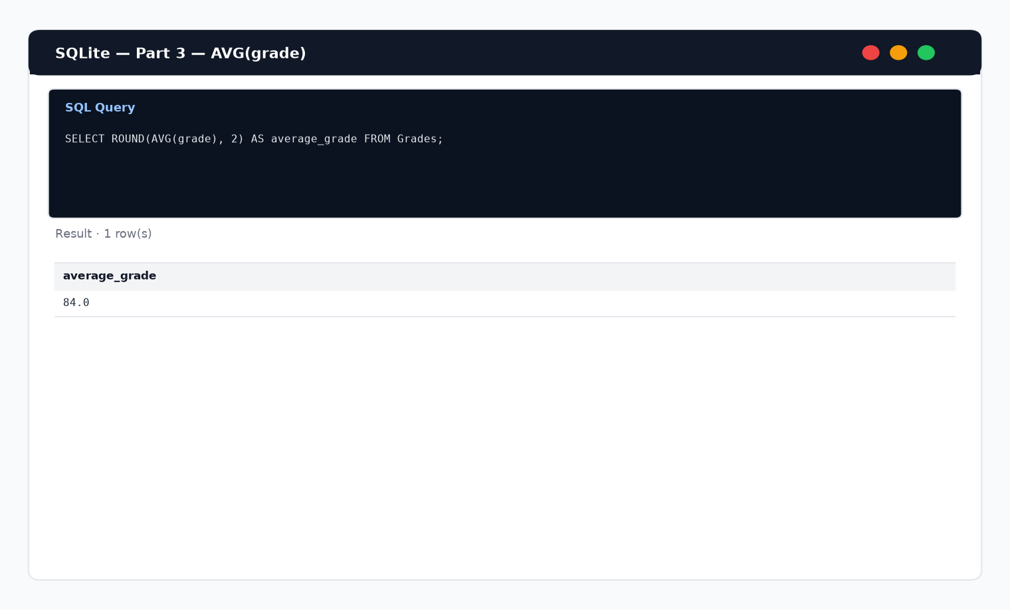
Figure 16. AVG(grade) = 84.0.
Report — Part 3
WHERE filters rows before they are returned. ORDER BY only changes the presentation order. COUNT, MAX, MIN and AVG summarize many values into a single metric. GROUP BY splits rows into buckets (here by group_id) so aggregates can be computed per group. In this database there are 15 students; grades range from 69 to 98 with an average of 84.0.
6. Part 4 — Joining tables using JOIN (Topic №10)
Related tables were joined on foreign-key columns. INNER JOIN returns only matching rows; LEFT JOIN keeps all rows from the left table.
6.1 Students ⋈ Groups
Connecting column: Students.group_id = Groups.group_id.
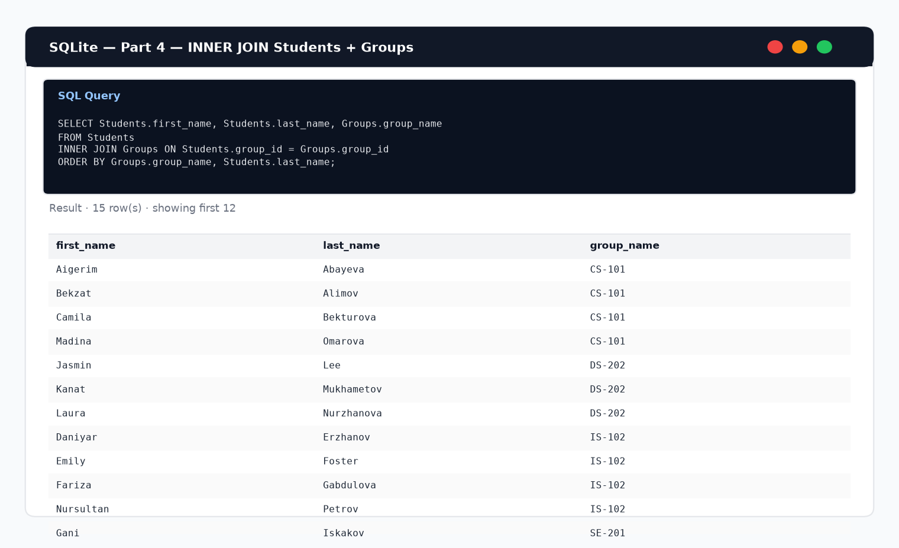
Figure 17. Student names with group_name.
6.2 Students ⋈ Grades
Connecting column: Students.student_id = Grades.student_id.
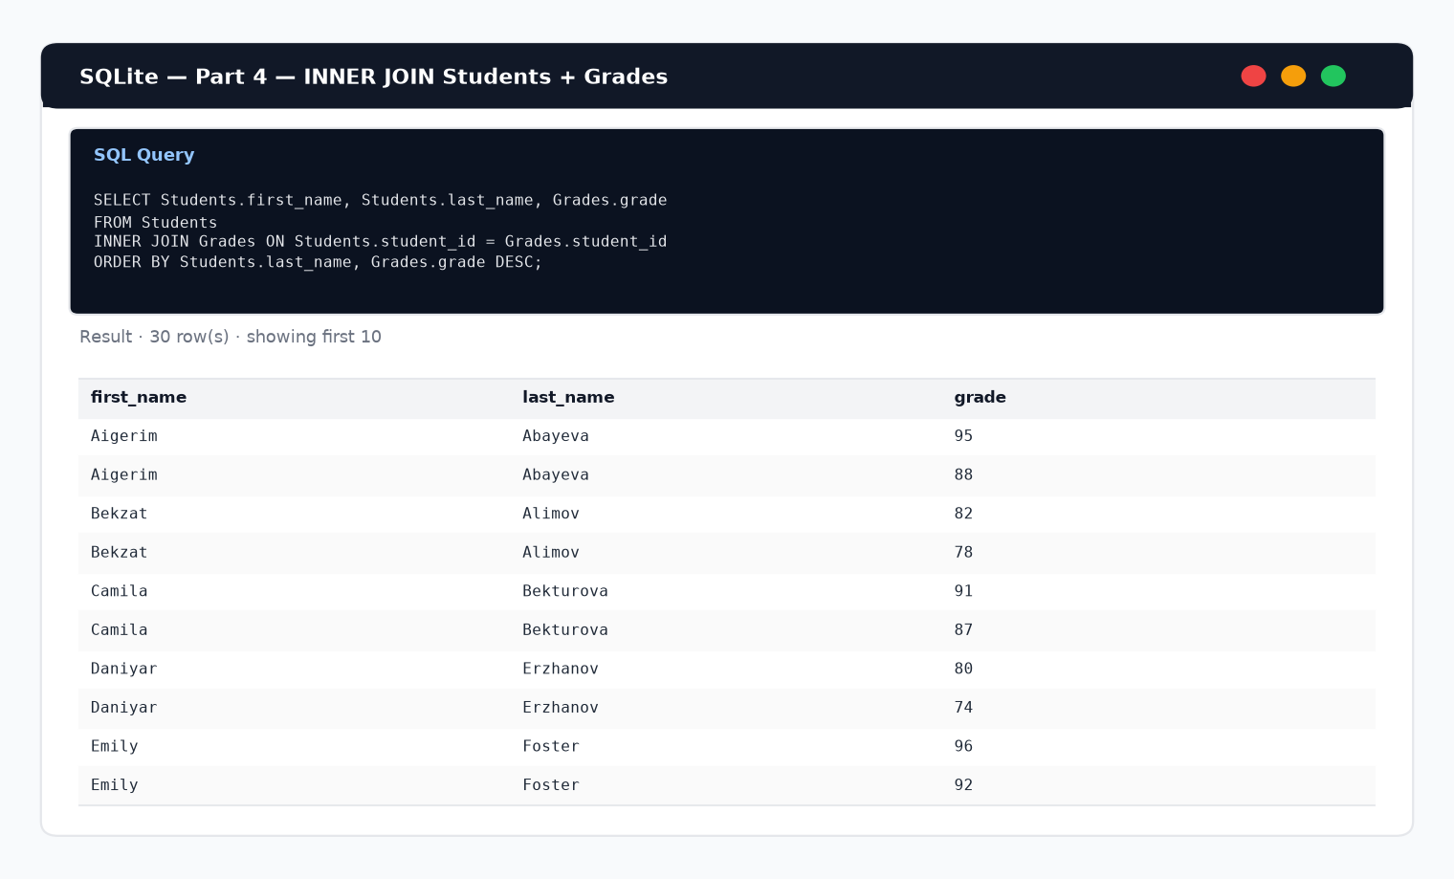
Figure 18. Students and their grades.
6.3 Students ⋈ Grades ⋈ Exams ⋈ Subjects
Connecting columns: Students.student_id = Grades.student_id; Grades.exam_id = Exams.exam_id; Exams.subject_id = Subjects.subject_id.
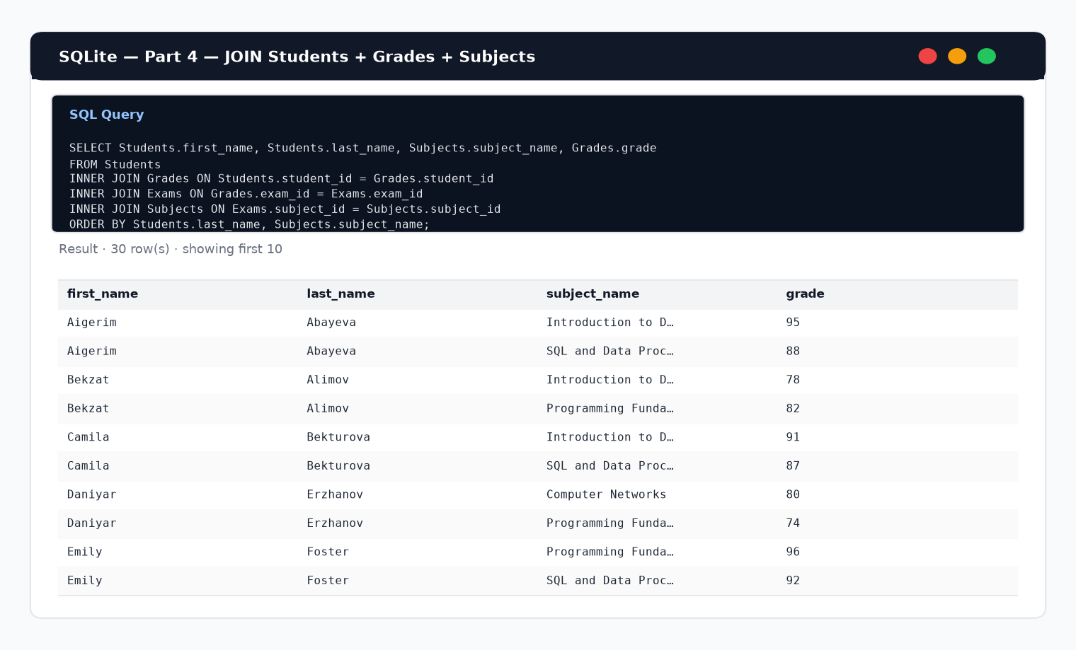
Figure 19. Student names, subject names and grades.
6.4 LEFT JOIN comparison
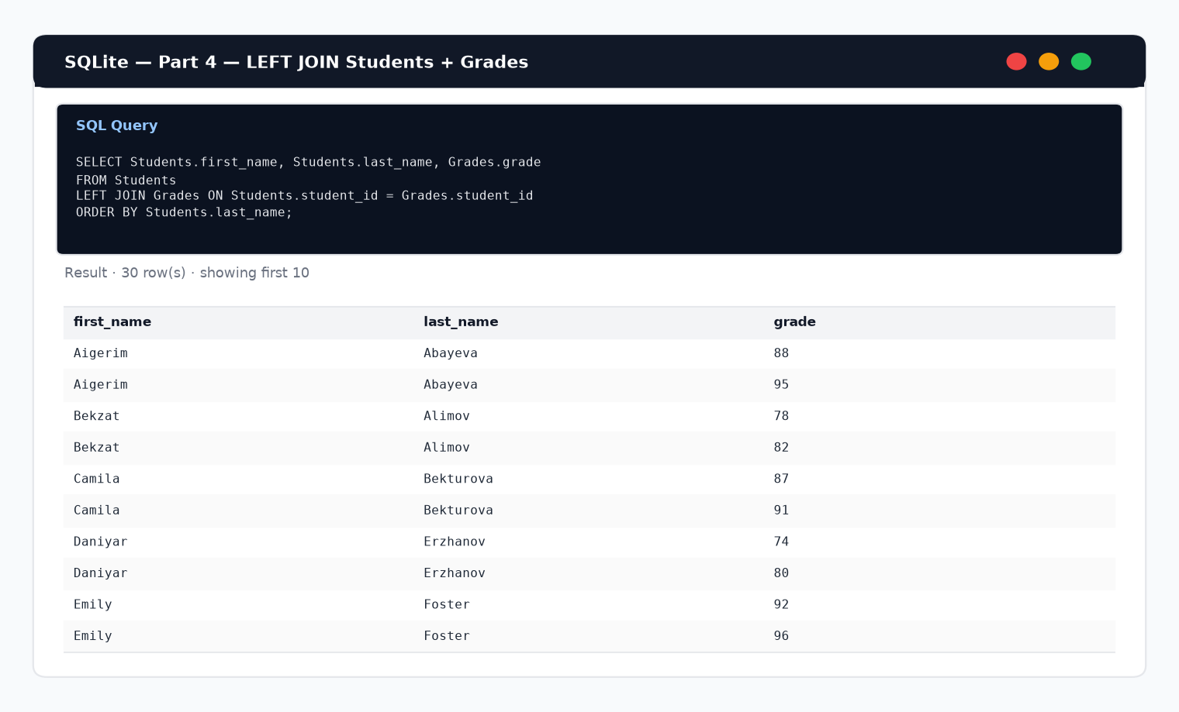
Figure 20. LEFT JOIN keeps every student; grade may be NULL if missing.
Report — Part 4
JOIN combines rows from multiple tables using matching key values. Compared with looking at Students or Grades alone, a JOIN result shows denormalized, human-readable information (name + group, or name + subject + grade) without duplicating master data in every sheet. INNER JOIN omits non-matching rows; LEFT JOIN preserves the left side and fills missing right-side columns with NULL. In this dataset every student has grades, so INNER and LEFT results contain the same people, but the pattern is ready for incomplete data.
7. Individual assignment — answers to six questions
1. What is the difference between sorting and filtering?
Sorting changes the order of rows according to one or more columns (for example A→Z by last_name) but keeps all records. Filtering temporarily hides rows that do not satisfy a condition (for example group_id = 1), so only matching records are shown.
2. What is SQL used for?
SQL is used to create and modify database structures, insert and update data, and — most importantly for this work — to query relational tables with SELECT, WHERE, ORDER BY, GROUP BY, aggregate functions and JOIN.
3. What is the difference between WHERE and ORDER BY?
WHERE selects which rows are included in the result based on conditions. ORDER BY does not remove rows; it only arranges the final result set (ASC or DESC) by chosen columns.
4. Why do we use GROUP BY and aggregate functions?
Aggregate functions (COUNT, SUM, AVG, MIN, MAX) compute summary values from many rows. GROUP BY partitions the data so those summaries are calculated separately for each group (for example student count per group_id).
5. What is the purpose of JOIN?
JOIN retrieves related information stored in different tables by matching key columns (foreign key = primary key), producing a combined result such as student name with group name or subject and grade.
6. What is the difference between INNER JOIN and LEFT JOIN?
INNER JOIN returns only rows that have a match in both tables. LEFT JOIN returns all rows from the left table and matching rows from the right table; if there is no match, right-table columns are NULL.
8. Conclusion
After completing this practical work, the Students dataset was sorted and filtered in Excel, including single-group filters, search by ID/name and a two-condition filter. The same university schema was implemented in SQLite. Basic SELECT queries projected full rows and selected columns from Students, Groups and Subjects. WHERE, ORDER BY, GROUP BY and aggregate functions (COUNT, MAX, MIN, AVG) were used to filter, order and summarize data. Finally, INNER JOIN and LEFT JOIN combined Students with Groups, Grades and Subjects, demonstrating how foreign keys connect tables and how joined results differ from reading each table alone. Overall, Excel is convenient for quick visual exploration, while SQL provides precise, repeatable queries for multi-table analysis.
9. Deliverables checklist
• Updated University_Database.xlsx (data/University_Database.xlsx)
• SQL script with all queries (sql/university_queries.sql)
• SQLite database file (data/university.db)
• Screenshots of Excel operations and executed SQL results (screenshots/)
• Short report with answers to the six questions (this document)
• Reports after each part and a final conclusion

