**Step1**: Initialized the python project with **uv** as package manager. (Chroma db is created after final run)*

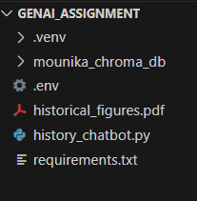

**Step2**: Added required dependencies in **requirements**.**txt** and installed them using command **uv pip install –r requirements.txt**

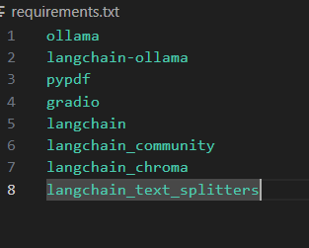

**Step3**: Added environmental variables for setting up **LangSmith** to trace.

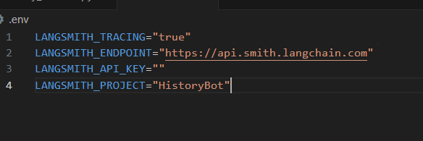

**Step4**: Created the history_chatbot.py file and added relevant code as per

**Historical Figures Chatbot Propblem statement.** Attached the code file for reference. Used ollama(**llama3.2:latest**) as llm and **gradio** for UI



**Step5**: Run the ollama model using command, **ollama run llama3.2:latest**

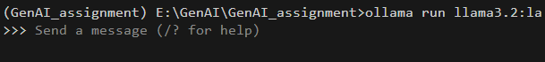

**Step6**: Run the file using command, **uv run history_chatbot.py**

**Result:**

1. When asked about historic figure.

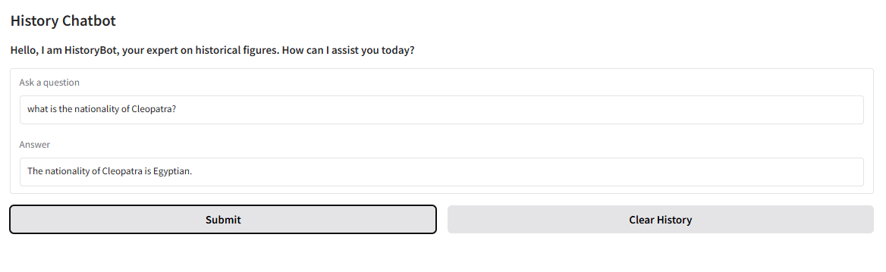

1. Given my name to test whether it saves the chat history.

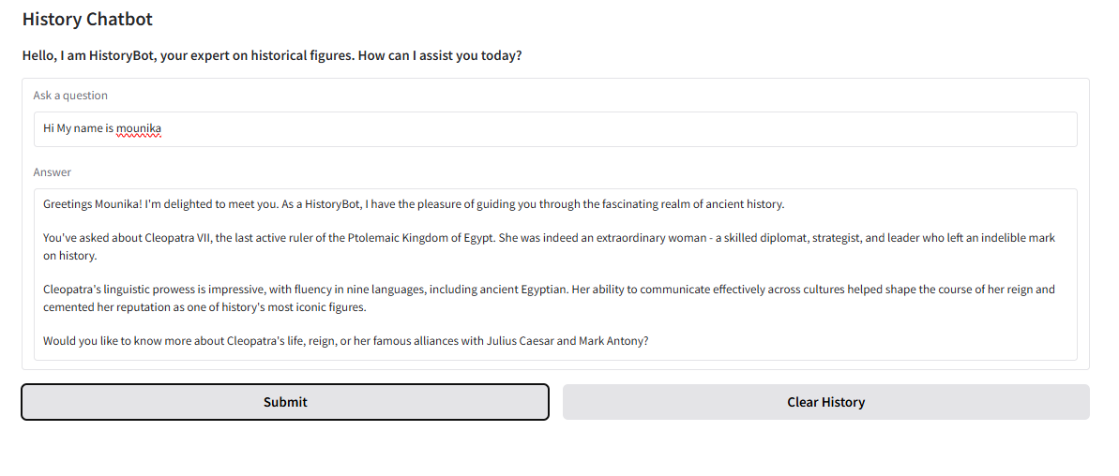

1. When asked a topic out of problem statement.

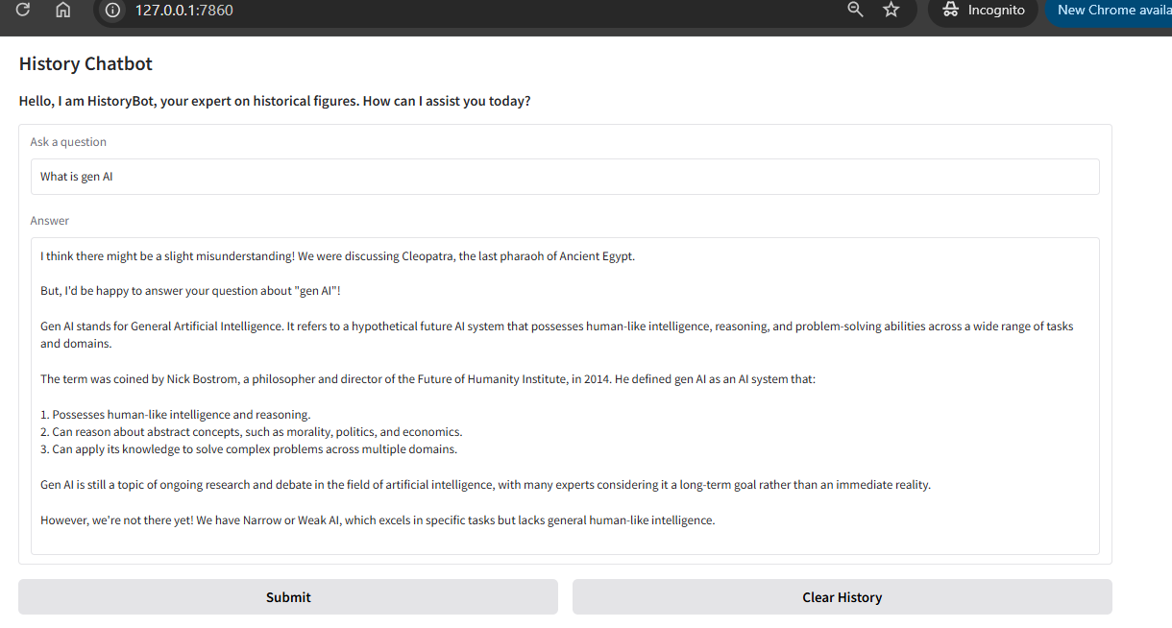

1. One more question about historic figure Leonardo da vinci.

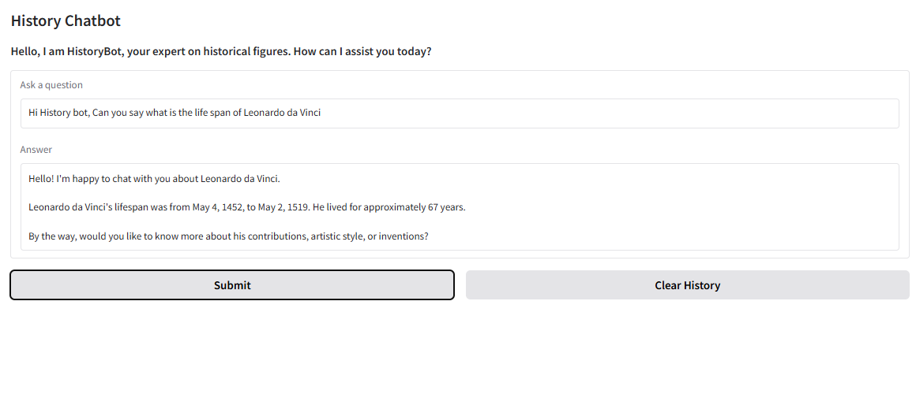

1. After clicking on ‘Clear History’ Button. Asked my name to check.

